Noor Blum

CPE301 – SPRING 2016

Design Assignment X

**DO NOT REMOVE THIS PAGE DURING SUBMISSION:**

The student understands that all required components should be submitted in complete for grading of this assignment.

|  |  |  |  |
| --- | --- | --- | --- |
| **NO** | **SUBMISSION ITEM** | **COMPLETED (Y/N)** | **MARKS**  **(/MAX)** |
| 0. | ASSEMBLY CODE TO ADD FIVE RANDOM NUMBER OF TASK 1/A |  |  |
| 1. | EXECUTION TIME/CYCLE OF CODE USING SIMULATION OF TASK 1/B |  |  |
| 2. | EXPLAINATION OF INSTRUCTION |  |  |
| 3. | SCREENSHOTS OF EACH TASK OUTPUT |  |  |

|  |  |  |  |
| --- | --- | --- | --- |
| 0. | ASSEMBLY CODE TO ADD FIVE RANDOM NUMBER OF TASK 1/A |  |  |

.nolist

.include "m328pdef.inc"

.list

.dseg

.cseg

.org $000

; init random number generator

ldi r16 , $3F

ldi r22 , $05

; init led ports

ldi r24 , $04

out DDRB , r24

ldi r24 , $00

out PORTB , r24

loop:

; lfsr pseudo random number generator algorithm

mov r17 , r16

andi r17 , $01

mov r18 , r16

andi r18 , $02

lsr r18

eor r17 , r18

andi r17 , $01

lsl r17

lsl r17

lsl r17

lsl r17

lsl r17

lsr r16

or r16 , r17

; end of algorithm data saved in r16

ldi r25 , $1E

cp r25 , r16

brge loop

ldi r25 , $3C

cp r16 , r25

brge loop

; led switching code

add r23 , r16

brbc 3 , skip

;PORTB.02 = 0

ldi r24 , $04

out PORTB , r24

rjmp continue

skip :

; PORTB.02 = 1

ldi r24 , $00

out PORTB , r24

continue:

dec r22

brne loop

end: jmp end

|  |  |  |  |
| --- | --- | --- | --- |
| 1. | EXECUTION TIME/CYCLE OF CODE USING SIMULATION OF TASK 1/B |  |  |

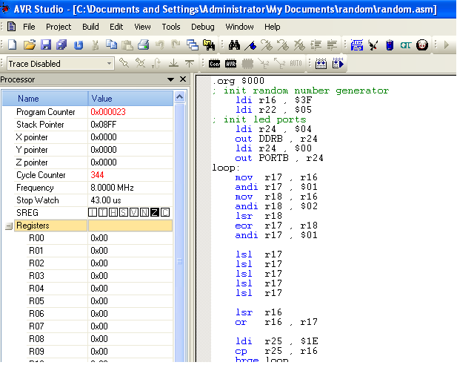

|  |  |  |  |
| --- | --- | --- | --- |
| 2. | EXPLAINATION OF INSTRUCTION USED |  |  |

LDI Rd, K Load Immediate Rd ← K

|  |  |  |  |
| --- | --- | --- | --- |
| 3. | SCREENSHOTS OF EACH TASK OUTPUT |  |  |

TASK 1/A: ADDING FIVE RANDOM NUMBER >30 AND <60

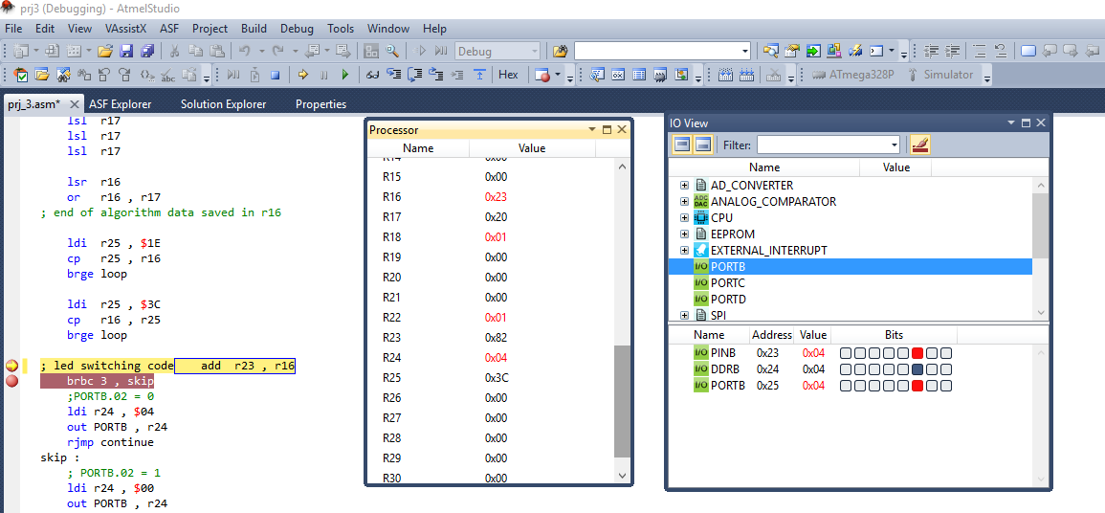

The addition result is stored in Register 23 i.e R23

Below screenshot shows the overflow of the Status Register.

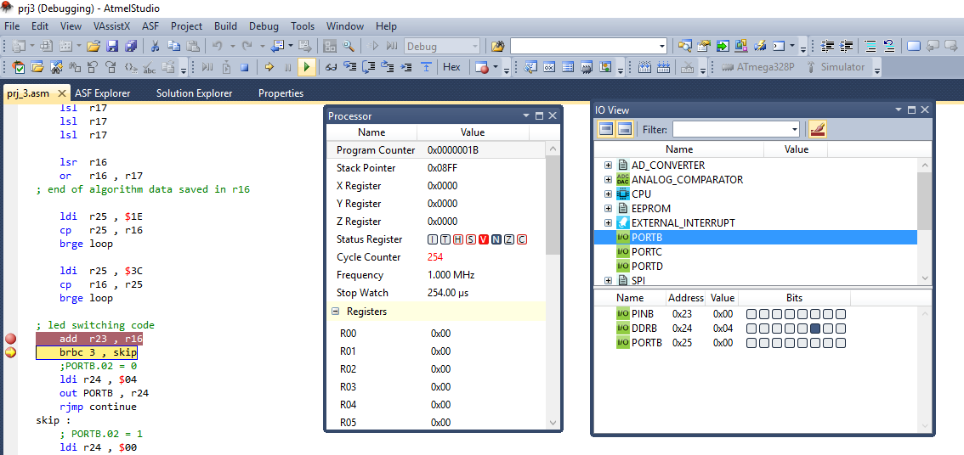

The next screenshots shows the change in PORTB.2 Status.

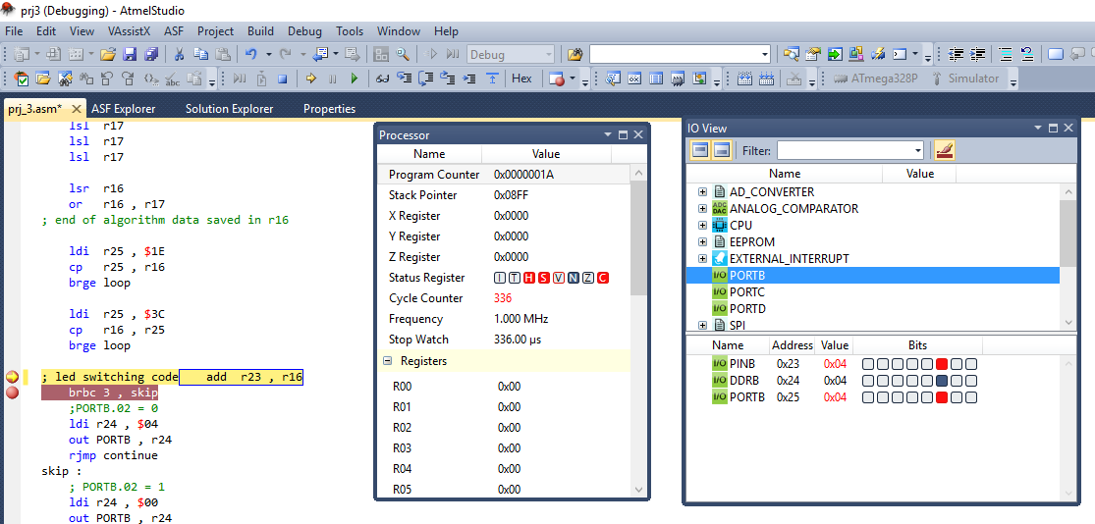

TASK 1/B: EXECUTION TIME/CYCLE OF CODE



**Student Academic Misconduct Policy**

<http://studentconduct.unlv.edu/misconduct/policy.html>

“This assignment submission is my own, original work”.

Noor Blum