Noor Blum

CPE301  UCLV

Weather Shield

CPE 301 EMBEDDED SYSTEM DESIGN S 2015

Contents

Goal: 2

Deliverables 2

Literature Survey: 2

Block Diagram 3

Flowchart 4

4

4

Working 4

• Hardware 4

• Software 5

• Cloud 6

Components 7

Schematic 8

PCB Design 9

Implementation 11

Snapshots/Screenshot/Videos 11

Code 12

• lcd_header.h 12

• serial_header.h 13

• main.c 14

References 18

**TITLE: Weather Shield using ESP8266 , DHT11 & ATmega328**

# Goal:

* Measure Temperature and humidity
* Send data on Cloud
* Monitor from Android Phone and PC

Deliverables:

* Source Code
* Hardware Schematics
* Android APK ( Generated )
* PCB Design Files
* Report Files

# Literature Survey:

We are always curious to measure our local weather irrespective of weather.com and accuweather.com, it always amused me to measure current room temperature and garden temperature, it is great fun to see and create a log of temperature on my cellphone with the help of cloud.

So this weather shield takes humidity and temperature readings from sensor DH11 and transfer the serial data through 1 wire protocol of ATmega328p port PB1, now Uart of ATmega328 will send the data to ESP8266, which will send data to free cloud service, and our android app and web browser will show the current temperature and humidity values with Pass Graph.

In summary we have following steps

* Microcontroller initialize the LCD , Ports , Serial Communication (RX,TX) and DTH11 Sensor
* Microcontroller fetch data from DTH11 sensor through port PB1 , by sending start signal and data comes out serially , in the code we have taken care and made the data into understandable format.
* Microcontroller send the same data ( after storing and basic checksum ) to LCD and on the TX
* In the initialization there is wifi_init function which setup the wifi to ESP8266 module.
* you have to provide you SSID(wifi name) and Password into code.
* if the blue LCD glows/blinks then data is transmitting
* so when data is received by sensor and displayed on LCD , and we have httppost and we will post the result in form of humidity and temp variable to the cloud platform.
* above operations (fetching data from sensor , display on lcd and posting on cloud ) in while infine loop.
* the same data should be updated on cloud webpage and app

# Block Diagram

**Cloud**

**ATMega328P**

**ESP8266**

DH11

Sensor

**OPTIONAL**

**(Only for Debugging)**

16x2 Matrix LCD

**Cloud**

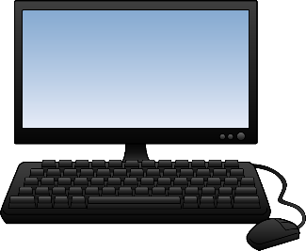

# Flowchart

Initialize Wifi

Initialize Ports/

Serial Communication

Start

Read Sensor Value

From DH11

# 

Send Data to Cloud

Send Data to TX/RX and ESP8266

# Working

Working of Weather Shield is simple enough to understand majorly there are 3 Parts Hardware, Software and Cloud, Basically Work of Hardware is to generate the value and DH11 will take value of temperature and humidity and send to port PB1 of ATmega328P through one wire protocol , then firmware inside ATmega328P will collect the data from Port , checksum the actual readings and send to TX of ATmega328p which is connected with RX of wifi module ,

Now wifi module will interact with internet and free cloud service, it will send data to cloud service and now device where you want to see, I have created one basic app which will see the cloud URL and display the picture. For collecting data we following one wire protocol as below:

1. Send request
2. Read response
3. Read each data segment and save it to a buffer
4. Sum the segments and check if the result is the same as CheckSum

If the CheckSum is correct, the values are correct so we can use them. If CheckSum is wrong we discard the packet.

## Hardware

Atmega328P is main hardware of this project , basically it configure ports and convert data into actual ratings , it has various IO ports , in portd we have connected 16x2 LCD just to debug the data taken by sensor ,it can be removed in production version of Weather shield. And DH11 is connected with Port PB1 and it interfaces the data through one wire protocol.

## Software

Software has major role in this project, firmware and other is app, the esp8266 will be configured through firmware and we are sending the data through the same firmware. So firmware plays an important role. We have implemented 1 wire protocol inside the software , through which DH11 is communicating with ATmega328p port PB1 , the procol is following :

**Request:**

To make the DHT-11 to send you the sensor readings you have to send it a request. The request is, to pull down the bus for more than 18ms in order to give DHT time to understand it and then pull it up for 40uS.

**Response:**

What comes after the request is the DHT-11 response. This is an automatic reply from DHT which indicates that DHT received your request. The response is ~54uS low and 80uS high.

**Data:**

What will come after the response is the sensor data. The data will be packed in a packet of 5 segments of 8-bits each. Totally 5×8 =40bits.

First two segments are Humidity read, integral & decimal. Following two are Temperature read in Celsius, integral & decimal and the last segment is the Check Sum which is the sum of the 4 first segments. If Check Sum's value isn't the same as the sum of the first 4 segments that means that data received isn't correct.

**How to Identify Bits:**

Each bit sent is a follow of ~54uS Low in the bus and ~24uS to 70uS High depending on the value of the bit.

Bit '0' : ~54uS Low and ~24uS High

Bit '1' : ~54uS Low and ~70uS High

**End Of Frame:**

At the end of packet DHT sends a ~54uS Low level, pulls the bus to High and goes to sleep mode.

In the following image you can see the request sent from the MCU to the DHT and following the packet. Because the long duration as you can see is about 20mS and packet received is in uS we can't view the data bits.

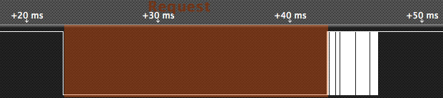

If we zoom in signals and area in question we can understand the data communication in protocol

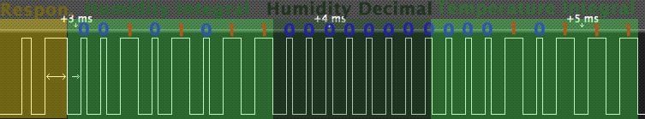

If we decode the above data we have.

Humidity 0b00101011.0b00000000 = 43.0%

Temperature 0b00010111 = 23 C.

The last two segments can't be seen in this image because of zoom.

## Cloud

We have used free cloud service <http://data.sparkfun.com> , it has provided basic interface which will generate the cloud data in the graphical format

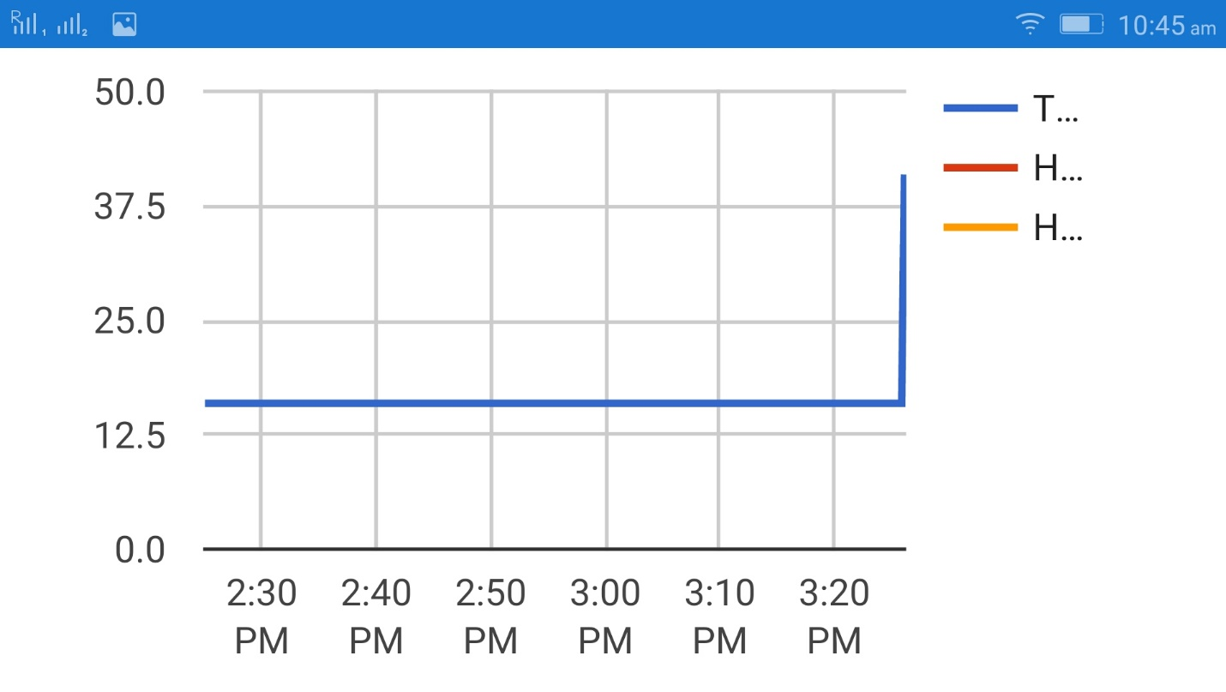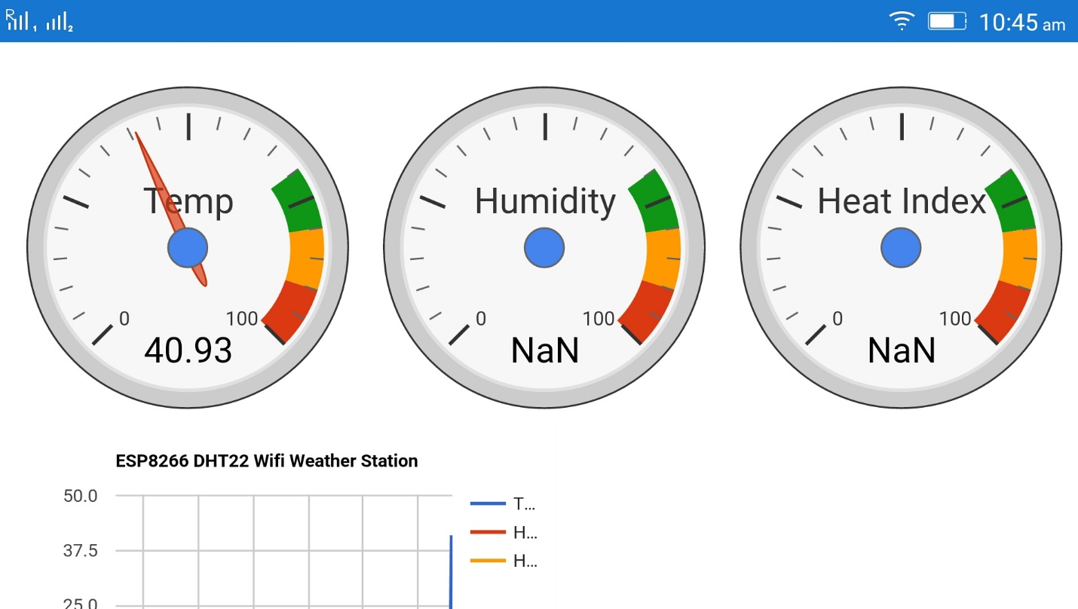

# Components

**Explain the main characteristics, interface, and limitation of the components used**

**Main Characteristic:**

In this project the main components are as below:

Microcontroller (ATMEGA328P)

* High Performance, Low Power Atmel®AVR® 8-Bit Microcontroller
* 32KBytes of In-System Self-Programmable Flash program memory
* 1KBytes EEPROM
* 2KBytes Internal SRAM
* 8-channel 10-bit ADC
* Programmable Serial USART

Temperature Sensor (DTH11)

* Measurement Range - 20-90%RH 0-50 ℃
* Humidity Accuracy - ±5％RH
* Temperature Accuracy - ±2℃
* Resolution -1

WiFi Module ( ESP8266 )

* 802.11 b/g/n
* Integrated low power 32-bit MCU
* Integrated 10-bit ADC
* Integrated TCP/IP protocol stack
* WiFi 2.4 GHz, support WPA/WPA2

LCD Display (16x2 LM016L)

* Mechanical dimension – 80mm x 36mm x 13.5mm
* Power Voltage – 7V max
* Operating Temperature – 0 - 50 C

# Schematic

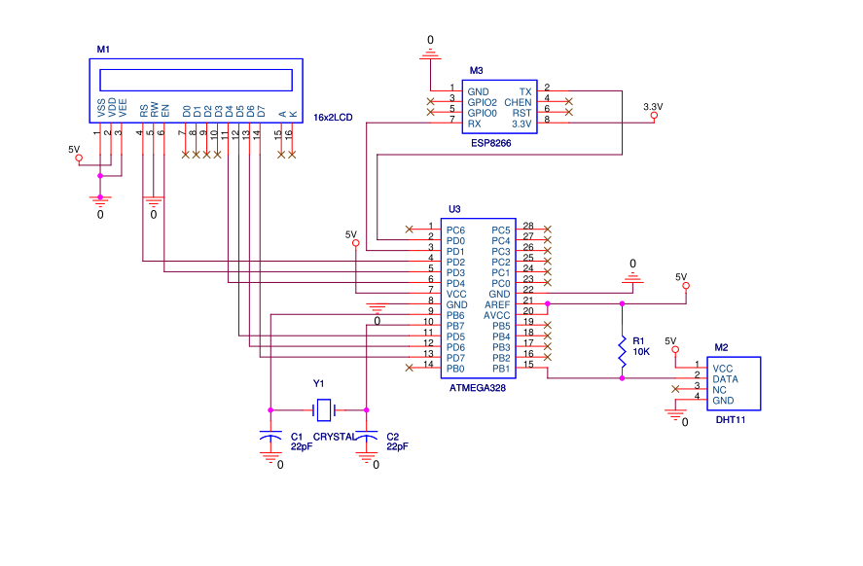



# PCB Design

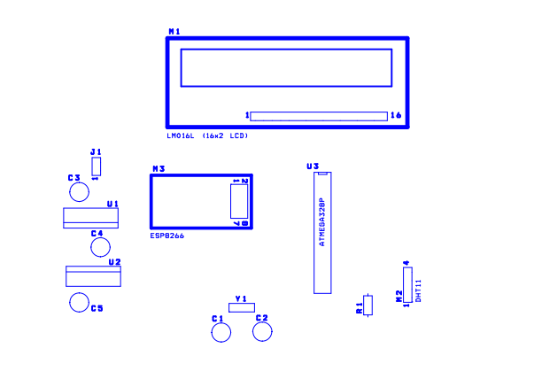

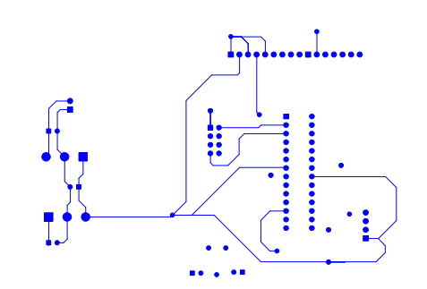

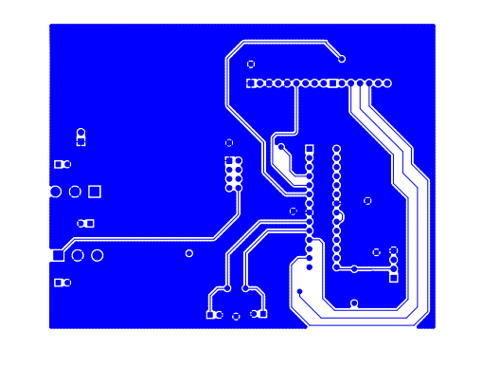

# Implementation

* Create a C Code which communicate with ESP8266 , take temperature from DTH11 and Display the commands on LCD Screen
* Connect the hardware as Schematic
* Now C code will take data from Sensor DTH11 through one wire protocol and upload to cloud.
* Change the wifi SSID and password into code as per your requirement.
* Log the data and see the results on HTML Webpage and Andoird App

# Snapshots/Screenshot/Videos

[https://github.com/blumn/weathershield/1.jpg](https://github.com/blumn/weathershield)

<https://github.com/blumn/weathershield/2.jpg>

<https://github.com/blumn/weathershield/3.jpg>

<https://github.com/blumn/weathershield/4.jpg>

<https://github.com/blumn/weathershield/5.jpg>

<https://github.com/blumn/weathershield/6.jpg>

<https://github.com/blumn/weathershield/7.jpg>

<https://github.com/blumn/weathershield/8.jpg>

<https://github.com/blumn/weathershield/videos.txt>

# Code

## lcd_header.h

#define F_CPU 16000000ul //define CPU Clock

#include <util/delay.h> //Included delay function , which used later in code

#define rs PD2 //define RS (register select) pin

#define en PD3 //define EN pin

void cmnd() //function cmnd() which take care timing of en and rs pins

{

PORTD&=(~(1<<rs)); // rs pin Low

PORTD|=(1<<en); // en pin high

*_delay_ms*(5); // delay of 5ms

PORTD&=(~(1<<en)); // en pin low

}

void lcdcmd(char ch) // lcd command writing function

{

PORTD=ch & 0xF0; // assign the data on pins

cmnd(); // called cmnd function

PORTD=(ch<<4) & 0xf0; // Data serially to pins

cmnd(); // called cmnd function

}

void lcd_init() // initialize sequence of LCD

{

lcdcmd(0x02);

lcdcmd(0x28);

lcdcmd(0x0e);

lcdcmd(0x01);

}

void data() // lcd data timing function same as cmnd

{

PORTD|=(1<<rs); // rs pin low

PORTD|=(1<<en); // en pin high

*_delay_ms*(5); // delay 5 ms

PORTD&=(~(1<<en)); // en pin low

}

void lcddata(char ch) // lcd data witing funcition

{

PORTD=ch & 0xF0; // configuring the ports

data(); // calling timing function

PORTD=(ch<<4) & 0xf0; // shifting pin serially

data(); // calling data function

}

void lcdprint(char *str) // data printing function on lcd

{

while(*str)

{

lcddata(*str); // transferring data until it is printed

str++; // incrementing

}

}

## serial_header.h

void serialbegin(unsigned int BAUD, unsigned int FOSC) //serial transfer init function

{

unsigned int MYUBRR=((((FOSC*1000000)/16))/BAUD)-1; //setting up the baud rate

UBRR0H = (MYUBRR >> 8);

UBRR0L = MYUBRR;

UCSR0B |= (1 << RXEN0) | (1 << TXEN0); // Enable receiver and transmitter

UCSR0B |= (1 << RXCIE0); // Enable reciever interrupt

UCSR0C |= (1 << UCSZ01) | (1 << UCSZ00); // Set frame: 8data, 1 stp

}

char serialread() // Serial read function

{

while(!(UCSR0A & (1<<RXC0))); // run until the RXC0 bit is set

return UDR0;

}

void serialwrite(unsigned char ch) // Serial write function

{

UDR0=ch;

while(!(UCSR0A & (1<<UDRE0))); // run until the URE0 bit set

}

void serialprintln(char *str) // Serial Printing function

{

serialprint(str);

serialprint("\r\n");

}

void serialprint(char *str) // Serial Printing String

{

while(*str)

{

serialwrite(*str);

str++;

}

}

## main.c

#include <avr/io.h> //include AVR IO lib header

#include <stdint.h> //include stdint headers

#include <avr/interrupt.h> //include interrupt headers

#include "serial_header.h" //include serial_header.h for sending data ESP5266

#include "lcd_header.h" //include lcd_header.h for printing status messages

#define sensor PB1 //Sensor DTH11 connected with this port

char *pvt_key="gzBw6x6Nx6Io2qd9Mlq5"; //pvt key used to log the data into cloud server

char *public_key="Jxr64n4Kn4Ir4KWpQXKL"; //public to get the log data and display

static char postUrl[200]; //url decleration

char *text,mytext[4];

unsigned char a = 0, b = 0,d = 0,t1 = 0,t2 = 0,

rh1 = 0,rh2 = 0,sum = 0;

char temperature[3];

char humidity[3];

int i=0;

char rec[100];

char ReceivedChar=0;

void StartSignal() //Function for Starting Sensor DTH11 value

{

DDRB|= 1<<sensor; //Configure RD2 as output

PORTB&= ~(1<<sensor); //RD2 sends 0 to the sensor

*_delay_ms*(18); //Delay Function

PORTB|=1<<sensor; //RD2 sends 1 to the sensor

DDRB&=~(1<<sensor);

PORTB&=~(1<<sensor);

}

void CheckResponse() //Checking the Sensor Response

{

a = 0;

*_delay_us*(40);

while((PINB&(1<<sensor))); // check Sensor pin is Set

if(!(PINB&(1<<sensor))) // if sensor pin is low

{

*_delay_us*(80); // delay

if (PINB&(1<<sensor))// if sensor in high

{

a = 1; // set variable a to 1

*_delay_us*(80);// delay

}

}

}

void ReadData() // Read Sensor reading

{

for(b=0;b<8;b++)

{

while(!(PINB&(1<<sensor))); //Wait until PORTD.F2 goes HIGH

*_delay_us*(40); // Delay

if(!(PINB&(1<<sensor))) // if Sensor pin low

d&=~(1<<(7-b)); // Clear bit (7-b)

else

{

d|= (1<<(7-b)); //Set bit (7-b)

while(PINB&(1<<sensor));//Until Sensor Pin is high

}

}

}

void show() // Calculate and Show Reading to LCD

{

if(a == 1)

{

ReadData(); // Read data from Sensor

rh1 =d; // Store data in variable

ReadData();

rh2 =d;

ReadData();

t1 =d;

ReadData();

t2 =d;

ReadData();

sum = d; // Read the sum of data

if(sum == rh1+rh2+t1+t2) // if Sum is Equal

{

lcdcmd(1); // LCD command

text = "Temp: .0C"; // Text Writing on LCD

lcdprint(text); // LCD Showing the above Text

lcdcmd(192); // LCD Command for writing at 0x192

text = "Humidity: .0%"; // Text should be writing on Sencond Line

lcdprint(text); // Display the Text

*sprintf*(temperature,"%d",t1); // Update the value with Temperature

lcdcmd(0x85); // Move the cursor

lcdprint(temperature); // Display the Temperature

*sprintf*(humidity,"%d",rh1); // Update the value with humidity

lcdcmd(0xc9); // Move the cursor

lcdprint(humidity); // Display the Humidity

}

else

{

lcdcmd(1); // Writing to first digit

lcdprint("Check sum error"); // Display “Check sum Error”

}

}

else

{

lcdcmd(1); // if Sensor is not connected

lcdprint("No response"); // No Response will display

lcdcmd(192); // Second line

lcdprint("from the sensor"); // From the Sensor will display

}

}

ISR(USART_RX_vect) // Interrupt Service Routine

{

ReceivedChar = UDR0; // Read data from the RX buffer

rec[i++]=ReceivedChar; // Write the data to the TX buffer

}

void get_ip() // get network IP Connection

{

char IP[16];

char ch=0,j=0;

char flag=0;

while(flag==0)

{

i=0;

serialprintln("AT+CIFSR"); //Send the AT Command CIFSR

*_delay_ms*(2000); // Delay

if(i>0)

{

for(j=0;j<i;j++)

{

lcdcmd(1); // Display 1

lcdprint("Wait...."); // Display wait

if(rec[j]=='S' && rec[j+1]=='T' && rec[j+2]=='A' && rec[j+3]=='I' && rec[j+4]=='P')

{

j=j+6;

int n=0;

while(i!=j)

{

while(rec[j]!='+')

{

IP[n++]=rec[j++];

}

flag=1;

break;

}

}

}

}

}

lcdcmd(1);

lcdprint("IP:"); // Display the IP

lcdprint(IP); // Print the IP

lcdcmd(192); // Print the Port on Second line

lcdprint("Port:"); // Print “Port”

lcdprint(80); // Print number 80

i=0; // Delay

*_delay_ms*(5000);

}

void send(char *str, unsigned int time) // Send Character on Serial to ESP8266

{

while(1) // this is forever loop ,

{ // through this function we send AT Commands

int j=0,temp=0;

i=0;

serialprintln(str); // send serial command

lcdcmd(1); // Move the Cusor 1

lcdprint(str); // lcd print the Serial Command

for(int t=0;t<time+2000;t++) // Delay

*_delay_ms*(1);

if(i>0) // print OK

{

for(j=0;j<i;j++)

{

if(rec[j]=='O' && rec[j+1]=='K')

{

lcdcmd(192);

lcdprint("OK");

temp=1;

*_delay_ms*(1000);

i=0;

break;

}

else if(rec[j]=='E' && rec[j+1]=='R' && rec[j+2]=='R' && rec[j+3]=='O' && rec[j+4]=='R') // Print Error

{

lcdcmd(192);

lcdprint("Error");

*_delay_ms*(1000);

i=0;

}

}

}

if(temp==1)

break;

}

}

void connect_wifi() // Connect Wifi function

{

send("AT",1000); // Send few AT Commands

send("AT+CWMODE=1",1000); // AT command CWMOD

lcdprint("Connecting WIFI"); //LCD will display

send("AT+CWJAP=\"wifissid\",\"wifipassword\"",10000); // Send command

}

void httpGet(char * ip, char *path, int port) // Get the Cloud Url

{

int resp;

port=80;

serialprint("AT+CIPSTART=\"TCP\",\""); // Sending URL

serialprint(ip); // Sending to Cloud

serialprintln("\",80");

*_delay_ms*(1000);

int len = *strlen*(path); // Path

char buff[3];

char *atSendCmd = "AT+CIPSEND=";

*sprintf*(buff,"%d",len); // Send the Length

serialprint(atSendCmd); // Send Command

serialprintln(buff); // Send buffer

//GET /invoice/ HTTP/1.0\r\n\r\n

serialprint("GET /");

serialprint(path);

serialprintln(" HTTP/1.0\r\n\r\n");

}

# References

* <http://www.atmel.com/Images/Atmel-8271-8-bit-AVR-Microcontroller-ATmega48A-48PA-88A-88PA-168A-168PA-328-328P_datasheet_Summary.pdf>
* <http://www.micropik.com/PDF/dht11.pdf>
* <https://cdn-shop.adafruit.com/product-files/2471/0A-ESP8266__Datasheet__EN_v4.3.pdf>
* <https://www.sparkfun.com/datasheets/LCD/ADM1602K-NSW-FBS-3.3v.pdf>
* [www.spartkfun.com](http://www.spartkfun.com)
* [www.hobisyste.com](http://www.hobisyste.com)
* [http://hobbyist.co.nz](http://hobbyist.co.nz/sites/default/files/datalog/graph/graph.html)
* <http://www.candrian.gr/index.php/dht-11-one-wire-bus/>

Noor Blum Page 18/18