#this is the explaination of the Logistic Regression and its confusion matrix

1. Short Explanation of the Output

The logistic regression model has been trained and tested, resulting in a high accuracy of 95.98%. The classification report shows the model's performance, with precision, recall, and f1-score values around 0.96 for both classes (0 and 1). The confusion matrix visually represents how well the model performed, with the majority of predictions being correct.

2. Detailed Explanation of the Confusion Matrix and Classification Report

Confusion Matrix:

True Positives (TP): The model correctly predicted 1s (positive class) 325 times.

True Negatives (TN): The model correctly predicted 0s (negative class) 296 times.

False Positives (FP): The model incorrectly predicted 1s when the true value was 0, 12 times.

False Negatives (FN): The model incorrectly predicted 0s when the true value was 1, 14 times.

Classification Report:

Precision: Precision for class 0 is 0.95, and for class 1 is 0.96. Precision measures the accuracy of positive predictions.

Precision

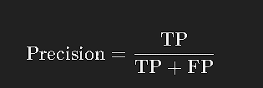

Recall: Recall for class 0 is 0.96, and for class 1 is also 0.96. Recall measures the ability of the model to find all the relevant cases.

Recall

​

F1-Score: The F1-Score is the harmonic mean of precision and recall, which is 0.96 for both classes, providing a balance between the two metrics.

F1-Score

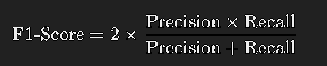

Support: The support shows the number of true instances for each class (308 for class 0 and 339 for class 1).

Accuracy:

The overall accuracy of the model, 95.98%, is the proportion of correct predictions (TP + TN) out of all predictions (TP + TN + FP + FN).

Overall Explanation:

The logistic regression model performed very well, with an accuracy of 95.98%. The confusion matrix indicates that most predictions were correct, with very few misclassifications. The classification report supports this, showing strong precision, recall, and f1-scores for both classes, suggesting that the model is reliable in predicting both the positive and negative classes.

#this is the explaination of Knn and its confusion matrix

**1. Short Explanation of the Output**

The K-Nearest Neighbors (KNN) model achieved an accuracy of 94.44%. The classification report shows strong performance metrics, with precision, recall, and f1-scores close to 0.94 for class 0 and 0.95 for class 1. The confusion matrix indicates that the majority of predictions were correct, but with a slight increase in false negatives compared to the logistic regression model.

**2. Detailed Explanation of the Confusion Matrix and Classification Report**

**Confusion Matrix:**

* **True Positives (TP)**: The model correctly predicted 1s (positive class) 315 times.
* **True Negatives (TN)**: The model correctly predicted 0s (negative class) 296 times.
* **False Positives (FP)**: The model incorrectly predicted 1s when the true value was 0, 12 times.
* **False Negatives (FN)**: The model incorrectly predicted 0s when the true value was 1, 24 times.

**Classification Report:**

* **Precision**: Precision for class 0 is 0.93, and for class 1 is 0.96. Precision indicates how many of the positive predictions were actually correct.

Precision

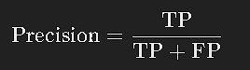 ​

* **Recall**: Recall for class 0 is 0.96, and for class 1 is 0.93. Recall indicates how many of the actual positives were correctly identified.

Recall



* **F1-Score**: The F1-Score is 0.94 for class 0 and 0.95 for class 1, balancing precision and recall.

F1-Score

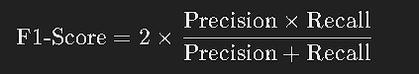

* **Support**: The support indicates the number of actual instances for each class, with 308 for class 0 and 339 for class 1.

**Accuracy:**

The model's overall accuracy is 94.44%, representing the proportion of correct predictions out of all predictions made.

**Overall Explanation:**

The KNN model performed well, with an accuracy of 94.44%. The confusion matrix shows that while the majority of predictions were correct, there were slightly more false negatives (24) than false positives (12). The classification report demonstrates that the model has high precision and recall, with an f1-score close to 0.95 for both classes. This suggests that the KNN model is effective, though slightly less so than the logistic regression model.

4o

**#this is the explaination of the Decision tree and its confusion matrix**

**1. Short Explanation of the Output**

The decision tree model achieved an accuracy of 94.44%. The classification report shows that both classes (0 and 1) have high precision, recall, and f1-scores, each around 0.94-0.95. The confusion matrix indicates that the majority of predictions were correct, with a balance between false positives and false negatives.

**2. Detailed Explanation of the Confusion Matrix and Classification Report**

**Confusion Matrix:**

* **True Positives (TP)**: The model correctly predicted 1s (positive class) 322 times.
* **True Negatives (TN)**: The model correctly predicted 0s (negative class) 290 times.
* **False Positives (FP)**: The model incorrectly predicted 1s when the true value was 0, 18 times.
* **False Negatives (FN)**: The model incorrectly predicted 0s when the true value was 1, 17 times.

**Classification Report:**

* **Precision**: Precision for class 0 is 0.94, and for class 1 is 0.95. Precision measures the accuracy of the positive predictions.

Precision

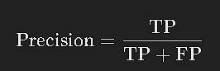

**Recall**: Recall for both classes is 0.94 for class 0 and 0.95 for class 1. Recall measures the proportion of actual positives that were correctly identified.

Recall

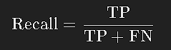

* **F1-Score**: The F1-Score, which is the harmonic mean of precision and recall, is 0.94 for class 0 and 0.95 for class 1, indicating balanced performance.

F1-Score

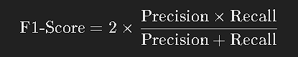 ​

* **Support**: The support is the number of actual occurrences for each class, with 308 for class 0 and 339 for class 1.

**Accuracy:**

The overall accuracy of the decision tree model is 94.44%, which means that 94.44% of the predictions made by the model were correct.

**Overall Explanation:**

The decision tree model performed well, with an accuracy of 94.44%. The confusion matrix shows a relatively balanced distribution of false positives and false negatives, with 18 and 17 misclassifications, respectively. The classification report highlights strong precision, recall, and f1-scores for both classes, indicating that the model is effective and reliable in making predictions for both positive and negative classes.