**1.1 Four ways to represent functions**

**1.Concepts of Functions**: Domain, range, x- or y-intercepts, vertical line test rule

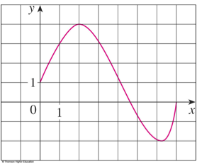A function*f*is a rule that assigns to each element *x* in a set *D* exactly one element *f*(*x*)

**#32:**  Domain:  **then** **interval:** 



4

0.5

**2.Evaluate Function** (#27) **Ex 3. **

a. f(-1), *b) f(a+h) c*.



in b) evaluate by replacing with : , do not miss



= Distribute 2 and to each term of polynomials.



c) = ( parentheses () )



= ( “” in front of (), and cancel terms)



== (divide each term by h, or )



**3. Equation of A straight line:** , or ,

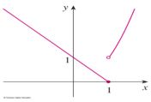Here b is y-intercept, slope 

Parallel line has same slopes, perpendicular lines: 

**Ex7 (#49) piece-wise function**: 

For is a line joining (0,1) and (1,0), the solid dot indicates the point (1,0) is included. And for , which is the part of the parabola that **lies to the right of the line , the open dot indicates that the point (1,1) is excluded.**

**4.Represent functions in four ways (words, table, graphs, formula)**

**#57.** A rectangle has perimeter 100 m, express the area as a function of one side.

Let length =*x,* width =*y*, then perimeter =*2x+2y=100*, or *x+y =50*

(has to) solve one variable *y=50-x*, and Area=*xy= x(50-x) =*

5.**Even/odd functions**: If for all, the graph is symmetric about *y-*axis. If , thenis an odd function, the graph is symmetric about the origin.



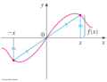 Det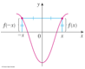ermine function odd/even, or neither

**a) . (Ans: odd, why?)**



b) (even, why?)



c) (neither) **Proof**:



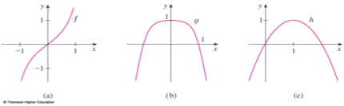Since and so is neither even nor odd.



**5. Increasing**: If whenever ; **Decreasing**: for



In **a) it increases everywhere c) It increases** on interval , decreases on .



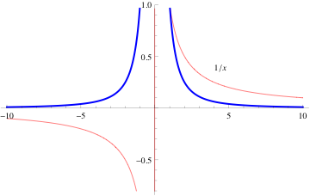**1.2 /1.5/1.6 Appendix A Mathematical Models**

**1.** For  , the graphs are

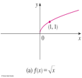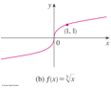

Reciprocal function: ,  ( in 1st and 3rd quadrant) ; in 1st and 2nd \

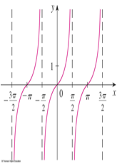As  or , call  as the (horizontal) **asymptote**

**2. Trigonometric** functions:



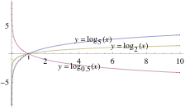**3**. **Exponential** functions: y=, base *a:*  constant



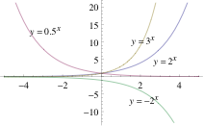

**4. Logarithmic Functions**: ,base *a>0.*  iff



in 1.6, logarithmic  is the inverse of , and **their graphs are symmetric about the line y=x**

**1.3 New Functions and Old Functions**

**1. Transformations of functions: Suppose that c>0,** and



**Vertical shifts:**  is just the graph *of y=f(x)* shifted up /down *c* units.



**Horizontal shifts** , shift to left with ,to right



2. **Vertical stretching:** *y=c f(x) . 0<c<1* compress vertically;

If *c>1* stretch *y=f(x) by c times*. 

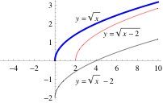**Horizontal stretching:** y=f (cx), 0<c<1, stretch horizontally; If b>1, compress horizontally:  .

**3.** **Reflect y=f(x) about x-axis to get** : 

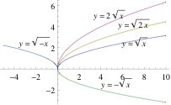**Reflect y=f(x) about y-axis to get **

**Ex1. Compare**

**a . y=** with y =, y=,



b. y =, y= ,y=, y=



in b) ,

: (1,1) 

4.**Generally:** , and , you should follow steps:



1)b: Horizontal scale 2)c:Horizontal translation3) a: Vertical Scale 4)d: Vertical Trans

**But for Sinusoid** curves, is called as **amplitude**, period , and is called frequency, is called **phase shaft**.



**Ex4**. Find amplitude, period, phase shift of and graph in one period.



**First** find Period T= , amplitude |3|=3, shift from .



Now the graph will start at phase shift , after one period , end at .



As an aid in sketching the graph, we divide the interval into 4 equal parts,



Then graph a sine curve with amplitude 3. (point is , then find..)



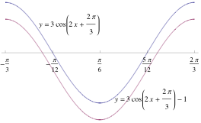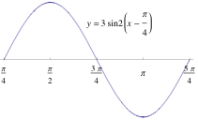

**For**.



First as in a), draw , then shift down 1 unit. Period , Shift from =0, So start at , end at , the mid-point of is . So draw a cosine curve with amplitude 3, then shift it down 1 units t



**4.Complete Square: Change the quadratics**  as the vertex form:



, where is the **vertex point,** the x-coordinate of vertex is given by *h* = , the *y*-coordinate of vertex .



**Ex.**,where , ,



. So **.**



**Or use to do it.:** = =



(combine first two terms and takes –3 out. Then we add and subtract ,



=- +1 (which is the square of the half of the coefficient of *x*,



= (the first 3 terms is the complete square: ,



= (multiplying the factor 3 to each term, note



= (which represents a parabola, vertex (3,28), opening down).



**5. Composite functions:** = . The diagram is



The domain should be those which make both and be defined



Ex 6. Find if, .



=



**Ex7.** Find , and each domain for



(plug into ), the domain of is: , or



, for its domain, first to be defined so , also , therefore .



**Ex8.** Find , if



**Ex 9 Decompose composite** function: (**From the inner most towards outer**)

Given , find f, g, h, such that



. **Solution:** We observe the structure of :



It says : first add 9, then take the cosine of the result, and finally square: So write:

=, , , and you can verify that .



The above way construct the composition from **inner most** to outer, sometime you can also see it from outer most to inner: in , first it’s square of something, so , also rewrite . We stop here since is the basic elementary function, so write in order of **outer to inner for each of the right side of , cosv , and x+9, so** , g(x)= ,



**1.4 Graphing Calculators (Viewing rectangle:[a,b] by [c,d])**

Ex 2. Domain: . Range:



. So use window [-3,3] by [0,4].



Ex4.. If use [-12,12] by {-1.5, 1.5], the graph looks fine.



We need to use the period use [-0.25,0.25] (cycles)



**2.** Use Intersections of Graphs **to solve equation** ,**Or find zeros of**



Ex9. Find the solution of correct to 2 decimal places. change to eqn: *x-cosx =0*



**3. Maple Software: commends**: Solve equations: solve ;



Graphing functions: plot ; or plot



**1.5 Exponential Functions (Special:** , )



**1.Exponent Rules ( Do not confuse:** power function, while is exponential)



**Ex.**



**2.Radicals: Evaluate**



, ()



**3. , domain , range** .  **Limit**:



**4.Exponential growth and decay**: . b>1, exponential growth , 0<b<1, decay..



**Ex.** The world population was 6 billion in 1999, and with exponential growth, and doubles every 35 years. Write the model, and when it will reaches 240 billion?

,  when t=35, 

so In 2050, t=51,,



Now : If , **Take Logarithm:**

, or 

**Ex.** The half-life of a radium 1620 years. If the initial mass is 10 mg., when it will have only 1mg? , as in above….

,so . Take logarithm both sides:



**#11.** Compare , and explain how you get ?



Step: a. Reflect about y-axis to get b. vertically to get . c. Reflect about y-axis to get d. move up 1 to get



**1.6 Inverse Functions ,Logarithms , Inverse Trig**

**1. Inverse**  is the reverse rule of: if then  . Domain of = Range of , range of =domain of. i.e.



**# 17. , what is** ? since

**Ex3 and #16**. If , for a. Find b



We **observe** that: when , so



For b), by the cancellation rule of the definition for inverse, we have



**2.** **One-to-one (1-1) function and its inverse:**

A function has inverse iff it is 1-1, where 1-1 means that , then . (any y –value corresponds to only one x, or different x-values



correspond to different y , if then ).



**3.Horizontal Line Test for 1-1**: Any horizontal line intersects the graph y=f(x) once.

A function is 1-1 if and only if it passes the horizontal line test. From our graphs, we

See that is 1-1 for all in its domain, while is not 1-1



on its domain. But when we restrict, then these functions could be 1-1.



**Ex.** is 1-1 on or , is 1-1 on , is on



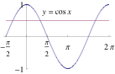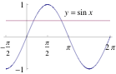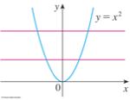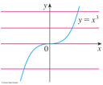

**4. How to** **find inverse:** a.Write *y=f(x)* b.solve *x =g(y)* (may restrict x) c. exchanging *x,y*

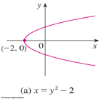**6.Solve functions** or  explicitly.

**Ex: ** is a parabola with vertex (-2,0) and opens

to the right side, symmetric about *x-*axis. **The graph does not represent a function** of *x, since there are vertical lines* intersects the parabola twice.

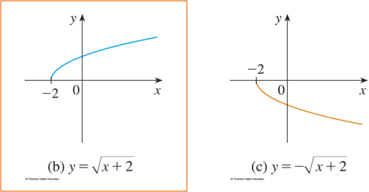

**But when rewrite** as, so  and.(**Do not miss** !), each of the upper and lower halves of the parabola be the function of *x*. **Note that**  does define *x* as a function of *y: .*

**Ex 4.** Find the inverse function of if the inverse exists.



Since is 1-1, so exists. Now we follow steps to find .



First write , solve from , we get .



Finally we exchange *x,y, then* , so the inverse function is .



**5. The Graphs** of: Reflect the graph *y=f(x*) about the line *y=x (symmetry about*



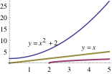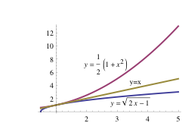 *line y=x.*  If is on the graph , then is on the graph



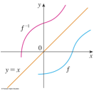

**Ex 5.** Find the inverse on the interval on which the function is 1-1, and then sketch

the graphs of y= f(x) and y= on the same coordinate axes, given



a. b. c. d. e.



a) . (see above graph)



b) is 1-1 only on (or ). If we consider on on, it has inverse. From, then . (You have two solutions ) . Since we **restrict** , so. Hence for.



c) For , it’s 1-1 on is on . solve from , , (here we use the definition of inverse cosine:



d) , to solve, we **use the equivalent form of logarithm**



for , , so



e), , ,



**6. Logarithm as the inverse** of exponential function . l



So logarithm gives the exponent in which , then , and



Common logarithm: ; Natural logarithm: .



**7.Lows of Logarithms:** *,* ,, (cancellation)



a. . Ex.



b.(not ).



c. . ,( !),



**8. Write sum of several logarithms as a single logarithm or verse visa.**

**#38.**



**9. Solve logarithmic equation**: Ex 7, 8 Find in the following:



a. b. c. d



a). ,



b) , so,



c) Use the law: , **take off the logarithm on** , then , , . But check the equation , it’s not defined for, **so there is no solution**.



d. Divide on both sides: , take ln on both sides: .



**10. Change of Base Formula for General Logarithms**: TI 83+ only has log and ln, so

for other base of logarithms, we can not find answer by directly hitting the calculator!

We have : ( or ) **Ex10**. .



As we did here: rewrite exponential function: (also change base).



11. Semi-logarithmic Function: Ex. Compare graphs:, y=,



Simplify . For, move to right 2.



12.Inverse trigonometric Functions (formulas, graphs on reference page 2,3 of book)

,; ,



(all inverse are angles ,)



Although for all in [-1,1], only for ,



, . For others, no cancellation.



Sometime **we could use calculator:** =.., , tan (arctan(10)), but you can not



**get exact answer**, instead, you should use trig tables in Ref page 2, …



**Ex.**  by calculator, but the exact answer be by the Ref Table.



**13. Simplify the trig and inverse of trig expression by hand by drawing diagram**

**Ex 13. Simplify the expression** a.  **b.**

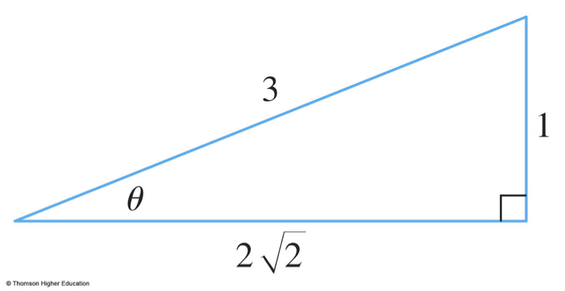

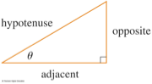a) Since is an angle, let ,so



. Draw a right triangle, we see that 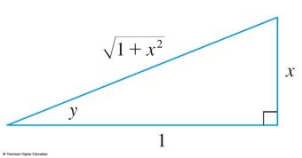.This enables us to get: .



b) Let , so .



Draw a right triangle, we get

, and



**14. Trigonometric Equations** (all solutions should plus multiple of period: 2n**π or nπ)**

a. =0 b. c. d. sin x + 2cos2 x-2=0



a) (find a solution x in the period , which is , and then plus multiple of period )



b) **HW: 69  

Then 

, there are two solutions in : or .



So or .



For , , two solutions in are:



so



c) This is a quadratic equations of , solve it by factoring: For , impossible for any. So there is no solution.



For the solution in is , the solution is



d) We use Trig identity for . So



.



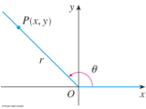From in period :So



15. Trigonometry (See Appendix D, pA.32)

For general angle ,  be any point on

the terminal side of , 

,    

, ,

 , or

  ( power- reducing or half-angle formula)

HW PA. 32 #30, if , find the remaining trigonometric ratios  
 Since , so let . And notice that , both  >0

From  . So the other five trigonometric ratios:

, , , , 

HW PA. 32 #49 Prove that 

Change to  ---



= 

Common Errors:

Square:  =)

 ,  ,

Root:  but    

Divide Partially:  , 

Typical Exponent /Power :  ( not  either)

Solve Equation:  if , . Where is Wrong?

You have change to :, then by quadratic formula or factoring:

 , then  or 

or quadratic formula, use it correctly: 

Trigonometric /Inverse Trigonometric