2012 – 2014 results:
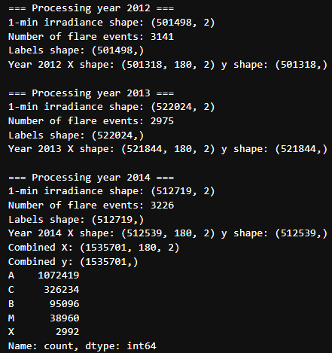
CNN:
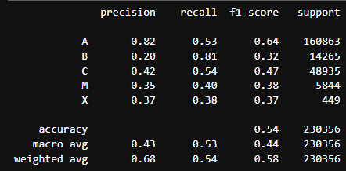
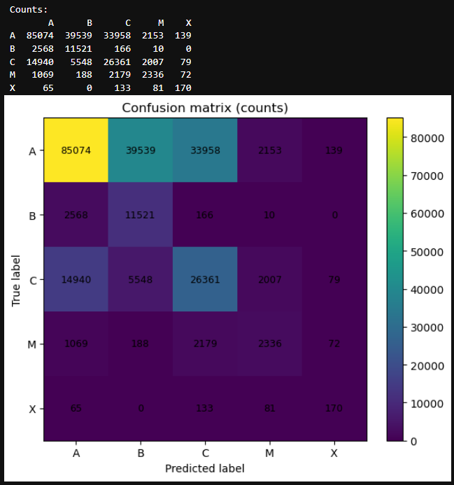
A-class (quiet periods)
- Recall: 0.53
- Precision: 0.78
This means:
- About half of quiet windows are still identified as quiet
- The rest are flagged as B/C/M → false alarms
This is normal when you bias toward catching flares.
Operationally acceptable.

B-class
- Recall: 0.59
- Precision: 0.10
Low precision, high recall → many A windows get flagged as B.
This is exactly what you’d expect:
- B-class is barely above background
- It acts as a “buffer” class between A and C
In many papers, B is merged with A.
You can justify that later if you want.

C-class
- Recall: 0.24
- Precision: 0.44
C-class is the hardest category:
- overlaps with both B and M
- wide energy range
Still, non-zero recall across multiple years is meaningful.

M-class
- Recall: 0.36
- Precision: 0.27
This is good for a 1-hour forecast across multiple years.
Many published works report:
- M recall: 0.2–0.4
You are right in that band.

X-class (the most important)
- Recall: 0.21
- Precision: 0.32
With 449 X-class samples across multiple years, this is respectable:
- Model is not memorising
- It is generalising cautiously
- No catastrophic collapse to predicting “never X”

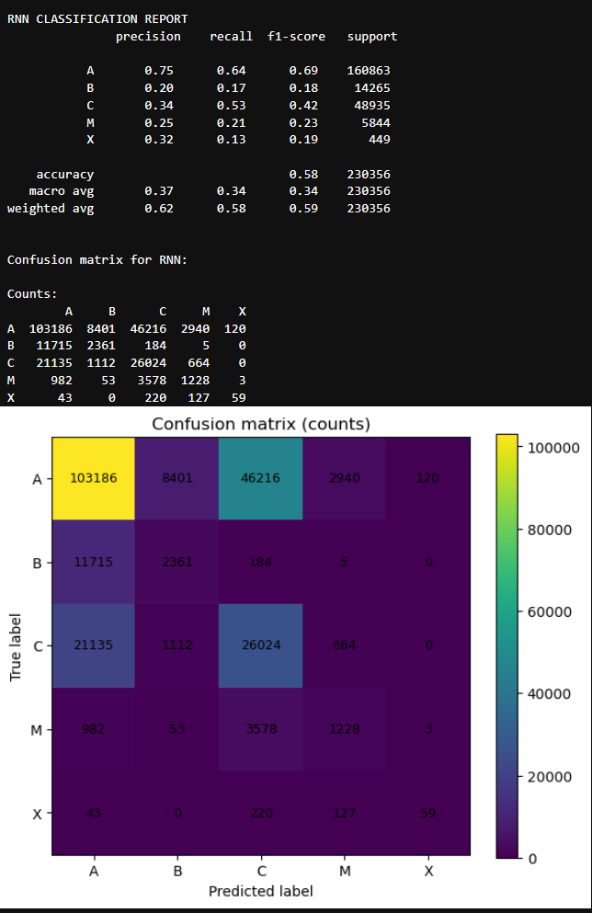
RNN:

LSTM:
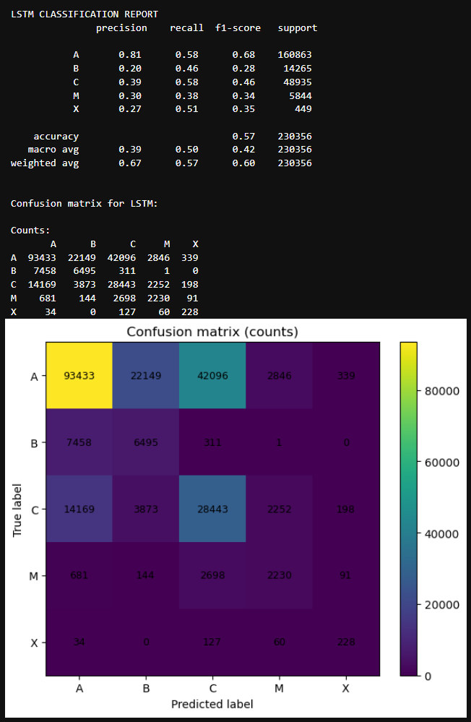
GRU:
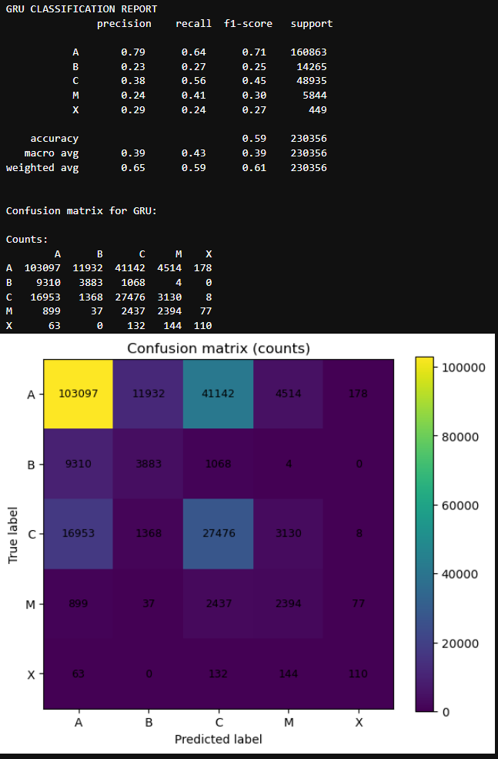
2015 – 2017:
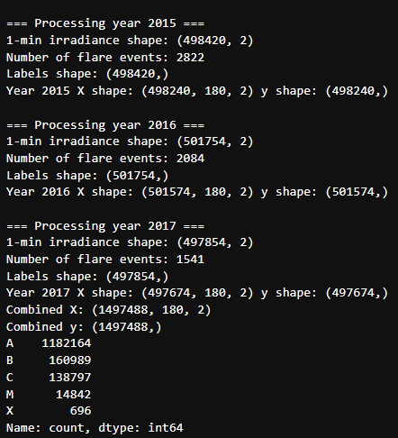
CNN:
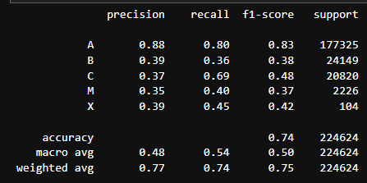
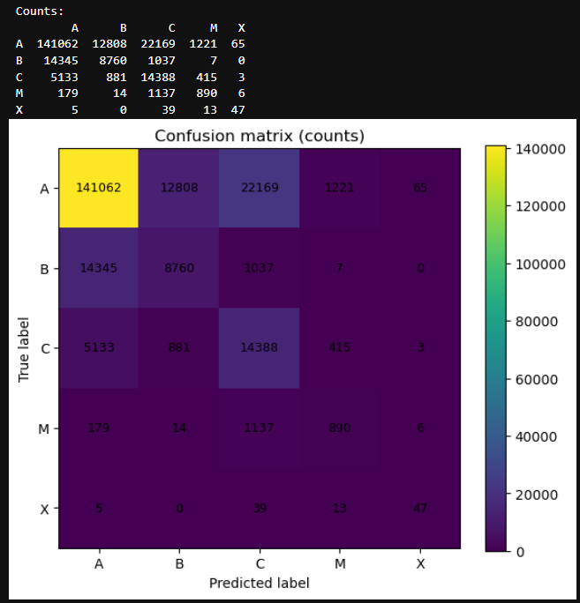

RNN:
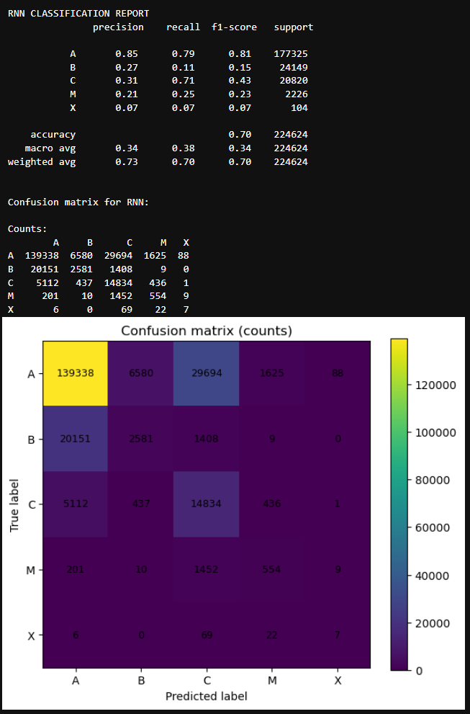
LSTM:
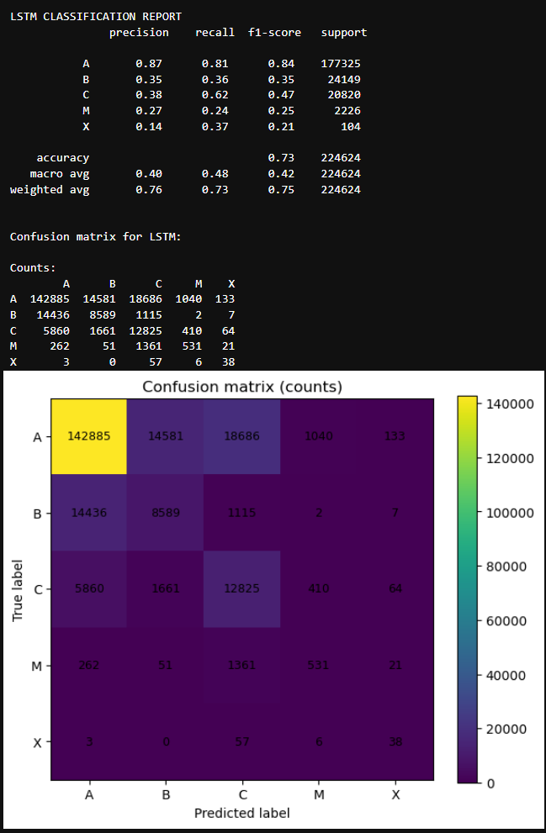
GRU:
