ARTICLE ABOUT DEVELOPMENT OF
LEADERBOARD OF GET SET FOSS

Leaderboard

Leaderboard aggregates data by Github user on:
- Merged PR’s.
- Labels on merged PR’s.
- Open and Merged PR’s.

Development

This projects consist of a backend written in Python and a frontend build with ReactJS.
The GitHub API is not directly queried by frontend because of rate limiting and performance as well as user experience and authentication concerns.

Backend
Code location: Backend Language: Python(Django).
The backend is concerned with PR data retrieval from GitHub API and transformation into aggregated, points on leaderboard.

Frontend
Code location: Frontend Language: ReactJS

The frontend visualises PR stats as a series of bar charts. It retrieves the underlying processed and aggregated PR data and increases the points on leaderboard according to the username.
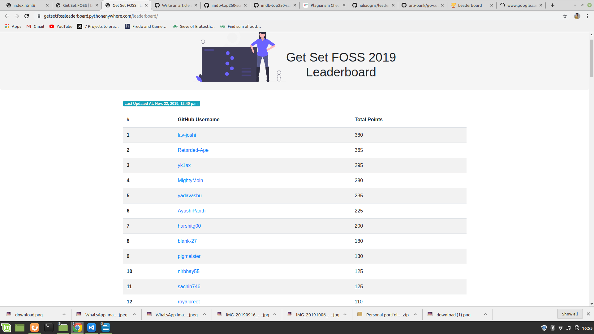
PythonAnywhere is an online integrated development environment(IDE) and web hosting (Platform as a service) based on the Python programming language.
There is no need to maintain the web server , everything is set up and ready to go. One can host their own domain using pythonanywhere.

