ARTICLE WRITING

Networking Protocols used in Back- End Development

Protocol meaning is that it a set of mutually accepted and implemented rules at both ends of the communications channel for the proper exchange of information. By adopting these rules, two devices can communicate with each other and can interchange information. We can't even think of using the Internet without Protocols. Each protocol is defined in different terms and different use with unique name.
They define rules and conventions for communication. They incorporate all the processes requirement and constraints of initiating and accomplishing communication between computers, routers, servers and other network enabled devices. Network protocols must be confirmed and installed by the sender and receiver to ensure network\data communication. It also applies software and hardware nodes that communicate on a network.

TYPES OF PROTOCOLS
A protocol technologies is required for communication between computers. To connect different types of computers from a variety of computer vendors, protocols must be first standardized. The ARPA (Advanced Research Project Agency) part of the US Defense program was the first to introduce the concept of a standardized protocol. ARPA is a resource sharing network connecting different computers at universities and laboratories in the US. The concept of the protocol and its layer structure, emerged from the ARPA network. ARPA developed an integrated network using packet protocol .

- Internet Protocol Suite:
Internet protocol suite is the set of communication protocols that implement the protocol stack on which the internet runs. The Internet protocol suite is sometimes called the TCP/IP protocol suite, after TCP\IP, which refers to the important protocols in it, the Transmission Control Protocol(TCP) and the Internet Protocol(IP). The Internet protocol suite can be described by the analogy with the OSI model, but there are some differences. Also not all of the layers correspond well.
1.Transmission Control Protocol (TCP)
The Transmission Control Protocol is the core protocol of the internet protocol suite. It originated in the network implementation in which it complemented the Internet Protocol. Therefore the entire suite is commonly referred to as TCP/IP. TCP provides reliable delivery of a stream of octets over an IP network. Ordering and error-checking are main characteristics of the TCP. All major Internet applications such as World Wide Web, email and file transfer rely on TCP.
2.Internet Protocol(IP)
The Internet Protocol is the principal protocol in the Internet protocol suite for relaying data across networks. Its routing function essentially establishes the internet. Historically it was the connectionless datagram service in the original Transmission Control Program; the other being the connection oriented protocol(TCP). Therefore, the Internet protocol suite is referred as TCP/IP.
- Hypertext Transfer Protocol (HTTP):
The HTTP is the foundation of data communication for the World Wide Web. The hypertext is structured text that uses hyperlinks between nodes containing texts. The HTTP is the application protocol for distributed and collaborative hypermedia information system.
The default port of HTTP is 80 and 443 is the secured port.

HTTP Request / Response
Communication between clients and servers is done by requests and responses.
- A client (a browser) sends an HTTP request to the web.
- An web server receives the request.
- The server runs an application to process the request.
- The server returns an HTTP response (output) to the browser.
- The client (the browser) receives the response.

- File Transfer Protocol (FTP)

The File Transfer Protocol(FTP) is a standard network protocol used for the transfer of computer files between a client and server on a computer network. FTP is built on a client-server model architecture using separate control and data connections between the client and the server.The default port of FTP is 20/21.
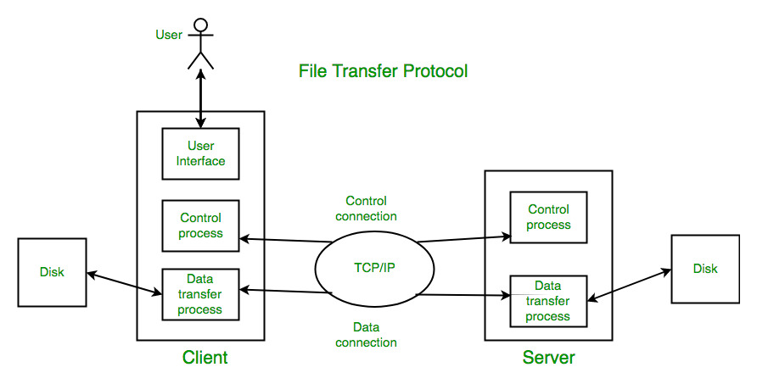
- Simple Mail Transfer Protocol (SMTP)
SMTP stands for Simple Mail Transfer Protocol.SMTP is a set of communication guidelines that allow software to transmit an electronic mail over the internet is called Simple Mail Transfer Protocol. It is a program used for sending messages to other computer users based on e-mail addresses. The main purpose of SMTP is used to set up communication rules between servers. The servers have a way of identifying themselves and announcing what kind of communication they are trying to perform.
- Post Office Protocol version 3 (POP 3)
The Post Office Protocol version 3 is one of the two main protocols used to retrieve mail from the internet. It is very simple as it allows the client to retrieve complete content from the server mail box and deletes contents from the server.
The default port of POP3 is 110 and secured is 995.
- Internet Message Access Protocol (IMAP)
IMAP version 3 is another main protocol that used to retrieve mail from a server. IMAP does not delete the content from the mail box of the server.
The default port of IMAP is 143 and secured is 993.
- Secured Shell (SSH)
SSH is the primary method used to manage the network devices securely at the command level. It usually used as the alternative of the Telnet which does not support secure connections.
The default port of SSH is 22.
- Telnet
Telnet is an established with some rules which are used to connect to another computer. Telnet is mainly used for the remote login process. The computer which is requesting for a connection that is a local computer and which is accepting the connection that is a remote computer. If you give a command in a local computer that command is executed in the remote computer. Telnet is also based on client and server model.

- Domain Name System (DNS)
Domain name system is used to convert the domain name to IP address. There are root servers, TLDs and authoritative servers in the DNS hierarchy
- Simple Network Management Protocol (SNMP)
The Simple Network Management Protocol is used to manage networks. It has abilities to monitor, configure and control network devices. SNMP traps can also be configured on network devices to notify a central server when specific action are occurring.
The default port of SNMP is 161/162.
- Gopher
Gopher is an application layer protocol, which is used for searching and retrieving documents from remote sites. This is possible to start an online connection with other computers through gopher.

