A Visual Study of E-Commerce Orders,
Delivery & Customer Satisfaction
Team Working Document — Data Preparation & Exploratory Findings
Data Visualization Design Project — May 2026
Status: Week 1–2 (Data Cleaning + EDA complete). Dashboard, final report and presentation still open.

1. Business Context & Goal
We work for an online marketplace connecting many small sellers to customers across a large, geographically spread country. Leadership wants to grow the marketplace (more sellers, more sales) without damaging customer satisfaction. Aggressive seller onboarding raises sales but can raise late deliveries and bad reviews; strict quality control protects satisfaction but shrinks the catalogue and slows growth. Leadership currently makes this tradeoff on gut feel, not data.
Our job: trace the full order journey — placement, payment, seller handling, freight, delivery, and the final review — and identify what actually drives customer satisfaction and where the business is quietly at risk. We need to tell leadership which categories, seller behaviours, regions and delivery patterns predict happy vs. unhappy customers, and where to invest vs. intervene.
Headline answer (previewed here, detailed in Section 5): the growth-vs-quality tradeoff leadership assumes is not really about which sellers/categories to allow — it's a logistics execution problem (delivery speed and order fragmentation).

2. Dataset Overview
The dataset (Olist e-commerce, Brazil) is split across 9 relational CSV files. No single file has everything — we had to join them together ourselves. Below is the map every team member should understand before touching the data.
File | Grain (1 row = ) | Key columns
orders_dataset.csv | 1 order | order_id, customer_id, order_status, purchase/approval/delivery timestamps
order_items_dataset.csv | 1 item within an order | order_id, product_id, seller_id, price, freight_value
order_payments_dataset.csv | 1 payment record | order_id, payment_type, installments, payment_value
order_reviews_dataset.csv | 1 review | order_id, review_score, comment title/message
customers_dataset.csv | 1 customer | customer_id, customer_state, customer_city
sellers_dataset.csv | 1 seller | seller_id, seller_state, seller_city
products_dataset.csv | 1 product | product_id, product_category_name, weight/dimensions
product_category_name_translation.csv | 1 category | Portuguese → English category name
geolocation_dataset.csv | 1 zip code | lat/lng — used only if we build a map view

How they connect (join keys):
- orders_dataset.order_id ↔ order_items / order_payments / order_reviews.order_id
- orders_dataset.customer_id ↔ customers_dataset.customer_id
- order_items_dataset.product_id ↔ products_dataset.product_id ↔ product_category_name_translation
- order_items_dataset.seller_id ↔ sellers_dataset.seller_id
Scope decision: we excluded the optional 'Marketing Funnel' dataset. Our core question (what drives satisfaction) is fully answerable from these 9 tables, and adding funnel data would add join complexity without adding to the satisfaction analysis. Revisit only if we finish core deliverables early.

3. Data Cleaning & Preparation Process
Full detail and runnable code is in 01_build_master_table.py (attached / in repo). This section documents every decision made and why, so any team member can explain it in the report or presentation.

3.1 Missing values found
Field | % missing | Decision & reasoning
review_comment_title / message | ~88% / ~59% | Expected — most customers leave a star rating without writing text. Not treated as a data quality issue; simply not used for text analysis.
order_delivered_customer_date | ~3% | Confirmed these are orders that were never delivered (status = shipped/canceled/unavailable/invoiced/processing), not data errors. Excluded from delivery-time calculations; kept in the table for status-level analysis.
product_category_name (+ english) | ~1.9% of products | Left as 'unknown' category rather than dropped, so the orders aren't lost from other analyses.
8 orders | status = 'delivered' but delivery date missing | Small, unexplained data glitch. Noted in the report as a limitation; left in place (excluded automatically from delivery-time calcs since the date is null).

3.2 Duplicate / multiplicity issues found
- order_reviews_dataset: 551 orders had more than one review row (likely re-reviews or seller responses creating extra rows). Resolved by averaging review_score per order_id rather than picking one arbitrarily or duplicating the order.
- order_payments_dataset: orders can have multiple payment rows (e.g., voucher + credit card). Aggregated per order_id: summed payment_value, took the first payment_type, and the max installment count.
- order_items_dataset: orders can contain multiple items (different products, sometimes different sellers). This is not an error — it's real structure — but it means item-level data had to be deliberately aggregated to one row per order (see 3.3) rather than merged directly, which would have silently multiplied review scores across items.

3.3 Grain decision: one row per order
Because reviews and delivery info exist once per order but items can repeat, we chose ORDER as the unit of analysis. Item-level detail was aggregated up before merging, using these rules:
- n_items = count of items in the order
- total_price = sum of item prices; total_freight = sum of freight costs
- main_category = category of the first item (orders are overwhelmingly single-category; a small minority are mixed, which we accept as a simplification)
- main_seller_state = state of the first seller; n_sellers = count of distinct sellers on the order (this became one of our most important variables — see Section 5.3)

3.4 Outlier check
Max delivery_days observed was 209 days. We inspected the 5 slowest deliveries directly (timestamps, states, categories) and confirmed these are real dates, not corrupted data — genuine extreme service failures. Decision: kept in the dataset rather than removed, since deleting them would hide a real risk signal leadership needs to see. To prevent them from distorting simple averages, we report medians alongside means and bucket delivery time into ranges (see Section 5.2) instead of relying on a single average.

3.5 Final joined table
Result: master_orders.csv — 98,666 rows (one per order with items), 23+ columns, built in 01_build_master_table.py. Row counts were checked after every merge step to confirm no accidental duplication (a common join bug).
Note: 98,666 vs. 99,441 total raw orders — the ~775 order gap is orders with no item rows at all (likely cancelled pre-fulfillment). Worth a one-line mention in the report, not a concern.

4. Exploratory Analysis — What We Tested
Full code in 02_exploratory_analysis.py. For every candidate driver of satisfaction, we grouped orders by that variable and compared average review_score (1–5) and/or % of 1-star reviews. Variables tested:
- Delivery outcome: on-time vs. late (is_late), and delivery speed in day buckets
- Order structure: number of items, number of distinct sellers per order
- Product: main_category
- Geography: customer_state, seller_state, and whether seller/customer are in the same state
- Cost: total_price, freight-to-price ratio, payment_type, number of installments
- A correlation check across the numeric variables against review_score, to sanity-check which factors matter most in aggregate

5. Key Insights

5.1 Late delivery is the single strongest driver of dissatisfaction
Average review score: 4.23 (on-time) vs. 2.27 (late) — a 1.96-point gap, larger than any other factor tested.
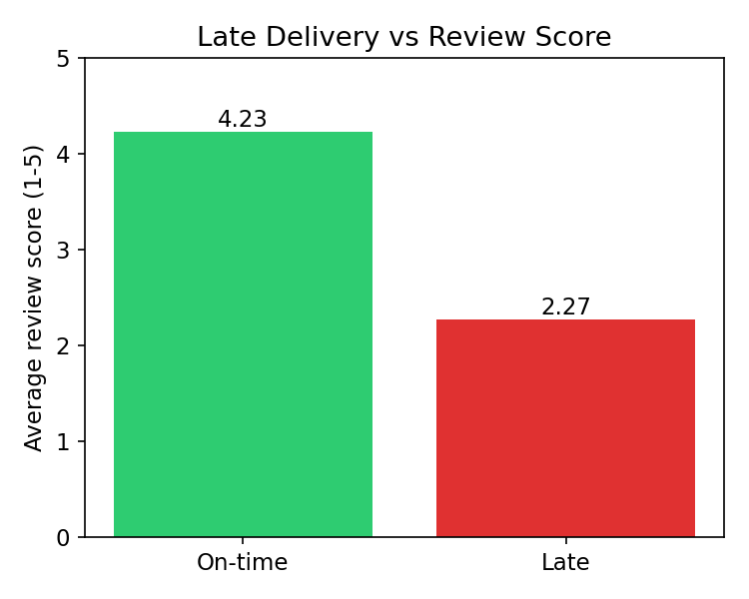

5.2 Satisfaction collapses past a delay threshold — it's a cliff, not a slope
Delivery time | Avg review score | % 1-star reviews
0–5 days | 4.43 | 5.2%
6–10 days | 4.35 | 6.0%
11–15 days | 4.25 | 7.1%
16–25 days | 3.98 | 11.0%
25+ days | 2.61 | 43.6%
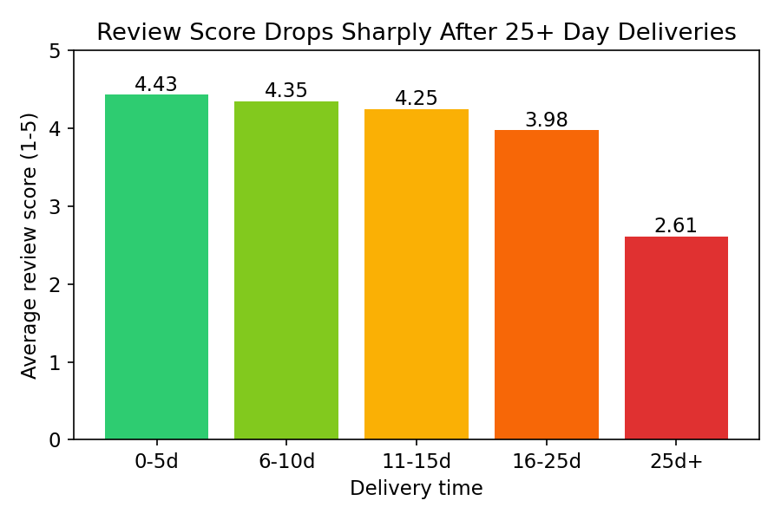
Implication: the fix isn't 'make every delivery faster' — it's specifically eliminating the long tail of 25+ day deliveries, which is a more targeted (and cheaper) operational fix.

5.3 Orders split across multiple sellers are far more likely to disappoint
# distinct sellers in order | Avg review score | # orders
1 | 4.12 | 96,653
2 | 2.88 | 1,205
3 | 2.35 | 54
4+ | ~1.0 | 5
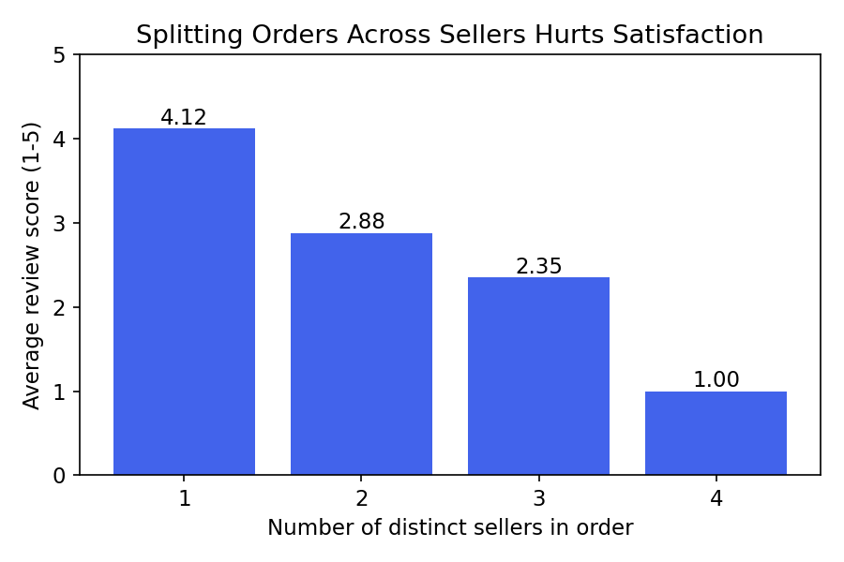
Similarly, orders with more items overall (regardless of seller count) also score worse: 4.16 (1 item) → 3.65 (2 items) → 3.51 (3 items) → 3.32 (4+ items). More items likely means more chances for something to go wrong (missing item, damaged item, staggered arrival).
Implication: multi-seller / multi-item fulfillment is a hidden operational risk factor, probably not currently tracked as a satisfaction driver internally. A candidate feature: flag and prioritize orders that split across sellers/shipments.

5.4 Geography correlates with both delivery time and satisfaction
Worst-performing customer states (min. 300 orders) — MA, AL, SE, PA, BA — all show longer average delivery times (18–24 days) and higher late rates (11–21%) than better-performing states like ES and PB (~15–20 days, ~10–11% late).
Same-state seller↔customer pairs score noticeably better than cross-state pairs: 4.21 vs. 4.05 — consistent with shorter shipping distance driving the effect, not the states themselves.
Implication: this reads as a logistics/infrastructure gap in specific regions, not 'customers in these states are pickier' — it tracks cleanly with measured delivery performance.

5.5 Product category has a real but comparatively small effect
Worst categories (avg score) | Best categories (avg score)
office_furniture — 3.62 | books_general_interest — 4.47
audio — 3.84 | books_technical — 4.40
home_confort — 3.88 | food_drink — 4.38
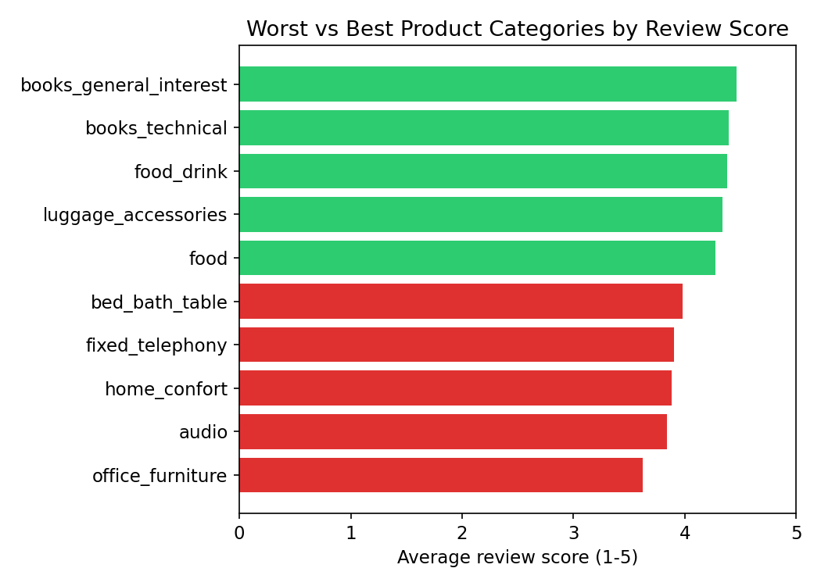
Category-level differences exist but are modest compared to the delivery and order-structure effects above — category alone is a weak predictor of satisfaction next to logistics factors.

5.6 Cost, payment method, and installments — weak effects
- Freight-to-price ratio: 4.13 (low freight share) vs. 4.07 (high freight share) — a small effect. Cost of shipping matters far less than its reliability (speed).
- Payment type: boleto 4.11, credit card 4.10, debit card 4.18, voucher 4.07 — essentially flat, not a meaningful driver.
- Installments: mild downward trend as installment count rises (4.14 for 1 installment down to 3.87 for 13+), likely a proxy for higher-value / higher-stress purchases rather than a direct cause.

5.7 Correlation check (sanity cross-check across all numeric factors)
Correlation of each variable with review_score, across all orders (closer to 0 = weaker relationship, negative = higher value associated with lower score):
Variable | Correlation with review_score
delivery_days | -0.33 (moderate)
days_early_or_late | -0.27 (moderate)
total_freight | -0.09 (weak)
total_price | -0.04 (very weak)
This confirms Sections 5.1–5.2 quantitatively: delivery timing dominates every cost/price variable we tested.

6. Advanced Analysis & Feature Engineering
Beyond the initial EDA, we engineered new features from data not yet used (delivery timestamps decomposed, product physical attributes, geolocation, seller-level aggregates, review text) to dig into root causes rather than just symptoms. Full code: 03_feature_engineering.py (builds master_orders_enriched.csv, 40 columns) and 04_advanced_analysis.py (produces the findings below).

6.1 New engineered features
Feature | What it measures | Why we built it
approval_lag_hours, seller_handling_days, carrier_transit_days | Delivery time split into 3 stages instead of one lump number | To find out WHICH stage of fulfillment actually drives satisfaction
distance_km | Haversine distance between customer & seller zip centroids | To test whether physical distance drives satisfaction directly or only through delivery time
seller_n_orders, seller_revenue, seller_avg_score, seller_late_rate | Seller-level performance, merged onto every order | To find high-volume sellers who are disproportionately hurting satisfaction
product_weight_g, product_volume_cm3, product_photos_qty, product_description_lenght | Physical/listing attributes of the main product | To test if product characteristics (not just category) predict reviews
review_has_comment, review_comment_length | Whether/how much a customer wrote | To understand review behavior patterns, useful groundwork for future text analysis
purchase_month, purchase_dow | Time of purchase | To check for seasonality or growth trends

6.2 Root cause: carrier transit delay matters far more than seller handling delay
We decomposed total delivery time into three stages: approval lag (payment confirmation), seller handling time (pack & hand off to carrier), and carrier transit time (hand-off to doorstep). Correlation with review_score: approval_lag -0.02 (negligible), seller_handling_days -0.16 (weak), carrier_transit_days -0.30 (moderate — the dominant stage).
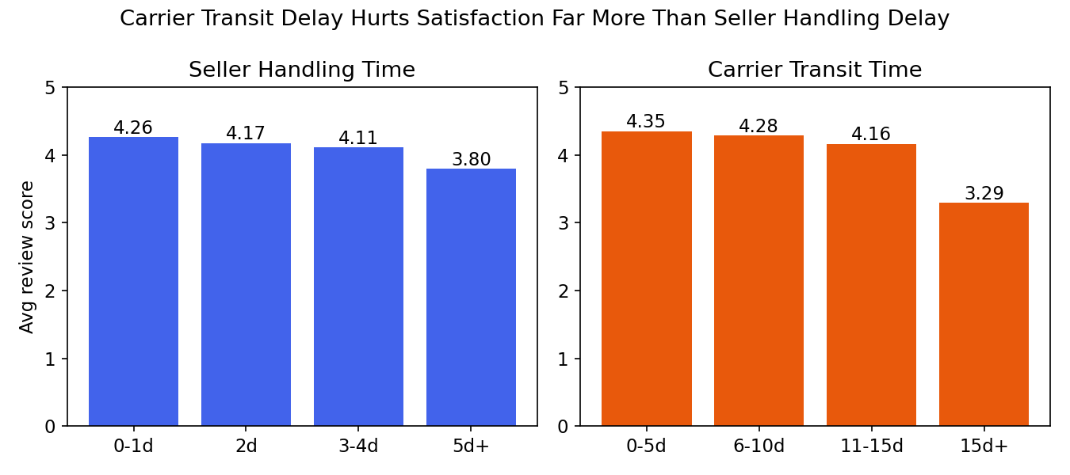
Bucketed comparison confirms it: seller handling time moves review score from 4.26 (fast) to 3.80 (5+ days) — a 0.46 point range. Carrier transit time moves it from 4.35 (fast) to 3.29 (15+ days) — a 1.06 point range, more than double the impact.
Actionable implication: shipping/carrier performance is a bigger lever than seller packing speed. Interventions should target carrier selection and routing, not just pressuring sellers to ship faster.

6.3 Revenue is highly concentrated — and some high-volume sellers are actively hurting satisfaction
Across 3,095 sellers: the top 1% (30 sellers) generate 25.7% of all revenue; the top 10% generate 67.5%. This is a classic Pareto pattern — a small number of sellers matter disproportionately to the business.
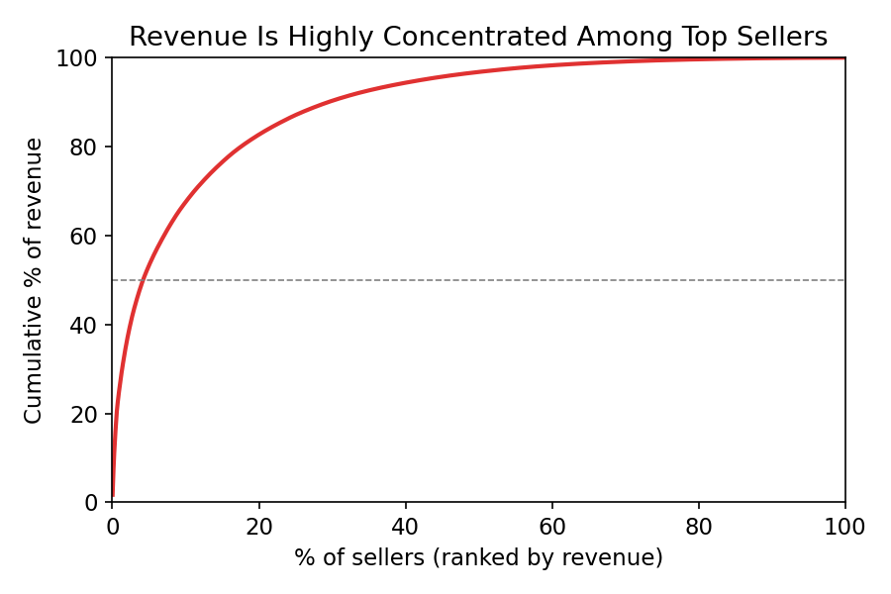
We cross-referenced this with performance: among high-volume sellers (80th percentile by order count, 30+ orders), 80 sellers score notably below the platform average (4.03) — some by a full point or more. One seller alone drives $187,923 in revenue across 982 orders but averages only 3.34 stars, despite a LOW late-delivery rate (8.8%) — meaning this seller's problem is product/service quality, not shipping speed. This is a distinct root cause from Sections 5.1–5.3, and would be invisible without seller-level aggregation.
Actionable implication: build a seller scorecard combining volume, revenue, and satisfaction — not just late-rate — to catch quality-driven risk (not just logistics-driven risk) among high-revenue sellers.

6.4 Distance affects satisfaction indirectly, through delivery time — not directly
Customer-seller distance correlates strongly with delivery time (r = 0.39) but only weakly with review score directly (r = -0.06). In other words, distance itself doesn't bother customers — the delay it causes does.
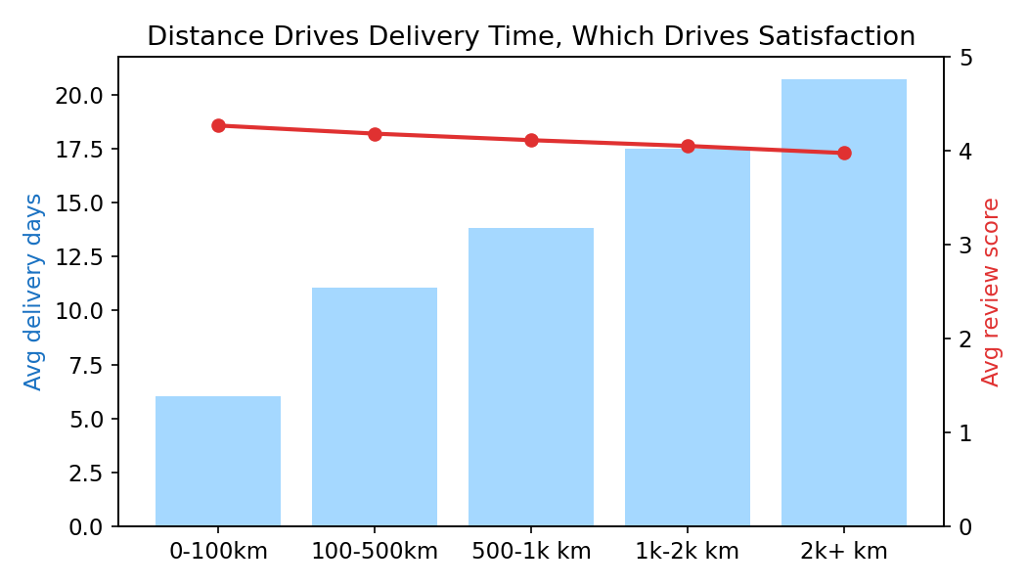
Actionable implication: don't treat 'far from seller' as inherently risky. Instead, target the delivery-time consequence directly (e.g. better carrier routing for long-distance orders) — fixing the mediator fixes the outcome.

6.5 Unhappy customers write far more, and write more often
76.5% of 1-star reviewers leave a written comment (averaging ~100 characters) vs. just 35.9% of 5-star reviewers (~52 characters). Comment volume decreases steadily as score rises (2-star: 68%, 3-star: 43%, 4-star: 31%).
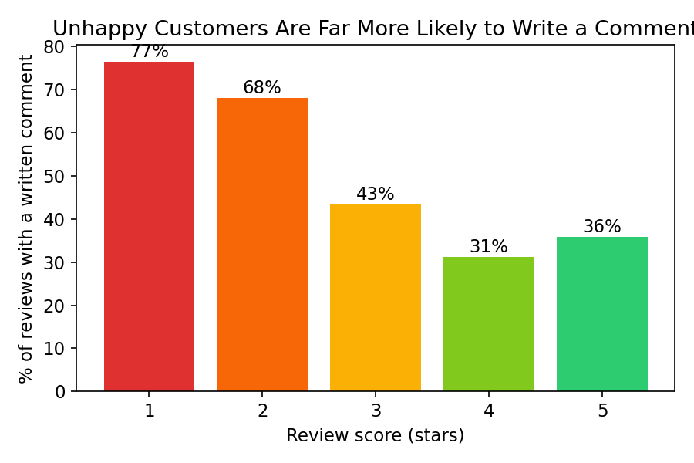
Actionable implication: negative-review comment text is a rich, disproportionately available data source. A follow-up text-mining pass (keyword extraction / topic modeling on 1-2 star comments) would likely surface specific complaint themes (e.g. 'wrong item', 'damaged', 'never arrived') cheaply, since this population already writes the most.

6.6 Time patterns: strong growth, flat weekly pattern, one operational anomaly
Order volume grew from a handful of orders in late 2016 to 6,000+ per month by mid-2018 — steady platform growth, useful context for interpreting all other findings (the business is scaling throughout this dataset).
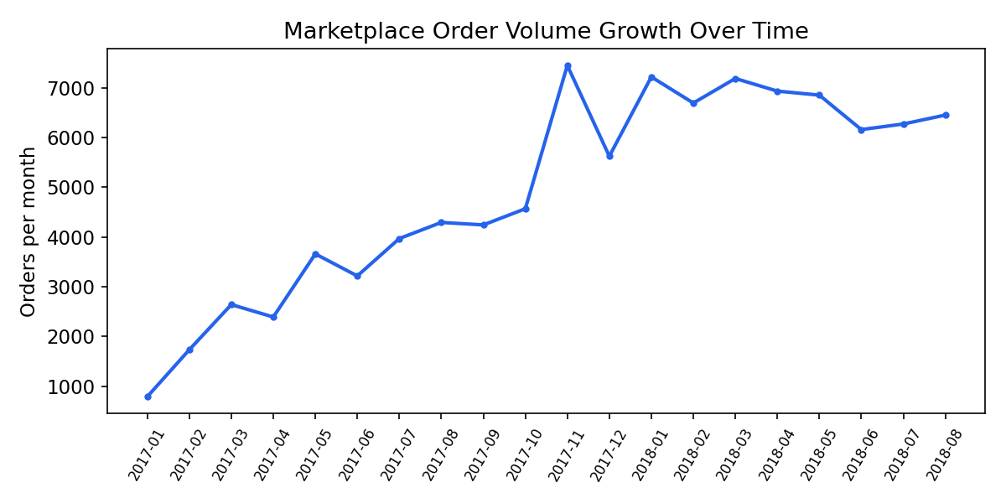
- Day of week has almost no effect on review score (4.05–4.13 across all days) — not a meaningful lever.
- Late-delivery rate spiked to 18.9% in March 2018 vs. a more typical 1–7% in surrounding months — a one-off operational disruption worth investigating directly with the logistics team rather than assuming it's a persistent pattern.

7. Recommendations for Leadership
The data does not support the simple growth-vs-quality tradeoff leadership assumes (aggressive seller onboarding vs. strict vetting). The dominant risk driver is operational/logistics execution, not which sellers or categories are allowed onto the platform. This means growth and satisfaction are not necessarily in conflict — if the company fixes fulfillment mechanics.
- Build a system to detect orders at risk of 25+ day delivery early (before they happen) and intervene — this single fix targets the group producing 43.6% one-star reviews.
- Reduce or better manage multi-seller / multi-shipment order splitting — this is currently an invisible risk factor with one of the largest satisfaction effects we found.
- Prioritize logistics investment in underperforming states (MA, AL, SE, PA, BA) rather than broad nationwide spend.
- Focus carrier/routing improvements over seller-packing-speed pressure — carrier transit delay has more than double the satisfaction impact of seller handling delay.
- Build a seller scorecard that flags high-revenue sellers on BOTH late-rate and review score — 80 high-volume sellers currently underperform, and at least one (~$188K revenue) has a quality problem invisible to a pure logistics/late-rate view.
- Deprioritize category-based vetting and distance-based seller restrictions as satisfaction levers — both have real but comparatively small or indirect effects next to delivery-time and seller-quality factors.
- Consider a lightweight text-mining pass on 1–2 star review comments (already the richest text data available) to identify specific complaint themes for R&D.

8. Data Caveats & Limitations (for the 'Constraints' report section)
- Review scores are skewed: 57% five-star, ~11% one-star. Any predictive modeling later needs to account for this imbalance.
- ~3% of orders lack a delivery date (not yet delivered / cancelled) — excluded from delivery-time analysis, kept for status analysis.
- 551 orders had duplicate review rows, resolved by averaging.
- Extreme delivery delays (up to 209 days) were verified as real, not data errors, and intentionally kept rather than removed.
- Dataset covers Sep 2016 – Oct 2018 (Brazil) — findings reflect this market/period and may not generalize directly to other geographies or timeframes without validation.
- main_category / main_seller_state use the FIRST item in multi-item orders as a simplification — a small share of mixed-category orders may be mislabeled by this choice.
- distance_km uses zip-code-prefix centroids (median lat/lng of all geolocation points sharing a prefix), not exact addresses — a reasonable approximation but not precise, especially for large/rural zip prefixes.
- The March 2018 late-rate spike is flagged but not explained by this dataset alone — would need external context (e.g. logistics provider records) to confirm cause.
- seller_avg_score / seller_late_rate are computed across the full dataset period (2016–2018) — they describe historical seller performance, not necessarily current performance if used for real-time decisions.

9. What's Left — Team Next Steps
Per the project roadmap, Week 1–2 (data prep + EDA) is essentially done. Still open:
Deliverable | Status | Suggested owner
Interactive Marketplace Dashboard | Not started | TBD
Explanatory charts refined for presentation (from Section 5) | Draft versions exist | TBD
Final Presentation deck | Not started | TBD
Full Technical Report write-up | This document is the raw material | TBD
Individual contribution logs / work log | Not started — required per team structure rules | Everyone
Attached alongside this document: 01_build_master_table.py, 02_exploratory_analysis.py, 03_feature_engineering.py, 04_advanced_analysis.py, master_orders.csv, master_orders_enriched.csv, and insights_summary.md — everything here is reproducible from those files.

