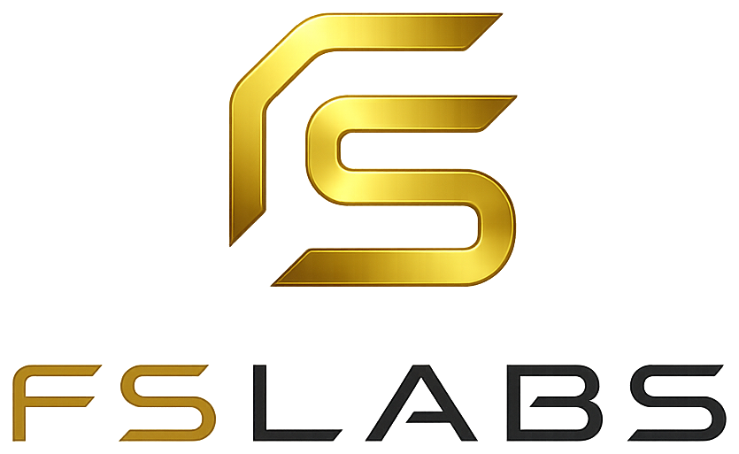
fslabs.tech · access@fslabs.tech

27 August 2026
Sheu Omoshalewa Q.
shalewa.oq@gmail.com
Re: Invitation to Join Folub & Samuel Labs as Strategic Partner & Advisor
Dear Omoshalewa,
I am writing to invite you to join Folub & Samuel Labs (“FSLabs” or “the Company”) as a Strategic Partner & Advisor.
This is not an offer of employment, and it is deliberately not one. You are a founder in your own right and a cybersecurity professional with a depth of expertise we do not have in-house. What I am interested in is your judgement — the way you think about security, about risk, and about building a company from nothing — not your hours. I would rather build alongside you than hire you.
FSLabs operates a portfolio of products rather than a single business, and the questions we face are increasingly strategic ones: which products to invest in, how to make security a genuine strength rather than an afterthought, and how to grow without breaking what already works. Those are better questions with you in the room.
The terms on which I am proposing we work together are set out below. They are intentionally light.

1. Purpose
The purpose of this arrangement is the mutual exchange of expertise, insight, and opportunity between you and FSLabs. It is founded on collaboration between equals. Nothing in this letter is intended to place you in a subordinate position to the Company or to any of its officers.

2. Scope of the Role
As Strategic Partner & Advisor, you are invited to contribute in the following areas, as your time and interest allow:
- Strategic direction — participating in conversations on product priorities, market positioning, and the Company’s growth across its portfolio;
- Security posture — advising on the Company’s approach to cybersecurity, risk, and data protection across its products and internal practice;
- Product and technical judgement — offering a second perspective on architecture, product decisions, and technical trade-offs;
- Founder-to-founder counsel — sharing experience on building, operating, and scaling a company; and
- Network and opportunity — introducing, where you see genuine fit, people and opportunities that benefit either party.
This list is illustrative, not exhaustive or binding. You are free to contribute where you see value and to decline anything you do not wish to take on.

3. Nature of the Relationship
For the avoidance of doubt:
- This is not a contract of employment and does not create an employer-employee relationship;
- You have no fixed hours, no minimum time commitment, and no reporting line within the Company;
- You are not required to be present at any particular location or at any particular time;
- The arrangement is non-exclusive on both sides; and
- You remain entirely free to continue leading and building your own company, which takes precedence over this arrangement at all times.

4. Time Commitment
There is no minimum commitment. Engagement will be as mutually convenient — a periodic strategy conversation, review of a specific decision, or ad-hoc input as questions arise. Where the Company would like your input on something substantial, it will ask, and you are free to decline without explanation.

5. Compensation
This arrangement is presently uncompensated on both sides. Neither party is under any financial obligation to the other by reason of this letter. Should the parties wish to put a compensation arrangement in place at any point, it will be discussed openly and agreed separately in writing; nothing in this letter creates any expectation or entitlement in that regard.

6. Confidentiality
This clause is mutual and protects both parties equally. Each party agrees to keep confidential all non-public information disclosed to it by the other — including business plans, product roadmaps, client and user information, security findings, technical materials, and financial information — and to use such information solely for the purposes of this collaboration.
Neither party will disclose the other’s confidential information to any third party without prior written consent. This obligation survives the ending of this arrangement and continues for so long as the information remains non-public.

7. Intellectual Property
Each party retains full ownership of all intellectual property it owned before this arrangement, and of all intellectual property it creates independently of it. Nothing in this letter transfers, assigns, or licenses any intellectual property belonging to you or to your company.
Where the parties jointly create something of value, ownership and any commercial terms will be agreed in writing at that time, before the work is put to commercial use.

8. Independence and Conflicts
You are and remain an independent party. You may hold other roles, advise other companies, and pursue any other interest without restriction under this letter.
Where a matter arises in which your interests and the Company’s may conflict, you are asked simply to say so and to step back from that matter. You are under no obligation to act against the interests of your own company, its clients, or any other party to whom you owe a duty.

9. No Partnership or Agency
Notwithstanding the use of the word “Partner” in your title, this letter does not create a legal partnership, joint venture, or agency between the parties. Neither party may enter into commitments, incur liabilities, or hold itself out as able to bind the other, without prior written authority.

10. Duration and Withdrawal
This arrangement is open-ended. Either party may withdraw from it at any time, for any reason or none, by written notice to the other. No notice period applies and no liability arises on either side as a result of withdrawal. The obligations in Clauses 6 and 7 survive.

11. Governing Law
This letter is governed by the laws of the Federal Republic of Nigeria.

12. Entire Agreement
This letter records the whole of what has been agreed between the parties and supersedes any prior discussions. It may be varied only in writing signed by both parties.
If this reflects your understanding and you would like to build together on this basis, please sign and return a copy. If you would rather talk it through first, or reshape any part of it, I would welcome that — this is a starting point, not a fixed position.
I would be glad to have you involved.
Yours sincerely,

Adeseko Samuel
Chief Technology Officer & Co-Founder
Folub & Samuel Labs

Agreed and Accepted
I, Sheu Omoshalewa Q., have read and understood this letter and agree to collaborate with Folub & Samuel Labs on the terms set out above.

Signature — Sheu Omoshalewa Q.

Date

