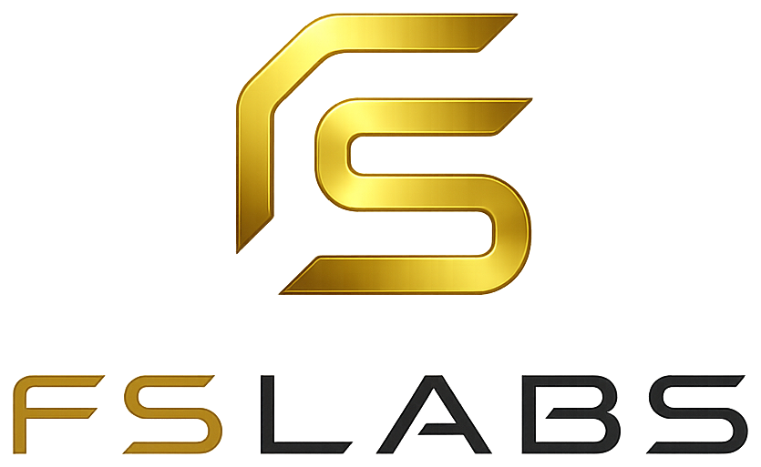
fslabs.tech · access@fslabs.tech

26 August 2026
Oreoluwa Afolabi
Re: Offer of Engagement — IT Support Engineer, Folub & Samuel Labs
Dear Oreoluwa,
On behalf of Folub & Samuel Labs (“FSLabs” or “the Company”), I am pleased to offer you the position of IT Support Engineer. We were impressed by what you bring, and we believe you will make a real contribution to the team.
The terms of this offer are set out below.

1. Position and Reporting
You will serve as IT Support Engineer, reporting directly to the Chief Technology Officer. Your duties will include providing first- and second-line technical support to the Company’s clients and internal team; logging, triaging and resolving support tickets; setting up, configuring and maintaining user accounts, devices and software; escalating unresolved issues to the engineering team; maintaining support documentation and internal knowledge-base articles; and any other responsibilities reasonably assigned to you by the Chief Technology Officer from time to time.

2. Commencement
Your engagement will commence on the date you sign and return this letter, subject to completion of any onboarding requirements.

3. Engagement Type and Working Arrangement
This is a full-time engagement. Your work location is remote. The Company does not set fixed daily working hours; you are expected to manage your own time so as to meet the expectations set out in Clause 4, and to be reachable and responsive during normal business hours.
Attendance at the Company’s online team meetings on Mondays, Wednesdays and Fridays is mandatory. Where you are unable to attend a scheduled meeting, you must notify the Chief Technology Officer in advance.

4. Performance Expectations
This offer is made on the express understanding that you will maintain consistent availability and an agreed standard of performance. Specifically, you are expected to:
- Be actively available and responsive during normal business hours, and communicate promptly if you will be unavailable;
- Attend the Company’s online team meetings on Mondays, Wednesdays and Fridays;
- Meet the deliverables, deadlines, and quality standards agreed with the Chief Technology Officer;
- Resolve support requests and tickets within the response times set by the Company;
- Provide regular updates on your work through the Company’s agreed tools and channels; and
- Meet any performance targets or milestones communicated to you in writing.
Performance and activity will be reviewed on a monthly basis.

5. Compensation
This engagement is commission-based. You will not receive a fixed salary. You will be paid a commission on revenue received by the Company from clients you introduce and who are onboarded by the Company. The applicable commission rate and payment schedule will be agreed between the parties in writing separately from this letter, and may be revised by written agreement from time to time.
A commission is earned only where the client is introduced by you, is accepted by the Company, and has paid the Company in full. Where a client’s payment is refunded, reversed, or charged back, any commission paid on it is repayable to the Company or may be set off against future commission. All commission is subject to applicable statutory deductions.
The Company may introduce a fixed salary at a later date. Any such change will be agreed in writing between the parties.

6. Termination
The Company may terminate this engagement where you fail to meet the expectations set out in Clause 4. Without limiting any other right the Company has at law, the Company may terminate this engagement if you fail to meet agreed performance standards or deliverables, if you repeatedly fail to attend the mandatory Monday, Wednesday and Friday online meetings, or if you are persistently inactive, unresponsive, or unavailable during normal business hours.
Where the Company considers the shortfall capable of correction, it will notify you in writing, identify what needs to change, and allow a period of not less than fourteen (14) days for improvement. If the required improvement is not achieved within that period, the Company may terminate the engagement with immediate effect.
The Company may terminate this engagement immediately, without notice or payment in lieu, in cases of gross misconduct, dishonesty, breach of confidentiality, or any other serious breach of this letter or Company policy.
Outside of the circumstances above, either party may terminate this engagement by giving two (2) weeks’ written notice. On termination, commission remains payable on clients introduced by you who had already paid the Company in full before the termination date; no commission accrues on payments received after that date.

7. Confidentiality and Intellectual Property
You agree to keep confidential all non-public information relating to the Company, its products, its clients, and its users, both during and after your engagement. All work product, code, designs, and other materials you create in the course of your engagement are the exclusive property of the Company.

8. Governing Law
This letter and your engagement are governed by the laws of the Federal Republic of Nigeria.

9. Entire Agreement
This letter sets out the full terms of your engagement and supersedes any prior discussions or representations, whether written or oral. It may only be varied in writing signed by both parties.
If these terms are acceptable to you, please sign and return a copy of this letter. We look forward to welcoming you to the team.
Yours sincerely,

Adeseko Samuel
Chief Technology Officer & Co-Founder
Folub & Samuel Labs

Acceptance
I, Oreoluwa Afolabi, have read, understood, and accept the terms of this offer of engagement.

Signature — Oreoluwa Afolabi

Date

