##### User

Property Managers

Cleaners

##### Functional Requirement

* + 1. Log In

User: Property Managers

Assigned username and password, with API token

No need to register for now

Destination: Overview



* + 1. Log Out

User: Property Managers

Destination: Log In page

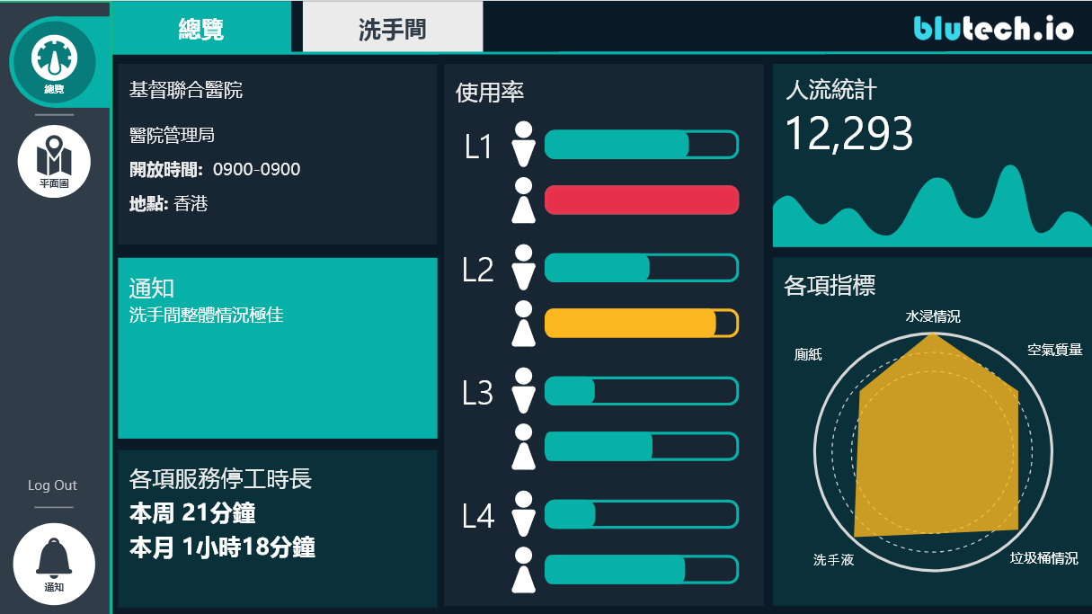

* + 1. Left Sidebar

**Overview**

**Floor Plan**

**--------**

**Log Out**

**--------**

**Notification**

* + 1. Overview

User: Property Managers



* + - 1. Basic Information of the Property

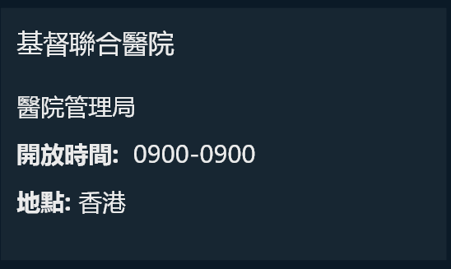

static

* + - 1. Notification



* Real time
* If everything is fine, display “Washroom situation is excellent” / “洗手間整體情況極佳”
* If not, display the notification messages.
* Can be scrolled down to display many notification messages.
  + - 1. Service Down Time

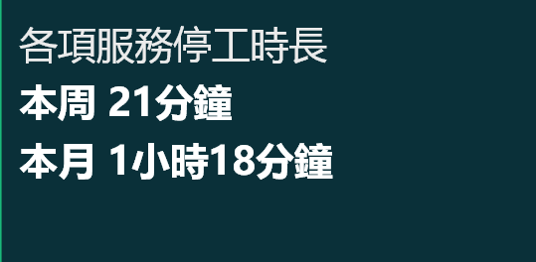

* Real time
* The total downtime of all the utensils due to late change of utensils.
* If the downtime of more than one utensil is overlapped, it should be counted separately.
* Calculate the total downtime of this week (from Monday) and this month (from 1st of this month).
  + - 1. Usage Rate

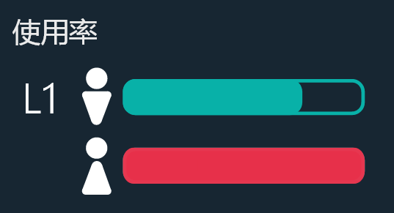 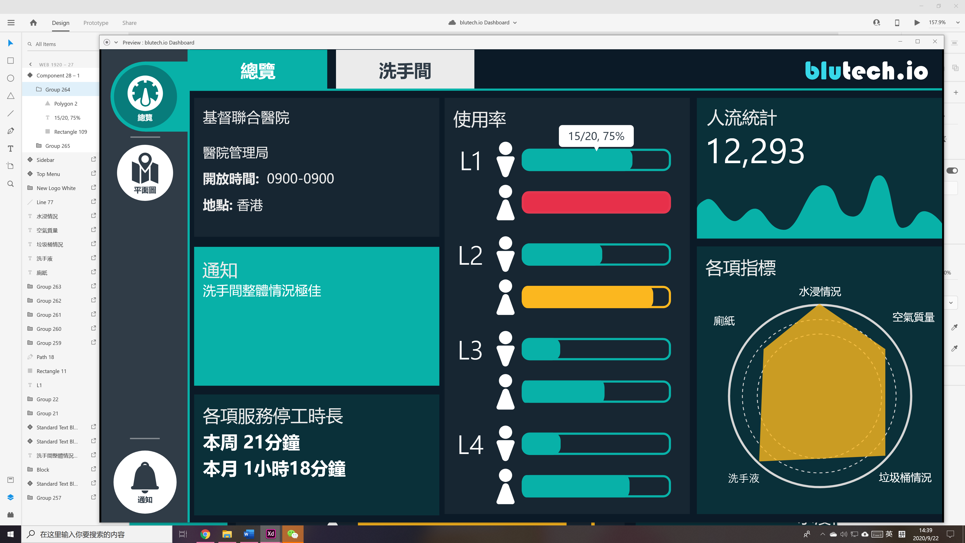

* Real time
* Categorized by the floor where toilets are located
* Hover: show “no. of occupied toilets / total no. of toilets, XX%”
* The color of the bar

|  |  |  |  |
| --- | --- | --- | --- |
| **Color** | ***Red*** | ***Yellow*** | ***Green*** |
| **Percentage** | =100% | 75 -99% | 0-74% |

* + - 1. People Count

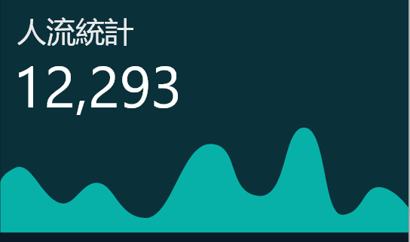

* Real time
* This number is the total people count of no. of people that used the toilets within the day (from the opening time of the property).
  + - 1. Overall Indicator

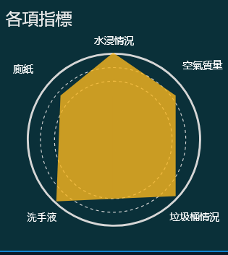

* Real time
* The overall conditions of the above five stuff in the whole property/shopping mall/building.
* The bigger the pentagon, the better.
* Calculation Method:
  + Toilet Paper Score:
  + Soap Dispenser Score:
  + Rubbish Bin Score:
  + IAQ Score:
  + Water Leakage Score:
    1. Toilets

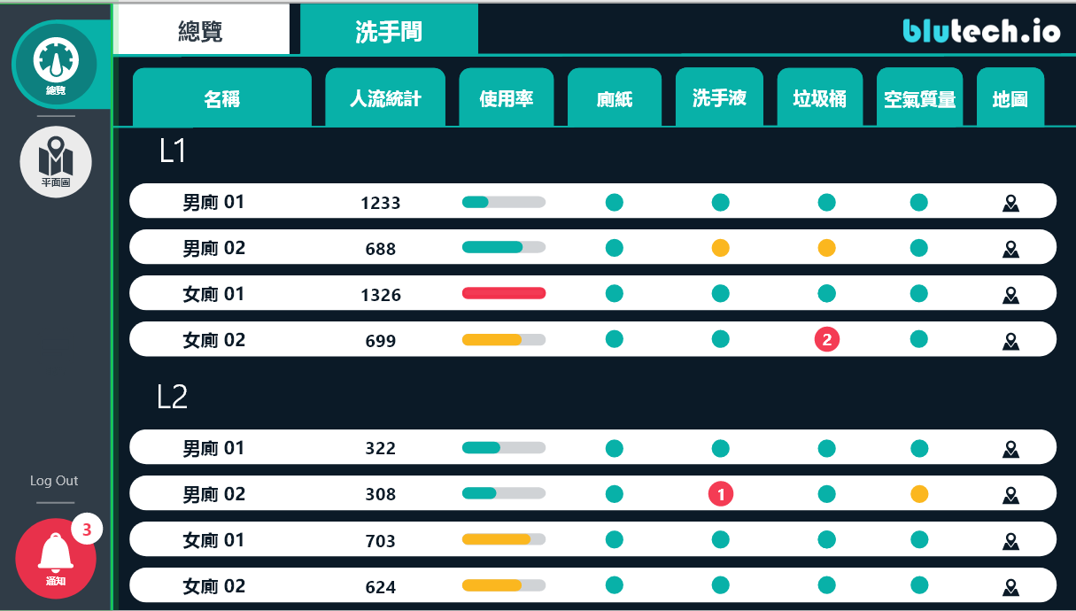

If not applied, the column will be in grey color.

* + - 1. Name of toilets
* Static
* The names will be assigned by customers
* Categorized by the floor where toilets are located
  + - 1. People Count
* Real time
* Total people count of no. of people that used the specific toilet within the day
  + - 1. Usage Rate
* Real time
* Current usage rate of the specific toilet
* Hover: show “no. of occupied toilets / total no. of toilets, XX%”
* The color of the bar

|  |  |  |  |
| --- | --- | --- | --- |
| **Color** | ***Red*** | ***Yellow*** | ***Green*** |
| **Percentage** | =100% | 75 -99% | 0-74% |

* + - 1. Toilet Paper
* Real time
* Whether toilet paper rolls in each toilet cubicles are enough
* The **color**, **number** and **hover** of the circle

|  |  |  |  |
| --- | --- | --- | --- |
| **Color** | ***Red*** | ***Yellow*** | ***Green*** |
| **Situation** | At least one cubicle is out of toilet paper (threshold may be changed by customers) | The toilet paper in at least one cubicle has below 25% left (threshold may be changed by customers) | Other situations |
| **Show No. of Cubicles with the above situation** | Yes | No | No |
| **Hover** | Shows“Cubicle 1, 2, 3… is out of toilet paper” | Shows “Cubicle 1, 2, 3… is almost out of toilet paper” | Nothing |

* + - 1. Soap Dispenser
* Real time
* Whether soap dispensers near the water tanks are enough
* The **color**, **number** and **hover** of the circle

|  |  |  |  |
| --- | --- | --- | --- |
| **Color** | ***Red*** | ***Yellow*** | ***Green*** |
| **Situation** | At least one soap dispenser is out of soap (threshold may be changed by customers) | At least one soap dispenser has below 25% of soap left (threshold may be changed by customers) | Other situations |
| **Show No. of Parameters with the above situation** | Yes | No | No |
| **Hover** | “Temperature  Ammonia is poor” | Shows “Soap Dispenser 1, 2, 3… is almost out of soap” | Nothing |

* + - 1. Rubbish Bin
* Real time
* Whether rubbish bins in the toilet are full
* The **color**, **number** and **hover** of the circle

|  |  |  |  |
| --- | --- | --- | --- |
| **Color** | ***Red*** | ***Yellow*** | ***Green*** |
| **Situation** | At least one rubbish bin is full (threshold may be changed by customers) | At least one rubbish bin is 75% full (threshold may be changed by customers) | Other situations |
| **Show No. of Cubicles with the above situation** | Yes | No | No |
| **Hover** | Shows“Rubbish Bin 1, 2, 3… is full” | Shows “Rubbish Bin 1, 2, 3… is almost full” | Nothing |

* + - 1. IAQ
* Real time
* Whether the Air Quality in the toilet is good
* Five parameters:
  + Temperature
  + Humidity
  + Hydrogen Sulphide
  + Ammonia
  + PM2.5
* The **color**, **number** and **hover** of the circle

|  |  |  |  |
| --- | --- | --- | --- |
| **Color** | ***Red*** | ***Yellow*** | ***Green*** |
| **Situation** | At least one parameter is **poor/較差** (threshold may be changed by customers) | At least one parameter is **average/良好** (threshold may be changed by customers) | All 5 parameters are **excellent/極佳** |
| **Show No. of Cubicles with the above situation** | Yes | No | No |
| **Hover** | Shows  “  Temperature: xx ºC  Humidity: xx %  H2S: excellent  NH3: poor  PM2.5: average  ”  (depends on real time data) | Shows  “  Temperature: xx ºC  Humidity: xx %  H2S: excellent  NH3: excellent  PM2.5: average  ” (depends on real time data) | Shows  “  Temperature: xx ºC  Humidity: xx %  H2S: excellent  NH3: excellent  PM2.5: excellent  ”  (depends on real time data) |

* + - 1. Map

Click the map ICON to open the floor plan of the specific toilet

* The sensor status shown in the floor plan are updated real time
* This pop-up page will show the status of all the sensors
* Floor plan is generated / re-drawn according to the floor plans of the property. (see if we can develop an easier or automatic or non-code way to draw this floor plan for easier implementation in the future)
  + 1. Floor Plan
       1. IAQ 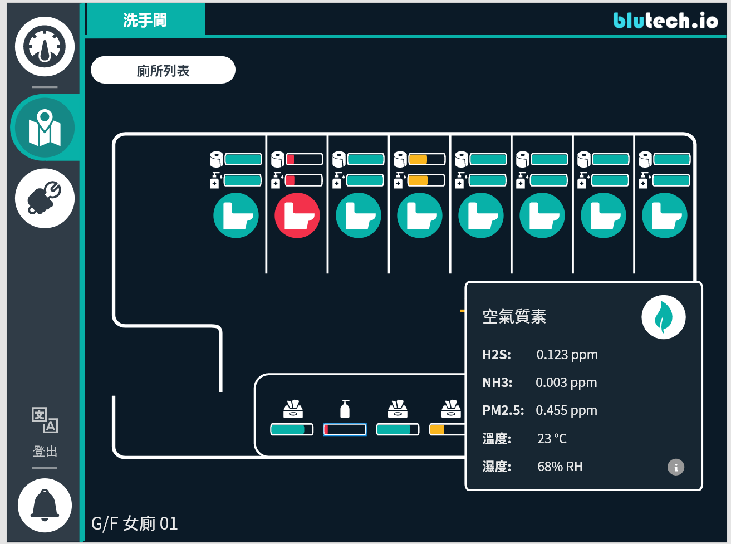

Click the  logo to open IAQ panel.

Click the  logo to open the explanation of each parameter.

|  |  |  |  |
| --- | --- | --- | --- |
| Parameter | Poor | Average | Excellent |
| H2S | (0.003,) | (0.001, 0.003] | [0, 0.001] |
| NH3 | (0.015, ) | (0.01, 0.015] | [0, 0.01] |
| PM2.5 | (65 ,) | (15, 65] | [0, 15] |
| Temperature | (,20] or (29,) | (20,22] or (27,29] | (22, 27] |
| Humidity | (90%, ) | (80%, 90%] | [0, 80%] |

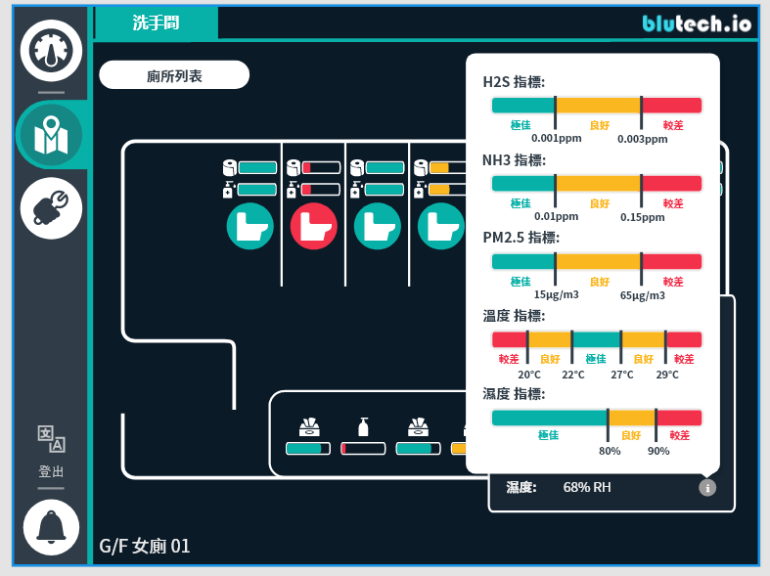

* + 1. Notification（still waiting for UI design）

- Show time occurred for each notification- Group notifications by each toilet

- Sound Alert

- Send SMS to certain phone numbers