MIX – Micronas Interconnect Spec expander

Introduction

Management Summary

Overview

Table of contents:
MIX – Micronas Interconnect Spec expander 1
Introduction 1
Management Summary 1
Overview 1
Table of contents: 1
Installation 2
Getting Started 2
A simple example 2
Mix it! 3
You get what you typed 5
Details 7
Common excel worksheet properties 7
HIER sheet properties 8
HIER columns details 9
Special HIER sheet properties 9
CONN sheet details 9
CONN columns details 9
Special CONN sheet signals 9
%OPEN% aka. open 9
Constants 10
Generics and Parameters 10
Predefined and user macros 10
CONN sheet macros 11
Generator statements 11
IO sheet 11
I2C sheet 11
VI2C sheet 11
Alarm clock example 11
MIX converter man page 11
Synopsis 11
Command line switches 11
Runtime options and configuration 12
Misc features 12
-delta mode 12
Intermediate Excel Sheet 13
Alarm clock example 13
Core logic 13
IO logic 13
Other examples 13
Known Bugs and limitations 13
Issue tracking: CADNET -> Issue tracking -> CAD Software -> MIX 13
Links 13
MIX paper and documentation 13
Micronas internal 14
Others 14
Used Software 14

Installation
The MIX toolset uses the Perl scripting language. Please install a recent version of Perl on your workstation, e.g. the freely available ActiveState Perl from K:\PROJECTS\MIX\PROG\ActivePerl-5.6.1.633-MSWin32-x86.msi.
Apart from that no installation is required.
Start MIX from the network drive like described in the examples below. That will also make sure, that you are using the most recent release automatically.
After the Perl installation, you can run MIX. immediately. Open a command shell on your desktop workstation
Start -> Ausführen -> cmd
and type
K:\Projects\MIX\PROG\mix_0.pl foo.xls
Caveat: Currently MIX is available on MS-Windows, only!

Getting Started
To receive useful results, MIX reads in various input spreadsheet data. At least you will need to prepare a description of your design hierarchy (HIER) and the connectivity sheet (CONN). Optionally MIX will convert a input/output sheet IO, listing input/output pads and iocells and how these are linked to the core logic into appropriate hierarchy and connection lists.

A simple example
To understand the usage of the various tables and options, a very simple example is shown and extended step by step. The simple example just has two components a and b, which are connected by the signal sigfoo. The two instances have a common parent chip

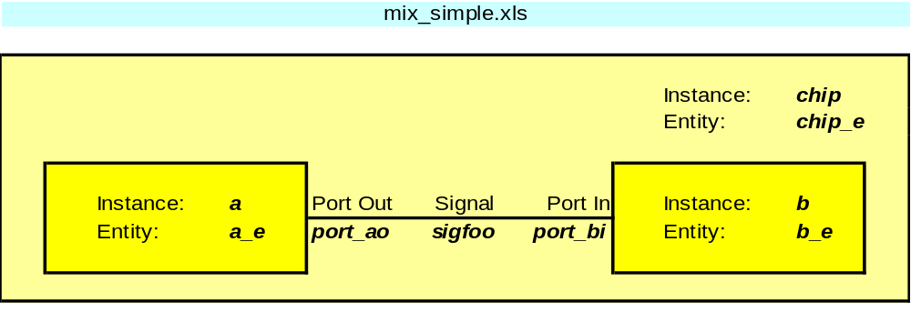
Image 1: Simple mix_simple.xls
The equivalent description of this simple design in MIX is made up from a worksheet HIER.
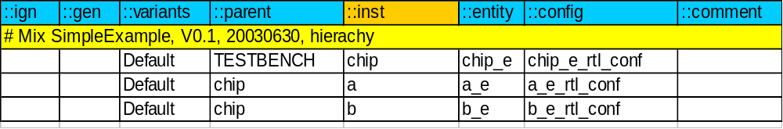
The first row defines the table headers names. The names have to be in the form “::NAME”. Several of the columns are required, some are optional and you can define additional columns on your own. For HIER sheets the “::inst” column is the primary key. One design element will be generated for each new name of an ::inst row. If a name is defined several times, these lines will be overloaded or summarized, depending on built-in rules of the MIX converter.
The “::ign” column has to come first. If it starts with a #, the rest of this row will be ignored. All other columns can be added in arbitrary order.

The second required worksheet is CONN:
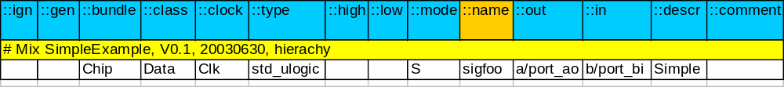As you see, this worksheet also starts with the table header definition line. The primary field is the “::name” column. The “::in” and “::out” columns are used to define the drivers and loads for the signals.

Mix it!
Run the MIX converter tool in the directory the excel spread sheet is stored in:
$ cd \work\MIX\doc\parts\simple
$ K:\Projects\MIX\PROG\mix_0.pl mix_simple.xls
This reads in the design description and evaluates the various sheets. It creates output files with an intermediate excel design description (mix_simple-mixed.xls) and the same data in a internal format (mix_simple.pld). A log file (mix_0.pl.log) and the HDL output files are written in the same run. Image 2 shows a screenshot of the mix_simpe.xls conversion. Only the most important errors and warnings are written to the screen, while a lot of information will be written to the log file. Search for the keywords “ERROR” and “WARNING” to verify proper conversion.

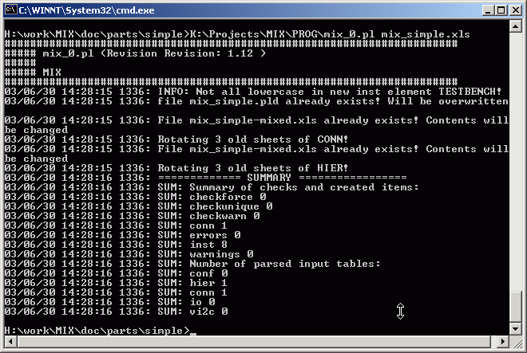
Image 2: Screenshot mix_simple conversion
All output files are stored in the current working directory. Old versions of the output files are overwritten. Except the log file that is appended by each converter run. The intermediate excel description file keeps a history of previous HIER and CONN sheets by rotating _N extended worksheet names.
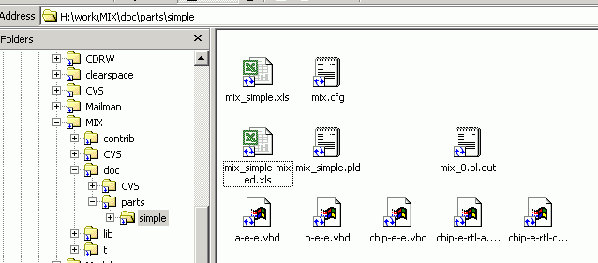

Intermediate files, log file

Input and configuration data

HDL files

You get what you typed
MIX generates various HDL files defined by the input data. If you select VHDL (also the default language) as output description for a hierarchy element, each element results in an appropriate entity, architecture and configuration description. By default MIX writes one file for all entities, one for all architecture and one for all configuration descriptions. Those file names are derived from the last excel input file name by stripping of the .xls extension and attaching a –e.vhd, -a.vhd and –c.vhd.
Here the working directory of the simple example contains a file mix.cfg, which is the convenient storage for MIX run-time configuration options. The lines “MIXCFG outarch ARCH”, “MIXCFG outenty ENTY”, and “MIXCFG outconf CONF” switch MIX outputs to separate files for each entity, architecture and configuration. In this case the file names are defined by the element name:
Type | Basename | Extension | Example
Entity | ::entity-column | -e.vhd | chip-e-e.vhd
Architecture | ::entity-column | -rtl-a.vhd | chip-e-rtl-a.vhd
Configuration | ::conf-column | -c.vhd | chip-e-rtl-conf-c.vhd
“_” in the element names are converted to -.

By default MIX does not write output data for leaf blocks (instances which are not parent for other instances). Adding a line like “MIXCFG generate.output.arch leaf” into the mix.cfg file changes that.

The generated output files contain head, body and footer sections. See the screenshots of the file a-e-e.vhd and chip-e-rtl-a.vhd for examples of an entity and an architecture definition.
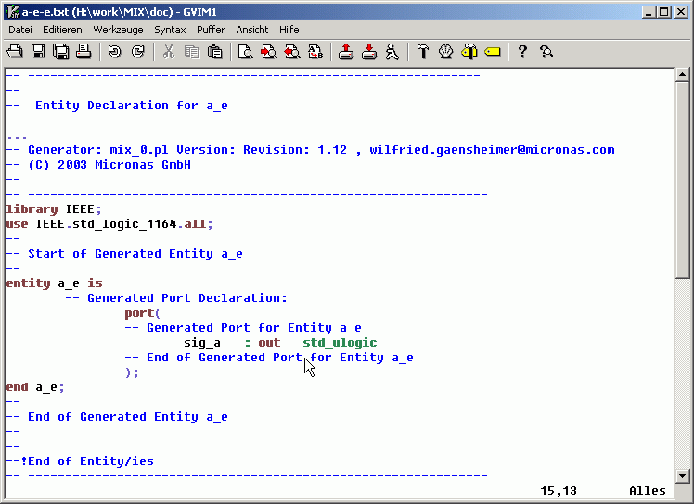
Image 3: Entity a-e-e.vhd
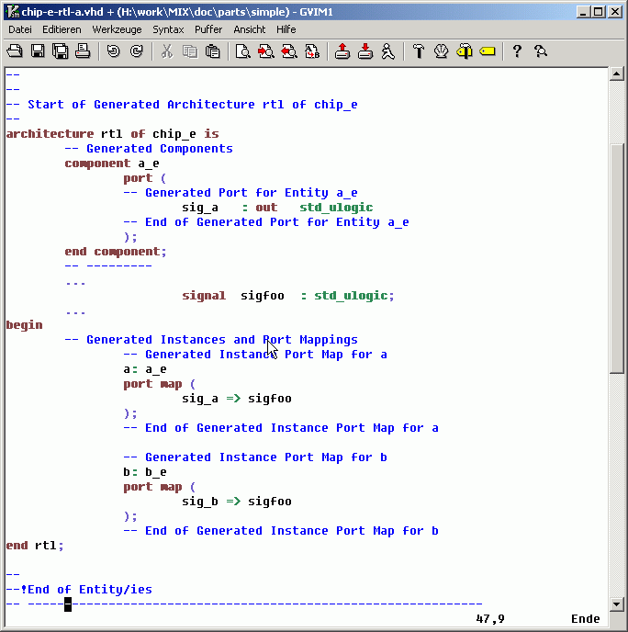
Image 4: architecture chip-e-rtl-a.vhd

Details

Common excel worksheet properties
All excel worksheets parsed by MIX share some common properties.
There needs to be a header line consisting only of keywords with leading double colon. All data before the header line is ignored. Only the first header line will be evaluated. Data in columns with no header or malformed headers will be ignored.
Commonly understood table headings are ::ign and ::comment. The ::ign column is special, because it needs to be the first column of a sheet. If a cell in the ::ign column starts with a #, the complete row is ignored.
The ::comment column can contain user or program generated comments for a given row. It’s data will be appended to it’s contents as it appears.
MIX reads the excel cell values. This is what you see, not the real contents of the cells. Thus all excel formulas can be used to define the cell values.
A lot of predefined text macros are understood and converted by MIX. A text macro is made up by a name surrounded by % signs. Retrieve a complete list of macros with the –listconf command line switch and grep all lines starting with “MIXCFG macro”. The table %macro% gives a list of predefined macros, their default settings and wether this macro can be used by the user. You can use text macros inside of any cell.
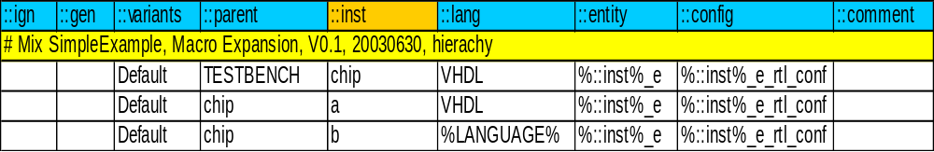
A second type of macros are available to reference other columns of a like through %::NAME%. This will be replaced by the contents of the ::NAME column of this row. ::NAME has to be defined for the current worksheet, obviously. In the above example %::inst%_e will evaluate to chip_e, a_e and b_e accordingly. %LANGUAGE% becomes vhdl. Macro expansion happens just before the intermediate design data is written out, after evaluation of all input data. Recursive macro expansion is not implemented. Macros in primary keys like signal and instance names are evaluated at signal or instance creation time.

HIER sheet properties
The hierarchy of a design is defined in the HIER sheet. By default the HIER sheet is named HIER, but you can set the configuration value hier.xls to a Perl regular expression. MIX will then consider all worksheets which names match the perl regular expression, to be HIER definitions. In that case you are free to use different header definitions on different sheets.
The HIER sheets require at least the columns marked man. (mandatory) in the following table.
Column name | Description | Default value | Req. | Example
::ign | Ignore line | <empty> | man. | # comm.
::gen | Generator and match | <empty> | man. | see below
::variants | Variant selector | Default | opt. | Var1
::parent | Instance name of this instances parent cell | W_NO_PARENT | man. | chip
::inst | Instance name, primary key! | n/a | man. | a_i1
::lang | Language definition | VHDL | opt. | vhdl
::entity | Entity name | W_NO_ENTITY | man. | a
::config | Configuration name | W_NO_CONFIG | man. | a_rtl_conf
::shortname | Short name | <empty> | opt. | text
::use | Additional, project specific libraries | <empty> | opt. | padlib.foo
::comment | Comment field | <empty> | opt. | text

Internally the kewords ::debug, ::hierarchy, ::skip and ::default are used. Please do not use them. Apart from that you are free to add columns of your own. User defined columns are usable in %::NAME% macro expansion and are listed in the intermediate design data output.
Only the ::inst column has to contain a value in each row (which could be a %::NAME% macro, though). All other columns will receive more or less reasonable default values in case they are left empty.

HIER columns details
::gen If a cell here is not empty, the line will be considered as generator. See description of generator statements below.
::variants Select a line depending on the –variant command line switch. If –variant VAR is set, only lines whose ::variant cell contains the keyword VAR, Default or empty, are selected and read in. Several variants may be given in one cell, separated by “,”. Without specifying the –variant switch, the “Default” and empty ::variant cells are read in and evaluated.
::inst Defines the instance name. If the same name appears in several rows, the resulting row will be overloaded from all input rows. The exact behaviour depends on the column name. Some are concatenated, some are replaced.
::lang HDL language selection, case insensitive. If this column is omitted or empty, VHDL output is generated. The default value can ve changed by means of the macro.%LANGUAGE% macro. Currently only VHDL and Verilog are supported (XXX: Verilog output still t.b.d.).

Additional columns:
::arch If no ::arch column is given, architecture will default to "rtl"
(configuration hier.field.::arch.[3] = rtl; cannot be changed globally)
::use Add project specific libraries and work packages to the HDL description files. See the ::use details below.

Special HIER sheet properties
%TOP%

CONN sheet details

CONN columns details

Special CONN sheet signals
Special signal names:
%LOW%, %HIGH%, %LOW_BUS%, %HIGH_BUS%

%OPEN% aka. open
Used the %OPEN% signal to leave some pins of module bar port a open
MIX has no knowledge about ports. Everything is defined in terms of signals and instances. Use the "open" pseudo signal to define the extra pins.

E.g.: wire foo/a port to bar/a port. bar/a has extra pins.

signal_a, ::high 7, ::low 0, ::out foo/a ::in bar/a
%OPEN%, ::high 1, ::low 0, ::out -, ::out bar/a(9:8)
XXX write this in spreadsheet XXX
You could also force the ::in pins to high or low, instead, e.g. use %HIGH%, %HIGH_BUS%, %LOW
or %LOW_BUS%. Or a constant.

Constants

Generics and Parameters

Predefined and user macros
The following table contains a list of predefined macros. Some of them are defined at run time (e.g. the current date), some are for internal purposes only. macros marked with a yes in the “User” column can be set freely by the user on the command line or in the mix.cfg configuration file.

Macro Name | Default Value | Description | User
%0% | mix_0.pl | Program name | run time
%ARGV% | K:\Projects\MIX\PROG\mix_0.pl –listoncf | Program arguments | run time
%BUFFER% | buffer |  | yes
%BUS_TYPE% | std_ulogic_vector |  | yes
%CONST% | __CONST__ |  | yes
%DATE% | Mon Jun 30 16:22:41 2003-06-30 | Current date | run time
%DEFAULT_MODE% | S | Signal default mode | yes
%EMPTY% |  | Empty string | yes
%GENERIC% | __GENERIC__ |  | -
%H% | $ | internal | -
%HIGH% | mix_logic1 | Name of logic high value | yes
%HIGH_BUS% | mix_logic1_bus | Name of logic high value bus | yes
%HOME% | H:\ |  | -
%IOCELL_SELECT_PORT% | select |  | yes
%IOCELL_TYPE% | __E_DEFAULT_IOCELL__ |  | -
%IOCR% | \n |  | -
%LANGUAGE% | vhdl |  | yes
%LOW% | mix_logic0 |  | yes
%LOW_BUS% | mix_logic0_bus |  | yes
%NULL% | 0 |  | -
%OPEN% | open |  | -
%PAD_CLASS% | PAD |  | yes
%PAD_TYPE% | __E_DEFAULT_PAD__ |  | -
%PARAMETER% | __PARAMETER__ |  | -
%PROJECT% | NO_PROJECT_SET |  | yes
%SIGNAL% | std_ulogic |  | yes
%SPACE% |  |  | yes
%TAB% | \t |  | -
%TBD% | __W_TO_BE_DEFINED |  | -
%TOP% | __TOP__ |  | yes
%UNDEF% | ERROR_UNDEF |  | -
%UNDEF_1% | ERROR_UNDEF_1 |  | -
%UNDEF_2% | ERROR_UNDEF_2 |  | -
%UNDEF_3% | ERROR_UNDEF_3 |  | -
%UNDEF_4% | ERROR_UNDEF_4 |  | -
%USER% | wig |  | run time
%VERILOG_TIMESCALE% | 'timescale 1ns / 1ns; |  | yes
%VERSION% | Revision: 1.12 |  | -
%VHDL_NOPROJ% | -- No project specific VHDL libraries |  | -
%VHDL_USE% | -- No project specific VHDL libraries |  | yes
%VHDL_USE_ARCH% | %VHDL_USE_DEFAULT%\n%VHDL_USE% |  | yes
%VHDL_USE_CONF% | %VHDL_USE_DEFAULT%\n%VHDL_USE% |  | yes
%VHDL_USE_DEFAULT% | library IEEE;\n  use IEEE.std_logic_1164.all;\n |  | yes
%VHDL_USE_ENTY% | %VHDL_USE_DEFAULT%\n%VHDL_USE% |  | yes
The default values can be changed by using
-conf macro.%THIS_MACRO%=my_value
command line switch. New macros can be defined the same way.
Alternatively a line like
MIXCFG macro.%THIS_MACRO% my_value
to the mix.cfg configuration file will achieve the same result.

CONN sheet macros
not text macros, but MH, MD and MX generators:
MH: Macro header: needs to match against the MX line ($X defines variables)
MD: Body of macro. Will be inserted after variable replacement.
MX: Triggers macro expansion. Will be matched against all MH lines known.
Defines variable values.

Generator statements

IO sheet

I2C sheet

VI2C sheet

Alarm clock example

MIX converter man page

Synopsis

Command line switches
-out OUTPUTFILE.ext defines output filename and type
-outenty OUT-e.vhd|ENTY|COMB
-- Write all entities into OUT-e.vhd.
-- If argument is ENTY, each entity will be written into a file called entityname-e.vhd.. (The exact naming depends on changeable rules).
-- If argument is COMB, entity, architecture and configuration will all be written into one file called entityname.vhd
-outarch OUT-rtl-a.vhd|ARCH|COMB
See description of outenty option.
-outconf OUT-c.vhd|CONF|COMB
See description of outenty option.
-combine
write entity, architecture and configuration into one file for each entity. Shortcut for setting –out[enty|arch|conf] to COMB individually.
-dir DIRECTORY
write intermediate, internal and backend data into the given DIRECTORY. By default MIX writes to the current working directory
-top TOPCELL
use TOPCELL as top. Default is TESTBENCH or daughter of TESTBENCH.
-adump
dump internal data in ASCII format, too (debugging, use with small data set).
-variant VAR1
Select VAR1 from the HIER worksheet.
-conf key.key.key=value
Overload $EH{key}{key}{key} with value or add a new configuration variable.
-listconf
Print out all available/predefined configurations options
-delta
Output will be compared against previous runs.
-sheet SHEET=MATCH
SHEET can be one of "hier", "conn", "vi2c". MATCH is a perl regular expression.
# Add your options here ....

"Standard" options:
my @stdopts = qw(help|h! verbose|v! quiet|q! nobanner! debug:i makeopts=s@ gmakeopts=s@);

Caveat: the –h option will not work on MS-Windows

Runtime options and configuration
Runtime configuration is controlled by (increasing precedence):
- built-in default values
- mix.cfg files
if found $HOME, $PROJECT and/or in current directory.
Format is: MIXCFG name.of.conf value
- CONF sheet found in input xls files
- command line switch
-conf foo.bar=value
- dedicated command line options

MIX reads in mix.cfg configuration files in the following locations:
  - $ENV{HOME}
'HOMEDRIVE', 'HOMEPATH', 'USERPROFILE' or 'C:\'
(only from the first matching location)
  - $ENV{PROJECT}
  - . (cwd)
Order: HOME / HOME / cwd() / -conf (last wins)

Misc features

-delta mode
Do not change output files, but report number of changes. Adds extra sheets DIFF_CONN and DIFF_HIER (and old versions of them) to the intermediate output. The FOO.pld internal output gets overwritten, though. All messages are appended to mix_0.pl
If a new HDL-file needs to be created by the changes, the –delta mode is not be applied for that file, but it is generated as new. If you never have written a FOO-mixed.xls intermediate output, there is no HIER or CONN sheet generated.
By adding the following two lines to your configuration (e.g. ./mix.cfg), delta mode will be the default:

MIXCFG output.generate.delta 1
MIXCFG output.delta sort,remove

See the configuration option description for more details.

-nodelta switches delta mode off, then.

Intermediate Excel Sheet
Format of intermediate xls sheet will be kept as is as long as the number and order of columns is unchanged.
MIX saves three old versions of the generated HIER and CONN sheets. The worksheets names are rotated by a trailing _ and number.

Output Redirection
MIX writes all output into the current working directory. By using the
-dir DIRECTORY
option, you can set the output directory for all intermediate, internal and HDL files to DIRECTORY. Absolute path names defined by other options (e.g. –out) are not changed, though. If DIRECTORY does not exist it will be created.
To have separate output directories, use the mix.cfg file:
MIXCFG output.path HDLDIRS
MIXCFG internal.path MIXINTERNAL
MIXCFG intermediate MIXINTERMEDIATE
writes internal, intermediate and HDL files to the given pathes. All directories have to exist and will not be created.

Alarm clock example

Core logic

IO logic

Other examples

Known Bugs and limitations
MS-Win/UNIX end-of-line issue:
Some EDA tools are not able to cope with the different end-of-line (CR vs LF/CR) of UNIX and MS-Windows. Use
$ module load freeware; recode “pc..lat1” *.vhd
to fix that after transferring data.

Issue tracking: CADNET -> Issue tracking -> CAD Software -> MIX
If you find unexpected or buggy behavior, please issue a trouble ticket. Don't forget to add a short description. The test case should contain all source files and also log files, the exact command line switches and configuration files applied.
Please provide a comprehensive description of issues found including all required input data and command line switch to allow fast debugging and fixing.

Links

MIX paper and documentation
EDP_2003_final_030331.pdf
MIX_Specification.xls (see \\Galaxy\Development\PROJECTS\MIX)
MIX_Intro.ppt (see \\Galaxy\Development\PROJECTS\MIX)

Micronas internal
Micronas HDL coding guidelines.pdf

Others

Used Software
Perl
Kommodo
Vim
WinCVS

