HAMS App
Wialon Integration Reference
For verification by the P99L hardware partner
Version 1.0
2026-05-25

1. What the app does
- Android app for FFB harvesters; replaces the P99L hardware tracker for cut counting.
- Worker presses + per FFB cut — the app stores GPS, battery, and timestamp locally.
- Batched events are pushed to the same Wialon platform as P99L when validated Wi-Fi appears.
- Uplink only — the app does not receive commands or replies from Wialon.

2. UI workflow
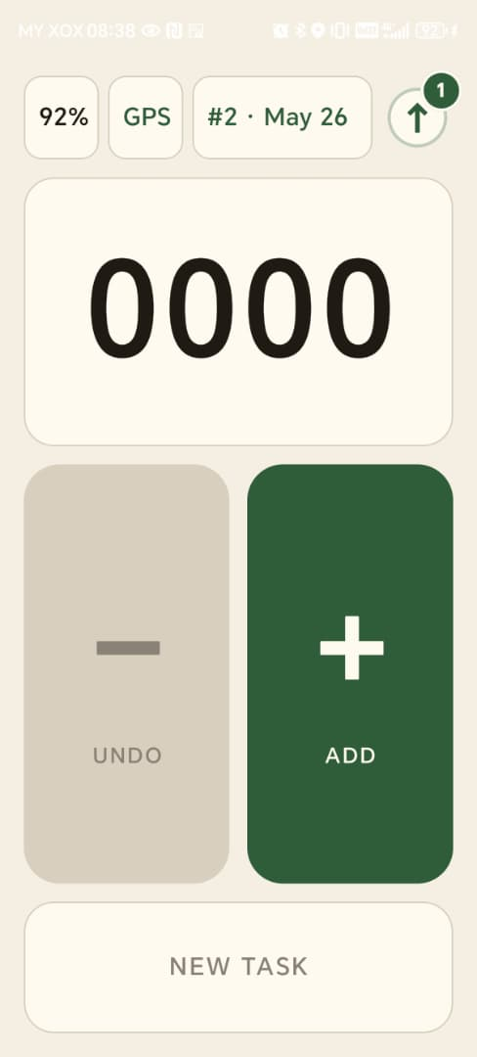

3. Wialon server target
Item | Value
IPS host | 185.213.1.24 (DNS: nl2.gpsgsm.org)
IPS port | 20332
Protocol | Wialon IPS v2.x, v1.1 frame variant (text frames over TCP)  Spec: https://help.wialon.com/en/wialon-hosting/user-guide/hardware/connecting-hardware#ivedesignedmyowngpsdevicewhichcommunicationprotocolshouldiimplement
REST API host (read-side only) | https://hst-api.wialon.eu
Web UI for verification | https://pro.navi-agnostics.com

No password used. Login frame: #L#<unique_id>;NA\r\n → expect #AL#1.

4. Unit configuration
The Android app is currently set up against the existing test unit. Please access it on the Web UI and verify settings the same way the P99L unit was verified.

Identity
Item | Value
Test unit name | TEST_HAMS_APP_001
Test unit ID | 601602811
Unique ID | HAMS_TEST_001
Device type | Wialon IPS (ID 600002235)
Password | (blank)

Required Advanced-tab filters
Filter | Required value
Maximum interval between messages (s) | 0
Average speed between messages | 0
Distance between coordinates | 0
Message validity filtration | Off

Critical: any non-zero or "on" value here causes Wialon to silently drop messages — no #AD# failure, no Messages-tab entry. Same constraint as the P99L unit.

5. Sensors on the unit
Sensor | Parameter | Type | Notes
FFB_CUT | ffb_cut | Custom | 1 = cut event
battery | battery | Custom (units %) | Phone battery percent
event_code | event_code | Custom | Optional calibration: 179 / 180 / 35
work_count | work_count | Counter | Displayed/net count per task

Parameter-naming difference from P99L. The HAMS app uses descriptive parameter names (ffb_cut, battery, event_code, work_count) instead of P99L's short single-letter names. Both are valid per IPS v1.1, but Wialon sensors created for HAMS units must use the descriptive names shown above.

6. Data frame — what the app sends
Standard 16-field IPS v1.1 data frame over TCP, one frame per event:
#D#DDMMYY;HHMMSS;DDMM.MMMM;N;DDDMM.MMMM;E;speed;course;alt;sats;hdop;inputs;outputs;adc;ibutton;params\r\n

Field | App-side value
date / time | UTC at the moment the event was captured.
latitude / longitude | DDMM.MMMM — latitude uses 2-digit degrees, longitude uses 3-digit degrees.
speed | 0 — worker on foot.
course | 0 — no heading. The legacy V5 course=1 FFB-hack is removed.
altitude | Terrain estimate.
satellites / hdop | From the Android Fused Location provider.
inputs / outputs | 0 / 0 (not applicable for a phone).
adc | Empty.
ibutton | NA
params | Custom params block (next section).

Expected gateway response per frame: #AD#1.

Custom params block (field 16)
ffb_cut:1:<0|1>,battery:2:<0.0-100.0>,event_code:1:<179|180|35>,work_count:1:<0..>

Param | Type code | Meaning
ffb_cut | 1 (int) | 1 on + press, 0 on every other event
battery | 2 (double) | Phone battery percent at capture
event_code | 1 (int) | Outbound code — see next section
work_count | 1 (int) | Displayed/net task count after this event

7. Outbound event codes
Only three codes are ever sent to Wialon.
Code | Meaning | Frequency
179 | FFB cut / plus | Per worker + press
180 | FFB correction / productive minus | Per worker − press, only when net count > 0
35 | Periodic beacon (heartbeat) | Once per minute while a task is active

App-internal lifecycle and health codes are stored on the device only and never reach Wialon.

Sample
#D#180526;090519;0435.9886;N;10104.6871;E;0;0;10;8;20;0;0;;NA;ffb_cut:1:1,battery:2:87,event_code:1:179,work_count:1:1\r\n
Server reply: #AD#1\r\n
Frame field | Came from
180526;090519 | Time 2026-05-18 09:05:19 UTC
0435.9886;N | Lat 4.59981 → 4° + 0.59981 × 60′
10104.6871;E | Lon 101.078118 → 101° + 0.078118 × 60′
0;0;10 | Speed / course / altitude
8 | Satellites — not shown in the Messages tab; placeholder. Open Raw data to read the real value.
20 | HDOP
0;0;;NA | inputs / outputs / adc (empty) / ibutton
ffb_cut:1:1,battery:2:87,event_code:1:179,work_count:1:1 | Params block

8. Push trigger and batching
Each event is captured and stored locally. The app pushes to Wialon when validated Wi-Fi becomes available, in the following sequence.

# | Step | Detail
1 | Worker presses + on the count screen | Event written to local SQLite with timestamp, GPS, battery, event_code=179, and work_count after the press.
2 | Event stored locally | Status: pending. App keeps storing events offline indefinitely (capacity ~30 days).
3 | Push trigger fires | Either (a) a validated unmetered Wi-Fi network connects, or (b) the user long-presses the manual push button for 3 seconds. Mobile data is never used.
4 | App opens TCP socket | Destination 185.213.1.24:20332. Socket is opened fresh per batch — no long-lived connections.
5 | Login | App sends #L#<unique_id>;NA  and waits for #AL#1  . On #AL#0 (rejected) the socket is closed and push stops; on timeout the app retries with backoff.
6 | Drain a batch | Up to 10 #D# frames per TCP session, ~75 ms between frames. Order: oldest pending event first.
7 | Per-frame ack | App reads #AD#<code> after each frame. #AD#1 = event marked uploaded. #AD#-1, #AD#15, etc. = event marked rejected (stays on device, not auto-retried).
8 | Close and continue | After 10 frames or queue empty, the app closes the socket. If more events remain, it opens a fresh session (new login) and repeats.
9 | Heartbeat | While a task is active, the app emits one event_code=35 frame per minute. Pushed with the next batch — never alone.
10 | Failure handling | TCP error / login rejection / timeout: socket closed, backoff 10s -> 30s -> 60s -> 120s, retry when Wi-Fi is still up. App never blocks the worker — counting continues regardless of push state.

Rule | Value
Trigger | Validated unmetered Wi-Fi (monitored by a background service).
Manual override | 3-second long-press on the push button in the app.
Frames per TCP session | 10
Inter-frame delay | ~75 ms
Login required per session | Yes (#L#…;NA)
The push monitor stays alive while pending events exist — even with the app closed or swiped from recents — so push fires the moment Wi-Fi appears.

9. What the app does NOT send
- No digital inputs / outputs bits (both = 0).
- No ADC values.
- No driver / ibutton key (sent as NA).
- No heading on course (sent as 0); the legacy V5 course=1 FFB-hack is removed.
- No HAMS-internal lifecycle or health event codes — they remain on the device only.
- No data flows back from Wialon to the app — push is uplink only.

10. How to verify
The same test unit (TEST_HAMS_APP_001, ID 601602811) is being used. Please open it on pro.navi-agnostics.com and verify the stored messages the same way the P99L unit was verified during its integration — message arrival, geofence resolution, sensor decode, and report runs.
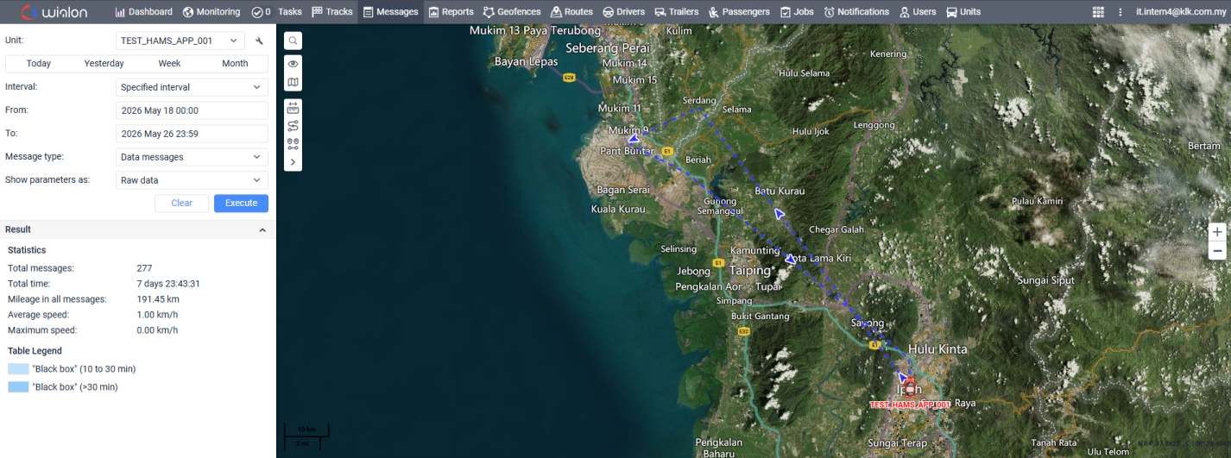

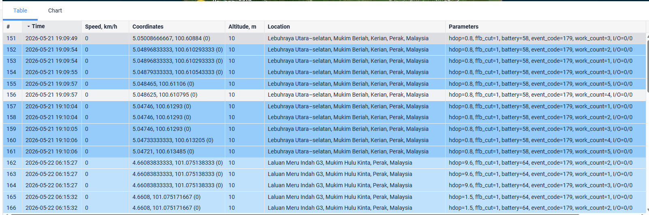
End of reference.

