KUALA LUMPUR KEPONG BERHAD
HAMS Task Recorder
Production Reference and User Guide
Prepared by Woo Ying Hui | it.intern4@klk.com.my
10 August 2026 | realme C85 | App 1.1 (2)
© 2026 Kuala Lumpur Kepong Berhad. All rights reserved.

Contents
1. Purpose and system scope 3
2. Device and application baseline 4
3. App user interface and field use 5
3.1 UI overview 5
3.2 Daily use 5
4. Data delivery, pairing, and release safety 6
4.1 Pairing and verification 6
4.2 Release and replacement 6
4.3 Pairing and release: precautions and fallback 6
5. Technical and backend reference 8
5.1 Local mobile database 8
5.2 Wialon IPS 8
5.3 n8n and PostgreSQL backend 8
6. Credentials, support, and change control 9
6.1 Sensitive data and credentials register 9
6.2 Support record 9
6.3 Controlled changes 9
Appendix A. Wialon task and reporting events 10
Appendix B. Wialon diagnostic telemetry codes 11
Appendix C. APK internal/local codes 12
Appendix D. PostgreSQL Data Dictionary 13
D.1 Unit registry: G_PM_IT_IOT_HAMS_UNITS 13
D.2 Office OTP table: G_PM_IT_IOT_HAMS_ADMIN_OTP 13
D.3 Routines 14
D.4 App-facing status values 14

Field | Value
Prepared by | Woo Ying Hui (it.intern4@klk.com.my)
Project PIC | Leong Kah Choon (kc.leong@klk.com.my)
Date | 10 August 2026
Copyright | © 2026 Kuala Lumpur Kepong Berhad. All rights reserved.
Status | Draft
Approved handset | realme C85
App version | 1.2
Android support | Android 13 (API 33) to Android 15 (API 35)

1. Purpose and system scope
HAMS Task Recorder is an offline-first Android app for field task counting. It stores each valid count with time, GPS, battery, and task-count data, then delivers eligible records through Wialon IPS.
Component | Responsibility
Android app | Field counting, local storage, direct IPS delivery, safe device binding behaviour.
Wialon | IPS reception, unit configuration, reporting, and notification rules.
n8n | Pairing, OTP, release, verification, and office administration APIs.
PostgreSQL | Unit registry and short-lived OTP state.

The app does not administer Wialon, n8n, or PostgreSQL, and it does not perform geofence matching or business reporting.

2. Device and application baseline
Item | Current baseline
Approved handset | realme C85
Application ID | com.klk.hams
Release version | 1.2
Android support | API 33–35
Local store | Room/SQLite hams.db, schema version 6
Orientation | Sensor portrait
Exact realme Android version | 15

Before use, install the approved signed build, enable location services, grant location permission, allow notifications, and complete pairing through the office process.

3. App user interface and field use

3.1 UI overview
UI area | Purpose
Pairing screen | Enter an approved unit ID and supervisor OTP when the phone is unpaired.
Count screen | Show task, count, battery, GPS, and delivery state; record plus/minus actions.
New Task control | Protected task transition to prevent accidental task changes.
Push status | Show manual/automatic delivery progress and outcome.
Administrator controls | Protected pairing/release actions.

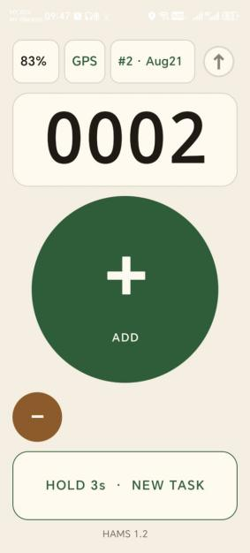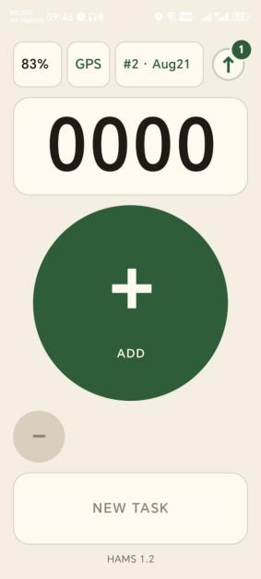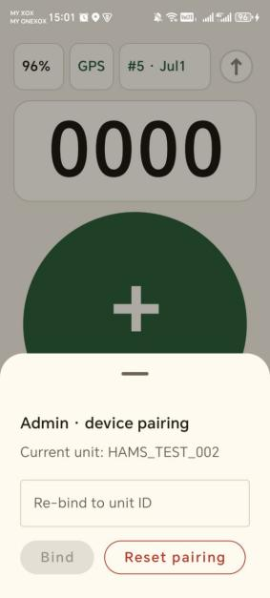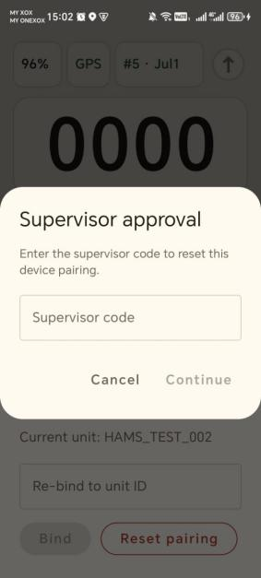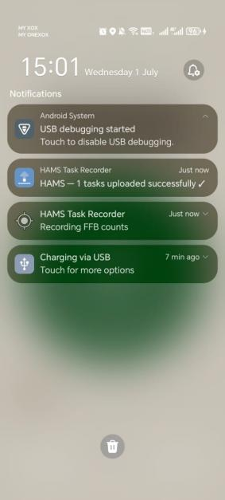

Visual reference: Leong Kah Choon (kc.leong@klk.com.my) is the contact for approved UI screenshots/reference. Woo Ying Hui will incorporate approved visual material into this report.

3.2 Daily use
- Open HAMS and confirm that the device is paired.
- Confirm GPS is ready before counting.
- Press + for each count and confirm the displayed net count.
- Use − only for a genuine correction.
- Use New Task only after completing the prior task.
- Use normal app controls to check delivery; do not uninstall the app to resolve a push issue.
State | Required response
GPS ready | Counting is permitted.
GPS unavailable/stale | Wait, move to an open area, or check location settings.
Push in progress | Wait; do not repeat the push.
Push failed | Keep the app installed, check network, and escalate if persistent.
Unpaired/released | Stop delivery and contact the office administrator.

4. Data delivery, pairing, and release safety
HAMS stores records locally before delivery. Current app configuration permits delivery on any connected network, including metered cellular data. [TO CONFIRM] that this remains the production policy.
Delivery control | Current value
Task-event batch size | 10
Maximum retry attempts | 5
Manual push timeout | 30 minutes
Release delivery budget | 15 seconds
Terminal-record retention | 30 days

4.1 Pairing and verification
An office administrator enters the approved unit ID and a valid OTP. The company pairing identifier convention is OC<NUM>_H_<SERIAL_NUMBER>; H identifies a phone and <SERIAL_NUMBER> is the phone’s original manufacturer serial number. Example: OC154_H_001. This is a company naming convention, not a format enforced by the Android app. The app uses the Android device fingerprint to claim/verify the binding and checks it at launch, before delivery, and periodically.
Binding result | App response
Bound | Continues normal operation.
Released | Performs safe release handling and returns unpaired.
Bound to another device | Stops unsafe delivery and returns unpaired.
Unit not found | Keeps local state conservatively; escalate to administrator.

4.2 Release and replacement
- Release through the protected administrator control using a valid OTP.
- The app verifies that it still owns the unit.
- It attempts bounded delivery while it remains bound.
- It releases the unit through the configured backend.
- Any remaining queued task rows are marked stranded (pushed = 2) and cannot upload under a later unit.
⚠ Never pair a replacement phone to the same unit while the old phone may contain unsent work.

4.3 Pairing and release: precautions and fallback
This section tells the person holding the phone what to do when pairing or release does not go as expected. In the tables below, the highlighted cell is the action to take.
Before pairing
- Take the unit ID from the office register. Do not guess it or type it from memory. The convention is OC<NUM>_H_<SERIAL_NUMBER>; a wrong ID either fails outright or binds the phone to the wrong unit.
- Confirm the phone has a working network connection. Pairing needs one. GPS is not required until counting starts.
- Pair one phone to one unit at a time, and record the pairing in the operational register.
If pairing does not succeed
Message on the phone | What it means | What to do
Unknown unit ID. Check and retry. | The unit is not in the office register. | Re-check the ID against the register. If it is correct, ask the office to confirm the unit was seeded.
This device is already bound to another unit. | This phone already owns a different unit. | Release that unit first, then pair to the new one.
That unit is bound to another device. | A different phone owns the unit. | Stop. Do not retry. The office must release the unit before this phone can take it.
This unit is finishing release from another device. | The previous phone is still inside its protected delivery window. | Wait a few minutes, then retry. The wait protects counts still being sent.
Supervisor code rejected. Check and retry. | The code is wrong, expired, or already used. | Request a fresh code. A code lasts 10 minutes and works once only.
Supervisor code is not configured. | The office code service is not set up. | Contact the office administrator. Nothing can be fixed on the phone.
No connection. Connect and retry. | The phone cannot reach the office service. | Restore the network and retry. Nothing is lost by retrying.

Before releasing or handing back a phone
- Deliver pending counts first, and confirm the push completed.
- Only then use the protected administrator release control with a valid supervisor code.
- Never uninstall the app to fix a delivery problem. Uninstalling destroys counts that have not been sent, and skips the safe release sequence entirely.

Fallback when a phone is reset, lost, or damaged
A factory reset changes the phone's Android identity. The rebuilt phone can no longer prove it owned the unit, so it cannot release the unit itself and cannot simply pair to it again. The office must force-release the unit first. The same unit ID can then be paired to the rebuilt or replacement phone, keeping its identity and its history.
Scenario | What has happened | Correct response
Phone works and is being reassigned | Normal case. The app can still prove it owns the unit. | Release from the app with a supervisor code. Pending counts are delivered first.
Phone was reset without releasing | The register still shows the unit claimed by an identity that no longer exists. | Ask the office to force-release the unit, then pair the same unit ID again.
Phone lost, stolen, or dead | The unit stays claimed and no phone is able to release it. | Ask the office to force-release the unit, then pair the replacement phone.
App unexpectedly returns to the pairing screen | The unit was released or reassigned somewhere else. | Stop counting. Do not pair again. Ask the office to check the unit assignment first.

⚠ Counts still unsent on a phone that is reset, lost, or damaged are permanently lost. Only a release performed from a working phone delivers pending work first.

⚠ Do not force-release a unit while the old phone may still be working and holding unsent counts. That phone will stop delivering, and the work it holds is stranded.

5. Technical and backend reference

5.1 Local mobile database
Record | Purpose
tasks | Task lifecycle, plus/minus/net counts, task date, and push status.
events | Count, heartbeat, and local audit records with per-row delivery state.
diagnostics | Device/provisioning telemetry and stranded-work metadata.

5.2 Wialon IPS
- The app logs in with #L#<unique_id>;NA and sends complete #D# data frames.
- Coordinates are converted to IPS DDMM.MMMM / DDDMM.MMMM format.
- Task-frame parameters are ffb_cut, battery, event_code, and work_count.
- ffb_cut=1 only for the plus/cut event code 179.

5.3 n8n and PostgreSQL backend
The company n8n server is the operational source of truth; repository workflow JSON files are sanitized recovery/reference snapshots.
n8n workflow | Role
Seed | Create/refresh unit registry records.
Device OTP | Issue office OTP.
Manual Claim | Pair a phone to a unit.
Verify | Check current phone-to-unit ownership.
Release | Release verified owner binding.
Admin Release | Office force-release for lost/reassigned phone.
List Units | Read-only registry view.

PostgreSQL item | Purpose
G_PM_IT_IOT_HAMS_UNITS | Current Wialon unit assignment, device fingerprint, app version, and release-drain state.
G_PM_IT_IOT_HAMS_ADMIN_OTP | Short-lived, single-use office OTPs.
Routines | Unit seeding, OTP issue/consume, manual claim, release, binding check, and admin release.

PostgreSQL is the provisioning registry, not the Android app’s harvest-event store. Database changes require DB-owner approval, backup, tested rollback, and a change record.

6. Credentials, support, and change control

6.1 Sensitive data and credentials register
This is the single reference section for sensitive data. Record only the item, owner, approved storage, and rotation/recovery rule here; never place an actual value in the report, Git, screenshots, tickets, or unrestricted chat.
Sensitive item | Owner / approved storage / rule
IPS host/port and provisioning URLs | Secure Android build configuration; never commit real values.
HAMS_CLAIM_SECRET | Secret owner; secure Android build configuration and matching n8n credential. It is compiled into the app, so it is not server-only.
WIALON_TOKEN | Company secret vault/admin tooling only; never include in the APK.
PostgreSQL/n8n connection credentials | Company secret vault or n8n Credentials; never store in SQL scripts or the report.
SMTP/email credentials | Company n8n Credentials; used for the OTP delivery process.
Office OTP | Short-lived, single-use n8n/PostgreSQL process; send to Leong Kah Choon (kc.leong@klk.com.my), never return it to the phone.
Release keystore and passwords | Secure keystore storage; changing the signing key requires controlled re-pairing.
Unit IDs and device fingerprints | Restricted operational register; do not expose in screenshots or open documents.

6.2 Support record
When escalating an issue, record handset asset ID, app version, unit ID, time/timezone, GPS/network state, current count, and the visible outcome. Remove confidential details from any screenshot before sharing.

6.3 Controlled changes
- Update application code, configuration, and this document together when behaviour changes.
- Back up and approve n8n/PostgreSQL changes before production deployment.
- Roll out new APK versions in controlled batches and record the validation outcome.

Appendix A. Wialon task and reporting events
These are task-path messages sent to Wialon. They are operational/reporting events, not diagnostics.
Code | Wialon task meaning | Delivery rule
179 | Plus/cut | Queued task event; ffb_cut=1.
180 | Productive minus/correction | Queued only when post-action count is above zero.
35 | Heartbeat | Queued task event; ffb_cut=0.

Appendix B. Wialon diagnostic telemetry codes
These codes use the separate diagnostics telemetry path. They are for operational visibility, not task-count reporting.
Code | Wialon diagnostic meaning
24 / 25 | GPS lost / GPS recovery
26 / 27 | Screen off / Screen on
29 / 40 | Device boot / Device shutdown
41 / 42 | Stop moving / Start moving
43 / 44 | Power connected / Power disconnected
301 | Binding released
302 | Work stranded; may include lost_cuts
303 / 304 | Device bound / Device unbound

Appendix C. APK internal/local codes
Code | APK meaning | Delivery rule
281 | New task | Local-only.
283 / 284 | Auto-save on kill / pre-push auto-save | Local-only.
291 / 292 | Battery warning / critical edge | Local-only.
293 | GPS degraded | Local-only.

Appendix D. PostgreSQL Data Dictionary
This database supports unit provisioning, OTP control, binding verification, and release. It is not the Android harvest-event store.
Metadata | Value
Engine | PostgreSQL
Tables | 2
Business routines | 8
Routine response | JSONB status objects
SQL reference | docs/operations/database-reference/hams_setup.sql

D.1 Unit registry: G_PM_IT_IOT_HAMS_UNITS
Column | Type | Default / constraint | Meaning
unique_id | TEXT | Primary key | Wialon IPS unit identity.
name | TEXT | Nullable | Human-readable unit label.
claimed | BOOLEAN | false | Whether a phone currently owns the unit.
device_fingerprint | TEXT | Unique; nullable | Paired Android identity; sensitive operational data.
status | TEXT | active | Unit lifecycle: active or retired.
last_seen | TIMESTAMPTZ | Nullable | Latest successful binding verification.
app_version | TEXT | Nullable | App version reported by the paired handset.
created_at | TIMESTAMPTZ | now() | Unit seed creation time.
updated_at | TIMESTAMPTZ | Set by routines | Latest unit-record mutation.
drain_until | TIMESTAMPTZ | Nullable | End of protected post-release delivery window.
drain_fingerprint | TEXT | Nullable | Fingerprint allowed to deliver during that window.

D.2 Office OTP table: G_PM_IT_IOT_HAMS_ADMIN_OTP
Column | Type | Rule | Meaning
code | TEXT | Primary key | Six-digit OTP; sensitive while valid.
created_at | TIMESTAMPTZ | now() | OTP issue time.
expires_at | TIMESTAMPTZ | Required | Hard expiry; default issue lifetime is 10 minutes.
used_at | TIMESTAMPTZ | Nullable | Consumption time; NULL means unused.

D.3 Routines
Routine | Purpose
seed_unit | Insert a unit or refresh its label without changing a live binding.
issue_otp | Purge expired OTPs and issue a six-digit OTP.
otp_is_valid | Check OTP validity without consuming it.
consume_otp | Atomically consume a valid OTP.
manual_claim | Bind a phone to a unit after ownership, OTP, and drain checks.
release_unit | Release a unit only for its proven owner.
check_binding | Return binding state and refresh owner activity/version when bound.
admin_release | Office force-release for lost, dead, or reassigned handset.

D.4 App-facing status values
Status | Typical HTTP | Meaning
ok | 200 | Requested action succeeded.
bad_request | 400 | Missing or blank input.
admin_auth_failed | 401 | OTP invalid, expired, or used.
not_found | 404 | Unit absent from registry.
already_bound | 409 | Unit belongs to another phone.
fingerprint_in_use | 409 | Phone owns another active unit.
not_owner_or_not_found | 409 | Release attempted by a non-owner.
draining | 409 | Former owner is within delivery-drain window.
bound | 200 | Requesting phone owns the unit.
released | 200 | Unit was released.
bound_other | 200 | Unit is owned by another phone.

⚠ Do not run hams_setup.sql during routine diagnosis. Production database changes require DB-owner approval, backup, tested rollback, and a recorded change.

