P R O D U C T I O N A U D I T - P H A S E 0
QuantEdge Pro
Production Audit and Target Architecture - Unified AI Market Intelligence + Trading Terminal
Audited deployment: https://c1eek7j3be20-d.space-z.ai
Audit date: September 2, 2026
Method: live endpoint probes - bundle analysis - UI walkthrough
Mandate: Master Upgrade Prompt, Sections 62 and 71 (audit before build)

Prepared by the QuantEdge Pro Architecture Desk Confidential - Internal Working Document

Table of Contents

Executive Summary 1
Audit Scope, Method, and Evidence 2
Part I - Production Audit (Items 1-24) 2
1. What Already Works 2
2. What Is Simulated 3
3. What Is Fake or Hard-Coded 4
4. What Is Broken 4
5. Security Vulnerabilities 4
6. Architecture Problems 5
7. Database Problems 5
8. API and Provider Problems 6
9. Analytics Gaps 6
10. SENTINEL Gaps 6
11. News and Catalyst Gaps 7
12. Crypto Gaps 7
13. Trading and Execution Gaps 8
14. Backtesting Gaps 8
15. Notification Gaps 8
16. Mobile Gaps 9
17. UX and UI Problems 9
18. SaaS and Account Gaps 10
19. Scaling Problems 10
20. Cost Problems 11
21. Free Alternatives 11
22. What Should Be Preserved 11
23. What Should Be Refactored 13
24. What Should Be Replaced 13
Part II - Recommended Final Architecture (Item 25, Artifacts A-J) 13
A. System Architecture 14
B. Database and Data Model 14
C. Provider Architecture 15
D. Analytics Architecture 15
E. SENTINEL Architecture 16
F. Notification Architecture 16
G. Security Architecture 17
H. Mobile Architecture 17
I. SaaS Architecture 17
J. Cost Model 18
Part III - Implementation Sequence and Readiness (Items 26-29) 18
26. Exact Implementation Sequence 18
27. Testing Strategy 19
28. Launch Readiness Checklist 20
29. Marketing-Site Readiness 20
Part IV - Decisions Required Before Implementation 21

Note: This Table of Contents is generated via field codes. To ensure page number accuracy after editing, please right-click the TOC and select "Update Field."

Executive Summary
QuantEdge Pro, as deployed at the audited URL, is a polished and unusually honest single-user day-trading paper terminal. It already delivers most of the surface experience the Master Upgrade Prompt asks for: a five-screen unified product (Dashboard, Charts & Signals, Universe, AI Bot, Manual), live United States equity data proxied server-side through Yahoo Finance, an AI desk briefing and per-symbol analysis generated by a real server-side language model, a seven-factor signal engine with visible factor contributions and ATR-based trade plans, and a permission-gated SENTINEL bot that ships switched off in SIGNAL_ONLY mode behind a deterministic risk governor (1% risk per trade, five concurrent positions, a 3% daily-loss circuit breaker, a 0.60 minimum confidence, and 600-second approval expiry - all verified directly from the bot configuration API).
The verdict of this audit is nonetheless clear: the product is not production-ready as a multi-user service, and it is not safe to charge money for in its current state. Three classes of blockers were verified during the audit. First, security: the application has no authentication whatsoever, and mutation endpoints respond to unauthenticated requests - during the audit, a forged POST to the bot tick endpoint successfully ran the trading engine, and a forged POST to the trade action endpoint was processed by business logic rather than rejected. Second, state model: the paper account, bot configuration, trades, and signals live in a single global record shared by every visitor, so any two people using the site at the same time are trading the same book. Third, missing subsystems: there is no news or catalyst engine, no notifications, no backtesting, no strategy lab, no billing, no admin console, and no per-user risk profiles.
At the same time, the audit strongly confirms the instruction to refactor rather than rebuild (Section 61). The two-brain philosophy, the permission-gated bot, the observe-by-default stance, the factor-transparency of the signal engine, the session playbook, the Reality Check marketing section, and the restrained dark terminal design language are all precisely the identity the upgrade prompt demands, and approximately two thirds of the existing implementation survives into the target architecture through wrapping, hardening, and extraction rather than replacement. The recommended path is an eleven-phase program (Phase 0 through Phase 10) on a zero-cost-first stack: managed PostgreSQL on a free tier, a free-tier news provider integrated behind a cost gate, free web push and email infrastructure, and AI usage metering with a bring-your-own-key option. Eight material decisions - including multi-user timing, news provider budget, and subscription model - are isolated in Part IV and require your confirmation before Phase 1 begins.

Audit Scope, Method, and Evidence
This audit was performed as a black-box engagement against the live deployment, because the current sandbox does not contain the application source code. Four evidence streams were collected on September 2, 2026, between 15:41 and 16:00 UTC: (1) direct probing of ten backend API endpoints with curated requests, including two deliberate unauthenticated mutation attempts; (2) static analysis of the seven largest served JavaScript bundles (approximately 1.17 MB combined) to enumerate API surface, storage usage, and external dependencies; (3) a full walkthrough of the five product screens captured as reference screenshots; and (4) a complete extraction and review of the marketing site copy.
Throughout this report, statements are tagged by confidence. Verified means reproduced first-hand during the audit (for example, an API response or a server behavior). Per UI means observed in screenshots or on-page copy. Inferred means an architectural judgment from observed behavior that source inspection should later confirm. This convention matters because Section 61 of the mandate requires the audit to distinguish what already works from what is assumed, and because the Phase 1 team should re-verify every inferred item against the source before touching it.
Scope boundary: performance profiling under load, dependency vulnerability scanning, and a line-by-line source review were out of reach for a black-box pass and are scheduled as Phase 1 entry tasks. Nothing in this report should be read as certifying code quality beyond observed behavior.

Part I - Production Audit (Items 1-24)
This part follows the 29-item structure mandated by Section 71 of the upgrade prompt, in the exact order given. Items 1 through 4 establish the true state of the current system; items 5 through 8 cover security, architecture, database, and provider weaknesses; items 9 through 20 map functional and business gaps against the target specification; item 21 maps free alternatives; and items 22 through 24 give the preserve, refactor, and replace verdicts that feed the Phase plan in Part III.

1. What Already Works
The strongest finding of this audit is that the core product concept is already standing. The five screens form one coherent product rather than stitched-together tools: the Dashboard carries the AI desk briefing with regime, focus list, and avoid list; Charts & Signals renders candlesticks with EMA 9/21/50, VWAP, and Bollinger overlays plus a signal panel that shows the full factor breakdown (at audit time on NVDA: RSI(14) 79.5, MACD histogram -0.049, Bollinger position 79%, relative volume 0.37x, ROC 1.13%) alongside an ATR-based plan with entry, stop, target, and a 1.47 R:R; Universe lists 130+ tickers across all eleven GICS sectors with sparklines and a six-item watchlist; the AI Bot screen exposes the three autonomy modes and the risk governor sliders; and the Manual is a genuine in-app handbook with a downloadable PDF.
The bot's safety posture is verified, not just claimed. The configuration API returns a bot that is disabled by default in SIGNAL_ONLY mode with a 1% risk per trade, a five-position cap, a 3% daily-loss circuit breaker with day-key tracking, a 0.60 minimum confidence, a 600-second pending-approval expiry, and a halted-reason field. The session intelligence endpoint grades intraday windows (opening range PRIME, lunch CAUTION) and the AI briefing composes a regime call with focus and avoid lists from live index, sector, and volatility data. Footer disclaimers correctly identify Yahoo Finance delayed data and paper-only trading.
- Verified: permission-gated bot, off by default, with deterministic hard limits (per /api/bot/config).
- Verified: 7-factor signal engine with per-factor contribution bars and ATR trade plan (per Charts & Signals screen).
- Per UI: coherent one-product experience across five screens; honest Reality Check section on the landing page.
- Verified: server-side data proxying - no provider keys or secrets are exposed to any client bundle.

2. What Is Simulated
Everything monetary in the product is paper, and that is by design, but the simulation itself is currently too perfect to be honest. The internal paper engine fills orders at the observed price with no evidence of slippage, spread crossing, latency, partial fills, or rejected orders - the exact failure modes Section 20 of the mandate requires modeled. A stop or target that would in reality trigger on a gap fill at a very different price here fills as if the market waited for the engine. This matters beyond realism: signal outcome statistics produced by ideal fills will flatter the engine, and users who later connect Alpaca Paper will experience worse results than the internal engine trained them to expect.
The $100,000 paper equity is simulated capital, which is correct and clearly disclosed. What is missing is the labeling discipline of Section 20: there is currently one execution engine, so nothing needs to distinguish QuantEdge Simulated from Alpaca Paper yet, but the moment the second provider lands the UI, notification copy, and trade log must carry explicit engine labels. Finally, the AI briefing and analysis simulate an analyst's judgment; that is legitimate AI output on real data, but as item 3 records, the grounding of that judgment needs work.

3. What Is Fake or Hard-Coded
No fabricated market data was found: quotes, candles, movers, and sparklines all trace to the server-side Yahoo Finance proxy, and the audit found no client-side number generation. This is an important positive finding given mandate rule 69-7 (never fabricate market data). The fakes that do exist are of a second kind - hard-coded product constants and one instance of AI narrative drift.
The verified AI grounding failure: during the audit, the briefing endpoint described NVDA as breaking $420 resistance while NVDA was trading at $227.24 with a session high of $227.88. The model composed a plausible-sounding level that no supplied data supported, which is precisely the failure mode Section 55 (fail safely, never invent) targets at the narrative layer. The fix is mechanical - every AI-generated level must be grounded in values passed to the prompt, with a data timestamp cited - and it is scheduled in Phase 2. Hard-coded items include the default 24-symbol watchlist, the static 130+ ticker universe list, the fixed session-window schedule, and the single global bot configuration record whose consequences item 4 details.

4. What Is Broken
The multi-user state model is not merely missing, it is actively wrong. The bot configuration endpoint returns an id of singleton, and every visitor observes and drives the same paper book. Two consequences follow immediately. First, if any visitor enables the bot, it trades the shared account for everyone; the audit deliberately did not do this on the live deployment, but the tick endpoint confirmed the engine responds to any visitor. Second, concurrent configuration changes race with last-write-wins semantics, and there is no identity to attribute any change to.
Beyond the state model, the audit verified that a client can force the trading engine to run (POST /api/bot/tick?force=1 returned ran: true), which means bot execution is partially client-driven rather than owned by a server-side scheduler - an availability and integrity hazard detailed in item 6. Smaller verified defects: the briefing narrative can drift from quote data (item 3); the watchlist lives only in localStorage so it does not follow a user across devices; and HEAD requests to API routes return 403 from the serving platform, which will confuse any uptime monitor pointed at API endpoints rather than the root page.

5. Security Vulnerabilities
Security is the audit's most serious chapter. Because the product was built as a no-signup demo, it ships with no authentication, no sessions, no CSRF protection, and no rate limiting - and its mutation endpoints are reachable by anyone on the internet. The table below lists findings verified during the audit, ordered by severity. None of these is theoretical: each was reproduced or directly observed against the live deployment.
Table 1: Security findings (verified against the live deployment)
# | Finding | Severity | Evidence | Required fix (phase)
S1 | No authentication on any endpoint; no auth routes, sessions, or cookies exist | CRITICAL | Probes to /api/auth, /api/session, /api/login, /api/user returned 404; no Set-Cookie on any response | Auth + sessions (Phase 1, §33)
S2 | Unauthenticated mutation: bot engine ran on a forged request | CRITICAL | POST /api/bot/tick?force=1 returned ran:true with HTTP 200 | Auth middleware on all mutations (Phase 1)
S3 | Unauthenticated mutation: trade action endpoint processes attacker input | CRITICAL | POST /api/trades/action with fabricated payload reached business logic (409, order-state message) | Auth + ownership checks (Phase 1)
S4 | Global shared financial state: one paper book for all visitors | CRITICAL | Bot config id = singleton; identical state returned to all clients | Per-user rows and scoping (Phase 1, §32)
S5 | No CSRF protection on state-changing endpoints | HIGH | Cross-site POSTs accepted with JSON bodies, no token checks | CSRF tokens / SameSite+Origin checks (Phase 1)
S6 | No rate limiting observed on API endpoints | HIGH | Repeated probe calls unthrottled | Per-IP and per-user throttles (Phase 1/7)
S7 | No audit trail: actions cannot be attributed to an actor | HIGH | No identity exists; no audit event store found | Immutable AuditEvent log (Phase 7, §45)
S8 | No input validation evidence on mutation parameters | MEDIUM | Arbitrary force and action values accepted by endpoints | Schema validation on every route (Phase 1)
S9 | Secrets exposure | OK | No provider keys in any served bundle; data proxied server-side | Preserve pattern; add BYOK encryption (Phase 6, §30)
The positive finding deserves emphasis: the server-side proxy pattern means broker and provider secrets never appear in frontend code, which is the pattern Section 46 demands and which many early-stage products get wrong. The critical findings S1 through S4 are expected for a demo and are fully repairable in Phase 1 without discarding any product code; they are, however, absolute blockers for charging money, and the audit recommends they be treated as the first work items of the entire program.

6. Architecture Problems
The application is a well-organized Next.js monolith with route handlers, which is the right skeleton; the architectural debts are what the monolith does not yet contain. There is no provider abstraction: the Yahoo Finance and GLM integrations are wired directly into route handlers, so no interface exists behind which a fallback market feed, a news provider, or a second AI vendor could appear (Section 28 requires eight such interfaces). There is no event bus and no shared computation layer: every client independently polls market endpoints on a roughly 25-second cadence, so request volume scales linearly with audience instead of with market activity - the exact anti-pattern Section 27 calls out for one thousand users watching one ticker.
Execution architecture has two specific hazards. Bot ticks can be forced by any client (verified, item 4), meaning the trading loop is partly driven from the browser rather than owned by a server-side worker; in a multi-instance deployment this both duplicates and starves ticks. And there are no idempotency keys on order or approval submission, so a retried request can double-fire - Section 59 makes idempotency non-negotiable before any second execution provider arrives. Finally, analytics are computed per request with no memoization evidence: each chart poll recomputes indicator series that a per-symbol, per-range cache could serve to all watchers.

7. Database Problems
The deployment environment configures a SQLite file database through a DATABASE_URL of the form file:custom.db, and nothing observed contradicts that this is the authoritative store. SQLite is an excellent development database and the audit does not recommend ripping it out mid-Phase-0; but it is single-writer, has no row-level security, and cannot serve concurrent multi-tenant traffic, so migration to managed PostgreSQL is a Phase 1 precondition for any multi-user work (Section 49 evaluates free-tier candidates; the recommendation is in Part IV).
The deeper problem is schema shape. Bot state, configuration, trades, and signals are persisted as opaque JSON blobs attached to a single record, rather than the normalized entity set Section 32 enumerates (users, subscriptions, entitlements, strategies, strategy versions, signals, signal factors, positions, orders, fills, risk profiles, broker connections, notifications, preferences, catalysts, regimes, backtests, usage events, audit events, system events). Blobs cannot be scoped per user, indexed for queries, or hash-chained for audit; every one of them must be decomposed into typed tables with a userId column before the first entitlement check is written. localStorage currently holds only the watchlist (capped at 30 items, verified in the bundle), which is acceptable as a cache but not as authority - Section 34 draws exactly this line.

8. API and Provider Problems
The API surface is small, coherent, and entirely public. The table below lists every endpoint discovered in bundle analysis, all of which the audit then probed live. The surface itself is a good specification of the domain; the problems are authentication (item 5), contract hygiene, and provider risk.
Table 2: Verified API surface (all endpoints publicly reachable at audit time)
Endpoint | Verified behavior
GET /api/market/status | Session state, ET clock, and the day's trading windows graded PRIME / GOOD / CAUTION with guidance notes
GET /api/market/quote?symbols= | Batch quotes with price, change, and a 30-point sparkline; errors cleanly when the parameter is missing
GET /api/market/chart?symbol=&range= | Candles plus metadata (exchange, 52-week range, volume) for the chart workspace
GET /api/market/movers | Gainers and losers with sparklines; embeds the session payload
GET /api/ai/briefing | AI desk note: regime, headline, narrative, focus list, avoid list, session guidance, risk notes
GET /api/ai/analysis?symbol= | Per-symbol AI thesis with bias, headline, and key levels
GET /api/bot/state | Bot configuration, trades, pending approvals, signals, equity curve, performance
GET /api/bot/config | Singleton bot configuration record (id: singleton)
POST /api/bot/tick?force=1 | Runs the trading engine; returned ran:true to an unauthenticated caller
POST /api/trades/action | Approve/reject processing; processed an unauthenticated fabricated payload
Provider risk concentrates on Yahoo Finance. The v8 endpoints consumed are unofficial: there is no service-level agreement, the terms of service are ambiguous for commercial reuse, rate limits are undocumented, and the data is delayed - a fact the site discloses only in its footer while the hero claims real-time (item 17 and Section 50's addendum). No provider health tracking, staleness flags, or failover path exists; the Section 42/43 duty to surface LIVE, DELAYED, STALE, and UNAVAILABLE states is unmet. The AI provider is similarly single-threaded onto one vendor with no metering and no bring-your-own-key path. Error responses are inconsistent (some routes return error objects, others ok:false), which complicates the friendly-error layer Section 42 requires.

9. Analytics Gaps
The signal engine is genuinely multi-factor and transparent, but analytics around it are thin. Portfolio intelligence (Section 15) is absent: there is no asset-allocation view, no sector or long/short exposure breakdown, no concentration warning for overlapping positions, no correlation matrix, no portfolio volatility or drawdown series, and no scenario analysis. The regime engine exists and demonstrably labels the briefing RISK_ON or RISK_OFF, but it publishes a state without the explanation Section 13 requires (why is this regime active?), and its vocabulary - risk-on, risk-off, mixed - does not yet include the volatility, momentum, mean-reversion, event-driven, and liquidity-stress states the mandate lists.
Factor coverage also lags the target list. ATR is used for stop construction but not surfaced as a scored contribution; liquidity, spread, relative strength, and portfolio-context factors (exposure and correlation) are absent from the factor set entirely. Signal performance tracking (Section 24) has the right seed - trades and a win-rate field exist - but there is no signal-level outcome ledger recording every generated signal with entry, stop, target, realized R-multiple, regime, and catalyst, which is what allows the product to measure whether its own engine is useful and to refuse cherry-picking. Finally, no beginner/advanced presentation split exists (Section 54): every user currently sees the full professional density.

10. SENTINEL Gaps
The mode architecture matches the spec's intent closely - SIGNAL_ONLY, SEMI-AUTO, and FULL AUTO map cleanly onto Observe, Approve, and Delegate - and the hard-limit sliders (risk per trade, max positions, daily-loss breaker, minimum confidence) are the right vocabulary. The gaps are in enforcement completeness and per-user binding. The approval flow has an expiry (600 seconds, configurable 30 to 600), but there is no evidence approvals are single-use tokens bound to one user and one trade; Section 16 requires user-specific, trade-specific, single-use, time-limited, audited approvals, and three of those five properties are unverifiable in the current singleton world.
Missing risk controls relative to Sections 4 and 16 include: a weekly loss cap, a maximum daily trades count, a correlated-exposure cap, minimum liquidity and spread requirements, volatility restrictions, and news/event restrictions (for example, blocking entries minutes before earnings). The safety-state machine of Section 17 is represented only by a haltedReason field; states such as WAITING_FOR_APPROVAL, RISK_LOCKED, BROKER_DISCONNECTED, DATA_UNAVAILABLE, NEWS_PROVIDER_UNAVAILABLE, and SYSTEM_DEGRADED need to exist as first-class, UI-explained states. And the emergency stop of Section 18 does not exist as a dedicated, always-visible control with cancel-pending semantics - the current enable/disable toggle is a mode switch, not a kill switch.

11. News and Catalyst Gaps
There is no news ingestion of any kind. No news provider is called, no catalyst entity exists, and the briefing's narratives are composed from price, volume, and sector data alone. This produces exactly the failure the mandate anticipated: the avoid list justified MDB with an earnings-disappointment narrative and NVDA with an AI-optimism narrative, but no headline, source, URL, or timestamp supports either claim - the model inferred stories from price action. Section 11 requires every catalyst to carry headline, source, timestamp, URL, category, sentiment, relevance, strength, and affected tickers, and forbids both fabrication and the display of No news unless absence was actually verified.
The cost warning in Section 11's addendum also applies in full: a news feed is the first feature on the roadmap with real recurring per-request cost, so the provider must be priced against free-tier limits at 100, 1,000, and 10,000 users before any UI is built. The audit's recommendation (detailed in item 21 and Part IV) is a free-tier-first integration behind the NewsProvider interface with server-side caching and deduplication, deferring paid feeds until users demonstrate the value.

12. Crypto Gaps
Crypto is entirely absent: the universe is equities and ETFs (including leveraged ETFs such as SOXL and TQQQ), the session model assumes an equity clock, and no 24/7 market handling exists anywhere in the observed behavior. This is acceptable for now - crypto was consciously deferred - but the audit flags the Section 4 addendum requirement early because it is architectural, not cosmetic: when crypto returns, SENTINEL's risk engine must apply asset-class-specific volatility bands, position sizing, ATR-termed stop distances, and daily-loss circuit breakers rather than reusing equity-calibrated defaults. A 24/7 market with higher realized volatility will otherwise either trip equity-tuned breakers constantly or, worse, undersize the controls relative to how fast crypto moves.
The practical consequences for the data model are worth stating now so Phase 1 does not paint the corner: SymbolMeta needs an assetClass field, the regime engine needs per-asset-class regimes, the session scheduler needs an always-open market mode, and the risk gate needs a calibration table keyed by asset class. None of this is expensive to include in the Phase 1 schema; all of it is annoying to retrofit after equity assumptions harden.

13. Trading and Execution Gaps
Execution is currently one internal paper engine behind ad-hoc endpoints, with no ExecutionProvider interface. The Section 19 abstraction - QuantEdgePaperProvider beside AlpacaPaperProvider, with an eye toward a future live provider - does not exist, and Alpaca integration is absent. Fill realism is the second cluster (item 2): slippage, spread, latency, partial fills, rejections, and gap behavior are all unmodeled. Third, order plumbing lacks the durability the mandate demands: no idempotency keys (Section 59), no explicit order lifecycle states (pending, partial, filled, cancelled, rejected), and no broker-connection health tracking that could drive a BROKER_DISCONNECTED safety state.
The approval-to-execution path exists in skeleton (pending approvals with expiry, approve/reject actions) but needs the Section 16 hardening: single-use tokens, user binding, audited decisions, and expiry that logs rather than executes. Finally, the Section 19 addendum instruction to design for a live-money future without building one should be honored explicitly: the ExecutionProvider interface and user-facing copy should be worded so a live broker could slot in later, while the audit records here - as the addendum requires - that enabling real-money execution would introduce broker-dealer, pattern-day-trader, and KYC obligations that paper trading does not carry, so that decision gets made deliberately.

14. Backtesting Gaps
There is no backtesting engine, no walk-forward validation, and no Strategy Lab. The bot's trade log is a forward paper record, not a backtest, and the audit found no historical simulation code path in the bundle. Section 21's metric suite (total return, CAGR, maximum drawdown, Sharpe, Sortino, win rate, average win and loss, largest win and loss, profit factor, expectancy, trade count, exposure, and benchmark comparison) and its bias controls (look-ahead, future-data leakage, survivorship bias, unrealistic fills) are therefore greenfield work, scheduled in Phase 3.
Two design notes from the audit are worth carrying into Phase 3. First, the signal engine already persists factor-level context; a backtest that replays the same factor computations over historical candles shares code with live scoring, which prevents the two engines from drifting apart. Second, the fill model built for realistic paper execution (item 13) must be the same fill model used inside the backtester, or paper results and backtest results will disagree in ways users will eventually notice. Walk-forward support (Section 22) should be designed in from the start - train and out-of-sample windows with an explicit explanation when out-of-sample performance diverges - rather than bolted on after a single-period backtester exists.

15. Notification Gaps
Notifications do not exist in any channel: no web push, no email, no mobile push, no in-app notification center, no preference management, no quiet hours, and no delivery state tracking. The event sources the mandate lists in Section 25 - new signals, high-confidence opportunities, approval requests, executions, stops and targets, risk limits, broker disconnection, major catalysts, system degradation, and security events - all already originate inside the bot and analytics logic, so the work is transport and preference machinery, not new intelligence.
The sequencing addendum to Section 25 is binding: web push and email ship first because they are deliverable from the current web app, and mobile push activates only once Phase 9 produces installable shells - a web-only build cannot deliver native push to a phone with no app. The delivery state machine (queued, sent, delivered, opened, failed, retry) and the honesty rule that the system never pretends a notification was delivered both belong to Phase 5 alongside the notification center UI.

16. Mobile Gaps
The current UI is a desktop terminal that shrinks; the audit found no mobile-specific navigation pattern, no bottom tab bar of the Section 36 shape (Home, Markets, Signals, Portfolio, More), and no PWA manifest or service worker in the served assets. The approval flow - the single most important mobile interaction in the product - has not been designed for one-or-two-tap completion on a phone, and chart interactions (pinch zoom, crosshair dragging) are unverified on touch devices.
The recommendation, elaborated in artifact H, is responsive web plus PWA first: the same backend brain with a dedicated mobile layout, installable to a home screen, shipping in Phase 8/9; native or wrapped shells follow only when store presence is actually needed, at which point the Section 35 addendum's in-app-purchase requirements and the Section 25 push sequencing both activate. Designing the component library now with mobile breakpoints in mind costs little; retrofitting it after the desktop layout hardens costs a Phase.

17. UX and UI Problems
The design language is already close to the Section 37 target of a premium quantitative intelligence terminal: one dark theme, semantic green/red/amber usage, restrained motion, tabular figures, and product-native visuals (charts, factor bars, sparklines, regime chips) instead of robot mascots and stock photos. The audit's UX findings are therefore mostly about honesty surfaces and progressive disclosure rather than aesthetics.
- Real-time claim vs delayed reality (verified): the hero reads LIVE US EQUITIES with a REAL-TIME DATA badge while the only delay disclosure sits in the footer. Section 50's addendum requires moving the disclosure up before someone clicks through - it is both an honesty issue and a store-review risk.
- Comparative claim (per UI): TradingView-grade candlesticks names a third-party trademark in a superiority claim; rephrase to product-native language.
- No product screenshots on the landing page (per UI): the entire pitch is text. Section 37's addendum calls real screenshots and an example SENTINEL approval card the single highest-leverage fix for a product about to charge money.
- No onboarding (Section 8) and no contextual education (Section 10): the Manual is good but passive; the signal-confidence tap-to-explain pattern does not exist yet, and no beginner/advanced split (Section 54) hides complexity from novices.
- Failure storytelling (Sections 42-43) is unmet: technical error strings can surface, and there are no STALE DATA or provider-down banners that explain what happened, what the system is doing, and what the user should do.

18. SaaS and Account Gaps
Every SaaS primitive from Section 32 onward is absent: no users, no profiles, no authentication (item 5), no subscriptions or entitlements, no usage metering, no bring-your-own-key handling, no billing provider, no admin control center, no user settings area, and no terms, privacy, or refund pages. The bot configuration that should be a per-user document is a global singleton; the settings that exist (risk sliders, modes, watchlist) have no owner.
Two architectural decisions from the mandate must land before the first paid subscriber. First, billing and entitlements are separate concerns (Section 35): a Subscription row records what was purchased, while an EntitlementService decides what a user may do, checked server-side on every privileged action and never trusted from the frontend. Second, the billing provider abstraction must plan for both worlds from the start (Section 35's addendum): Stripe for the web now, StoreKit and Google Play Billing for native shells later, both feeding the same entitlement service - a Stripe checkout embedded in a native app is not a permitted path for digital subscriptions on either store. The full gap closure plan is artifact I.

19. Scaling Problems
The scaling model fails between 100 and 1,000 users for arithmetic reasons. Every client polls market endpoints on a roughly 25-second cadence; at 1,000 concurrent users that is on the order of 2,400 requests per minute against the API before any fan-out, and without a shared cache each request can cascade into upstream provider calls - the precise structure Section 27 forbids. Indicator computation repeats per request rather than per symbol, so CPU cost also scales with audience instead of with market breadth. The singleton bot row is a write contention point under any concurrency, and a multi-instance deployment would run duplicate trading loops unless tick ownership moves to a single server-side scheduler.
The fixes are established and scheduled: a per-symbol TTL cache with request coalescing in front of providers; memoized indicator series keyed by symbol and range; one event bus publishing market, signal, and system events to all subscribers; server-side scheduled ticks; and, later, WebSocket or server-sent-events fan-out so real-time updates replace polling. Section 56's 1 / 100 / 1,000 / 10,000-user review is built into the Phase 7 exit criteria, and the cost consequences appear in artifact J.

20. Cost Problems
Today's run-rate is effectively zero: the platform hosts the deployment, Yahoo Finance's unofficial endpoints are free, and the AI model rides the bundled SDK - genuinely aligned with the Section 29 zero-cost principle, and the audit found no paid service lurking in the stack. The problems are prospective. The news feed is the first real recurring cost and must be priced before its UI is committed (Section 11's addendum). AI usage is unmetered: no usage events are recorded, so there is no data to price tiers, no per-user attribution, and no bring-your-own-key escape valve (Sections 30-31). If marketing ever claims real-time data, licensed feeds move from free to one of the largest line items instantly.
The audit's cost discipline, applied throughout Part II and artifact J: every external service gets a free-tier-first candidate with hard limits verified, a BYOK variant where user activity drives variable cost, and a measured estimate at 100, 1,000, and 10,000 users before the feature ships. No feature enters a roadmap phase with an unpriced provider dependency.

21. Free Alternatives
The table below maps each required capability to a free-first option, its hard limits as publicly documented (to be re-verified before commit, per Section 65 - free never means unlimited), and the fallback or paid path if the free tier proves insufficient. Quantitative figures are planning estimates from public pricing pages as of the audit date and must be confirmed at implementation time.
Table 3: Free-first service map (verify limits before each Phase commit)
Need | Free-first choice | Hard limits (verify) | Fallback / escalation
Market data | Yahoo Finance (existing proxy) | Unofficial; undocumented rate limits; delayed | Stooq fallback; Polygon/BYOK if real-time is marketed
News / catalysts | Finnhub company news | About 60 requests/min on free tier (verify) | Marketaux free tier; paid Benzinga via BYOK
Database | Supabase or Neon PostgreSQL | About 0.5 GB / per-project free tiers (verify) | Paid tiers scale past 1,000 users; measure in artifact J
Web push | VAPID Web Push | Browser-quirk limited, effectively unlimited | None needed
Mobile push | FCM | Free with app shell (Phase 9) | APNs free with developer account
Email | Resend or Brevo | About 3,000/month or about 300/day (verify) | Second provider behind EmailProvider interface
AI | GLM via bundled SDK + BYOK | SDK quota; BYOK shifts cost to user | OpenAI-compatible adapter for user keys
Error tracking | Sentry free tier | About 5,000 errors/month (verify) | Self-hosted GlitchTip
Uptime | UptimeRobot free tier | 50 monitors / 5-min intervals | Healthchecks.io

22. What Should Be Preserved
Section 61's instruction to identify and keep good existing work yields a long list, and preserving it is the difference between an upgrade and an unnecessary rewrite. The product philosophy is already correct: one externally unified product, analytics as the primary brain, SENTINEL as the optional action layer, observe mode as the default, and automation that cannot bypass deterministic risk limits. The implementation artifacts worth carrying forward largely intact are the following.
- The five-screen information architecture and the dark terminal design language, including semantic colors and factor-transparency patterns.
- The 7-factor signal engine, its factor-contribution display, and the ATR-based trade plan construction.
- The session intelligence layer: ET session states, graded trading windows, and the daily playbook.
- The AI briefing and per-symbol analysis as product features (with the grounding fix from item 3).
- The server-side provider proxy pattern that keeps all secrets off the client.
- The honest marketing posture: the Reality Check section, the not-investment-advice framing, and the no-profit-claims discipline.
- The in-app Manual plus PDF, which becomes the seed of the Section 9 Help Center rather than a rewrite.

23. What Should Be Refactored
Refactor targets are components whose concept survives but whose implementation must change shape to serve multiple users safely. The bot and its state move from one global singleton record to per-user rows with authenticated, validated, ownership-checked routes. Authentication middleware wraps every mutation endpoint, with CSRF and rate limiting added at the same seam. The Yahoo and GLM integrations move behind the Section 28 provider interfaces so fallbacks, health checks, and BYOK variants can appear without touching call sites.
The analytics pipeline gains its shared-cache and coalescing layer so one provider request serves all watchers, and indicator computation is memoized per symbol and range. The AI briefing gains a grounding pass - every generated level must trace to data passed in the prompt, with timestamps. The tick loop moves from client-forceable HTTP to an owned server scheduler. Error responses converge on one envelope so the friendly-error layer can be systematic. The watchlist becomes server-authoritative with localStorage demoted to cache. None of these changes the product's face; all of them are prerequisites for the phases that follow.

24. What Should Be Replaced
Four replacements are justified rather than refactors. The SQLite file database is replaced by managed PostgreSQL in Phase 1 - not because SQLite is bad, but because per-user row scoping, concurrent writers, and managed backups are table stakes for a SaaS and free tiers of Supabase or Neon provide them at zero cost. The client-driven tick is replaced by a server-side scheduler with single-owner semantics. The hero's LIVE and REAL-TIME DATA claims are replaced by an accurate delayed-data badge surfaced before the click-through, per Section 50's addendum - this is a copy change with legal weight, not a cosmetic one.
Finally, the localStorage-authoritative watchlist is replaced by server-side per-user watchlists (localStorage remains as an offline cache only). Everything else the audit examined - the framework, the hosting model, the design system, the component patterns, the manual, the signal and risk logic - is retained or refactored, consistent with the mandate's warning against deleting good existing work.

Part II - Recommended Final Architecture (Item 25, Artifacts A-J)
Item 25's recommendation is deliberately conservative: keep the Next.js monolith and the existing product surface, and grow it into the target architecture by adding layers rather than by rewriting. The monolith is deployed, debuggable, and aligned with zero-cost hosting; premature decomposition would spend Phase 1 budget on infrastructure theater. What changes is what surrounds the route handlers: provider adapters in front of every external dependency; a shared analytics pipeline with caching and coalescing; a deterministic risk engine and SENTINEL orchestrator as distinct modules; per-user data in PostgreSQL behind authenticated routes; an event bus feeding a real notification service; an entitlement service separating billing from capability; and an observability and audit substrate. Figures 1 through 6 render the architecture; artifacts G through J cover security, mobile, SaaS, and cost in tabular form.

A. System Architecture
Figure 1 shows the two-brain system end to end. Data flows downward through six layers - clients, the API and session layer, the Analytics Brain, the Decision layer, the SENTINEL action layer, and execution - while four cross-cutting services (event bus, notification service, audit trail, observability) run alongside. Two invariants deserve restating because the whole diagram enforces them: the Analytics Brain works with SENTINEL completely disabled, and AI reasoning annotates but never decides - every candidate order passes the deterministic risk gate regardless of mode.
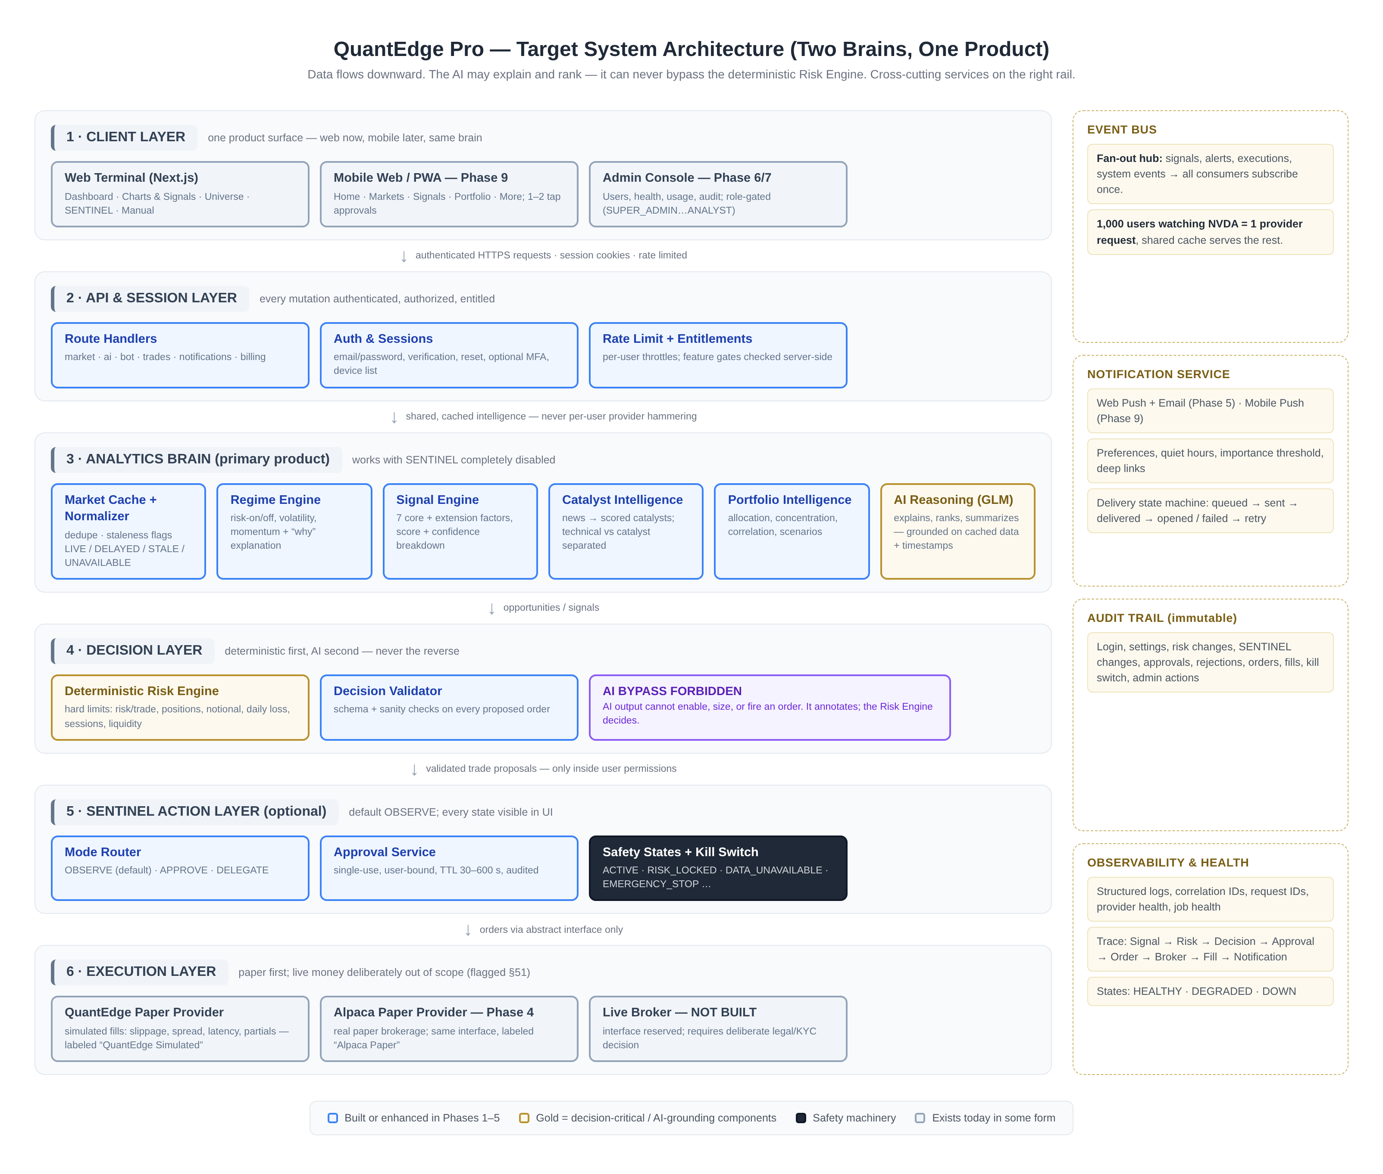
Figure 1: Target system architecture: two brains, one product, with cross-cutting services

B. Database and Data Model
Figure 2 renders the core entity model grouped into six domains - identity and SaaS, market data and intelligence, signals and performance, trading and execution, risk and SENTINEL, and operations - with key fields listed per entity. Two design rules bind the whole model: every user-owned row carries a userId and queries are scoped by it at the repository layer, and the audit trail is append-only with a hash chain so tampering is detectable. The model includes the crypto-ready fields (assetClass, per-class calibration) and the strategy-versioning structure now, while they are cheap, per item 12's warning against retrofitting.
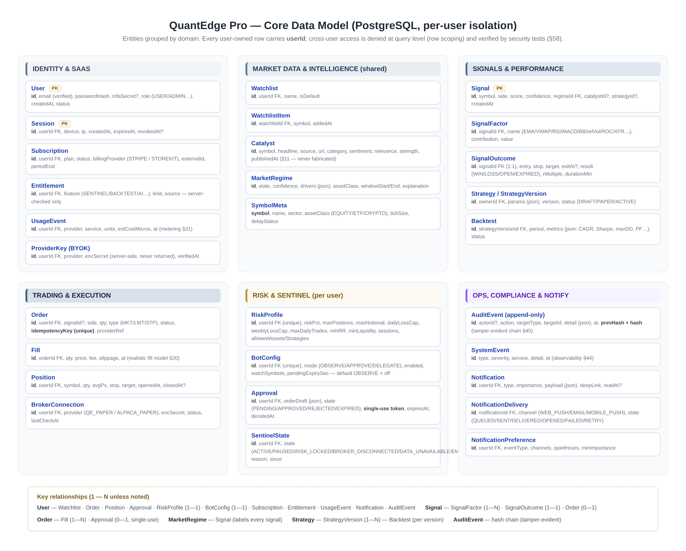
Figure 2: Core data model: six domains, per-user isolation, append-only audit
Migration mechanics: Phase 1 introduces PostgreSQL alongside SQLite, defines this schema with a real migration tool, backfills the derived history (trades, signals) that is worth keeping, and flips reads behind feature flags. The watchlist moves first because it is low-risk and immediately user-visible.

C. Provider Architecture
Figure 3 shows the eight Section 28 interfaces with their implementations and build phases. The governing rules: every external dependency sits behind an interface; every free tier's limits are measured before the feature ships; secrets stay server-side and encrypted, never returned by any API; and BYOK adapters shift variable cost to the user where user activity drives it. The interface set is also the lock-in insurance the mandate demands - Yahoo can be replaced by Stooq or Polygon without touching product code, and a live broker can appear later behind the same ExecutionProvider without a rewrite.
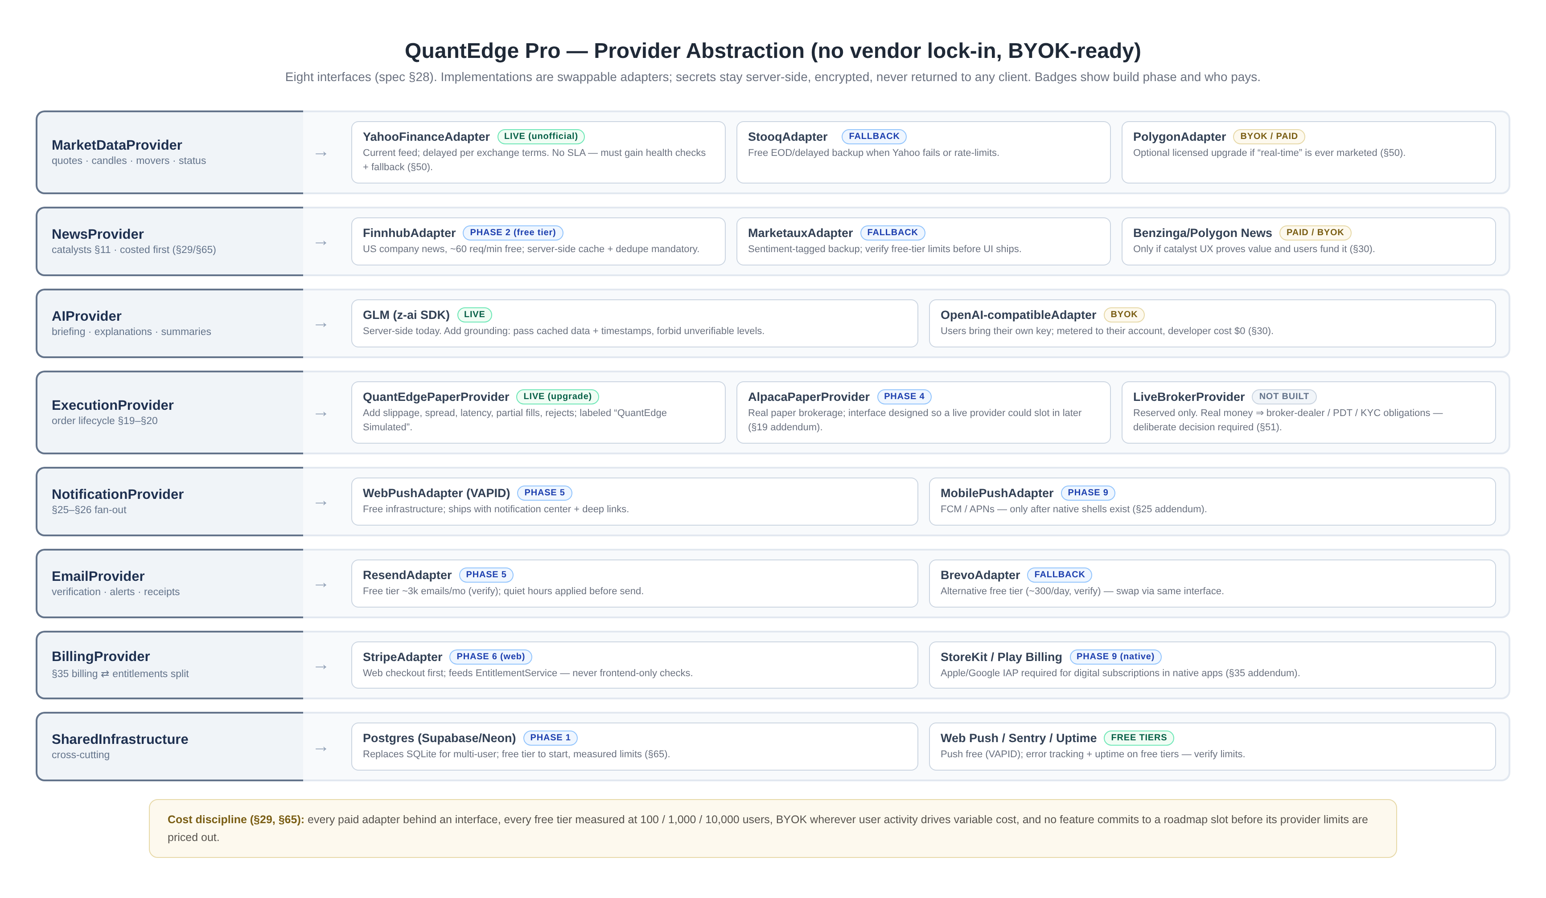
Figure 3: Provider abstraction: interfaces, implementations, phases, and cost posture

D. Analytics Architecture
Figure 4 traces the analytics pipeline from ingest through normalization, indicator computation, the three engines (regime, signal, catalyst), opportunity aggregation, and serving. The pipeline is shared infrastructure: one provider request serves every watcher of a symbol, indicator series are memoized per symbol and range, and every generated signal is persisted with its factors and later its outcome - the honesty ledger that lets the product measure its own engine. Portfolio intelligence runs as a sibling service over positions and history, producing the concentration and correlation warnings Section 15 requires.
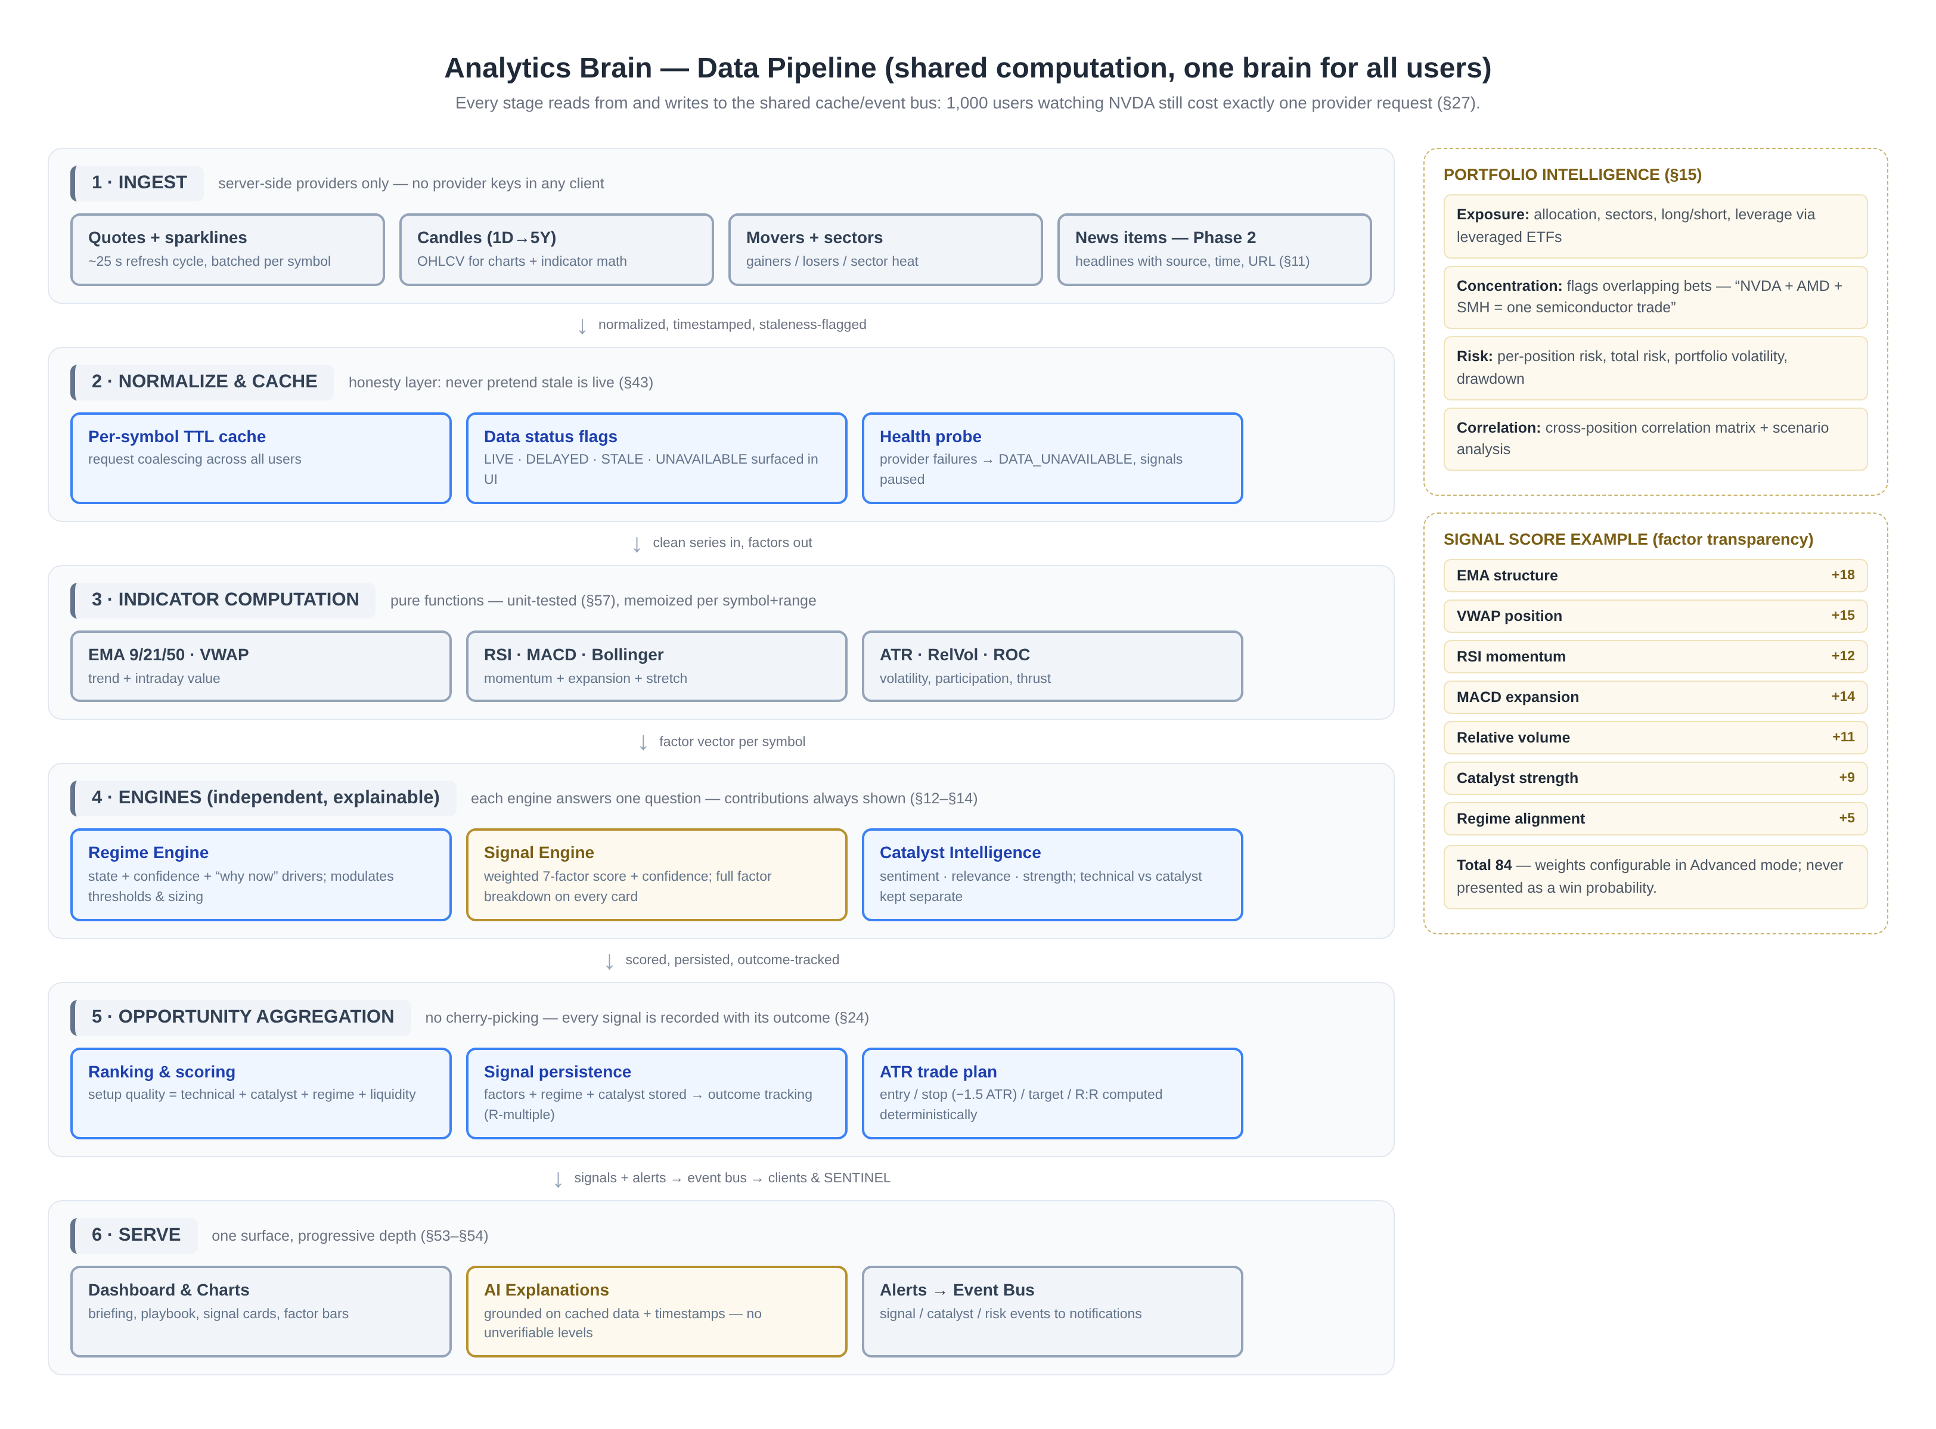
Figure 4: Analytics pipeline: shared computation from ingest to serving

E. SENTINEL Architecture
Figure 5 renders the action layer as a five-stage pipeline with its safety machinery. The deterministic risk gate sits between candidates and the mode router and checks the full Section 16 control set, including the asset-class calibration the Section 4 addendum requires. The mode router preserves today's three-mode UX with Observe as factory default; approvals become single-use, user-bound, expiring, audited artifacts; execution goes through the provider adapter with idempotent submission and realistic fills; and the position monitor enforces exits mechanically, feeding outcomes back into the signal ledger.
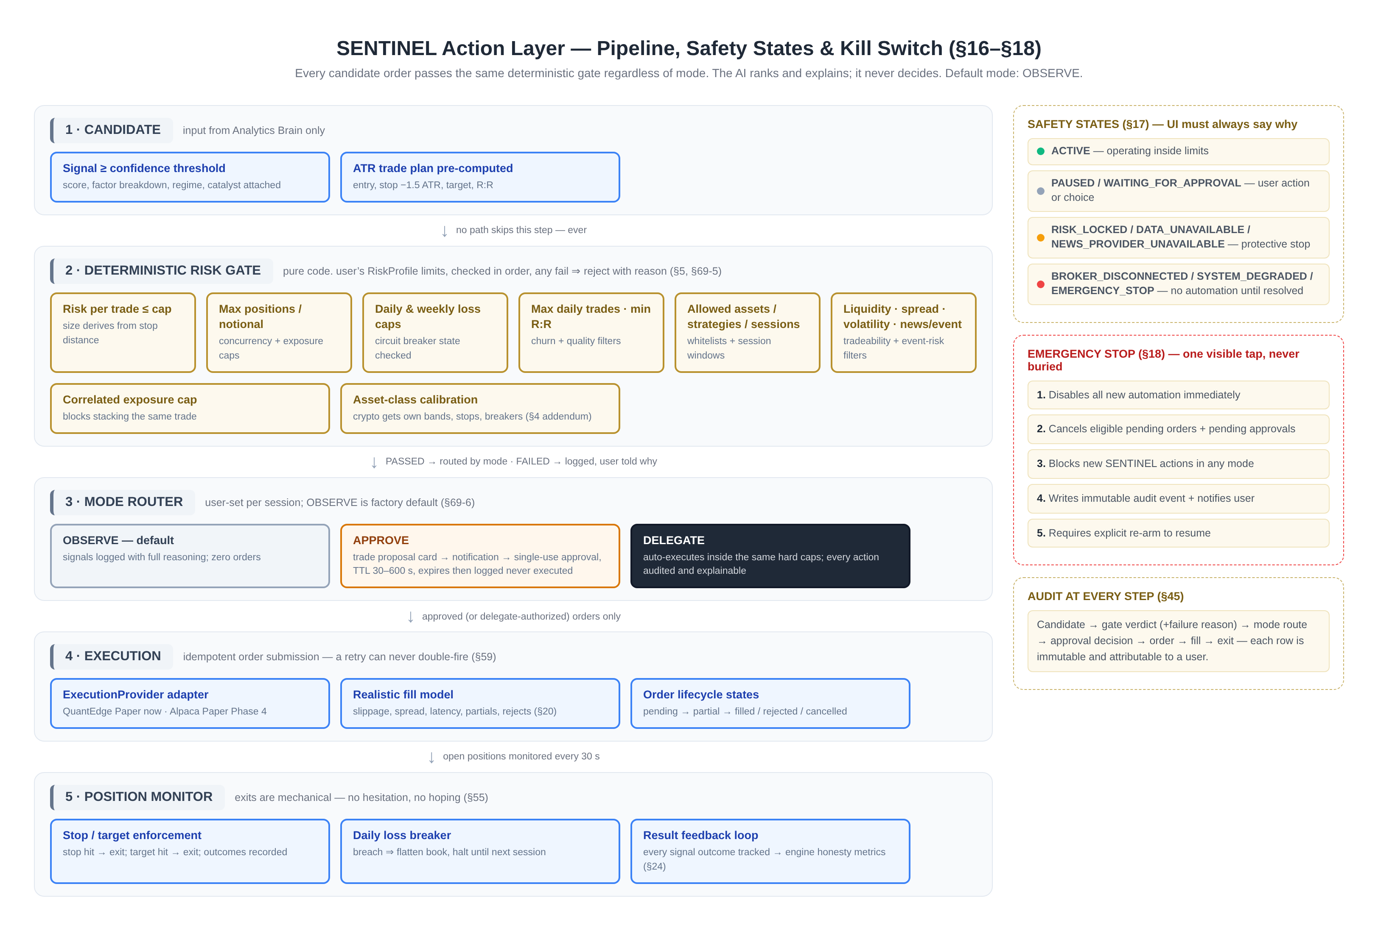
Figure 5: SENTINEL pipeline: deterministic gate, mode router, execution, monitoring, kill switch

F. Notification Architecture
Figure 6 shows the event-driven notification path: sources publish once to the event bus; the notification service deduplicates, applies per-user preferences, importance thresholds, and quiet hours, and tracks delivery states honestly; channels activate in the mandated order - web push and email in Phase 5, mobile push only when Phase 9 produces installable shells. Every notification carries a deep link to the exact screen it concerns, with the approval card as the canonical example.
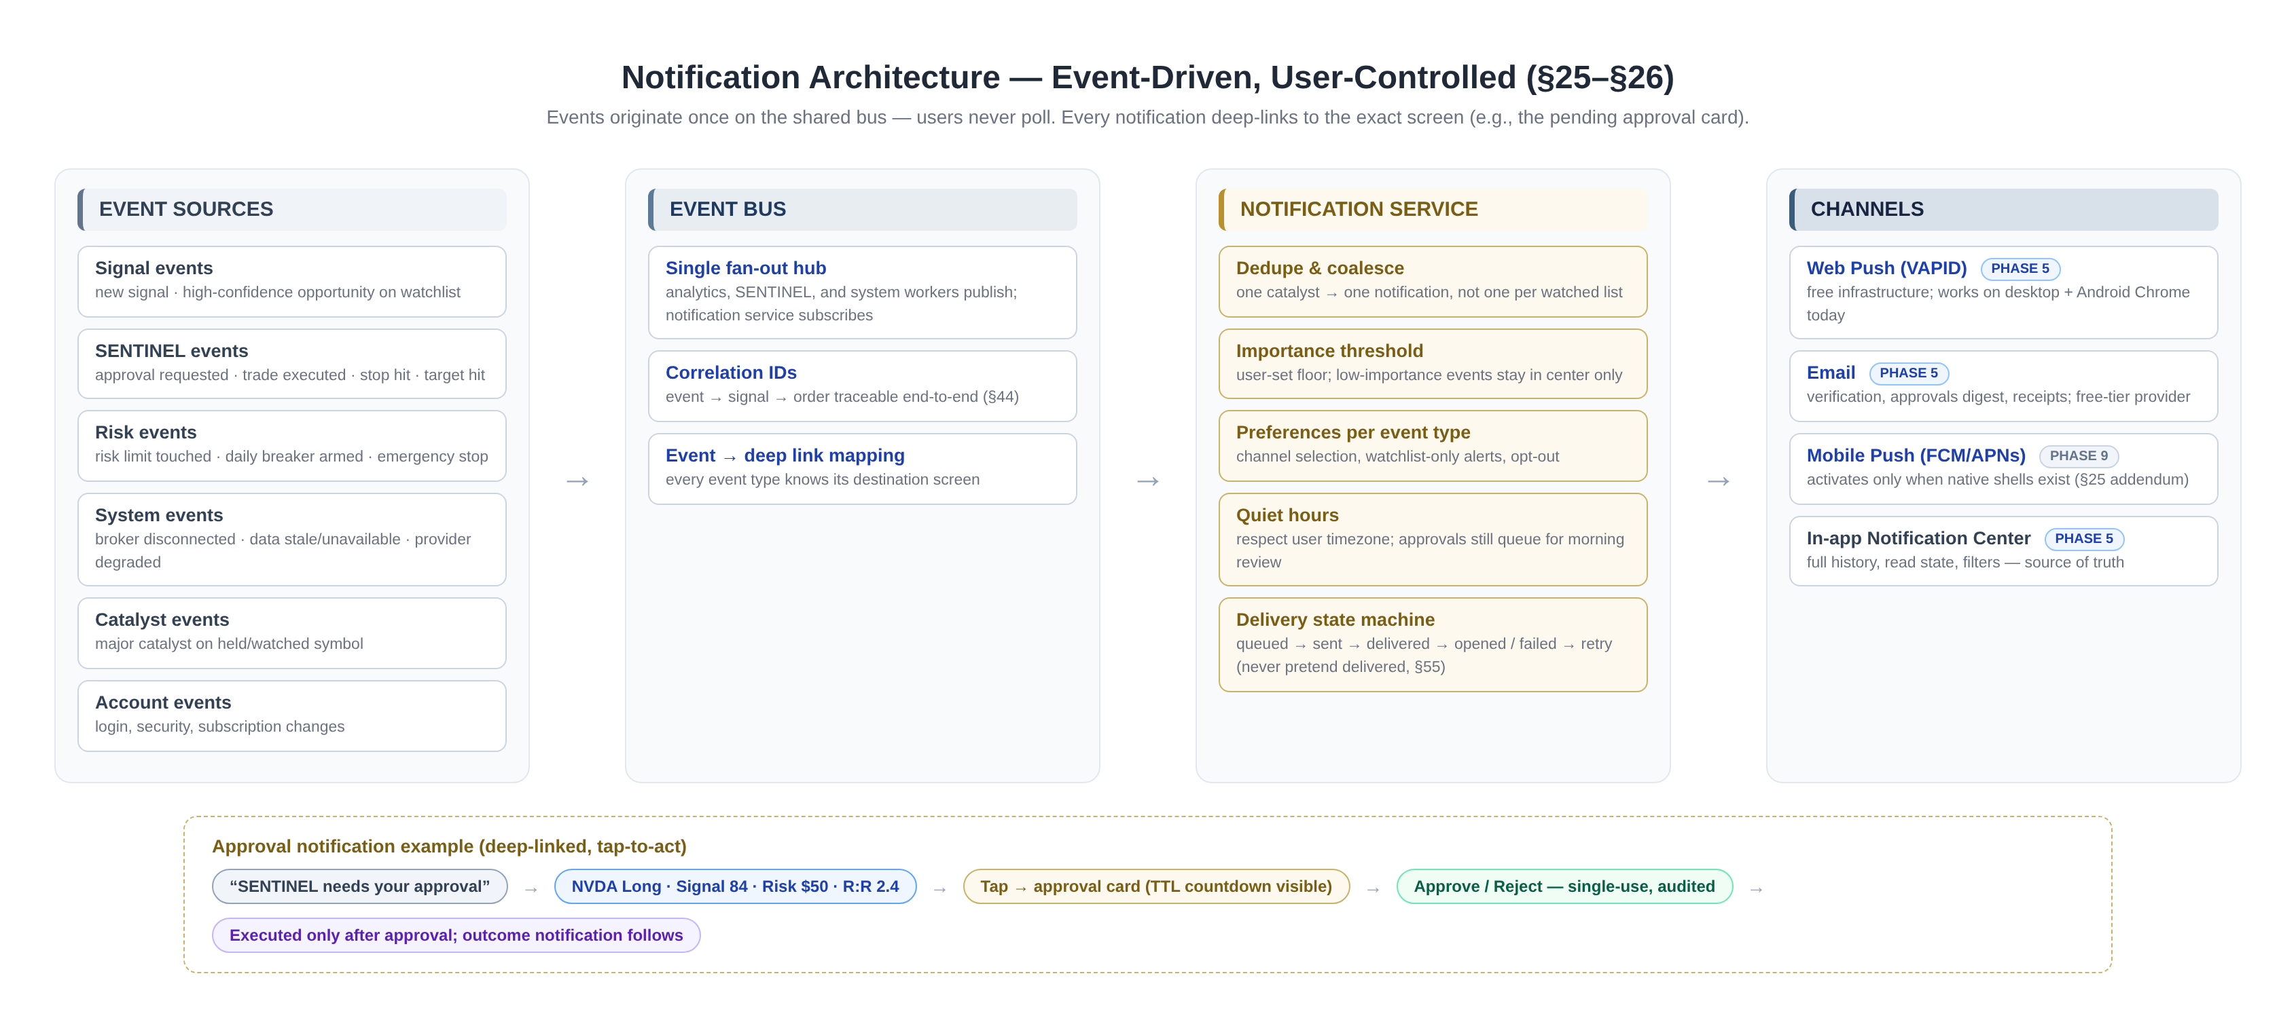
Figure 6: Notification architecture: event sources, bus, service, channels, deep links

G. Security Architecture
Security is layered so that no single failure exposes user data or money-equivalent state. The table below assigns the Section 46 control set to layers, with the Phase 1 items marked as foundational. The design principle throughout is that the server never trusts the client: entitlements, ownership, and risk limits are checked server-side on every privileged action, and the AI layer is architecturally incapable of overriding any of them.
Table 4: Security control layers
Layer | Controls
Edge | HTTPS everywhere; secure headers (CSP, HSTS, frame options); platform WAF; per-IP throttling in front of auth and mutation routes
Identity | Email/password with verification; password reset; secure session cookies; optional MFA; device and session management; brute-force lockout; suspicious-login detection
Authorization | Per-user row scoping at the repository layer; server-side entitlement checks on every privileged route; admin roles (SUPER_ADMIN, ADMIN, SUPPORT, ANALYST) with least privilege
Input | Schema validation on every route; CSRF tokens on mutations; XSS-safe rendering; parameterized queries
Secrets | Server-side only; encrypted at rest; never logged, never returned in API responses; BYOK secrets encrypted per user
Trading integrity | Idempotency keys on orders and approvals; single-use approval tokens; deterministic risk gate with no AI bypass; emergency stop with cancel-pending semantics
Audit | Append-only, hash-chained AuditEvent log covering logins, settings, risk and SENTINEL changes, approvals, rejections, orders, fills, kill switch, and admin actions (Section 45)
Verification | The Section 58 test suite as a standing gate: cross-user access, broken authorization, key leakage, session attacks, injection, XSS, CSRF, rate-limit bypass, entitlement bypass, approval replay, duplicate orders

H. Mobile Architecture
One brain, three surfaces. The web terminal remains the flagship; the mobile experience is a dedicated responsive layout of the same product - bottom navigation (Home, Markets, Signals, Portfolio, More), approval cards designed for one-or-two-tap decisions, charts adapted for touch - shipped as a PWA with a manifest and service worker so it installs to a home screen and survives offline starts. Native shells (wrapped or fully native) arrive only when store distribution is genuinely needed, consuming exactly the same APIs; the push sequencing addendum binds mobile push to that moment (Section 25).
The audit recommends committing to the PWA-first path now (Part IV, decision 7) because it preserves the zero-cost posture, avoids the App Store review and in-app-purchase constraints until there is revenue to justify them, and keeps the Section 36 requirement - the same backend intelligence on every surface - structurally guaranteed rather than aspirational.

I. SaaS Architecture
Multi-tenancy is a single database with per-user scoping, not per-tenant databases - the scale profile (many small users) and the free-tier budget both point that way. Billing and entitlements stay separate (Section 35): Stripe checkout on the web first, StoreKit and Play Billing when native shells exist, both feeding one EntitlementService whose decisions are enforced server-side. Usage metering records provider, service, units, timestamp, and estimated cost per user (Section 31), which later becomes the pricing backbone; BYOK keys are encrypted, per-user, and never returned (Section 30).
The admin control center (Section 47) reads from the same observability and audit substrate users never see: users and subscriptions, provider health, usage, failed notifications, background jobs, and security events, with the four-role model. The user control center (Section 48) consolidates trading, SENTINEL, notification, provider, broker, and account settings into one friendly surface - most of which exists today as scattered bot sliders and needs reorganization, not invention.

J. Cost Model
The table below states the operating cost posture at four scale points, using the free-first map of item 21. Figures are planning estimates in US dollars per month based on public pricing as of the audit date; Section 65 requires them re-verified against current provider pages at each phase gate. The pattern to note is that cost stays at effectively zero through the first several hundred users on free tiers, and the first meaningful line items - database beyond free capacity, news above free request limits, and email volume - arrive only with real traction, by which point the subscription under decision 3 funds them.
Table 5: Monthly operating cost posture (planning estimates - verify at each phase gate)
Service | Now (1 user) | 100 users | 1,000 users | 10,000 users | Escalation path
Hosting (current platform) | $0 (bundled) | $0 | $0 - low | Low - moderate | Scale within platform; container hosting if needed
Market data (Yahoo proxy) | $0 | $0 | $0 (cache-coalesced) | $0 + Stooq fallback | Polygon BYOK/paid only if real-time claimed
News (Finnhub free tier) | $0 | $0 (cached, deduped) | $0 - low (limits reached) | Paid tier or BYOK | Marketaux fallback; Benzinga via BYOK
PostgreSQL (Supabase/Neon) | $0 | $0 | $0 - $25 | $25 - $100 | Paid tiers; measure storage and connections
AI (GLM + metering + BYOK) | $0 (bundled) | $0 - low | Low (metered, BYOK share) | Moderate | BYOK shifts heavy usage to users
Push + email | $0 | $0 | $0 - low | Low | Second email provider behind interface
Monitoring (Sentry/Uptime) | $0 | $0 | $0 | $0 - low | Paid tiers or self-hosted
Total (indicative) | About $0 | About $0 | Under ~$50 | Under ~$250 | Funded by subscription before it bites
Reading the table: the -low and -moderate ranges are deliberate. The mandate forbids designing around fake unlimited-free assumptions, so every cell with growth is paired with a measured escalation path rather than a hopeful zero.

Part III - Implementation Sequence and Readiness (Items 26-29)

26. Exact Implementation Sequence
The sequence below follows Section 63's phase order exactly, with two audit-driven adjustments that do not change the order: security hardening is pulled to the front of Phase 1 (items S1-S4 of item 5 are prerequisites for everything else, including honest testing), and each phase carries an explicit exit criterion so progress is verifiable rather than narrative. No phase begins until its predecessor's exit criteria are met and any Part IV decisions it depends on are answered.
Table 6: Phase plan with focus, key deliverables, and exit criteria
Phase | Focus | Key deliverables | Exit criteria
0 (done) | Audit | This document; evidence inventory; decision list | Owner approves audit and answers Part IV
1 - Foundation | Security + data | Auth, sessions, MFA-optional; PostgreSQL + migrations; per-user schema; provider interfaces; S1-S8 closed; admin bootstrap | All mutations authenticated; per-user isolation verified; provider interfaces merged
2 - Analytics brain | Market + news | Cached/coalesced pipeline; staleness states; news provider + catalyst entities; regime explanations; portfolio intelligence; AI grounding fix | One provider request serves N watchers; catalysts carry source+time; briefing levels all grounded
3 - Research | Proof | Signal ledger with outcomes; backtester with bias controls; walk-forward; Strategy Lab with versions | Backtest metrics suite complete; live and backtest fill models identical
4 - SENTINEL | Action | Per-user modes; full risk-gate control set; single-use approvals; ExecutionProvider + realistic fills; Alpaca Paper; kill switch + safety states | Gate blocks every violation class in tests; approval replay impossible; kill switch drilled
5 - Realtime | Delivery | Event bus fan-out; SSE/WebSocket updates; web push; email; notification center + deep links; delivery states | Approval notification to action under 5 s; zero pretend-delivered states
6 - SaaS | Revenue | Subscriptions (Stripe web); entitlements server-side; usage metering; BYOK; user + admin control centers | Entitlement bypass tests pass; metering reconciles with provider dashboards
7 - Security + reliability | Hardening | Audit trail (hash-chained); observability; idempotency everywhere; rate limits; Section 57/58 test suites; scale review at 1/100/1k/10k | Security suite green; failure-mode drills pass; scale report accepted
8 - UX/UI | One product | Unified dashboard polish; onboarding; contextual education; beginner/advanced split; friendly errors; marketing screenshots | Onboarding completes unaided in tests; every complex concept has its explainer
9 - Mobile | Reach | Responsive + PWA; mobile approval flow; native shells if decided; mobile push activation | Approval in 1-2 taps on phones; store checklist clear if shells ship
10 - Launch | Trust | Legal pages; disclaimers; status page; backups/recovery; monitoring; store compliance; final QA | Launch checklist (item 28) fully green

27. Testing Strategy
Testing follows Section 57's three tiers plus the security and performance suites, with one QuantEdge-specific rule: financial logic is tested by property, not just by example. Risk sizing, regime classification, and backtest metrics get property-based tests (for example, no sequence of inputs lets position risk exceed the cap), because example tests alone cannot cover the input space that decides whether a user's paper account behaves sanely.
- Unit: every indicator (EMA, VWAP, RSI, MACD, Bollinger, ATR, relative volume, ROC) against known series; signal scoring with factor weights; position sizing from stop distance; regime classification edges; backtest metric math.
- Integration: market and news providers against recorded fixtures (no live calls in CI); auth and session flows; database scoping (user A can never read user B); broker adapter lifecycle; notification provider contracts.
- End-to-end: the full happy path signal, risk, SENTINEL, approval, execution, fill, notification - plus the failure paths Section 57 demands: stale data pauses automation, broker disconnect halts SENTINEL, provider outage degrades gracefully, approval expiry logs but never executes, duplicate submission fires once, kill switch stops everything.
- Security: the Section 58 suite as standing CI gates - cross-user access, broken authorization, approval replay, duplicate orders, entitlement bypass, rate-limit bypass, injection, XSS, CSRF.
- Performance: scripted load at 1, 100, 1,000, and 10,000 simulated users measuring API latency, cache hit ratio, provider request counts (the fan-out proof), and notification delivery time.

28. Launch Readiness Checklist
The checklist below defines the Phase 10 gate. Each line is binary and evidence-backed; the right-hand column names the phase that produces the evidence, so launch readiness is built up across the program rather than assembled at the end.
Table 7: Launch gate (all lines must be green before charging any user)
Area | Requirement | Evidence from
Security | Auth live; MFA optional; S1-S8 closed; Section 58 suite green | Phase 1 + 7
Isolation | Per-user scoping verified by adversarial tests; no shared financial state | Phase 1
Safety | Kill switch drilled; safety states surfaced; approvals single-use and expiring | Phase 4
Honesty | Delayed-data disclosure before click-through; no real-time claim; simulated vs paper labeled; no profit claims | Phase 2 + 8
Legal | Terms of Service, Privacy Policy, refund/cancellation policy live and linked from site and app | Phase 6 + 10
Compliance | Store requirements verified current (if shells ship); billing approach matches Section 35 addendum | Phase 9 + 10
Operations | Status page; monitoring and alerting; backups and restore drill; support contact | Phase 7 + 10
Data integrity | Idempotency verified under retry; audit trail hash-chain verified | Phase 4 + 7
Support | Help Center covers Sections 9's map; contextual education present on complex concepts | Phase 8
Quality | Full regression green on desktop, laptop, tablet, iPhone, Android | Phase 8 + 9

29. Marketing-Site Readiness
The landing page's honest tone is a genuine asset, and its structural gaps are exactly the eight findings Section 70 anticipated; the audit verified each against the live page. Fixes are ordered by leverage, per Section 37's addendum that real screenshots outrank any font or color work.
- Add real product evidence: screenshots of the terminal, a chart with the signal plan, and an example SENTINEL approval card - replacing an all-text pitch (verified: no imagery exists).
- Publish the legal trio: Terms of Service, Privacy Policy, and a refund/cancellation policy, plus contact information - required before charging anyone and by both stores at review (verified: absent).
- Move the data-delay disclosure up: the hero's LIVE and REAL-TIME DATA badges must be qualified before the click-through, not in the footer (verified: footer-only disclosure).
- Rephrase TradingView-grade to product-native language (verified claim).
- Decide subscription billing before store submission: web Stripe now, native IAP when shells exist (Section 35 addendum).
- Price the news provider before the feature is marketed (Section 11 addendum; item 21's map is the starting point).
- Gate crypto marketing on its own risk calibration (Section 4 addendum).
- Frame Alpaca paper as the on-ramp it is, with the live-trading regulatory flag kept explicit in any copy that mentions brokerage connectivity (Section 19 addendum).

Part IV - Decisions Required Before Implementation
Section 64 asks for questions only where an answer materially changes cost, architecture, security, legal posture, or roadmap - and asks that everything else be decided by best practice and documented. Eight decisions meet that bar. Each is stated with a recommendation and the default that will apply if you prefer not to decide now; defaults follow the mandate's zero-cost, safety-first, web-first principles. These are the only blocking questions; everything else in this audit proceeds on documented best practice.
Table 8: Decisions, recommendations, and defaults
# | Decision | Recommendation | Default if unanswered
D1 | Multi-user timing: full multi-tenant now vs invite-only soft launch | Multi-tenant schema in Phase 1; invite-only launch until Phase 6 | Multi-tenant schema; invite-only
D2 | News provider budget: free tier first vs paid feed | Finnhub free tier behind NewsProvider; cache and dedupe; revisit at 100 users | Free tier first
D3 | Subscription model and price point | Free Analytics tier + paid Pro (SENTINEL Delegate, backtesting, advanced alerts); price set in Phase 6 with metering data in hand | Two-tier model; price at Phase 6
D4 | Data honesty: relabel hero as delayed vs license real-time | Relabel now (free, honest); revisit licensed feeds only with revenue | Relabel as delayed
D5 | Alpaca Paper integration timing | Phase 4 behind ExecutionProvider; live-money path stays unbuilt and flagged | Phase 4, live path deferred
D6 | Crypto scope | Schema-ready in Phase 1 (assetClass, calibration table); feature return deferred to a post-Phase-4 cycle | Schema-ready, feature deferred
D7 | Mobile approach: PWA first vs native shells now | Responsive + PWA in Phase 8/9; native only when store presence is needed | PWA first
D8 | Database migration timing | PostgreSQL (Supabase or Neon free tier) in Phase 1 alongside auth work | Phase 1 migration
With this audit approved and the eight decisions answered (or defaulted), Phase 1 begins with security hardening and the foundation layer, on the sequence of item 26. The audit will be re-run in compressed form at the Phase 7 gate - re-verifying every item marked Inferred here against the then-current source - so that the launch decision in Phase 10 rests on verified rather than assumed ground.

