Міністерство освіти і науки України
Національний технічний університет України
«Київський політехнічний інститут імені Ігоря Сікорського»
Факультет інформатики та обчислювальної техніки
Кафедра обчислювальної техніки

Лабораторна робота №6
із дисципліни
“Основи розробки ПЗ на платформі Java”

Виконав: Перевірила:
студент групи ІМ-43 лектор Дифучина О.Ю
Калєнченко Михайло Олександрович Оцінка:
Номер у списку групи: 2 Дата перевірки:

Київ 2026
Мета: дослідити механізми розробки графічних об’єктиів та
маніпулювання ними.

Завдання до роботи:
1.Опрацювати приклади «Візуалізація моделі клітинного автомату» та
«Маніпулювання графічними об’єктами». 10 балів.
2. Додати в приклад «Модель клітинного автомату «Життя» елементи
віконного інтерфейсу, які реалізують можливість запуску моделі для
заданого користувачем початкового стану клітинного автомату. 20 балів.
3. Використовуючи графічні примітиви, розробити візуалізацію моделі
предметної області, що розроблялась на попередніх лабораторних роботах.
30 балів.
5. Використовуючи запуск подій з заданим інтервалом, розробити
анімацію подій, що відбуваються в моделі предметної області. 30 балів.
6. Додати елементи управління запуском, призупинкою чи зупинкою
анімації̈ моделі до інтерфейсу користувача, який̆ був розроблений̆ на
попередній̆ лабораторній роботі. 10 балів.

Лістинг програми:
ConwayGameOfLifeFrame.java
import javax.swing.BorderFactory;
import javax.swing.Box;
import javax.swing.JButton;
import javax.swing.JFrame;
import javax.swing.JLabel;
import javax.swing.JPanel;
import javax.swing.JSlider;
import javax.swing.JSpinner;
import javax.swing.SpinnerNumberModel;
import javax.swing.SwingUtilities;
import javax.swing.Timer;
import java.awt.BorderLayout;
import java.awt.FlowLayout;

public class ConwayGameOfLifeFrame extends JFrame {
private static final int DEFAULT_ROWS = 25;
private static final int DEFAULT_COLUMNS = 35;

private final ConwayGameOfLifePanel gamePanel;
private final Timer timer;
private final JLabel generationLabel;
private final JLabel statusLabel;
private final JSpinner densitySpinner;
private final JSlider speedSlider;

public ConwayGameOfLifeFrame() {
setTitle("Conway Game of Life");
setDefaultCloseOperation(JFrame.DISPOSE_ON_CLOSE);
setLayout(new BorderLayout(10, 10));

gamePanel = new ConwayGameOfLifePanel(DEFAULT_ROWS, DEFAULT_COLUMNS);
generationLabel = new JLabel("Generation: 0");
statusLabel = new JLabel("Status: editing");
densitySpinner = new JSpinner(new SpinnerNumberModel(30, 5, 95, 5));
speedSlider = new JSlider(50, 500, 150);
timer = new Timer(speedSlider.getValue(), e -> advanceSimulation());

add(buildTopPanel(), BorderLayout.NORTH);
add(gamePanel, BorderLayout.CENTER);
add(buildBottomPanel(), BorderLayout.SOUTH);

speedSlider.addChangeListener(e -> timer.setDelay(speedSlider.getValue()));

pack();
setLocationRelativeTo(null);
}

private JPanel buildTopPanel() {
JPanel panel = new JPanel(new FlowLayout(FlowLayout.LEFT));
panel.setBorder(BorderFactory.createTitledBorder("Model controls"));

JButton startButton = new JButton("Start");
JButton pauseButton = new JButton("Pause");
JButton stepButton = new JButton("Next step");
JButton clearButton = new JButton("Clear");
JButton randomButton = new JButton("Random state");

startButton.addActionListener(e -> startSimulation());
pauseButton.addActionListener(e -> pauseSimulation());
stepButton.addActionListener(e -> advanceSimulation());
clearButton.addActionListener(e -> clearSimulation());
randomButton.addActionListener(e -> randomizeSimulation());

panel.add(startButton);
panel.add(pauseButton);
panel.add(stepButton);
panel.add(clearButton);
panel.add(randomButton);
panel.add(Box.createHorizontalStrut(10));
panel.add(new JLabel("Alive %:"));
panel.add(densitySpinner);
panel.add(Box.createHorizontalStrut(10));
panel.add(new JLabel("Speed (ms):"));
panel.add(speedSlider);

return panel;
}

private JPanel buildBottomPanel() {
JPanel panel = new JPanel(new FlowLayout(FlowLayout.LEFT));
panel.setBorder(BorderFactory.createEmptyBorder(0, 8, 8, 8));
panel.add(generationLabel);
panel.add(Box.createHorizontalStrut(20));
panel.add(statusLabel);
panel.add(Box.createHorizontalStrut(20));
panel.add(new JLabel("Click cells to define the initial state before start."));
return panel;
}

private void startSimulation() {
gamePanel.setEditingEnabled(false);
timer.start();
statusLabel.setText("Status: running");
}

private void pauseSimulation() {
timer.stop();
gamePanel.setEditingEnabled(true);
statusLabel.setText("Status: paused");
}

private void clearSimulation() {
timer.stop();
gamePanel.setEditingEnabled(true);
gamePanel.clearGrid();
refreshGenerationLabel();
statusLabel.setText("Status: cleared");
}

private void randomizeSimulation() {
timer.stop();
gamePanel.setEditingEnabled(true);
int densityPercent = (Integer) densitySpinner.getValue();
gamePanel.randomize(densityPercent / 100.0);
refreshGenerationLabel();
statusLabel.setText("Status: random initial state created");
}

private void advanceSimulation() {
gamePanel.nextGeneration();
refreshGenerationLabel();
}

private void refreshGenerationLabel() {
generationLabel.setText("Generation: " + gamePanel.getGeneration());
}

public static void main(String[] args) {
SwingUtilities.invokeLater(() -> new ConwayGameOfLifeFrame().setVisible(true));
}
}

ConwayGameOfLifePanel.java
import javax.swing.JPanel;
import java.awt.Color;
import java.awt.Dimension;
import java.awt.Graphics;
import java.awt.Graphics2D;
import java.awt.RenderingHints;
import java.awt.event.MouseAdapter;
import java.awt.event.MouseEvent;
import java.util.Random;

public class ConwayGameOfLifePanel extends JPanel {
private static final int CELL_SIZE = 18;
private static final Color GRID_COLOR = new Color(210, 214, 220);
private static final Color DEAD_CELL_COLOR = new Color(248, 249, 251);
private static final Color LIVE_CELL_COLOR = new Color(46, 122, 214);

private final boolean[][] grid;
private int generation;
private boolean editingEnabled = true;

public ConwayGameOfLifePanel(int rows, int columns) {
if (rows <= 0 || columns <= 0) {
throw new IllegalArgumentException("Rows and columns must be positive.");
}

grid = new boolean[rows][columns];
setBackground(Color.WHITE);

addMouseListener(new MouseAdapter() {
@Override
public void mousePressed(MouseEvent event) {
if (!editingEnabled) {
return;
}

int column = event.getX() / CELL_SIZE;
int row = event.getY() / CELL_SIZE;
toggleCell(row, column);
}
});
}

@Override
public Dimension getPreferredSize() {
return new Dimension(grid[0].length * CELL_SIZE, grid.length * CELL_SIZE);
}

public int getGeneration() {
return generation;
}

public void setEditingEnabled(boolean editingEnabled) {
this.editingEnabled = editingEnabled;
}

public void clearGrid() {
for (int row = 0; row < grid.length; row++) {
for (int column = 0; column < grid[row].length; column++) {
grid[row][column] = false;
}
}
generation = 0;
repaint();
}

public void randomize(double aliveProbability) {
if (aliveProbability < 0 || aliveProbability > 1) {
throw new IllegalArgumentException("Alive probability must be between 0 and 1.");
}

Random random = new Random();
for (int row = 0; row < grid.length; row++) {
for (int column = 0; column < grid[row].length; column++) {
grid[row][column] = random.nextDouble() < aliveProbability;
}
}
generation = 0;
repaint();
}

public void nextGeneration() {
boolean[][] nextGrid = new boolean[grid.length][grid[0].length];

for (int row = 0; row < grid.length; row++) {
for (int column = 0; column < grid[row].length; column++) {
int liveNeighbours = countLiveNeighbours(row, column);
nextGrid[row][column] = shouldCellLive(row, column, liveNeighbours);
}
}

for (int row = 0; row < grid.length; row++) {
System.arraycopy(nextGrid[row], 0, grid[row], 0, grid[row].length);
}

generation++;
repaint();
}

private void toggleCell(int row, int column) {
if (row < 0 || row >= grid.length || column < 0 || column >= grid[row].length) {
return;
}

grid[row][column] = !grid[row][column];
repaint();
}

private int countLiveNeighbours(int row, int column) {
int liveNeighbours = 0;

for (int rowOffset = -1; rowOffset <= 1; rowOffset++) {
for (int columnOffset = -1; columnOffset <= 1; columnOffset++) {
if (rowOffset == 0 && columnOffset == 0) {
continue;
}

int neighbourRow = row + rowOffset;
int neighbourColumn = column + columnOffset;

if (neighbourRow >= 0 && neighbourRow < grid.length
&& neighbourColumn >= 0 && neighbourColumn < grid[neighbourRow].length
&& grid[neighbourRow][neighbourColumn]) {
liveNeighbours++;
}
}
}

return liveNeighbours;
}

private boolean shouldCellLive(int row, int column, int liveNeighbours) {
if (grid[row][column]) {
return liveNeighbours == 2 || liveNeighbours == 3;
}
return liveNeighbours == 3;
}

@Override
protected void paintComponent(Graphics graphics) {
super.paintComponent(graphics);
Graphics2D g2 = (Graphics2D) graphics.create();
g2.setRenderingHint(RenderingHints.KEY_ANTIALIASING, RenderingHints.VALUE_ANTIALIAS_ON);

for (int row = 0; row < grid.length; row++) {
for (int column = 0; column < grid[row].length; column++) {
g2.setColor(grid[row][column] ? LIVE_CELL_COLOR : DEAD_CELL_COLOR);
g2.fillRect(column * CELL_SIZE, row * CELL_SIZE, CELL_SIZE, CELL_SIZE);
g2.setColor(GRID_COLOR);
g2.drawRect(column * CELL_SIZE, row * CELL_SIZE, CELL_SIZE, CELL_SIZE);
}
}

g2.dispose();
}
}

Car.java
public class Car implements Comparable<Car> {
private final String manufacturer;
private final String model;
private String color;
private double tankCapacity;
private int producingYear;

public Car(String manufacturer, String model, String color, double tankCapacity, int producingYear) {
if (manufacturer == null || manufacturer.isBlank()) {
throw new IllegalArgumentException("Manufacturer is required.");
}
if (model == null || model.isBlank()) {
throw new IllegalArgumentException("Model is required.");
}
if (color == null || color.isBlank()) {
throw new IllegalArgumentException("Color is required.");
}
if (tankCapacity <= 0) {
throw new IllegalArgumentException("Tank capacity must be positive.");
}
if (producingYear < 1886 || producingYear > 2026) {
throw new IllegalArgumentException("Producing year is out of supported range.");
}

this.manufacturer = manufacturer;
this.model = model;
this.color = color;
this.tankCapacity = tankCapacity;
this.producingYear = producingYear;
}

public String getColor() {
return color;
}

public void setColor(String color) {
if (color != null && !color.isBlank()) {
this.color = color;
}
}

public double getTankCapacity() {
return tankCapacity;
}

public int getProducingYear() {
return producingYear;
}

public String getManufacturer() {
return manufacturer;
}

public String getModel() {
return model;
}

public void outputCarInfo() {
System.out.println("Car Info: " + manufacturer + " " + model + ", Color: " + color
+ ", Year: " + producingYear + ", Tank: " + tankCapacity + "L");
}

@Override
public String toString() {
return manufacturer + " " + model + " (" + producingYear + ")";
}

@Override
public int compareTo(Car other) {
return Integer.compare(this.producingYear, other.producingYear);
}
}

Fleet.java
import java.util.Arrays;

public class Fleet<T extends Car> {
private final String fleetName;
private final T[] vehicles;

public Fleet(String fleetName, T[] vehicles) {
if (fleetName == null || fleetName.isBlank()) {
throw new IllegalArgumentException("Fleet name is required.");
}
if (vehicles == null) {
throw new IllegalArgumentException("Vehicles array is required.");
}

this.fleetName = fleetName;
this.vehicles = vehicles;
}

public String getFleetName() {
return fleetName;
}

public T[] getVehicles() {
return vehicles;
}

public class FleetStatistics {
public double calculateTotalFleetTanksCapacity() {
double total = 0;
for (T vehicle : vehicles) {
total += vehicle.getTankCapacity();
}
return total;
}

public void displayTotalFleetTanksCapacity() {
System.out.println("Total tank capacity of fleet '" + fleetName + "': "
+ calculateTotalFleetTanksCapacity() + " L.");
}
}

public void performFleetAudit() {
class Auditor {
void check() {
System.out.println("Audit completed. Vehicles count: " + vehicles.length);
}
}

Auditor auditor = new Auditor();
auditor.check();
}

public T findCarByModel(String targetModel) {
if (targetModel == null || targetModel.isBlank()) {
return null;
}

for (T vehicle : vehicles) {
if (vehicle.getModel().equalsIgnoreCase(targetModel)) {
return vehicle;
}
}
return null;
}

public void sortVehiclesByYear() {
Arrays.sort(vehicles);
}

public T[] getFleetBackup() {
return Arrays.copyOf(vehicles, vehicles.length);
}
}

FleetAnimationPanel.java
import javax.swing.JPanel;
import java.awt.BasicStroke;
import java.awt.Color;
import java.awt.Cursor;
import java.awt.Dimension;
import java.awt.Font;
import java.awt.Graphics;
import java.awt.Graphics2D;
import java.awt.Point;
import java.awt.RenderingHints;
import java.awt.event.MouseAdapter;
import java.awt.event.MouseEvent;
import java.util.ArrayList;
import java.util.List;
import java.util.Random;

public class FleetAnimationPanel extends JPanel {
private static final int PREF_WIDTH = 900;
private static final int PREF_HEIGHT = 420;

private final List<TaxiVisualState> taxiStates = new ArrayList<>();
private final Random random = new Random();
private final RoadNetwork roadNetwork = new RoadNetwork();

private TaxiVisualState selectedTaxi;
private Point dragOffset;
private boolean dragging;

public FleetAnimationPanel() {
setBackground(new Color(235, 242, 224));

MouseAdapter mouseHandler = new MouseAdapter() {
@Override
public void mousePressed(MouseEvent event) {
selectTaxiAt(event.getPoint());
dragging = false;
if (selectedTaxi != null) {
dragOffset = new Point(
(int) (event.getX() - selectedTaxi.getBounds().getX()),
(int) (event.getY() - selectedTaxi.getBounds().getY())
);
}
repaint();
}

@Override
public void mouseClicked(MouseEvent event) {
TaxiVisualState taxiState = findTaxiAt(event.getPoint());
if (taxiState != null && event.getClickCount() >= 2) {
assignRandomRoute(taxiState);
repaint();
}
}

@Override
public void mouseReleased(MouseEvent event) {
if (selectedTaxi != null && dragging) {
selectedTaxi.storeCurrentPositionAsInitial();
assignRandomRoute(selectedTaxi);
}
dragOffset = null;
dragging = false;
}
};

addMouseListener(mouseHandler);
addMouseMotionListener(new MouseAdapter() {
@Override
public void mouseDragged(MouseEvent event) {
if (selectedTaxi == null || dragOffset == null) {
return;
}

dragging = true;
double newX = event.getX() - dragOffset.x;
double newY = event.getY() - dragOffset.y;
selectedTaxi.setPosition(
clamp(newX, 10, getWidth() - selectedTaxi.getWidth() - 10),
clamp(newY, 10, getHeight() - selectedTaxi.getHeight() - 10)
);
repaint();
}

@Override
public void mouseMoved(MouseEvent event) {
setCursor(findTaxiAt(event.getPoint()) == null
? Cursor.getDefaultCursor()
: Cursor.getPredefinedCursor(Cursor.HAND_CURSOR));
}
});
}

@Override
public Dimension getPreferredSize() {
return new Dimension(PREF_WIDTH, PREF_HEIGHT);
}

public void addTaxi(Taxi taxi) {
java.awt.geom.Point2D.Double spawnPoint = roadNetwork.getRandomSpawnPoint(random);
TaxiVisualState taxiState = new TaxiVisualState(taxi, spawnPoint.x, spawnPoint.y);
assignRandomRoute(taxiState);
taxiState.storeCurrentPositionAsInitial();
taxiStates.add(taxiState);
repaint();
}

public void setTaxis(List<Taxi> taxis) {
taxiStates.clear();
for (Taxi taxi : taxis) {
addTaxi(taxi);
}
clearSelection();
repaint();
}

public void animateStep() {
for (TaxiVisualState taxiState : taxiStates) {
boolean reachedTarget = taxiState.updatePosition();
if (reachedTarget) {
assignRandomRoute(taxiState);
}
}
repaint();
}

public void resetAnimation() {
for (TaxiVisualState taxiState : taxiStates) {
taxiState.resetToInitialPosition();
}
repaint();
}

public Taxi getSelectedTaxi() {
return selectedTaxi == null ? null : selectedTaxi.getTaxi();
}

private void selectTaxiAt(Point point) {
TaxiVisualState newSelection = findTaxiAt(point);
if (selectedTaxi != null) {
selectedTaxi.setSelected(false);
}
selectedTaxi = newSelection;
if (selectedTaxi != null) {
selectedTaxi.setSelected(true);
}
}

private TaxiVisualState findTaxiAt(Point point) {
for (int i = taxiStates.size() - 1; i >= 0; i--) {
TaxiVisualState taxiState = taxiStates.get(i);
if (taxiState.contains(point.getX(), point.getY())) {
return taxiState;
}
}
return null;
}

private void clearSelection() {
if (selectedTaxi != null) {
selectedTaxi.setSelected(false);
}
selectedTaxi = null;
}

private double clamp(double value, double min, double max) {
return Math.max(min, Math.min(max, value));
}

@Override
protected void paintComponent(Graphics graphics) {
super.paintComponent(graphics);
Graphics2D g2 = (Graphics2D) graphics.create();
g2.setRenderingHint(RenderingHints.KEY_ANTIALIASING, RenderingHints.VALUE_ANTIALIAS_ON);

roadNetwork.paint(g2);
paintLegend(g2);
for (TaxiVisualState taxiState : taxiStates) {
paintTaxi(g2, taxiState);
}

g2.dispose();
}

private void paintLegend(Graphics2D g2) {
g2.setColor(new Color(25, 25, 25));
g2.setFont(new Font("SansSerif", Font.BOLD, 14));
g2.drawString("Taxi fleet animation area", 20, 24);
g2.setFont(new Font("SansSerif", Font.PLAIN, 12));
g2.drawString("Drag a taxi to set its initial position. Double-click a taxi to assign a new route.", 20, 44);
}

private void paintTaxi(Graphics2D g2, TaxiVisualState taxiState) {
int x = (int) taxiState.getBounds().getX();
int y = (int) taxiState.getBounds().getY();
int width = taxiState.getWidth();
int height = taxiState.getHeight();

g2.setColor(taxiState.getBodyColor());
g2.fillRoundRect(x, y, width, height, 12, 12);

g2.setColor(Color.DARK_GRAY);
g2.fillRect(x + 12, y + 7, width - 24, 10);
g2.fillOval(x + 8, y + height - 6, 12, 12);
g2.fillOval(x + width - 20, y + height - 6, 12, 12);

g2.setColor(Color.BLACK);
g2.drawRoundRect(x, y, width, height, 12, 12);

if (taxiState.isSelected()) {
g2.setColor(new Color(65, 125, 255));
g2.setStroke(new BasicStroke(3f));
g2.drawRoundRect(x - 3, y - 3, width + 6, height + 6, 14, 14);
}

g2.setFont(new Font("SansSerif", Font.BOLD, 11));
g2.drawString(taxiState.getLabel(), x, y - 6);
g2.setFont(new Font("SansSerif", Font.PLAIN, 10));
g2.drawString("Route to " + taxiState.getDestinationName(), x, y + height + 14);
}

private void assignRandomRoute(TaxiVisualState taxiState) {
String startIntersection = roadNetwork.findNearestIntersectionName(taxiState.getCurrentPosition());
String destinationIntersection = roadNetwork.getRandomDestinationName(startIntersection, random);
applyRoute(taxiState, startIntersection, destinationIntersection);
}

private void applyRoute(TaxiVisualState taxiState,
String startIntersection,
String destinationIntersection) {
taxiState.setRoute(
roadNetwork.buildRoute(startIntersection, destinationIntersection, false),
destinationIntersection
);
taxiState.setRouteMetadata(startIntersection, destinationIntersection, false);
}
}

FleetFrame.java
import javax.swing.BorderFactory;
import javax.swing.Box;
import javax.swing.JButton;
import javax.swing.JFrame;
import javax.swing.JLabel;
import javax.swing.JOptionPane;
import javax.swing.JPanel;
import javax.swing.JScrollPane;
import javax.swing.JTextArea;
import javax.swing.JTextField;
import javax.swing.SwingUtilities;
import javax.swing.Timer;
import java.awt.BorderLayout;
import java.awt.Color;
import java.awt.FlowLayout;
import java.awt.GridLayout;
import java.awt.event.ActionEvent;
import java.text.SimpleDateFormat;
import java.util.ArrayList;
import java.util.Date;
import java.util.List;

public class FleetFrame extends JFrame {
private final List<Taxi> taxiList = new ArrayList<>();

private JTextField txtManufacturer;
private JTextField txtModel;
private JTextField txtColor;
private JTextField txtTank;
private JTextField txtYear;
private JTextField txtTaxiId;
private JTextField txtDriver;
private JTextArea txtOutput;
private JLabel lblClock;
private JLabel lblAnimationStatus;
private FleetAnimationPanel animationPanel;
private Timer clockTimer;
private Timer animationTimer;

public FleetFrame() {
setTitle("Taxi Fleet Management System");
setDefaultCloseOperation(JFrame.EXIT_ON_CLOSE);
setSize(1120, 720);
setLocationRelativeTo(null);
setLayout(new BorderLayout(10, 10));

add(buildInputPanel(), BorderLayout.NORTH);
add(buildCenterPanel(), BorderLayout.CENTER);
add(buildControlPanel(), BorderLayout.SOUTH);

configureTimers();
seedDemoData();
displayFleet();
}

private JPanel buildInputPanel() {
JPanel inputPanel = new JPanel(new GridLayout(4, 4, 6, 6));
inputPanel.setBorder(BorderFactory.createTitledBorder("Taxi data"));

inputPanel.add(new JLabel("Manufacturer:"));
txtManufacturer = new JTextField();
inputPanel.add(txtManufacturer);

inputPanel.add(new JLabel("Model:"));
txtModel = new JTextField();
inputPanel.add(txtModel);

inputPanel.add(new JLabel("Color:"));
txtColor = new JTextField();
inputPanel.add(txtColor);

inputPanel.add(new JLabel("Tank (liters):"));
txtTank = new JTextField();
inputPanel.add(txtTank);

inputPanel.add(new JLabel("Producing Year:"));
txtYear = new JTextField();
inputPanel.add(txtYear);

inputPanel.add(new JLabel("Taxi ID:"));
txtTaxiId = new JTextField();
inputPanel.add(txtTaxiId);

inputPanel.add(new JLabel("Driver:"));
txtDriver = new JTextField();
inputPanel.add(txtDriver);

JButton btnAdd = new JButton("Add Taxi");
btnAdd.addActionListener(e -> addTaxiAction());
inputPanel.add(btnAdd);

JButton btnSelectInfo = new JButton("Selected Taxi");
btnSelectInfo.addActionListener(e -> showSelectedTaxiInfo());
inputPanel.add(btnSelectInfo);

return inputPanel;
}

private JPanel buildCenterPanel() {
JPanel centerPanel = new JPanel(new GridLayout(1, 2, 10, 10));

animationPanel = new FleetAnimationPanel();
JScrollPane visualWrapper = new JScrollPane(animationPanel);
visualWrapper.setBorder(BorderFactory.createTitledBorder("Fleet visualization"));
centerPanel.add(visualWrapper);

txtOutput = new JTextArea();
txtOutput.setEditable(false);
JScrollPane outputPane = new JScrollPane(txtOutput);
outputPane.setBorder(BorderFactory.createTitledBorder("Results and logs"));
centerPanel.add(outputPane);

return centerPanel;
}

private JPanel buildControlPanel() {
JPanel controlPanel = new JPanel(new FlowLayout(FlowLayout.LEFT));

JButton btnShowFleet = new JButton("Show Fleet");
JButton btnTotalCapacity = new JButton("Total Capacity");
JButton btnFindNewest = new JButton("Find Newest");
JButton btnStart = new JButton("Start");
JButton btnPause = new JButton("Pause");
JButton btnStop = new JButton("Stop");

btnShowFleet.addActionListener(e -> displayFleet());
btnTotalCapacity.addActionListener(e -> calculateTotalCapacity());
btnFindNewest.addActionListener(e -> findNewestTaxi());
btnStart.addActionListener(e -> startAnimation());
btnPause.addActionListener(e -> pauseAnimation());
btnStop.addActionListener(e -> stopAnimation());

lblAnimationStatus = new JLabel("Animation: stopped");
lblAnimationStatus.setForeground(new Color(170, 60, 60));

lblClock = new JLabel("Current Time: --:--:--");
lblClock.setForeground(new Color(45, 87, 195));

controlPanel.add(btnShowFleet);
controlPanel.add(btnTotalCapacity);
controlPanel.add(btnFindNewest);
controlPanel.add(Box.createHorizontalStrut(10));
controlPanel.add(btnStart);
controlPanel.add(btnPause);
controlPanel.add(btnStop);
controlPanel.add(Box.createHorizontalStrut(16));
controlPanel.add(lblAnimationStatus);
controlPanel.add(Box.createHorizontalStrut(16));
controlPanel.add(lblClock);

return controlPanel;
}

private void configureTimers() {
clockTimer = new Timer(1000, this::updateTime);
clockTimer.start();

animationTimer = new Timer(40, e -> animationPanel.animateStep());
}

private void seedDemoData() {
addTaxiToFleet(new Taxi("Toyota", "Prius", "White", 45.0, 2018, "TX-101", "Misha"));
addTaxiToFleet(new Taxi("Skoda", "Octavia", "Green", 60.0, 2021, "TX-202", "Maxim"));
addTaxiToFleet(new Taxi("Nissan", "Leaf", "Yellow", 40.0, 2020, "TX-303", "Anna"));
}

private void addTaxiAction() {
try {
Taxi newTaxi = buildTaxiFromForm();
addTaxiToFleet(newTaxi);
txtOutput.append(">> Successfully added: " + newTaxi + "\n");
clearInputFields();
} catch (NumberFormatException ex) {
JOptionPane.showMessageDialog(
this,
"Tank and producing year must be numeric values.",
"Input Error",
JOptionPane.ERROR_MESSAGE
);
} catch (IllegalArgumentException ex) {
JOptionPane.showMessageDialog(
this,
ex.getMessage(),
"Input Error",
JOptionPane.WARNING_MESSAGE
);
}
}

private Taxi buildTaxiFromForm() {
String manufacturer = txtManufacturer.getText().trim();
String model = txtModel.getText().trim();
String color = txtColor.getText().trim();
String taxiId = txtTaxiId.getText().trim();
String driverName = txtDriver.getText().trim();

double tank = Double.parseDouble(txtTank.getText().trim());
int year = Integer.parseInt(txtYear.getText().trim());

ensureUniqueTaxiId(taxiId);
return new Taxi(manufacturer, model, color, tank, year, taxiId, driverName);
}

private void ensureUniqueTaxiId(String taxiId) {
for (Taxi taxi : taxiList) {
if (taxi.getTaxiId().equalsIgnoreCase(taxiId)) {
throw new IllegalArgumentException("Taxi ID must be unique.");
}
}
}

private void addTaxiToFleet(Taxi taxi) {
taxiList.add(taxi);
animationPanel.addTaxi(taxi);
}

private void clearInputFields() {
txtManufacturer.setText("");
txtModel.setText("");
txtColor.setText("");
txtTank.setText("");
txtYear.setText("");
txtTaxiId.setText("");
txtDriver.setText("");
}

private void displayFleet() {
txtOutput.append("Current Fleet:\n");
if (taxiList.isEmpty()) {
txtOutput.append("Fleet is empty.\n");
return;
}

for (Taxi taxi : taxiList) {
txtOutput.append(taxi + " (Tank: " + taxi.getTankCapacity() + " liters)\n");
}
txtOutput.append("--------------------------\n");
}

private void calculateTotalCapacity() {
if (taxiList.isEmpty()) {
txtOutput.append(">> Fleet is empty. Total capacity is 0.\n");
return;
}

Fleet<Taxi> fleet = new Fleet<>("City taxi fleet", taxiList.toArray(new Taxi[0]));
Fleet<Taxi>.FleetStatistics statistics = fleet.new FleetStatistics();
txtOutput.append(">> Total tanks capacity: "
+ statistics.calculateTotalFleetTanksCapacity() + " liters.\n");
}

private void findNewestTaxi() {
if (taxiList.isEmpty()) {
txtOutput.append(">> Fleet is empty.\n");
return;
}

Taxi newest = GenericUtils.findMaxElement(taxiList.toArray(new Taxi[0]));
if (newest != null) {
txtOutput.append(">> Newest taxi: " + newest + "\n");
}
}

private void showSelectedTaxiInfo() {
Taxi selectedTaxi = animationPanel.getSelectedTaxi();
if (selectedTaxi == null) {
txtOutput.append(">> No taxi selected on the visualization panel.\n");
return;
}

txtOutput.append(">> Selected taxi: " + selectedTaxi + ", tank: "
+ selectedTaxi.getTankCapacity() + " liters.\n");
}

private void startAnimation() {
if (taxiList.isEmpty()) {
txtOutput.append(">> Add at least one taxi before starting animation.\n");
return;
}

animationTimer.start();
lblAnimationStatus.setText("Animation: running");
lblAnimationStatus.setForeground(new Color(25, 120, 35));
txtOutput.append(">> Animation started. Drag taxis to set initial positions before stop/reset.\n");
}

private void pauseAnimation() {
animationTimer.stop();
lblAnimationStatus.setText("Animation: paused");
lblAnimationStatus.setForeground(new Color(180, 120, 30));
txtOutput.append(">> Animation paused.\n");
}

private void stopAnimation() {
animationTimer.stop();
animationPanel.resetAnimation();
lblAnimationStatus.setText("Animation: stopped");
lblAnimationStatus.setForeground(new Color(170, 60, 60));
txtOutput.append(">> Animation stopped and positions restored.\n");
}

private void updateTime(ActionEvent event) {
SimpleDateFormat sdf = new SimpleDateFormat("HH:mm:ss");
lblClock.setText("Current Time: " + sdf.format(new Date()));
}

public static void main(String[] args) {
SwingUtilities.invokeLater(() -> new FleetFrame().setVisible(true));
}
}

GenericUtils.java
import java.util.List;

public final class GenericUtils {
private GenericUtils() {
}

public static <T extends Comparable<? super T>> T findMaxElement(T[] array) {
if (array == null || array.length == 0) {
return null;
}

T max = array[0];
for (T element : array) {
if (element.compareTo(max) > 0) {
max = element;
}
}
return max;
}

public static void printListElements(List<?> list) {
if (list == null) {
System.out.println("List is null.");
return;
}

System.out.println("--- Printing list elements (size: " + list.size() + ") ---");
for (Object item : list) {
System.out.println(" - " + item);
}
}
}

RoadNetwork.java
import java.awt.BasicStroke;
import java.awt.Color;
import java.awt.Graphics2D;
import java.awt.geom.Point2D;
import java.util.ArrayDeque;
import java.util.ArrayList;
import java.util.Collections;
import java.util.HashMap;
import java.util.LinkedHashMap;
import java.util.List;
import java.util.Map;
import java.util.Queue;
import java.util.Random;

public class RoadNetwork {
private final Map<String, Point2D.Double> intersections = new LinkedHashMap<>();
private final Map<String, List<String>> adjacency = new HashMap<>();
private final List<RoadSegment> roadSegments = new ArrayList<>();

public RoadNetwork() {
addIntersection("DEPOT", 80, 120);
addIntersection("WEST_A", 250, 120);
addIntersection("CENTER_A", 460, 120);
addIntersection("EAST_A", 700, 120);

addIntersection("WEST_B", 250, 230);
addIntersection("CENTER_B", 460, 230);
addIntersection("EAST_B", 700, 230);

addIntersection("SOUTH_W", 250, 340);
addIntersection("SOUTH_C", 460, 340);
addIntersection("AIRPORT", 700, 340);

connectTwoWay("DEPOT", "WEST_A");
connectTwoWay("WEST_A", "CENTER_A");
connectTwoWay("CENTER_A", "EAST_A");

connectTwoWay("WEST_B", "CENTER_B");
connectTwoWay("CENTER_B", "EAST_B");

connectTwoWay("SOUTH_W", "SOUTH_C");
connectTwoWay("SOUTH_C", "AIRPORT");

connectTwoWay("WEST_A", "WEST_B");
connectTwoWay("WEST_B", "SOUTH_W");

connectTwoWay("CENTER_A", "CENTER_B");
connectTwoWay("CENTER_B", "SOUTH_C");

connectTwoWay("EAST_A", "EAST_B");
connectTwoWay("EAST_B", "AIRPORT");

connectTwoWay("WEST_A", "CENTER_B");
connectTwoWay("CENTER_B", "EAST_A");
connectTwoWay("CENTER_A", "EAST_B");
}

public Point2D.Double getRandomSpawnPoint(Random random) {
List<String> keys = new ArrayList<>(intersections.keySet());
return copy(intersections.get(keys.get(random.nextInt(keys.size()))));
}

public String findNearestIntersectionName(Point2D.Double point) {
String nearest = null;
double minDistance = Double.MAX_VALUE;
for (Map.Entry<String, Point2D.Double> entry : intersections.entrySet()) {
double distance = point.distance(entry.getValue());
if (distance < minDistance) {
minDistance = distance;
nearest = entry.getKey();
}
}
return nearest;
}

public String getRandomDestinationName(String excludedIntersection, Random random) {
List<String> names = new ArrayList<>(intersections.keySet());
names.remove(excludedIntersection);
if (names.isEmpty()) {
return excludedIntersection;
}
return names.get(random.nextInt(names.size()));
}

public List<Point2D.Double> buildRoute(String startIntersection, String destinationIntersection, boolean reverseLane) {
if (startIntersection == null || destinationIntersection == null) {
return Collections.emptyList();
}
if (startIntersection.equals(destinationIntersection)) {
return List.of(copy(intersections.get(startIntersection)));
}

Queue<String> queue = new ArrayDeque<>();
Map<String, String> previous = new HashMap<>();
queue.add(startIntersection);
previous.put(startIntersection, null);

while (!queue.isEmpty()) {
String current = queue.poll();
if (current.equals(destinationIntersection)) {
break;
}

for (String next : adjacency.getOrDefault(current, List.of())) {
if (!previous.containsKey(next)) {
previous.put(next, current);
queue.add(next);
}
}
}

if (!previous.containsKey(destinationIntersection)) {
return Collections.emptyList();
}

List<String> path = new ArrayList<>();
String cursor = destinationIntersection;
while (cursor != null) {
path.add(cursor);
cursor = previous.get(cursor);
}
Collections.reverse(path);

List<Point2D.Double> points = new ArrayList<>();
for (int i = 0; i < path.size(); i++) {
Point2D.Double current = intersections.get(path.get(i));
if (i == path.size() - 1) {
points.add(copy(current));
continue;
}

Point2D.Double next = intersections.get(path.get(i + 1));
points.add(applyLaneOffset(current, next, reverseLane));
}
return points;
}

public void paint(Graphics2D g2) {
g2.setColor(new Color(70, 74, 82));
g2.setStroke(new BasicStroke(34f, BasicStroke.CAP_ROUND, BasicStroke.JOIN_ROUND));
for (RoadSegment segment : roadSegments) {
Point2D.Double from = intersections.get(segment.from());
Point2D.Double to = intersections.get(segment.to());
g2.drawLine((int) from.x, (int) from.y, (int) to.x, (int) to.y);
}

g2.setColor(new Color(245, 214, 80));
g2.setStroke(new BasicStroke(2.5f));
for (RoadSegment segment : roadSegments) {
Point2D.Double from = intersections.get(segment.from());
Point2D.Double to = intersections.get(segment.to());
drawCenterLine(g2, from, to);
}

g2.setColor(new Color(230, 230, 230));
for (Map.Entry<String, Point2D.Double> entry : intersections.entrySet()) {
Point2D.Double point = entry.getValue();
g2.drawString(entry.getKey(), (int) point.x - 20, (int) point.y - 12);
}
}

private Point2D.Double applyLaneOffset(Point2D.Double from, Point2D.Double to, boolean reverseLane) {
double dx = to.x - from.x;
double dy = to.y - from.y;
double length = Math.hypot(dx, dy);
if (length == 0) {
return copy(from);
}

double offsetDistance = reverseLane ? -8.0 : 8.0;
double offsetX = -dy / length * offsetDistance;
double offsetY = dx / length * offsetDistance;
return new Point2D.Double(from.x + offsetX, from.y + offsetY);
}

private void drawCenterLine(Graphics2D g2, Point2D.Double from, Point2D.Double to) {
int segments = 12;
for (int i = 0; i < segments; i += 2) {
double t1 = (double) i / segments;
double t2 = (double) (i + 1) / segments;
int x1 = (int) (from.x + (to.x - from.x) * t1);
int y1 = (int) (from.y + (to.y - from.y) * t1);
int x2 = (int) (from.x + (to.x - from.x) * t2);
int y2 = (int) (from.y + (to.y - from.y) * t2);
g2.drawLine(x1, y1, x2, y2);
}
}

private void addIntersection(String name, double x, double y) {
intersections.put(name, new Point2D.Double(x, y));
adjacency.put(name, new ArrayList<>());
}

private void connectTwoWay(String from, String to) {
adjacency.get(from).add(to);
adjacency.get(to).add(from);
roadSegments.add(new RoadSegment(from, to));
}

private Point2D.Double copy(Point2D.Double point) {
return new Point2D.Double(point.x, point.y);
}

private record RoadSegment(String from, String to) {
}
}

Taxi.java
public class Taxi extends Car {
private final String taxiId;
private final String driverName;

public Taxi(String manufacturer, String model, String color, double tankCapacity,
int producingYear, String taxiId, String driverName) {
super(manufacturer, model, color, tankCapacity, producingYear);
if (taxiId == null || taxiId.isBlank()) {
throw new IllegalArgumentException("Taxi ID is required.");
}
if (driverName == null || driverName.isBlank()) {
throw new IllegalArgumentException("Driver name is required.");
}

this.taxiId = taxiId;
this.driverName = driverName;
}

public String getTaxiId() {
return taxiId;
}

public String getDriverName() {
return driverName;
}

@Override
public void outputCarInfo() {
System.out.print("[TAXI " + taxiId + " | Driver: " + driverName + "] ");
super.outputCarInfo();
}

@Override
public String toString() {
return "[TAXI " + taxiId + "] " + super.toString() + " - Driver: " + driverName;
}
}

TaxiVisualState.java
import java.awt.Color;
import java.awt.geom.Point2D;
import java.awt.geom.Rectangle2D;
import java.util.ArrayList;
import java.util.List;
import java.util.Random;

public class TaxiVisualState {
private static final int WIDTH = 72;
private static final int HEIGHT = 34;
private static final double SPEED = 2.4;

private final Taxi taxi;
private double x;
private double y;
private double initialX;
private double initialY;
private boolean selected;
private List<Point2D.Double> route = new ArrayList<>();
private int routeIndex;
private String destinationName = "No route";

public TaxiVisualState(Taxi taxi, double x, double y) {
this.taxi = taxi;
this.x = x;
this.y = y;
this.initialX = x;
this.initialY = y;
}

public Taxi getTaxi() {
return taxi;
}

public Rectangle2D getBounds() {
return new Rectangle2D.Double(x, y, WIDTH, HEIGHT);
}

public boolean contains(double pointX, double pointY) {
return getBounds().contains(pointX, pointY);
}

public void setPosition(double newX, double newY) {
this.x = newX;
this.y = newY;
}

public void storeCurrentPositionAsInitial() {
this.initialX = x;
this.initialY = y;
}

public void resetToInitialPosition() {
x = initialX;
y = initialY;
routeIndex = 0;
}

public boolean updatePosition() {
if (route.isEmpty() || routeIndex >= route.size()) {
return true;
}

Point2D.Double targetPoint = route.get(routeIndex);
double dx = targetPoint.x - x;
double dy = targetPoint.y - y;
double distance = Math.hypot(dx, dy);

if (distance < SPEED) {
x = targetPoint.x;
y = targetPoint.y;
routeIndex++;
return routeIndex >= route.size();
}

x += SPEED * dx / distance;
y += SPEED * dy / distance;
return false;
}

public Color getBodyColor() {
String colorName = taxi.getColor().trim().toLowerCase();
return switch (colorName) {
case "white" -> Color.WHITE;
case "yellow" -> new Color(255, 214, 10);
case "green" -> new Color(104, 197, 94);
case "black" -> new Color(45, 45, 45);
case "red" -> new Color(215, 68, 68);
case "blue" -> new Color(86, 132, 255);
case "gray", "grey" -> new Color(150, 150, 150);
default -> new Color(255, 200, 80);
};
}

public String getLabel() {
return taxi.getTaxiId() + " / " + taxi.getDriverName();
}

public String getDestinationName() {
return destinationName;
}

public void setRoute(List<Point2D.Double> routePoints, String destinationName) {
route = new ArrayList<>(routePoints);
routeIndex = 0;
this.destinationName = destinationName;
if (!route.isEmpty()) {
x = route.get(0).x;
y = route.get(0).y;
}
}

public void setRouteMetadata(String startIntersectionName, String destinationName, boolean reverseLane) {
this.destinationName = destinationName;
}

public Point2D.Double getCurrentPosition() {
return new Point2D.Double(x, y);
}

public void chooseRandomTarget(int panelWidth, int panelHeight, Random random) {
double safeWidth = Math.max(WIDTH + 20, panelWidth - WIDTH - 20);
double safeHeight = Math.max(HEIGHT + 20, panelHeight - HEIGHT - 20);
double newTargetX = 10 + random.nextDouble() * (safeWidth - 10);
double newTargetY = 10 + random.nextDouble() * (safeHeight - 10);
setRoute(List.of(
new Point2D.Double(x, y),
new Point2D.Double(newTargetX, newTargetY)
), "Free route");
}

public int getWidth() {
return WIDTH;
}

public int getHeight() {
return HEIGHT;
}

public boolean isSelected() {
return selected;
}

public void setSelected(boolean selected) {
this.selected = selected;
}
}

Скриншоти тестування:
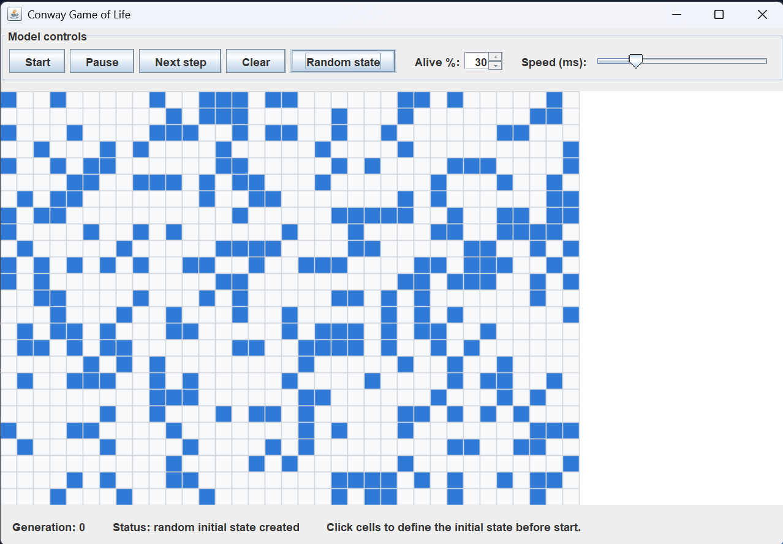
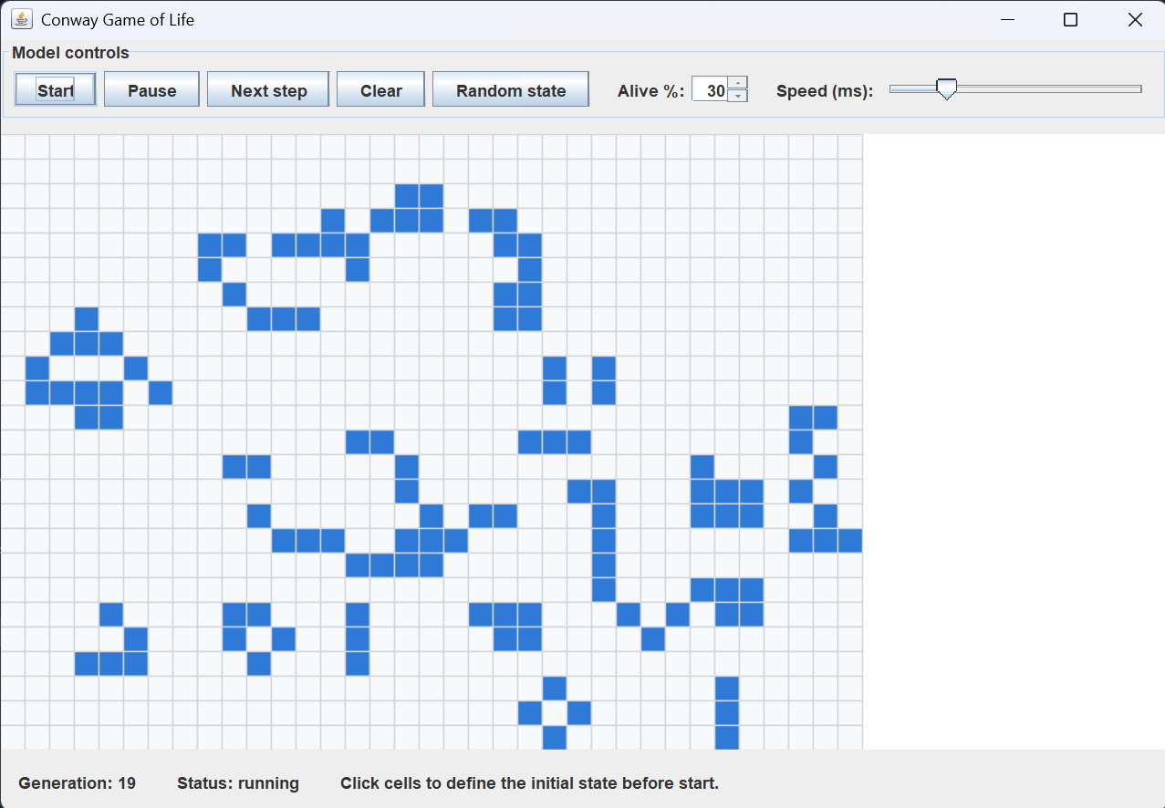
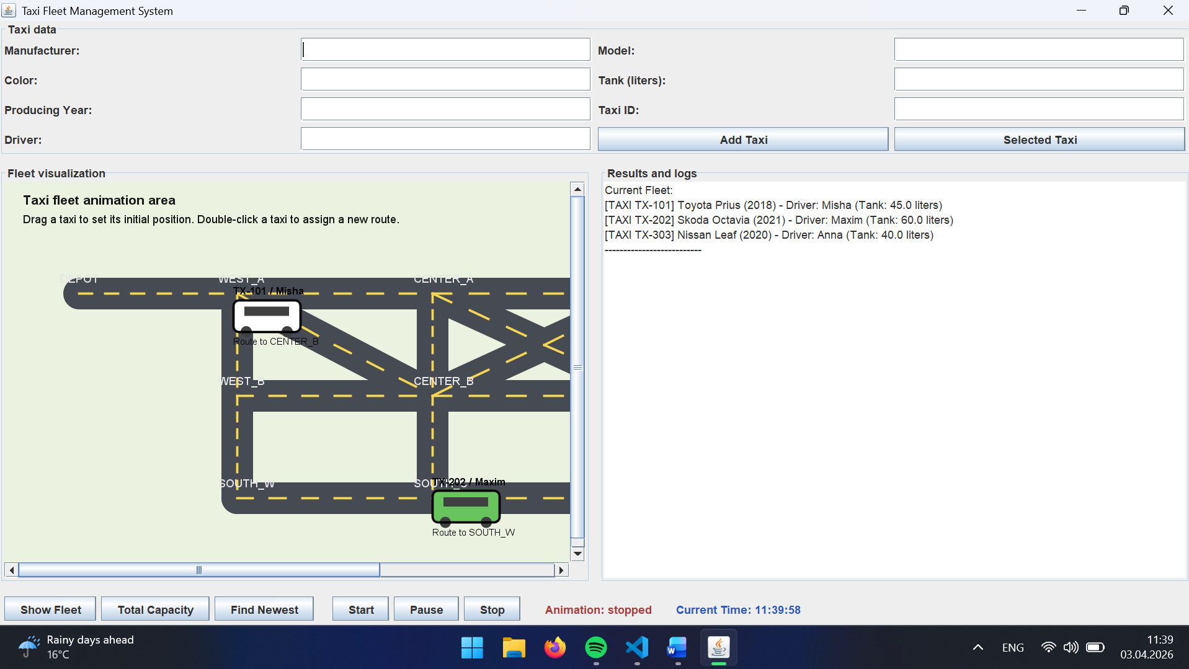
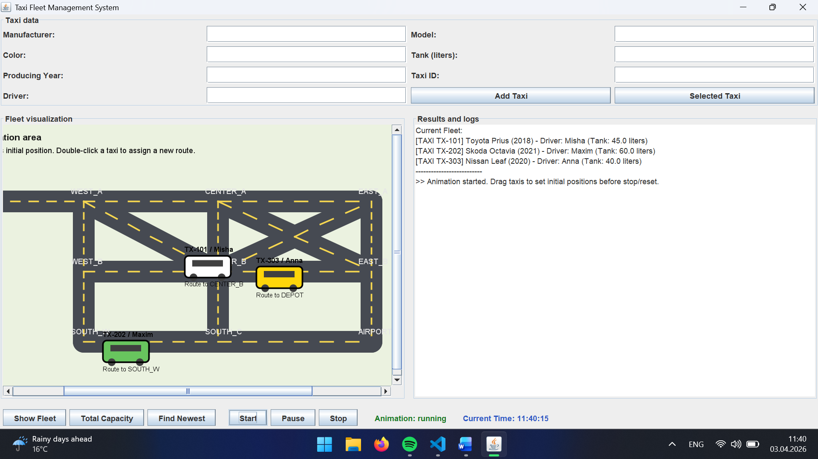

Висновок:
У ході виконання лабораторної роботи досліджувалось створення графічних об’єктів, їх відображення та керування ними за допомогою слухачів подій у Java Swing. Було імплементовано графічну візуалізацію предметної області, у якій таксі відображаються як анімовані об’єкти на панелі.
У роботі було створено панель візуалізації з перевизначеним методом paintComponent(), реалізовано анімацію руху через Timer, а також додано обробку подій миші та елементи керування запуском, паузою і зупинкою анімації. Для руху таксі використано модель дорожньої мережі та окремий клас візуального стану об’єкта.

