Міністерство освіти і науки України
Національний технічний університет України
«Київський політехнічний інститут імені Ігоря Сікорського»
Факультет інформатики та обчислювальної техніки
Кафедра обчислювальної техніки

Лабораторна робота №7
із дисципліни
“Основи розробки ПЗ на платформі Java”

Виконав: Перевірила:
студент групи ІМ-43 лектор Дифучина О.Ю
Калєнченко Михайло Олександрович Оцінка:
Номер у списку групи: 2 Дата перевірки:

Київ 2026
Мета: дослідити механізм серіалзації об’єктів.

Завдання до роботи:
1. Опрацювати приклад програмного коду для збереження елементів
списку (див. презентацію лекції). 10 балів.
2. Використовуючи механізм серіалізації, розробити класи для
збереження елементів моделі предметної області, що розроблялась на
попередніх лабораторних роботах, та їх відновлення при повторному відкритті
програми. 30 балів.
3. Додати до інтерфейсу користувача командне меню «File» з
відповідними вкладками для збереження об’єктів. 10 балів.
4. Використовуючи запис у файл значень параметрів об’єктів, розробити
клас для відновлення об’єктів моделі предметної області, що розроблялась на
попередніх лабораторних роботах. 40 балів.
5. Додати до командного меню «Файл» вкладку для збереження
параметрів об’єкта у файлі. 10 балів.

Лістинг програми:
Car.java
import java.io.Serial;
import java.io.Serializable;

public class Car implements Comparable<Car>, Serializable {
@Serial
private static final long serialVersionUID = 1L;

private final String manufacturer;
private final String model;
private String color;
private double tankCapacity;
private int producingYear;

public Car(String manufacturer, String model, String color, double tankCapacity, int producingYear) {
if (manufacturer == null || manufacturer.isBlank()) {
throw new IllegalArgumentException("Manufacturer is required.");
}
if (model == null || model.isBlank()) {
throw new IllegalArgumentException("Model is required.");
}
if (color == null || color.isBlank()) {
throw new IllegalArgumentException("Color is required.");
}
if (tankCapacity <= 0) {
throw new IllegalArgumentException("Tank capacity must be positive.");
}
if (producingYear < 1886 || producingYear > 2026) {
throw new IllegalArgumentException("Producing year is out of supported range.");
}

this.manufacturer = manufacturer;
this.model = model;
this.color = color;
this.tankCapacity = tankCapacity;
this.producingYear = producingYear;
}

public String getColor() {
return color;
}

public void setColor(String color) {
if (color != null && !color.isBlank()) {
this.color = color;
}
}

public double getTankCapacity() {
return tankCapacity;
}

public int getProducingYear() {
return producingYear;
}

public String getManufacturer() {
return manufacturer;
}

public String getModel() {
return model;
}

public void outputCarInfo() {
System.out.println("Car Info: " + manufacturer + " " + model + ", Color: " + color
+ ", Year: " + producingYear + ", Tank: " + tankCapacity + "L");
}

@Override
public String toString() {
return manufacturer + " " + model + " (" + producingYear + ")";
}

@Override
public int compareTo(Car other) {
return Integer.compare(this.producingYear, other.producingYear);
}
}

Fleet.java
import java.util.Arrays;

public class Fleet<T extends Car> {
private final String fleetName;
private final T[] vehicles;

public Fleet(String fleetName, T[] vehicles) {
if (fleetName == null || fleetName.isBlank()) {
throw new IllegalArgumentException("Fleet name is required.");
}
if (vehicles == null) {
throw new IllegalArgumentException("Vehicles array is required.");
}

this.fleetName = fleetName;
this.vehicles = vehicles;
}

public String getFleetName() {
return fleetName;
}

public T[] getVehicles() {
return vehicles;
}

public class FleetStatistics {
public double calculateTotalFleetTanksCapacity() {
double total = 0;
for (T vehicle : vehicles) {
total += vehicle.getTankCapacity();
}
return total;
}

public void displayTotalFleetTanksCapacity() {
System.out.println("Total tank capacity of fleet '" + fleetName + "': "
+ calculateTotalFleetTanksCapacity() + " L.");
}
}

public void performFleetAudit() {
class Auditor {
void check() {
System.out.println("Audit completed. Vehicles count: " + vehicles.length);
}
}

Auditor auditor = new Auditor();
auditor.check();
}

public T findCarByModel(String targetModel) {
if (targetModel == null || targetModel.isBlank()) {
return null;
}

for (T vehicle : vehicles) {
if (vehicle.getModel().equalsIgnoreCase(targetModel)) {
return vehicle;
}
}
return null;
}

public void sortVehiclesByYear() {
Arrays.sort(vehicles);
}

public T[] getFleetBackup() {
return Arrays.copyOf(vehicles, vehicles.length);
}
}

FleetAnimationPanel.java
import javax.swing.JPanel;
import java.awt.BasicStroke;
import java.awt.Color;
import java.awt.Cursor;
import java.awt.Dimension;
import java.awt.Font;
import java.awt.Graphics;
import java.awt.Graphics2D;
import java.awt.Point;
import java.awt.RenderingHints;
import java.awt.event.MouseAdapter;
import java.awt.event.MouseEvent;
import java.util.ArrayList;
import java.util.List;
import java.util.Random;

public class FleetAnimationPanel extends JPanel {
private static final int PREF_WIDTH = 900;
private static final int PREF_HEIGHT = 420;

private final List<TaxiVisualState> taxiStates = new ArrayList<>();
private final Random random = new Random();
private final RoadNetwork roadNetwork = new RoadNetwork();

private TaxiVisualState selectedTaxi;
private Point dragOffset;
private boolean dragging;

public FleetAnimationPanel() {
setBackground(new Color(235, 242, 224));

MouseAdapter mouseHandler = new MouseAdapter() {
@Override
public void mousePressed(MouseEvent event) {
selectTaxiAt(event.getPoint());
dragging = false;
if (selectedTaxi != null) {
dragOffset = new Point(
(int) (event.getX() - selectedTaxi.getBounds().getX()),
(int) (event.getY() - selectedTaxi.getBounds().getY())
);
}
repaint();
}

@Override
public void mouseClicked(MouseEvent event) {
TaxiVisualState taxiState = findTaxiAt(event.getPoint());
if (taxiState != null && event.getClickCount() >= 2) {
assignRandomRoute(taxiState);
repaint();
}
}

@Override
public void mouseReleased(MouseEvent event) {
if (selectedTaxi != null && dragging) {
selectedTaxi.storeCurrentPositionAsInitial();
assignRandomRoute(selectedTaxi);
}
dragOffset = null;
dragging = false;
}
};

addMouseListener(mouseHandler);
addMouseMotionListener(new MouseAdapter() {
@Override
public void mouseDragged(MouseEvent event) {
if (selectedTaxi == null || dragOffset == null) {
return;
}

dragging = true;
double newX = event.getX() - dragOffset.x;
double newY = event.getY() - dragOffset.y;
selectedTaxi.setPosition(
clamp(newX, 10, getWidth() - selectedTaxi.getWidth() - 10),
clamp(newY, 10, getHeight() - selectedTaxi.getHeight() - 10)
);
repaint();
}

@Override
public void mouseMoved(MouseEvent event) {
setCursor(findTaxiAt(event.getPoint()) == null
? Cursor.getDefaultCursor()
: Cursor.getPredefinedCursor(Cursor.HAND_CURSOR));
}
});
}

@Override
public Dimension getPreferredSize() {
return new Dimension(PREF_WIDTH, PREF_HEIGHT);
}

public void addTaxi(Taxi taxi) {
java.awt.geom.Point2D.Double spawnPoint = roadNetwork.getRandomSpawnPoint(random);
TaxiVisualState taxiState = new TaxiVisualState(taxi, spawnPoint.x, spawnPoint.y);
assignRandomRoute(taxiState);
taxiState.storeCurrentPositionAsInitial();
taxiStates.add(taxiState);
repaint();
}

public void setTaxis(List<Taxi> taxis) {
taxiStates.clear();
for (Taxi taxi : taxis) {
addTaxi(taxi);
}
clearSelection();
repaint();
}

public void animateStep() {
for (TaxiVisualState taxiState : taxiStates) {
boolean reachedTarget = taxiState.updatePosition();
if (reachedTarget) {
assignRandomRoute(taxiState);
}
}
repaint();
}

public void resetAnimation() {
for (TaxiVisualState taxiState : taxiStates) {
taxiState.resetToInitialPosition();
}
repaint();
}

public Taxi getSelectedTaxi() {
return selectedTaxi == null ? null : selectedTaxi.getTaxi();
}

private void selectTaxiAt(Point point) {
TaxiVisualState newSelection = findTaxiAt(point);
if (selectedTaxi != null) {
selectedTaxi.setSelected(false);
}
selectedTaxi = newSelection;
if (selectedTaxi != null) {
selectedTaxi.setSelected(true);
}
}

private TaxiVisualState findTaxiAt(Point point) {
for (int i = taxiStates.size() - 1; i >= 0; i--) {
TaxiVisualState taxiState = taxiStates.get(i);
if (taxiState.contains(point.getX(), point.getY())) {
return taxiState;
}
}
return null;
}

private void clearSelection() {
if (selectedTaxi != null) {
selectedTaxi.setSelected(false);
}
selectedTaxi = null;
}

private double clamp(double value, double min, double max) {
return Math.max(min, Math.min(max, value));
}

@Override
protected void paintComponent(Graphics graphics) {
super.paintComponent(graphics);
Graphics2D g2 = (Graphics2D) graphics.create();
g2.setRenderingHint(RenderingHints.KEY_ANTIALIASING, RenderingHints.VALUE_ANTIALIAS_ON);

roadNetwork.paint(g2);
paintLegend(g2);
for (TaxiVisualState taxiState : taxiStates) {
paintTaxi(g2, taxiState);
}

g2.dispose();
}

private void paintLegend(Graphics2D g2) {
g2.setColor(new Color(25, 25, 25));
g2.setFont(new Font("SansSerif", Font.BOLD, 14));
g2.drawString("Taxi fleet animation area", 20, 24);
g2.setFont(new Font("SansSerif", Font.PLAIN, 12));
g2.drawString("Drag a taxi to set its initial position. Double-click a taxi to assign a new route.", 20, 44);
}

private void paintTaxi(Graphics2D g2, TaxiVisualState taxiState) {
int x = (int) taxiState.getBounds().getX();
int y = (int) taxiState.getBounds().getY();
int width = taxiState.getWidth();
int height = taxiState.getHeight();

g2.setColor(taxiState.getBodyColor());
g2.fillRoundRect(x, y, width, height, 12, 12);

g2.setColor(Color.DARK_GRAY);
g2.fillRect(x + 12, y + 7, width - 24, 10);
g2.fillOval(x + 8, y + height - 6, 12, 12);
g2.fillOval(x + width - 20, y + height - 6, 12, 12);

g2.setColor(Color.BLACK);
g2.drawRoundRect(x, y, width, height, 12, 12);

if (taxiState.isSelected()) {
g2.setColor(new Color(65, 125, 255));
g2.setStroke(new BasicStroke(3f));
g2.drawRoundRect(x - 3, y - 3, width + 6, height + 6, 14, 14);
}

g2.setFont(new Font("SansSerif", Font.BOLD, 11));
g2.drawString(taxiState.getLabel(), x, y - 6);
g2.setFont(new Font("SansSerif", Font.PLAIN, 10));
g2.drawString("Route to " + taxiState.getDestinationName(), x, y + height + 14);
}

private void assignRandomRoute(TaxiVisualState taxiState) {
String startIntersection = roadNetwork.findNearestIntersectionName(taxiState.getCurrentPosition());
String destinationIntersection = roadNetwork.getRandomDestinationName(startIntersection, random);
applyRoute(taxiState, startIntersection, destinationIntersection);
}

private void applyRoute(TaxiVisualState taxiState,
String startIntersection,
String destinationIntersection) {
taxiState.setRoute(
roadNetwork.buildRoute(startIntersection, destinationIntersection, false),
destinationIntersection
);
taxiState.setRouteMetadata(startIntersection, destinationIntersection, false);
}
}

FleetFrame.java
import javax.swing.BorderFactory;
import javax.swing.Box;
import javax.swing.JButton;
import javax.swing.JFrame;
import javax.swing.JLabel;
import javax.swing.JMenu;
import javax.swing.JMenuBar;
import javax.swing.JMenuItem;
import javax.swing.JOptionPane;
import javax.swing.JPanel;
import javax.swing.JScrollPane;
import javax.swing.JTextArea;
import javax.swing.JTextField;
import javax.swing.SwingUtilities;
import javax.swing.Timer;
import java.awt.BorderLayout;
import java.awt.Color;
import java.awt.FlowLayout;
import java.awt.GridLayout;
import java.awt.event.ActionEvent;
import java.io.IOException;
import java.nio.file.Files;
import java.nio.file.Path;
import java.text.SimpleDateFormat;
import java.util.ArrayList;
import java.util.Date;
import java.util.List;

public class FleetFrame extends JFrame {
private final List<Taxi> taxiList = new ArrayList<>();
private final TaxiObjectStorage taxiObjectStorage = new TaxiObjectStorage();
private final TaxiParametersStorage taxiParametersStorage = new TaxiParametersStorage();

private JTextField txtManufacturer;
private JTextField txtModel;
private JTextField txtColor;
private JTextField txtTank;
private JTextField txtYear;
private JTextField txtTaxiId;
private JTextField txtDriver;
private JTextArea txtOutput;
private JLabel lblClock;
private JLabel lblAnimationStatus;
private FleetAnimationPanel animationPanel;
private Timer clockTimer;
private Timer animationTimer;

public FleetFrame() {
setTitle("Taxi Fleet Management System");
setDefaultCloseOperation(JFrame.EXIT_ON_CLOSE);
setSize(1120, 720);
setLocationRelativeTo(null);
setLayout(new BorderLayout(10, 10));
setJMenuBar(buildMenuBar());

add(buildInputPanel(), BorderLayout.NORTH);
add(buildCenterPanel(), BorderLayout.CENTER);
add(buildControlPanel(), BorderLayout.SOUTH);

configureTimers();
restoreFleetOnStartup();
displayFleet();
}

private JMenuBar buildMenuBar() {
JMenuBar menuBar = new JMenuBar();
JMenu fileMenu = new JMenu("File");

JMenuItem saveObjectsItem = new JMenuItem("Save Objects");
JMenuItem loadObjectsItem = new JMenuItem("Load Objects");
JMenuItem saveParametersItem = new JMenuItem("Save Parameters");
JMenuItem loadParametersItem = new JMenuItem("Load Parameters");
JMenuItem exitItem = new JMenuItem("Exit");

saveObjectsItem.addActionListener(e -> saveObjectsToDefaultFile());
loadObjectsItem.addActionListener(e -> loadObjectsFromDefaultFile());
saveParametersItem.addActionListener(e -> saveParametersToDefaultFile());
loadParametersItem.addActionListener(e -> loadParametersFromDefaultFile());
exitItem.addActionListener(e -> dispose());

fileMenu.add(saveObjectsItem);
fileMenu.add(loadObjectsItem);
fileMenu.addSeparator();
fileMenu.add(saveParametersItem);
fileMenu.add(loadParametersItem);
fileMenu.addSeparator();
fileMenu.add(exitItem);

menuBar.add(fileMenu);
return menuBar;
}

private JPanel buildInputPanel() {
JPanel inputPanel = new JPanel(new GridLayout(4, 4, 6, 6));
inputPanel.setBorder(BorderFactory.createTitledBorder("Taxi data"));

inputPanel.add(new JLabel("Manufacturer:"));
txtManufacturer = new JTextField();
inputPanel.add(txtManufacturer);

inputPanel.add(new JLabel("Model:"));
txtModel = new JTextField();
inputPanel.add(txtModel);

inputPanel.add(new JLabel("Color:"));
txtColor = new JTextField();
inputPanel.add(txtColor);

inputPanel.add(new JLabel("Tank (liters):"));
txtTank = new JTextField();
inputPanel.add(txtTank);

inputPanel.add(new JLabel("Producing Year:"));
txtYear = new JTextField();
inputPanel.add(txtYear);

inputPanel.add(new JLabel("Taxi ID:"));
txtTaxiId = new JTextField();
inputPanel.add(txtTaxiId);

inputPanel.add(new JLabel("Driver:"));
txtDriver = new JTextField();
inputPanel.add(txtDriver);

JButton btnAdd = new JButton("Add Taxi");
btnAdd.addActionListener(e -> addTaxiAction());
inputPanel.add(btnAdd);

JButton btnSelectInfo = new JButton("Selected Taxi");
btnSelectInfo.addActionListener(e -> showSelectedTaxiInfo());
inputPanel.add(btnSelectInfo);

return inputPanel;
}

private JPanel buildCenterPanel() {
JPanel centerPanel = new JPanel(new GridLayout(1, 2, 10, 10));

animationPanel = new FleetAnimationPanel();
JScrollPane visualWrapper = new JScrollPane(animationPanel);
visualWrapper.setBorder(BorderFactory.createTitledBorder("Fleet visualization"));
centerPanel.add(visualWrapper);

txtOutput = new JTextArea();
txtOutput.setEditable(false);
JScrollPane outputPane = new JScrollPane(txtOutput);
outputPane.setBorder(BorderFactory.createTitledBorder("Results and logs"));
centerPanel.add(outputPane);

return centerPanel;
}

private JPanel buildControlPanel() {
JPanel controlPanel = new JPanel(new FlowLayout(FlowLayout.LEFT));

JButton btnShowFleet = new JButton("Show Fleet");
JButton btnTotalCapacity = new JButton("Total Capacity");
JButton btnFindNewest = new JButton("Find Newest");
JButton btnStart = new JButton("Start");
JButton btnPause = new JButton("Pause");
JButton btnStop = new JButton("Stop");

btnShowFleet.addActionListener(e -> displayFleet());
btnTotalCapacity.addActionListener(e -> calculateTotalCapacity());
btnFindNewest.addActionListener(e -> findNewestTaxi());
btnStart.addActionListener(e -> startAnimation());
btnPause.addActionListener(e -> pauseAnimation());
btnStop.addActionListener(e -> stopAnimation());

lblAnimationStatus = new JLabel("Animation: stopped");
lblAnimationStatus.setForeground(new Color(170, 60, 60));

lblClock = new JLabel("Current Time: --:--:--");
lblClock.setForeground(new Color(45, 87, 195));

controlPanel.add(btnShowFleet);
controlPanel.add(btnTotalCapacity);
controlPanel.add(btnFindNewest);
controlPanel.add(Box.createHorizontalStrut(10));
controlPanel.add(btnStart);
controlPanel.add(btnPause);
controlPanel.add(btnStop);
controlPanel.add(Box.createHorizontalStrut(16));
controlPanel.add(lblAnimationStatus);
controlPanel.add(Box.createHorizontalStrut(16));
controlPanel.add(lblClock);

return controlPanel;
}

private void configureTimers() {
clockTimer = new Timer(1000, this::updateTime);
clockTimer.start();

animationTimer = new Timer(40, e -> animationPanel.animateStep());
}

private void seedDemoData() {
addTaxiToFleet(new Taxi("Toyota", "Prius", "White", 45.0, 2018, "TX-101", "Misha"));
addTaxiToFleet(new Taxi("Skoda", "Octavia", "Green", 60.0, 2021, "TX-202", "Maxim"));
addTaxiToFleet(new Taxi("Nissan", "Leaf", "Yellow", 40.0, 2020, "TX-303", "Anna"));
}

private void restoreFleetOnStartup() {
try {
Path defaultObjectsFile = StoragePaths.getObjectsFile();
if (Files.exists(defaultObjectsFile)) {
replaceFleet(taxiObjectStorage.load(defaultObjectsFile));
txtOutput.append(">> Fleet restored from serialized objects file.\n");
return;
}
} catch (IOException | ClassNotFoundException ex) {
txtOutput.append(">> Could not restore serialized objects on startup: " + ex.getMessage() + "\n");
}

seedDemoData();
txtOutput.append(">> Demo fleet loaded. No saved objects file found.\n");
}

private void addTaxiAction() {
try {
Taxi newTaxi = buildTaxiFromForm();
addTaxiToFleet(newTaxi);
txtOutput.append(">> Successfully added: " + newTaxi + "\n");
clearInputFields();
} catch (NumberFormatException ex) {
JOptionPane.showMessageDialog(
this,
"Tank and producing year must be numeric values.",
"Input Error",
JOptionPane.ERROR_MESSAGE
);
} catch (IllegalArgumentException ex) {
JOptionPane.showMessageDialog(
this,
ex.getMessage(),
"Input Error",
JOptionPane.WARNING_MESSAGE
);
}
}

private Taxi buildTaxiFromForm() {
String manufacturer = txtManufacturer.getText().trim();
String model = txtModel.getText().trim();
String color = txtColor.getText().trim();
String taxiId = txtTaxiId.getText().trim();
String driverName = txtDriver.getText().trim();

double tank = Double.parseDouble(txtTank.getText().trim());
int year = Integer.parseInt(txtYear.getText().trim());

ensureUniqueTaxiId(taxiId);
return new Taxi(manufacturer, model, color, tank, year, taxiId, driverName);
}

private void ensureUniqueTaxiId(String taxiId) {
for (Taxi taxi : taxiList) {
if (taxi.getTaxiId().equalsIgnoreCase(taxiId)) {
throw new IllegalArgumentException("Taxi ID must be unique.");
}
}
}

private void addTaxiToFleet(Taxi taxi) {
ensureUniqueTaxiId(taxi.getTaxiId());
taxiList.add(taxi);
animationPanel.addTaxi(taxi);
}

private void replaceFleet(List<Taxi> taxis) {
taxiList.clear();
taxiList.addAll(taxis);
animationPanel.setTaxis(taxiList);
}

private void clearInputFields() {
txtManufacturer.setText("");
txtModel.setText("");
txtColor.setText("");
txtTank.setText("");
txtYear.setText("");
txtTaxiId.setText("");
txtDriver.setText("");
}

private void displayFleet() {
txtOutput.append("Current Fleet:\n");
if (taxiList.isEmpty()) {
txtOutput.append("Fleet is empty.\n");
return;
}

for (Taxi taxi : taxiList) {
txtOutput.append(taxi + " (Tank: " + taxi.getTankCapacity() + " liters)\n");
}
txtOutput.append("--------------------------\n");
}

private void calculateTotalCapacity() {
if (taxiList.isEmpty()) {
txtOutput.append(">> Fleet is empty. Total capacity is 0.\n");
return;
}

Fleet<Taxi> fleet = new Fleet<>("City taxi fleet", taxiList.toArray(new Taxi[0]));
Fleet<Taxi>.FleetStatistics statistics = fleet.new FleetStatistics();
txtOutput.append(">> Total tanks capacity: "
+ statistics.calculateTotalFleetTanksCapacity() + " liters.\n");
}

private void findNewestTaxi() {
if (taxiList.isEmpty()) {
txtOutput.append(">> Fleet is empty.\n");
return;
}

Taxi newest = GenericUtils.findMaxElement(taxiList.toArray(new Taxi[0]));
if (newest != null) {
txtOutput.append(">> Newest taxi: " + newest + "\n");
}
}

private void showSelectedTaxiInfo() {
Taxi selectedTaxi = animationPanel.getSelectedTaxi();
if (selectedTaxi == null) {
txtOutput.append(">> No taxi selected on the visualization panel.\n");
return;
}

txtOutput.append(">> Selected taxi: " + selectedTaxi + ", tank: "
+ selectedTaxi.getTankCapacity() + " liters.\n");
}

private void startAnimation() {
if (taxiList.isEmpty()) {
txtOutput.append(">> Add at least one taxi before starting animation.\n");
return;
}

animationTimer.start();
lblAnimationStatus.setText("Animation: running");
lblAnimationStatus.setForeground(new Color(25, 120, 35));
txtOutput.append(">> Animation started. Drag taxis to set initial positions before stop/reset.\n");
}

private void pauseAnimation() {
animationTimer.stop();
lblAnimationStatus.setText("Animation: paused");
lblAnimationStatus.setForeground(new Color(180, 120, 30));
txtOutput.append(">> Animation paused.\n");
}

private void stopAnimation() {
animationTimer.stop();
animationPanel.resetAnimation();
lblAnimationStatus.setText("Animation: stopped");
lblAnimationStatus.setForeground(new Color(170, 60, 60));
txtOutput.append(">> Animation stopped and positions restored.\n");
}

private void updateTime(ActionEvent event) {
SimpleDateFormat sdf = new SimpleDateFormat("HH:mm:ss");
lblClock.setText("Current Time: " + sdf.format(new Date()));
}

private void saveObjectsToDefaultFile() {
try {
Path objectsFile = StoragePaths.getObjectsFile();
taxiObjectStorage.save(taxiList, objectsFile);
txtOutput.append(">> Objects saved to: " + objectsFile.toAbsolutePath() + "\n");
} catch (IOException ex) {
showStorageError("Could not save serialized objects.", ex);
}
}

private void loadObjectsFromDefaultFile() {
try {
Path objectsFile = StoragePaths.getObjectsFile();
replaceFleet(taxiObjectStorage.load(objectsFile));
txtOutput.append(">> Objects restored from: " + objectsFile.toAbsolutePath() + "\n");
displayFleet();
} catch (IOException | ClassNotFoundException ex) {
showStorageError("Could not load serialized objects.", ex);
}
}

private void saveParametersToDefaultFile() {
try {
Path parametersFile = StoragePaths.getParametersFile();
taxiParametersStorage.save(taxiList, parametersFile);
txtOutput.append(">> Parameters saved to: " + parametersFile.toAbsolutePath() + "\n");
} catch (IOException ex) {
showStorageError("Could not save parameters file.", ex);
}
}

private void loadParametersFromDefaultFile() {
try {
Path parametersFile = StoragePaths.getParametersFile();
replaceFleet(taxiParametersStorage.load(parametersFile));
txtOutput.append(">> Fleet restored from parameters file: "
+ parametersFile.toAbsolutePath() + "\n");
displayFleet();
} catch (IOException ex) {
showStorageError("Could not load parameters file.", ex);
}
}

private void showStorageError(String message, Exception ex) {
JOptionPane.showMessageDialog(this, message + "\n" + ex.getMessage(),
"Storage Error", JOptionPane.ERROR_MESSAGE);
txtOutput.append(">> " + message + " " + ex.getMessage() + "\n");
}

public static void main(String[] args) {
SwingUtilities.invokeLater(() -> new FleetFrame().setVisible(true));
}
}

GenericUtils.java
import java.util.List;

public final class GenericUtils {
private GenericUtils() {
}

public static <T extends Comparable<? super T>> T findMaxElement(T[] array) {
if (array == null || array.length == 0) {
return null;
}

T max = array[0];
for (T element : array) {
if (element.compareTo(max) > 0) {
max = element;
}
}
return max;
}

public static void printListElements(List<?> list) {
if (list == null) {
System.out.println("List is null.");
return;
}

System.out.println("--- Printing list elements (size: " + list.size() + ") ---");
for (Object item : list) {
System.out.println(" - " + item);
}
}
}

RoadNetwork.java
import java.awt.BasicStroke;
import java.awt.Color;
import java.awt.Graphics2D;
import java.awt.geom.Point2D;
import java.util.ArrayDeque;
import java.util.ArrayList;
import java.util.Collections;
import java.util.HashMap;
import java.util.LinkedHashMap;
import java.util.List;
import java.util.Map;
import java.util.Queue;
import java.util.Random;

public class RoadNetwork {
private final Map<String, Point2D.Double> intersections = new LinkedHashMap<>();
private final Map<String, List<String>> adjacency = new HashMap<>();
private final List<RoadSegment> roadSegments = new ArrayList<>();

public RoadNetwork() {
addIntersection("DEPOT", 80, 120);
addIntersection("WEST_A", 250, 120);
addIntersection("CENTER_A", 460, 120);
addIntersection("EAST_A", 700, 120);

addIntersection("WEST_B", 250, 230);
addIntersection("CENTER_B", 460, 230);
addIntersection("EAST_B", 700, 230);

addIntersection("SOUTH_W", 250, 340);
addIntersection("SOUTH_C", 460, 340);
addIntersection("AIRPORT", 700, 340);

connectTwoWay("DEPOT", "WEST_A");
connectTwoWay("WEST_A", "CENTER_A");
connectTwoWay("CENTER_A", "EAST_A");

connectTwoWay("WEST_B", "CENTER_B");
connectTwoWay("CENTER_B", "EAST_B");

connectTwoWay("SOUTH_W", "SOUTH_C");
connectTwoWay("SOUTH_C", "AIRPORT");

connectTwoWay("WEST_A", "WEST_B");
connectTwoWay("WEST_B", "SOUTH_W");

connectTwoWay("CENTER_A", "CENTER_B");
connectTwoWay("CENTER_B", "SOUTH_C");

connectTwoWay("EAST_A", "EAST_B");
connectTwoWay("EAST_B", "AIRPORT");

connectTwoWay("WEST_A", "CENTER_B");
connectTwoWay("CENTER_B", "EAST_A");
connectTwoWay("CENTER_A", "EAST_B");
}

public Point2D.Double getRandomSpawnPoint(Random random) {
List<String> keys = new ArrayList<>(intersections.keySet());
return copy(intersections.get(keys.get(random.nextInt(keys.size()))));
}

public String findNearestIntersectionName(Point2D.Double point) {
String nearest = null;
double minDistance = Double.MAX_VALUE;
for (Map.Entry<String, Point2D.Double> entry : intersections.entrySet()) {
double distance = point.distance(entry.getValue());
if (distance < minDistance) {
minDistance = distance;
nearest = entry.getKey();
}
}
return nearest;
}

public String getRandomDestinationName(String excludedIntersection, Random random) {
List<String> names = new ArrayList<>(intersections.keySet());
names.remove(excludedIntersection);
if (names.isEmpty()) {
return excludedIntersection;
}
return names.get(random.nextInt(names.size()));
}

public List<Point2D.Double> buildRoute(String startIntersection, String destinationIntersection, boolean reverseLane) {
if (startIntersection == null || destinationIntersection == null) {
return Collections.emptyList();
}
if (startIntersection.equals(destinationIntersection)) {
return List.of(copy(intersections.get(startIntersection)));
}

Queue<String> queue = new ArrayDeque<>();
Map<String, String> previous = new HashMap<>();
queue.add(startIntersection);
previous.put(startIntersection, null);

while (!queue.isEmpty()) {
String current = queue.poll();
if (current.equals(destinationIntersection)) {
break;
}

for (String next : adjacency.getOrDefault(current, List.of())) {
if (!previous.containsKey(next)) {
previous.put(next, current);
queue.add(next);
}
}
}

if (!previous.containsKey(destinationIntersection)) {
return Collections.emptyList();
}

List<String> path = new ArrayList<>();
String cursor = destinationIntersection;
while (cursor != null) {
path.add(cursor);
cursor = previous.get(cursor);
}
Collections.reverse(path);

List<Point2D.Double> points = new ArrayList<>();
for (int i = 0; i < path.size(); i++) {
Point2D.Double current = intersections.get(path.get(i));
if (i == path.size() - 1) {
points.add(copy(current));
continue;
}

Point2D.Double next = intersections.get(path.get(i + 1));
points.add(applyLaneOffset(current, next, reverseLane));
}
return points;
}

public void paint(Graphics2D g2) {
g2.setColor(new Color(70, 74, 82));
g2.setStroke(new BasicStroke(34f, BasicStroke.CAP_ROUND, BasicStroke.JOIN_ROUND));
for (RoadSegment segment : roadSegments) {
Point2D.Double from = intersections.get(segment.from());
Point2D.Double to = intersections.get(segment.to());
g2.drawLine((int) from.x, (int) from.y, (int) to.x, (int) to.y);
}

g2.setColor(new Color(245, 214, 80));
g2.setStroke(new BasicStroke(2.5f));
for (RoadSegment segment : roadSegments) {
Point2D.Double from = intersections.get(segment.from());
Point2D.Double to = intersections.get(segment.to());
drawCenterLine(g2, from, to);
}

g2.setColor(new Color(230, 230, 230));
for (Map.Entry<String, Point2D.Double> entry : intersections.entrySet()) {
Point2D.Double point = entry.getValue();
g2.drawString(entry.getKey(), (int) point.x - 20, (int) point.y - 12);
}
}

private Point2D.Double applyLaneOffset(Point2D.Double from, Point2D.Double to, boolean reverseLane) {
double dx = to.x - from.x;
double dy = to.y - from.y;
double length = Math.hypot(dx, dy);
if (length == 0) {
return copy(from);
}

double offsetDistance = reverseLane ? -8.0 : 8.0;
double offsetX = -dy / length * offsetDistance;
double offsetY = dx / length * offsetDistance;
return new Point2D.Double(from.x + offsetX, from.y + offsetY);
}

private void drawCenterLine(Graphics2D g2, Point2D.Double from, Point2D.Double to) {
int segments = 12;
for (int i = 0; i < segments; i += 2) {
double t1 = (double) i / segments;
double t2 = (double) (i + 1) / segments;
int x1 = (int) (from.x + (to.x - from.x) * t1);
int y1 = (int) (from.y + (to.y - from.y) * t1);
int x2 = (int) (from.x + (to.x - from.x) * t2);
int y2 = (int) (from.y + (to.y - from.y) * t2);
g2.drawLine(x1, y1, x2, y2);
}
}

private void addIntersection(String name, double x, double y) {
intersections.put(name, new Point2D.Double(x, y));
adjacency.put(name, new ArrayList<>());
}

private void connectTwoWay(String from, String to) {
adjacency.get(from).add(to);
adjacency.get(to).add(from);
roadSegments.add(new RoadSegment(from, to));
}

private Point2D.Double copy(Point2D.Double point) {
return new Point2D.Double(point.x, point.y);
}

private record RoadSegment(String from, String to) {
}
}

StoragePaths.java
import java.io.IOException;
import java.nio.file.Files;
import java.nio.file.Path;
import java.nio.file.Paths;

public final class StoragePaths {
private static final Path OUTPUT_DIRECTORY = Paths.get("out");
private static final Path OBJECTS_FILE = OUTPUT_DIRECTORY.resolve("fleet-objects.ser");
private static final Path PARAMETERS_FILE = OUTPUT_DIRECTORY.resolve("fleet-parameters.json");

private StoragePaths() {
}

public static Path getObjectsFile() throws IOException {
ensureOutputDirectory();
return OBJECTS_FILE;
}

public static Path getParametersFile() throws IOException {
ensureOutputDirectory();
return PARAMETERS_FILE;
}

private static void ensureOutputDirectory() throws IOException {
Files.createDirectories(OUTPUT_DIRECTORY);
}
}

Taxi.java
import java.io.Serial;

public class Taxi extends Car {
@Serial
private static final long serialVersionUID = 1L;

private final String taxiId;
private final String driverName;

public Taxi(String manufacturer, String model, String color, double tankCapacity,
int producingYear, String taxiId, String driverName) {
super(manufacturer, model, color, tankCapacity, producingYear);
if (taxiId == null || taxiId.isBlank()) {
throw new IllegalArgumentException("Taxi ID is required.");
}
if (driverName == null || driverName.isBlank()) {
throw new IllegalArgumentException("Driver name is required.");
}

this.taxiId = taxiId;
this.driverName = driverName;
}

public String getTaxiId() {
return taxiId;
}

public String getDriverName() {
return driverName;
}

@Override
public void outputCarInfo() {
System.out.print("[TAXI " + taxiId + " | Driver: " + driverName + "] ");
super.outputCarInfo();
}

@Override
public String toString() {
return "[TAXI " + taxiId + "] " + super.toString() + " - Driver: " + driverName;
}
}

TaxiObjectsStorage.java
import java.io.IOException;
import java.io.ObjectInputStream;
import java.io.ObjectOutputStream;
import java.io.Serial;
import java.io.Serializable;
import java.nio.file.Files;
import java.nio.file.Path;
import java.util.ArrayList;
import java.util.List;

public class TaxiObjectStorage {
public void save(List<Taxi> taxis, Path path) throws IOException {
FleetData fleetData = new FleetData(new ArrayList<>(taxis));
try (ObjectOutputStream outputStream = new ObjectOutputStream(Files.newOutputStream(path))) {
outputStream.writeObject(fleetData);
}
}

public List<Taxi> load(Path path) throws IOException, ClassNotFoundException {
try (ObjectInputStream inputStream = new ObjectInputStream(Files.newInputStream(path))) {
Object loadedObject = inputStream.readObject();
if (!(loadedObject instanceof FleetData fleetData)) {
throw new IOException("Unsupported objects file format.");
}
return new ArrayList<>(fleetData.taxis());
}
}

private record FleetData(List<Taxi> taxis) implements Serializable {
@Serial
private static final long serialVersionUID = 1L;
}
}

TaxiParametersStotage.java
import java.io.IOException;
import java.nio.charset.StandardCharsets;
import java.nio.file.Files;
import java.nio.file.Path;
import java.util.ArrayList;
import java.util.List;
import java.util.regex.Matcher;
import java.util.regex.Pattern;

public class TaxiParametersStorage {
private static final Pattern TAXI_OBJECT_PATTERN = Pattern.compile("\\{(.*?)\\}", Pattern.DOTALL);
private static final Pattern FIELD_PATTERN =
Pattern.compile("\"(.*?)\"\\s*:\\s*(\"(?:\\\\.|[^\"])*\"|-?\\d+(?:\\.\\d+)?)");

public void save(List<Taxi> taxis, Path path) throws IOException {
StringBuilder json = new StringBuilder();
json.append("[\n");

for (int i = 0; i < taxis.size(); i++) {
Taxi taxi = taxis.get(i);
json.append(" {\n");
json.append(" \"manufacturer\": \"").append(escapeJson(taxi.getManufacturer())).append("\",\n");
json.append(" \"model\": \"").append(escapeJson(taxi.getModel())).append("\",\n");
json.append(" \"color\": \"").append(escapeJson(taxi.getColor())).append("\",\n");
json.append(" \"tankCapacity\": ").append(taxi.getTankCapacity()).append(",\n");
json.append(" \"producingYear\": ").append(taxi.getProducingYear()).append(",\n");
json.append(" \"taxiId\": \"").append(escapeJson(taxi.getTaxiId())).append("\",\n");
json.append(" \"driverName\": \"").append(escapeJson(taxi.getDriverName())).append("\"\n");
json.append(" }");
if (i < taxis.size() - 1) {
json.append(",");
}
json.append("\n");
}
json.append("]\n");

Files.writeString(path, json.toString(), StandardCharsets.UTF_8);
}

public List<Taxi> load(Path path) throws IOException {
String content = Files.readString(path, StandardCharsets.UTF_8).trim();
List<Taxi> taxis = new ArrayList<>();

if (content.isEmpty() || content.equals("[]")) {
return taxis;
}
if (!content.startsWith("[") || !content.endsWith("]")) {
throw new IOException("Invalid JSON parameters format.");
}

Matcher objectMatcher = TAXI_OBJECT_PATTERN.matcher(content);
while (objectMatcher.find()) {
JsonTaxiData data = parseTaxiData(objectMatcher.group(1));
taxis.add(new Taxi(
data.manufacturer(),
data.model(),
data.color(),
data.tankCapacity(),
data.producingYear(),
data.taxiId(),
data.driverName()
));
}

return taxis;
}

private JsonTaxiData parseTaxiData(String objectBody) throws IOException {
String manufacturer = null;
String model = null;
String color = null;
Double tankCapacity = null;
Integer producingYear = null;
String taxiId = null;
String driverName = null;

Matcher fieldMatcher = FIELD_PATTERN.matcher(objectBody);
while (fieldMatcher.find()) {
String fieldName = fieldMatcher.group(1);
String rawValue = fieldMatcher.group(2);

switch (fieldName) {
case "manufacturer" -> manufacturer = parseJsonString(rawValue);
case "model" -> model = parseJsonString(rawValue);
case "color" -> color = parseJsonString(rawValue);
case "tankCapacity" -> tankCapacity = Double.parseDouble(rawValue);
case "producingYear" -> producingYear = Integer.parseInt(rawValue);
case "taxiId" -> taxiId = parseJsonString(rawValue);
case "driverName" -> driverName = parseJsonString(rawValue);
default -> {
}
}
}

if (manufacturer == null || model == null || color == null
|| tankCapacity == null || producingYear == null
|| taxiId == null || driverName == null) {
throw new IOException("JSON object does not contain all required taxi fields.");
}

return new JsonTaxiData(manufacturer, model, color, tankCapacity, producingYear, taxiId, driverName);
}

private String escapeJson(String value) {
return value
.replace("\\", "\\\\")
.replace("\"", "\\\"");
}

private String parseJsonString(String rawValue) {
String trimmed = rawValue.substring(1, rawValue.length() - 1);
return trimmed
.replace("\\\"", "\"")
.replace("\\\\", "\\");
}

private record JsonTaxiData(
String manufacturer,
String model,
String color,
double tankCapacity,
int producingYear,
String taxiId,
String driverName
) {
}
}

TaxiVisualState.java
import java.awt.Color;
import java.awt.geom.Point2D;
import java.awt.geom.Rectangle2D;
import java.util.ArrayList;
import java.util.List;
import java.util.Random;

public class TaxiVisualState {
private static final int WIDTH = 72;
private static final int HEIGHT = 34;
private static final double SPEED = 2.4;

private final Taxi taxi;
private double x;
private double y;
private double initialX;
private double initialY;
private boolean selected;
private List<Point2D.Double> route = new ArrayList<>();
private int routeIndex;
private String destinationName = "No route";

public TaxiVisualState(Taxi taxi, double x, double y) {
this.taxi = taxi;
this.x = x;
this.y = y;
this.initialX = x;
this.initialY = y;
}

public Taxi getTaxi() {
return taxi;
}

public Rectangle2D getBounds() {
return new Rectangle2D.Double(x, y, WIDTH, HEIGHT);
}

public boolean contains(double pointX, double pointY) {
return getBounds().contains(pointX, pointY);
}

public void setPosition(double newX, double newY) {
this.x = newX;
this.y = newY;
}

public void storeCurrentPositionAsInitial() {
this.initialX = x;
this.initialY = y;
}

public void resetToInitialPosition() {
x = initialX;
y = initialY;
routeIndex = 0;
}

public boolean updatePosition() {
if (route.isEmpty() || routeIndex >= route.size()) {
return true;
}

Point2D.Double targetPoint = route.get(routeIndex);
double dx = targetPoint.x - x;
double dy = targetPoint.y - y;
double distance = Math.hypot(dx, dy);

if (distance < SPEED) {
x = targetPoint.x;
y = targetPoint.y;
routeIndex++;
return routeIndex >= route.size();
}

x += SPEED * dx / distance;
y += SPEED * dy / distance;
return false;
}

public Color getBodyColor() {
String colorName = taxi.getColor().trim().toLowerCase();
return switch (colorName) {
case "white" -> Color.WHITE;
case "yellow" -> new Color(255, 214, 10);
case "green" -> new Color(104, 197, 94);
case "black" -> new Color(45, 45, 45);
case "red" -> new Color(215, 68, 68);
case "blue" -> new Color(86, 132, 255);
case "gray", "grey" -> new Color(150, 150, 150);
default -> new Color(255, 200, 80);
};
}

public String getLabel() {
return taxi.getTaxiId() + " / " + taxi.getDriverName();
}

public String getDestinationName() {
return destinationName;
}

public void setRoute(List<Point2D.Double> routePoints, String destinationName) {
route = new ArrayList<>(routePoints);
routeIndex = 0;
this.destinationName = destinationName;
if (!route.isEmpty()) {
x = route.get(0).x;
y = route.get(0).y;
}
}

public void setRouteMetadata(String startIntersectionName, String destinationName, boolean reverseLane) {
this.destinationName = destinationName;
}

public Point2D.Double getCurrentPosition() {
return new Point2D.Double(x, y);
}

public void chooseRandomTarget(int panelWidth, int panelHeight, Random random) {
double safeWidth = Math.max(WIDTH + 20, panelWidth - WIDTH - 20);
double safeHeight = Math.max(HEIGHT + 20, panelHeight - HEIGHT - 20);
double newTargetX = 10 + random.nextDouble() * (safeWidth - 10);
double newTargetY = 10 + random.nextDouble() * (safeHeight - 10);
setRoute(List.of(
new Point2D.Double(x, y),
new Point2D.Double(newTargetX, newTargetY)
), "Free route");
}

public int getWidth() {
return WIDTH;
}

public int getHeight() {
return HEIGHT;
}

public boolean isSelected() {
return selected;
}

public void setSelected(boolean selected) {
this.selected = selected;
}
}

Скриншоти тестування:
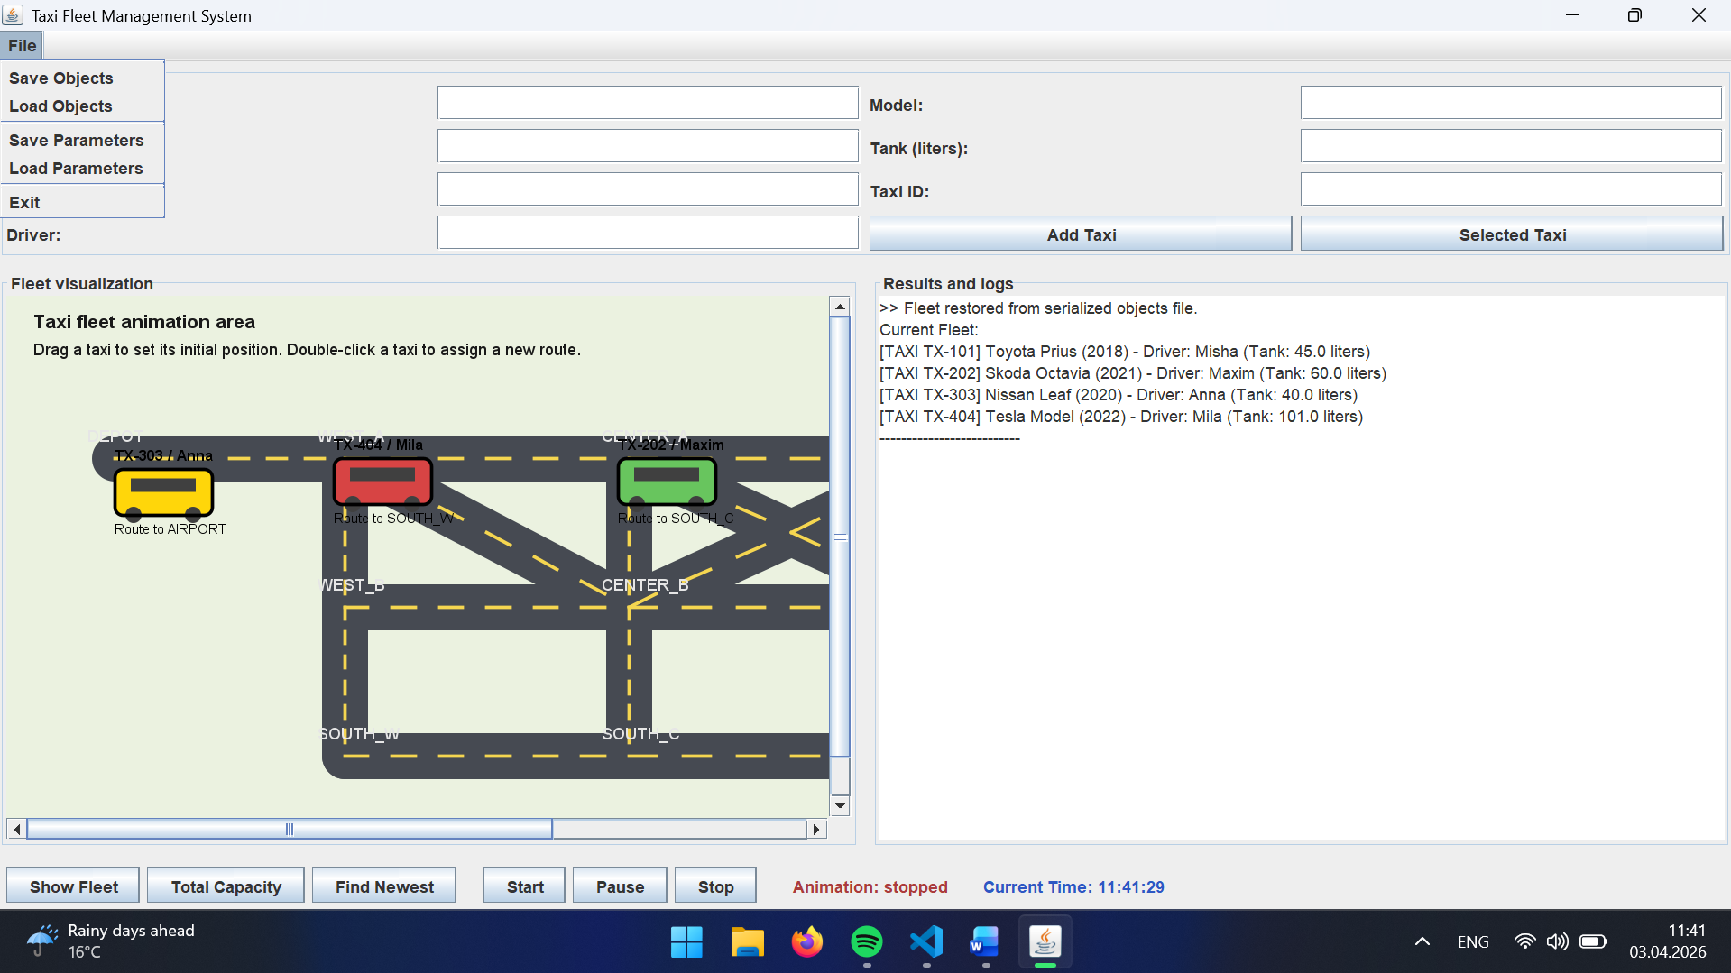
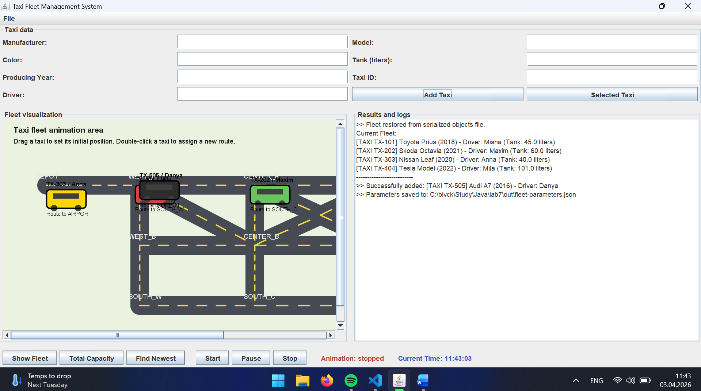
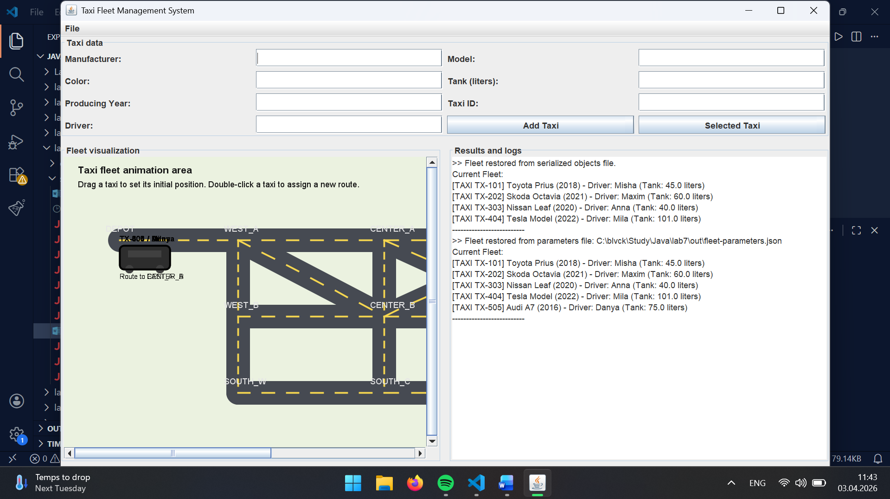
Висновок:
У ході виконання лабораторної роботи було досліджено механізми збереження та відновлення об’єктів у Java. Для моделі предметної області системи управління таксопарком реалізовано два підходи до персистентності даних: серіалізацію об’єктів та запис параметрів об’єктів у JSON-файл з подальшим відновленням моделі.
У межах роботи до графічного інтерфейсу було додано меню File з командами для збереження і завантаження даних. Це дало змогу забезпечити повторне використання створених об’єктів після перезапуску програми та показати відмінність між збереженням повного стану об’єктів і збереженням лише їх параметрів.

