Pilot Implementation of Rabbit Artificial Insemination (AI) System in Rwanda
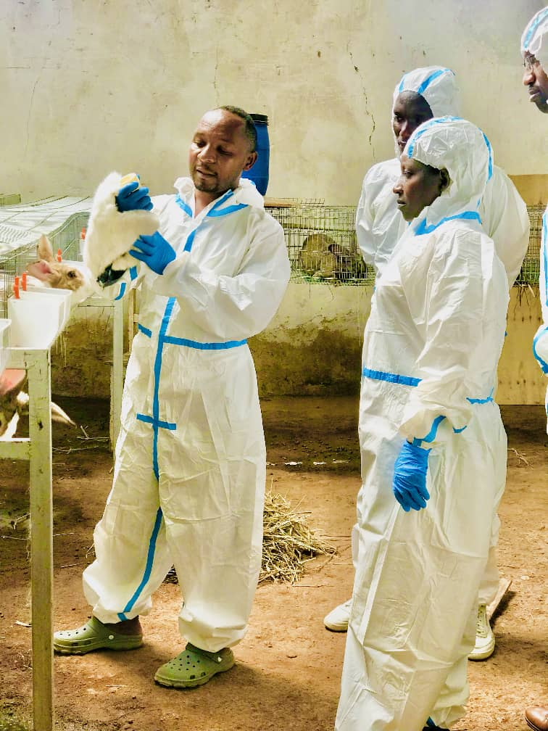
Implementing Organization: KIGALI RABBIT FARM LTD
Report Date: 15 June 2025
Project Period: January 2024 – June 2024
Location: Nyarugenge, Nyamirambo, Rwanda]

1. Introduction
This report presents the outcomes of a pilot project introducing an Artificial Insemination (AI) system in rabbit farming across selected sites in Rwanda. The initiative aimed to improve reproductive efficiency, reduce disease transmission, and introduce modern genetic improvement technologies to smallholder rabbit producers.
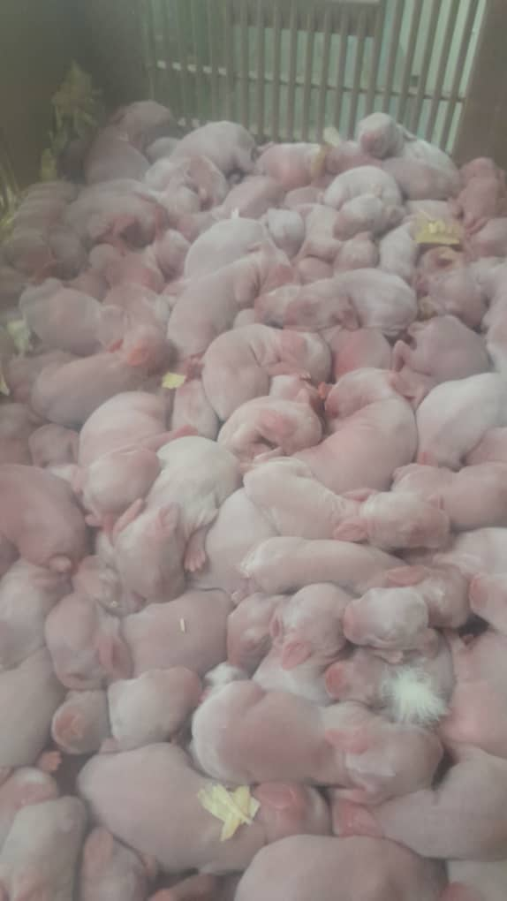

2. Objectives of the Pilot Project
- Introduce AI as an alternative to natural rabbit mating to reduce disease risk.
- Improve genetic quality and productivity using elite bucks.
- Train veterinary technicians and farmers in AI procedures.
- Evaluate AI success rates and acceptability among smallholder farmers.

3. Project Activities
Activity | Date | Details
Site and farm selection | January 2024 | 5 pilot farms in 2 districts selected
Equipment procurement and setup | January–February | AI kits, semen collection tools, storage units
Training of technicians and farmers | February 2024 | 2 technicians & 5 farmers trained
Semen collection from elite bucks | March 2024 | 4 high-genetic-value bucks used
AI procedures carried out | March–April 2024 | 60 does inseminated under supervision
Monitoring and data collection | April–June 2024 | Data on conception, litter size, and health
Evaluation workshop | June 2024 | Shared outcomes with stakeholders

4. Key Results
Indicator | Value
Number of does inseminated | 60
Conception rate (average) | 67%
Average litter size | 8.1 kits per litter
Average litter size (natural mating) | 4.3 kits
Number of trained technicians | 2
Farmer satisfaction (post-survey) | 90%

5. Achievements
- First successful AI procedures in community rabbit farming in Rwanda.
- Significant improvement in litter size and reproductive control.
- Local technicians are now competent to replicate the process.
- High acceptance rate and enthusiasm among trained farmers.

6. Challenges
- Resistance or skepticism from some farmers unfamiliar with AI.
- Timing challenges for heat detection affected some inseminations.
- Limited semen storage capacity reduced the time window for use.
- Logistical constraints in remote farm visits during the initial phase.

7. Lessons Learned
- Success in AI depends heavily on proper timing and training in heat detection.
- Local ownership and follow-up after training are essential to adoption.
- Early demonstration of successful litters increases farmer trust and demand.
- Investing in mobile cooling and record-keeping tools is critical for scale-up.
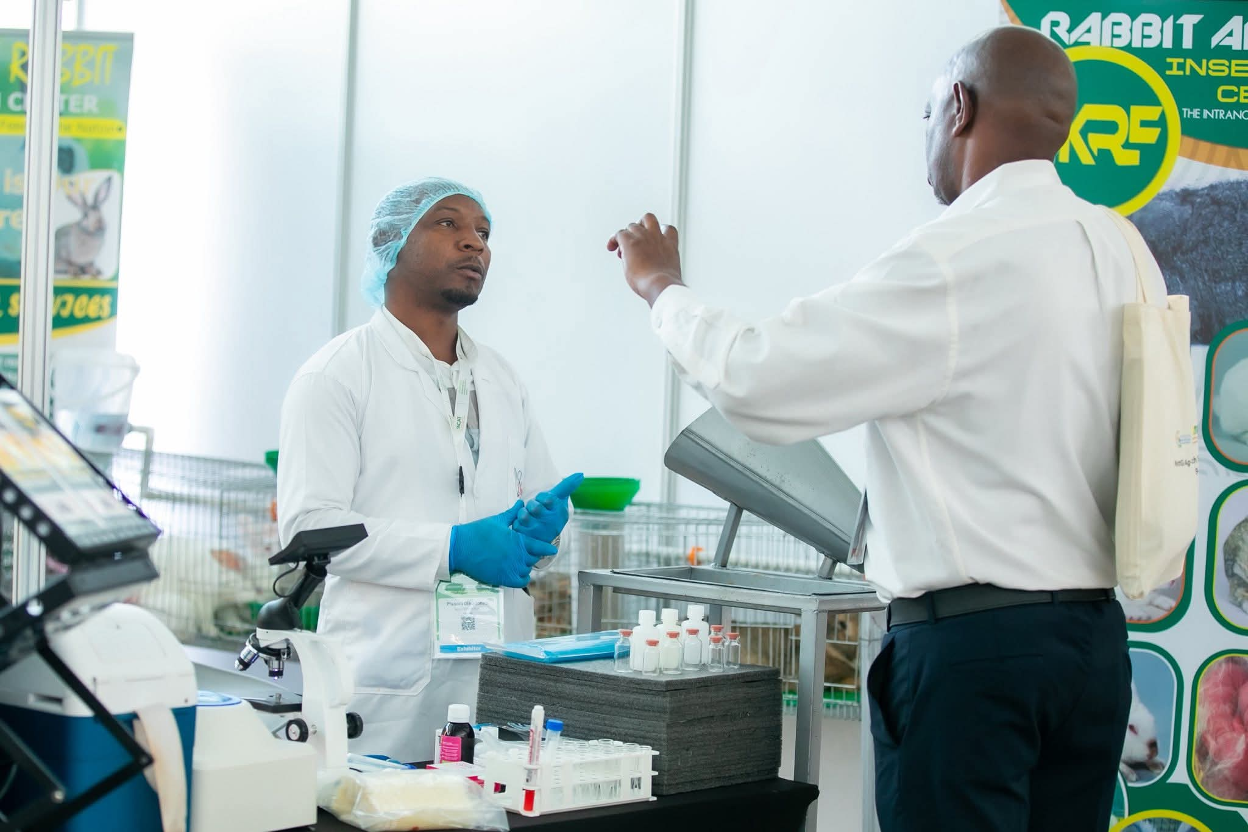

8. Recommendations
- Upgrading the existent rabbit AI center in on other to provide and scale AI services in Rwanda
- Scale AI services gradually to additional cooperatives and schools.
- Train more AI technicians and equip them with portable AI kits.
- Provide refresher courses and practical sessions for farmers and TVET schools
- Explore partnerships with University, RAB and MINAGRI to embed AI in national rabbit programs.

9. Conclusion
This pilot demonstrates that AI in rabbit farming is technically viable, improves productivity, and is well-received by farmers when supported with training and follow-up. With modest investment, the model is scalable and contributes to Rwanda’s goals of improving animal genetics, youth employment, and sustainable livestock systems.

10. Appendices
- Appendix A: Training Curriculum and Attendance Sheets
- Appendix B: AI Insemination and Fertility Records
- Appendix C: Farmer Feedback and Evaluation Forms
- Appendix D: Photographic Documentation



