# 1.1 Background

The usage of social networks spread rapidly. It became a common sense that information is collected through online information portal.

This product mainly aims to help users collect useful information as well as manage their personal information convenience.

## The complexity of information resources is causing problems

Nowadays there are various sources of information.

Light sources, such as RenRen, Sina Micro Blog (Weibo) produce news all the time. Many users are using one, or all, of them, then they need to open one or more webpages in order to get all the news feeds.

Moreover, some heavey sources like NetEase, Yahoo!, or some other individual blogs may produce information from time to time. Readers may not be willing to refresh them again and again to get the latest article.

According to the pre-survey, most social networks users are facing the situation that the complexity of information resources is causing them problems.

* The quantity
  + The large quantity of web portals, social networks makes users tired of changing webpages from one to another again and again.
* The repeated information
  + It is a waste of time for users to get similar information through different portals.

Therefore, an information collector is in great demand, in order to simplify the flow of getting the latest information. Users can find what they want in just one place.

It can be concluded that users are in badly needed to one browsing-friendly page that contains all the information they need.

## 1.1.2 The analysis of existed information portals

In this section, the possibility of combining information resources will be illustrated.

During this section, let’s take the Weibo, Renren and Zhihu as examples.

#### The User’s Interface:

It is not hard to be found out that the user’s interfaces designed by different websites do not distinguish a lot. There are considerably parts that follow the similar format.

The interfaces are mainly divided into four categories:

1. The main interface
2. the personal interface
3. the managing and editing interface
4. other individual functions.

**The Main Interface**

The main interface is the page that provides the most important and useful information. Users mainly receive information through this page.

As we can see in the following figures, the main interfaces’ features are listed as followed.

1. Information items are listed and presented by vertical blocks.(figure 1, figure 2, figure 3)
2. The item-block consists of the the author, the subtitle, the text message and the picture part.(figure 1, figure 2)

Since the speciality of the format that the interfaces are following can be easily caught, it provides the possibility to combine those pages together.

# 1.2Goals

This product is designing according to the needs of users. It will provide the users with a entirely new experience of gathering information——by using one information collector.

Technically, a collector which can be custom-made and widened is required, for it's inevitable that diﬀerent users ask for diﬀerent information. Even more, if the collector can be capable to suggest subscribers articles which they may interested in, they are more sticky to this collector in all probability

# 1.3Future works

our collector provides extensible interfaces. The API makes it possible to expand different functions based on this collector.

For instance, a Text-to-Speech system can be used upon the collector ,so that users will be able to hear the information instead of browsing.

Meanwhile, based on the users behavior, a recommendation system could be most valuable to users that recommend stuff which is meaningful to individual users.

This collector could be transformed into various platforms such as Android, iOS, Linux, Mac OS.

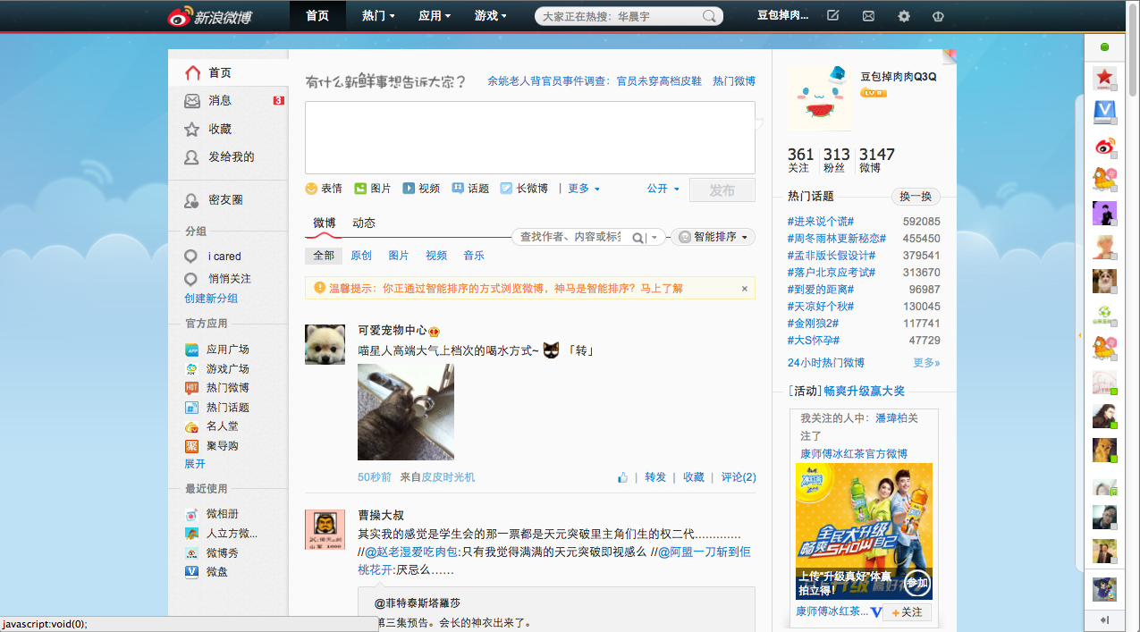

(figure 1 the main interface of Weibo)

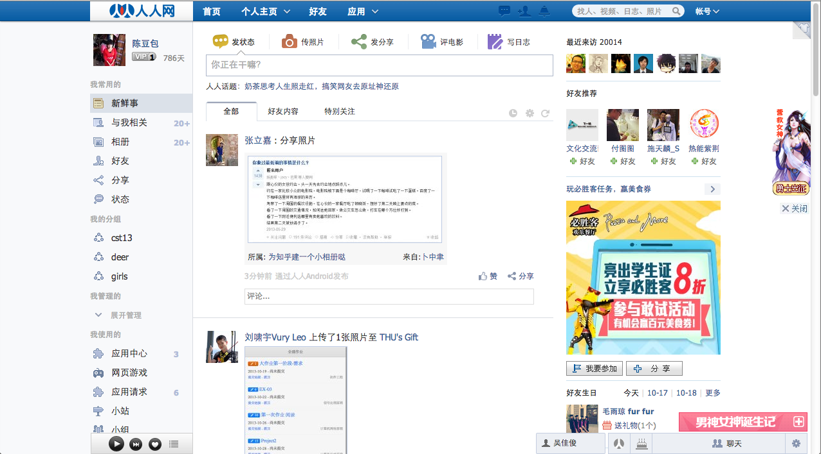

(figure 2 the main interface of Renren)

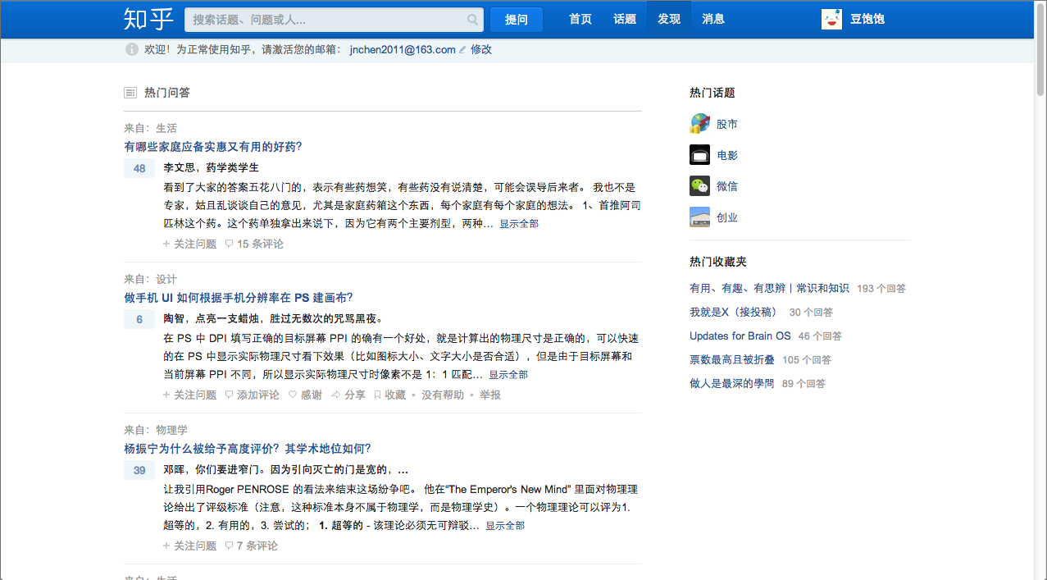

(figure 3 the main interface of Zhihu)