ARQUITECTURA CLOUD-NATIVE PARA PLATAFORMA DE PAGOS ELECTRÓNICOS

ePayco: Diseño de Sistema Distribuido en AWS

PARTE 1: CONTEXTO Y DECISIONES ESTRATÉGICAS

1.1 Análisis del Problema

Requisitos No Funcionales Consolidados:
Dimensión | Requisito | Implicación Técnica
Disponibilidad | ≥99.9% (8.77 hrs downtime/año) | Multi-AZ obligatorio, RTO < 5 min, failover automático
Latencia | Transacciones < 500ms P95 | Caché en capas, conexiones prewarmed, minimal I/O bloqueante
Throughput | Picos 10k-50k req/min (campañas) | Autoescalado predictivo, cola de transacciones, backpressure
Seguridad | PCI DSS Level 1, datos financieros | Cifrado end-to-end, aislamiento de datos sensibles, audit trail
Consistencia | Transacciones ACID locales + eventual distribuida | SAGA orquestada, compensaciones definidas
Escalabilidad Geográfica | Colombia → Latinoamérica | Multi-región, sincronización eventual, routing geográfico

Drivers de Decisión Principales: - Dominio: pagos financieros → requisito de trazabilidad y auditabilidad extrema - Escala variable → elasticidad crítica - Evolución independiente de dominios → límites claros de contexto acotado - Resiliencia ante fallos de terceros (gateways, bancos)

1.2 Decisión Arquitectónica Fundamental: Microservicios vs. Monolito Modular
DECISIÓN: Arquitectura Híbrida con Microservicios Segregados por Dominio

Justificación
Por qué NO monolito modular puro: - Dominio de pagos exige independencia operativa (deploy, scaling, recuperación) - Dominios tienen ciclos de vida distintos (comercios escalan diferente a usuarios) - Antifraude requiere aislamiento de recursos (spike sin afectar checkout) - Cumplimiento regulatorio demanda segregación de datos por contexto

Por qué NO microservicios granulares: - ePayco no necesita (aún) 50+ servicios independientes - Overhead operativo sería prohibitivo en etapa de maduración - Latencia de checkout (P2P entre muchos servicios) sería problema - Complejidad de debugging y traces excesiva para dominio financiero.

Solución Elegida: Cohesión por Dominio
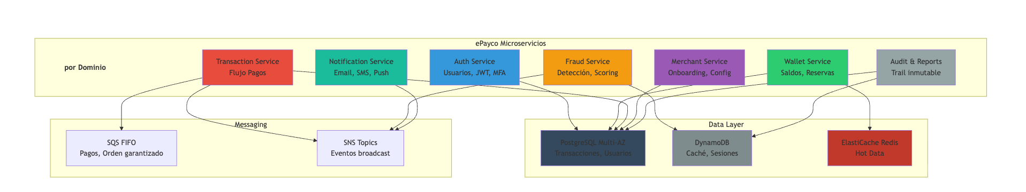
%%{init: {'flowchart': {'htmlLabels': true, 'useMaxWidth': false}}}%%
flowchart TB
subgraph subGraph0["ePayco Microservicios"]
direction TB
titleText["por Dominio"]:::subtitle
AS["Auth Service<br>Usuarios, JWT, MFA"]
WS["Wallet Service<br>Saldos, Reservas"]
TS["Transaction Service<br>Flujo Pagos"]
FS["Fraud Service<br>Detección, Scoring"]
MS["Merchant Service<br>Onboarding, Config"]
NS["Notification Service<br>Email, SMS, Push"]
ARS["Audit & Reports<br>Trail inmutable"]
end
subgraph subGraph1["Data Layer"]
RDS["PostgreSQL Multi-AZ<br>Transacciones, Usuarios"]
DDB["DynamoDB<br>Caché, Sesiones"]
CACHE["ElastiCache Redis<br>Hot Data"]
end
subgraph Messaging["Messaging"]
SQS["SQS FIFO<br>Pagos, Orden garantizado"]
SNS["SNS Topics<br>Eventos broadcast"]
end
AS --> RDS
WS --> RDS & CACHE
TS --> RDS & SQS & SNS
FS --> DDB & SNS
NS --> SNS
MS --> RDS
ARS --> RDS & DDB

classDef subtitle fill:none,stroke:none,font-weight:bold;

style AS fill:#3498db
style WS fill:#2ecc71
style TS fill:#e74c3c
style FS fill:#f39c12
style MS fill:#9b59b6
style NS fill:#1abc9c
style ARS fill:#95a5a6
style RDS fill:#34495e
style DDB fill:#7f8c8d
style CACHE fill:#c0392b

Trade-offs Aceptados: - Escalabilidad independiente (fraud escala sin afectar wallet) - Resiliencia acotada (fallo de notificaciones ≠ fallo de pago) - Teams autónomos por dominio - Complejidad operativa aumentada (observabilidad crítica) - Latencia inter-servicio (mitigada con colocación + caché)

PARTE 2: ARQUITECTURA CLOUD EN AWS

2.1 Topología de Red y Aislamiento
DECISIÓN: Multi-AZ con tres capas de aislamiento de red
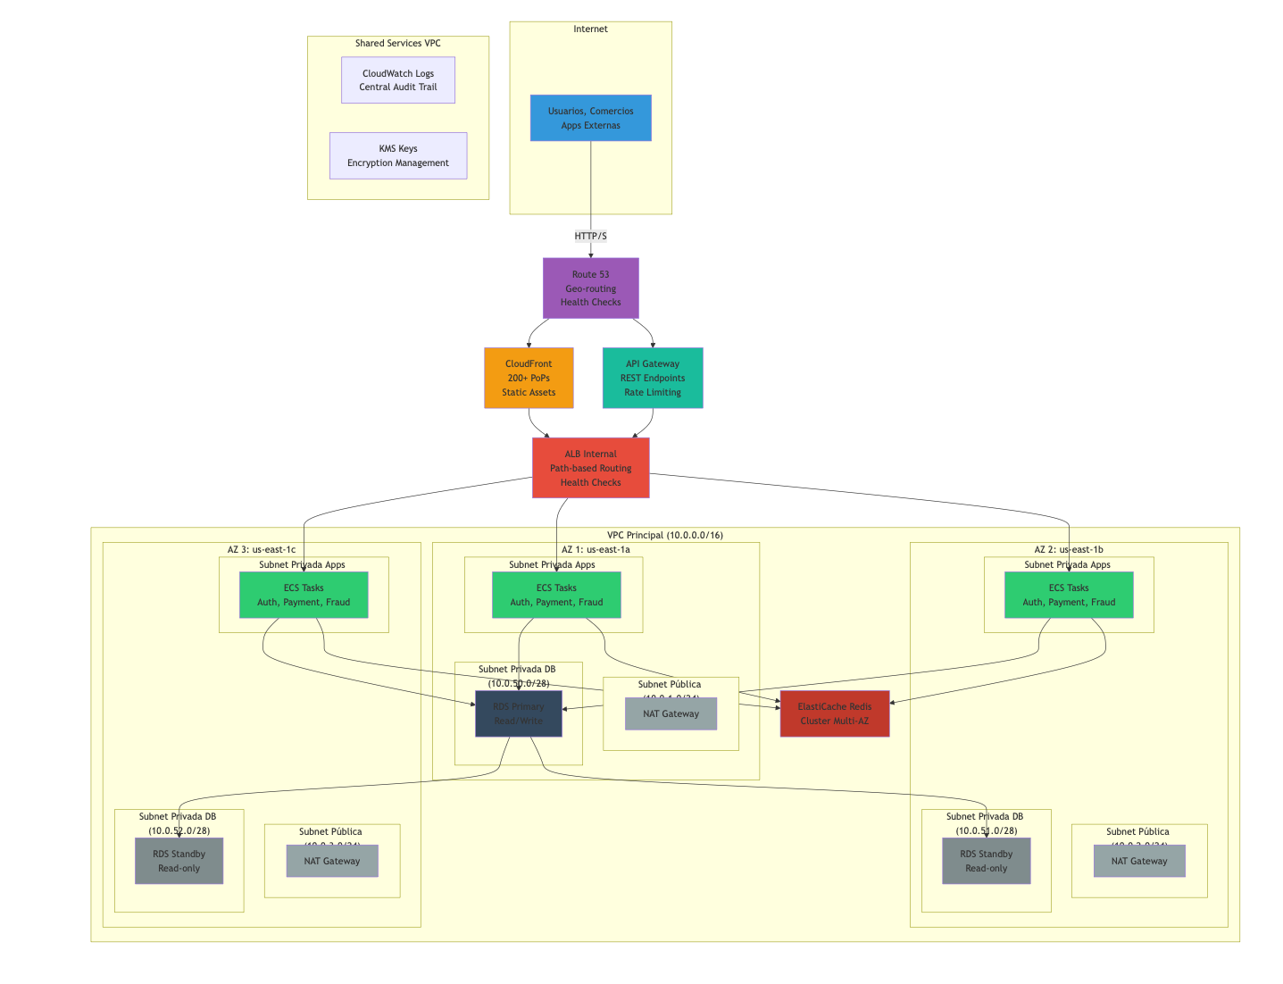
graph TB
subgraph "Internet"
USERS["Usuarios, Comercios<br/>Apps Externas"]
end
USERS -->|HTTP/S| ROUTE53["Route 53<br/>Geo-routing<br/>Health Checks"]
ROUTE53 --> CF["CloudFront<br/>200+ PoPs<br/>Static Assets"]
ROUTE53 --> APIGW["API Gateway<br/>REST Endpoints<br/>Rate Limiting"]
CF --> ALB["ALB Internal<br/>Path-based Routing<br/>Health Checks"]
APIGW --> ALB
subgraph "VPC Principal (10.0.0.0/16)"
subgraph "AZ 1: us-east-1a"
subgraph "Subnet Pública (10.0.1.0/24)"
NAT1["NAT Gateway"]
end
subgraph "Subnet Privada Apps (10.0.10.0/24)"
ECS1["ECS Tasks<br/>Auth, Payment, Fraud"]
end
subgraph "Subnet Privada DB (10.0.50.0/28)"
RDS_P["RDS Primary<br/>Read/Write"]
end
end
subgraph "AZ 2: us-east-1b"
subgraph "Subnet Pública (10.0.2.0/24)"
NAT2["NAT Gateway"]
end
subgraph "Subnet Privada Apps (10.0.20.0/24)"
ECS2["ECS Tasks<br/>Auth, Payment, Fraud"]
end
subgraph "Subnet Privada DB (10.0.51.0/28)"
RDS_S1["RDS Standby<br/>Read-only"]
end
end
subgraph "AZ 3: us-east-1c"
subgraph "Subnet Pública (10.0.3.0/24)"
NAT3["NAT Gateway"]
end
subgraph "Subnet Privada Apps (10.0.30.0/24)"
ECS3["ECS Tasks<br/>Auth, Payment, Fraud"]
end
subgraph "Subnet Privada DB (10.0.52.0/28)"
RDS_S2["RDS Standby<br/>Read-only"]
end
end
CACHE["ElastiCache Redis<br/>Cluster Multi-AZ"]
end
ALB --> ECS1
ALB --> ECS2
ALB --> ECS3
ECS1 --> RDS_P
ECS2 --> RDS_P
ECS3 --> RDS_P
ECS1 --> CACHE
ECS2 --> CACHE
ECS3 --> CACHE
RDS_P --> RDS_S1
RDS_P --> RDS_S2
subgraph "Shared Services VPC"
LOGS["CloudWatch Logs<br/>Central Audit Trail"]
KMS["KMS Keys<br/>Encryption Management"]
end
style USERS fill:#3498db
style ROUTE53 fill:#9b59b6
style CF fill:#f39c12
style APIGW fill:#1abc9c
style ALB fill:#e74c3c
style ECS1 fill:#2ecc71
style ECS2 fill:#2ecc71
style ECS3 fill:#2ecc71
style RDS_P fill:#34495e
style RDS_S1 fill:#7f8c8d
style RDS_S2 fill:#7f8c8d
style CACHE fill:#c0392b
style NAT1 fill:#95a5a6
style NAT2 fill:#95a5a6
style NAT3 fill:#95a5a6

Security Groups - Principio de Menor Privilegio:
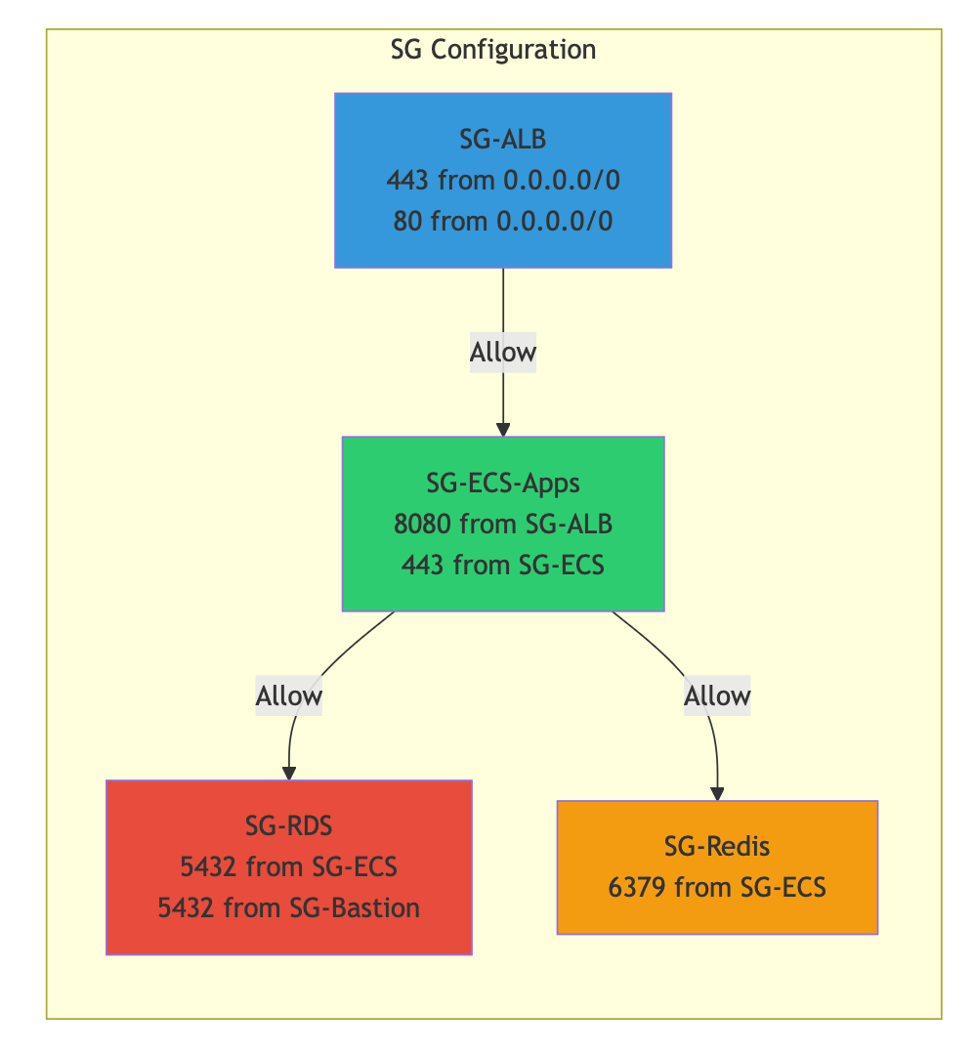
graph LR
subgraph "SG Configuration"
SG_ALB["SG-ALB<br/>443 from 0.0.0.0/0<br/>80 from 0.0.0.0/0"]
SG_ECS["SG-ECS-Apps<br/>8080 from SG-ALB<br/>443 from SG-ECS"]
SG_RDS["SG-RDS<br/>5432 from SG-ECS<br/>5432 from SG-Bastion"]
SG_REDIS["SG-Redis<br/>6379 from SG-ECS"]
end
SG_ALB -->|Allow| SG_ECS
SG_ECS -->|Allow| SG_RDS
SG_ECS -->|Allow| SG_REDIS
style SG_ALB fill:#3498db
style SG_ECS fill:#2ecc71
style SG_RDS fill:#e74c3c
style SG_REDIS fill:#f39c12

2.2 Ingress, CDN y Aceleración
DECISIÓN: CloudFront + API Gateway + ALB (Arquitectura en capas)
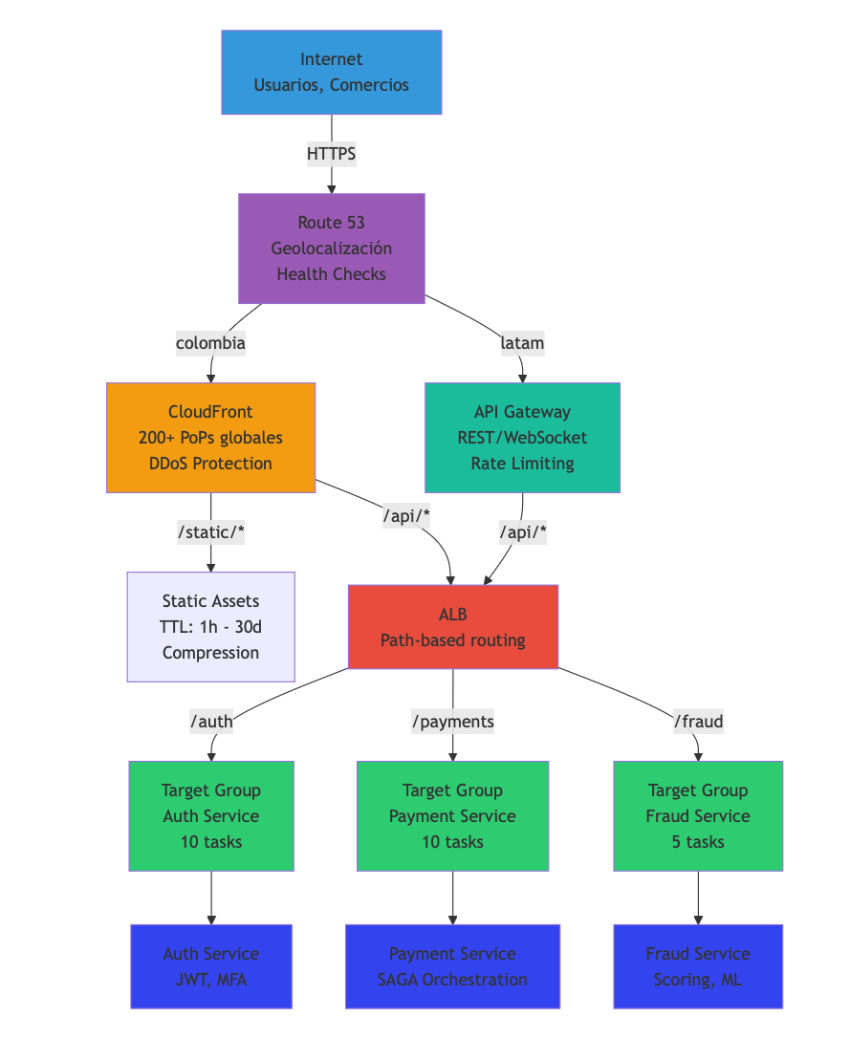
graph TD
INTERNET["Internet<br/>Usuarios, Comercios"]
INTERNET -->|HTTPS| ROUTE53["Route 53<br/>Geolocalización<br/>Health Checks"]
ROUTE53 -->|colombia| CF["CloudFront<br/>200+ PoPs globales<br/>DDoS Protection"]
ROUTE53 -->|latam| APIGW["API Gateway<br/>REST/WebSocket<br/>Rate Limiting"]
CF -->|/static/*| STATIC["Static Assets<br/>TTL: 1h - 30d<br/>Compression"]
CF -->|/api/*| ALB["ALB<br/>Path-based routing"]
APIGW -->|/api/*| ALB
ALB -->|/auth| AUTH_TG["Target Group<br/>Auth Service<br/>10 tasks"]
ALB -->|/payments| PAYMENT_TG["Target Group<br/>Payment Service<br/>10 tasks"]
ALB -->|/fraud| FRAUD_TG["Target Group<br/>Fraud Service<br/>5 tasks"]
AUTH_TG --> AUTH["Auth Service<br/>JWT, MFA"]
PAYMENT_TG --> PAYMENT["Payment Service<br/>SAGA Orchestration"]
FRAUD_TG --> FRAUD["Fraud Service<br/>Scoring, ML"]
style INTERNET fill:#3498db
style ROUTE53 fill:#9b59b6
style CF fill:#f39c12
style APIGW fill:#1abc9c
style ALB fill:#e74c3c
style AUTH_TG fill:#2ecc71
style PAYMENT_TG fill:#2ecc71
style FRAUD_TG fill:#2ecc71
style AUTH fill:#34e
style PAYMENT fill:#34e
style FRAUD fill:#34e

Razonamiento por Capa:
Capa | Servicio | Beneficio
Capa 1 | Route 53 | Geolocalización, failover automático
Capa 2 | CloudFront | 200+ PoPs, <50ms latencia global, DDoS mitigation
Capa 3 | API Gateway | Rate limiting (1000 req/s), CORS, request transformation
Capa 4 | ALB | Routing interno, health checks, stickiness disabled (stateless)

2.3 Compute: ECS vs. EKS vs. Lambda
DECISIÓN: ECS (Fargate) para servicios core + Lambda para eventos asincronos
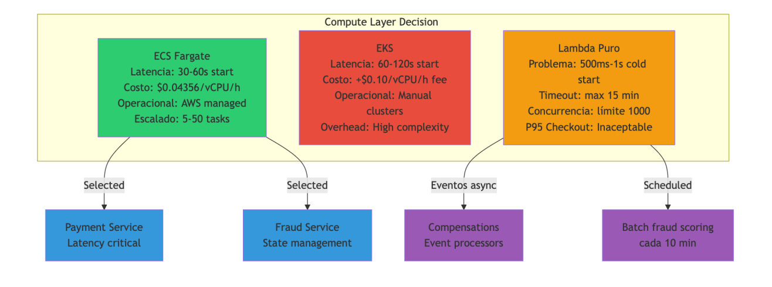
graph TB
subgraph "Compute Layer Decision Matrix"
ECS["ECS Fargate<br/>Latencia: 30-60s start<br/>Costo: $0.04356/vCPU/h<br/>Operacional: AWS managed<br/>Escalado: 5-50 tasks"]
EKS["EKS<br/>Latencia: 60-120s start<br/>Costo: +$0.10/vCPU/h fee<br/>Operacional: Manual clusters<br/>Overhead: High complexity"]
LAMBDA["Lambda Puro<br/>Problema: 500ms-1s cold start<br/>Timeout: max 15 min<br/>Concurrencia: límite 1000<br/>P95 Checkout: Inaceptable"]
end
ECS -->|Selected| PAYMENT_ARCH["Payment Service<br/>Latency critical"]
ECS -->|Selected| FRAUD_ARCH["Fraud Service<br/>State management"]
LAMBDA -->|Eventos async| COMPENSATION["Compensations<br/>Event processors"]
LAMBDA -->|Scheduled| BATCH["Batch fraud scoring<br/>cada 10 min"]
style ECS fill:#2ecc71
style EKS fill:#e74c3c
style LAMBDA fill:#f39c12
style PAYMENT_ARCH fill:#3498db
style FRAUD_ARCH fill:#3498db
style COMPENSATION fill:#9b59b6
style BATCH fill:#9b59b6

Configuración de ECS:
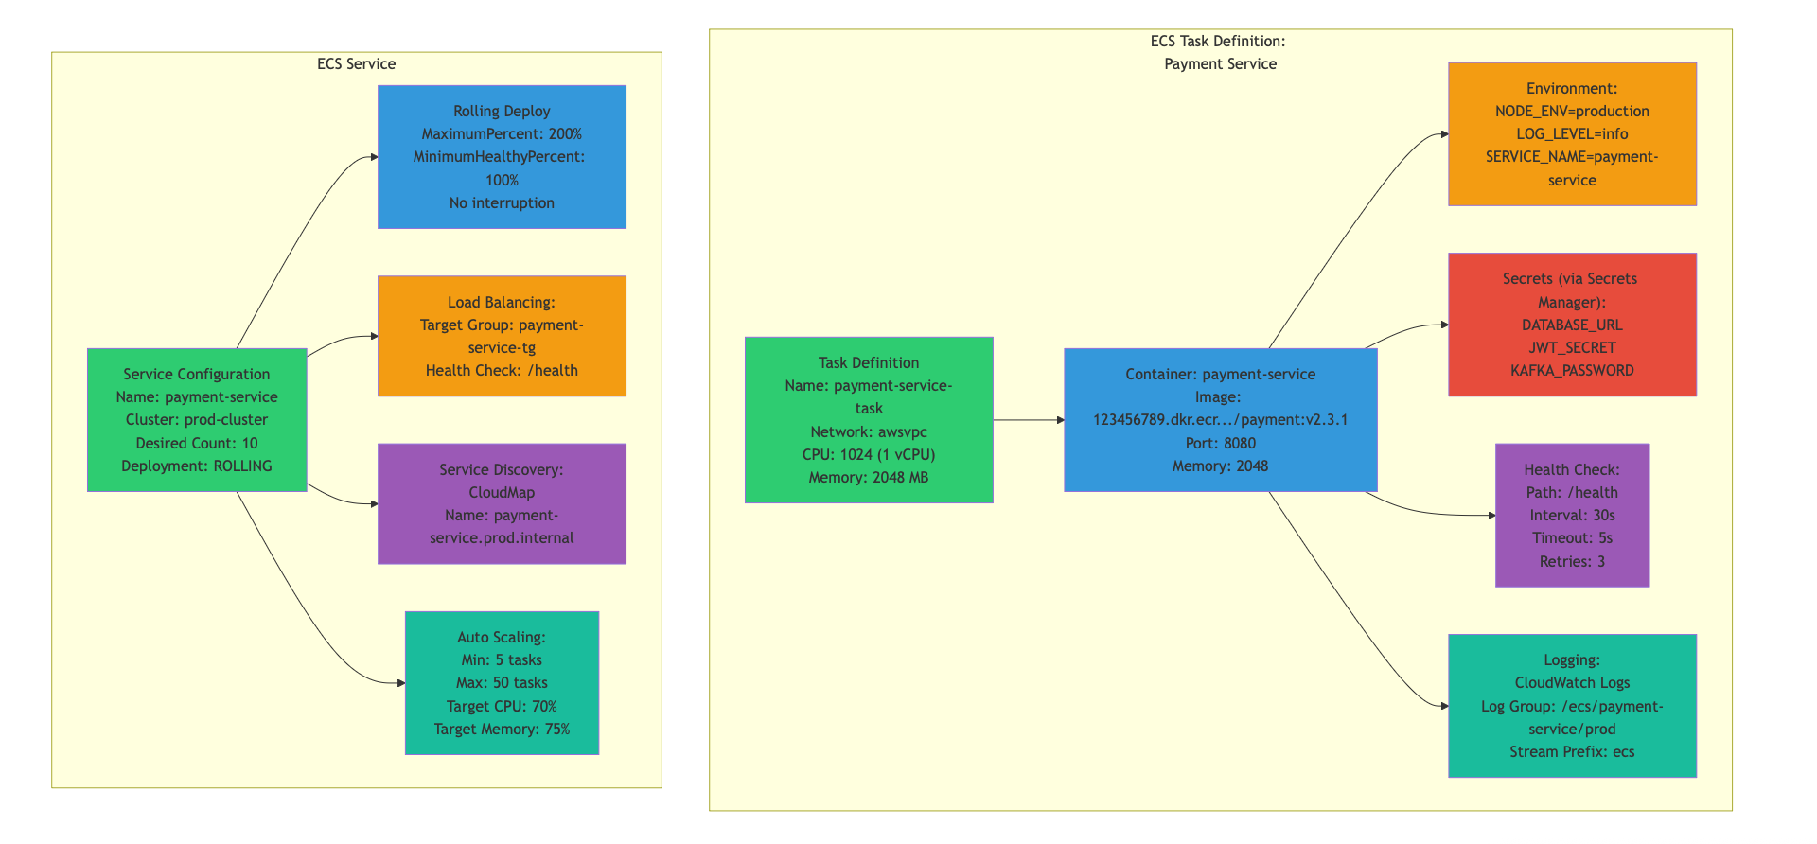
graph TB
subgraph "ECS Task Definition: Payment Service"
TD["Task Definition<br/>Name: payment-service-task<br/>Network: awsvpc<br/>CPU: 1024 (1 vCPU)<br/>Memory: 2048 MB"]
CONTAINER["Container: payment-service<br/>Image: 123456789.dkr.ecr.../payment:v2.3.1<br/>Port: 8080<br/>Memory: 2048"]
ENV["Environment:<br/>NODE_ENV=production<br/>LOG_LEVEL=info<br/>SERVICE_NAME=payment-service"]
SECRETS["Secrets (via Secrets Manager):<br/>DATABASE_URL<br/>JWT_SECRET<br/>KAFKA_PASSWORD"]
HEALTH["Health Check:<br/>Path: /health<br/>Interval: 30s<br/>Timeout: 5s<br/>Retries: 3"]
LOGS["Logging:<br/>CloudWatch Logs<br/>Log Group: /ecs/payment-service/prod<br/>Stream Prefix: ecs"]
end
subgraph "ECS Service"
SVC["Service Configuration<br/>Name: payment-service<br/>Cluster: prod-cluster<br/>Desired Count: 10<br/>Deployment: ROLLING"]
DEPLOY["Rolling Deploy<br/>MaximumPercent: 200%<br/>MinimumHealthyPercent: 100%<br/>No interruption"]
LB["Load Balancing:<br/>Target Group: payment-service-tg<br/>Health Check: /health"]
DISC["Service Discovery:<br/>CloudMap<br/>Name: payment-service.prod.internal"]
AUTO["Auto Scaling:<br/>Min: 5 tasks<br/>Max: 50 tasks<br/>Target CPU: 70%<br/>Target Memory: 75%"]
end
TD --> CONTAINER
CONTAINER --> ENV
CONTAINER --> SECRETS
CONTAINER --> HEALTH
CONTAINER --> LOGS
SVC --> DEPLOY
SVC --> LB
SVC --> DISC
SVC --> AUTO
style TD fill:#2ecc71
style CONTAINER fill:#3498db
style ENV fill:#f39c12
style SECRETS fill:#e74c3c
style HEALTH fill:#9b59b6
style LOGS fill:#1abc9c
style SVC fill:#2ecc71
style DEPLOY fill:#3498db
style LB fill:#f39c12
style DISC fill:#9b59b6
style AUTO fill:#1abc9c

2.4 Base de Datos: RDS vs. DynamoDB
DECISIÓN: PostgreSQL Multi-AZ (RDS) + DynamoDB para caché/audit
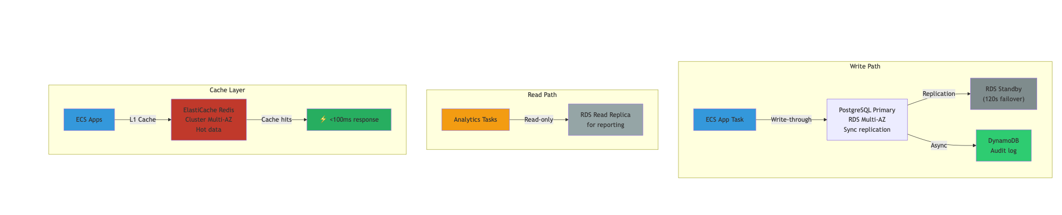
graph TB
subgraph "Write Path"
APP["ECS App Task"]
APP -->|Write-through| RDS_PRIMARY["PostgreSQL Primary<br/>RDS Multi-AZ<br/>Sync replication"]
RDS_PRIMARY -->|Replication| RDS_STANDBY["RDS Standby<br/>(120s failover)"]
RDS_PRIMARY -->|Async| DDB["DynamoDB<br/>Audit log"]
end
subgraph "Read Path"
ANALYTICS["Analytics Tasks"]
ANALYTICS -->|Read-only| RDS_REPLICA["RDS Read Replica<br/>for reporting"]
end
subgraph "Cache Layer"
CACHE_APP["ECS Apps"]
CACHE_APP -->|L1 Cache| REDIS["ElastiCache Redis<br/>Cluster Multi-AZ<br/>Hot data"]
REDIS -->|Cache hits| RESPONSE["⚡ <100ms response"]
end
style APP fill:#3498db
style RDS_PRIMARY fill:#34495e
style RDS_STANDBY fill:#7f8c8d
style DDB fill:#2ecc71
style ANALYTICS fill:#f39c12
style RDS_REPLICA fill:#95a5a6
style CACHE_APP fill:#3498db
style REDIS fill:#c0392b
style RESPONSE fill:#27ae60

Selección por Tabla:
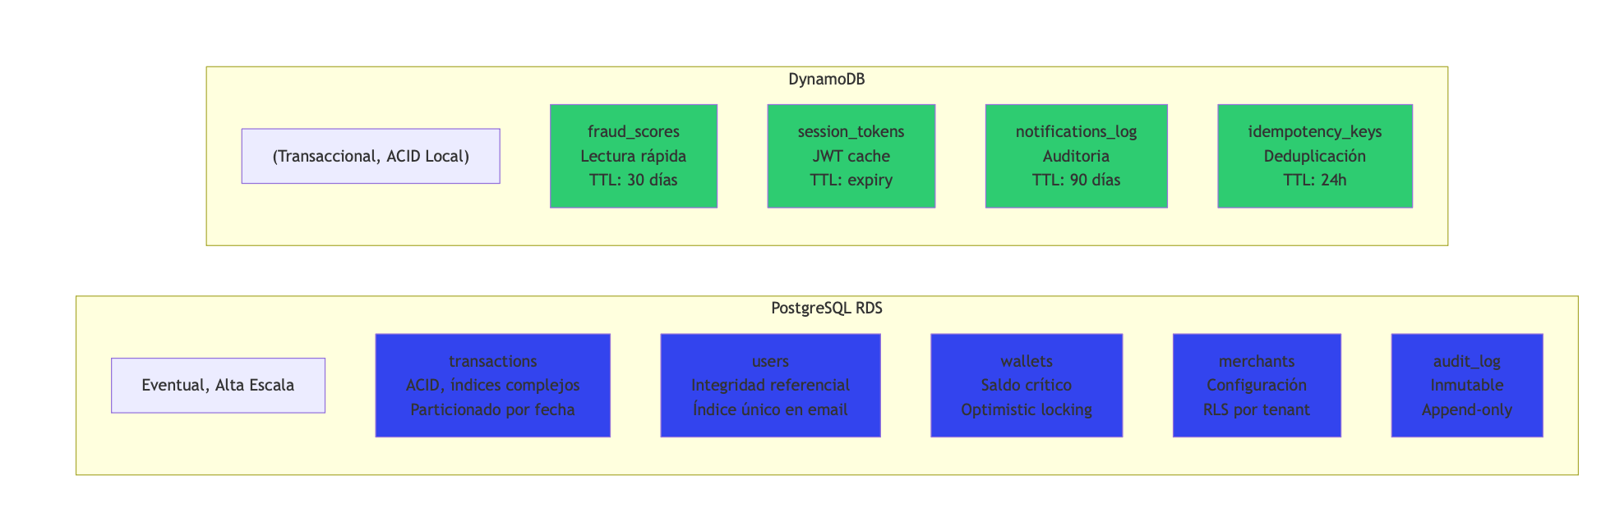
graph LR
subgraph "PostgreSQL RDS"
direction TB
titleText["(Transaccional, ACID Local)"]:::subtitle
TRANS["transactions<br/>ACID, índices complejos<br/>Particionado por fecha"]
USERS["users<br/>Integridad referencial<br/>Índice único en email"]
WALLETS["wallets<br/>Saldo crítico<br/>Optimistic locking"]
MERCHANTS["merchants<br/>Configuración<br/>RLS por tenant"]
AUDIT_RDS["audit_log<br/>Inmutable<br/>Append-only"]
end
subgraph DynamoDB["DynamoDB"]
direction TB
titleText["Eventual, Alta Escala"]:::subtitle
spacer["(Transaccional, ACID Local)"]:::invisible
FRAUD_SCORES["fraud_scores<br/>Lectura rápida<br/>TTL: 30 días"]
SESSIONS["session_tokens<br/>JWT cache<br/>TTL: expiry"]
NOTIF_LOG["notifications_log<br/>Auditoria<br/>TTL: 90 días"]
IDEMPOTENCY["idempotency_keys<br/>Deduplicación<br/>TTL: 24h"]
end
style TRANS fill:#34e
style USERS fill:#34e
style WALLETS fill:#34e
style MERCHANTS fill:#34e
style AUDIT_RDS fill:#34e
style FRAUD_SCORES fill:#2ecc71
style SESSIONS fill:#2ecc71
style NOTIF_LOG fill:#2ecc71
style IDEMPOTENCY fill:#2ecc71

2.5 Colas y Mensajería: SQS vs. SNS vs. Kafka
DECISIÓN: SQS (core) + SNS (eventos broadcast) + EventBridge (orquestación)
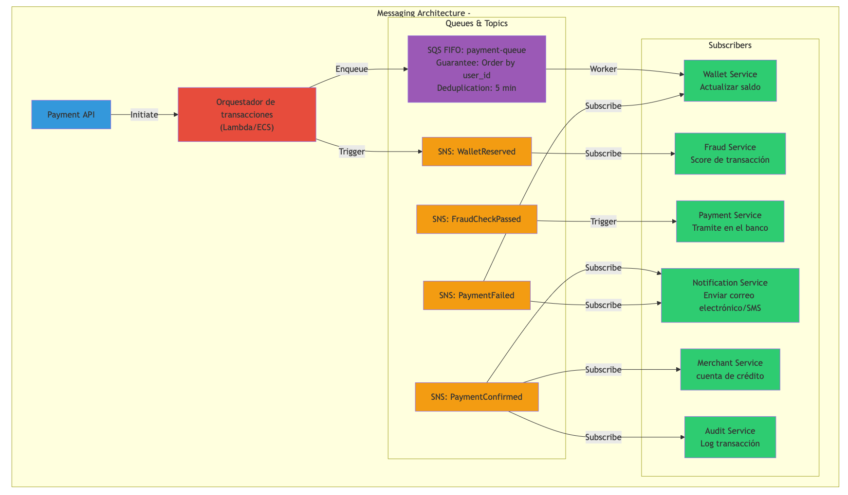
graph TB
subgraph "Messaging Architecture - SAGA Orquestada"
APP["Payment API"]
ORCH["Orquestador de transacciones<br/>(Lambda/ECS)"]
subgraph "Queues & Topics"
SQS1["SQS FIFO: payment-queue<br/>Guarantee: Order by user_id<br/>Deduplication: 5 min"]
SNS_RESERVE["SNS: WalletReserved"]
SNS_FRAUD["SNS: FraudCheckPassed"]
SNS_SUCCESS["SNS: PaymentConfirmed"]
SNS_FAILED["SNS: PaymentFailed"]
end
subgraph "Subscribers"
WALLET["Wallet Service<br/>Actualizar saldo"]
FRAUD["Fraud Service<br/>Score de transacción"]
PAYMENT["Payment Service<br/>Tramite en el banco"]
NOTIF["Notification Service<br/>Enviar correo electrónico/SMS"]
MERCHANT["Merchant Service<br/>cuenta de crédito"]
AUDIT["Audit Service<br/>Log transacción"]
end
end
APP -->|Initiate| ORCH
ORCH -->|Enqueue| SQS1
ORCH -->|Trigger| SNS_RESERVE
SQS1 -->|Worker| WALLET
SNS_RESERVE -->|Subscribe| FRAUD
SNS_FRAUD -->|Trigger| PAYMENT
SNS_SUCCESS -->|Subscribe| NOTIF
SNS_SUCCESS -->|Subscribe| MERCHANT
SNS_SUCCESS -->|Subscribe| AUDIT
SNS_FAILED -->|Subscribe| WALLET
SNS_FAILED -->|Subscribe| NOTIF
style APP fill:#3498db
style ORCH fill:#e74c3c
style SQS1 fill:#9b59b6
style SNS_RESERVE fill:#f39c12
style SNS_FRAUD fill:#f39c12
style SNS_SUCCESS fill:#f39c12
style SNS_FAILED fill:#f39c12
style WALLET fill:#2ecc71
style FRAUD fill:#2ecc71
style PAYMENT fill:#2ecc71
style NOTIF fill:#2ecc71
style MERCHANT fill:#2ecc71
style AUDIT fill:#2ecc71

2.6 Seguridad: IAM, Secrets, Cifrado
DECISIÓN: Defense in Depth (múltiples capas)
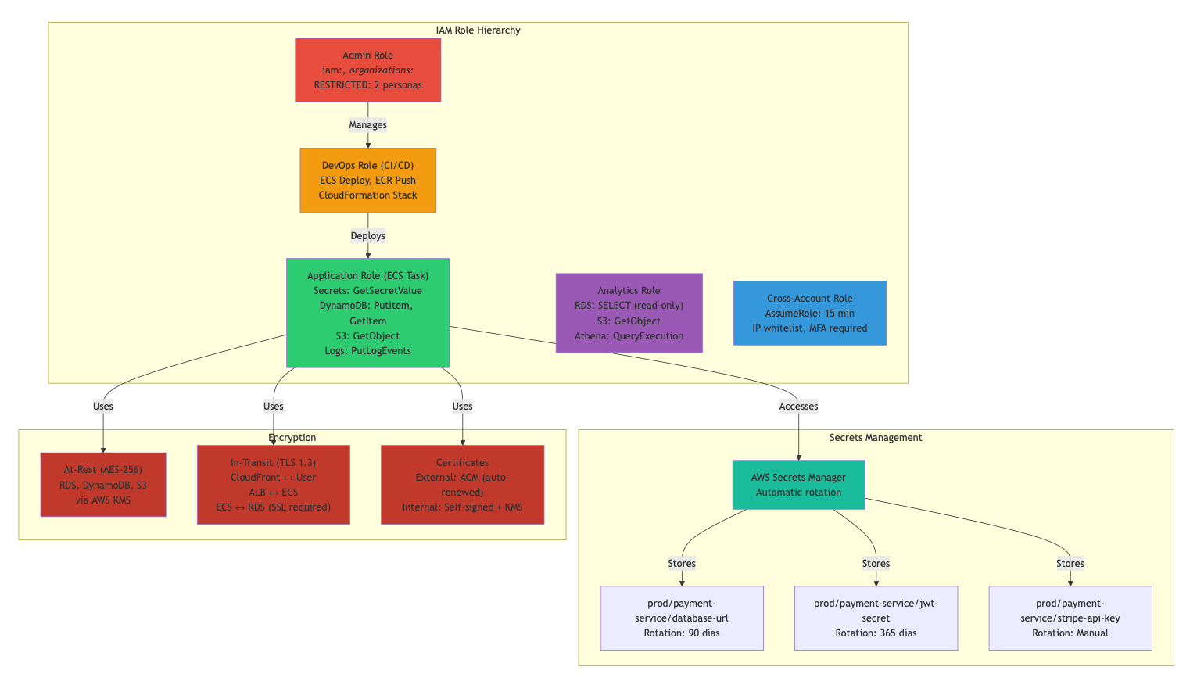
graph TB
subgraph "IAM Role Hierarchy"
ADMIN["Admin Role<br/>iam:*, organizations:*<br/>RESTRICTED: 2 personas"]
DEVOPS["DevOps Role (CI/CD)<br/>ECS Deploy, ECR Push<br/>CloudFormation Stack"]
APP_ROLE["Application Role (ECS Task)<br/>Secrets: GetSecretValue<br/>DynamoDB: PutItem, GetItem<br/>S3: GetObject<br/>Logs: PutLogEvents"]
ANALYTICS["Analytics Role<br/>RDS: SELECT (read-only)<br/>S3: GetObject<br/>Athena: QueryExecution"]
CROSS_ACCOUNT["Cross-Account Role<br/>AssumeRole: 15 min<br/>IP whitelist, MFA required"]
end
subgraph "Secrets Management"
SM["AWS Secrets Manager<br/>Automatic rotation"]
DB_SECRET["prod/payment-service/database-url<br/>Rotation: 90 días"]
JWT_SECRET["prod/payment-service/jwt-secret<br/>Rotation: 365 días"]
STRIPE_KEY["prod/payment-service/stripe-api-key<br/>Rotation: Manual"]
end
subgraph "Encryption"
ATREST["At-Rest (AES-256)<br/>RDS, DynamoDB, S3<br/>via AWS KMS"]
INTRANSIT["In-Transit (TLS 1.3)<br/>CloudFront ↔ User<br/>ALB ↔ ECS<br/>ECS ↔ RDS (SSL required)"]
CERT["Certificates<br/>External: ACM (auto-renewed)<br/>Internal: Self-signed + KMS"]
end
ADMIN -->|Manages| DEVOPS
DEVOPS -->|Deploys| APP_ROLE
APP_ROLE -->|Accesses| SM
SM -->|Stores| DB_SECRET
SM -->|Stores| JWT_SECRET
SM -->|Stores| STRIPE_KEY
APP_ROLE -->|Uses| ATREST
APP_ROLE -->|Uses| INTRANSIT
APP_ROLE -->|Uses| CERT
style ADMIN fill:#e74c3c
style DEVOPS fill:#f39c12
style APP_ROLE fill:#2ecc71
style ANALYTICS fill:#9b59b6
style CROSS_ACCOUNT fill:#3498db
style SM fill:#1abc9c
style DB_SECRET fill:#4235e
style JWT_SECRET fill:#4235e
style STRIPE_KEY fill:#4235e
style ATREST fill:#c0392b
style INTRANSIT fill:#c0392b
style CERT fill:#c0392b

AWS WAF Rules:
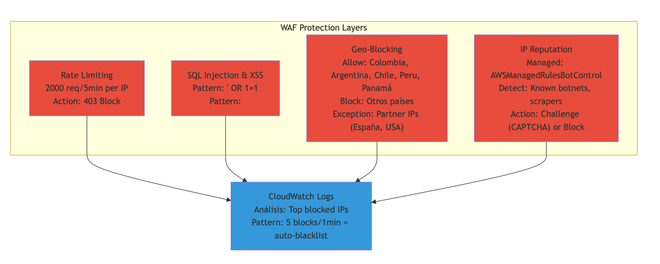
graph TB
subgraph "WAF Protection Layers"
RATE["Rate Limiting<br/>2000 req/5min per IP<br/>Action: 403 Block"]
INJECTION["SQL Injection & XSS<br/>Pattern: ' OR 1=1<br/>Pattern: <script> tags<br/>Action: Block + Log"]
GEO["Geo-Blocking<br/>Allow: Colombia, Argentina, Chile, Peru, Panamá<br/>Block: Otros países<br/>Exception: Partner IPs (España, USA)"]
BOT["IP Reputation<br/>Managed: AWSManagedRulesBotControl<br/>Detect: Known botnets, scrapers<br/>Action: Challenge (CAPTCHA) or Block"]
end
LOG["CloudWatch Logs<br/>Análisis: Top blocked IPs<br/>Pattern: 5 blocks/1min = auto-blacklist"]
RATE --> LOG
INJECTION --> LOG
GEO --> LOG
BOT --> LOG
style RATE fill:#e74c3c
style INJECTION fill:#e74c3c
style GEO fill:#e74c3c
style BOT fill:#e74c3c
style LOG fill:#3498db

2.7 Recuperación ante Desastres (DR)
DECISIÓN: RTO = 5 min, RPO = 1 hora (Regional failover)
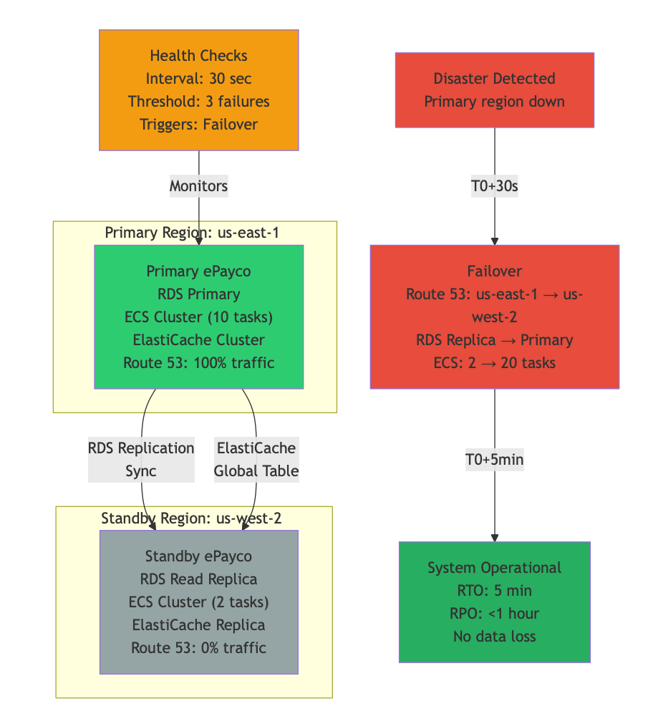
graph TB
subgraph "Primary Region: us-east-1 (Active)"
PRIMARY["Primary ePayco<br/>RDS Primary<br/>ECS Cluster (10 tasks)<br/>ElastiCache Cluster<br/>Route 53: 100% traffic"]
end
subgraph "Standby Region: us-west-2 (Warm)"
STANDBY["Standby ePayco<br/>RDS Read Replica<br/>ECS Cluster (2 tasks)<br/>ElastiCache Replica<br/>Route 53: 0% traffic"]
end
HEALTH["Health Checks<br/>Interval: 30 sec<br/>Threshold: 3 failures<br/>Triggers: Failover"]
PRIMARY -->|RDS Replication<br/>Sync| STANDBY
PRIMARY -->|ElastiCache<br/>Global Table| STANDBY
HEALTH -->|Monitors| PRIMARY
FAILURE["Disaster Detected<br/>Primary region down"]
FAILURE -->|T0+30s| FAILOVER["Failover<br/>Route 53: us-east-1 → us-west-2<br/>RDS Replica → Primary<br/>ECS: 2 → 20 tasks"]
FAILOVER -->|T0+5min| OPERATIONAL["System Operational<br/>RTO: 5 min<br/>RPO: <1 hour<br/>No data loss"]
style PRIMARY fill:#2ecc71
style STANDBY fill:#95a5a6
style HEALTH fill:#f39c12
style FAILURE fill:#e74c3c
style FAILOVER fill:#e74c3c
style OPERATIONAL fill:#27ae60

Disaster Recovery Timeline:
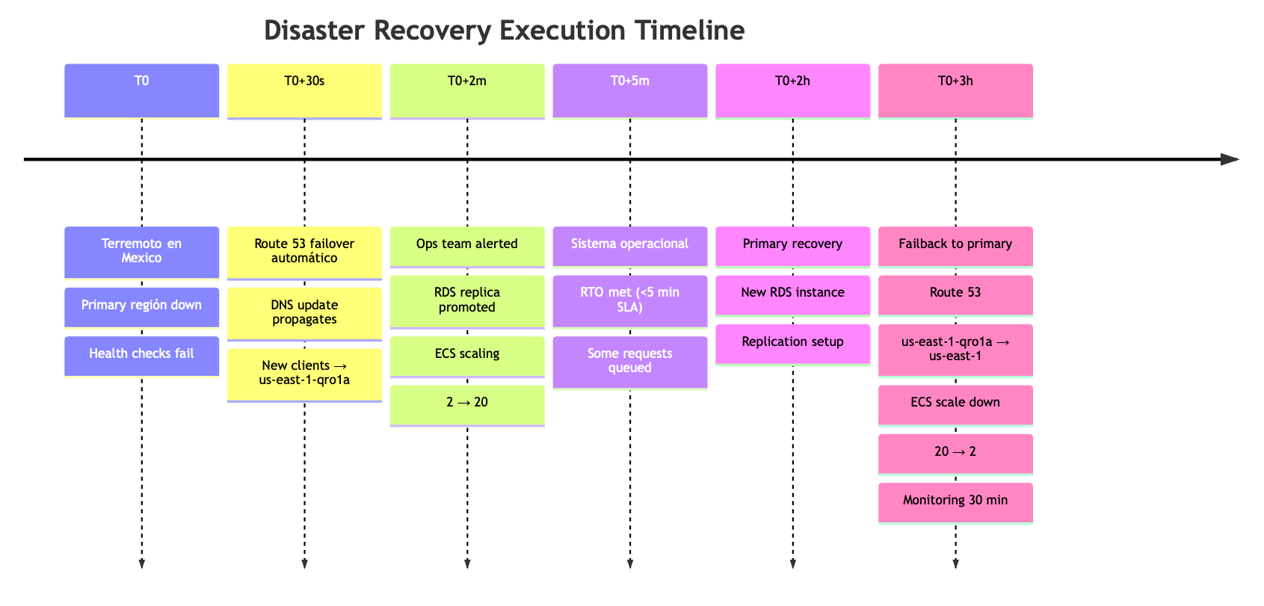
timeline
title Disaster Recovery Execution Timeline
T0 : Terremoto en Mexico
: Primary región down
: Health checks fail
T0+30s : Route 53 failover automático
: DNS update propagates
: New clients → us-east-1-qro1a
T0+2m : Ops team alerted
: RDS replica promoted
: ECS scaling: 2 → 20
T0+5m : Sistema operacional
: RTO met (<5 min SLA)
: Some requests queued
T0+2h : Primary recovery
: New RDS instance
: Replication setup
T0+3h : Failback to primary
: Route 53: us-east-1-qro1a → us-east-1
: ECS scale down: 20 → 2
: Monitoring 30 min

PARTE 3: ARQUITECTURA BACKEND (Node.js/NestJS)

3.1 Estructura de Microservicios
DECISIÓN: DDD (Domain Driven Design) + Clean Architecture
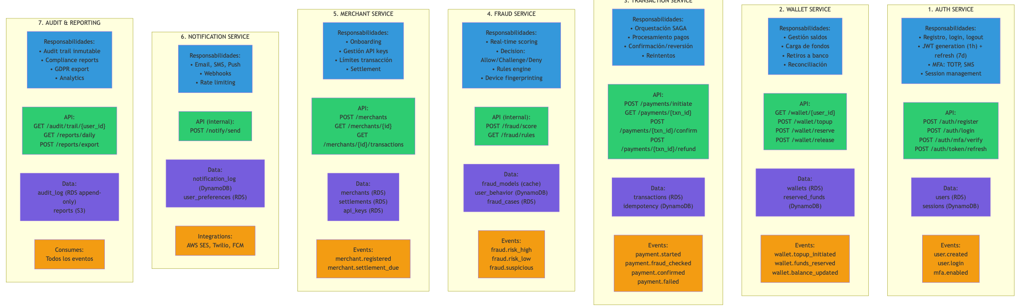
graph TB
subgraph "1. AUTH SERVICE"
AUTH_RESP["Responsabilidades:<br/>• Registro, login, logout<br/>• JWT generation (1h) + refresh (7d)<br/>• MFA: TOTP, SMS<br/>• Session management"]
AUTH_API["API:<br/>POST /auth/register<br/>POST /auth/login<br/>POST /auth/mfa/verify<br/>POST /auth/token/refresh"]
AUTH_DATA["Data:<br/>users (RDS)<br/>sessions (DynamoDB)"]
AUTH_EVENTS["Events:<br/>user.created<br/>user.login<br/>mfa.enabled"]
end
subgraph "2. WALLET SERVICE"
WALLET_RESP["Responsabilidades:<br/>• Gestión saldos<br/>• Carga de fondos<br/>• Retiros a banco<br/>• Reconciliación"]
WALLET_API["API:<br/>GET /wallet/{user_id}<br/>POST /wallet/topup<br/>POST /wallet/reserve<br/>POST /wallet/release"]
WALLET_DATA["Data:<br/>wallets (RDS)<br/>reserved_funds (DynamoDB)"]
WALLET_EVENTS["Events:<br/>wallet.topup_initiated<br/>wallet.funds_reserved<br/>wallet.balance_updated"]
end
subgraph "3. TRANSACTION SERVICE"
TRANS_RESP["Responsabilidades:<br/>• Orquestación SAGA<br/>• Procesamiento pagos<br/>• Confirmación/reversión<br/>• Reintentos"]
TRANS_API["API:<br/>POST /payments/initiate<br/>GET /payments/{txn_id}<br/>POST /payments/{txn_id}/confirm<br/>POST /payments/{txn_id}/refund"]
TRANS_DATA["Data:<br/>transactions (RDS)<br/>idempotency (DynamoDB)"]
TRANS_EVENTS["Events:<br/>payment.started<br/>payment.fraud_checked<br/>payment.confirmed<br/>payment.failed"]
end
subgraph "4. FRAUD SERVICE"
FRAUD_RESP["Responsabilidades:<br/>• Real-time scoring<br/>• Decision: Allow/Challenge/Deny<br/>• Rules engine<br/>• Device fingerprinting"]
FRAUD_API["API (internal):<br/>POST /fraud/score<br/>GET /fraud/rules"]
FRAUD_DATA["Data:<br/>fraud_models (cache)<br/>user_behavior (DynamoDB)<br/>fraud_cases (RDS)"]
FRAUD_EVENTS["Events:<br/>fraud.risk_high<br/>fraud.risk_low<br/>fraud.suspicious"]
end
subgraph "5. MERCHANT SERVICE"
MERCHANT_RESP["Responsabilidades:<br/>• Onboarding<br/>• Gestión API keys<br/>• Límites transacción<br/>• Settlement"]
MERCHANT_API["API:<br/>POST /merchants<br/>GET /merchants/{id}<br/>GET /merchants/{id}/transactions"]
MERCHANT_DATA["Data:<br/>merchants (RDS)<br/>settlements (RDS)<br/>api_keys (RDS)"]
MERCHANT_EVENTS["Events:<br/>merchant.registered<br/>merchant.settlement_due"]
end
subgraph "6. NOTIFICATION SERVICE"
NOTIF_RESP["Responsabilidades:<br/>• Email, SMS, Push<br/>• Webhooks<br/>• Rate limiting"]
NOTIF_API["API (internal):<br/>POST /notify/send"]
NOTIF_DATA["Data:<br/>notification_log (DynamoDB)<br/>user_preferences (RDS)"]
NOTIF_INT["Integrations:<br/>AWS SES, Twilio, FCM"]
end
subgraph "7. AUDIT & REPORTING"
AUDIT_RESP["Responsabilidades:<br/>• Audit trail inmutable<br/>• Compliance reports<br/>• GDPR export<br/>• Analytics"]
AUDIT_API["API:<br/>GET /audit/trail/{user_id}<br/>GET /reports/daily<br/>POST /reports/export"]
AUDIT_DATA["Data:<br/>audit_log (RDS append-only)<br/>reports (S3)"]
AUDIT_EVENTS["Consumes:<br/>Todos los eventos"]
end
style AUTH_RESP fill:#3498db
style AUTH_API fill:#2ecc71
style AUTH_DATA fill:#42db
style AUTH_EVENTS fill:#f39c12
style WALLET_RESP fill:#3498db
style WALLET_API fill:#2ecc71
style WALLET_DATA fill:#42db
style WALLET_EVENTS fill:#f39c12
style TRANS_RESP fill:#3498db
style TRANS_API fill:#2ecc71
style TRANS_DATA fill:#42db
style TRANS_EVENTS fill:#f39c12
style FRAUD_RESP fill:#3498db
style FRAUD_API fill:#2ecc71
style FRAUD_DATA fill:#42db
style FRAUD_EVENTS fill:#f39c12
style MERCHANT_RESP fill:#3498db
style MERCHANT_API fill:#2ecc71
style MERCHANT_DATA fill:#42db
style MERCHANT_EVENTS fill:#f39c12
style NOTIF_RESP fill:#3498db
style NOTIF_API fill:#2ecc71
style NOTIF_DATA fill:#42db
style NOTIF_INT fill:#f39c12
style AUDIT_RESP fill:#3498db
style AUDIT_API fill:#2ecc71
style AUDIT_DATA fill:#42db
style AUDIT_EVENTS fill:#f39c12

3.2 Clean Architecture + SOLID
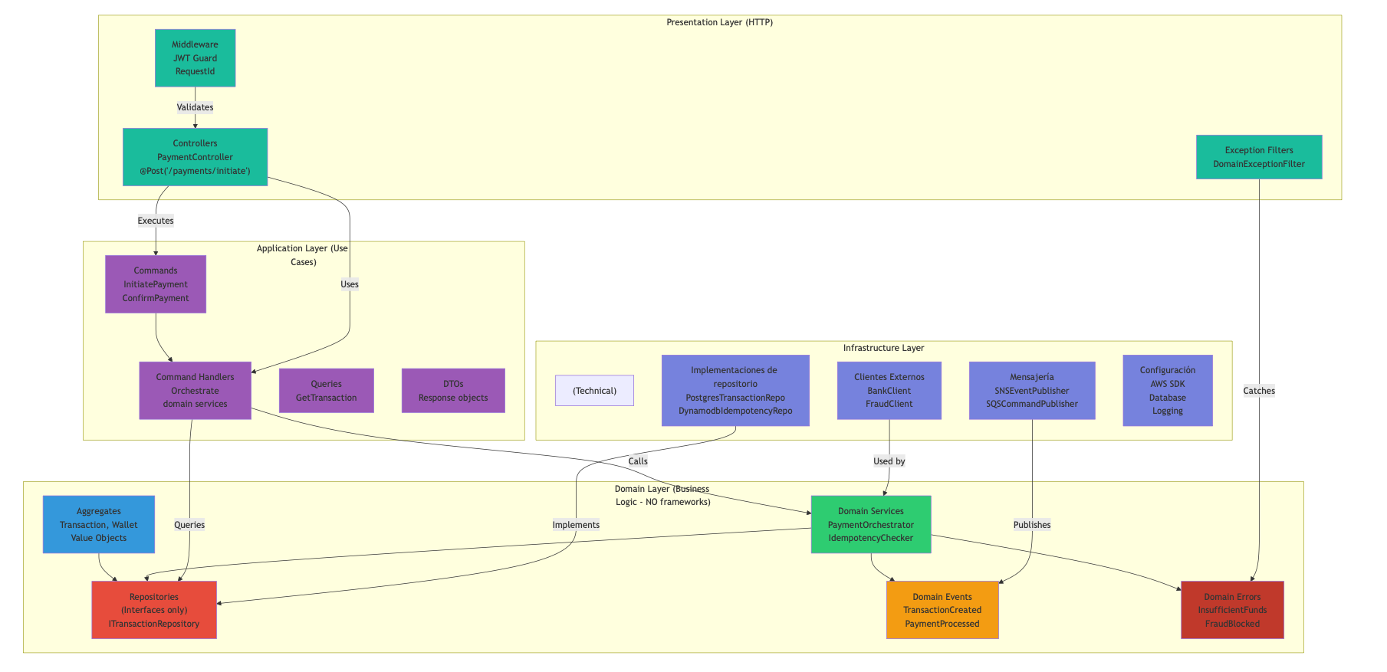
graph TB
subgraph "Domain Layer (Business Logic - NO frameworks)"
AGGREGATES["Aggregates<br/>Transaction, Wallet<br/>Value Objects"]
REPOSITORIES["Repositories<br/>(Interfaces only)<br/>ITransactionRepository"]
SERVICES["Domain Services<br/>PaymentOrchestrator<br/>IdempotencyChecker"]
EVENTS["Domain Events<br/>TransactionCreated<br/>PaymentProcessed"]
ERRORS["Domain Errors<br/>InsufficientFunds<br/>FraudBlocked"]
end
subgraph "Application Layer (Use Cases)"
COMMANDS["Commands<br/>InitiatePayment<br/>ConfirmPayment"]
HANDLERS["Command Handlers<br/>Orchestrate<br/>domain services"]
QUERIES["Queries<br/>GetTransaction"]
DTO["DTOs<br/>Response objects"]
end
subgraph "Infrastructure Layer"
direction TB
titleText["(Technical)"]:::subtitle
REPO_IMPL["Implementaciones de repositorio<br/>PostgresTransactionRepo<br/>DynamodbIdempotencyRepo"]
CLIENTS["Clientes Externos<br/>BankClient<br/>FraudClient"]
MESSAGING["Mensajería<br/>SNSEventPublisher<br/>SQSCommandPublisher"]
CONFIG["Configuración<br/>AWS SDK<br/>Database<br/>Logging"]
end
subgraph "Presentation Layer (HTTP)"
CONTROLLERS["Controllers<br/>PaymentController<br/>@Post('/payments/initiate')"]
FILTERS["Exception Filters<br/>DomainExceptionFilter"]
MIDDLEWARE["Middleware<br/>JWT Guard<br/>RequestId"]
end
AGGREGATES --> REPOSITORIES
SERVICES --> REPOSITORIES
SERVICES --> EVENTS
SERVICES --> ERRORS
COMMANDS --> HANDLERS
HANDLERS -->|Queries| REPOSITORIES
HANDLERS -->|Calls| SERVICES
REPO_IMPL -->|Implements| REPOSITORIES
CLIENTS -->|Used by| SERVICES
MESSAGING -->|Publishes| EVENTS
CONTROLLERS -->|Executes| COMMANDS
CONTROLLERS -->|Uses| HANDLERS
FILTERS -->|Catches| ERRORS
MIDDLEWARE -->|Validates| CONTROLLERS
style AGGREGATES fill:#3498db
style REPOSITORIES fill:#e74c3c
style SERVICES fill:#2ecc71
style EVENTS fill:#f39c12
style ERRORS fill:#c0392b
style COMMANDS fill:#9b59b6
style HANDLERS fill:#9b59b6
style QUERIES fill:#9b59b6
style DTO fill:#9b59b6
style REPO_IMPL fill:#45db
style CLIENTS fill:#45db
style MESSAGING fill:#45db
style CONFIG fill:#45db
style CONTROLLERS fill:#1abc9c
style FILTERS fill:#1abc9c
style MIDDLEWARE fill:#1abc9c

PARTE 4: FLUJO PRINCIPAL DE PAGO (Detallado)

4.1 Diagrama de Flujo Completo
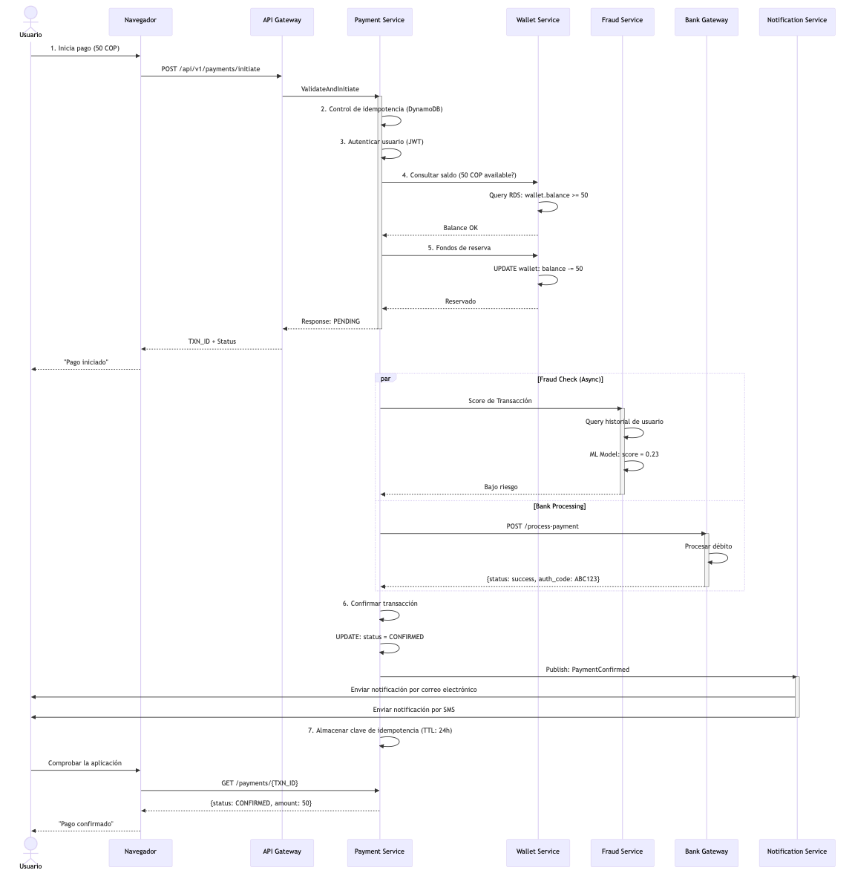
sequenceDiagram
actor User as Usuario
participant Web as Navegador
participant API as API Gateway
participant Payment as Payment Service
participant Wallet as Wallet Service
participant Fraud as Fraud Service
participant Bank as Bank Gateway
participant Notif as Notification Service
User->>Web: 1. Inicia pago (50 COP)
Web->>API: POST /api/v1/payments/initiate
API->>Payment: ValidateAndInitiate
activate Payment
Payment->>Payment: 2. Control de idempotencia (DynamoDB)
Payment->>Payment: 3. Autenticar usuario (JWT)
Payment->>Wallet: 4. Consultar saldo (50 COP available?)
Wallet->>Wallet: Query RDS: wallet.balance >= 50
Wallet-->>Payment: Balance OK
Payment->>Wallet: 5. Fondos de reserva
Wallet->>Wallet: UPDATE wallet: balance -= 50
Wallet-->>Payment: Reservado
Payment-->>API: Response: PENDING
deactivate Payment
API-->>Web: TXN_ID + Status
Web-->>User: "Pago iniciado"
par Fraud Check (Async)
Payment->>Fraud: Score de Transacción
activate Fraud
Fraud->>Fraud: Query historial de usuario
Fraud->>Fraud: ML Model: score = 0.23
Fraud-->>Payment: Bajo riesgo
deactivate Fraud
and Bank Processing
Payment->>Bank: POST /process-payment
activate Bank
Bank->>Bank: Procesar débito
Bank-->>Payment: {status: success, auth_code: ABC123}
deactivate Bank
end
Payment->>Payment: 6. Confirmar transacción
Payment->>Payment: UPDATE: status = CONFIRMED
Payment->>Notif: Publish: PaymentConfirmed
activate Notif
Notif->>User: Enviar notificación por correo electrónico
Notif->>User: Enviar notificación por SMS
deactivate Notif
Payment->>Payment: 7. Almacenar clave de idempotencia (TTL: 24h)
User->>Web: Comprobar la aplicación
Web->>Payment: GET /payments/{TXN_ID}
Payment-->>Web: {status: CONFIRMED, amount: 50}
Web-->>User: "Pago confirmado"

4.2 Estado de Transacción - State Machine
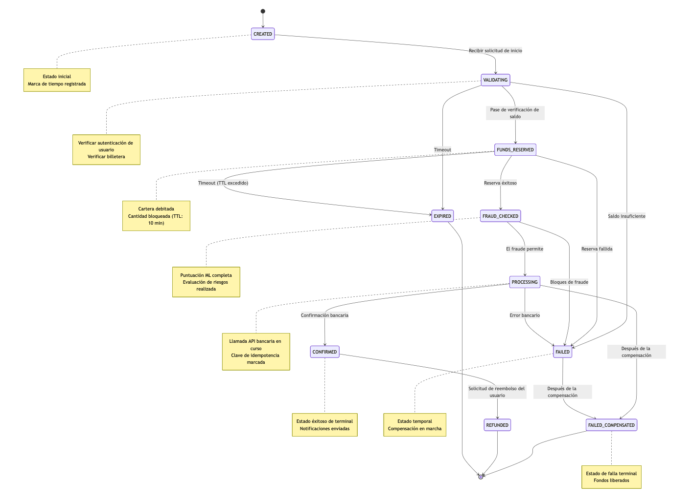
stateDiagram-v2
[*] --> CREATED
CREATED --> VALIDATING: Recibir solicitud de inicio
VALIDATING --> FUNDS_RESERVED: Pase de verificación de saldo
VALIDATING --> FAILED: Saldo insuficiente
VALIDATING --> EXPIRED: Timeout
FUNDS_RESERVED --> FRAUD_CHECKED: Reserva éxitoso
FUNDS_RESERVED --> FAILED: Reserva fallida
FUNDS_RESERVED --> EXPIRED: Timeout (TTL excedido)
FRAUD_CHECKED --> PROCESSING: El fraude permite
FRAUD_CHECKED --> FAILED: Bloques de fraude
PROCESSING --> CONFIRMED: Confirmación bancaria
PROCESSING --> FAILED: Error bancario
PROCESSING --> FAILED_COMPENSATED: Después de la compensación
CONFIRMED --> REFUNDED: Solicitud de reembolso del usuario
FAILED --> FAILED_COMPENSATED: Después de la compensación
FAILED_COMPENSATED --> [*]
REFUNDED --> [*]
EXPIRED --> [*]
note right of CREATED
Estado inicial
Marca de tiempo registrada
end note
note right of VALIDATING
Verificar autenticación de usuario
Verificar billetera
end note
note right of FUNDS_RESERVED
Cartera debitada
Cantidad bloqueada (TTL: 10 min)
end note
note right of FRAUD_CHECKED
Puntuación ML completa
Evaluación de riesgos realizada
end note
note right of PROCESSING
Llamada API bancaria en curso
Clave de idempotencia marcada
end note
note right of CONFIRMED
Estado éxitoso de terminal
Notificaciones enviadas
end note
note right of FAILED
Estado temporal
Compensación en marcha
end note
note right of FAILED_COMPENSATED
Estado de falla terminal
Fondos liberados
end note

4.3 Cronología y Latencias
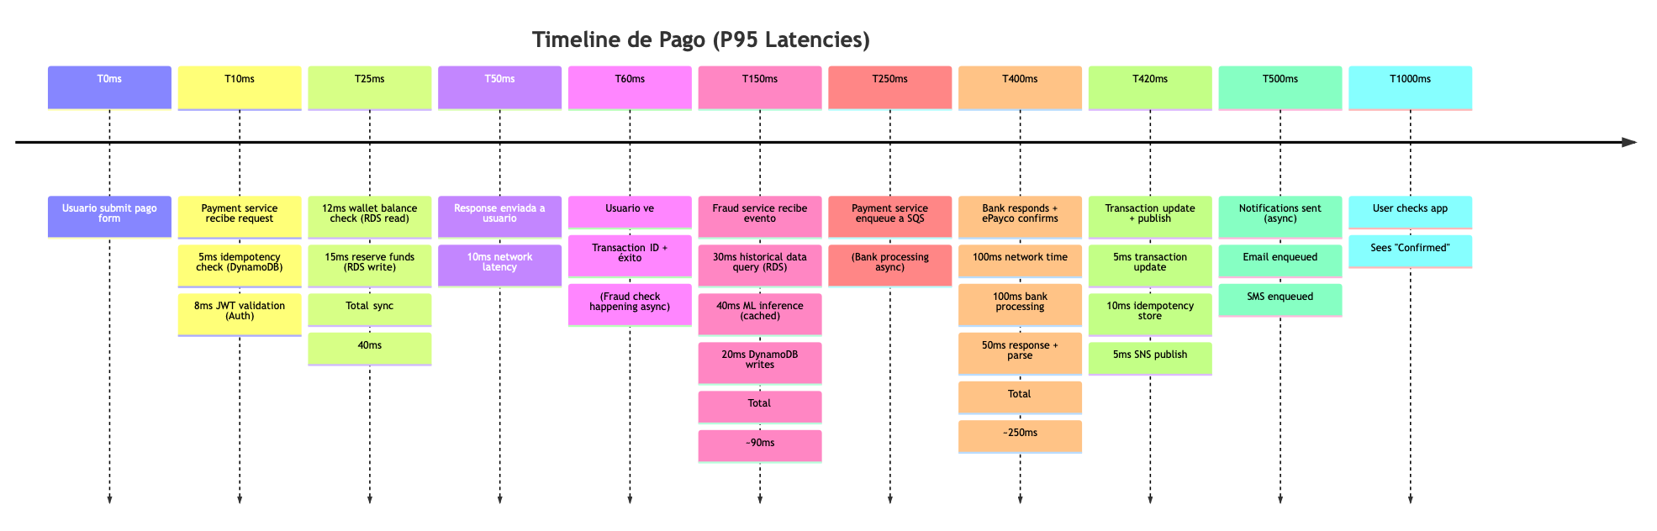
timeline
title Timeline de Pago (P95 Latencies)
T0ms : Usuario submit pago form
T10ms : Payment service recibe request
: 5ms idempotency check (DynamoDB)
: 8ms JWT validation (Auth)
T25ms : 12ms wallet balance check (RDS read)
: 15ms reserve funds (RDS write)
: Total sync: 40ms
T50ms : Response enviada a usuario
: 10ms network latency
T60ms : Usuario ve: Transaction ID + éxito
: (Fraud check happening async)
T150ms : Fraud service recibe evento
: 30ms historical data query (RDS)
: 40ms ML inference (cached)
: 20ms DynamoDB writes
: Total: ~90ms
T250ms : Payment service enqueue a SQS
: (Bank processing async)
T400ms : Bank responds + ePayco confirms
: 100ms network time
: 100ms bank processing
: 50ms response + parse
: Total: ~250ms
T420ms : Transaction update + publish
: 5ms transaction update
: 10ms idempotency store
: 5ms SNS publish
T500ms : Notifications sent (async)
: Email enqueued
: SMS enqueued
T1000ms : User checks app
: Sees "Confirmed"

PARTE 5: SAGA Y TRANSACCIONES DISTRIBUIDAS

5.1 Tipo de SAGA: Orquestada vs. Coreografiada
DECISIÓN: SAGA Orquestada (Orchestration-based)
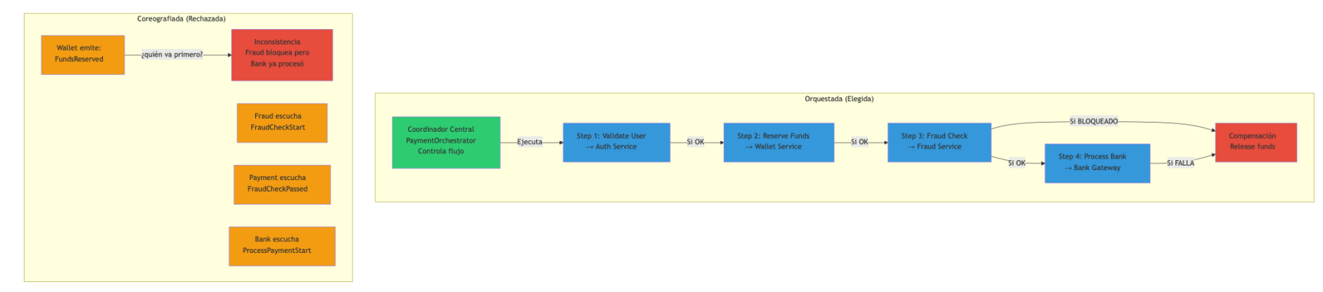
graph TB
subgraph "Orquestada (Elegida)"
ORCH["Coordinador Central<br/>PaymentOrchestrator<br/>Controla flujo"]
STEP1["Step 1: Validate User<br/>→ Auth Service"]
STEP2["Step 2: Reserve Funds<br/>→ Wallet Service"]
STEP3["Step 3: Fraud Check<br/>→ Fraud Service"]
STEP4["Step 4: Process Bank<br/>→ Bank Gateway"]
ORCH -->|Ejecuta| STEP1
STEP1 -->|Si OK| STEP2
STEP2 -->|Si OK| STEP3
STEP3 -->|Si OK| STEP4
STEP3 -->|Si BLOQUEADO| COMP["Compensación<br/>Release funds"]
STEP4 -->|Si FALLA| COMP
end
subgraph "Coreografiada (Rechazada)"
EVENT1["Wallet emite:<br/>FundsReserved"]
EVENT2["Fraud escucha<br/>FraudCheckStart"]
EVENT3["Payment escucha<br/>FraudCheckPassed"]
EVENT4["Bank escucha<br/>ProcessPaymentStart"]
EVENT1 -->|¿quién va primero?| PROBLEM["Inconsistencia<br/>Fraud bloquea pero<br/>Bank ya procesó"]
end
style ORCH fill:#2ecc71
style STEP1 fill:#3498db
style STEP2 fill:#3498db
style STEP3 fill:#3498db
style STEP4 fill:#3498db
style COMP fill:#e74c3c
style EVENT1 fill:#f39c12
style EVENT2 fill:#f39c12
style EVENT3 fill:#f39c12
style EVENT4 fill:#f39c12
style PROBLEM fill:#e74c3c

5.2 Flujo SAGA Detallado
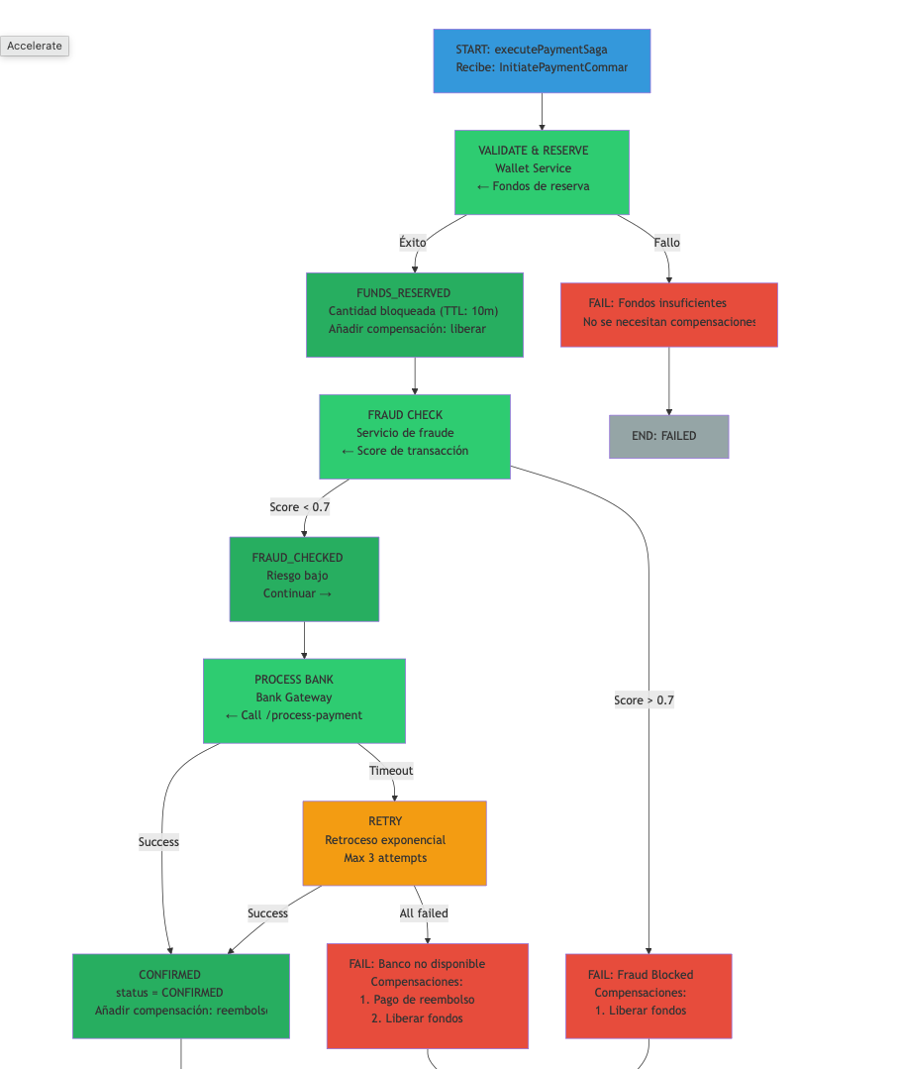
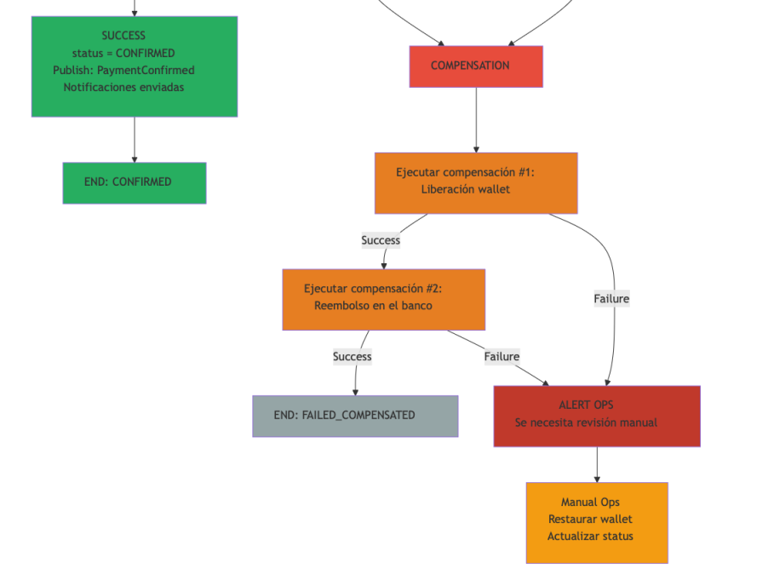
flowchart TD
START["START: executePaymentSaga<br/>Recibe: InitiatePaymentCommand"]
START --> VALIDATE["VALIDATE & RESERVE<br/>Wallet Service<br/>← Fondos de reserva"]
VALIDATE -->|Éxito| RESERVED["FUNDS_RESERVED<br/>Cantidad bloqueada (TTL: 10m)<br/>Añadir compensación: liberar"]
VALIDATE -->|Fallo| FAIL1["FAIL: Fondos insuficientes<br/>No se necesitan compensaciones"]
RESERVED --> FRAUD["FRAUD CHECK<br/>Servicio de fraude<br/>← Score de transacción"]
FRAUD -->|Score < 0.7| PASSED["FRAUD_CHECKED<br/>Riesgo bajo<br/>Continuar →"]
FRAUD -->|Score > 0.7| FAIL2["FAIL: Fraud Blocked<br/>Compensaciones:<br/>1. Liberar fondos"]
PASSED --> BANK["PROCESS BANK<br/>Bank Gateway<br/>← Call /process-payment"]
BANK -->|Success| CONFIRMED["CONFIRMED<br/>status = CONFIRMED<br/>Añadir compensación: reembolso"]
BANK -->|Timeout| RETRY["RETRY<br/>Retroceso exponencial<br/>Max 3 attempts"]
RETRY -->|Success| CONFIRMED
RETRY -->|All failed| FAIL3["FAIL: Banco no disponible<br/>Compensaciones:<br/>1. Pago de reembolso<br/>2. Liberar fondos"]
FAIL1 --> END1["END: FAILED"]
FAIL2 --> COMP["COMPENSATION"]
FAIL3 --> COMP
COMP --> COMP1["Ejecutar compensación #1:<br/>Liberación wallet"]
COMP1 -->|Success| COMP2["Ejecutar compensación #2:<br/>Reembolso en el banco"]
COMP1 -->|Failure| ALERT["ALERT OPS<br/>Se necesita revisión manual"]
COMP2 -->|Success| END2["END: FAILED_COMPENSATED"]
COMP2 -->|Failure| ALERT
CONFIRMED --> SUCCESS["SUCCESS<br/>status = CONFIRMED<br/>Publish: PaymentConfirmed<br/>Notificaciones enviadas"]
SUCCESS --> END3["END: CONFIRMED"]
ALERT --> MANUAL["Manual Ops<br/>Restaurar wallet<br/>Actualizar status"]
style START fill:#3498db
style VALIDATE fill:#2ecc71
style RESERVED fill:#27ae60
style FAIL1 fill:#e74c3c
style FRAUD fill:#2ecc71
style PASSED fill:#27ae60
style FAIL2 fill:#e74c3c
style BANK fill:#2ecc71
style CONFIRMED fill:#27ae60
style RETRY fill:#f39c12
style FAIL3 fill:#e74c3c
style COMP fill:#e74c3c
style COMP1 fill:#e67e22
style COMP2 fill:#e67e22
style ALERT fill:#c0392b
style SUCCESS fill:#27ae60
style END1 fill:#95a5a6
style END2 fill:#95a5a6
style END3 fill:#27ae60
style MANUAL fill:#f39c12

5.3 Eventos de Dominio
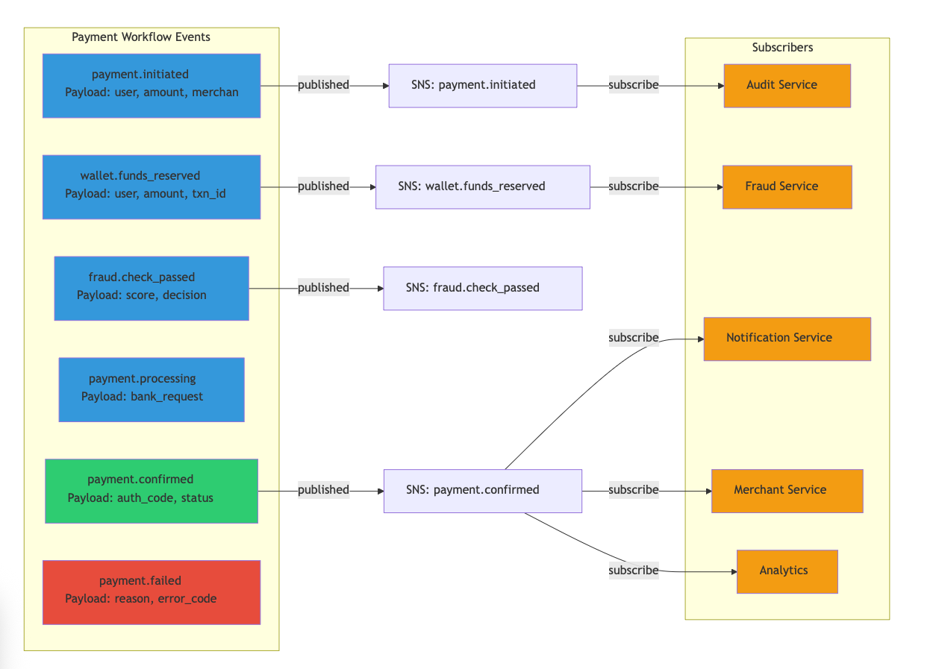
graph LR
subgraph "Payment Workflow Events"
E1["payment.initiated<br/>Payload: user, amount, merchant"]
E2["wallet.funds_reserved<br/>Payload: user, amount, txn_id"]
E3["fraud.check_passed<br/>Payload: score, decision"]
E4["payment.processing<br/>Payload: bank_request"]
E5["payment.confirmed<br/>Payload: auth_code, status"]
E6["payment.failed<br/>Payload: reason, error_code"]
end
subgraph "Subscribers"
SUB1["Fraud Service"]
SUB2["Notification Service"]
SUB3["Merchant Service"]
SUB4["Audit Service"]
SUB5["Analytics"]
end
E1 -->|published| SNS1["SNS: payment.initiated"]
E2 -->|published| SNS2["SNS: wallet.funds_reserved"]
E3 -->|published| SNS3["SNS: fraud.check_passed"]
E5 -->|published| SNS5["SNS: payment.confirmed"]
SNS2 -->|subscribe| SUB1
SNS5 -->|subscribe| SUB2
SNS5 -->|subscribe| SUB3
SNS1 -->|subscribe| SUB4
SNS5 -->|subscribe| SUB5
style E1 fill:#3498db
style E2 fill:#3498db
style E3 fill:#3498db
style E4 fill:#3498db
style E5 fill:#2ecc71
style E6 fill:#e74c3c
style SUB1 fill:#f39c12
style SUB2 fill:#f39c12
style SUB3 fill:#f39c12
style SUB4 fill:#f39c12
style SUB5 fill:#f39c12

PARTE 6: RESILIENCIA Y OBSERVABILIDAD

6.1 Patrones de Resiliencia
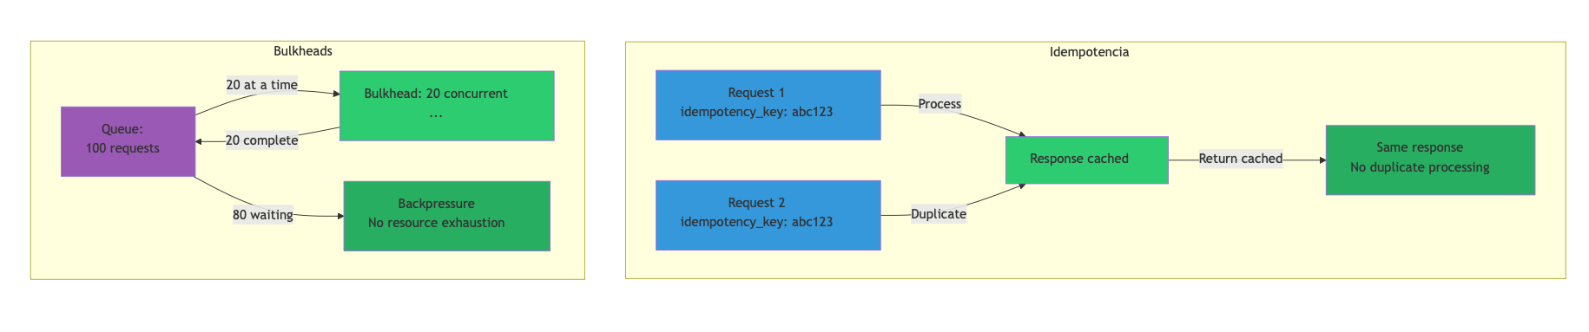
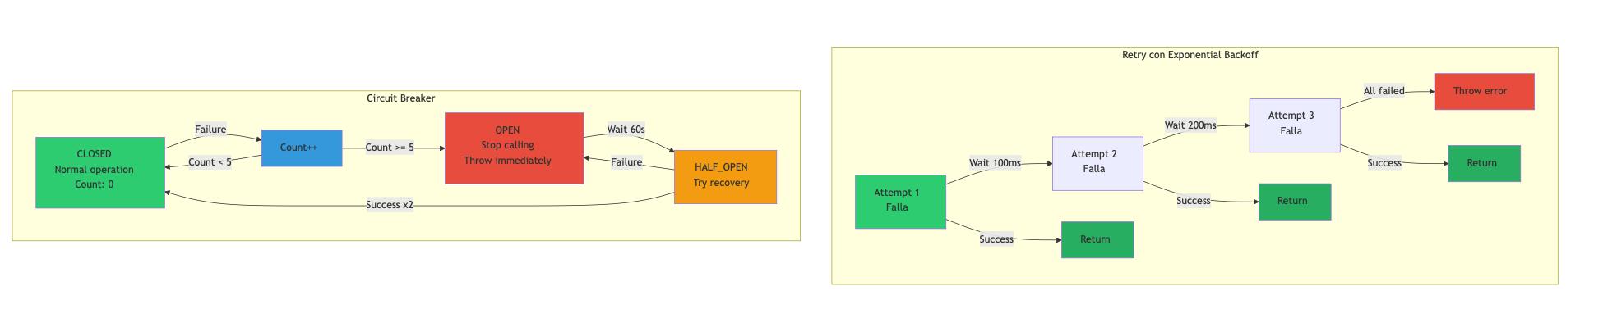
graph TB
subgraph "Retry con Exponential Backoff"
RETRY["Attempt 1<br/>Falla"]
RETRY -->|Wait 100ms| RETRY2["Attempt 2<br/>Falla"]
RETRY2 -->|Wait 200ms| RETRY3["Attempt 3<br/>Falla"]
RETRY3 -->|All failed| ERR["Throw error"]
RETRY -->|Success| OK1["Return"]
RETRY2 -->|Success| OK2["Return"]
RETRY3 -->|Success| OK3["Return"]
end
subgraph "Circuit Breaker"
CLOSED["CLOSED<br/>Normal operation<br/>Count: 0"]
CLOSED -->|Failure| COUNT["Count++"]
COUNT -->|Count < 5| CLOSED
COUNT -->|Count >= 5| OPEN["OPEN<br/>Stop calling<br/>Throw immediately"]
OPEN -->|Wait 60s| HALF["HALF_OPEN<br/>Try recovery"]
HALF -->|Success x2| CLOSED
HALF -->|Failure| OPEN
end
subgraph "Idempotencia"
REQ1["Request 1<br/>idempotency_key: abc123"]
REQ1 -->|Process| RES["Response cached"]
REQ2["Request 2<br/>idempotency_key: abc123"] -->|Duplicate| RES
RES -->|Return cached| CLIENT["Same response<br/>No duplicate processing"]
end
subgraph "Bulkheads"
QUEUE["Queue:<br/>100 requests"]
BULKHEAD["Bulkhead: 20 concurrent<br/>..."]
QUEUE -->|20 at a time| BULKHEAD
BULKHEAD -->|20 complete| QUEUE
QUEUE -->|80 waiting| MANAGED["Backpressure<br/>No resource exhaustion"]
end
style RETRY fill:#2ecc71
style OK1 fill:#27ae60
style OK2 fill:#27ae60
style OK3 fill:#27ae60
style ERR fill:#e74c3c
style CLOSED fill:#2ecc71
style OPEN fill:#e74c3c
style HALF fill:#f39c12
style COUNT fill:#3498db
style REQ1 fill:#3498db
style REQ2 fill:#3498db
style RES fill:#2ecc71
style CLIENT fill:#27ae60
style QUEUE fill:#9b59b6
style BULKHEAD fill:#2ecc71
style MANAGED fill:#27ae60

6.2 Observabilidad: Logs, Métricas, Traces
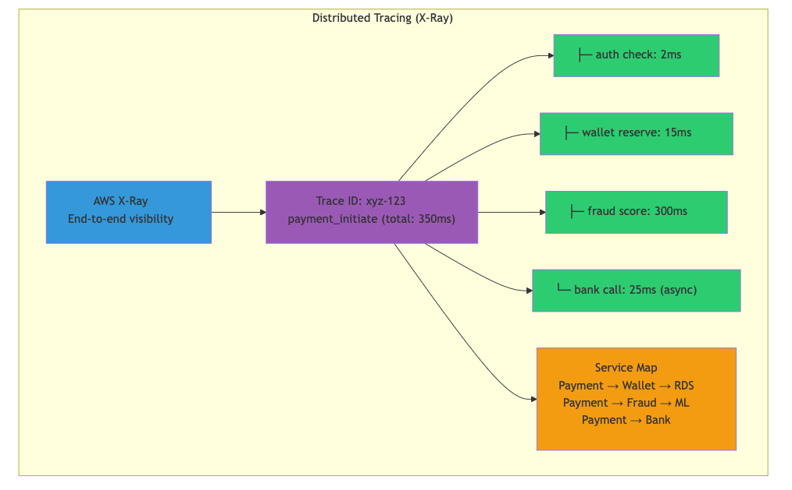
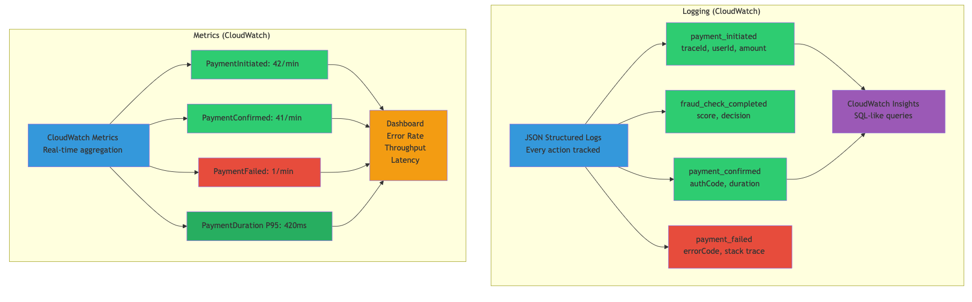
graph TB
subgraph "Logging (CloudWatch)"
LOGS["JSON Structured Logs<br/>Every action tracked"]
LOG1["payment_initiated<br/>traceId, userId, amount"]
LOG2["fraud_check_completed<br/>score, decision"]
LOG3["payment_confirmed<br/>authCode, duration"]
LOG4["payment_failed<br/>errorCode, stack trace"]
LOGS --> LOG1
LOGS --> LOG2
LOGS --> LOG3
LOGS --> LOG4
QUERY["CloudWatch Insights<br/>SQL-like queries"]
LOG1 --> QUERY
LOG3 --> QUERY
end
subgraph "Metrics (CloudWatch)"
METRICS["CloudWatch Metrics<br/>Real-time aggregation"]
M1["PaymentInitiated: 42/min"]
M2["PaymentConfirmed: 41/min"]
M3["PaymentFailed: 1/min"]
M4["PaymentDuration P95: 420ms"]
METRICS --> M1
METRICS --> M2
METRICS --> M3
METRICS --> M4
DASHBOARD["Dashboard<br/>Error Rate<br/>Throughput<br/>Latency"]
M1 --> DASHBOARD
M2 --> DASHBOARD
M3 --> DASHBOARD
M4 --> DASHBOARD
end
subgraph "Distributed Tracing (X-Ray)"
XRAY["AWS X-Ray<br/>End-to-end visibility"]
TRACE["Trace ID: xyz-123<br/>payment_initiate (total: 350ms)"]
SEG1["├─ auth check: 2ms"]
SEG2["├─ wallet reserve: 15ms"]
SEG3["├─ fraud score: 300ms"]
SEG4["└─ bank call: 25ms (async)"]
XRAY --> TRACE
TRACE --> SEG1
TRACE --> SEG2
TRACE --> SEG3
TRACE --> SEG4
SMAP["Service Map<br/>Payment → Wallet → RDS<br/>Payment → Fraud → ML<br/>Payment → Bank"]
TRACE --> SMAP
end
style LOGS fill:#3498db
style LOG1 fill:#2ecc71
style LOG2 fill:#2ecc71
style LOG3 fill:#2ecc71
style LOG4 fill:#e74c3c
style QUERY fill:#9b59b6
style METRICS fill:#3498db
style M1 fill:#2ecc71
style M2 fill:#2ecc71
style M3 fill:#e74c3c
style M4 fill:#27ae60
style DASHBOARD fill:#f39c12
style XRAY fill:#3498db
style TRACE fill:#9b59b6
style SEG1 fill:#2ecc71
style SEG2 fill:#2ecc71
style SEG3 fill:#2ecc71
style SEG4 fill:#2ecc71
style SMAP fill:#f39c12

CONCLUSIONES Y RECOMENDACIONES

Puntos Clave de Diseño
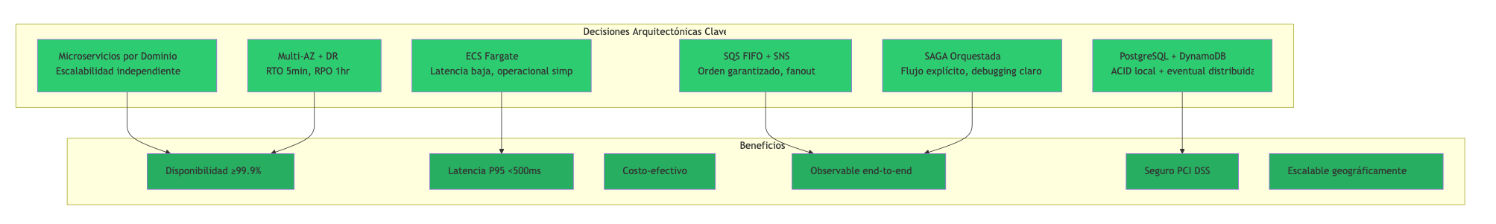
graph TB
subgraph "Decisiones Arquitectónicas Clave"
D1["Microservicios por Dominio<br/>Escalabilidad independiente"]
D2["ECS Fargate<br/>Latencia baja, operacional simple"]
D3["PostgreSQL + DynamoDB<br/>ACID local + eventual distribuida"]
D4["SQS FIFO + SNS<br/>Orden garantizado, fanout"]
D5["SAGA Orquestada<br/>Flujo explícito, debugging claro"]
D6["Multi-AZ + DR<br/>RTO 5min, RPO 1hr"]
end
subgraph "Beneficios"
B1["Disponibilidad ≥99.9%"]
B2["Latencia P95 <500ms"]
B3["Costo-efectivo"]
B4["Observable end-to-end"]
B5["Seguro PCI DSS"]
B6["Escalable geográficamente"]
end
D1 --> B1
D2 --> B2
D3 --> B5
D4 --> B4
D5 --> B4
D6 --> B1
style D1 fill:#2ecc71
style D2 fill:#2ecc71
style D3 fill:#2ecc71
style D4 fill:#2ecc71
style D5 fill:#2ecc71
style D6 fill:#2ecc71
style B1 fill:#27ae60
style B2 fill:#27ae60
style B3 fill:#27ae60
style B4 fill:#27ae60
style B5 fill:#27ae60
style B6 fill:#27ae60

Roadmap de Implementación (Fases)
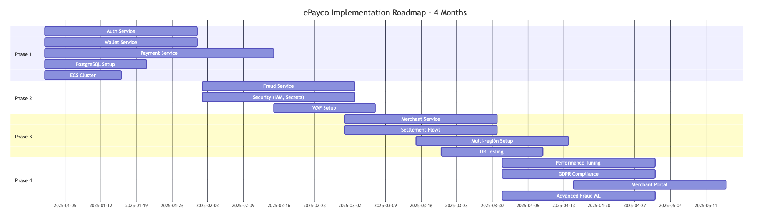
gantt
title ePayco Implementation Roadmap - 4 Months
dateFormat YYYY-MM-DD
section Phase 1
Auth Service :p1a, 2025-01-01, 30d
Wallet Service :p1b, 2025-01-01, 30d
Payment Service :p1c, 2025-01-01, 45d
PostgreSQL Setup :p1d, 2025-01-01, 20d
ECS Cluster :p1e, 2025-01-01, 15d
section Phase 2
Fraud Service :p2a, 2025-02-01, 30d
Security (IAM, Secrets) :p2b, 2025-02-01, 30d
WAF Setup :p2c, 2025-02-15, 20d
section Phase 3
Merchant Service :p3a, 2025-03-01, 30d
Settlement Flows :p3b, 2025-03-01, 30d
Multi-región Setup :p3c, 2025-03-15, 30d
DR Testing :p3d, 2025-03-20, 20d
section Phase 4
Performance Tuning :p4a, 2025-04-01, 30d
GDPR Compliance :p4b, 2025-04-01, 30d
Merchant Portal :p4c, 2025-04-15, 30d
Advanced Fraud ML :p4d, 2025-04-01, 30d

Métricas de Éxito
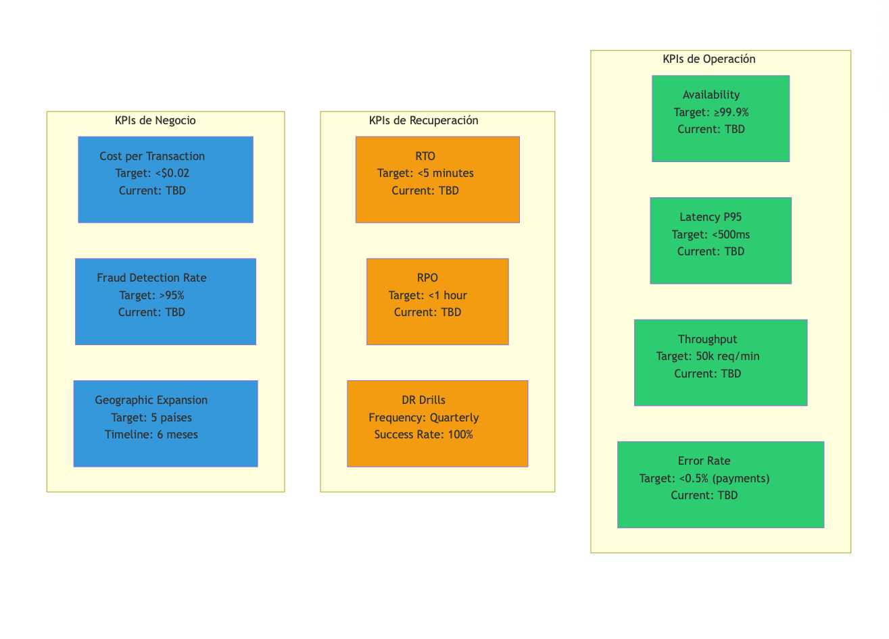
graph TB
subgraph "KPIs de Operación"
KPI1["Availability<br/>Target: ≥99.9%<br/>Current: TBD"]
KPI2["Latency P95<br/>Target: <500ms<br/>Current: TBD"]
KPI3["Throughput<br/>Target: 50k req/min<br/>Current: TBD"]
KPI4["Error Rate<br/>Target: <0.5% (payments)<br/>Current: TBD"]
end
subgraph "KPIs de Recuperación"
KPI5["RTO<br/>Target: <5 minutes<br/>Current: TBD"]
KPI6["RPO<br/>Target: <1 hour<br/>Current: TBD"]
KPI7["DR Drills<br/>Frequency: Quarterly<br/>Success Rate: 100%"]
end
subgraph "KPIs de Negocio"
KPI8["Cost per Transaction<br/>Target: <$0.02<br/>Current: TBD"]
KPI9["Fraud Detection Rate<br/>Target: >95%<br/>Current: TBD"]
KPI10["Geographic Expansion<br/>Target: 5 países<br/>Timeline: 6 meses"]
end
style KPI1 fill:#2ecc71
style KPI2 fill:#2ecc71
style KPI3 fill:#2ecc71
style KPI4 fill:#2ecc71
style KPI5 fill:#f39c12
style KPI6 fill:#f39c12
style KPI7 fill:#f39c12
style KPI8 fill:#3498db
style KPI9 fill:#3498db
style KPI10 fill:#3498db

Fin del documento de arquitectura
Este diseño proporciona una base sólida para una plataforma de pagos escalable, resiliente y observable. Las decisiones están documentadas con trade-offs explícitos, permitiendo futuras iteraciones informadas.

