Optimization using Binary coded Genetic Algorithm

By

Dharmik Patel

204103318

* Optimization Problem

Minimize the given Objective Function, $f\left(x_{1}, x_{2}\right)= x_{1}+ x_{2}-2*{x_{1}}^{2}- {x_{2}}^{2}+ x_{1}x_{2}$

In the range of $0.0 ≤ x_{1}, x_{2} ≤0.5$

* Results

The given problem has two minima points in the given range. One point is $(0,0)$ and second point is $(0.5,0)$.

Predefined values:

Number of variable = 2

Maximum value of variables = 0.5

Minimum value of variables = 0.0

Population size = 6

Crossover probability = 0.9

Mutation probability = 0.1

Fitness Value is calculated by: $FV= \frac{1}{1+OFV}$, where OFV = Objective Function Value

Here, two results are shown below:

1. Result-1:

Initial population:

0 1 1 1 1 1 0 1 0 0 1 1

1 0 1 0 0 1 1 1 1 0 1 0

0 0 0 1 0 1 0 0 0 0 1 0

1 0 0 1 1 1 1 0 0 0 0 1

1 1 1 0 0 0 0 1 1 0 0 1

0 0 0 1 1 1 0 0 1 1 1 0

Initial X-values and fitness values:

|  |  |  |  |
| --- | --- | --- | --- |
| $$x_{1}$$ | $$x_{2}$$ | Fitness Value | Objective Function Value |
| 0.2460 | 0.1508 | 0.7751 | 0.2901 |
| 0.3254 | 0.4603 | 0.6614 | 0.5118 |
| 0.0397 | 0.0159 | 0.9499 | 0.0528 |
| 0.3095 | 0.2619 | 0.7182 | 0.3923 |
| 0.4444 | 0.1984 | 0.771 | 0.2966 |
| 0.0556 | 0.1111 | 0.8663 | 0.1543 |

No. Generation taken to reach at optimum solution $(0,0)$ = 28 (considering initial as generation = 1)

|  |  |  |  |
| --- | --- | --- | --- |
| $$x_{1}$$ | $$x_{2}$$ | Fitness Value | Objective Function Value |
| 0 | 0 | 1 | 0 |

Below, three graphs for the above run are shown:

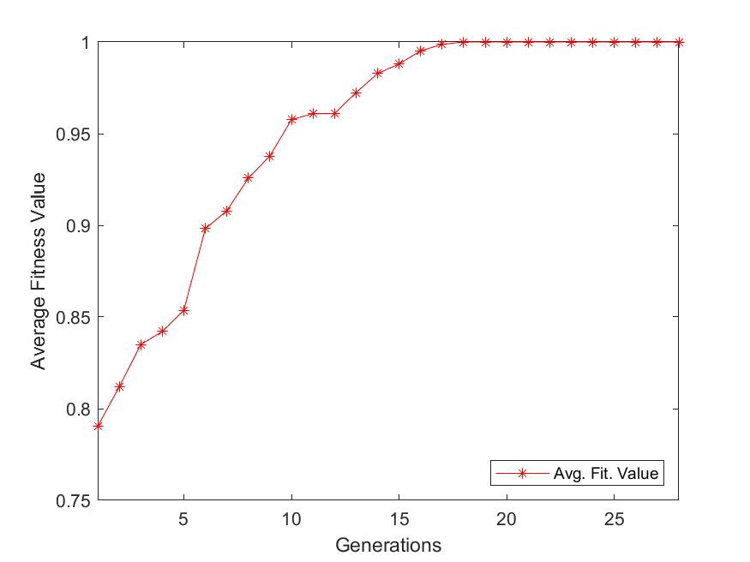

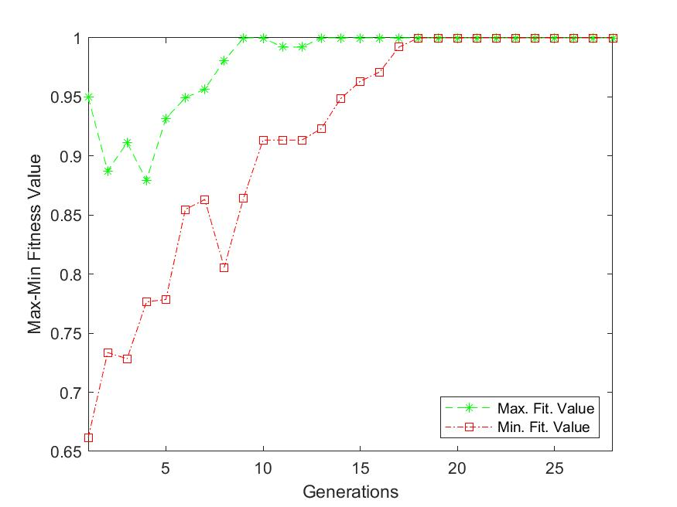

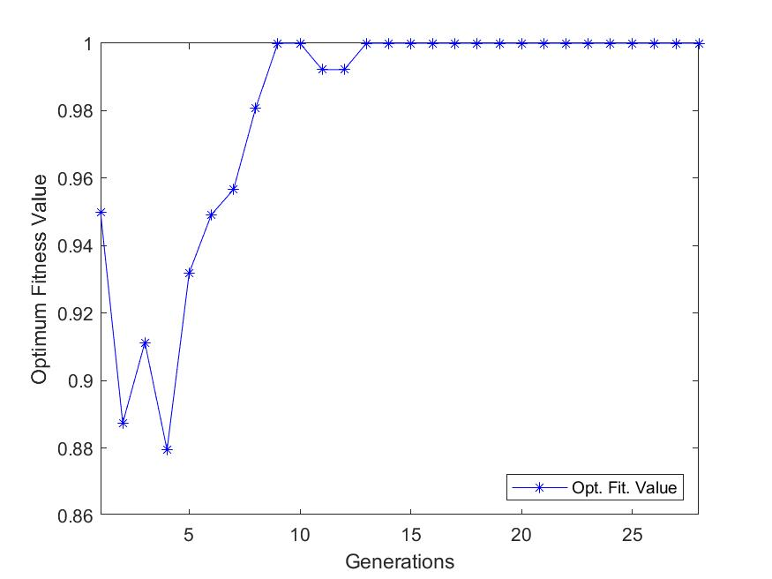

1. Result-2:

Initial population:

0 1 1 1 1 0 0 1 0 0 0 1

0 1 0 1 1 0 1 0 0 1 0 1

0 0 1 1 1 1 0 1 0 1 0 1

0 1 1 0 1 1 1 0 0 0 1 1

1 0 0 1 1 0 0 0 1 1 1 0

0 1 1 0 0 0 1 1 0 0 1 0

Initial X-values and fitness values:

|  |  |  |  |
| --- | --- | --- | --- |
| $$x_{1}$$ | $$x_{2}$$ | Fitness Value | Objective Function Value |
| 0.2381 | 0.1349 | 0.7852 | 0.2736 |
| 0.1746 | 0.2937 | 0.7287 | 0.3723 |
| 0.1190 | 0.1667 | 0.8004 | 0.2494 |
| 0.2143 | 0.2778 | 0.7233 | 0.3826 |
| 0.3016 | 0.1111 | 0.7988 | 0.2519 |
| 0.1905 | 0.3968 | 0.6979 | 0.4329 |

No. Generation taken to reach at optimum solution $(0,0)$ = 28 (considering initial as generation = 1)

|  |  |  |  |
| --- | --- | --- | --- |
| $$x_{1}$$ | $$x_{2}$$ | Fitness Value | Objective Function Value |
| 0.5 | 0 | 1 | 0 |

Below, three graphs for the above run are shown:

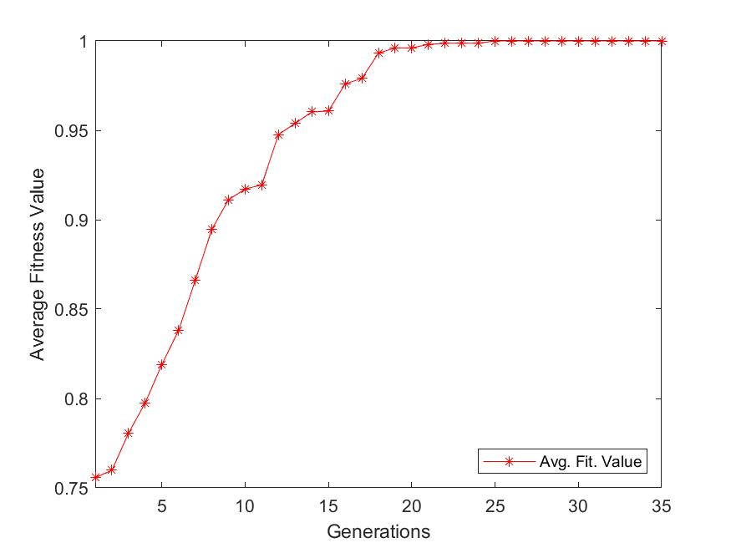

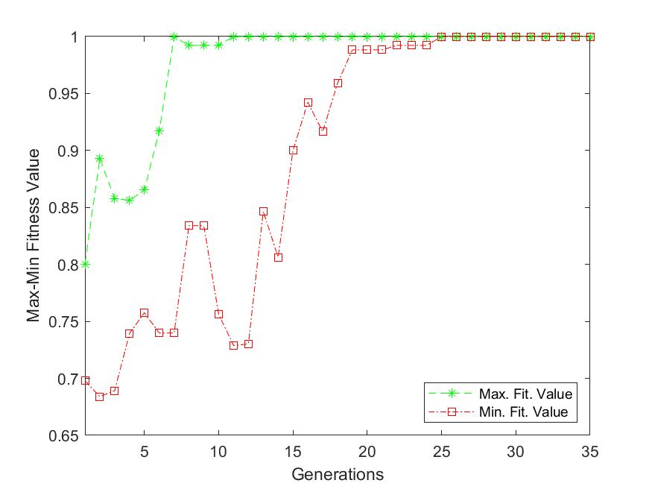

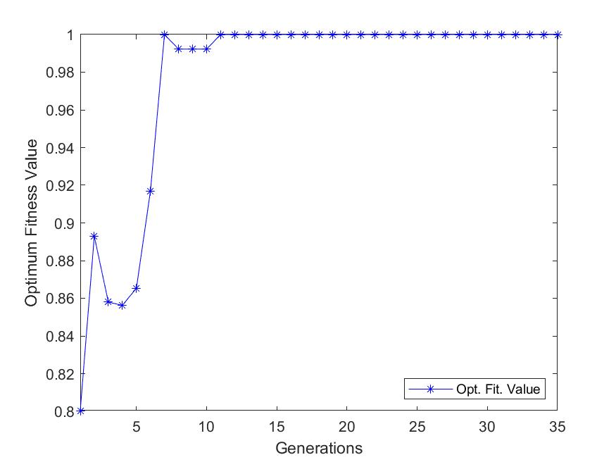

* Important Points:

1. In the given code, after calculation of mutation step if average fitness value of that solution comes greater than average fitness value of previous generation solution, then that solution will be taken as present generation solution (if this condition is not put then we might have optimum solution at one point, but due to not satisfying terminating conditions, it will continue to run until last and we lose our optimum solution). So, this code will run for few iterations within one generation, to get optimum value.
2. ­Two termination conditions are taken in present code. Those are, one termination condition is that, if generation number goes beyond maximum generation number given by user, then code will be terminated. Second termination condition is that, if average fitness value of present generation is equal to average fitness value before 10 generations, then in this case also code will be terminated.