Boot Pins/Jumpers Explained
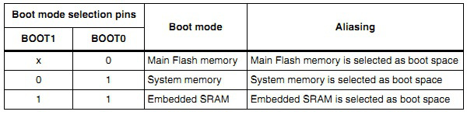
first case is when BOOT0 pin is tied to ground and BOOT1 is open or at logical state 0 then after reset program is executed from Main Flash Memory. This is your normal configuration when executing programs. Second case (BOOT1=0; BOOT0=1) means that after reset execution starts at System memory where built int bootloader resides. This is the case when we need to upload binaries via USART1. And third case means that program execution is performed in SRAM.
a
Option 2 “System memory” is BOOT 1 towards jtag connector BOOT 0 towards mini-usb end

Programming Via JTAG JS-LINK V2 and OPENOCD

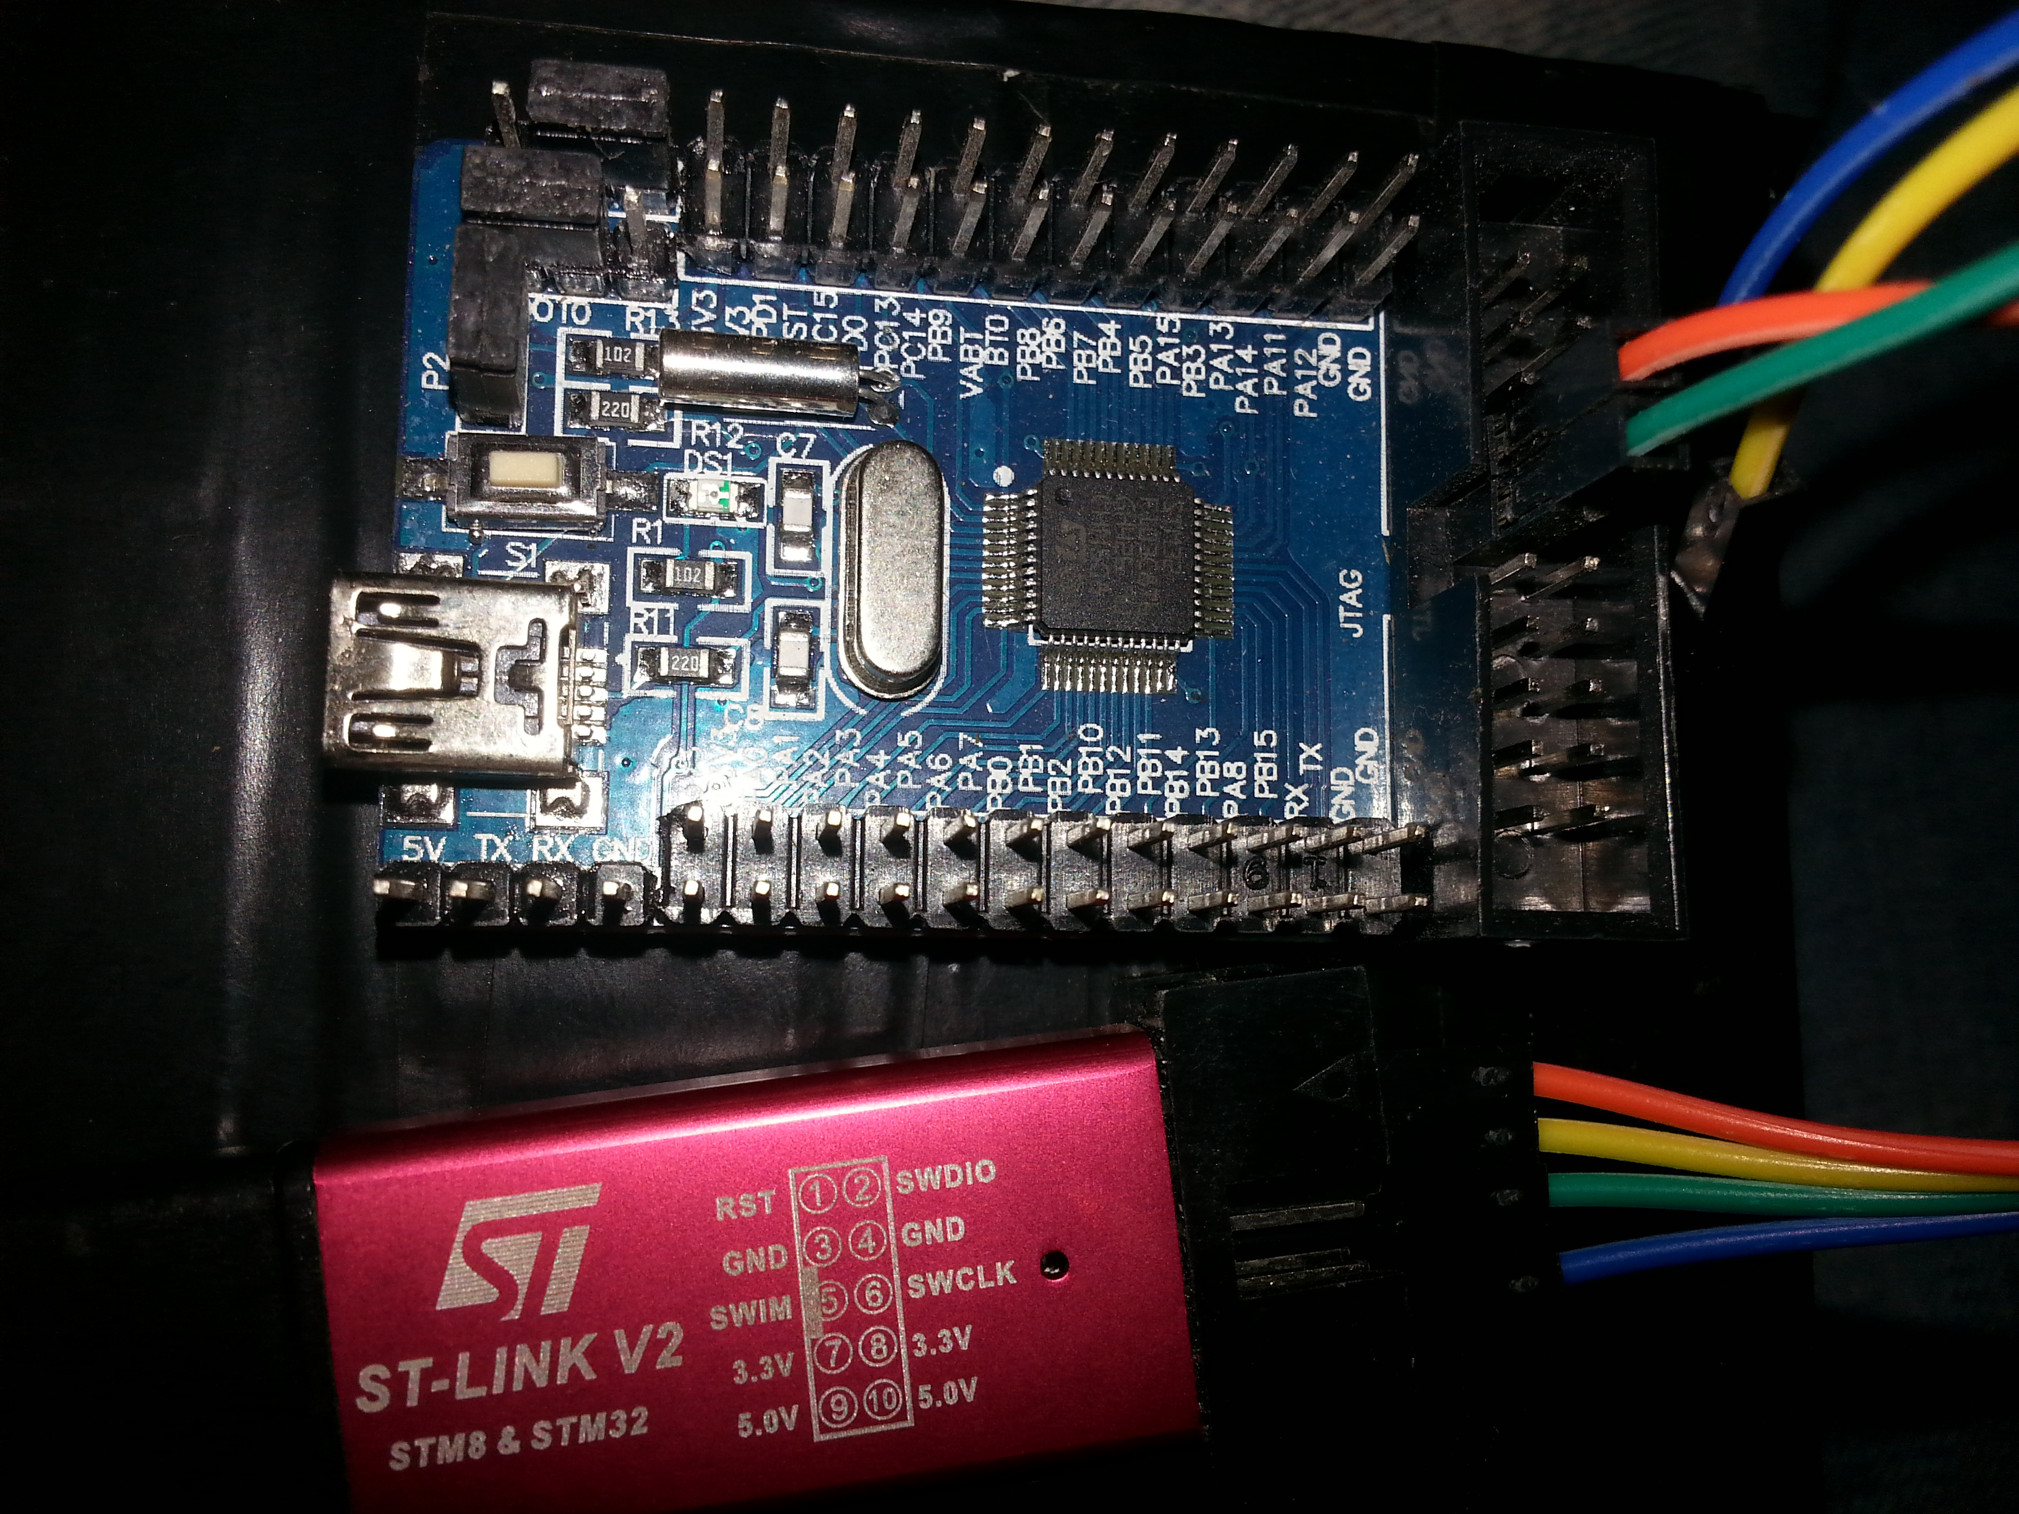
Green SWCLK orange SWDIO
NOTE: If you have an .elf file then convert to a intel .bin with the following command
arm-none-eabi-objcopy -Obinary main.elf main.bin

1 START OPENOCD;

while true; do openocd -f /usr/share/openocd/scripts/interface/stlink-v2.cfg -f /usr/share/openocd/scripts/target/stm32f1x.cfg ; sleep 1;done

(For NRF58122 use);

openocd -f /usr/share/openocd/scripts/interface/stlink-v2.cfg -f /usr/share/openocd/scripts/target/nrf51.cfg

(slightly different but seemed to work)

openocd -d3 -f /usr/share/openocd/scripts/interface/stlink-v2.cfg -f /usr/share/openocd/scripts/target/nrf51.cfg

(NRF51822 NOTES)
UART pins for RedBearLab BOOTROM pin p009=tx p011=rx
/usr/share/openocd/scripts/target/nrf51.cfg
/usr/share/openocd/scripts/target/nrf51_stlink.tcl
/usr/share/openocd/scripts/interface/stlink-v2.cfg

2 CONNECT TO OPENOCD

telnet 127.0.0.1 4444

3 (nRF51822)
>flash banks
>halt
>flash write_image erase PATH-TO-YOUR-BINARY/YOUR-BINARY.bin 0
>reset
(MASS ERASE INCLUDING UICR) >nrf51 mass_erase

3 (STM32) RESET HALT sequence

press and hold reset on stm32 (DONT LET GO)
in telnet issue command > reset halt (should have error)
release reset button (stm32 should halt after reset)

VARIOUS THINGS TO DO; (STM32 and probly others)

1 DUMP EXISTING FIRMWARE

dump_image dump.bin 0x08000000 0x1ffff

2 INSTALL BOOTLOADER ??ANY APP??

> reset halt
> flash write_image erase generic-none_bootloader.bin 0x08000000
> reset run

******************** SECOND LIST OF COMMANDS FOUND **********************

1 START OPENOCD AND TELNET TO IT SAME AS ABOVE THEN FLASH NEW PROGRAM VIA THESE COMMANDS (INSIDE TELNET)

> reset halt
> flash probe 0
> stm32f1x unlock 0
> flash write_image erase main.bin 0x08000000
> reset
> exit

0x8002000 0x8005000
************* nRF51822 COMBINE SOFTDEVICE, BOOTLOADER, AND APP **************

srec_cat s130_nrf51_1.0.0_softdevice.hex -intel BLE_beacon.cpp_OTA.RBL_nRF51822.hex -intel bootloader.hex -intel -exclude 0x3FC00 0x3FC20 -generate 0x3FC00 0x3FC04 -l-e-constant 0x01 4 -generate 0x3FC04 0x3FC08 -l-e-constant 0x00 4 -generate 0x3FC08 0x3FC0C -l-e-constant 0xFE 4 -generate 0x3FC0C 0x3FC20 -constant 0x00 -o combined.hex -intel

*************************** nRF51822 GDB programming ******************************

NOTE: On my generic stm32f103c8 board PA4 to Nrf51822 SDO and PA5 to Nrf51822 SCLK

sudo gdb
set confirm off
target extended-remote \\.\<THE COM PORT OF YOU BLACK MAGIC PROBE GDB SERER>
monitor swdp_scan
attach 1
monitor erase_mass
file <THE PATH TO THE S130 SOFTDEVICE HEX FILE>
load
quit

