MSFS CamControl V 0.70.0.70

See (V0.70) indications for updates from the previous version (V0.65)

# Control the Sim Camera from an independent App

* The App supports many Cam functions in a more condensed space than the MSFS Cam Window
* However at the time of writing many functions in SimConnect are not (yet) working – so this App is to be considered as Work In Progress
* As soon as MSFS supports more it will be added to the App

**Please read the Setup guide page 3 in order to make full use of the added functionality**

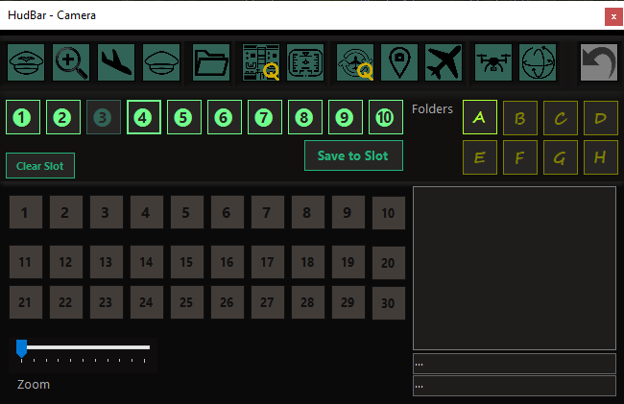

It is modelled to match the Views available in the Sim Camera Tool.

## V 0.70 News

* GUI redesign
* FlyBy Helper
* Custom Camera selection
* Fixed 6DOF Pitch direction – was changed in one of the SU’s

## Old News

…

Content

Control the Sim Camera from an independent App 1

V 0.70 News 2

Old News 2

Usage of the Standalone App 3

Setup (V0.70 new) 3

Limitations – please read (V0.70 new) 3

Camera Management Console 4

6DOF Camera 6

Selecting Custom Cameras (V0.70 new) 7

FlyBy Helper (V0.70 new) 8

Controls Monitor (V0.70 new) 10

Key Setup (V0.70 new) 11

Distributed Contents: 12

Appendix: 12

Issue Reporting: 12

# Usage of the Standalone App

* Deploy the release all zip content in a folder (no installer provided or needed)

Best is to start MSFS first, then the CamControl   
Start MSFS2020 first and once the Main Menu is shown

* Start FS20_CamControl.exe
* It attempts to connect to the Flight simulator in 5 sec intervals, but shows a red line on top while it cannot connect

# Setup (V0.70 new)

In order to use the new functionality you have to setup the key-bindings in the Cam Window first, and only once…

**Right** Click into an empty area to find the Configure Key menu an click it.

See **Key Setup** Chapter page 11 below on how to do it.

# Limitations – please read (V0.70 new)

* With the new features the Application will sometimes issue keystrokes to the Simulator window.   
  This might be detected by some virus checkers or other security programs – I did not encounter it so far.  
  In such cases you may want to add the App to the exclusion list of such security programs.

*Disclosure: The Camera App sends keystrokes for the 10 Custom cameras when selecting the custom cam, and 6 Drone movements (up, down, left, right, forward, backward) when using the FlyBy Helper.*

* I appears that sometimes commands are ignored by the Sim.  
  This is due to the time the sim needs switching cameras and views. The Sim then simply ignores or ‘forgets’ commands issued by outside programs.  
  If you encounter, just try again and it may work. At least I could not find a way to force the Sim to do things…

# Camera Management Console

A separate Window to control the Camera Views.

It is modelled to match the Views available in the Sim Camera Tool.  
*Hint: to see what is what open the Sim Camera tool and hit some buttons in the new Console – the Sim Tool will update accordingly*

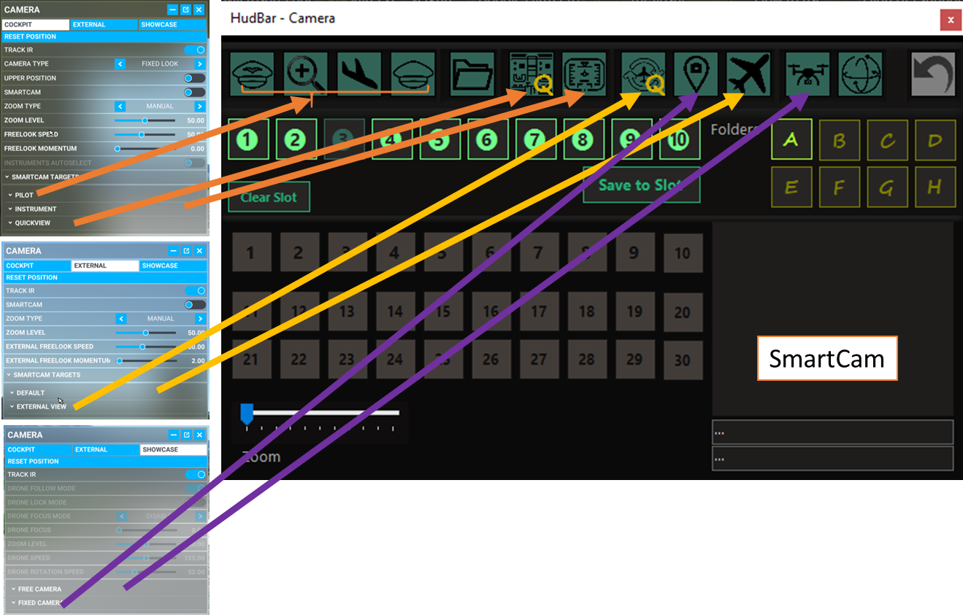

With HudBar running **Open** the Console via RightClick Menu **Camera…**

**Close** it with the X top right

The **View Icons** match according to the illustration to the right.

**Quick** Views are named as such and marked with Q.

**Free** Views are the **Drone** and the **External** Default Cameras

The **Cockpit** View goes with **Pilot**, **Instrument** and the **Quick** View.  
For the Pilot the 4 fixed positions are named (Pilot, Close, Land, CoPilot)

Except for the Free Views the preset camera POI is selected with a **numbered button 1..30**.   
Quick Views have 8, other Views according to the configuration file of the aircraft.

Starred ☼ Views

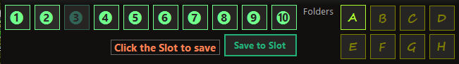

**Up to 80** views can be stored and are available in the upper part of the Cam App.

You may **save** the **current** view into one of the 8 Folders (**A..H**) - Slots (❶..❿), only the View is saved, not position, angle etc. when changed with the mouse.

To **Save**, click ‘**Save to Slot**’ and then the **Slot** to save to. To **Cancel** Save, click the Save button again.  
The red advice should then go away. To clear a slot click ‘**Clear Slot**’.

To **Recall**, click the **Folder/Slot** while not in Save mode.

Indexed Views

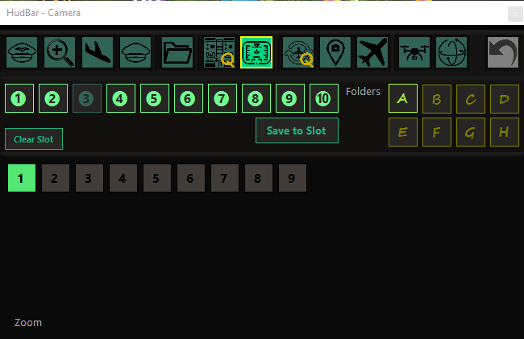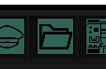In MSFS some camera modes are indexed. Means a number of views are predefined and available for the user to choose from.

Quick Views have always 8 views.

Instrument and Showcase fixes cameras have aircraft dependent different number of views.  
The Cam App will enable the correct number of view buttons when selecting a mode.  
(Here the instrument view has 9 possible views)

Custom Views

**Custom Views** can now be recalled by using keyboard injection (V0.70 new )  
Custom views are selected like any other numbered view from buttons 1..10 which ,match the views 1..9, and 0 for 10

🡪 Be sure do configure the keys when first using it.

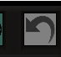

Reset View

Sometimes it is helpful to **Reset** a View

HotKey Binding for the HudBar Version

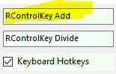**Show/Hide** can be assigned to a **keyboard shortcut**. It is also mapped to a MSFS command (ADF2_FRACT_DEC_CARRY), both must be enabled in Configuration (see Hotkeys above).  
There is no label, it is two above the CheckBox for Keyboard Hotkeys (see Tooltip)  
Here I assigned it to <Right Control> + <Numpad+>, default it is empty.

NOTE: Sometimes switching Views or POIs may not change the first time, just hit the button again.  
I assume there is still quite a bit of WorkInProgress ™ by Asobo… as the Sim Tool does the same.  
Also note that I cannot retrieve the names of the POI views as shown in the Sim Window – we have to live with the numbers …

# 6DOF Camera

This is *undocumented* in the MSFS SDK but works in SU14 …  
*ASOBO mentioned it is no longer supported any may no longer work in future updates … let’s see…*

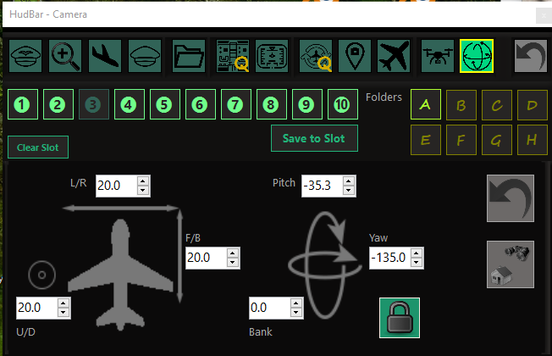

The 6DOF Camera is a gimballed camera firmly attached to the aircraft at position 0/0/0 which is usually close to the pilot seat.   
Note: the camera is really attached to the plane and will follow ALL movements of the aircraft, especially when on a runway it shakes quite a bit...

One can adjust the position of the camera relative to its origin in X,Y,Z which is front, back; above, below; and left, right of that center point.  
The gimbal, or viewpoint of the camera is controlled by heading (left, right), pitch (up, down), and bank values.

! 6DOF Camera Positions can be saved to Slots and recalled like other camera positions (see Starred Views).  
For the 6DOF camera also the number values are saved and restored.

When selecting the 6DOF cam the button area is overlaid by the numeric controls shown above.

Using the numeric controls one can adjust the **position** and **viewpoint** (gimbal) of the camera.

* On the left side is the cam position (the circle is up, down movement)
* On the right side the viewpoint (gimbal)
* Checking **LOCK** will maintain the viewpoint towards the aircraft while moving the camera position
* The button to the right will set a ‘look down’ viewpoint either left or right down

Numeric controls can be clicked, clicked and held, or accept a number entry.  
The value range is +-500.0 for the position which is an increment of about 10cm (4 inch) and +-180.0° for the viewpoint.

*Note: the MSFS Camera Dialog show does not support this mode but you still can revert to any other cam view if you wish (need) to do so.*

# Selecting Custom Cameras (V0.70 new)

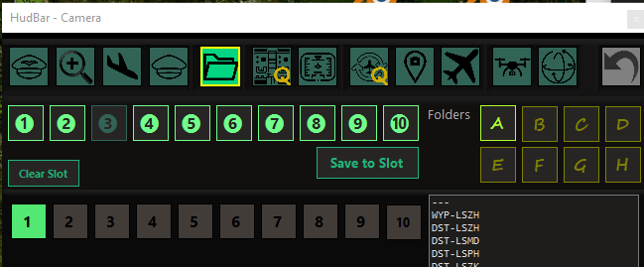

It is now possible to select custom cameras i.e. the ones you saved into slot 1..9, 0

The slots are selected using the index buttons 1..10, where 1..9 relate to custom camera 1..9 and the number 10 index calls custom camera 0

The **Key Setup** is required to have this work properly.

Technical stuff…

As the Sim API custom cam selection does not work and no due date is assigned to this bug by ASOBO;  
a workaround is implemented now.  
It is done by issuing key strokes to the Simulator Main Window.  
The Sim Window is activated and then keystrokes are sent to the active window (that is how Windows allows it).

# FlyBy Helper (V0.70 new)

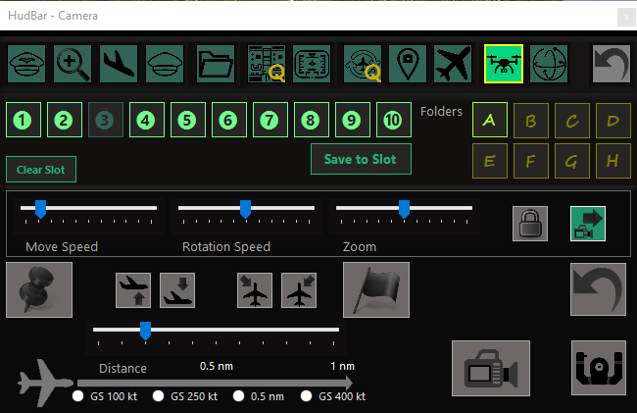

Also known as poor man’s Flyby.

The Drone Camera is used to showcase a fly by.

Here is how it can be done manually.

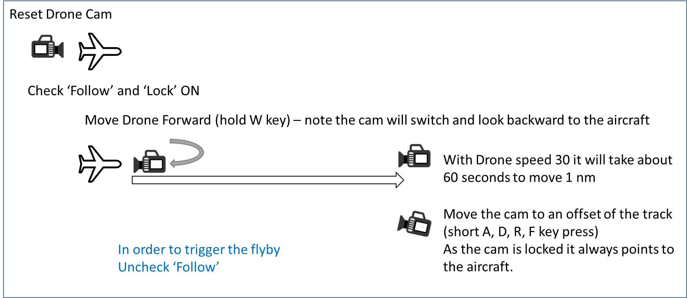

The App will perform those tasks for you and take in account how far out you want to have the camera and if the aircraft is climbing or descending.

You need then only to hit the **FlyBy button** to let the aircraft passing by.

You may use **Zoom** to get closer to the aircraft if needed.

The **Key Setup** for TRANSLATE DRONE keys is required to have this work properly (see page 11).

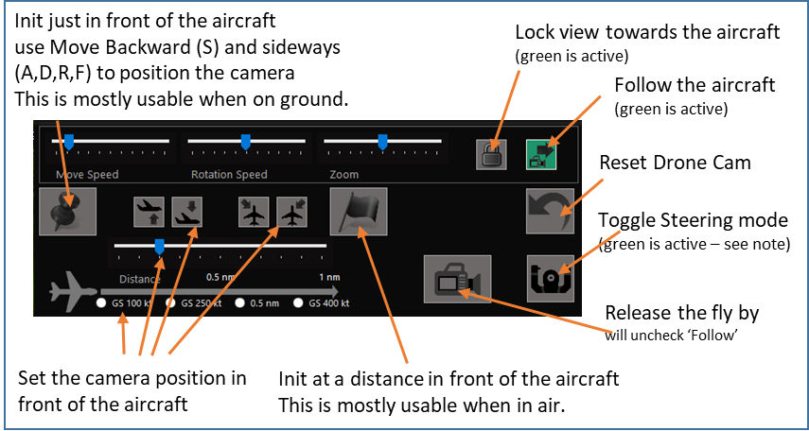FlyBy Helper GUI:

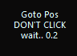

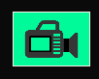While the app is placing the drone there is a countdown timer instead of the FlyBy Button.  
Please wait patiently until it expires and don’t click the App GUI, otherwise keyboard strokes may get lost.  
 When finished the Cam icon reappears in green and is ready to be clicked.

*Note: the app calculates some vertical offset based on the current vertical rate but may not be at level when the VS changes during the setup.  
Also the cam only moves straight forward from the moment the cam is reset. I.e. in turns the camera is most likely not where it is expected but can make for some interesting flybys.*

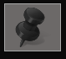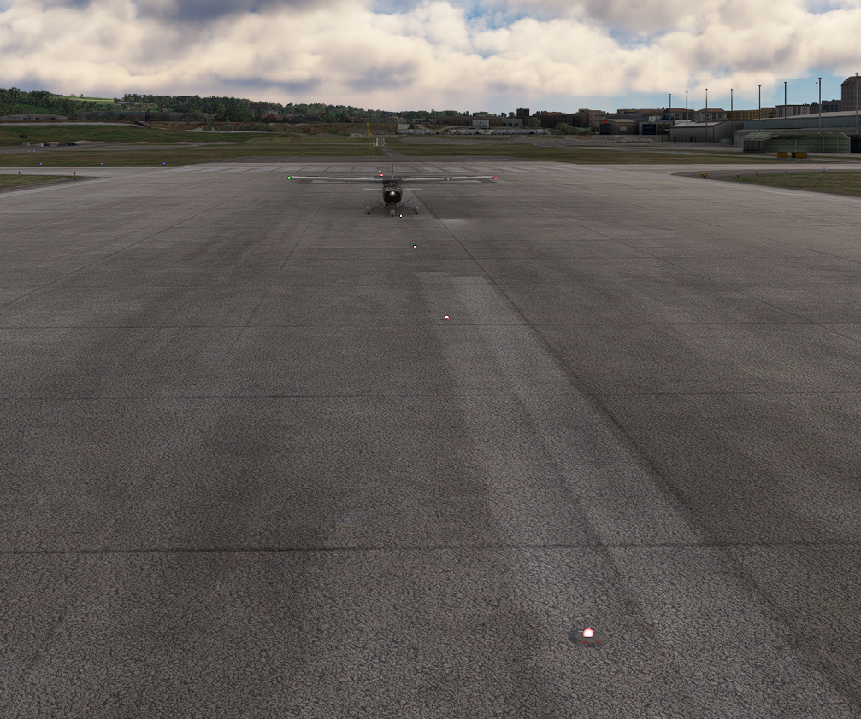**Init in front of the aircraft**

You may move the camera using the designated Drone movement keys or controls (usually WASD+RF)

If you start the aircraft the camera will move together with the aircraft until you hit the Release button. From then on the camera will stop moving and follow the aircraft while passing by.

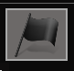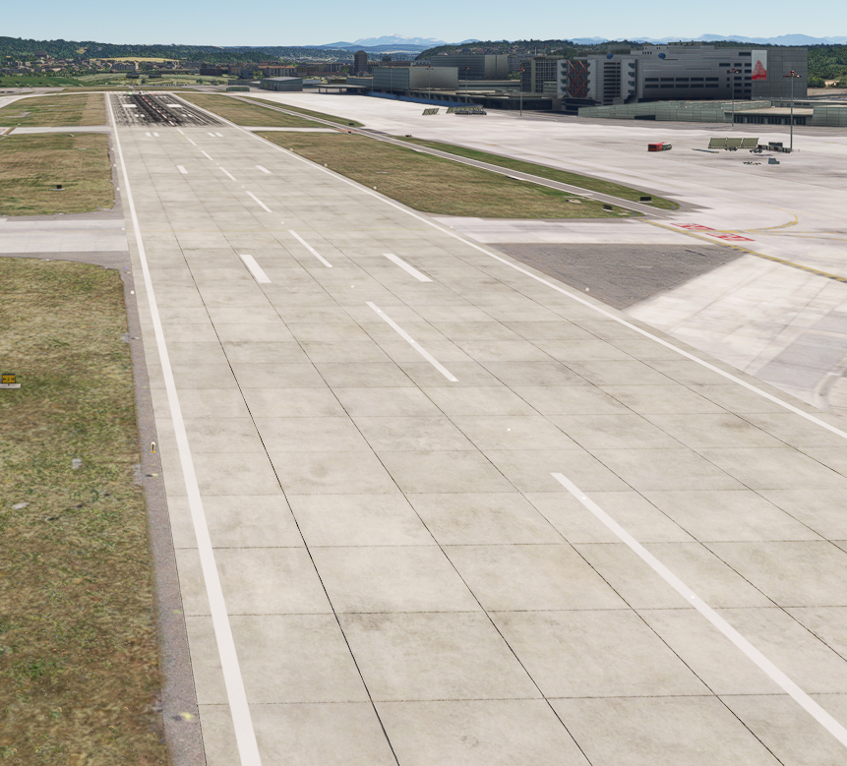**Init 0.5 nm out right side and above as seen from the aircraft**

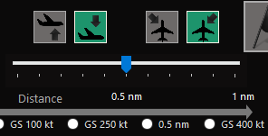

If you start the aircraft the camera will move together with the aircraft until you hit the Release button. From then on the camera will stop moving and follow the aircraft while passing by.

# Controls Monitor (V0.70 new)

**Toggle Controls** is used to either control the aircraft or the camera in Drone mode. Default is drone control.  
If you press C then the controls are back to the aircraft and the drone will not move anymore until pressing C again.

The Cam App can track and display the status BUT assumes the default when starting and can track changes done only when done via CamApp button. It lets you know which controls are active.

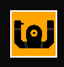If you don’t use the Cam App button tracking is lost as there is no way to learn the state from the Sim.

Orange means controlling the aircraft and no longer the drone.

# Key Setup (V0.70 new)

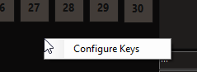In order to be able to issue the right keystrokes to the Sim Window the Camera App needs to know which keys are required – and this is a user setting in MSFS.  
**Right** Click into an empty area to find the Configure Key menu an click it.

The App starts with MSFS defaults:

Drone Movements: W, A, S, D, R, F (forward, left, backward, right, up, down)

Custom Camera: Left Alt+1 .. Left Alt+0

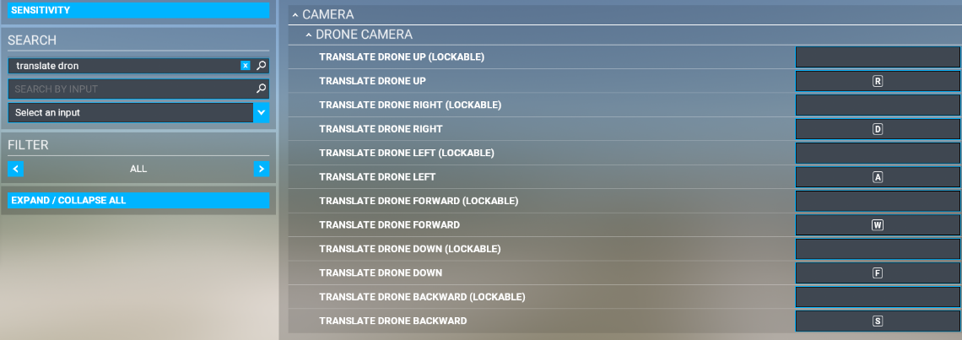Use the Key Setup dialog (**Configure Keys menu**) if you don’t use those defaults and want to change them.  
🡪Settings are saved and it’s only needed once or when changed.

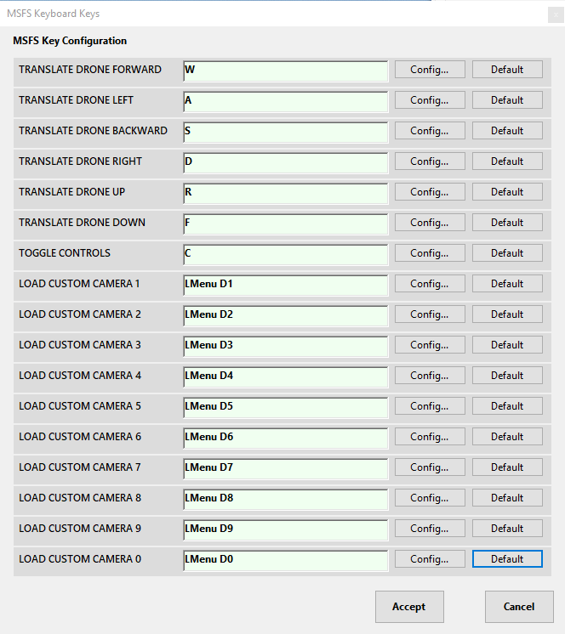Best is to visit the Sim Keyboard setup you are using and selecting the controls via “By Name“. And see which ones are configured.   
(Here all are default for TRANSLATE DRONE)

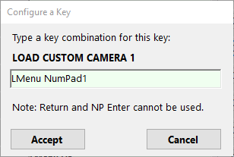

Click **Config…** for the one you need to change, then press the keys required to activate the function. (here it was left ALT and Numpad 1)   
Double check the shown key combination for validity – if not OK redo it.

Click **Accept** or **Cancel** to close and proceed.

Click **Default** to reset to MSFS Default setting.

When done with Key Setup, close the Dialog with **Accept** and the settings will be saved and used immediately.  
Else return with **Cancel**, and all changes are ignored.

*Note: in Windows the Alt key is called Menu i.e. ‘Left ALT’ is ‘LMenu’, Number keys are labelled D1..D0, number keys on the right pad are NumPad1..NumPad0.*

# Distributed Contents:

My FlightSim Libraries (included in the release package)

SEE README.TXT FOR THE LIST

# Appendix:

## Issue Reporting:

In case you encounter a problem please include as much information as possible. Sometimes it is also relevant which aircraft you were using.

To get some helpful information the following procedure will create such output:

Locate where the application is stored (where you extracted the ZIP)

**Enable Logging:** In the application folder **copy** ‘NLog.config.OFF’ to ‘NLog.config’  
Logging will create generations of ‘FS20_HudBar.log’ which might be useful to resolve issues

**Disable Logging:** Delete the ‘NLog.config’ file

Restart the HudBar and try to reproduce the problem

Exit the HudBar and include the FS20_HudBar.log file in the failure report

It is a plain text file – so you can check the contents for anything you don’t like to be sent out.

Issues can be reported directly via GitHub (or a Message in Flightsim.to)

<https://github.com/bm98/FS20_HudBar/issues>

<https://flightsim.to/file/16604/msfs-hudbar>