MSFS Checklist Box V 0.71.0.71

# Independent Checklist Box App

* The up to 20 user definable Checklists
* 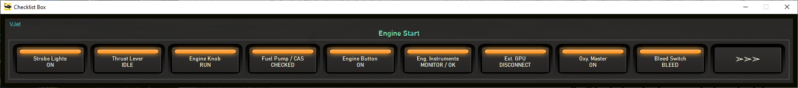There are up to 5 Flight Phases per checklist with up to 10 Check items per Phase.

Credit:

Missionary Bush Pilot: https://www.missionarybushpilot.com/checklistbox  
where the idea of the Checklist box is 'borrowed' from

Content

Independent Checklist Box App 1

News V0.71 1

Usage 1

Checklist Box 2

Distributed Contents: 4

Appendix: 4

File Storage: 4

Issue Reporting: 4

# News V0.71

* Add 3 more Flightphases per Checklist (F,G,H)
* Add Next Phase button at the end of each Checklist
* Add Button Color Amber (in Config)
* Update Config Dialog sizeable and stores location

# Usage

* Deploy the release all zip content in a folder (no installer provided or needed)
* Start FS20_ChecklistBox.exe

## Checklist Box

Simple Checklist for the Pilot.   
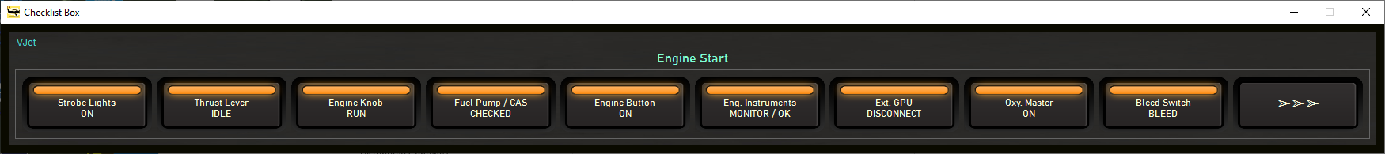

**Checklist –> Phase –> Check**

* Item checking goes along the Airbus logic i.e. Checked (OK) is dark, unchecked is lit up
* Once all items are checked it is framed with a dark green band
* The number of definable Checklists is limited to 30 for practical reasons. (V0.71 update)
* There are up to 8 Flight Phases per checklist with up to 10 Check items per Phase. (V0.71 update)
* In Configuration mark the Phases to be used - the Phase name will highlight with green background.
* 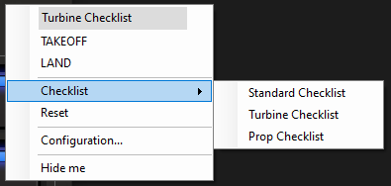Leave a Check item text field empty and it will not show as button
* The text for all items is editable where the number of characters for the List and Phase names is max. 25.
* Text for Check items is not constraint but the button only shows 2 lines  
  Enter (Return) is allowed for line breaks
* 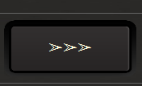Right Click an empty area in the Box for a context menu to choose from:  
  *The Phase to check, the checklist to use, reset all checked items, Configure, Hide*
* Selecting a new Phase will start with all items unchecked
* The last button (with arrows) will switch to the next phase of the selected checklist (V0.71 new)
* Use to **HudBar** Context Menu to Show/Hide the Checklist Box (or an assigned Hotkey)

Configuration:

There is one Tab per Checklist. Edit any field you wish. Check a Phase to get it selectable in the Context Menu.  
Add a new Checklist (Tab) at the end. Copy an existing to a new (at the end of the Tabs). Delete a Checklist.

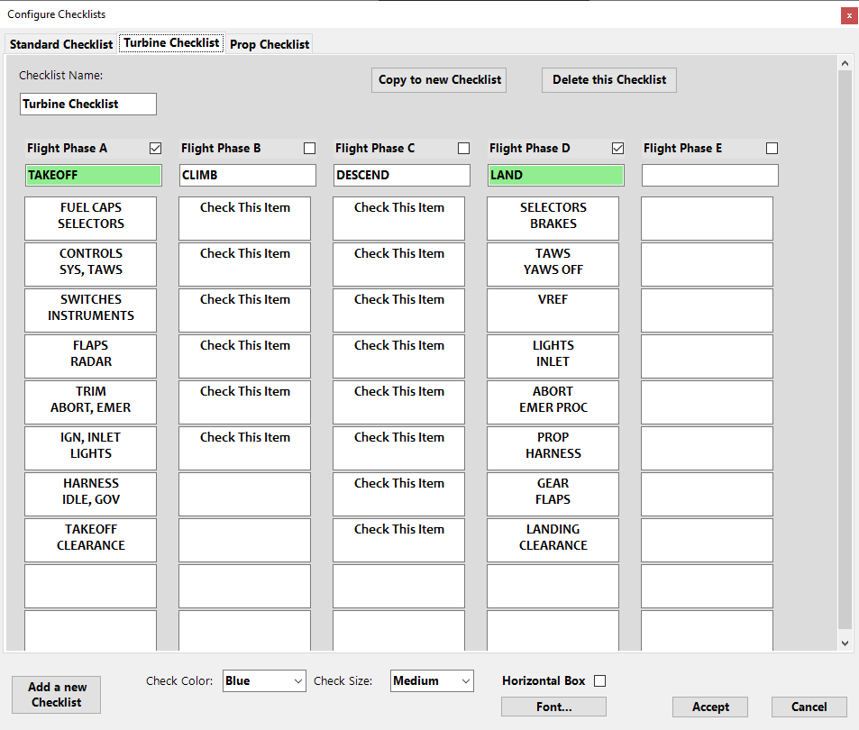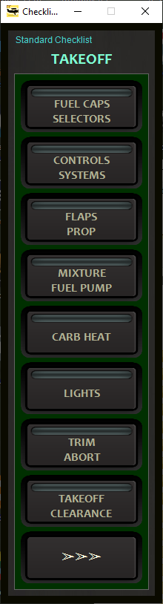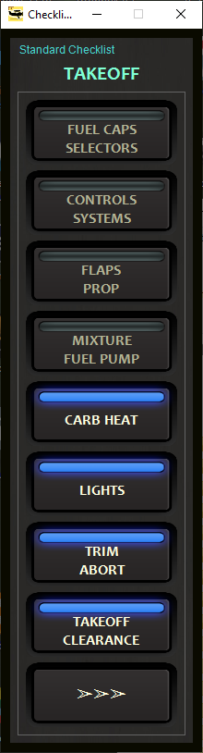Use the **Horizontal Box** check field to switch the orientation, there are 6 LED colors and 3 sizes available. (V0.71 update)  
Leave Configuration with **Accept** to save or **Cancel** to ignore ALL changes.

While changing the **Font** the check text entries are rescaled to approx. fit the Check Button layout, though it is not ‘exact’.

HotKey Binding for the HudBar Version

**Show/Hide** can be assigned to a **keyboard shortcut**. It is also mapped to a MSFS command (ADF2_RADIO_TENTHS_DEC), both must be enabled in Configuration.  
See also in the HudBar Quick Guide.

# Distributed Contents:

My FlightSim Libraries (included in the release package)

SEE README.TXT FOR THE LIST

Credit:

Missionary Bush Pilot: https://www.missionarybushpilot.com/checklistbox  
where the idea of the Checklist box is 'borrowed' from

# Appendix:

## File Storage:

Files are stored in “<USER-DOCUMENTS>\MSFS_HudBarSave” folder

The Config file is stored as: <My Documents>\MSFS_HudBarSave\CheckLists.json

## Issue Reporting:

In case you encounter a problem please include as much information as possible. Sometimes it is also relevant which aircraft you were using.

Issues can be reported directly via GitHub (or a Message in Flightsim.to)

<https://github.com/bm98/FS20_HudBar/issues>

<https://flightsim.to/file/16604/msfs-hudbar>