MSFS HudBar V 0.21.0.14

# Display essential Information as Bar or Tile at any side of the primary screen

* Displays essential aircraft and flight information as Bar or Tile
* Supports 1 and 2 engine aircrafts (Prop/Engine RPM, Fuel Flow for each)
* Provides 5 different content profiles which are fully configurable
* The pilot can directly activate Autopilot commands
* Auto Elevator Trim on a click
* Bottom/Top Bars work best with wide screen monitors

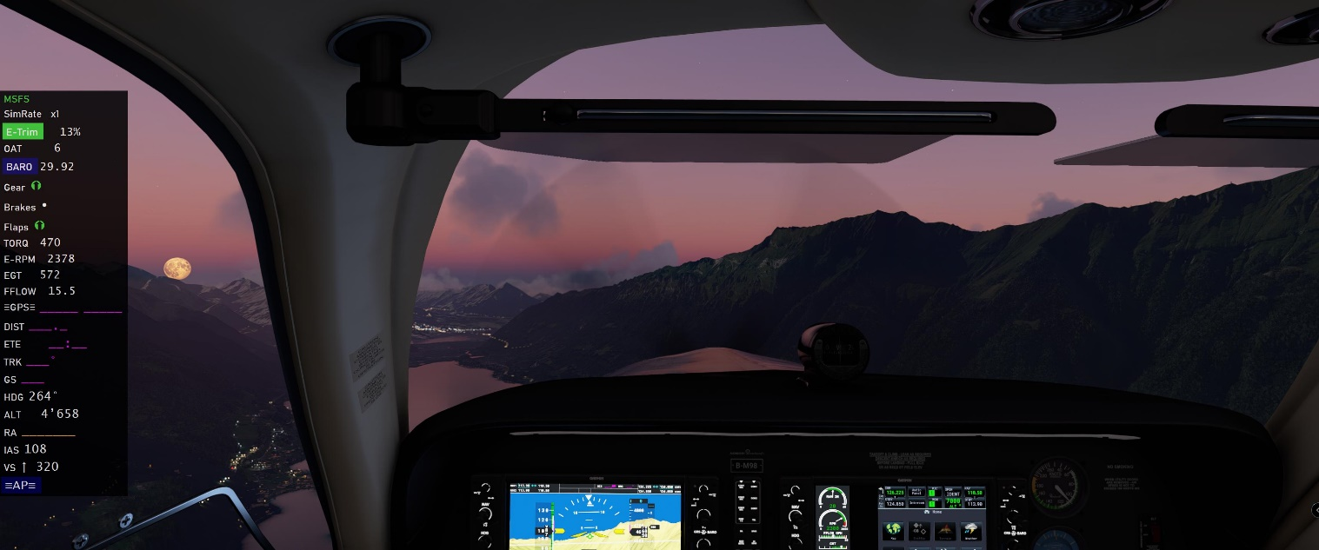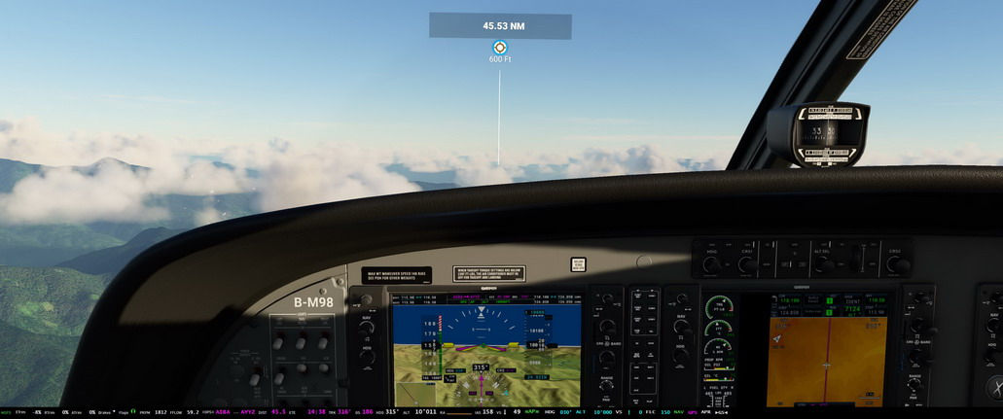

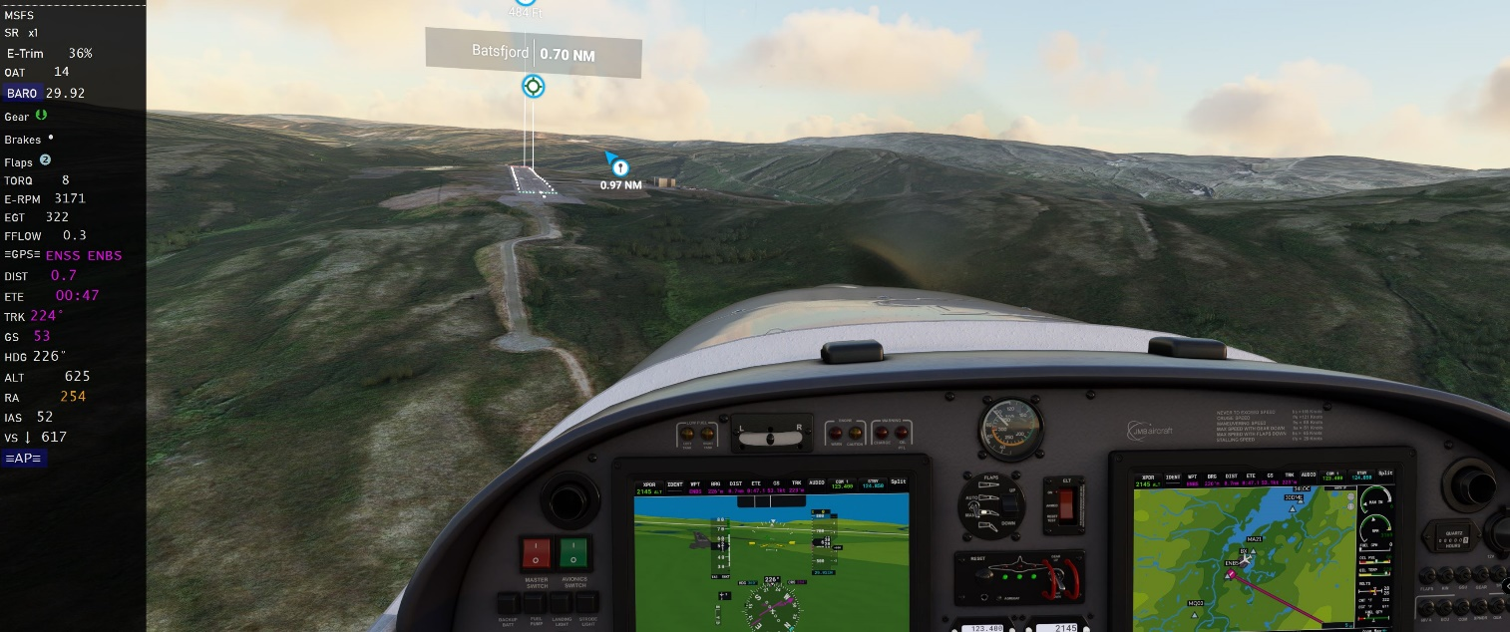

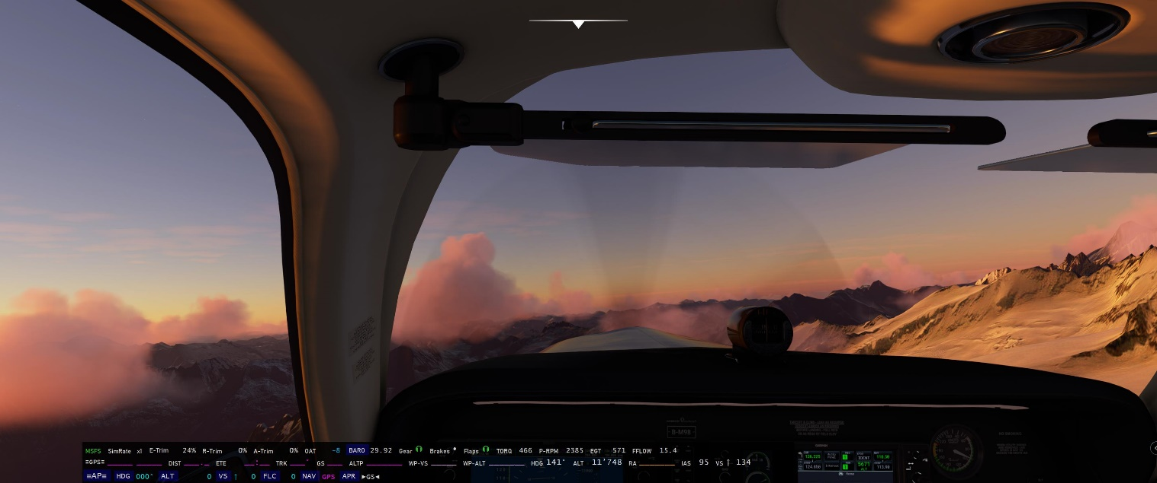FS20_HudBar scale 50%

# Usage

* Deploy the release zip content in a folder (no installer provided or needed)

Best is to start MSFS first, then the Bar

* Start MSFS2020 first and once the Main Menu is shown
* Start FS20\_HudBar.exe
* It attempts to connect to the Flight simulator in 5 sec intervals, but shows an error message while it cannot connect
* Note: the shown values are a bit meaningless until the aircraft and flight is live  
  Also note that the bar is shown on the **++PRIMARY monitor++** at the bottom of the screen
* **Right** Click the Bar and choose from the pop up menu
  + To **select** a Profile (1..5 - your names)
  + To **Configure**.. to check or uncheck the items to be shown
  + To **Exit** and stop the program
* The Hud can be shown as **Bar** or **Tile**   
  (to be changed in Configuration, default is Bar at the Bottom of the screen)
  + Bar: a full width window attached to the defined side of the screen
  + Tile: a window sized to accommodate the selected items  
    A Tile can be moved freely along the side where it is attached to

*Note: the previous Splitter is no longer available – use Tile and move the tile wherever you want.*

# What is shown

Fields can be selected to be shown in the Configuration Window

The sequence can be adjusted to your needs in Configuration

From the Left - MSFS indicates if the Bar is connected to the Simulation (**red** if not connected)

Then there are: Trim, Gear, Brakes (Park), Flaps

Followed by: Engine Values, GPS data, Aircraft data and Auto Pilot Indications

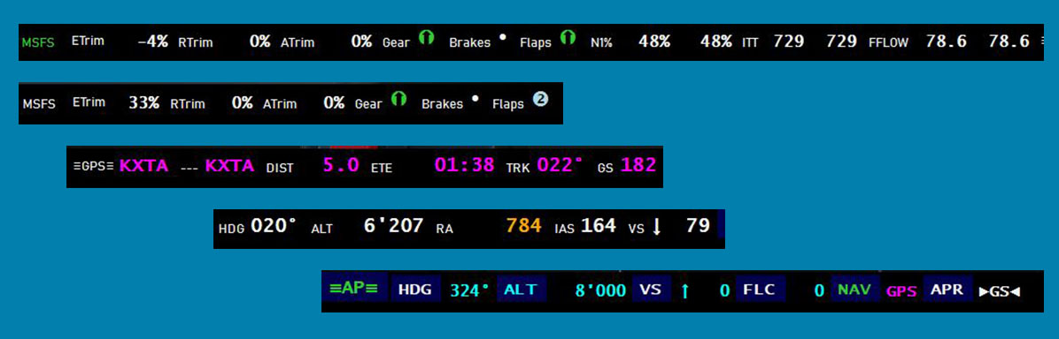

## Autopilot commands

Some accept **mouse clicks to toggle** those have a dark blue background and show a hand while hovering the active area

* -AP-, HDG, ALT, VS, FLC, NAV and APR can be directly toggled

## Setting the BARO to the current pressure

Click BARO to set it to current (same as the keyboard B button)

## Automatic Elevator Trim

**ETrim** – Aside from showing the current Elevator Trim % it provides an Auto Elevator Trim function:

Clicking the ETrim label will activate the Auto Elevator Trim module for about 20 seconds.  
It will display ETrim in green color while active - clicking the active module again will switch it off  
Note: the module controls the Elevator Trim in a way to level the aircraft towards zero vertical speed.  
It may or may not work to your expectation.. so use it only if you feel comfortable with.

## Moving a Tile Hud

If a profile is set as **Tile** one is able to move the window along the bound edge of the screen

Movement is available if the cursor shows up as Cross with Arrows

Click the **Left** mouse button and drag the window, it will remain attached to the bound border while moving it

## Available Info Fields:

For Engine related fields the Bar shows up to 2 Engines only.  
Once a 2 Engine aircraft is detected the left one is Engine 1 and the second/right one Engine 2

**SimRate x** : the current Sim Rate factor – if not x1 it is shown with yellow background

**E-**, **R-**, **A-Trim**: Elevator, Rudder, Aileron Trim % values +- deflection

**OAT**: Outside Air Temperature (only in °C – sorry…)

**BARO**: Setting is available as InHg or HPA – chose one that fits the needs

**Gear**: either Up, down or Unknown (Transient) 

**Brakes**: Parking Brake indication - Set: Released:•

**Flaps**: either full up, down or steps in-between (depends on the number of steps available) ❶❷❸

**TORQ**: Engine torque value is available as ft/lb or % – chose one that fits the needs

**P-RPM**: Propeller RPM Value

**E-RPM**: Engine RPM Value

**N1**: Turbine N1 % Value

**ITT**: Turbine ITT Temperature in °C

**EGT**: Engine Exhaust Gas Temperature in °C

**FFLOW**: Fuel Flow value is available as pounds per hour or gallons per hour – chose one that fits the needs

**-GPS-** Shows the previous and next Waypoint if a flight plan is active

WYP **DIST** shows the GPS Distance to the next Waypoint

WYP **ETE** shows the GPS Estimated Time Enroute to the next Waypoint

**TRK** shows the GPS ground track

**GS** shows the GPS ground speed

**ALTP** shows the GPS Waypoint Altitude if it is available

***Calculated*** fields when a "Next Waypoint" is available:

* **WP-VS** Estimated VS to WYP@ALT:  
  Calculated VS to reach the next waypoint at the proposed altitude with the current GS and DIST   
  (ALTP altitude when purple or Setting Alt when blue)
* **WP-ALT** Estimated ALT@WYP:  
  Calculated altitude at next waypoint using the actual GS, VS and DIST

*Note: the calculated fields are experimental they are rounded to the nearest 100.*

**HDG**: Current Heading

**ALT**: Current Altitude (ft)

**RA**: Radio Altitude (ft AOG) available when <1000ft AOG

**IAS**: Indicated Airspeed (kt)

**VS**: Vertical rate (feet per minute)

**-AP-**: Autopilot Master (all Autopilot signs turn to **Green** text if active)

**HDG**: Heading Mode Sign and Heading Setting

**ALT**: Altitude Mode Sign and Altitude Setting (ft)

**VS**: Vertical Rate Sign and VS Setting (fpm)

**FLC**: Flight Level Change Sign and IAS Setting (kt)

**NAV**: Nav Mode Sign and GPS Source – GPS active source shown in purple letters else GPS is greyed out

**APR**: Approach Mode Sign and Glide Slope/Path (**>GS<**) Capture. GS turns **green** if captured

# Configuration

The currently selected one will show up with a green background color (here it was “Prop”)

**Name** and use up to 5 different profiles

Type the profile name into the field of the topmost row (here Prop, Turboprop A, …)

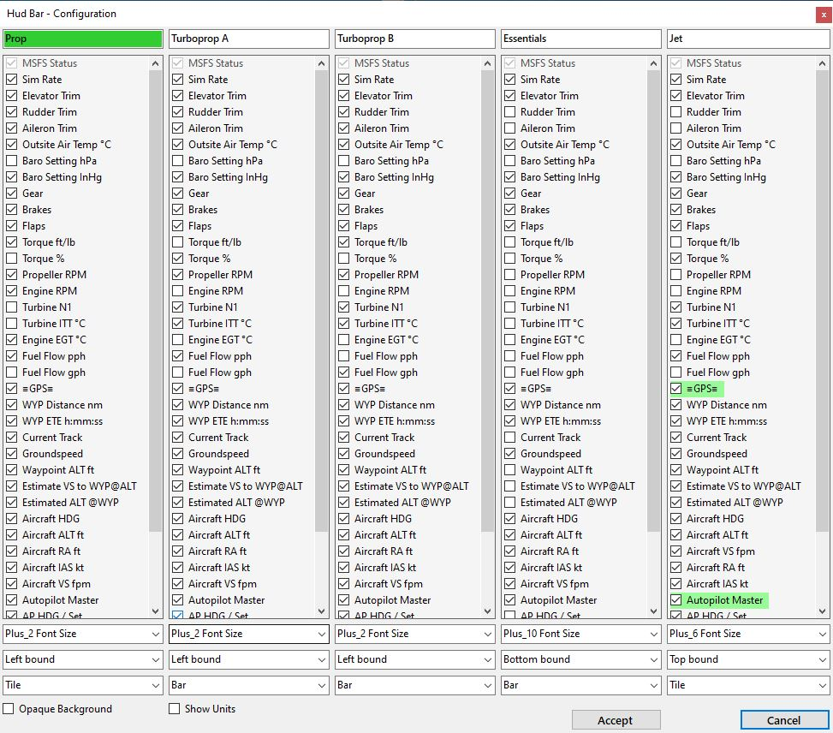

General Settings are:

* Check **Show Units** to display the units along the values
* Check **Opaque Background** to have the Bar completely black, else it is slightly transparent

For any profile:

* Check / Uncheck the items in the list which to show / hide items
* Select a **Fontsize** from Regular, Plus 2,4,6,8,10 an Minus 2,4  
  (the bar rescales to multiple rows/columns to fit all checked items on the screen)
* Select the **Alignment** of the bar for any profile (left, right, top, bottom)
* Select the **Kind** of the bar – where Bar is a full width or height band and Tile is a rectangle bound to the Alignment border, the size of the tile will adapt to the items shown
* Checked items are shown in either horizontal or vertical order as they are shown in the configuration panel.  
  See below how to re-arrange the order here and to apply new lines

## Move an item within a bar:

*Works about the same as Drag and Drop*

* **Left** Click and hold the item which will be moved
* Move the mouse up or down – the cursor will change to a NS sign
* Drop (**Release** the mouse button) – the item should appear at the drop position  
  *Note: Due to the rearrangement of the affected items the behavior is different if you move an item up or down – sometimes you need a second drag to place it where you want it to be*
* Hit **Escape** or move the mouse out of the drop zone and release the mouse button if you wish to cancel the movement

## Start a new line for the item and its successors:

* **Right** click an item to start it on a new line/column in the Hud
* New Lines are indicated with items that have a light green background color (e.g -GPS- above)
* **Right** click again to remove the New Line – the background color reverts to light gray

*Note: if the New Line item is unchecked the line break is omitted*

## Leaving the Configuration Window

* Click **Accept** to accept all changes made to the configuration
* Click **Cancel** to discard all changes made
* The window will close and the Hud is rebuilt according to the profile

All settings are automatically saved and should be available for any further use

My FlightSim Libraries (included in the release package)

* SimConnectClient.dll -- FlightSim interface to MSFS2020 SimConnect
* FSimClientIF.dll -- Generic FSim Client interface definition
* FSimIF.dll -- Generic FSim interface definition

From MSFS2020 Developer Kit for convenience included:

* SimConnect.cfg
* Microsoft.FlightSimulator.SimConnect.dll
* SimConnect.dll

**Full Credit goes to JayDeeGaming**

where the idea of this HudBar is 'borrowed' from  
<https://www.youtube.com/c/JayDeeGaming/about>