MapLib – Map tile retrieval library

© 2022 - M.Burri

# Supported Map Providers

**MapLib** supports a fixed number of Map Tile Providers as well as 3 user defined ones.

* ALWAYS consider the terms of use for any of the map providers

**Free and open Tile services are at the time of writing** – enabled by defaultOpenStreetMap (OSM) and some derivatives

<https://www.openstreetmap.org>

OpenTopo, a 3d enhanced map from an open source project.

<https://opentopomap.org>

Stamen 3d shaped terrain map

<http://maps.stamen.com>

**Tile Services which need either a key or are subject to licensing terms** – disabled by default

Bing Maps (Microsoft map service) needs a key and subject to licensing

<https://docs.microsoft.com/en-us/bingmaps/getting-started>

ESRI/ARCGIS Tile Services as part of their offering – subject to license, don’t use if not licensed

<https://developers.arcgis.com/documentation/mapping-apis-and-services/data-hosting/services/image-tile-service/>

Remark:  
Don’t ask for Google Map support – I don’t have a key and they are rather complicated to work with…

**User defined tile services**

You may have an own tile service running on your NAS or know a tile service you like to use.  
The URL to be provided looks like:

Http=https://ip_or_address/route/{z}/{y}/{x}.imageformat

Where the {z} {y} {x} parts will be replaced by the requested zoom and coordinates.  
The library expects a Mercator Tile Set with 0/0 top left tile number and 256x256 sized tiles – PNG and JPG image formats are supported.

Example:

Http=https://myNas:23356/tiles/{z}/{y}/{x}.jpg

## Data retrieval and storage disclaimer

**MapLib** retrieves tiles only for the user requested location and zoom level.  
The visualization WinForms UserControl **bm98_Map** requests tiles as a matrix of 8x8 tiles at zoom levels for the 5 different ranges: FF= 9, F=11, M= 12, N=13, C=15  
  
**MapLib** stores tiles per provider in a computer local disk cache and will clean up tiles older than 100 days or when the providers cache exceeds ~64MB / ~2560 tiles at startup of the application.  
**MapLib** maintains a memory cache for 400 tiles (about 10 MB RAM) while an application is running.  
🡪 If you encounter incorrect tiles or other oddities – first delete the cache files and try again.

# INI File

Configuration goes via an **INI File** (MapLibProvider.ini) located per default in the **Applications directory**.

IF the Library finds a MapLibProvider.ini file in a user folder (MyDocuments\MSFS_HudBarSave) it takes preference over the default one.  
I.e. if you change INI settings, first copy the original file to this folder and make changes there, else it will be overwritten when extracting a new version from the Zip file

* The INI file consists of the Main section + a number of Provider sections
* INI files consists of lines where everything after a semicolon <;> is considered as comment.
* INI files do have a Keyword and a content in the form of: Keyword=Content
* INI files do have sections which start with a bracketed Name: [Section]
* The part of the INI file which is not lead by a section name is the Main Section
* INI files are text files, use **only** Notepad or similar editors, never Word or other text processing programs to edit it’s content

## Main Section

DefaultProvider= .. 🡪 Default Provider and tiles the Map starts with

Use any of the enabled [ProviderNames] found in the later sections Use the exact name, or uncomment the template ones, only the first entry in the file is considered.

Example:

DefaultProvider=OSM_OpenStreetMap

BingKey= .. 🡪 A Key to use Bing Maps (see remark below)

A rather large number of characters provided by BING Maps in order to access their map services, visit URLs below at Microsoft

<https://docs.microsoft.com/en-us/bingmaps/getting-started>

<https://docs.microsoft.com/en-us/bingmaps/getting-started/bing-maps-dev-center-help/getting-a-bing-maps-key>

## Provider Sections:

[ProviderName] 🡪 Provider name – don’t change, the library expects those names

Enabled=.. 🡪 True if the provider is enabled else False  
To enable a provider set this entry to True, to disable use False  
Enabled providers will show up in the map selection to choose from.  
The free providers are enabled in the INI file, not so free ones disabled.

Example:

Enabled=True

Http=.. 🡪 The map tile server address, most don’t need an entry and are listed as comment for reference.  
For OSM one could use a variety of specialized servers in order to get e.g. names in another language than OSM provides them, e.g. the .de server will supply translated city names for parts of Asia.  
For the User Entries see below.

Http=https://ip_or_address/route/{z}/{y}/{x}.imageformat

Where the {z} {y} {x} parts will be replaced by the requested zoom and coordinates.  
The library expects a Mercator Tile Set with 0/0 top left tile number and 256x256 sized tiles – PNG and JPG image formats are supported.

Example: see above

## Data Loader

Go for the application folder and then into the subfolder \dataLoader

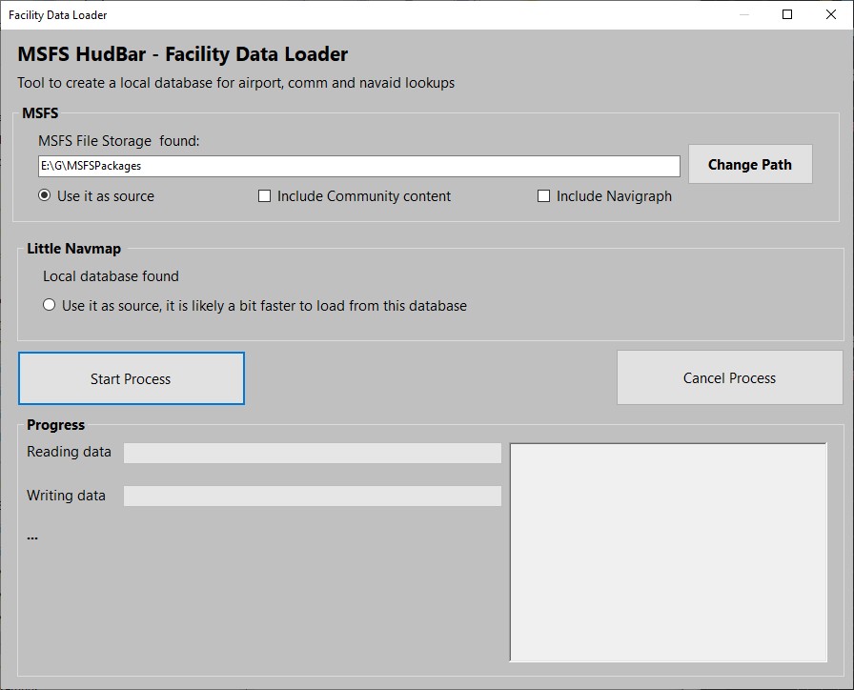Run FacilityDataLoader.exe:   
First check if the program finds the MSFS data path.  
It does follow the MS specs for Store and Steam but…

If not you may need to use Change Path.. to point it to the folder (where Community and Official folders can be found)

If the LittleNavMap database is found it will show it as well.

You may choose the source for the data, either collecting from the MS files where you may include Community content and/or Navigraph (if installed)  
Or from the LittleNavMap database which is usually faster.  
Check one of the sources.  
Then hit Start Process and have some patience.  
The program will report progress and once it finished its data collection it will tell you.  
The database is stored at MyDocuments\MSFS_HudBarSave\db\fs2020genApt.dblite and is somewhat larger than 130MB.

REDO this process when either a new Navigraph version is out and when MS provides substantial updates.

# APPENDIX (default INI File):

; MapLib Provider Overrides

;

; Format:

; /// DefaultProvider=PROVIDER

; /// BingKey=KEY

; ///

; /// [PROVIDER]

; /// Enabled=TRUE

; /// Http=URL

;

; Text after a semicolon is treated as comment

;

; => Filename must be 'MapLibProvider.ini'

;

; Define the DefaultProvider from the [PROVIDER] names

;

; In each providers section:

; Set 'Enabled=true' to be able to use it

; Uncomment 'Http=http....' to override the URL used to retrieve map tiles

; -> If unsure, leave it alone (The App may break or not respond any longer)

;

; For URLs:

; There are 3 placeholders for {x},{y},{z} (xy tile coords + zoom)

; When multiple server instances are available - {s} can be used

; For some you need an accees key (personal, subscription etc)

; Key=sadfsdfsdf

;

; NOTE there is not privacy or protection when typing the key here

; the key is only used in the tile loading HTTP request as per provider guidance

;

;

; Default Provider to use => one of the Provider Chapter IDs ([NAME] from below)

DefaultProvider=OSM_OpenStreetMap ; OSM_OpenStreetMap is the free default provider

;DefaultProvider=OpenTopo

;DefaultProvider=Stamen_Terrain

; Here comes your Bing Map Key if you want to use Bing Maps

BingKey=<YOUR KEY>

[OSM_OpenStreetMap]

; OpenStreetMap (see terms of use before using it)

Enabled=true ; should never be disabled

;Http=https://{s}.tile.openstreetmap.org/{z}/{x}/{y}.png ; default, labeled according to the region (e.g. Japanese etc)

;Http=https://{s}.tile.openstreetmap.de/{z}/{x}/{y}.png ; adds translated names to the local ones

;Http=https://{s}.tile.openstreetmap.fr/osmfr/{z}/{x}/{y}.png ; focus on french translation; international items are partly translated

[OpenTopo]

; Street Map 3D enhanced

; OpenTopo (see terms of use before using it)

Enabled=true

;Http=https://tile.opentopomap.org/{z}/{x}/{y}.png ; default

[Stamen_Terrain]

; Street Map 3D shaped

; Stamen.com (see terms of use before using it)

Enabled=true

;Http=https://stamen-tiles.a.ssl.fastly.net/terrain/{z}/{x}/{y}.jpg ; default

; ***************

; Microsoft Bing MAPS (needs a Key to access -> https://www.microsoft.com/en-us/maps/create-a-bing-maps-key)

; ***************

; Note: Bing URLs are retrieved dynamically and changing the Provider here has no effect (for reference only)

[Bing_Imagery]

; Satellite Imagery

Enabled=false

;Http=https://ecn.{subdomain}.tiles.virtualearth.net/tiles/a{quadkey}.jpeg?g=12552 ; not used, for reference only

[Bing_ImageryLabels]

; Satellite Imagery with road labels

Enabled=false

;Http=https://ecn.{subdomain}.tiles.virtualearth.net/tiles/h{quadkey}.jpeg?g=12552&mkt={culture} ; not used, for reference only

[Bing_OStreetMap]

; Street Map

Enabled=false

;Http=https://ecn.{subdomain}.tiles.virtualearth.net/tiles/r{quadkey}.jpeg?g=12552&mkt={culture}&shading=hill ; not used, for reference only

; ***************

; ESRI/ARCGIS Maps (subject to terms of use - your at your own here...)

; ***************

[ESRI_Imagery]

; Satellite Imagery

; ESRI/ARCGIS World Imagery (see terms of use before using it)

Enabled=false

;Http=https://services.arcgisonline.com/arcgis/rest/services/World_Imagery/MapServer/tile/{z}/{y}/{x} ; default

[ESRI_StreetMap]

; Street Map

; ESRI/ARCGIS StreetMap (see terms of use before using it)

Enabled=false

;Http=https://services.arcgisonline.com/arcgis/rest/services/World_Street_Map/MapServer/tile/{z}/{y}/{x} ; default

[ESRI_WorldTopo]

; Street Map 3D shaped

; ESRI/ARCGIS WorldTopo (see terms of use before using it)

Enabled=false

;Http=https://services.arcgisonline.com/arcgis/rest/services/World_Topo_Map/MapServer/tile/{z}/{y}/{x} ; default

; ***************

; USER Maps (your at your own here...)

; ***************

[USER_TILES_1]

; User defines Tile Server No 1

Enabled=false

;Http=https://ip_or_address/route/{z}/{y}/{x}.imageformat

[USER_TILES_2]

; User defines Tile Server No 2

Enabled=false

;Http=https://ip_or_address/route/{z}/{y}/{x}.imageformat

[USER_TILES_3]

; User defines Tile Server No 3

Enabled=false

;Http=https://ip_or_address/route/{z}/{y}/{x}.imageformat