Guide how to create your local geo data

20190817/BM

In order to make use of the additional layers provided you may need to create your regional data.

Regional because the size of world data for airports, navaids and more is huge and will kill load times.

In general you may want to limit the geo data to the range of your receiver or a bit more.

I use a radius of 300nm around my receiver location.

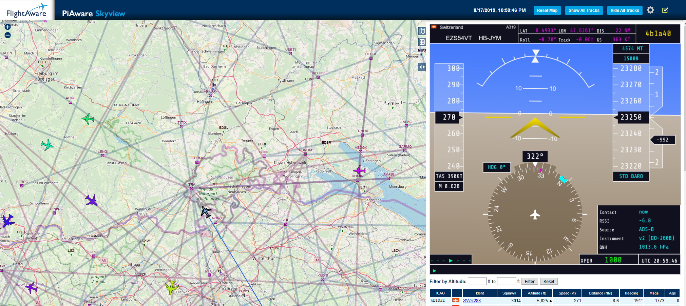

A tool do create your regional geodata as well as updating the databases for aircrafts is available on GitHub: <https://github.com/bm98/dump-dbTool>

See doc folder: dump1090-dbTool-GUIDE-V0.9.pdf for all information needed

*Note: It is Win only – sorry may be someone wants to convert it to Node.JS or Java to have it more platform independent – feel free to do it.*

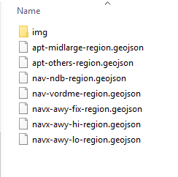

Once you have regional geo files just upload them into the folder

/usr/share/dump1090-fa/html_2/layers

Overwriting the existing files.

Geo location files are:

The ones provided as example are around Lat/Lon/Radius: 47.7/8.15/300nm.

Switching layers is in additional settings:

