LIBRARY MANAGEMENT SYSTEM

Madhura B Shetty

CONTENTS

|  |  |  |
| --- | --- | --- |
|  |  | Page No. |
| **CHAPTER 1** | **INTRODUCTION** | **4** |
|  | 1.1 Overview…………………………………………………… | 4 |
|  | 1.2 Research…………………………………………………….. | 5 |
|  | 1.3 Cost…………………………………………………………. | 5 |
|  | 1.4 Time………………………………………………………… | 5 |
|  | 1.5 Features……………………………………………………... | 5 |
| **CHAPTER 2** | **REQUIREMENTS AND SPECIFICATIONS** | **6** |
|  | 2.1 Hardware Requirements……………………………………. | 6 |
|  | 2.2 Software Requirements……………………………………... | 6 |
| **CHAPTER 3** | **SYSTEM DESIGN AND ANALYSIS** | **7** |
|  | 3.1 System Design……………………………………………… | 7 |
|  | 3.2 Architecture………………………………………………… | 7 |
|  | 3.2.1 Behaviour Diagram……………………………………….. | 7-9 |
|  | 3.2.2 System Design……………………………………………. | 9-11 |
| **CHAPTER 4** | **TESTING** | **12-13** |
| **CHAPTER 5** | **RESULTS AND SCREENSHOTS** | **14-16** |
|  | **RERENCES** | **17** |

LIST OF FIGURES

|  |  |
| --- | --- |
|  | Page No. |
| Figure 3.1 System Design…………………………………………………….... | 7 |
| Figure 3.2 High Level Behaviour Diagram –Admin…………………………... | 7 |
| Figure 3.3 Low Level Behaviour Diagram –Admin…………………………… | 8 |
| Figure 3.4 High Level Behaviour Diagram –Student………………………….. | 8 |
| Figure 3.5 Low Level Behaviour Diagram –Student………………………… | 9 |
| Figure 3.6 High Level System Diagram –Admin……………………………… | 9 |
| Figure 3.7 Low Level System Diagram –Admin………………………………. | 10 |
| Figure 3.8 High Level System Diagram –Student……………………………... | 11 |
| Figure 3.9 Low Level System Diagram –Student……………………………… | 11 |
| Figure 5.1 Login Page………………………………………………………... | 14 |
| Figure 5.2 Home page……………………………………………………… | 14 |
| Figure 5.3 Add Students Page……………………………………………….. | 15 |
| Figure 5.4 Add Books Page………………………………………………….. | 15 |
| Figure 5.5 Assign Books Page……………………………………………….. | 15 |
| Figure 5.6 Overdue Page…………………………………………………...... | 16 |
| Figure 5.7 Update Penalty Page……………………………………………… | 16 |
| Figure 5.8 Student Page……………………………………………………… | 16 |

**CHAPTER 1**

**INTRODUCTION**

**1.1 OVERVIEW**

Library management is a sub-discipline of institutional management that focuses on specific issues faced by libraries and library management professionals. Library management normal managerial tasks, as well as intellectual freedom and fundraising responsibilities. Issues faced in library management frequently overlap with those faced in managing non-profit organizations.

Library Management System is an application which refers to library systems which are generally small or medium in size. It is used by librarian to manage the library using a computerized system where he/she can record various transactions like issue of books, return of books, addition of new books, addition of new students etc. Books and student maintenance modules are also included in this system which would keep track of the students using the library and also a detailed description about the books a library contains. With this computerized system there will be no loss of book record or member record which generally happens when a non-computerized system is used.

**1.2 Research**

* The history of libraries began with the first efforts to organize collections of documents. The first libraries consisted of archives of the earliest form of writing—the clay tablets in cuneiform script discovered in Sumer, some dating back to 2600 BC.
* Private or personal libraries made up of written books appeared in classical Greece in the 5th century BC.
* The Fatimids (r. 909-1171) also possessed many great libraries within their domains. The historian Ibn Abi Tayyi’ describes their palace library, which probably contained the largest collection of literature on earth at the time, as a “wonder of the world”.

**1.3 Cost**

Library automation software has been created for educational institutions to help them campus management, academic administrative tasks effectively comparing with the cost it would start around Rs.20,000 and increases based on the customer requirements.

**1.4 Time**

The essence of time management involves increasing efficiency and effectiveness in a limited time period.

**1.5 Features**

* Can create a computerized management system for a library
* Has the capability to issue books
* Has the capability to return books
* Has an administrator account
* Tracks the books that users have issued
* Keeps the databases correct and up-to-date

**CHAPTER 2**

**REQUIREMENT AND SPECIFICATIONS**

Software Requirement Specification (SRS) is a description of a software system to be developed, laying out functional and non-functional requirements, and may include a set of use cases that describe interactions the users will have with the software. The purpose of this SRS document is to collect and analyze all assorted ideas that have come up to define the system, its requirements with respect to consumers and also to provide a detailed overview of our software product, its parameters and goals. SRS provides an overview of the entire system with purpose, scope, definitions, acronyms, abbreviations, references. The aim of this document is to gather and analyze and give an in-depth insight of the system by defining the problem statement in detail. Also, we shall predict and sort out how we hope this product will be used in order to gain a better understanding of the project, outline concepts that may be developed later, and document ideas that are being considered, but may be discarded as the product develops.

**2.1 HARDWARE REQUIREMENTS**

Processor : core i7

RAM : 8GB

Hard Disk : 20GB

Speed : 1.2 GHz+

**2.2 SOFTWARE REQUIREMENTS**

Operating System : Windows 10

IDE : Visual Studio 2015

Language : C# and HTML

Framework : ASP.NET 4.0

Back End : MS SQL Server

**CHAPTER 3**

**SYSTEM DESIGN AND ANALYSES**

**3.1 System Design**

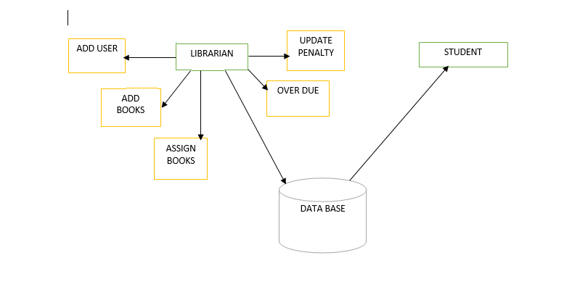

Figure 3.1 System Design

**3.2 Architecture**

**3.2.1 Behaviour Design**

**ADMIN**

#### **High Level Behaviour Diagram- ADMIN**

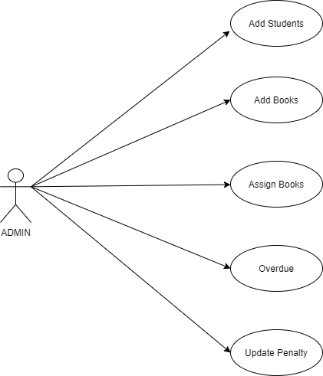

#### Figure 3.2 High Level Behaviour Diagram-Admin

#### **Low Level Behavioural Diagram- ADMIN**

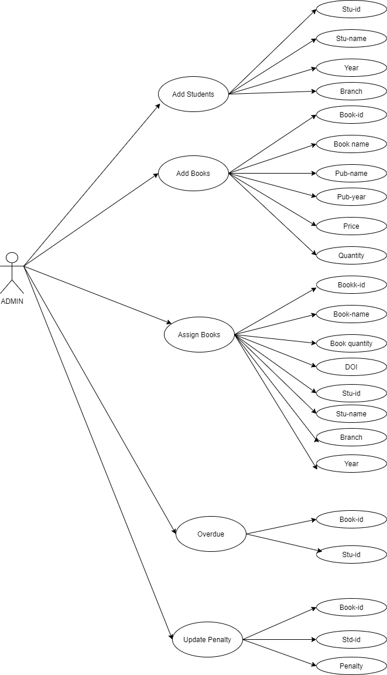

Figure 3.3 Low Level Behavioural Diagram-ADMIN

**STUDENT**

#### **High Level Behavioural Diagram- STUDENT**

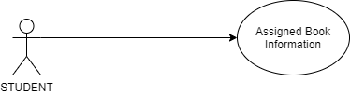

#### Figure 3.4 High Level Behavioural Diagram- STUDENT

#### **Low Level Behavioural Diagram- STUDENT**

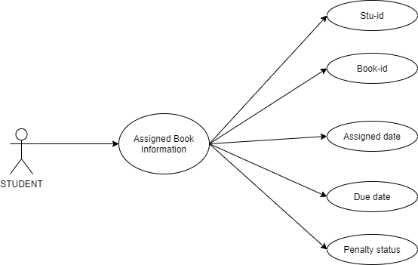

Figure 3.5 Low level Behavioural Diagram-STUDENT

**3.2.2 System Diagram**

**ADMIN**

#### **High Level System Diagram-ADMIN**

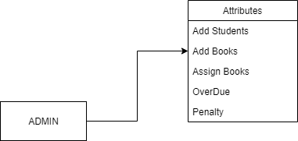

Figure 3.6 High Level System Diagram-Admin

#### **Low Level System Diagram-ADMIN**

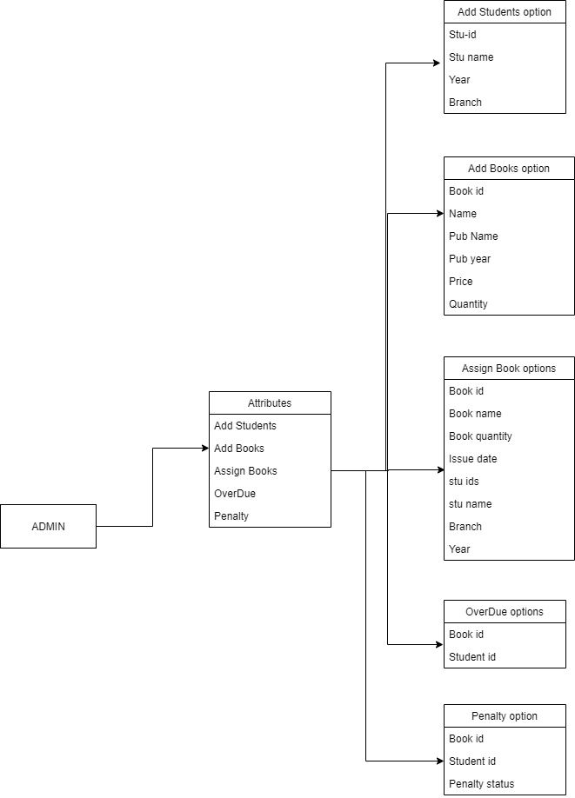

Figure 3.7 Low Level System Diagram-Admin

**STUDENT**

#### **High Level System Diagram-STUDENT**

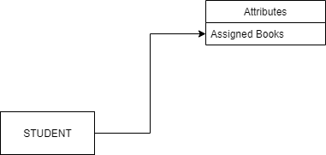

Figure 3.8 High Level System Diagram –Student

#### **Low Level System Diagram-STUDENT**

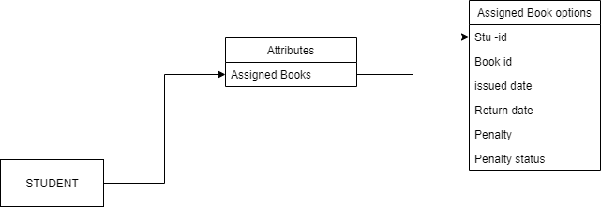

#### Figure 3.9 Low Level System Diagram-student

CHAPTER 4

TESTING

|  |  |  |  |  |  |
| --- | --- | --- | --- | --- | --- |
| **Test Case**  **ID** | **Test Case**  **Name** | **Test Case**  **Description** | **Test Steps** | | |
| **I/P given** | **Expected O/P** | **Actual O/P** |
| TC1.1 | Login Validation for Admin | Enter a valid username and wrong password | valid username and wrong password | Invalid credentials | Invalid credentials |
| TC1.2 | Login Validation for Admin | Enter a valid username and correct password | valid username and correct password | valid credentials | valid credentials |
| TC 2.1 | Add student form Validation | Enter no fields and click on Add user button | Enter no fields | Enter the Fields | Enter the Fields |
| TC2.2 | Add student form Validation | Enter fields and click on Add user button | Enter fields | Students info added | Students info added |
| TC 3.1 | Add books form Validation | Enter no fields and click on Add button | Enter no field | Add the books | Add the books |
| TC 3.2 | Add books form Validation | Enter fields and click on Add button | Enter field | Books added | Books added |
| TC 4.1 | Assign books form validation | Enter no fields and click on Assign button | Enter no fields | Enter All Fields | Enter All Fields |
| TC 4.2 | Assign books form validation | Enter fields and click on Assign button | Enter fields | Books Assigned | Books Assigned |
| TC 5.1 | Update penalty form validation | Enter no assign id field | Enter no fields | Fill the assign id field | Fill the assign id field |
| TC 5.2 | Update penalty form validation | Enter assign id field | Enter fields | Penalty updated | Penalty updated |
| TC 6.1 | Login Validation for Student | Enter a valid username and wrong password | valid username and wrong password | Invalid credentials | Invalid credentials |
| TC 6.2 | Login Validation for Student | Enter a valid username and correct password | valid username and correct password | valid credentials | valid credentials |

CHAPTER 5

RESULTS AND SNAPSHOTS

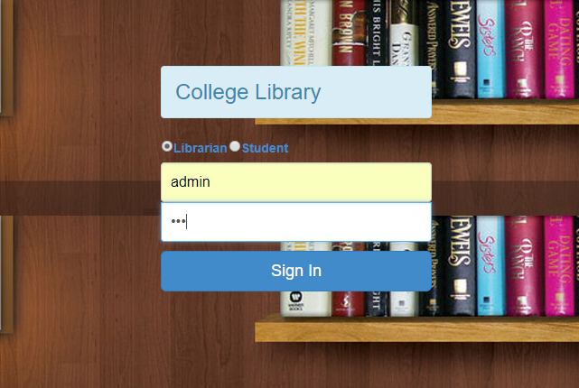

Figure 5.1 Login Page



Figure 5.2 Home page

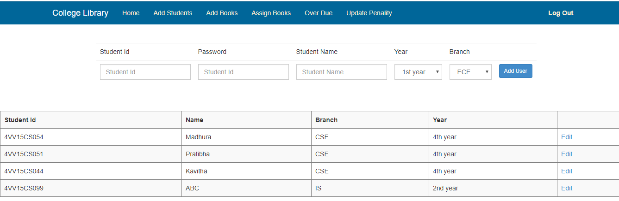

Figure 5.3 Add Students Page

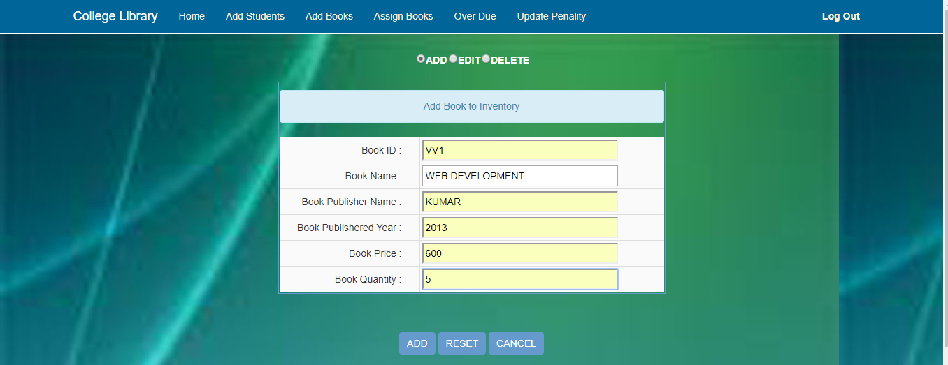

Figure 5.4 Add Books Page

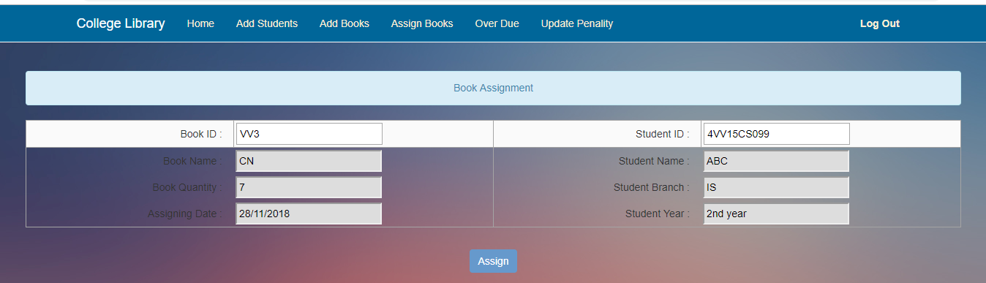

Figure 5.5 Assign Books Page

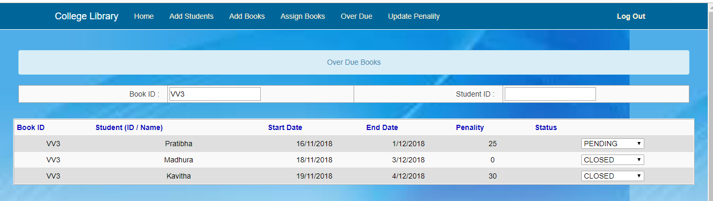

Figure 5.6 Overdue Page

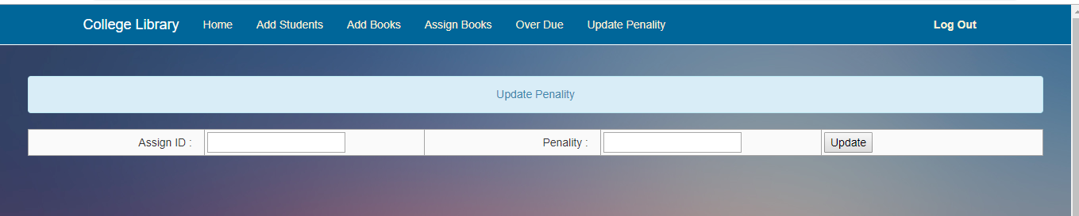

Figure 5.7 Update Penalty Page

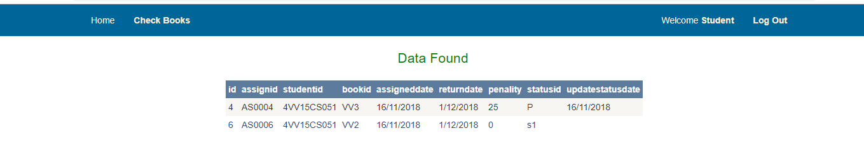

Figure 5.8 Student Page

**REFERENCES**

* Repository link: <https://github.com/bmadhurashetty/library-system-software>
* <https://en.wikipedia.org/wiki/Library_management>
* UML Diagram Tools - <https://app.diagrams.net/>