**XplainIQ lite: Channel Readiness Scoring Index**

October 20, 2025

________________________________________________________________________________

**Innovative Networx, LLC**

Channel Readiness Assessment

*Technology Service Distributor: Intelisys*

**EXECUTIVE SUMMARY**

**50**

Channel Readiness Score  
Developing Maturity

|  |  |
| --- | --- |
| Contact | William Madison |
| Email | wmadison@innovativenetworx.com |
| Title | owner |
| Phone | 2012641578 |

**Capability Assessment Radar**

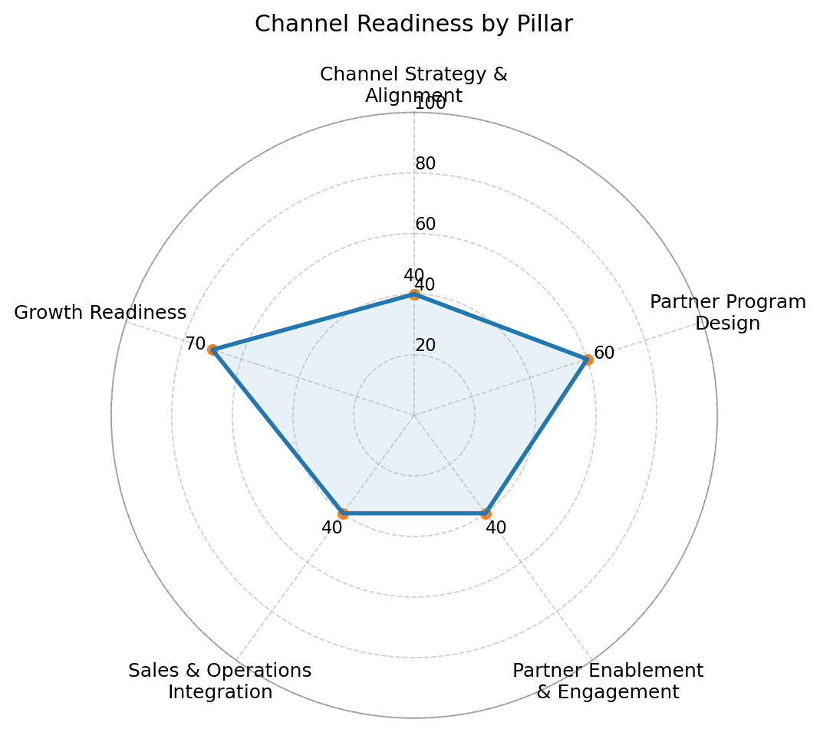

**Detailed Assessment Results**

________________________________________________________________________________

**Pillar Performance Summary**

|  |  |  |
| --- | --- | --- |
| Pillar | Score | Assessment |
| A. Channel Strategy & Alignment | **40** | Emerging |
| B. Partner Program Design | **60** | Solid Foundation |
| C. Partner Enablement & Engagement | **40** | Emerging |
| D. Sales & Operations Integration | **40** | Emerging |
| E. Growth Readiness | **70** | Solid Foundation |

**Key Findings**

**Areas of Strength:**

* E. Growth Readiness
* B. Partner Program Design

**Development Priorities:**

* A. Channel Strategy & Alignment
* C. Partner Enablement & Engagement
* D. Sales & Operations Integration

**Strategic Recommendations (Next 90 Days)**

1. Clarify the partner role by segment and set a 12-month channel thesis with 3 measurable outcomes.
2. Stand up a 30-60-90 enablement cadence: onboarding kit, monthly enablement call, quarterly MDF campaign.
3. Separate channel pipeline tracking; define lead routing/quoting SLAs; add 'channel' to forecast reviews.

**Ready to achieve a 90+ Channel Readiness Score?**

Schedule a comprehensive XplainIQ GTM Assessment

________________________________________________________________________________

© Innovative Networx – XplainIQ™ | Confidential & Proprietary