Day 1: 5/1/25
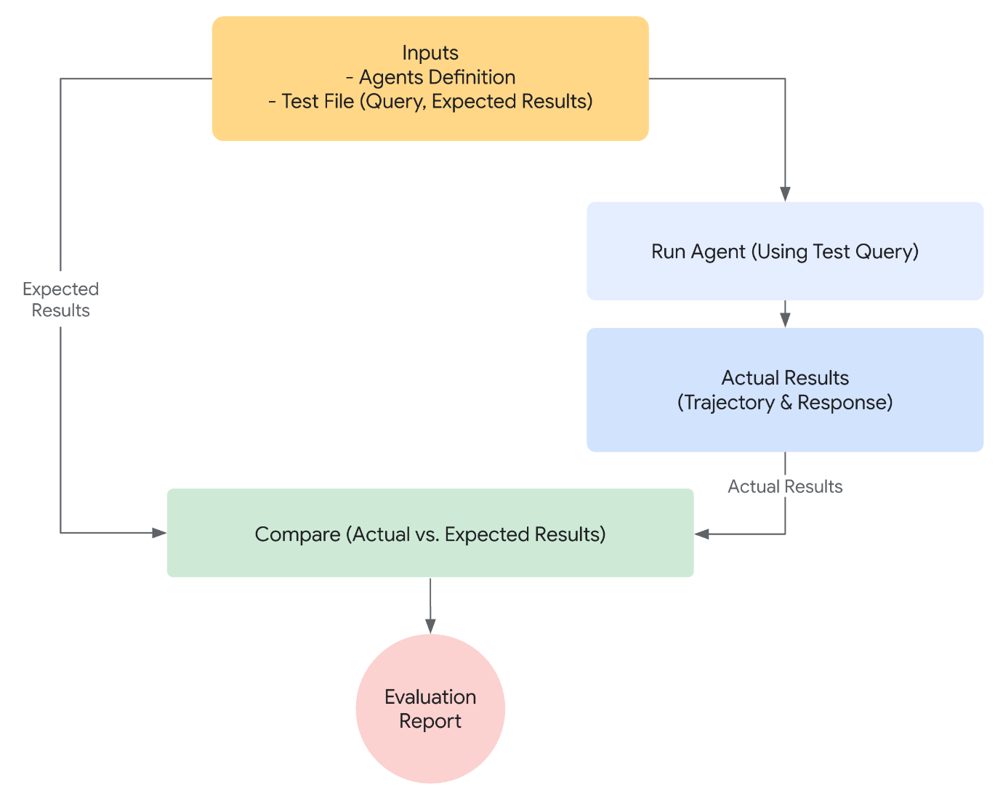
- Define Success: What constitutes a successful outcome for your agent?
- Identify Critical Tasks: What are the essential tasks your agent must accomplish?
- Choose Relevant Metrics: What metrics will you track to measure performance?
{
"criteria": {
"tool_trajectory_avg_score": 1.0,
"response_match_score": 0.8
}
}
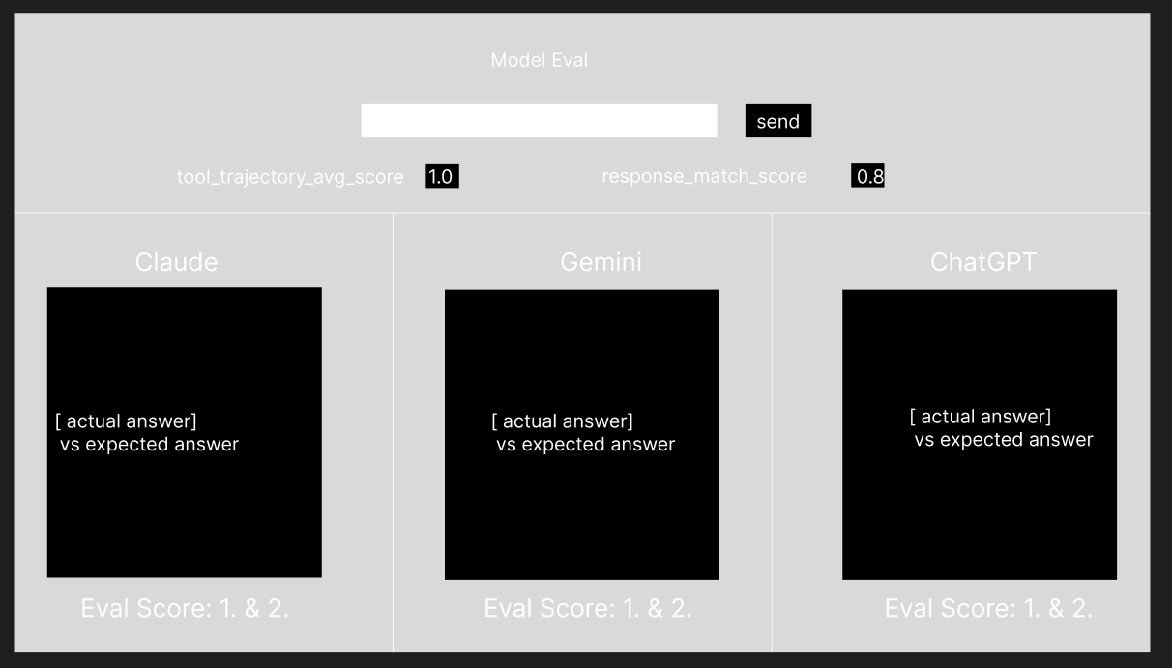

Use judge Ollama + Claude + GPT4
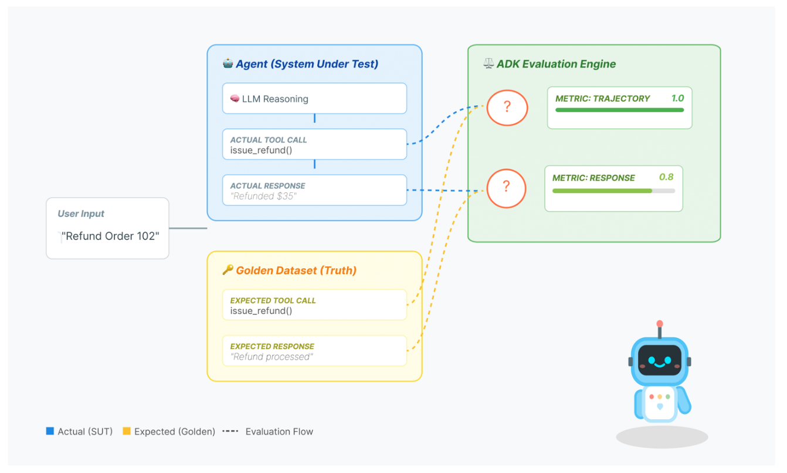
Include use of golden dataset
The golden dataset doesn't need to be perfect. It's just:
- What you/client decided the agent SHOULD do
- The reference point for evaluation
- The baseline for "is this good enough?"

Scoring Metrics
The system tracks two distinct metrics:
- Pass Score (0-1):
  - Definition: A binary-style check. Did the agent satisfy the user's intent?
  - Why: An answer can be "correct" (Pass=1.0) even if it's phrased poorly. This measures functional success.
- Threshold Score (0-1):
  - Definition: A quality/similarity score. How closely does the style and content match the golden answer?
  - Why: This differentiates between a bare-minimum answer and a perfect, high-quality response.
COULD HAVE
Multi-Judge Consensus (Optional)
The system can trigger a "Multi-Judge" mode (evaluate_multi_judge in eval_backend.py).
- Logic: It sends the same data to Ollama, Claude, and GPT-4 simultaneously.
- Why: AI models have biases. If Llama 3 scores an agent low but GPT-4 scores it high, the system averages them to find a fair "consensus score."
TO IMPROVE
• Hallucination Check: Specifically ask the judge: "Does the answer contain information not present in the provided context?" (Crucial if your agent uses RAG).
• Tone/Style Consistency: "Is the tone professional and empathetic?"
• Conciseness: "Is the answer unnecessarily wordy?"
• Faithfulness: "Does the answer directly answer the user question without pivoting?"

Day 2: 6/1/25
Vector DB (Chroma) and LiteLLM integration
Primary + fallback LLaMA judge models 70B main and 15B fallback
https://github.com/chroma-core/chroma
or FAISS or PINECONE (semantic search)
- sqlite3 Embeddings: all-MiniLM-L6-v2 (384-dim).
Cosine similarity scoring during evaluation; plus helper methods to store/query embeddings. Golden cases are pre-indexed on startup when Chroma + embeddings are available.

Day 3: 7/1/25
Almost got laptop, met with prod manager, the learned about UI choices and USP being priority, temperature top p, top k and vars to adjust agents for user choices.

Day 4: 8/1/25
User->OA->agent
Need to make a persistent agent in google adk env
Using gemini 2.5 flash
