Expected zooplankton biomass change according to salinity

Brian Mahardja

2023-02-23

Original script and dataset packages was written by Sam Bashevkin and can be found here: <https://github.com/sbashevkin/FLOATDrought> Models were re-built and re-purposed for the Delta Smelt Summer-Fall X2 Value of Information analysis.

# Load packages

require(conflicted)  
require(MASS)  
require(dplyr)  
require(zooper)  
require(lubridate)  
require(readr)  
require(tidyr)  
require(ggplot2)  
require(sf)  
require(readxl)  
require(stringr)  
require(mgcv)  
require(purrr)  
require(deltamapr)  
require(scales)  
  
conflict_prefer("filter", "dplyr")  
conflict_prefer("select", "dplyr")

# Load and wrangle data

Data was acquired from the ‘zooper’ package. Citation: <https://journals.plos.org/plosone/article?id=10.1371/journal.pone.0265402>

## [1] "These species have no relatives in their size class common to all datasets and have been removed from one or more size classes: Ostracoda Adult (Meso), Cumacea Undifferentiated (Meso), Annelida Adult (Meso), Gammarus Adult (Meso), Orientomysis aspera Adult (Meso), Chironomidae Larva (Meso), Insecta Larva (Meso)"

Read in zoop mass conversions using excel sheet.

Read in zoop groupings

Load Mysid biomass data

Start processing the zoop data

zoop_data_mass<-zoop_data%>%  
 mutate(Taxlifestage=str_remove(Taxlifestage, fixed("_UnID")))%>%  
 filter(  
 !(SizeClass=="Meso" & #eliminating species which are counted in meso and micro and retained better in the micro net from the meso calcs  
   
 Taxlifestage%in%c("Asplanchna Adult", "Copepoda Larva","Cyclopoida Juvenile", "Eurytemora Larva", "Harpacticoida Undifferentiated",  
 "Keratella Adult", "Limnoithona Adult", "Limnoithona Juvenile", "Limnoithona sinenesis Adult", "Limnoithona tetraspina  
 Adult", "Oithona Adult", "Oithona Juvenile", "Oithona davisae Adult", "Polyarthra Adult","Pseudodiaptomus Larva",   
 "Rotifera Adult", "Sinocalanus doerrii Larva", "Synchaeta Adult", "Synchaeta bicornis Adult", "Trichocerca Adult")) &  
   
 !(SizeClass=="Micro" &Taxlifestage%in%c("Cirripedia Larva", "Cyclopoida Adult", "Oithona similis")) & #removing categories better retained in meso net from micro net matrix  
 (is.na(Order) | Order!="Amphipoda") & # Remove amphipods  
 (is.na(Order) | Order!="Mysida" | Taxlifestage=="Hyperacanthomysis longirostris Adult"))%>% #Only retain Hyperacanthomysis longirostris  
 mutate(Taxlifestage=recode(Taxlifestage, `Synchaeta bicornis Adult`="Synchaeta Adult", # Change some names to match to biomass conversion dataset  
 `Pseudodiaptomus Adult`="Pseudodiaptomus forbesi Adult",  
 `Acanthocyclops vernalis Adult`="Acanthocyclops Adult"))%>%  
 left_join(zoop_mass_conversions, by="Taxlifestage")%>% # Add biomass conversions  
 left_join(zoop_mysid, by=c("SampleID", "Taxlifestage", "SizeClass"))%>% # Add mysid biomass  
 left_join(zoop_groups, by="Taxlifestage")%>% # Add IBMR categories  
 mutate(BPUE=if_else(Taxlifestage=="Hyperacanthomysis longirostris Adult", BPUE_mysid, CPUE*CarbonWeight_ug))%>% # Create 1 BPUE variable  
 filter(!is.na(BPUE) & !is.na(Latitude) & !is.na(Longitude) & !is.na(SalSurf))%>% # Removes any data without BPUE, which is currently restricted to Rotifera Adult, Copepoda Larva, and H. longirostris from STN. Also removes 20mm and EMP EZ stations without coordinates  
 group_by(IBMR)%>%  
 mutate(flag=if_else(all(c("Micro", "Meso")%in%SizeClass), "Remove", "Keep"))%>% # This and the next 2 lines are meant to ensure that all categories are consistent across the surveys. Since only EMP samples microzoops, only EMP data can be used for categories that include both micro and mesozoops.  
 ungroup()%>%  
 filter(!(flag=="Remove" & Source!="EMP"))%>%  
 select(SampleID, Station, Latitude, Longitude, SalSurf, Date, Year, IBMR, BPUE)%>%  
 group_by(across(-BPUE))%>%  
 summarise(BPUE=sum(BPUE), .groups="drop")%>% # Sum each IBMR categories  
 st_as_sf(coords=c("Longitude", "Latitude"), crs=4326)%>%  
 st_transform(crs=st_crs(deltamapr::R_DSIBM)) %>%   
 st_join(deltamapr::R_DSIBM %>%  
 select(SUBREGION)) %>%  
 st_drop_geometry() %>%   
 filter(SUBREGION %in% c("NW Suisun","SW Suisun","NE Suisun","SE Suisun","Confluence", "Suisun Marsh"))%>%  
 mutate(doy=yday(Date), #Day of year  
 Month=month(Date), # Month  
 Year_fac=factor(Year), # Factor year for model random effect  
 Station_fac=factor(Station), # Factor station for model random effect  
 across(c(SalSurf, doy), list(s=~(.x-mean(.x))/sd(.x))), # Center and standardize predictors  
 BPUE_log1p=log(BPUE+1)) # log1p transform BPUE for model

Check sample size

zoop_sample_size <- zoop_data_mass %>%   
 group_by(SampleID,Year,Month,SUBREGION,Station) %>%   
 summarise(BPUE=sum(BPUE)) %>%   
 mutate(Samplesize=1) %>%  
 group_by(Year, Month, SUBREGION) %>%   
 summarise(mean_BPUE=mean(BPUE),Samplesize=sum(Samplesize)) %>%  
 filter(Year>=1995)  
  
ggplot(zoop_sample_size, aes(x=Year, y=Month, fill=Samplesize))+  
 geom_tile()+  
 scale_y_continuous(breaks=1:12, labels=month(1:12, label=T))+  
 scale_fill_viridis_c(breaks=c(1,5,10,15,20))+  
 facet_wrap(~SUBREGION)+  
 theme_bw()

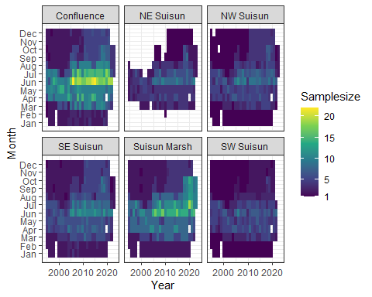

All the remaining brackish regions have sufficient sample size with the exception of NE Suisun. As such, NE Suisun is to be combined with SE Suisun while the rest of the regions are to be analyzed on their own.

Create a new column with IBMR edited regions to accomodate combination of NE and SE Suisun regions.

zoop_data_mass$Subregion_edit<-ifelse(zoop_data_mass$SUBREGION%in%c("NE Suisun", "SE Suisun"), "East Suisun", zoop_data_mass$SUBREGION)

# Model

## Prediction data

Set up prediction data for model

# Min year to start models  
year_min<-1995  
  
newdata_function<-function(region, data=zoop_data_mass, quant=0.99){  
   
 lower<-(1-quant)/(2)  
 upper<-1-lower  
   
 data_filt<-data%>%  
 filter(Subregion_edit%in%region & Year >= year_min)  
   
 # Calculate monthly quantiles of salinity  
 month_sal<-data_filt%>%  
 group_by(Month)%>%  
 summarise(l=quantile(SalSurf, lower),  
 u=quantile(SalSurf, upper), .groups="drop")  
   
 newdata<-expand_grid(date=mdy(paste(1:12, 15, 2001, sep="/")), # The 15th of each month on a non-leap year  
 SalSurf=seq(round(min(data_filt$SalSurf), 1),   
 round(max(data_filt$SalSurf), 1), by=0.1))%>% # Salinity sequence nicely rounded to 1 decimal  
 mutate(Month=month(date),  
 doy=yday(date), # Day of year  
 SalSurf_s=(SalSurf-mean(data$SalSurf))/sd(data$SalSurf), # center and standardize salinity to match data  
 doy_s=(doy-mean(data$doy))/sd(data$doy))%>% # center and standardize doy to match data  
 left_join(month_sal, by="Month")%>%  
 filter(SalSurf >= l & SalSurf <= u)%>% # Remove any salinity values outside the quantiles for each month  
 select(Month, doy, doy_s, SalSurf, SalSurf_s)  
   
}  
  
newdata<-map(set_names(unique(zoop_data_mass$Subregion_edit)), newdata_function)

## Posterior prediction function

# Function to generate posterior predictions from a gam model  
# From https://stats.stackexchange.com/questions/190348/can-i-use-bootstrapping-to-estimate-the-uncertainty-in-a-maximum-value-of-a-gam  
predict_posterior<-function(model, newdata, exclude, n=1e3, seed=999){  
 Xp <- predict(model, newdata=newdata, type="lpmatrix", exclude=exclude, newdata.guaranteed=TRUE) ## map coefs to fitted curves  
 beta <- coef(model)  
 Vb <- vcov(model) ## posterior mean and cov of coefs  
 set.seed(seed)  
 mrand <- mvrnorm(n, beta, Vb) ## simulate n rep coef vectors from posterior  
 pred<-matrix(nrow=nrow(newdata), ncol=n)  
 ilink <- family(model)$linkinv  
 for (i in seq_len(n)) {   
 pred[,i] <- ilink(Xp %*% mrand[i, ])  
 }  
 colnames(pred)<-paste("draw", 1:n, sep="_")  
 pred<-as_tibble(pred)  
 return(pred)  
}

## Model fitting

model

sal_model<-function(group,region,new_data=newdata){  
   
 cat("<<<<<<<<<<<<<<<<<<<<<<< modeling", group, region, ">>>>>>>>>>>>>>>>>>>>>>>>>\n\n")  
   
 new_data<-new_data[[region]]  
   
 data<-filter(zoop_data_mass, IBMR==group & Subregion_edit==region & Year>=year_min)  
   
 par(mfrow=c(2,2))  
   
 if(length(unique(data$Station_fac))>1){  
 model<-gam(BPUE_log1p ~ te(SalSurf_s, doy_s, k=c(5,5), bs=c("cs", "cc")) +   
 s(Year_fac, bs="re") + s(Station_fac, bs="re"),  
 data=data,   
 method="REML")  
   
 random_effects<-c("s(Year_fac)", "s(Station_fac)")  
   
 }else{  
   
 model<-gam(BPUE_log1p ~ te(SalSurf_s, doy_s, k=c(5,5), bs=c("cs", "cc")) +   
 s(Year_fac, bs="re"),  
 data=data,   
 method="REML")  
   
 random_effects<-c("s(Year_fac)")  
 }  
   
 cat("-------------gam check-------------\n")  
 gam.check(model)  
   
 cat("\n\n-------------summary-------------\n")  
 print(summary(model))  
   
 sal<-predict_posterior(model, new_data, random_effects)%>%  
 bind_cols(new_data%>% # Add covariate columns before these columns  
 select(-doy_s, -SalSurf_s),   
 .)  
 return(sal)  
}

Apply model to all groups and regions

model_factors<-expand_grid(IBMR=unique(zoop_data_mass$IBMR),  
 Subregion_edit=unique(zoop_data_mass$Subregion_edit))%>%  
 mutate(IBMR=set_names(IBMR, paste(IBMR, Subregion_edit)))  
  
sal_conversions<-pmap_dfr(model_factors, function(IBMR, Subregion_edit) sal_model(IBMR, Subregion_edit), .id = "IBMR_region")%>%  
 mutate(IBMR=sapply(IBMR_region, function(x) str_split(x, " ", n=2)[[1]][1]),  
 Region=factor(sapply(IBMR_region, function(x) str_split(x, " ", n=2)[[1]][2]),  
 levels=c("Confluence", "Suisun Marsh", "East Suisun",   
 "NW Suisun", "SW Suisun")),  
 Month=as.integer(Month))%>%  
 select(-IBMR_region, -doy)%>%  
 relocate(Region, Month, IBMR, SalSurf)

## <<<<<<<<<<<<<<<<<<<<<<< modeling acartela SW Suisun >>>>>>>>>>>>>>>>>>>>>>>>>  
##   
## -------------gam check-------------

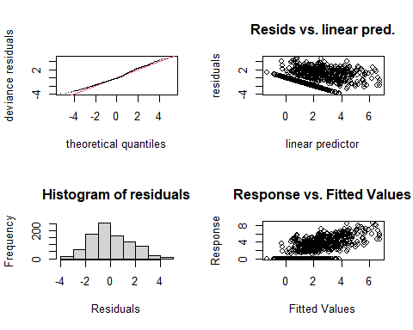

##   
## Method: REML Optimizer: outer newton  
## full convergence after 9 iterations.  
## Gradient range [-0.001485937,0.0007402877]  
## (score 1793.635 & scale 2.644295).  
## Hessian positive definite, eigenvalue range [0.8075608,455.8671].  
## Model rank = 53 / 53   
##   
## Basis dimension (k) checking results. Low p-value (k-index<1) may  
## indicate that k is too low, especially if edf is close to k'.  
##   
## k' edf k-index p-value  
## te(SalSurf_s,doy_s) 19.00 11.43 0.98 0.19  
## s(Year_fac) 28.00 23.94 NA NA  
## s(Station_fac) 5.00 3.63 NA NA  
##   
##   
## -------------summary-------------  
##   
## Family: gaussian   
## Link function: identity   
##   
## Formula:  
## BPUE_log1p ~ te(SalSurf_s, doy_s, k = c(5, 5), bs = c("cs", "cc")) +   
## s(Year_fac, bs = "re") + s(Station_fac, bs = "re")  
##   
## Parametric coefficients:  
## Estimate Std. Error t value Pr(>|t|)   
## (Intercept) 2.7513 0.7302 3.768 0.000176 ***  
## ---  
## Signif. codes: 0 '***' 0.001 '**' 0.01 '*' 0.05 '.' 0.1 ' ' 1  
##   
## Approximate significance of smooth terms:  
## edf Ref.df F p-value   
## te(SalSurf_s,doy_s) 11.433 19 656.212 < 0.0000000000000002 ***  
## s(Year_fac) 23.935 27 9.509 < 0.0000000000000002 ***  
## s(Station_fac) 3.626 4 11.504 0.00000169 ***  
## ---  
## Signif. codes: 0 '***' 0.001 '**' 0.01 '*' 0.05 '.' 0.1 ' ' 1  
##   
## R-sq.(adj) = 0.464 Deviance explained = 48.7%  
## -REML = 1793.6 Scale est. = 2.6443 n = 912  
## <<<<<<<<<<<<<<<<<<<<<<< modeling acartela NW Suisun >>>>>>>>>>>>>>>>>>>>>>>>>  
##   
## -------------gam check-------------

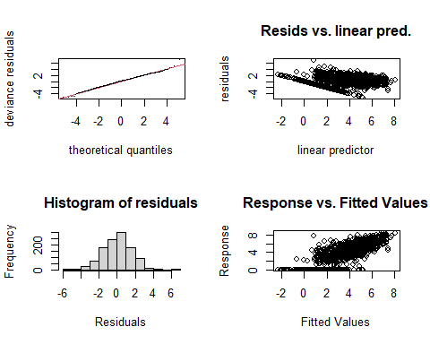

##   
## Method: REML Optimizer: outer newton  
## full convergence after 8 iterations.  
## Gradient range [-0.001942177,0.0009222772]  
## (score 2150.983 & scale 2.461951).  
## Hessian positive definite, eigenvalue range [1.409033,553.8878].  
## Model rank = 54 / 54   
##   
## Basis dimension (k) checking results. Low p-value (k-index<1) may  
## indicate that k is too low, especially if edf is close to k'.  
##   
## k' edf k-index p-value   
## te(SalSurf_s,doy_s) 19.00 16.03 0.95 0.05 *  
## s(Year_fac) 29.00 26.40 NA NA   
## s(Station_fac) 5.00 3.66 NA NA   
## ---  
## Signif. codes: 0 '***' 0.001 '**' 0.01 '*' 0.05 '.' 0.1 ' ' 1  
##   
##   
## -------------summary-------------  
##   
## Family: gaussian   
## Link function: identity   
##   
## Formula:  
## BPUE_log1p ~ te(SalSurf_s, doy_s, k = c(5, 5), bs = c("cs", "cc")) +   
## s(Year_fac, bs = "re") + s(Station_fac, bs = "re")  
##   
## Parametric coefficients:  
## Estimate Std. Error t value Pr(>|t|)   
## (Intercept) 2.7394 0.4822 5.681 0.0000000172 ***  
## ---  
## Signif. codes: 0 '***' 0.001 '**' 0.01 '*' 0.05 '.' 0.1 ' ' 1  
##   
## Approximate significance of smooth terms:  
## edf Ref.df F p-value   
## te(SalSurf_s,doy_s) 16.032 19 284.19 <0.0000000000000002 ***  
## s(Year_fac) 26.397 28 21.54 <0.0000000000000002 ***  
## s(Station_fac) 3.655 4 31.93 <0.0000000000000002 ***  
## ---  
## Signif. codes: 0 '***' 0.001 '**' 0.01 '*' 0.05 '.' 0.1 ' ' 1  
##   
## R-sq.(adj) = 0.612 Deviance explained = 62.8%  
## -REML = 2151 Scale est. = 2.462 n = 1108  
## <<<<<<<<<<<<<<<<<<<<<<< modeling acartela East Suisun >>>>>>>>>>>>>>>>>>>>>>>>>  
##   
## -------------gam check-------------

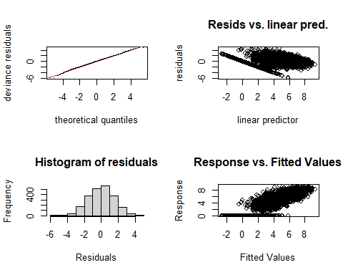

##   
## Method: REML Optimizer: outer newton  
## full convergence after 8 iterations.  
## Gradient range [-0.0007368473,0.0006003538]  
## (score 4298.725 & scale 2.414573).  
## Hessian positive definite, eigenvalue range [2.822869,1125.217].  
## Model rank = 59 / 59   
##   
## Basis dimension (k) checking results. Low p-value (k-index<1) may  
## indicate that k is too low, especially if edf is close to k'.  
##   
## k' edf k-index p-value   
## te(SalSurf_s,doy_s) 19.00 17.45 0.87 <0.0000000000000002 ***  
## s(Year_fac) 29.00 27.40 NA NA   
## s(Station_fac) 10.00 7.68 NA NA   
## ---  
## Signif. codes: 0 '***' 0.001 '**' 0.01 '*' 0.05 '.' 0.1 ' ' 1  
##   
##   
## -------------summary-------------  
##   
## Family: gaussian   
## Link function: identity   
##   
## Formula:  
## BPUE_log1p ~ te(SalSurf_s, doy_s, k = c(5, 5), bs = c("cs", "cc")) +   
## s(Year_fac, bs = "re") + s(Station_fac, bs = "re")  
##   
## Parametric coefficients:  
## Estimate Std. Error t value Pr(>|t|)   
## (Intercept) 4.1724 0.3483 11.98 <0.0000000000000002 ***  
## ---  
## Signif. codes: 0 '***' 0.001 '**' 0.01 '*' 0.05 '.' 0.1 ' ' 1  
##   
## Approximate significance of smooth terms:  
## edf Ref.df F p-value   
## te(SalSurf_s,doy_s) 17.449 19 986.64 <0.0000000000000002 ***  
## s(Year_fac) 27.401 28 52.02 <0.0000000000000002 ***  
## s(Station_fac) 7.677 9 15.04 <0.0000000000000002 ***  
## ---  
## Signif. codes: 0 '***' 0.001 '**' 0.01 '*' 0.05 '.' 0.1 ' ' 1  
##   
## R-sq.(adj) = 0.694 Deviance explained = 70.1%  
## -REML = 4298.7 Scale est. = 2.4146 n = 2251  
## <<<<<<<<<<<<<<<<<<<<<<< modeling acartela Confluence >>>>>>>>>>>>>>>>>>>>>>>>>  
##   
## -------------gam check-------------

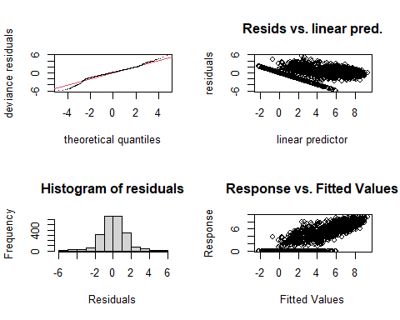

##   
## Method: REML Optimizer: outer newton  
## full convergence after 7 iterations.  
## Gradient range [-0.0002937872,0.0002410674]  
## (score 3971.78 & scale 1.888798).  
## Hessian positive definite, eigenvalue range [2.688032,1112.213].  
## Model rank = 59 / 59   
##   
## Basis dimension (k) checking results. Low p-value (k-index<1) may  
## indicate that k is too low, especially if edf is close to k'.  
##   
## k' edf k-index p-value   
## te(SalSurf_s,doy_s) 19.00 16.91 0.93 <0.0000000000000002 ***  
## s(Year_fac) 29.00 27.13 NA NA   
## s(Station_fac) 10.00 7.41 NA NA   
## ---  
## Signif. codes: 0 '***' 0.001 '**' 0.01 '*' 0.05 '.' 0.1 ' ' 1  
##   
##   
## -------------summary-------------  
##   
## Family: gaussian   
## Link function: identity   
##   
## Formula:  
## BPUE_log1p ~ te(SalSurf_s, doy_s, k = c(5, 5), bs = c("cs", "cc")) +   
## s(Year_fac, bs = "re") + s(Station_fac, bs = "re")  
##   
## Parametric coefficients:  
## Estimate Std. Error t value Pr(>|t|)   
## (Intercept) 4.1031 0.2345 17.5 <0.0000000000000002 ***  
## ---  
## Signif. codes: 0 '***' 0.001 '**' 0.01 '*' 0.05 '.' 0.1 ' ' 1  
##   
## Approximate significance of smooth terms:  
## edf Ref.df F p-value   
## te(SalSurf_s,doy_s) 16.909 19 3552.53 <0.0000000000000002 ***  
## s(Year_fac) 27.127 28 37.04 <0.0000000000000002 ***  
## s(Station_fac) 7.412 9 14.79 <0.0000000000000002 ***  
## ---  
## Signif. codes: 0 '***' 0.001 '**' 0.01 '*' 0.05 '.' 0.1 ' ' 1  
##   
## R-sq.(adj) = 0.811 Deviance explained = 81.5%  
## -REML = 3971.8 Scale est. = 1.8888 n = 2225  
## <<<<<<<<<<<<<<<<<<<<<<< modeling acartela Suisun Marsh >>>>>>>>>>>>>>>>>>>>>>>>>  
##   
## -------------gam check-------------

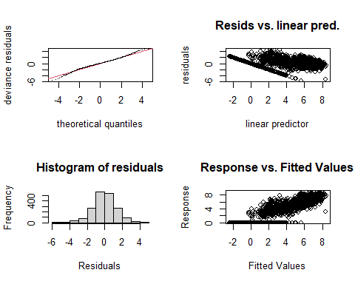

##   
## Method: REML Optimizer: outer newton  
## full convergence after 7 iterations.  
## Gradient range [-0.0004515553,0.0002586066]  
## (score 3309.904 & scale 1.805059).  
## Hessian positive definite, eigenvalue range [2.046184,936.7479].  
## Model rank = 58 / 58   
##   
## Basis dimension (k) checking results. Low p-value (k-index<1) may  
## indicate that k is too low, especially if edf is close to k'.  
##   
## k' edf k-index p-value   
## te(SalSurf_s,doy_s) 19.00 16.96 0.93 <0.0000000000000002 ***  
## s(Year_fac) 29.00 27.14 NA NA   
## s(Station_fac) 9.00 6.02 NA NA   
## ---  
## Signif. codes: 0 '***' 0.001 '**' 0.01 '*' 0.05 '.' 0.1 ' ' 1  
##   
##   
## -------------summary-------------  
##   
## Family: gaussian   
## Link function: identity   
##   
## Formula:  
## BPUE_log1p ~ te(SalSurf_s, doy_s, k = c(5, 5), bs = c("cs", "cc")) +   
## s(Year_fac, bs = "re") + s(Station_fac, bs = "re")  
##   
## Parametric coefficients:  
## Estimate Std. Error t value Pr(>|t|)   
## (Intercept) 3.5909 0.2271 15.81 <0.0000000000000002 ***  
## ---  
## Signif. codes: 0 '***' 0.001 '**' 0.01 '*' 0.05 '.' 0.1 ' ' 1  
##   
## Approximate significance of smooth terms:  
## edf Ref.df F p-value   
## te(SalSurf_s,doy_s) 16.961 19 1741.03 <0.0000000000000002 ***  
## s(Year_fac) 27.136 28 31.41 <0.0000000000000002 ***  
## s(Station_fac) 6.017 8 11.22 <0.0000000000000002 ***  
## ---  
## Signif. codes: 0 '***' 0.001 '**' 0.01 '*' 0.05 '.' 0.1 ' ' 1  
##   
## R-sq.(adj) = 0.79 Deviance explained = 79.6%  
## -REML = 3309.9 Scale est. = 1.8051 n = 1874  
## <<<<<<<<<<<<<<<<<<<<<<< modeling daphnia SW Suisun >>>>>>>>>>>>>>>>>>>>>>>>>  
##   
## -------------gam check-------------

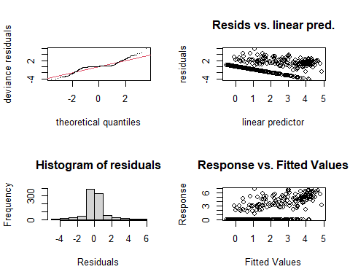

##   
## Method: REML Optimizer: outer newton  
## full convergence after 6 iterations.  
## Gradient range [-0.00009023408,0.00005854747]  
## (score 1423.048 & scale 1.218276).  
## Hessian positive definite, eigenvalue range [0.00008466343,455.7353].  
## Model rank = 53 / 53   
##   
## Basis dimension (k) checking results. Low p-value (k-index<1) may  
## indicate that k is too low, especially if edf is close to k'.  
##   
## k' edf k-index p-value   
## te(SalSurf_s,doy_s) 19.000000 14.013923 0.83 <0.0000000000000002 ***  
## s(Year_fac) 28.000000 18.032356 NA NA   
## s(Station_fac) 5.000000 0.000498 NA NA   
## ---  
## Signif. codes: 0 '***' 0.001 '**' 0.01 '*' 0.05 '.' 0.1 ' ' 1  
##   
##   
## -------------summary-------------  
##   
## Family: gaussian   
## Link function: identity   
##   
## Formula:  
## BPUE_log1p ~ te(SalSurf_s, doy_s, k = c(5, 5), bs = c("cs", "cc")) +   
## s(Year_fac, bs = "re") + s(Station_fac, bs = "re")  
##   
## Parametric coefficients:  
## Estimate Std. Error t value Pr(>|t|)   
## (Intercept) 0.67054 0.06567 10.21 <0.0000000000000002 ***  
## ---  
## Signif. codes: 0 '***' 0.001 '**' 0.01 '*' 0.05 '.' 0.1 ' ' 1  
##   
## Approximate significance of smooth terms:  
## edf Ref.df F p-value   
## te(SalSurf_s,doy_s) 14.0139233 19 83.56 < 0.0000000000000002 ***  
## s(Year_fac) 18.0323560 27 2.09 0.000000391 ***  
## s(Station_fac) 0.0004984 4 0.00 0.516   
## ---  
## Signif. codes: 0 '***' 0.001 '**' 0.01 '*' 0.05 '.' 0.1 ' ' 1  
##   
## R-sq.(adj) = 0.573 Deviance explained = 58.8%  
## -REML = 1423 Scale est. = 1.2183 n = 912  
## <<<<<<<<<<<<<<<<<<<<<<< modeling daphnia NW Suisun >>>>>>>>>>>>>>>>>>>>>>>>>  
##   
## -------------gam check-------------

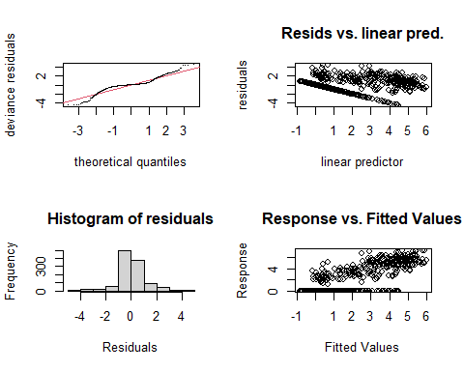

##   
## Method: REML Optimizer: outer newton  
## full convergence after 8 iterations.  
## Gradient range [-0.000194362,0.0001389984]  
## (score 1712.205 & scale 1.159603).  
## Hessian positive definite, eigenvalue range [1.094337,553.7822].  
## Model rank = 54 / 54   
##   
## Basis dimension (k) checking results. Low p-value (k-index<1) may  
## indicate that k is too low, especially if edf is close to k'.  
##   
## k' edf k-index p-value   
## te(SalSurf_s,doy_s) 19.00 16.32 0.9 <0.0000000000000002 ***  
## s(Year_fac) 29.00 21.85 NA NA   
## s(Station_fac) 5.00 2.46 NA NA   
## ---  
## Signif. codes: 0 '***' 0.001 '**' 0.01 '*' 0.05 '.' 0.1 ' ' 1  
##   
##   
## -------------summary-------------  
##   
## Family: gaussian   
## Link function: identity   
##   
## Formula:  
## BPUE_log1p ~ te(SalSurf_s, doy_s, k = c(5, 5), bs = c("cs", "cc")) +   
## s(Year_fac, bs = "re") + s(Station_fac, bs = "re")  
##   
## Parametric coefficients:  
## Estimate Std. Error t value Pr(>|t|)   
## (Intercept) 0.9169 0.1154 7.943 0.00000000000000497 ***  
## ---  
## Signif. codes: 0 '***' 0.001 '**' 0.01 '*' 0.05 '.' 0.1 ' ' 1  
##   
## Approximate significance of smooth terms:  
## edf Ref.df F p-value   
## te(SalSurf_s,doy_s) 16.322 19 214.604 < 0.0000000000000002 ***  
## s(Year_fac) 21.848 28 3.428 < 0.0000000000000002 ***  
## s(Station_fac) 2.457 4 4.900 0.0000868 ***  
## ---  
## Signif. codes: 0 '***' 0.001 '**' 0.01 '*' 0.05 '.' 0.1 ' ' 1  
##   
## R-sq.(adj) = 0.694 Deviance explained = 70.5%  
## -REML = 1712.2 Scale est. = 1.1596 n = 1108  
## <<<<<<<<<<<<<<<<<<<<<<< modeling daphnia East Suisun >>>>>>>>>>>>>>>>>>>>>>>>>  
##   
## -------------gam check-------------

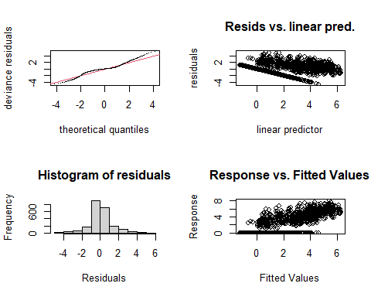

##   
## Method: REML Optimizer: outer newton  
## full convergence after 8 iterations.  
## Gradient range [-0.001571207,0.005874486]  
## (score 3656.413 & scale 1.405088).  
## Hessian positive definite, eigenvalue range [0.01246569,1125.179].  
## Model rank = 59 / 59   
##   
## Basis dimension (k) checking results. Low p-value (k-index<1) may  
## indicate that k is too low, especially if edf is close to k'.  
##   
## k' edf k-index p-value   
## te(SalSurf_s,doy_s) 19.000 17.128 0.86 <0.0000000000000002 ***  
## s(Year_fac) 29.000 26.047 NA NA   
## s(Station_fac) 10.000 0.337 NA NA   
## ---  
## Signif. codes: 0 '***' 0.001 '**' 0.01 '*' 0.05 '.' 0.1 ' ' 1  
##   
##   
## -------------summary-------------  
##   
## Family: gaussian   
## Link function: identity   
##   
## Formula:  
## BPUE_log1p ~ te(SalSurf_s, doy_s, k = c(5, 5), bs = c("cs", "cc")) +   
## s(Year_fac, bs = "re") + s(Station_fac, bs = "re")  
##   
## Parametric coefficients:  
## Estimate Std. Error t value Pr(>|t|)   
## (Intercept) 1.3110 0.1066 12.3 <0.0000000000000002 ***  
## ---  
## Signif. codes: 0 '***' 0.001 '**' 0.01 '*' 0.05 '.' 0.1 ' ' 1  
##   
## Approximate significance of smooth terms:  
## edf Ref.df F p-value   
## te(SalSurf_s,doy_s) 17.128 19 927.79 <0.0000000000000002 ***  
## s(Year_fac) 26.047 28 12.15 <0.0000000000000002 ***  
## s(Station_fac) 0.337 9 0.04 0.38   
## ---  
## Signif. codes: 0 '***' 0.001 '**' 0.01 '*' 0.05 '.' 0.1 ' ' 1  
##   
## R-sq.(adj) = 0.702 Deviance explained = 70.8%  
## -REML = 3656.4 Scale est. = 1.4051 n = 2251  
## <<<<<<<<<<<<<<<<<<<<<<< modeling daphnia Confluence >>>>>>>>>>>>>>>>>>>>>>>>>  
##   
## -------------gam check-------------

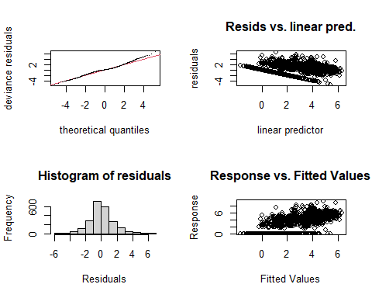

##   
## Method: REML Optimizer: outer newton  
## full convergence after 10 iterations.  
## Gradient range [-0.001278415,0.003709605]  
## (score 4116.541 & scale 2.216326).  
## Hessian positive definite, eigenvalue range [0.001281671,1112.172].  
## Model rank = 59 / 59   
##   
## Basis dimension (k) checking results. Low p-value (k-index<1) may  
## indicate that k is too low, especially if edf is close to k'.  
##   
## k' edf k-index p-value   
## te(SalSurf_s,doy_s) 19.0000 16.3928 0.86 <0.0000000000000002 ***  
## s(Year_fac) 29.0000 25.3205 NA NA   
## s(Station_fac) 10.0000 0.0102 NA NA   
## ---  
## Signif. codes: 0 '***' 0.001 '**' 0.01 '*' 0.05 '.' 0.1 ' ' 1  
##   
##   
## -------------summary-------------  
##   
## Family: gaussian   
## Link function: identity   
##   
## Formula:  
## BPUE_log1p ~ te(SalSurf_s, doy_s, k = c(5, 5), bs = c("cs", "cc")) +   
## s(Year_fac, bs = "re") + s(Station_fac, bs = "re")  
##   
## Parametric coefficients:  
## Estimate Std. Error t value Pr(>|t|)   
## (Intercept) 1.803 0.113 15.96 <0.0000000000000002 ***  
## ---  
## Signif. codes: 0 '***' 0.001 '**' 0.01 '*' 0.05 '.' 0.1 ' ' 1  
##   
## Approximate significance of smooth terms:  
## edf Ref.df F p-value   
## te(SalSurf_s,doy_s) 16.39279 19 506.123 <0.0000000000000002 ***  
## s(Year_fac) 25.32051 28 9.973 <0.0000000000000002 ***  
## s(Station_fac) 0.01019 9 0.001 0.599   
## ---  
## Signif. codes: 0 '***' 0.001 '**' 0.01 '*' 0.05 '.' 0.1 ' ' 1  
##   
## R-sq.(adj) = 0.604 Deviance explained = 61.1%  
## -REML = 4116.5 Scale est. = 2.2163 n = 2225  
## <<<<<<<<<<<<<<<<<<<<<<< modeling daphnia Suisun Marsh >>>>>>>>>>>>>>>>>>>>>>>>>  
##   
## -------------gam check-------------

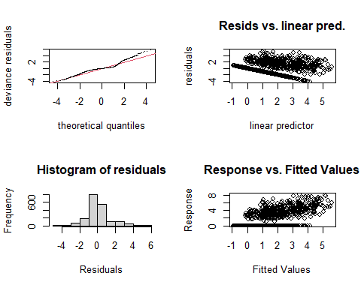

##   
## Method: REML Optimizer: outer newton  
## full convergence after 9 iterations.  
## Gradient range [-0.000002238439,0.000002012211]  
## (score 3184.154 & scale 1.638469).  
## Hessian positive definite, eigenvalue range [1.841798,936.6889].  
## Model rank = 58 / 58   
##   
## Basis dimension (k) checking results. Low p-value (k-index<1) may  
## indicate that k is too low, especially if edf is close to k'.  
##   
## k' edf k-index p-value   
## te(SalSurf_s,doy_s) 19.00 15.24 0.94 <0.0000000000000002 ***  
## s(Year_fac) 29.00 23.79 NA NA   
## s(Station_fac) 9.00 4.35 NA NA   
## ---  
## Signif. codes: 0 '***' 0.001 '**' 0.01 '*' 0.05 '.' 0.1 ' ' 1  
##   
##   
## -------------summary-------------  
##   
## Family: gaussian   
## Link function: identity   
##   
## Formula:  
## BPUE_log1p ~ te(SalSurf_s, doy_s, k = c(5, 5), bs = c("cs", "cc")) +   
## s(Year_fac, bs = "re") + s(Station_fac, bs = "re")  
##   
## Parametric coefficients:  
## Estimate Std. Error t value Pr(>|t|)   
## (Intercept) 0.8609 0.1015 8.484 <0.0000000000000002 ***  
## ---  
## Signif. codes: 0 '***' 0.001 '**' 0.01 '*' 0.05 '.' 0.1 ' ' 1  
##   
## Approximate significance of smooth terms:  
## edf Ref.df F p-value   
## te(SalSurf_s,doy_s) 15.243 19 134.379 < 0.0000000000000002 ***  
## s(Year_fac) 23.789 28 5.212 < 0.0000000000000002 ***  
## s(Station_fac) 4.353 8 3.209 0.0000214 ***  
## ---  
## Signif. codes: 0 '***' 0.001 '**' 0.01 '*' 0.05 '.' 0.1 ' ' 1  
##   
## R-sq.(adj) = 0.492 Deviance explained = 50.4%  
## -REML = 3184.2 Scale est. = 1.6385 n = 1874  
## <<<<<<<<<<<<<<<<<<<<<<< modeling eurytem SW Suisun >>>>>>>>>>>>>>>>>>>>>>>>>  
##   
## -------------gam check-------------

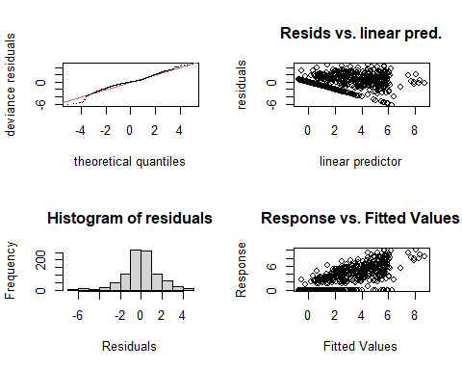

##   
## Method: REML Optimizer: outer newton  
## full convergence after 7 iterations.  
## Gradient range [-0.00005391874,0.00004618768]  
## (score 1739.542 & scale 2.440519).  
## Hessian positive definite, eigenvalue range [1.463964,455.6386].  
## Model rank = 53 / 53   
##   
## Basis dimension (k) checking results. Low p-value (k-index<1) may  
## indicate that k is too low, especially if edf is close to k'.  
##   
## k' edf k-index p-value   
## te(SalSurf_s,doy_s) 19.00 13.11 0.95 0.045 *  
## s(Year_fac) 28.00 12.21 NA NA   
## s(Station_fac) 5.00 3.67 NA NA   
## ---  
## Signif. codes: 0 '***' 0.001 '**' 0.01 '*' 0.05 '.' 0.1 ' ' 1  
##   
##   
## -------------summary-------------  
##   
## Family: gaussian   
## Link function: identity   
##   
## Formula:  
## BPUE_log1p ~ te(SalSurf_s, doy_s, k = c(5, 5), bs = c("cs", "cc")) +   
## s(Year_fac, bs = "re") + s(Station_fac, bs = "re")  
##   
## Parametric coefficients:  
## Estimate Std. Error t value Pr(>|t|)   
## (Intercept) 2.9008 0.7259 3.996 0.0000698 ***  
## ---  
## Signif. codes: 0 '***' 0.001 '**' 0.01 '*' 0.05 '.' 0.1 ' ' 1  
##   
## Approximate significance of smooth terms:  
## edf Ref.df F p-value   
## te(SalSurf_s,doy_s) 13.111 19 1176.998 < 0.0000000000000002 ***  
## s(Year_fac) 12.211 27 0.827 0.00816 **   
## s(Station_fac) 3.665 4 11.971 < 0.0000000000000002 ***  
## ---  
## Signif. codes: 0 '***' 0.001 '**' 0.01 '*' 0.05 '.' 0.1 ' ' 1  
##   
## R-sq.(adj) = 0.643 Deviance explained = 65.4%  
## -REML = 1739.5 Scale est. = 2.4405 n = 912  
## <<<<<<<<<<<<<<<<<<<<<<< modeling eurytem NW Suisun >>>>>>>>>>>>>>>>>>>>>>>>>  
##   
## -------------gam check-------------

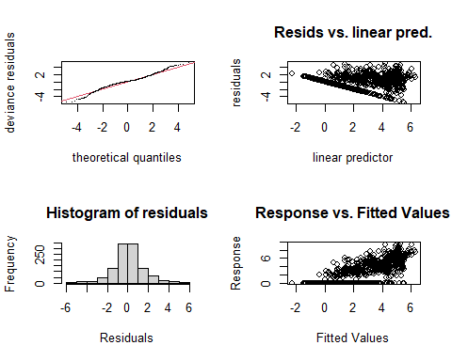

##   
## Method: REML Optimizer: outer newton  
## full convergence after 9 iterations.  
## Gradient range [-0.0002364081,0.0001378661]  
## (score 2053.916 & scale 2.153944).  
## Hessian positive definite, eigenvalue range [0.0848522,553.763].  
## Model rank = 54 / 54   
##   
## Basis dimension (k) checking results. Low p-value (k-index<1) may  
## indicate that k is too low, especially if edf is close to k'.  
##   
## k' edf k-index p-value   
## te(SalSurf_s,doy_s) 19.000 16.942 0.96 0.075 .  
## s(Year_fac) 29.000 20.762 NA NA   
## s(Station_fac) 5.000 0.683 NA NA   
## ---  
## Signif. codes: 0 '***' 0.001 '**' 0.01 '*' 0.05 '.' 0.1 ' ' 1  
##   
##   
## -------------summary-------------  
##   
## Family: gaussian   
## Link function: identity   
##   
## Formula:  
## BPUE_log1p ~ te(SalSurf_s, doy_s, k = c(5, 5), bs = c("cs", "cc")) +   
## s(Year_fac, bs = "re") + s(Station_fac, bs = "re")  
##   
## Parametric coefficients:  
## Estimate Std. Error t value Pr(>|t|)   
## (Intercept) 1.84006 0.09952 18.49 <0.0000000000000002 ***  
## ---  
## Signif. codes: 0 '***' 0.001 '**' 0.01 '*' 0.05 '.' 0.1 ' ' 1  
##   
## Approximate significance of smooth terms:  
## edf Ref.df F p-value   
## te(SalSurf_s,doy_s) 16.9415 19 154.523 <0.0000000000000002 ***  
## s(Year_fac) 20.7623 28 2.784 <0.0000000000000002 ***  
## s(Station_fac) 0.6829 4 0.244 0.241   
## ---  
## Signif. codes: 0 '***' 0.001 '**' 0.01 '*' 0.05 '.' 0.1 ' ' 1  
##   
## R-sq.(adj) = 0.642 Deviance explained = 65.5%  
## -REML = 2053.9 Scale est. = 2.1539 n = 1108  
## <<<<<<<<<<<<<<<<<<<<<<< modeling eurytem East Suisun >>>>>>>>>>>>>>>>>>>>>>>>>  
##   
## -------------gam check-------------

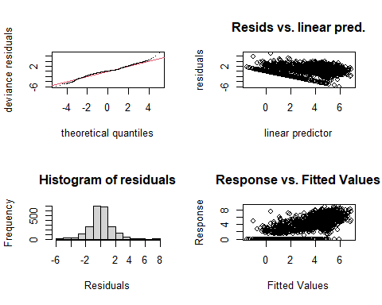

##   
## Method: REML Optimizer: outer newton  
## full convergence after 10 iterations.  
## Gradient range [-0.0001935674,0.0001790197]  
## (score 4080.627 & scale 2.05502).  
## Hessian positive definite, eigenvalue range [1.361564,1125.163].  
## Model rank = 59 / 59   
##   
## Basis dimension (k) checking results. Low p-value (k-index<1) may  
## indicate that k is too low, especially if edf is close to k'.  
##   
## k' edf k-index p-value   
## te(SalSurf_s,doy_s) 19.00 17.21 0.77 <0.0000000000000002 ***  
## s(Year_fac) 29.00 23.16 NA NA   
## s(Station_fac) 10.00 6.58 NA NA   
## ---  
## Signif. codes: 0 '***' 0.001 '**' 0.01 '*' 0.05 '.' 0.1 ' ' 1  
##   
##   
## -------------summary-------------  
##   
## Family: gaussian   
## Link function: identity   
##   
## Formula:  
## BPUE_log1p ~ te(SalSurf_s, doy_s, k = c(5, 5), bs = c("cs", "cc")) +   
## s(Year_fac, bs = "re") + s(Station_fac, bs = "re")  
##   
## Parametric coefficients:  
## Estimate Std. Error t value Pr(>|t|)   
## (Intercept) 2.1980 0.1474 14.92 <0.0000000000000002 ***  
## ---  
## Signif. codes: 0 '***' 0.001 '**' 0.01 '*' 0.05 '.' 0.1 ' ' 1  
##   
## Approximate significance of smooth terms:  
## edf Ref.df F p-value   
## te(SalSurf_s,doy_s) 17.210 19 418.858 < 0.0000000000000002 ***  
## s(Year_fac) 23.159 28 4.410 < 0.0000000000000002 ***  
## s(Station_fac) 6.585 9 3.389 0.0000779 ***  
## ---  
## Signif. codes: 0 '***' 0.001 '**' 0.01 '*' 0.05 '.' 0.1 ' ' 1  
##   
## R-sq.(adj) = 0.685 Deviance explained = 69.1%  
## -REML = 4080.6 Scale est. = 2.055 n = 2251  
## <<<<<<<<<<<<<<<<<<<<<<< modeling eurytem Confluence >>>>>>>>>>>>>>>>>>>>>>>>>  
##   
## -------------gam check-------------

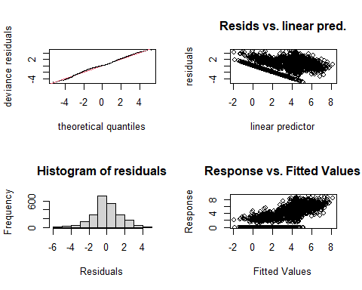

##   
## Method: REML Optimizer: outer newton  
## full convergence after 11 iterations.  
## Gradient range [-0.0000004755084,0.0000002465697]  
## (score 4132.048 & scale 2.24016).  
## Hessian positive definite, eigenvalue range [0.5358441,1112.166].  
## Model rank = 59 / 59   
##   
## Basis dimension (k) checking results. Low p-value (k-index<1) may  
## indicate that k is too low, especially if edf is close to k'.  
##   
## k' edf k-index p-value   
## te(SalSurf_s,doy_s) 19.00 17.34 0.74 <0.0000000000000002 ***  
## s(Year_fac) 29.00 24.03 NA NA   
## s(Station_fac) 10.00 2.49 NA NA   
## ---  
## Signif. codes: 0 '***' 0.001 '**' 0.01 '*' 0.05 '.' 0.1 ' ' 1  
##   
##   
## -------------summary-------------  
##   
## Family: gaussian   
## Link function: identity   
##   
## Formula:  
## BPUE_log1p ~ te(SalSurf_s, doy_s, k = c(5, 5), bs = c("cs", "cc")) +   
## s(Year_fac, bs = "re") + s(Station_fac, bs = "re")  
##   
## Parametric coefficients:  
## Estimate Std. Error t value Pr(>|t|)   
## (Intercept) 2.3400 0.0969 24.15 <0.0000000000000002 ***  
## ---  
## Signif. codes: 0 '***' 0.001 '**' 0.01 '*' 0.05 '.' 0.1 ' ' 1  
##   
## Approximate significance of smooth terms:  
## edf Ref.df F p-value   
## te(SalSurf_s,doy_s) 17.337 19 292.783 <0.0000000000000002 ***  
## s(Year_fac) 24.030 28 6.446 <0.0000000000000002 ***  
## s(Station_fac) 2.489 9 0.501 0.099 .   
## ---  
## Signif. codes: 0 '***' 0.001 '**' 0.01 '*' 0.05 '.' 0.1 ' ' 1  
##   
## R-sq.(adj) = 0.68 Deviance explained = 68.6%  
## -REML = 4132 Scale est. = 2.2402 n = 2225  
## <<<<<<<<<<<<<<<<<<<<<<< modeling eurytem Suisun Marsh >>>>>>>>>>>>>>>>>>>>>>>>>  
##   
## -------------gam check-------------

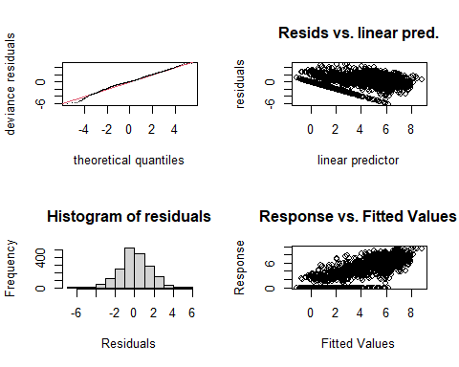

##   
## Method: REML Optimizer: outer newton  
## full convergence after 8 iterations.  
## Gradient range [-0.002279972,0.001682734]  
## (score 3609.604 & scale 2.56949).  
## Hessian positive definite, eigenvalue range [1.261341,936.6977].  
## Model rank = 58 / 58   
##   
## Basis dimension (k) checking results. Low p-value (k-index<1) may  
## indicate that k is too low, especially if edf is close to k'.  
##   
## k' edf k-index p-value   
## te(SalSurf_s,doy_s) 19.00 14.28 0.78 <0.0000000000000002 ***  
## s(Year_fac) 29.00 24.06 NA NA   
## s(Station_fac) 9.00 6.04 NA NA   
## ---  
## Signif. codes: 0 '***' 0.001 '**' 0.01 '*' 0.05 '.' 0.1 ' ' 1  
##   
##   
## -------------summary-------------  
##   
## Family: gaussian   
## Link function: identity   
##   
## Formula:  
## BPUE_log1p ~ te(SalSurf_s, doy_s, k = c(5, 5), bs = c("cs", "cc")) +   
## s(Year_fac, bs = "re") + s(Station_fac, bs = "re")  
##   
## Parametric coefficients:  
## Estimate Std. Error t value Pr(>|t|)   
## (Intercept) 3.2120 0.1779 18.06 <0.0000000000000002 ***  
## ---  
## Signif. codes: 0 '***' 0.001 '**' 0.01 '*' 0.05 '.' 0.1 ' ' 1  
##   
## Approximate significance of smooth terms:  
## edf Ref.df F p-value   
## te(SalSurf_s,doy_s) 14.276 19 463.645 <0.0000000000000002 ***  
## s(Year_fac) 24.063 28 5.571 <0.0000000000000002 ***  
## s(Station_fac) 6.036 8 11.321 <0.0000000000000002 ***  
## ---  
## Signif. codes: 0 '***' 0.001 '**' 0.01 '*' 0.05 '.' 0.1 ' ' 1  
##   
## R-sq.(adj) = 0.713 Deviance explained = 72%  
## -REML = 3609.6 Scale est. = 2.5695 n = 1874  
## <<<<<<<<<<<<<<<<<<<<<<< modeling othcalad SW Suisun >>>>>>>>>>>>>>>>>>>>>>>>>  
##   
## -------------gam check-------------

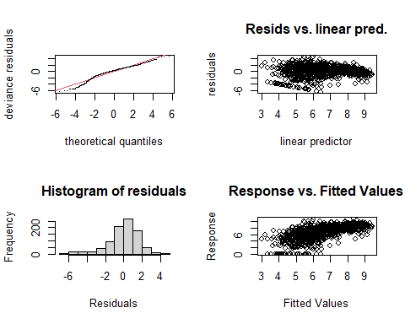

##   
## Method: REML Optimizer: outer newton  
## full convergence after 8 iterations.  
## Gradient range [-0.000002247259,0.000001995823]  
## (score 1840.401 & scale 3.027566).  
## Hessian positive definite, eigenvalue range [1.504264,455.751].  
## Model rank = 53 / 53   
##   
## Basis dimension (k) checking results. Low p-value (k-index<1) may  
## indicate that k is too low, especially if edf is close to k'.  
##   
## k' edf k-index p-value  
## te(SalSurf_s,doy_s) 19.00 12.82 0.99 0.33  
## s(Year_fac) 28.00 19.01 NA NA  
## s(Station_fac) 5.00 2.94 NA NA  
##   
##   
## -------------summary-------------  
##   
## Family: gaussian   
## Link function: identity   
##   
## Formula:  
## BPUE_log1p ~ te(SalSurf_s, doy_s, k = c(5, 5), bs = c("cs", "cc")) +   
## s(Year_fac, bs = "re") + s(Station_fac, bs = "re")  
##   
## Parametric coefficients:  
## Estimate Std. Error t value Pr(>|t|)   
## (Intercept) 6.535 0.385 16.98 <0.0000000000000002 ***  
## ---  
## Signif. codes: 0 '***' 0.001 '**' 0.01 '*' 0.05 '.' 0.1 ' ' 1  
##   
## Approximate significance of smooth terms:  
## edf Ref.df F p-value   
## te(SalSurf_s,doy_s) 12.821 19 86.69 <0.0000000000000002 ***  
## s(Year_fac) 19.007 27 2.73 <0.0000000000000002 ***  
## s(Station_fac) 2.936 4 35.03 <0.0000000000000002 ***  
## ---  
## Signif. codes: 0 '***' 0.001 '**' 0.01 '*' 0.05 '.' 0.1 ' ' 1  
##   
## R-sq.(adj) = 0.382 Deviance explained = 40.5%  
## -REML = 1840.4 Scale est. = 3.0276 n = 912  
## <<<<<<<<<<<<<<<<<<<<<<< modeling othcalad NW Suisun >>>>>>>>>>>>>>>>>>>>>>>>>  
##   
## -------------gam check-------------

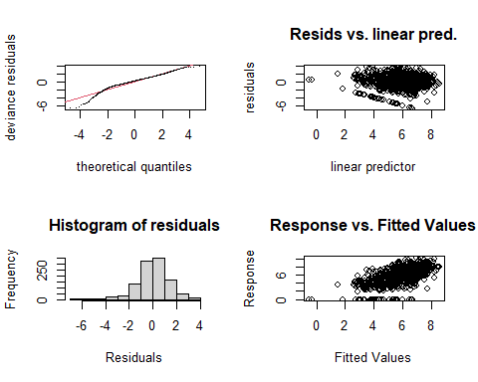

##   
## Method: REML Optimizer: outer newton  
## full convergence after 7 iterations.  
## Gradient range [-0.0005007208,0.0004246103]  
## (score 2012.9 & scale 2.049666).  
## Hessian positive definite, eigenvalue range [1.697628,553.6139].  
## Model rank = 54 / 54   
##   
## Basis dimension (k) checking results. Low p-value (k-index<1) may  
## indicate that k is too low, especially if edf is close to k'.  
##   
## k' edf k-index p-value   
## te(SalSurf_s,doy_s) 19.00 14.83 0.95 0.075 .  
## s(Year_fac) 29.00 11.16 NA NA   
## s(Station_fac) 5.00 3.91 NA NA   
## ---  
## Signif. codes: 0 '***' 0.001 '**' 0.01 '*' 0.05 '.' 0.1 ' ' 1  
##   
##   
## -------------summary-------------  
##   
## Family: gaussian   
## Link function: identity   
##   
## Formula:  
## BPUE_log1p ~ te(SalSurf_s, doy_s, k = c(5, 5), bs = c("cs", "cc")) +   
## s(Year_fac, bs = "re") + s(Station_fac, bs = "re")  
##   
## Parametric coefficients:  
## Estimate Std. Error t value Pr(>|t|)   
## (Intercept) 5.4486 0.7877 6.917 0.0000000000079 ***  
## ---  
## Signif. codes: 0 '***' 0.001 '**' 0.01 '*' 0.05 '.' 0.1 ' ' 1  
##   
## Approximate significance of smooth terms:  
## edf Ref.df F p-value   
## te(SalSurf_s,doy_s) 14.828 19 591.471 < 0.0000000000000002 ***  
## s(Year_fac) 11.159 28 0.747 0.00694 **   
## s(Station_fac) 3.905 4 28.105 < 0.0000000000000002 ***  
## ---  
## Signif. codes: 0 '***' 0.001 '**' 0.01 '*' 0.05 '.' 0.1 ' ' 1  
##   
## R-sq.(adj) = 0.419 Deviance explained = 43.5%  
## -REML = 2012.9 Scale est. = 2.0497 n = 1108  
## <<<<<<<<<<<<<<<<<<<<<<< modeling othcalad East Suisun >>>>>>>>>>>>>>>>>>>>>>>>>  
##   
## -------------gam check-------------

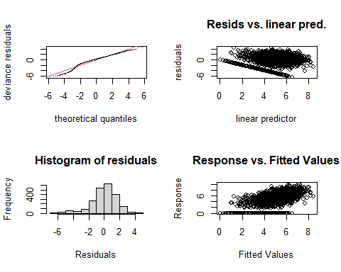

##   
## Method: REML Optimizer: outer newton  
## full convergence after 7 iterations.  
## Gradient range [-0.002395014,0.001980715]  
## (score 4376.691 & scale 2.708589).  
## Hessian positive definite, eigenvalue range [1.733493,1125.153].  
## Model rank = 59 / 59   
##   
## Basis dimension (k) checking results. Low p-value (k-index<1) may  
## indicate that k is too low, especially if edf is close to k'.  
##   
## k' edf k-index p-value   
## te(SalSurf_s,doy_s) 19.00 14.66 0.92 <0.0000000000000002 ***  
## s(Year_fac) 29.00 23.00 NA NA   
## s(Station_fac) 10.00 6.09 NA NA   
## ---  
## Signif. codes: 0 '***' 0.001 '**' 0.01 '*' 0.05 '.' 0.1 ' ' 1  
##   
##   
## -------------summary-------------  
##   
## Family: gaussian   
## Link function: identity   
##   
## Formula:  
## BPUE_log1p ~ te(SalSurf_s, doy_s, k = c(5, 5), bs = c("cs", "cc")) +   
## s(Year_fac, bs = "re") + s(Station_fac, bs = "re")  
##   
## Parametric coefficients:  
## Estimate Std. Error t value Pr(>|t|)   
## (Intercept) 5.3496 0.1464 36.53 <0.0000000000000002 ***  
## ---  
## Signif. codes: 0 '***' 0.001 '**' 0.01 '*' 0.05 '.' 0.1 ' ' 1  
##   
## Approximate significance of smooth terms:  
## edf Ref.df F p-value   
## te(SalSurf_s,doy_s) 14.657 19 141.396 <0.0000000000000002 ***  
## s(Year_fac) 22.996 28 5.501 <0.0000000000000002 ***  
## s(Station_fac) 6.087 9 7.686 <0.0000000000000002 ***  
## ---  
## Signif. codes: 0 '***' 0.001 '**' 0.01 '*' 0.05 '.' 0.1 ' ' 1  
##   
## R-sq.(adj) = 0.354 Deviance explained = 36.7%  
## -REML = 4376.7 Scale est. = 2.7086 n = 2251  
## <<<<<<<<<<<<<<<<<<<<<<< modeling othcalad Confluence >>>>>>>>>>>>>>>>>>>>>>>>>  
##   
## -------------gam check-------------

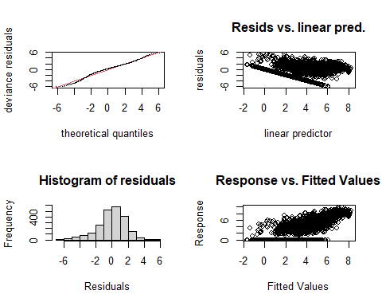

##   
## Method: REML Optimizer: outer newton  
## full convergence after 8 iterations.  
## Gradient range [-0.00008084772,0.00001031899]  
## (score 4508.438 & scale 3.118615).  
## Hessian positive definite, eigenvalue range [1.092928,1112.194].  
## Model rank = 59 / 59   
##   
## Basis dimension (k) checking results. Low p-value (k-index<1) may  
## indicate that k is too low, especially if edf is close to k'.  
##   
## k' edf k-index p-value   
## te(SalSurf_s,doy_s) 19.00 16.40 0.86 <0.0000000000000002 ***  
## s(Year_fac) 29.00 26.39 NA NA   
## s(Station_fac) 10.00 4.98 NA NA   
## ---  
## Signif. codes: 0 '***' 0.001 '**' 0.01 '*' 0.05 '.' 0.1 ' ' 1  
##   
##   
## -------------summary-------------  
##   
## Family: gaussian   
## Link function: identity   
##   
## Formula:  
## BPUE_log1p ~ te(SalSurf_s, doy_s, k = c(5, 5), bs = c("cs", "cc")) +   
## s(Year_fac, bs = "re") + s(Station_fac, bs = "re")  
##   
## Parametric coefficients:  
## Estimate Std. Error t value Pr(>|t|)   
## (Intercept) 4.2123 0.1881 22.39 <0.0000000000000002 ***  
## ---  
## Signif. codes: 0 '***' 0.001 '**' 0.01 '*' 0.05 '.' 0.1 ' ' 1  
##   
## Approximate significance of smooth terms:  
## edf Ref.df F p-value   
## te(SalSurf_s,doy_s) 16.399 19 309.566 < 0.0000000000000002 ***  
## s(Year_fac) 26.388 28 17.649 < 0.0000000000000002 ***  
## s(Station_fac) 4.978 9 1.886 0.00315 **   
## ---  
## Signif. codes: 0 '***' 0.001 '**' 0.01 '*' 0.05 '.' 0.1 ' ' 1  
##   
## R-sq.(adj) = 0.567 Deviance explained = 57.7%  
## -REML = 4508.4 Scale est. = 3.1186 n = 2225  
## <<<<<<<<<<<<<<<<<<<<<<< modeling othcalad Suisun Marsh >>>>>>>>>>>>>>>>>>>>>>>>>  
##   
## -------------gam check-------------

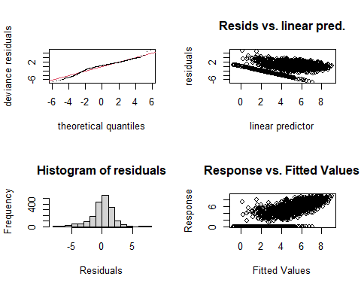

##   
## Method: REML Optimizer: outer newton  
## full convergence after 8 iterations.  
## Gradient range [-0.00005659958,0.00005123574]  
## (score 3737.587 & scale 2.908556).  
## Hessian positive definite, eigenvalue range [2.306247,936.7132].  
## Model rank = 58 / 58   
##   
## Basis dimension (k) checking results. Low p-value (k-index<1) may  
## indicate that k is too low, especially if edf is close to k'.  
##   
## k' edf k-index p-value   
## te(SalSurf_s,doy_s) 19.00 16.96 0.94 <0.0000000000000002 ***  
## s(Year_fac) 29.00 24.64 NA NA   
## s(Station_fac) 9.00 6.28 NA NA   
## ---  
## Signif. codes: 0 '***' 0.001 '**' 0.01 '*' 0.05 '.' 0.1 ' ' 1  
##   
##   
## -------------summary-------------  
##   
## Family: gaussian   
## Link function: identity   
##   
## Formula:  
## BPUE_log1p ~ te(SalSurf_s, doy_s, k = c(5, 5), bs = c("cs", "cc")) +   
## s(Year_fac, bs = "re") + s(Station_fac, bs = "re")  
##   
## Parametric coefficients:  
## Estimate Std. Error t value Pr(>|t|)   
## (Intercept) 5.1938 0.2112 24.59 <0.0000000000000002 ***  
## ---  
## Signif. codes: 0 '***' 0.001 '**' 0.01 '*' 0.05 '.' 0.1 ' ' 1  
##   
## Approximate significance of smooth terms:  
## edf Ref.df F p-value   
## te(SalSurf_s,doy_s) 16.956 19 289.044 <0.0000000000000002 ***  
## s(Year_fac) 24.643 28 9.395 <0.0000000000000002 ***  
## s(Station_fac) 6.285 8 10.942 <0.0000000000000002 ***  
## ---  
## Signif. codes: 0 '***' 0.001 '**' 0.01 '*' 0.05 '.' 0.1 ' ' 1  
##   
## R-sq.(adj) = 0.527 Deviance explained = 53.9%  
## -REML = 3737.6 Scale est. = 2.9086 n = 1874  
## <<<<<<<<<<<<<<<<<<<<<<< modeling othcaljuv SW Suisun >>>>>>>>>>>>>>>>>>>>>>>>>  
##   
## -------------gam check-------------

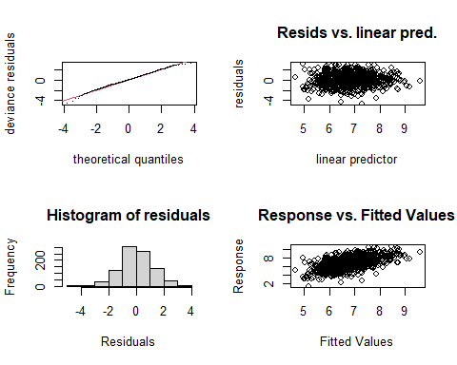

##   
## Method: REML Optimizer: outer newton  
## full convergence after 8 iterations.  
## Gradient range [-0.00000657465,0.000003443105]  
## (score 1494.703 & scale 1.382329).  
## Hessian positive definite, eigenvalue range [1.075524,455.8082].  
## Model rank = 53 / 53   
##   
## Basis dimension (k) checking results. Low p-value (k-index<1) may  
## indicate that k is too low, especially if edf is close to k'.  
##   
## k' edf k-index p-value  
## te(SalSurf_s,doy_s) 19.00 14.87 0.98 0.21  
## s(Year_fac) 28.00 20.76 NA NA  
## s(Station_fac) 5.00 3.36 NA NA  
##   
##   
## -------------summary-------------  
##   
## Family: gaussian   
## Link function: identity   
##   
## Formula:  
## BPUE_log1p ~ te(SalSurf_s, doy_s, k = c(5, 5), bs = c("cs", "cc")) +   
## s(Year_fac, bs = "re") + s(Station_fac, bs = "re")  
##   
## Parametric coefficients:  
## Estimate Std. Error t value Pr(>|t|)   
## (Intercept) 7.2604 0.3776 19.23 <0.0000000000000002 ***  
## ---  
## Signif. codes: 0 '***' 0.001 '**' 0.01 '*' 0.05 '.' 0.1 ' ' 1  
##   
## Approximate significance of smooth terms:  
## edf Ref.df F p-value   
## te(SalSurf_s,doy_s) 14.87 19 117.481 0.00000053 ***  
## s(Year_fac) 20.76 27 3.127 < 0.0000000000000002 ***  
## s(Station_fac) 3.36 4 14.162 < 0.0000000000000002 ***  
## ---  
## Signif. codes: 0 '***' 0.001 '**' 0.01 '*' 0.05 '.' 0.1 ' ' 1  
##   
## R-sq.(adj) = 0.311 Deviance explained = 34.1%  
## -REML = 1494.7 Scale est. = 1.3823 n = 912  
## <<<<<<<<<<<<<<<<<<<<<<< modeling othcaljuv NW Suisun >>>>>>>>>>>>>>>>>>>>>>>>>  
##   
## -------------gam check-------------

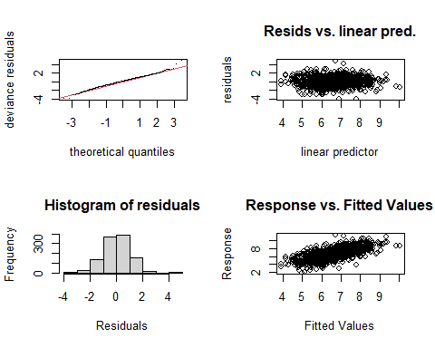

##   
## Method: REML Optimizer: outer newton  
## full convergence after 7 iterations.  
## Gradient range [-0.000001318061,0.000001112305]  
## (score 1698.681 & scale 1.109952).  
## Hessian positive definite, eigenvalue range [0.1806273,553.855].  
## Model rank = 54 / 54   
##   
## Basis dimension (k) checking results. Low p-value (k-index<1) may  
## indicate that k is too low, especially if edf is close to k'.  
##   
## k' edf k-index p-value   
## te(SalSurf_s,doy_s) 19.00 15.98 0.96 0.065 .  
## s(Year_fac) 29.00 25.24 NA NA   
## s(Station_fac) 5.00 2.65 NA NA   
## ---  
## Signif. codes: 0 '***' 0.001 '**' 0.01 '*' 0.05 '.' 0.1 ' ' 1  
##   
##   
## -------------summary-------------  
##   
## Family: gaussian   
## Link function: identity   
##   
## Formula:  
## BPUE_log1p ~ te(SalSurf_s, doy_s, k = c(5, 5), bs = c("cs", "cc")) +   
## s(Year_fac, bs = "re") + s(Station_fac, bs = "re")  
##   
## Parametric coefficients:  
## Estimate Std. Error t value Pr(>|t|)   
## (Intercept) 6.7214 0.1509 44.54 <0.0000000000000002 ***  
## ---  
## Signif. codes: 0 '***' 0.001 '**' 0.01 '*' 0.05 '.' 0.1 ' ' 1  
##   
## Approximate significance of smooth terms:  
## edf Ref.df F p-value   
## te(SalSurf_s,doy_s) 15.975 19 82.993 < 0.0000000000000002 ***  
## s(Year_fac) 25.241 28 9.201 < 0.0000000000000002 ***  
## s(Station_fac) 2.655 4 3.606 0.00292 **   
## ---  
## Signif. codes: 0 '***' 0.001 '**' 0.01 '*' 0.05 '.' 0.1 ' ' 1  
##   
## R-sq.(adj) = 0.484 Deviance explained = 50.5%  
## -REML = 1698.7 Scale est. = 1.11 n = 1108  
## <<<<<<<<<<<<<<<<<<<<<<< modeling othcaljuv East Suisun >>>>>>>>>>>>>>>>>>>>>>>>>  
##   
## -------------gam check-------------

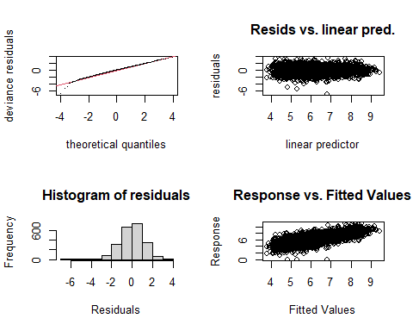

##   
## Method: REML Optimizer: outer newton  
## full convergence after 8 iterations.  
## Gradient range [-0.000002713304,0.000002680241]  
## (score 3553.013 & scale 1.294976).  
## Hessian positive definite, eigenvalue range [1.998543,1125.143].  
## Model rank = 59 / 59   
##   
## Basis dimension (k) checking results. Low p-value (k-index<1) may  
## indicate that k is too low, especially if edf is close to k'.  
##   
## k' edf k-index p-value   
## te(SalSurf_s,doy_s) 19.00 16.54 0.88 <0.0000000000000002 ***  
## s(Year_fac) 29.00 21.31 NA NA   
## s(Station_fac) 10.00 6.47 NA NA   
## ---  
## Signif. codes: 0 '***' 0.001 '**' 0.01 '*' 0.05 '.' 0.1 ' ' 1  
##   
##   
## -------------summary-------------  
##   
## Family: gaussian   
## Link function: identity   
##   
## Formula:  
## BPUE_log1p ~ te(SalSurf_s, doy_s, k = c(5, 5), bs = c("cs", "cc")) +   
## s(Year_fac, bs = "re") + s(Station_fac, bs = "re")  
##   
## Parametric coefficients:  
## Estimate Std. Error t value Pr(>|t|)   
## (Intercept) 6.2761 0.1077 58.29 <0.0000000000000002 ***  
## ---  
## Signif. codes: 0 '***' 0.001 '**' 0.01 '*' 0.05 '.' 0.1 ' ' 1  
##   
## Approximate significance of smooth terms:  
## edf Ref.df F p-value   
## te(SalSurf_s,doy_s) 16.542 19 250.782 <0.0000000000000002 ***  
## s(Year_fac) 21.311 28 3.397 <0.0000000000000002 ***  
## s(Station_fac) 6.474 9 7.289 <0.0000000000000002 ***  
## ---  
## Signif. codes: 0 '***' 0.001 '**' 0.01 '*' 0.05 '.' 0.1 ' ' 1  
##   
## R-sq.(adj) = 0.498 Deviance explained = 50.8%  
## -REML = 3553 Scale est. = 1.295 n = 2251  
## <<<<<<<<<<<<<<<<<<<<<<< modeling othcaljuv Confluence >>>>>>>>>>>>>>>>>>>>>>>>>  
##   
## -------------gam check-------------

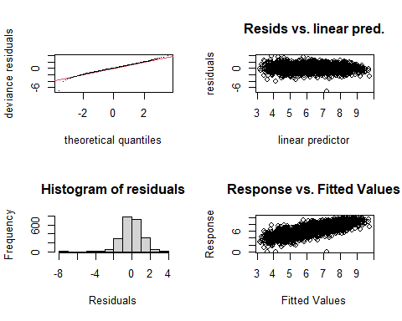

##   
## Method: REML Optimizer: outer newton  
## full convergence after 12 iterations.  
## Gradient range [-0.000002289376,0.00000007458013]  
## (score 3300.853 & scale 1.059301).  
## Hessian positive definite, eigenvalue range [2.763937,1112.173].  
## Model rank = 59 / 59   
##   
## Basis dimension (k) checking results. Low p-value (k-index<1) may  
## indicate that k is too low, especially if edf is close to k'.  
##   
## k' edf k-index p-value   
## te(SalSurf_s,doy_s) 19.00 16.42 0.77 <0.0000000000000002 ***  
## s(Year_fac) 29.00 24.05 NA NA   
## s(Station_fac) 10.00 7.22 NA NA   
## ---  
## Signif. codes: 0 '***' 0.001 '**' 0.01 '*' 0.05 '.' 0.1 ' ' 1  
##   
##   
## -------------summary-------------  
##   
## Family: gaussian   
## Link function: identity   
##   
## Formula:  
## BPUE_log1p ~ te(SalSurf_s, doy_s, k = c(5, 5), bs = c("cs", "cc")) +   
## s(Year_fac, bs = "re") + s(Station_fac, bs = "re")  
##   
## Parametric coefficients:  
## Estimate Std. Error t value Pr(>|t|)   
## (Intercept) 6.3002 0.1145 55.01 <0.0000000000000002 ***  
## ---  
## Signif. codes: 0 '***' 0.001 '**' 0.01 '*' 0.05 '.' 0.1 ' ' 1  
##   
## Approximate significance of smooth terms:  
## edf Ref.df F p-value   
## te(SalSurf_s,doy_s) 16.416 19 831.847 <0.0000000000000002 ***  
## s(Year_fac) 24.050 28 7.091 <0.0000000000000002 ***  
## s(Station_fac) 7.224 9 16.184 <0.0000000000000002 ***  
## ---  
## Signif. codes: 0 '***' 0.001 '**' 0.01 '*' 0.05 '.' 0.1 ' ' 1  
##   
## R-sq.(adj) = 0.65 Deviance explained = 65.8%  
## -REML = 3300.9 Scale est. = 1.0593 n = 2225  
## <<<<<<<<<<<<<<<<<<<<<<< modeling othcaljuv Suisun Marsh >>>>>>>>>>>>>>>>>>>>>>>>>  
##   
## -------------gam check-------------

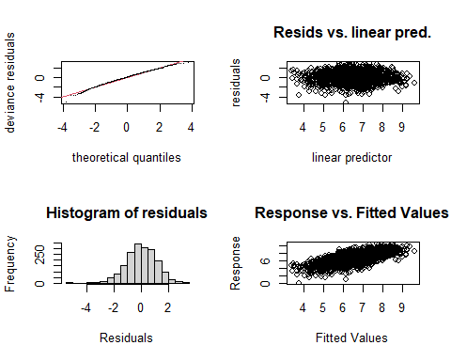

##   
## Method: REML Optimizer: outer newton  
## full convergence after 9 iterations.  
## Gradient range [-0.001208781,0.0001171013]  
## (score 2908.551 & scale 1.207566).  
## Hessian positive definite, eigenvalue range [2.159037,936.6753].  
## Model rank = 58 / 58   
##   
## Basis dimension (k) checking results. Low p-value (k-index<1) may  
## indicate that k is too low, especially if edf is close to k'.  
##   
## k' edf k-index p-value   
## te(SalSurf_s,doy_s) 19.00 16.75 0.92 <0.0000000000000002 ***  
## s(Year_fac) 29.00 21.28 NA NA   
## s(Station_fac) 9.00 7.36 NA NA   
## ---  
## Signif. codes: 0 '***' 0.001 '**' 0.01 '*' 0.05 '.' 0.1 ' ' 1  
##   
##   
## -------------summary-------------  
##   
## Family: gaussian   
## Link function: identity   
##   
## Formula:  
## BPUE_log1p ~ te(SalSurf_s, doy_s, k = c(5, 5), bs = c("cs", "cc")) +   
## s(Year_fac, bs = "re") + s(Station_fac, bs = "re")  
##   
## Parametric coefficients:  
## Estimate Std. Error t value Pr(>|t|)   
## (Intercept) 6.4410 0.2364 27.25 <0.0000000000000002 ***  
## ---  
## Signif. codes: 0 '***' 0.001 '**' 0.01 '*' 0.05 '.' 0.1 ' ' 1  
##   
## Approximate significance of smooth terms:  
## edf Ref.df F p-value   
## te(SalSurf_s,doy_s) 16.754 19 164.825 <0.0000000000000002 ***  
## s(Year_fac) 21.284 28 3.496 <0.0000000000000002 ***  
## s(Station_fac) 7.356 8 46.716 <0.0000000000000002 ***  
## ---  
## Signif. codes: 0 '***' 0.001 '**' 0.01 '*' 0.05 '.' 0.1 ' ' 1  
##   
## R-sq.(adj) = 0.45 Deviance explained = 46.3%  
## -REML = 2908.6 Scale est. = 1.2076 n = 1874  
## <<<<<<<<<<<<<<<<<<<<<<< modeling othclad SW Suisun >>>>>>>>>>>>>>>>>>>>>>>>>  
##   
## -------------gam check-------------

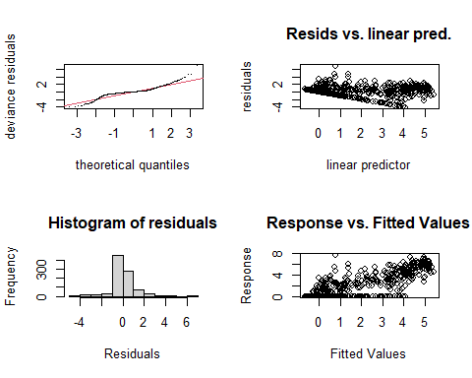

##   
## Method: REML Optimizer: outer newton  
## full convergence after 9 iterations.  
## Gradient range [-0.00009982164,0.00001201685]  
## (score 1379.221 & scale 1.083643).  
## Hessian positive definite, eigenvalue range [0.0001001583,455.8394].  
## Model rank = 53 / 53   
##   
## Basis dimension (k) checking results. Low p-value (k-index<1) may  
## indicate that k is too low, especially if edf is close to k'.  
##   
## k' edf k-index p-value  
## te(SalSurf_s,doy_s) 19.00000 12.27995 1 0.56  
## s(Year_fac) 28.00000 22.99183 NA NA  
## s(Station_fac) 5.00000 0.00132 NA NA  
##   
##   
## -------------summary-------------  
##   
## Family: gaussian   
## Link function: identity   
##   
## Formula:  
## BPUE_log1p ~ te(SalSurf_s, doy_s, k = c(5, 5), bs = c("cs", "cc")) +   
## s(Year_fac, bs = "re") + s(Station_fac, bs = "re")  
##   
## Parametric coefficients:  
## Estimate Std. Error t value Pr(>|t|)   
## (Intercept) 1.05365 0.09361 11.26 <0.0000000000000002 ***  
## ---  
## Signif. codes: 0 '***' 0.001 '**' 0.01 '*' 0.05 '.' 0.1 ' ' 1  
##   
## Approximate significance of smooth terms:  
## edf Ref.df F p-value   
## te(SalSurf_s,doy_s) 12.279954 19 244.007 <0.0000000000000002 ***  
## s(Year_fac) 22.991835 27 4.681 <0.0000000000000002 ***  
## s(Station_fac) 0.001319 4 0.000 0.421   
## ---  
## Signif. codes: 0 '***' 0.001 '**' 0.01 '*' 0.05 '.' 0.1 ' ' 1  
##   
## R-sq.(adj) = 0.706 Deviance explained = 71.7%  
## -REML = 1379.2 Scale est. = 1.0836 n = 912  
## <<<<<<<<<<<<<<<<<<<<<<< modeling othclad NW Suisun >>>>>>>>>>>>>>>>>>>>>>>>>  
##   
## -------------gam check-------------

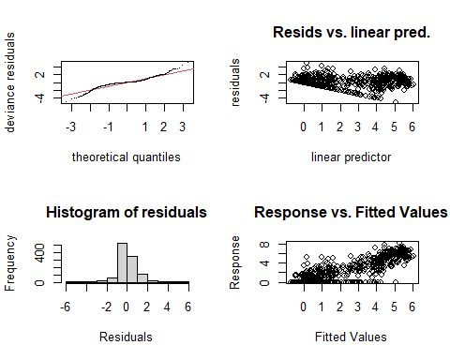

##   
## Method: REML Optimizer: outer newton  
## full convergence after 7 iterations.  
## Gradient range [-0.00001435124,0.00001207577]  
## (score 1622.655 & scale 0.9833315).  
## Hessian positive definite, eigenvalue range [0.9025138,553.8209].  
## Model rank = 54 / 54   
##   
## Basis dimension (k) checking results. Low p-value (k-index<1) may  
## indicate that k is too low, especially if edf is close to k'.  
##   
## k' edf k-index p-value   
## te(SalSurf_s,doy_s) 19.00 14.68 0.85 <0.0000000000000002 ***  
## s(Year_fac) 29.00 24.08 NA NA   
## s(Station_fac) 5.00 2.32 NA NA   
## ---  
## Signif. codes: 0 '***' 0.001 '**' 0.01 '*' 0.05 '.' 0.1 ' ' 1  
##   
##   
## -------------summary-------------  
##   
## Family: gaussian   
## Link function: identity   
##   
## Formula:  
## BPUE_log1p ~ te(SalSurf_s, doy_s, k = c(5, 5), bs = c("cs", "cc")) +   
## s(Year_fac, bs = "re") + s(Station_fac, bs = "re")  
##   
## Parametric coefficients:  
## Estimate Std. Error t value Pr(>|t|)   
## (Intercept) 1.1876 0.1143 10.39 <0.0000000000000002 ***  
## ---  
## Signif. codes: 0 '***' 0.001 '**' 0.01 '*' 0.05 '.' 0.1 ' ' 1  
##   
## Approximate significance of smooth terms:  
## edf Ref.df F p-value   
## te(SalSurf_s,doy_s) 14.675 19 481.443 < 0.0000000000000002 ***  
## s(Year_fac) 24.079 28 6.052 < 0.0000000000000002 ***  
## s(Station_fac) 2.324 4 3.779 0.000763 ***  
## ---  
## Signif. codes: 0 '***' 0.001 '**' 0.01 '*' 0.05 '.' 0.1 ' ' 1  
##   
## R-sq.(adj) = 0.767 Deviance explained = 77.5%  
## -REML = 1622.7 Scale est. = 0.98333 n = 1108  
## <<<<<<<<<<<<<<<<<<<<<<< modeling othclad East Suisun >>>>>>>>>>>>>>>>>>>>>>>>>  
##   
## -------------gam check-------------

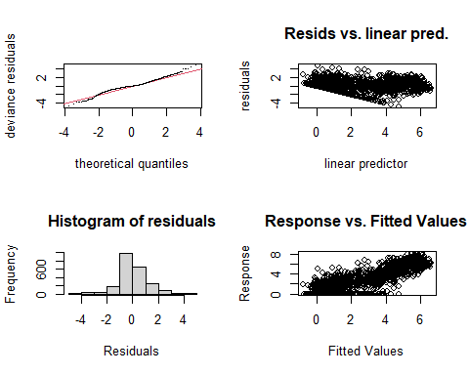

##   
## Method: REML Optimizer: outer newton  
## full convergence after 8 iterations.  
## Gradient range [-0.000005249218,0.000004573773]  
## (score 3446.975 & scale 1.156756).  
## Hessian positive definite, eigenvalue range [1.103649,1125.198].  
## Model rank = 59 / 59   
##   
## Basis dimension (k) checking results. Low p-value (k-index<1) may  
## indicate that k is too low, especially if edf is close to k'.  
##   
## k' edf k-index p-value   
## te(SalSurf_s,doy_s) 19.00 16.48 0.84 <0.0000000000000002 ***  
## s(Year_fac) 29.00 26.74 NA NA   
## s(Station_fac) 10.00 5.03 NA NA   
## ---  
## Signif. codes: 0 '***' 0.001 '**' 0.01 '*' 0.05 '.' 0.1 ' ' 1  
##   
##   
## -------------summary-------------  
##   
## Family: gaussian   
## Link function: identity   
##   
## Formula:  
## BPUE_log1p ~ te(SalSurf_s, doy_s, k = c(5, 5), bs = c("cs", "cc")) +   
## s(Year_fac, bs = "re") + s(Station_fac, bs = "re")  
##   
## Parametric coefficients:  
## Estimate Std. Error t value Pr(>|t|)   
## (Intercept) 1.7501 0.1314 13.32 <0.0000000000000002 ***  
## ---  
## Signif. codes: 0 '***' 0.001 '**' 0.01 '*' 0.05 '.' 0.1 ' ' 1  
##   
## Approximate significance of smooth terms:  
## edf Ref.df F p-value   
## te(SalSurf_s,doy_s) 16.483 19 2550.751 < 0.0000000000000002 ***  
## s(Year_fac) 26.736 28 18.895 < 0.0000000000000002 ***  
## s(Station_fac) 5.029 9 2.827 0.00018 ***  
## ---  
## Signif. codes: 0 '***' 0.001 '**' 0.01 '*' 0.05 '.' 0.1 ' ' 1  
##   
## R-sq.(adj) = 0.77 Deviance explained = 77.5%  
## -REML = 3447 Scale est. = 1.1568 n = 2251  
## <<<<<<<<<<<<<<<<<<<<<<< modeling othclad Confluence >>>>>>>>>>>>>>>>>>>>>>>>>  
##   
## -------------gam check-------------

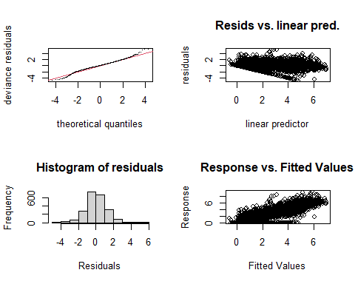

##   
## Method: REML Optimizer: outer newton  
## full convergence after 7 iterations.  
## Gradient range [-0.0004454626,0.0003548625]  
## (score 3700.391 & scale 1.52369).  
## Hessian positive definite, eigenvalue range [1.598462,1112.183].  
## Model rank = 59 / 59   
##   
## Basis dimension (k) checking results. Low p-value (k-index<1) may  
## indicate that k is too low, especially if edf is close to k'.  
##   
## k' edf k-index p-value   
## te(SalSurf_s,doy_s) 19.00 13.40 0.9 <0.0000000000000002 ***  
## s(Year_fac) 29.00 25.78 NA NA   
## s(Station_fac) 10.00 6.77 NA NA   
## ---  
## Signif. codes: 0 '***' 0.001 '**' 0.01 '*' 0.05 '.' 0.1 ' ' 1  
##   
##   
## -------------summary-------------  
##   
## Family: gaussian   
## Link function: identity   
##   
## Formula:  
## BPUE_log1p ~ te(SalSurf_s, doy_s, k = c(5, 5), bs = c("cs", "cc")) +   
## s(Year_fac, bs = "re") + s(Station_fac, bs = "re")  
##   
## Parametric coefficients:  
## Estimate Std. Error t value Pr(>|t|)   
## (Intercept) 2.8210 0.1377 20.49 <0.0000000000000002 ***  
## ---  
## Signif. codes: 0 '***' 0.001 '**' 0.01 '*' 0.05 '.' 0.1 ' ' 1  
##   
## Approximate significance of smooth terms:  
## edf Ref.df F p-value   
## te(SalSurf_s,doy_s) 13.396 19 1678.88 <0.0000000000000002 ***  
## s(Year_fac) 25.780 28 13.27 <0.0000000000000002 ***  
## s(Station_fac) 6.767 9 11.84 <0.0000000000000002 ***  
## ---  
## Signif. codes: 0 '***' 0.001 '**' 0.01 '*' 0.05 '.' 0.1 ' ' 1  
##   
## R-sq.(adj) = 0.686 Deviance explained = 69.2%  
## -REML = 3700.4 Scale est. = 1.5237 n = 2225  
## <<<<<<<<<<<<<<<<<<<<<<< modeling othclad Suisun Marsh >>>>>>>>>>>>>>>>>>>>>>>>>  
##   
## -------------gam check-------------

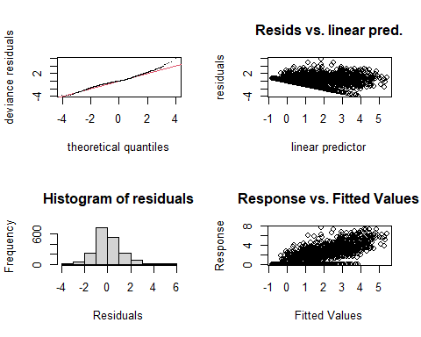

##   
## Method: REML Optimizer: outer newton  
## full convergence after 7 iterations.  
## Gradient range [-0.0002722827,0.0001548685]  
## (score 3032.009 & scale 1.378255).  
## Hessian positive definite, eigenvalue range [1.773587,936.7191].  
## Model rank = 58 / 58   
##   
## Basis dimension (k) checking results. Low p-value (k-index<1) may  
## indicate that k is too low, especially if edf is close to k'.  
##   
## k' edf k-index p-value   
## te(SalSurf_s,doy_s) 19.00 13.56 0.96 0.015 *  
## s(Year_fac) 29.00 26.00 NA NA   
## s(Station_fac) 9.00 6.34 NA NA   
## ---  
## Signif. codes: 0 '***' 0.001 '**' 0.01 '*' 0.05 '.' 0.1 ' ' 1  
##   
##   
## -------------summary-------------  
##   
## Family: gaussian   
## Link function: identity   
##   
## Formula:  
## BPUE_log1p ~ te(SalSurf_s, doy_s, k = c(5, 5), bs = c("cs", "cc")) +   
## s(Year_fac, bs = "re") + s(Station_fac, bs = "re")  
##   
## Parametric coefficients:  
## Estimate Std. Error t value Pr(>|t|)   
## (Intercept) 1.3651 0.1634 8.352 <0.0000000000000002 ***  
## ---  
## Signif. codes: 0 '***' 0.001 '**' 0.01 '*' 0.05 '.' 0.1 ' ' 1  
##   
## Approximate significance of smooth terms:  
## edf Ref.df F p-value   
## te(SalSurf_s,doy_s) 13.558 19 507.81 <0.0000000000000002 ***  
## s(Year_fac) 26.000 28 12.51 <0.0000000000000002 ***  
## s(Station_fac) 6.337 8 18.00 <0.0000000000000002 ***  
## ---  
## Signif. codes: 0 '***' 0.001 '**' 0.01 '*' 0.05 '.' 0.1 ' ' 1  
##   
## R-sq.(adj) = 0.554 Deviance explained = 56.5%  
## -REML = 3032 Scale est. = 1.3783 n = 1874  
## <<<<<<<<<<<<<<<<<<<<<<< modeling pdiapfor SW Suisun >>>>>>>>>>>>>>>>>>>>>>>>>  
##   
## -------------gam check-------------

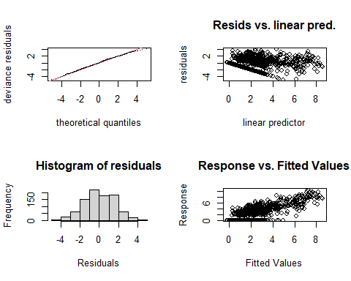

##   
## Method: REML Optimizer: outer newton  
## full convergence after 9 iterations.  
## Gradient range [-0.000112479,0.00009637187]  
## (score 1756.268 & scale 2.455226).  
## Hessian positive definite, eigenvalue range [0.6987968,455.8353].  
## Model rank = 53 / 53   
##   
## Basis dimension (k) checking results. Low p-value (k-index<1) may  
## indicate that k is too low, especially if edf is close to k'.  
##   
## k' edf k-index p-value  
## te(SalSurf_s,doy_s) 19.00 12.98 0.96 0.1  
## s(Year_fac) 28.00 22.44 NA NA  
## s(Station_fac) 5.00 3.08 NA NA  
##   
##   
## -------------summary-------------  
##   
## Family: gaussian   
## Link function: identity   
##   
## Formula:  
## BPUE_log1p ~ te(SalSurf_s, doy_s, k = c(5, 5), bs = c("cs", "cc")) +   
## s(Year_fac, bs = "re") + s(Station_fac, bs = "re")  
##   
## Parametric coefficients:  
## Estimate Std. Error t value Pr(>|t|)   
## (Intercept) 3.0814 0.3996 7.712 0.0000000000000337 ***  
## ---  
## Signif. codes: 0 '***' 0.001 '**' 0.01 '*' 0.05 '.' 0.1 ' ' 1  
##   
## Approximate significance of smooth terms:  
## edf Ref.df F p-value   
## te(SalSurf_s,doy_s) 12.981 19 621.859 < 0.0000000000000002 ***  
## s(Year_fac) 22.442 27 4.490 < 0.0000000000000002 ***  
## s(Station_fac) 3.079 4 5.878 0.000294 ***  
## ---  
## Signif. codes: 0 '***' 0.001 '**' 0.01 '*' 0.05 '.' 0.1 ' ' 1  
##   
## R-sq.(adj) = 0.58 Deviance explained = 59.8%  
## -REML = 1756.3 Scale est. = 2.4552 n = 912  
## <<<<<<<<<<<<<<<<<<<<<<< modeling pdiapfor NW Suisun >>>>>>>>>>>>>>>>>>>>>>>>>  
##   
## -------------gam check-------------

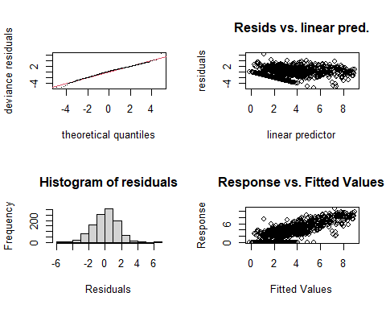

##   
## Method: REML Optimizer: outer newton  
## full convergence after 8 iterations.  
## Gradient range [-0.0003749406,0.001126984]  
## (score 2064.631 & scale 2.207119).  
## Hessian positive definite, eigenvalue range [0.0003761138,553.8107].  
## Model rank = 54 / 54   
##   
## Basis dimension (k) checking results. Low p-value (k-index<1) may  
## indicate that k is too low, especially if edf is close to k'.  
##   
## k' edf k-index p-value   
## te(SalSurf_s,doy_s) 19.00000 12.79733 0.93 0.01 **  
## s(Year_fac) 29.00000 24.21144 NA NA   
## s(Station_fac) 5.00000 0.00408 NA NA   
## ---  
## Signif. codes: 0 '***' 0.001 '**' 0.01 '*' 0.05 '.' 0.1 ' ' 1  
##   
##   
## -------------summary-------------  
##   
## Family: gaussian   
## Link function: identity   
##   
## Formula:  
## BPUE_log1p ~ te(SalSurf_s, doy_s, k = c(5, 5), bs = c("cs", "cc")) +   
## s(Year_fac, bs = "re") + s(Station_fac, bs = "re")  
##   
## Parametric coefficients:  
## Estimate Std. Error t value Pr(>|t|)   
## (Intercept) 3.2666 0.1343 24.32 <0.0000000000000002 ***  
## ---  
## Signif. codes: 0 '***' 0.001 '**' 0.01 '*' 0.05 '.' 0.1 ' ' 1  
##   
## Approximate significance of smooth terms:  
## edf Ref.df F p-value   
## te(SalSurf_s,doy_s) 12.797326 19 183.211 <0.0000000000000002 ***  
## s(Year_fac) 24.211438 28 5.599 <0.0000000000000002 ***  
## s(Station_fac) 0.004081 4 0.001 0.45   
## ---  
## Signif. codes: 0 '***' 0.001 '**' 0.01 '*' 0.05 '.' 0.1 ' ' 1  
##   
## R-sq.(adj) = 0.609 Deviance explained = 62.2%  
## -REML = 2064.6 Scale est. = 2.2071 n = 1108  
## <<<<<<<<<<<<<<<<<<<<<<< modeling pdiapfor East Suisun >>>>>>>>>>>>>>>>>>>>>>>>>  
##   
## -------------gam check-------------

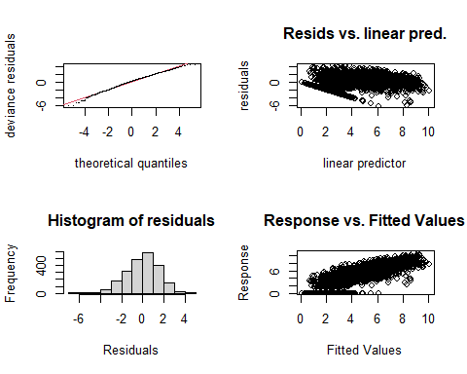

##   
## Method: REML Optimizer: outer newton  
## full convergence after 11 iterations.  
## Gradient range [-0.0006346738,0.0006116255]  
## (score 4241.887 & scale 2.38615).  
## Hessian positive definite, eigenvalue range [1.348857,1125.173].  
## Model rank = 59 / 59   
##   
## Basis dimension (k) checking results. Low p-value (k-index<1) may  
## indicate that k is too low, especially if edf is close to k'.  
##   
## k' edf k-index p-value   
## te(SalSurf_s,doy_s) 19.00 13.21 0.8 <0.0000000000000002 ***  
## s(Year_fac) 29.00 25.07 NA NA   
## s(Station_fac) 10.00 6.54 NA NA   
## ---  
## Signif. codes: 0 '***' 0.001 '**' 0.01 '*' 0.05 '.' 0.1 ' ' 1  
##   
##   
## -------------summary-------------  
##   
## Family: gaussian   
## Link function: identity   
##   
## Formula:  
## BPUE_log1p ~ te(SalSurf_s, doy_s, k = c(5, 5), bs = c("cs", "cc")) +   
## s(Year_fac, bs = "re") + s(Station_fac, bs = "re")  
##   
## Parametric coefficients:  
## Estimate Std. Error t value Pr(>|t|)   
## (Intercept) 4.1945 0.1722 24.36 <0.0000000000000002 ***  
## ---  
## Signif. codes: 0 '***' 0.001 '**' 0.01 '*' 0.05 '.' 0.1 ' ' 1  
##   
## Approximate significance of smooth terms:  
## edf Ref.df F p-value   
## te(SalSurf_s,doy_s) 13.21 19 800.289 <0.0000000000000002 ***  
## s(Year_fac) 25.07 28 9.261 <0.0000000000000002 ***  
## s(Station_fac) 6.54 9 8.689 <0.0000000000000002 ***  
## ---  
## Signif. codes: 0 '***' 0.001 '**' 0.01 '*' 0.05 '.' 0.1 ' ' 1  
##   
## R-sq.(adj) = 0.656 Deviance explained = 66.3%  
## -REML = 4241.9 Scale est. = 2.3862 n = 2251  
## <<<<<<<<<<<<<<<<<<<<<<< modeling pdiapfor Confluence >>>>>>>>>>>>>>>>>>>>>>>>>  
##   
## -------------gam check-------------

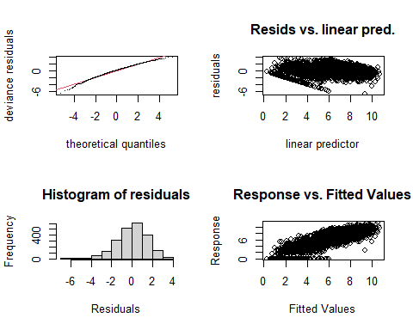

##   
## Method: REML Optimizer: outer newton  
## full convergence after 13 iterations.  
## Gradient range [-0.00007833514,0.00007210195]  
## (score 4149.975 & scale 2.283322).  
## Hessian positive definite, eigenvalue range [1.465869,1112.177].  
## Model rank = 59 / 59   
##   
## Basis dimension (k) checking results. Low p-value (k-index<1) may  
## indicate that k is too low, especially if edf is close to k'.  
##   
## k' edf k-index p-value   
## te(SalSurf_s,doy_s) 19.00 14.33 0.7 <0.0000000000000002 ***  
## s(Year_fac) 29.00 25.07 NA NA   
## s(Station_fac) 10.00 6.68 NA NA   
## ---  
## Signif. codes: 0 '***' 0.001 '**' 0.01 '*' 0.05 '.' 0.1 ' ' 1  
##   
##   
## -------------summary-------------  
##   
## Family: gaussian   
## Link function: identity   
##   
## Formula:  
## BPUE_log1p ~ te(SalSurf_s, doy_s, k = c(5, 5), bs = c("cs", "cc")) +   
## s(Year_fac, bs = "re") + s(Station_fac, bs = "re")  
##   
## Parametric coefficients:  
## Estimate Std. Error t value Pr(>|t|)   
## (Intercept) 5.9526 0.1529 38.94 <0.0000000000000002 ***  
## ---  
## Signif. codes: 0 '***' 0.001 '**' 0.01 '*' 0.05 '.' 0.1 ' ' 1  
##   
## Approximate significance of smooth terms:  
## edf Ref.df F p-value   
## te(SalSurf_s,doy_s) 14.334 19 526.129 <0.0000000000000002 ***  
## s(Year_fac) 25.070 28 9.324 <0.0000000000000002 ***  
## s(Station_fac) 6.684 9 8.175 <0.0000000000000002 ***  
## ---  
## Signif. codes: 0 '***' 0.001 '**' 0.01 '*' 0.05 '.' 0.1 ' ' 1  
##   
## R-sq.(adj) = 0.694 Deviance explained = 70.1%  
## -REML = 4150 Scale est. = 2.2833 n = 2225  
## <<<<<<<<<<<<<<<<<<<<<<< modeling pdiapfor Suisun Marsh >>>>>>>>>>>>>>>>>>>>>>>>>  
##   
## -------------gam check-------------

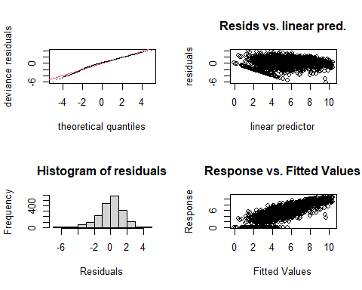

##   
## Method: REML Optimizer: outer newton  
## full convergence after 9 iterations.  
## Gradient range [-0.00001056243,0.000008829413]  
## (score 3437.639 & scale 2.079573).  
## Hessian positive definite, eigenvalue range [1.411735,936.7407].  
## Model rank = 58 / 58   
##   
## Basis dimension (k) checking results. Low p-value (k-index<1) may  
## indicate that k is too low, especially if edf is close to k'.  
##   
## k' edf k-index p-value   
## te(SalSurf_s,doy_s) 19.00 16.76 0.87 <0.0000000000000002 ***  
## s(Year_fac) 29.00 26.49 NA NA   
## s(Station_fac) 9.00 6.88 NA NA   
## ---  
## Signif. codes: 0 '***' 0.001 '**' 0.01 '*' 0.05 '.' 0.1 ' ' 1  
##   
##   
## -------------summary-------------  
##   
## Family: gaussian   
## Link function: identity   
##   
## Formula:  
## BPUE_log1p ~ te(SalSurf_s, doy_s, k = c(5, 5), bs = c("cs", "cc")) +   
## s(Year_fac, bs = "re") + s(Station_fac, bs = "re")  
##   
## Parametric coefficients:  
## Estimate Std. Error t value Pr(>|t|)   
## (Intercept) 5.2247 0.2586 20.21 <0.0000000000000002 ***  
## ---  
## Signif. codes: 0 '***' 0.001 '**' 0.01 '*' 0.05 '.' 0.1 ' ' 1  
##   
## Approximate significance of smooth terms:  
## edf Ref.df F p-value   
## te(SalSurf_s,doy_s) 16.763 19 1997.29 <0.0000000000000002 ***  
## s(Year_fac) 26.492 28 15.91 <0.0000000000000002 ***  
## s(Station_fac) 6.879 8 28.72 <0.0000000000000002 ***  
## ---  
## Signif. codes: 0 '***' 0.001 '**' 0.01 '*' 0.05 '.' 0.1 ' ' 1  
##   
## R-sq.(adj) = 0.684 Deviance explained = 69.3%  
## -REML = 3437.6 Scale est. = 2.0796 n = 1874  
## <<<<<<<<<<<<<<<<<<<<<<< modeling allcopnaup SW Suisun >>>>>>>>>>>>>>>>>>>>>>>>>  
##   
## -------------gam check-------------

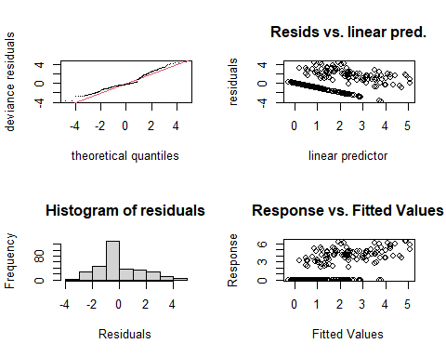

##   
## Method: REML Optimizer: outer newton  
## full convergence after 6 iterations.  
## Gradient range [-0.0001218611,0.0001338777]  
## (score 626.4337 & scale 2.627281).  
## Hessian positive definite, eigenvalue range [0.0001218792,158.517].  
## Model rank = 50 / 50   
##   
## Basis dimension (k) checking results. Low p-value (k-index<1) may  
## indicate that k is too low, especially if edf is close to k'.  
##   
## k' edf k-index p-value  
## te(SalSurf_s,doy_s) 19.000000 7.458863 1.14 1  
## s(Year_fac) 27.000000 16.996577 NA NA  
## s(Station_fac) 3.000000 0.000514 NA NA  
##   
##   
## -------------summary-------------  
##   
## Family: gaussian   
## Link function: identity   
##   
## Formula:  
## BPUE_log1p ~ te(SalSurf_s, doy_s, k = c(5, 5), bs = c("cs", "cc")) +   
## s(Year_fac, bs = "re") + s(Station_fac, bs = "re")  
##   
## Parametric coefficients:  
## Estimate Std. Error t value Pr(>|t|)   
## (Intercept) 1.3653 0.1588 8.599 0.000000000000000502 ***  
## ---  
## Signif. codes: 0 '***' 0.001 '**' 0.01 '*' 0.05 '.' 0.1 ' ' 1  
##   
## Approximate significance of smooth terms:  
## edf Ref.df F p-value   
## te(SalSurf_s,doy_s) 7.458863 19 12.277 < 0.0000000000000002 ***  
## s(Year_fac) 16.996577 26 1.952 0.00000371 ***  
## s(Station_fac) 0.000514 2 0.000 0.55   
## ---  
## Signif. codes: 0 '***' 0.001 '**' 0.01 '*' 0.05 '.' 0.1 ' ' 1  
##   
## R-sq.(adj) = 0.39 Deviance explained = 43.7%  
## -REML = 626.43 Scale est. = 2.6273 n = 317  
## <<<<<<<<<<<<<<<<<<<<<<< modeling allcopnaup NW Suisun >>>>>>>>>>>>>>>>>>>>>>>>>  
##   
## -------------gam check-------------

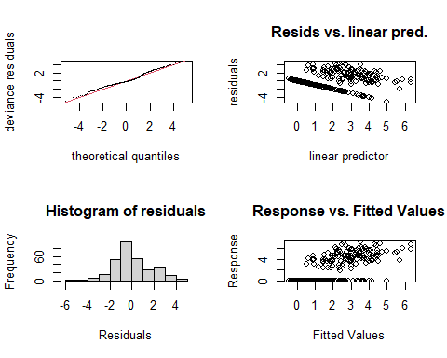

##   
## Method: REML Optimizer: outer newton  
## full convergence after 6 iterations.  
## Gradient range [-0.000009243147,0.000001259638]  
## (score 646.3905 & scale 3.1024).  
## Hessian positive definite, eigenvalue range [0.8984986,155.2844].  
## Model rank = 47 / 47   
##   
## Basis dimension (k) checking results. Low p-value (k-index<1) may  
## indicate that k is too low, especially if edf is close to k'.  
##   
## k' edf k-index p-value  
## te(SalSurf_s,doy_s) 19.0 7.8 0.95 0.11  
## s(Year_fac) 27.0 20.8 NA NA  
##   
##   
## -------------summary-------------  
##   
## Family: gaussian   
## Link function: identity   
##   
## Formula:  
## BPUE_log1p ~ te(SalSurf_s, doy_s, k = c(5, 5), bs = c("cs", "cc")) +   
## s(Year_fac, bs = "re")  
##   
## Parametric coefficients:  
## Estimate Std. Error t value Pr(>|t|)   
## (Intercept) 1.7455 0.2292 7.615 0.000000000000406 ***  
## ---  
## Signif. codes: 0 '***' 0.001 '**' 0.01 '*' 0.05 '.' 0.1 ' ' 1  
##   
## Approximate significance of smooth terms:  
## edf Ref.df F p-value   
## te(SalSurf_s,doy_s) 7.80 19 13.147 <0.0000000000000002 ***  
## s(Year_fac) 20.79 26 4.061 <0.0000000000000002 ***  
## ---  
## Signif. codes: 0 '***' 0.001 '**' 0.01 '*' 0.05 '.' 0.1 ' ' 1  
##   
## R-sq.(adj) = 0.44 Deviance explained = 49.2%  
## -REML = 646.39 Scale est. = 3.1024 n = 310  
## <<<<<<<<<<<<<<<<<<<<<<< modeling allcopnaup East Suisun >>>>>>>>>>>>>>>>>>>>>>>>>  
##   
## -------------gam check-------------

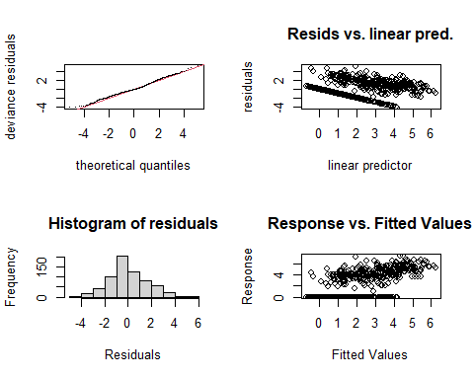

##   
## Method: REML Optimizer: outer newton  
## full convergence after 8 iterations.  
## Gradient range [-0.0004954652,-0.00001010831]  
## (score 1324.118 & scale 2.697151).  
## Hessian positive definite, eigenvalue range [0.3010848,334.4011].  
## Model rank = 51 / 51   
##   
## Basis dimension (k) checking results. Low p-value (k-index<1) may  
## indicate that k is too low, especially if edf is close to k'.  
##   
## k' edf k-index p-value   
## te(SalSurf_s,doy_s) 19.00 12.04 0.95 0.035 *  
## s(Year_fac) 27.00 21.20 NA NA   
## s(Station_fac) 4.00 1.51 NA NA   
## ---  
## Signif. codes: 0 '***' 0.001 '**' 0.01 '*' 0.05 '.' 0.1 ' ' 1  
##   
##   
## -------------summary-------------  
##   
## Family: gaussian   
## Link function: identity   
##   
## Formula:  
## BPUE_log1p ~ te(SalSurf_s, doy_s, k = c(5, 5), bs = c("cs", "cc")) +   
## s(Year_fac, bs = "re") + s(Station_fac, bs = "re")  
##   
## Parametric coefficients:  
## Estimate Std. Error t value Pr(>|t|)   
## (Intercept) 1.9557 0.1984 9.859 <0.0000000000000002 ***  
## ---  
## Signif. codes: 0 '***' 0.001 '**' 0.01 '*' 0.05 '.' 0.1 ' ' 1  
##   
## Approximate significance of smooth terms:  
## edf Ref.df F p-value   
## te(SalSurf_s,doy_s) 12.036 19 41.977 <0.0000000000000002 ***  
## s(Year_fac) 21.198 26 4.344 <0.0000000000000002 ***  
## s(Station_fac) 1.506 3 1.497 0.0515 .   
## ---  
## Signif. codes: 0 '***' 0.001 '**' 0.01 '*' 0.05 '.' 0.1 ' ' 1  
##   
## R-sq.(adj) = 0.502 Deviance explained = 52.8%  
## -REML = 1324.1 Scale est. = 2.6972 n = 669  
## <<<<<<<<<<<<<<<<<<<<<<< modeling allcopnaup Confluence >>>>>>>>>>>>>>>>>>>>>>>>>  
##   
## -------------gam check-------------

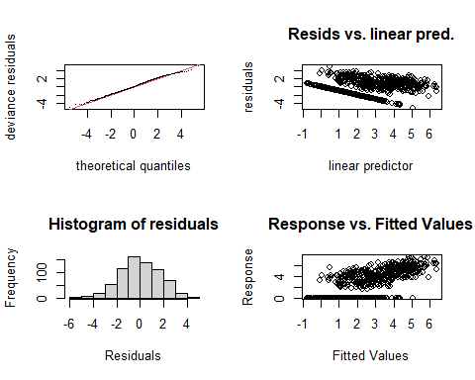

##   
## Method: REML Optimizer: outer newton  
## full convergence after 9 iterations.  
## Gradient range [-0.0002402798,0.001394055]  
## (score 1404.192 & scale 2.965962).  
## Hessian positive definite, eigenvalue range [0.0002438232,347.3781].  
## Model rank = 52 / 52   
##   
## Basis dimension (k) checking results. Low p-value (k-index<1) may  
## indicate that k is too low, especially if edf is close to k'.  
##   
## k' edf k-index p-value   
## te(SalSurf_s,doy_s) 19.00000 10.66432 0.93 0.005 **  
## s(Year_fac) 27.00000 21.40941 NA NA   
## s(Station_fac) 5.00000 0.00361 NA NA   
## ---  
## Signif. codes: 0 '***' 0.001 '**' 0.01 '*' 0.05 '.' 0.1 ' ' 1  
##   
##   
## -------------summary-------------  
##   
## Family: gaussian   
## Link function: identity   
##   
## Formula:  
## BPUE_log1p ~ te(SalSurf_s, doy_s, k = c(5, 5), bs = c("cs", "cc")) +   
## s(Year_fac, bs = "re") + s(Station_fac, bs = "re")  
##   
## Parametric coefficients:  
## Estimate Std. Error t value Pr(>|t|)   
## (Intercept) 2.4086 0.1607 14.99 <0.0000000000000002 ***  
## ---  
## Signif. codes: 0 '***' 0.001 '**' 0.01 '*' 0.05 '.' 0.1 ' ' 1  
##   
## Approximate significance of smooth terms:  
## edf Ref.df F p-value   
## te(SalSurf_s,doy_s) 10.664321 19 34.480 <0.0000000000000002 ***  
## s(Year_fac) 21.409407 26 4.660 <0.0000000000000002 ***  
## s(Station_fac) 0.003608 4 0.001 0.386   
## ---  
## Signif. codes: 0 '***' 0.001 '**' 0.01 '*' 0.05 '.' 0.1 ' ' 1  
##   
## R-sq.(adj) = 0.476 Deviance explained = 50%  
## -REML = 1404.2 Scale est. = 2.966 n = 695  
## <<<<<<<<<<<<<<<<<<<<<<< modeling allcopnaup Suisun Marsh >>>>>>>>>>>>>>>>>>>>>>>>>  
##   
## -------------gam check-------------

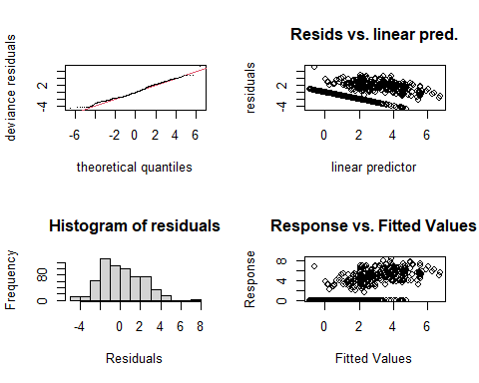

##   
## Method: REML Optimizer: outer newton  
## full convergence after 9 iterations.  
## Gradient range [-0.000297875,0.00006039964]  
## (score 1366.52 & scale 4.182628).  
## Hessian positive definite, eigenvalue range [0.0002977048,310.4781].  
## Model rank = 49 / 49   
##   
## Basis dimension (k) checking results. Low p-value (k-index<1) may  
## indicate that k is too low, especially if edf is close to k'.  
##   
## k' edf k-index p-value   
## te(SalSurf_s,doy_s) 19.000000 7.676102 0.94 0.04 *  
## s(Year_fac) 27.000000 23.310881 NA NA   
## s(Station_fac) 2.000000 0.000717 NA NA   
## ---  
## Signif. codes: 0 '***' 0.001 '**' 0.01 '*' 0.05 '.' 0.1 ' ' 1  
##   
##   
## -------------summary-------------  
##   
## Family: gaussian   
## Link function: identity   
##   
## Formula:  
## BPUE_log1p ~ te(SalSurf_s, doy_s, k = c(5, 5), bs = c("cs", "cc")) +   
## s(Year_fac, bs = "re") + s(Station_fac, bs = "re")  
##   
## Parametric coefficients:  
## Estimate Std. Error t value Pr(>|t|)   
## (Intercept) 2.1816 0.2619 8.331 0.000000000000000563 ***  
## ---  
## Signif. codes: 0 '***' 0.001 '**' 0.01 '*' 0.05 '.' 0.1 ' ' 1  
##   
## Approximate significance of smooth terms:  
## edf Ref.df F p-value   
## te(SalSurf_s,doy_s) 7.6761019 19 14.44 <0.0000000000000002 ***  
## s(Year_fac) 23.3108813 26 8.87 <0.0000000000000002 ***  
## s(Station_fac) 0.0007166 1 0.00 0.681   
## ---  
## Signif. codes: 0 '***' 0.001 '**' 0.01 '*' 0.05 '.' 0.1 ' ' 1  
##   
## R-sq.(adj) = 0.392 Deviance explained = 42.2%  
## -REML = 1366.5 Scale est. = 4.1826 n = 621  
## <<<<<<<<<<<<<<<<<<<<<<< modeling limno SW Suisun >>>>>>>>>>>>>>>>>>>>>>>>>  
##   
## -------------gam check-------------

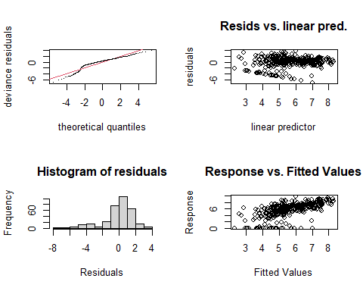

##   
## Method: REML Optimizer: outer newton  
## full convergence after 5 iterations.  
## Gradient range [-0.0001041989,0.00009834495]  
## (score 681.8699 & scale 3.423087).  
## Hessian positive definite, eigenvalue range [0.00004447807,161.454].  
## Model rank = 50 / 50   
##   
## Basis dimension (k) checking results. Low p-value (k-index<1) may  
## indicate that k is too low, especially if edf is close to k'.  
##   
## k' edf k-index p-value   
## te(SalSurf_s,doy_s) 19.000000 9.269681 0.88 0.005 **  
## s(Year_fac) 27.000000 15.572609 NA NA   
## s(Station_fac) 3.000000 0.000165 NA NA   
## ---  
## Signif. codes: 0 '***' 0.001 '**' 0.01 '*' 0.05 '.' 0.1 ' ' 1  
##   
##   
## -------------summary-------------  
##   
## Family: gaussian   
## Link function: identity   
##   
## Formula:  
## BPUE_log1p ~ te(SalSurf_s, doy_s, k = c(5, 5), bs = c("cs", "cc")) +   
## s(Year_fac, bs = "re") + s(Station_fac, bs = "re")  
##   
## Parametric coefficients:  
## Estimate Std. Error t value Pr(>|t|)   
## (Intercept) 5.6535 0.1667 33.92 <0.0000000000000002 ***  
## ---  
## Signif. codes: 0 '***' 0.001 '**' 0.01 '*' 0.05 '.' 0.1 ' ' 1  
##   
## Approximate significance of smooth terms:  
## edf Ref.df F p-value   
## te(SalSurf_s,doy_s) 9.2696808 19 7.295 < 0.0000000000000002 ***  
## s(Year_fac) 15.5726093 26 1.500 0.000103 ***  
## s(Station_fac) 0.0001648 2 0.000 0.593029   
## ---  
## Signif. codes: 0 '***' 0.001 '**' 0.01 '*' 0.05 '.' 0.1 ' ' 1  
##   
## R-sq.(adj) = 0.343 Deviance explained = 39.4%  
## -REML = 681.87 Scale est. = 3.4231 n = 323  
## <<<<<<<<<<<<<<<<<<<<<<< modeling limno NW Suisun >>>>>>>>>>>>>>>>>>>>>>>>>  
##   
## -------------gam check-------------

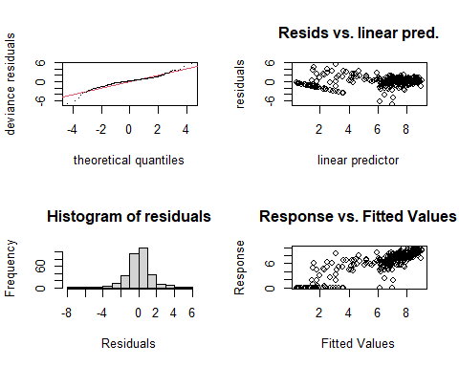

##   
## Method: REML Optimizer: outer newton  
## full convergence after 6 iterations.  
## Gradient range [-0.000150143,0.00009574354]  
## (score 600.4573 & scale 2.201123).  
## Hessian positive definite, eigenvalue range [1.593401,156.5484].  
## Model rank = 47 / 47   
##   
## Basis dimension (k) checking results. Low p-value (k-index<1) may  
## indicate that k is too low, especially if edf is close to k'.  
##   
## k' edf k-index p-value  
## te(SalSurf_s,doy_s) 19.0 11.7 0.98 0.3  
## s(Year_fac) 27.0 16.2 NA NA  
##   
##   
## -------------summary-------------  
##   
## Family: gaussian   
## Link function: identity   
##   
## Formula:  
## BPUE_log1p ~ te(SalSurf_s, doy_s, k = c(5, 5), bs = c("cs", "cc")) +   
## s(Year_fac, bs = "re")  
##   
## Parametric coefficients:  
## Estimate Std. Error t value Pr(>|t|)   
## (Intercept) 6.4074 0.1397 45.85 <0.0000000000000002 ***  
## ---  
## Signif. codes: 0 '***' 0.001 '**' 0.01 '*' 0.05 '.' 0.1 ' ' 1  
##   
## Approximate significance of smooth terms:  
## edf Ref.df F p-value   
## te(SalSurf_s,doy_s) 11.75 19 46.76 < 0.0000000000000002 ***  
## s(Year_fac) 16.17 26 1.67 0.0000324 ***  
## ---  
## Signif. codes: 0 '***' 0.001 '**' 0.01 '*' 0.05 '.' 0.1 ' ' 1  
##   
## R-sq.(adj) = 0.703 Deviance explained = 73%  
## -REML = 600.46 Scale est. = 2.2011 n = 313  
## <<<<<<<<<<<<<<<<<<<<<<< modeling limno East Suisun >>>>>>>>>>>>>>>>>>>>>>>>>  
##   
## -------------gam check-------------

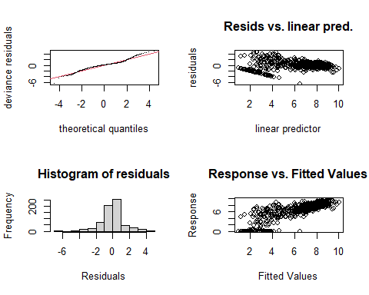

##   
## Method: REML Optimizer: outer newton  
## full convergence after 8 iterations.  
## Gradient range [-0.00005284354,0.00003258294]  
## (score 1236.802 & scale 1.965852).  
## Hessian positive definite, eigenvalue range [0.8024665,335.9463].  
## Model rank = 51 / 51   
##   
## Basis dimension (k) checking results. Low p-value (k-index<1) may  
## indicate that k is too low, especially if edf is close to k'.  
##   
## k' edf k-index p-value   
## te(SalSurf_s,doy_s) 19.00 15.16 0.85 <0.0000000000000002 ***  
## s(Year_fac) 27.00 21.43 NA NA   
## s(Station_fac) 4.00 2.32 NA NA   
## ---  
## Signif. codes: 0 '***' 0.001 '**' 0.01 '*' 0.05 '.' 0.1 ' ' 1  
##   
##   
## -------------summary-------------  
##   
## Family: gaussian   
## Link function: identity   
##   
## Formula:  
## BPUE_log1p ~ te(SalSurf_s, doy_s, k = c(5, 5), bs = c("cs", "cc")) +   
## s(Year_fac, bs = "re") + s(Station_fac, bs = "re")  
##   
## Parametric coefficients:  
## Estimate Std. Error t value Pr(>|t|)   
## (Intercept) 6.765 0.245 27.62 <0.0000000000000002 ***  
## ---  
## Signif. codes: 0 '***' 0.001 '**' 0.01 '*' 0.05 '.' 0.1 ' ' 1  
##   
## Approximate significance of smooth terms:  
## edf Ref.df F p-value   
## te(SalSurf_s,doy_s) 15.159 19 123.851 < 0.0000000000000002 ***  
## s(Year_fac) 21.432 26 4.426 < 0.0000000000000002 ***  
## s(Station_fac) 2.319 3 5.540 0.000576 ***  
## ---  
## Signif. codes: 0 '***' 0.001 '**' 0.01 '*' 0.05 '.' 0.1 ' ' 1  
##   
## R-sq.(adj) = 0.703 Deviance explained = 72%  
## -REML = 1236.8 Scale est. = 1.9659 n = 672  
## <<<<<<<<<<<<<<<<<<<<<<< modeling limno Confluence >>>>>>>>>>>>>>>>>>>>>>>>>  
##   
## -------------gam check-------------

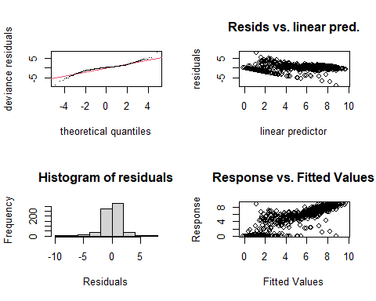

##   
## Method: REML Optimizer: outer newton  
## full convergence after 7 iterations.  
## Gradient range [-0.00004883231,0.000008133469]  
## (score 1345.344 & scale 2.325183).  
## Hessian positive definite, eigenvalue range [1.009805,350.4133].  
## Model rank = 52 / 52   
##   
## Basis dimension (k) checking results. Low p-value (k-index<1) may  
## indicate that k is too low, especially if edf is close to k'.  
##   
## k' edf k-index p-value   
## te(SalSurf_s,doy_s) 19.00 14.78 0.95 0.085 .  
## s(Year_fac) 27.00 21.16 NA NA   
## s(Station_fac) 5.00 2.34 NA NA   
## ---  
## Signif. codes: 0 '***' 0.001 '**' 0.01 '*' 0.05 '.' 0.1 ' ' 1  
##   
##   
## -------------summary-------------  
##   
## Family: gaussian   
## Link function: identity   
##   
## Formula:  
## BPUE_log1p ~ te(SalSurf_s, doy_s, k = c(5, 5), bs = c("cs", "cc")) +   
## s(Year_fac, bs = "re") + s(Station_fac, bs = "re")  
##   
## Parametric coefficients:  
## Estimate Std. Error t value Pr(>|t|)   
## (Intercept) 5.4572 0.2244 24.32 <0.0000000000000002 ***  
## ---  
## Signif. codes: 0 '***' 0.001 '**' 0.01 '*' 0.05 '.' 0.1 ' ' 1  
##   
## Approximate significance of smooth terms:  
## edf Ref.df F p-value   
## te(SalSurf_s,doy_s) 14.784 19 187.879 < 0.0000000000000002 ***  
## s(Year_fac) 21.155 26 4.447 < 0.0000000000000002 ***  
## s(Station_fac) 2.337 4 5.369 0.0000308 ***  
## ---  
## Signif. codes: 0 '***' 0.001 '**' 0.01 '*' 0.05 '.' 0.1 ' ' 1  
##   
## R-sq.(adj) = 0.748 Deviance explained = 76.2%  
## -REML = 1345.3 Scale est. = 2.3252 n = 701  
## <<<<<<<<<<<<<<<<<<<<<<< modeling limno Suisun Marsh >>>>>>>>>>>>>>>>>>>>>>>>>  
##   
## -------------gam check-------------

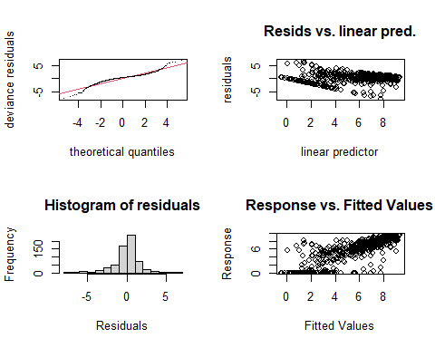

##   
## Method: REML Optimizer: outer newton  
## full convergence after 7 iterations.  
## Gradient range [-0.000001815078,0.000001657233]  
## (score 1260.726 & scale 2.853199).  
## Hessian positive definite, eigenvalue range [0.4726169,313.8115].  
## Model rank = 49 / 49   
##   
## Basis dimension (k) checking results. Low p-value (k-index<1) may  
## indicate that k is too low, especially if edf is close to k'.  
##   
## k' edf k-index p-value  
## te(SalSurf_s,doy_s) 19.000 13.894 0.95 0.12  
## s(Year_fac) 27.000 16.906 NA NA  
## s(Station_fac) 2.000 0.973 NA NA  
##   
##   
## -------------summary-------------  
##   
## Family: gaussian   
## Link function: identity   
##   
## Formula:  
## BPUE_log1p ~ te(SalSurf_s, doy_s, k = c(5, 5), bs = c("cs", "cc")) +   
## s(Year_fac, bs = "re") + s(Station_fac, bs = "re")  
##   
## Parametric coefficients:  
## Estimate Std. Error t value Pr(>|t|)   
## (Intercept) 5.8838 0.4269 13.78 <0.0000000000000002 ***  
## ---  
## Signif. codes: 0 '***' 0.001 '**' 0.01 '*' 0.05 '.' 0.1 ' ' 1  
##   
## Approximate significance of smooth terms:  
## edf Ref.df F p-value   
## te(SalSurf_s,doy_s) 13.8945 19 92.214 < 0.0000000000000002 ***  
## s(Year_fac) 16.9063 26 1.801 0.00000819 ***  
## s(Station_fac) 0.9731 1 36.475 < 0.0000000000000002 ***  
## ---  
## Signif. codes: 0 '***' 0.001 '**' 0.01 '*' 0.05 '.' 0.1 ' ' 1  
##   
## R-sq.(adj) = 0.693 Deviance explained = 70.8%  
## -REML = 1260.7 Scale est. = 2.8532 n = 628  
## <<<<<<<<<<<<<<<<<<<<<<< modeling mysid SW Suisun >>>>>>>>>>>>>>>>>>>>>>>>>  
##   
## -------------gam check-------------

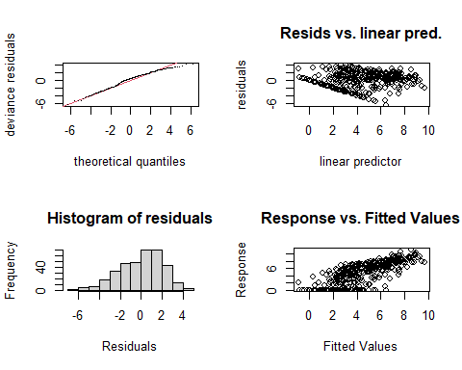

##   
## Method: REML Optimizer: outer newton  
## full convergence after 5 iterations.  
## Gradient range [-0.0003850967,0.0002974669]  
## (score 800.589 & scale 4.432278).  
## Hessian positive definite, eigenvalue range [0.1906857,177.1153].  
## Model rank = 50 / 50   
##   
## Basis dimension (k) checking results. Low p-value (k-index<1) may  
## indicate that k is too low, especially if edf is close to k'.  
##   
## k' edf k-index p-value  
## te(SalSurf_s,doy_s) 19.000 10.192 1.03 0.71  
## s(Year_fac) 26.000 19.153 NA NA  
## s(Station_fac) 4.000 0.968 NA NA  
##   
##   
## -------------summary-------------  
##   
## Family: gaussian   
## Link function: identity   
##   
## Formula:  
## BPUE_log1p ~ te(SalSurf_s, doy_s, k = c(5, 5), bs = c("cs", "cc")) +   
## s(Year_fac, bs = "re") + s(Station_fac, bs = "re")  
##   
## Parametric coefficients:  
## Estimate Std. Error t value Pr(>|t|)   
## (Intercept) 4.3767 0.3914 11.18 <0.0000000000000002 ***  
## ---  
## Signif. codes: 0 '***' 0.001 '**' 0.01 '*' 0.05 '.' 0.1 ' ' 1  
##   
## Approximate significance of smooth terms:  
## edf Ref.df F p-value   
## te(SalSurf_s,doy_s) 10.1924 19 25.218 <0.0000000000000002 ***  
## s(Year_fac) 19.1528 25 3.255 <0.0000000000000002 ***  
## s(Station_fac) 0.9676 3 0.933 0.12   
## ---  
## Signif. codes: 0 '***' 0.001 '**' 0.01 '*' 0.05 '.' 0.1 ' ' 1  
##   
## R-sq.(adj) = 0.544 Deviance explained = 58.3%  
## -REML = 800.59 Scale est. = 4.4323 n = 354  
## <<<<<<<<<<<<<<<<<<<<<<< modeling mysid NW Suisun >>>>>>>>>>>>>>>>>>>>>>>>>  
##   
## -------------gam check-------------

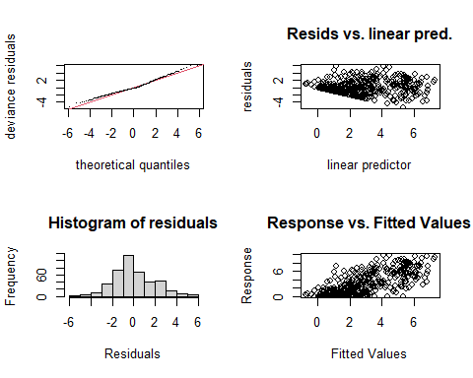

##   
## Method: REML Optimizer: outer newton  
## full convergence after 7 iterations.  
## Gradient range [-0.0000008772581,0.0000008332563]  
## (score 905.1353 & scale 3.788971).  
## Hessian positive definite, eigenvalue range [0.927108,208.44].  
## Model rank = 50 / 50   
##   
## Basis dimension (k) checking results. Low p-value (k-index<1) may  
## indicate that k is too low, especially if edf is close to k'.  
##   
## k' edf k-index p-value   
## te(SalSurf_s,doy_s) 19.00 9.72 0.93 0.045 *  
## s(Year_fac) 26.00 17.38 NA NA   
## s(Station_fac) 4.00 2.94 NA NA   
## ---  
## Signif. codes: 0 '***' 0.001 '**' 0.01 '*' 0.05 '.' 0.1 ' ' 1  
##   
##   
## -------------summary-------------  
##   
## Family: gaussian   
## Link function: identity   
##   
## Formula:  
## BPUE_log1p ~ te(SalSurf_s, doy_s, k = c(5, 5), bs = c("cs", "cc")) +   
## s(Year_fac, bs = "re") + s(Station_fac, bs = "re")  
##   
## Parametric coefficients:  
## Estimate Std. Error t value Pr(>|t|)   
## (Intercept) 4.450 1.089 4.084 0.0000538 ***  
## ---  
## Signif. codes: 0 '***' 0.001 '**' 0.01 '*' 0.05 '.' 0.1 ' ' 1  
##   
## Approximate significance of smooth terms:  
## edf Ref.df F p-value   
## te(SalSurf_s,doy_s) 9.717 19 12.094 0.00571 **   
## s(Year_fac) 17.383 25 2.461 < 0.0000000000000002 ***  
## s(Station_fac) 2.942 3 93.494 < 0.0000000000000002 ***  
## ---  
## Signif. codes: 0 '***' 0.001 '**' 0.01 '*' 0.05 '.' 0.1 ' ' 1  
##   
## R-sq.(adj) = 0.498 Deviance explained = 53.4%  
## -REML = 905.14 Scale est. = 3.789 n = 417  
## <<<<<<<<<<<<<<<<<<<<<<< modeling mysid East Suisun >>>>>>>>>>>>>>>>>>>>>>>>>  
##   
## -------------gam check-------------

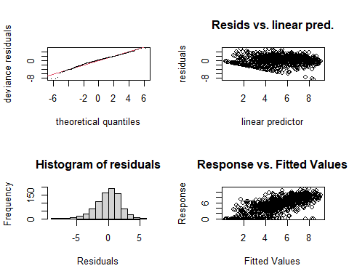

##   
## Method: REML Optimizer: outer newton  
## full convergence after 5 iterations.  
## Gradient range [-0.0009278945,0.0005095288]  
## (score 1797.217 & scale 3.738696).  
## Hessian positive definite, eigenvalue range [2.018086,417.8264].  
## Model rank = 56 / 56   
##   
## Basis dimension (k) checking results. Low p-value (k-index<1) may  
## indicate that k is too low, especially if edf is close to k'.  
##   
## k' edf k-index p-value   
## te(SalSurf_s,doy_s) 19.00 14.78 0.92 0.01 **  
## s(Year_fac) 26.00 19.00 NA NA   
## s(Station_fac) 10.00 8.11 NA NA   
## ---  
## Signif. codes: 0 '***' 0.001 '**' 0.01 '*' 0.05 '.' 0.1 ' ' 1  
##   
##   
## -------------summary-------------  
##   
## Family: gaussian   
## Link function: identity   
##   
## Formula:  
## BPUE_log1p ~ te(SalSurf_s, doy_s, k = c(5, 5), bs = c("cs", "cc")) +   
## s(Year_fac, bs = "re") + s(Station_fac, bs = "re")  
##   
## Parametric coefficients:  
## Estimate Std. Error t value Pr(>|t|)   
## (Intercept) 5.2058 0.4966 10.48 <0.0000000000000002 ***  
## ---  
## Signif. codes: 0 '***' 0.001 '**' 0.01 '*' 0.05 '.' 0.1 ' ' 1  
##   
## Approximate significance of smooth terms:  
## edf Ref.df F p-value   
## te(SalSurf_s,doy_s) 14.785 19 66.931 <0.0000000000000002 ***  
## s(Year_fac) 18.997 25 3.894 <0.0000000000000002 ***  
## s(Station_fac) 8.105 9 15.436 <0.0000000000000002 ***  
## ---  
## Signif. codes: 0 '***' 0.001 '**' 0.01 '*' 0.05 '.' 0.1 ' ' 1  
##   
## R-sq.(adj) = 0.52 Deviance explained = 54.4%  
## -REML = 1797.2 Scale est. = 3.7387 n = 836  
## <<<<<<<<<<<<<<<<<<<<<<< modeling mysid Confluence >>>>>>>>>>>>>>>>>>>>>>>>>  
##   
## -------------gam check-------------

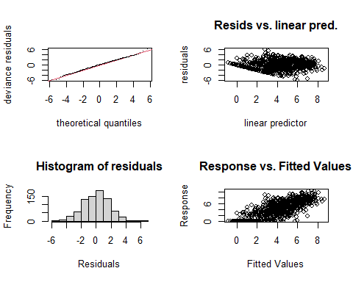

##   
## Method: REML Optimizer: outer newton  
## full convergence after 5 iterations.  
## Gradient range [-0.0005067797,0.000348451]  
## (score 1646.715 & scale 3.170488).  
## Hessian positive definite, eigenvalue range [2.159014,397.3703].  
## Model rank = 55 / 55   
##   
## Basis dimension (k) checking results. Low p-value (k-index<1) may  
## indicate that k is too low, especially if edf is close to k'.  
##   
## k' edf k-index p-value   
## te(SalSurf_s,doy_s) 19.00 15.08 0.92 <0.0000000000000002 ***  
## s(Year_fac) 26.00 20.56 NA NA   
## s(Station_fac) 9.00 5.98 NA NA   
## ---  
## Signif. codes: 0 '***' 0.001 '**' 0.01 '*' 0.05 '.' 0.1 ' ' 1  
##   
##   
## -------------summary-------------  
##   
## Family: gaussian   
## Link function: identity   
##   
## Formula:  
## BPUE_log1p ~ te(SalSurf_s, doy_s, k = c(5, 5), bs = c("cs", "cc")) +   
## s(Year_fac, bs = "re") + s(Station_fac, bs = "re")  
##   
## Parametric coefficients:  
## Estimate Std. Error t value Pr(>|t|)   
## (Intercept) 4.2493 0.3046 13.95 <0.0000000000000002 ***  
## ---  
## Signif. codes: 0 '***' 0.001 '**' 0.01 '*' 0.05 '.' 0.1 ' ' 1  
##   
## Approximate significance of smooth terms:  
## edf Ref.df F p-value   
## te(SalSurf_s,doy_s) 15.081 19 94.520 <0.0000000000000002 ***  
## s(Year_fac) 20.563 25 4.866 <0.0000000000000002 ***  
## s(Station_fac) 5.976 8 8.510 <0.0000000000000002 ***  
## ---  
## Signif. codes: 0 '***' 0.001 '**' 0.01 '*' 0.05 '.' 0.1 ' ' 1  
##   
## R-sq.(adj) = 0.564 Deviance explained = 58.7%  
## -REML = 1646.7 Scale est. = 3.1705 n = 795  
## <<<<<<<<<<<<<<<<<<<<<<< modeling mysid Suisun Marsh >>>>>>>>>>>>>>>>>>>>>>>>>  
##   
## -------------gam check-------------

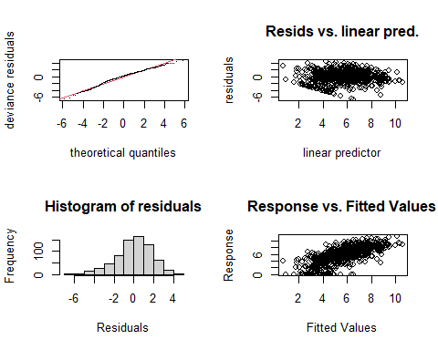

##   
## Method: REML Optimizer: outer newton  
## full convergence after 6 iterations.  
## Gradient range [-0.000000295065,0.0000002095552]  
## (score 1484.915 & scale 3.363534).  
## Hessian positive definite, eigenvalue range [1.725832,350.4738].  
## Model rank = 53 / 53   
##   
## Basis dimension (k) checking results. Low p-value (k-index<1) may  
## indicate that k is too low, especially if edf is close to k'.  
##   
## k' edf k-index p-value   
## te(SalSurf_s,doy_s) 19.00 14.97 0.92 0.005 **  
## s(Year_fac) 26.00 22.50 NA NA   
## s(Station_fac) 7.00 5.46 NA NA   
## ---  
## Signif. codes: 0 '***' 0.001 '**' 0.01 '*' 0.05 '.' 0.1 ' ' 1  
##   
##   
## -------------summary-------------  
##   
## Family: gaussian   
## Link function: identity   
##   
## Formula:  
## BPUE_log1p ~ te(SalSurf_s, doy_s, k = c(5, 5), bs = c("cs", "cc")) +   
## s(Year_fac, bs = "re") + s(Station_fac, bs = "re")  
##   
## Parametric coefficients:  
## Estimate Std. Error t value Pr(>|t|)   
## (Intercept) 5.2433 0.6501 8.066 0.00000000000000346 ***  
## ---  
## Signif. codes: 0 '***' 0.001 '**' 0.01 '*' 0.05 '.' 0.1 ' ' 1  
##   
## Approximate significance of smooth terms:  
## edf Ref.df F p-value   
## te(SalSurf_s,doy_s) 14.971 19 73.989 <0.0000000000000002 ***  
## s(Year_fac) 22.501 25 8.826 <0.0000000000000002 ***  
## s(Station_fac) 5.455 6 18.012 <0.0000000000000002 ***  
## ---  
## Signif. codes: 0 '***' 0.001 '**' 0.01 '*' 0.05 '.' 0.1 ' ' 1  
##   
## R-sq.(adj) = 0.482 Deviance explained = 51.4%  
## -REML = 1484.9 Scale est. = 3.3635 n = 701  
## <<<<<<<<<<<<<<<<<<<<<<< modeling othcyc SW Suisun >>>>>>>>>>>>>>>>>>>>>>>>>  
##   
## -------------gam check-------------

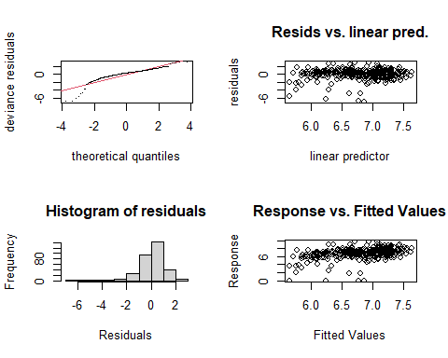

##   
## Method: REML Optimizer: outer newton  
## full convergence after 13 iterations.  
## Gradient range [-0.0002017452,0.000949099]  
## (score 547.798 & scale 1.638293).  
## Hessian positive definite, eigenvalue range [0.0002017947,161.0378].  
## Model rank = 50 / 50   
##   
## Basis dimension (k) checking results. Low p-value (k-index<1) may  
## indicate that k is too low, especially if edf is close to k'.  
##   
## k' edf k-index p-value  
## te(SalSurf_s,doy_s) 19.00000 6.95873 0.99 0.32  
## s(Year_fac) 27.00000 0.00231 NA NA  
## s(Station_fac) 3.00000 0.74286 NA NA  
##   
##   
## -------------summary-------------  
##   
## Family: gaussian   
## Link function: identity   
##   
## Formula:  
## BPUE_log1p ~ te(SalSurf_s, doy_s, k = c(5, 5), bs = c("cs", "cc")) +   
## s(Year_fac, bs = "re") + s(Station_fac, bs = "re")  
##   
## Parametric coefficients:  
## Estimate Std. Error t value Pr(>|t|)   
## (Intercept) 6.5758 0.3049 21.57 <0.0000000000000002 ***  
## ---  
## Signif. codes: 0 '***' 0.001 '**' 0.01 '*' 0.05 '.' 0.1 ' ' 1  
##   
## Approximate significance of smooth terms:  
## edf Ref.df F p-value   
## te(SalSurf_s,doy_s) 6.958726 19 2.637 <0.0000000000000002 ***  
## s(Year_fac) 0.002307 26 0.000 0.701   
## s(Station_fac) 0.742859 2 0.636 0.173   
## ---  
## Signif. codes: 0 '***' 0.001 '**' 0.01 '*' 0.05 '.' 0.1 ' ' 1  
##   
## R-sq.(adj) = 0.132 Deviance explained = 15.3%  
## -REML = 547.8 Scale est. = 1.6383 n = 323  
## <<<<<<<<<<<<<<<<<<<<<<< modeling othcyc NW Suisun >>>>>>>>>>>>>>>>>>>>>>>>>  
##   
## -------------gam check-------------

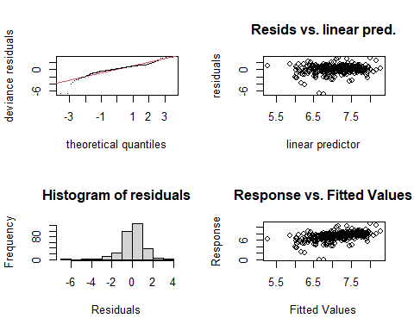

##   
## Method: REML Optimizer: outer newton  
## full convergence after 15 iterations.  
## Gradient range [-0.0004131309,0.0001947524]  
## (score 518.9493 & scale 1.457279).  
## Hessian positive definite, eigenvalue range [0.0001372543,156.328].  
## Model rank = 47 / 47   
##   
## Basis dimension (k) checking results. Low p-value (k-index<1) may  
## indicate that k is too low, especially if edf is close to k'.  
##   
## k' edf k-index p-value   
## te(SalSurf_s,doy_s) 19.00 4.93 0.93 0.095 .  
## s(Year_fac) 27.00 13.27 NA NA   
## ---  
## Signif. codes: 0 '***' 0.001 '**' 0.01 '*' 0.05 '.' 0.1 ' ' 1  
##   
##   
## -------------summary-------------  
##   
## Family: gaussian   
## Link function: identity   
##   
## Formula:  
## BPUE_log1p ~ te(SalSurf_s, doy_s, k = c(5, 5), bs = c("cs", "cc")) +   
## s(Year_fac, bs = "re")  
##   
## Parametric coefficients:  
## Estimate Std. Error t value Pr(>|t|)   
## (Intercept) 7.12099 0.09818 72.53 <0.0000000000000002 ***  
## ---  
## Signif. codes: 0 '***' 0.001 '**' 0.01 '*' 0.05 '.' 0.1 ' ' 1  
##   
## Approximate significance of smooth terms:  
## edf Ref.df F p-value   
## te(SalSurf_s,doy_s) 4.929 19 2.656 < 0.0000000000000002 ***  
## s(Year_fac) 13.274 26 1.061 0.00187 **   
## ---  
## Signif. codes: 0 '***' 0.001 '**' 0.01 '*' 0.05 '.' 0.1 ' ' 1  
##   
## R-sq.(adj) = 0.193 Deviance explained = 24%  
## -REML = 518.95 Scale est. = 1.4573 n = 313  
## <<<<<<<<<<<<<<<<<<<<<<< modeling othcyc East Suisun >>>>>>>>>>>>>>>>>>>>>>>>>  
##   
## -------------gam check-------------

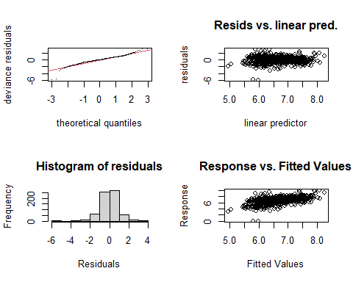

##   
## Method: REML Optimizer: outer newton  
## full convergence after 7 iterations.  
## Gradient range [-0.0000005210175,0.00000005749455]  
## (score 950.7203 & scale 0.8863708).  
## Hessian positive definite, eigenvalue range [0.115119,335.8596].  
## Model rank = 51 / 51   
##   
## Basis dimension (k) checking results. Low p-value (k-index<1) may  
## indicate that k is too low, especially if edf is close to k'.  
##   
## k' edf k-index p-value   
## te(SalSurf_s,doy_s) 19.00 10.10 0.92 0.015 *  
## s(Year_fac) 27.00 20.47 NA NA   
## s(Station_fac) 4.00 1.18 NA NA   
## ---  
## Signif. codes: 0 '***' 0.001 '**' 0.01 '*' 0.05 '.' 0.1 ' ' 1  
##   
##   
## -------------summary-------------  
##   
## Family: gaussian   
## Link function: identity   
##   
## Formula:  
## BPUE_log1p ~ te(SalSurf_s, doy_s, k = c(5, 5), bs = c("cs", "cc")) +   
## s(Year_fac, bs = "re") + s(Station_fac, bs = "re")  
##   
## Parametric coefficients:  
## Estimate Std. Error t value Pr(>|t|)   
## (Intercept) 6.69021 0.09854 67.89 <0.0000000000000002 ***  
## ---  
## Signif. codes: 0 '***' 0.001 '**' 0.01 '*' 0.05 '.' 0.1 ' ' 1  
##   
## Approximate significance of smooth terms:  
## edf Ref.df F p-value   
## te(SalSurf_s,doy_s) 10.096 19 9.895 <0.0000000000000002 ***  
## s(Year_fac) 20.473 26 3.957 <0.0000000000000002 ***  
## s(Station_fac) 1.183 3 0.836 0.121   
## ---  
## Signif. codes: 0 '***' 0.001 '**' 0.01 '*' 0.05 '.' 0.1 ' ' 1  
##   
## R-sq.(adj) = 0.29 Deviance explained = 32.4%  
## -REML = 950.72 Scale est. = 0.88637 n = 672  
## <<<<<<<<<<<<<<<<<<<<<<< modeling othcyc Confluence >>>>>>>>>>>>>>>>>>>>>>>>>  
##   
## -------------gam check-------------

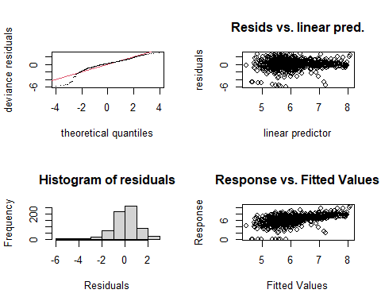

##   
## Method: REML Optimizer: outer newton  
## full convergence after 7 iterations.  
## Gradient range [-0.0000005407004,0.0000002814948]  
## (score 1184.537 & scale 1.558617).  
## Hessian positive definite, eigenvalue range [0.8820017,350.307].  
## Model rank = 52 / 52   
##   
## Basis dimension (k) checking results. Low p-value (k-index<1) may  
## indicate that k is too low, especially if edf is close to k'.  
##   
## k' edf k-index p-value  
## te(SalSurf_s,doy_s) 19.00 9.79 1 0.58  
## s(Year_fac) 27.00 19.25 NA NA  
## s(Station_fac) 5.00 1.92 NA NA  
##   
##   
## -------------summary-------------  
##   
## Family: gaussian   
## Link function: identity   
##   
## Formula:  
## BPUE_log1p ~ te(SalSurf_s, doy_s, k = c(5, 5), bs = c("cs", "cc")) +   
## s(Year_fac, bs = "re") + s(Station_fac, bs = "re")  
##   
## Parametric coefficients:  
## Estimate Std. Error t value Pr(>|t|)   
## (Intercept) 6.1620 0.1411 43.66 <0.0000000000000002 ***  
## ---  
## Signif. codes: 0 '***' 0.001 '**' 0.01 '*' 0.05 '.' 0.1 ' ' 1  
##   
## Approximate significance of smooth terms:  
## edf Ref.df F p-value   
## te(SalSurf_s,doy_s) 9.795 19 13.366 < 0.0000000000000002 ***  
## s(Year_fac) 19.249 26 2.874 < 0.0000000000000002 ***  
## s(Station_fac) 1.916 4 3.208 0.000602 ***  
## ---  
## Signif. codes: 0 '***' 0.001 '**' 0.01 '*' 0.05 '.' 0.1 ' ' 1  
##   
## R-sq.(adj) = 0.278 Deviance explained = 31%  
## -REML = 1184.5 Scale est. = 1.5586 n = 701  
## <<<<<<<<<<<<<<<<<<<<<<< modeling othcyc Suisun Marsh >>>>>>>>>>>>>>>>>>>>>>>>>  
##   
## -------------gam check-------------

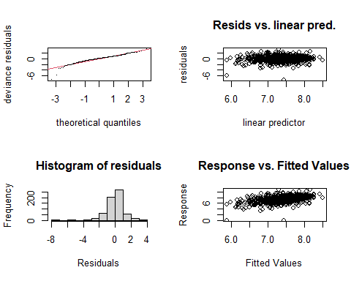

##   
## Method: REML Optimizer: outer newton  
## full convergence after 9 iterations.  
## Gradient range [-0.00002678443,0.000006649489]  
## (score 949.5397 & scale 1.102314).  
## Hessian positive definite, eigenvalue range [0.3677644,313.7443].  
## Model rank = 49 / 49   
##   
## Basis dimension (k) checking results. Low p-value (k-index<1) may  
## indicate that k is too low, especially if edf is close to k'.  
##   
## k' edf k-index p-value  
## te(SalSurf_s,doy_s) 19.000 9.280 0.95 0.16  
## s(Year_fac) 27.000 16.074 NA NA  
## s(Station_fac) 2.000 0.946 NA NA  
##   
##   
## -------------summary-------------  
##   
## Family: gaussian   
## Link function: identity   
##   
## Formula:  
## BPUE_log1p ~ te(SalSurf_s, doy_s, k = c(5, 5), bs = c("cs", "cc")) +   
## s(Year_fac, bs = "re") + s(Station_fac, bs = "re")  
##   
## Parametric coefficients:  
## Estimate Std. Error t value Pr(>|t|)   
## (Intercept) 7.3648 0.1889 39 <0.0000000000000002 ***  
## ---  
## Signif. codes: 0 '***' 0.001 '**' 0.01 '*' 0.05 '.' 0.1 ' ' 1  
##   
## Approximate significance of smooth terms:  
## edf Ref.df F p-value   
## te(SalSurf_s,doy_s) 9.2801 19 5.791 < 0.0000000000000002 ***  
## s(Year_fac) 16.0736 26 1.604 0.0000292 ***  
## s(Station_fac) 0.9458 1 17.481 0.0000199 ***  
## ---  
## Signif. codes: 0 '***' 0.001 '**' 0.01 '*' 0.05 '.' 0.1 ' ' 1  
##   
## R-sq.(adj) = 0.19 Deviance explained = 22.4%  
## -REML = 949.54 Scale est. = 1.1023 n = 628  
## <<<<<<<<<<<<<<<<<<<<<<< modeling other SW Suisun >>>>>>>>>>>>>>>>>>>>>>>>>  
##   
## -------------gam check-------------

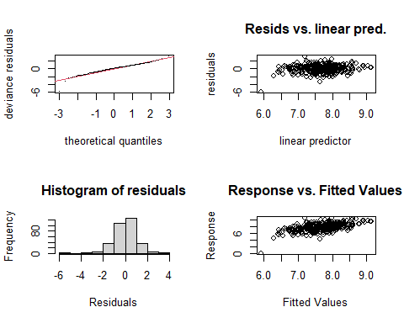

##   
## Method: REML Optimizer: outer newton  
## full convergence after 11 iterations.  
## Gradient range [-0.0003409518,0.000164426]  
## (score 483.1728 & scale 1.019466).  
## Hessian positive definite, eigenvalue range [0.00001141316,161.4539].  
## Model rank = 50 / 50   
##   
## Basis dimension (k) checking results. Low p-value (k-index<1) may  
## indicate that k is too low, especially if edf is close to k'.  
##   
## k' edf k-index p-value  
## te(SalSurf_s,doy_s) 19.0000000 6.3112886 0.97 0.32  
## s(Year_fac) 27.0000000 15.6414280 NA NA  
## s(Station_fac) 3.0000000 0.0000383 NA NA  
##   
##   
## -------------summary-------------  
##   
## Family: gaussian   
## Link function: identity   
##   
## Formula:  
## BPUE_log1p ~ te(SalSurf_s, doy_s, k = c(5, 5), bs = c("cs", "cc")) +   
## s(Year_fac, bs = "re") + s(Station_fac, bs = "re")  
##   
## Parametric coefficients:  
## Estimate Std. Error t value Pr(>|t|)   
## (Intercept) 7.70332 0.09041 85.2 <0.0000000000000002 ***  
## ---  
## Signif. codes: 0 '***' 0.001 '**' 0.01 '*' 0.05 '.' 0.1 ' ' 1  
##   
## Approximate significance of smooth terms:  
## edf Ref.df F p-value   
## te(SalSurf_s,doy_s) 6.31128862 19 3.933 < 0.0000000000000002 ***  
## s(Year_fac) 15.64142798 26 1.604 0.0000343 ***  
## s(Station_fac) 0.00003832 2 0.000 0.628   
## ---  
## Signif. codes: 0 '***' 0.001 '**' 0.01 '*' 0.05 '.' 0.1 ' ' 1  
##   
## R-sq.(adj) = 0.259 Deviance explained = 31%  
## -REML = 483.17 Scale est. = 1.0195 n = 323  
## <<<<<<<<<<<<<<<<<<<<<<< modeling other NW Suisun >>>>>>>>>>>>>>>>>>>>>>>>>  
##   
## -------------gam check-------------

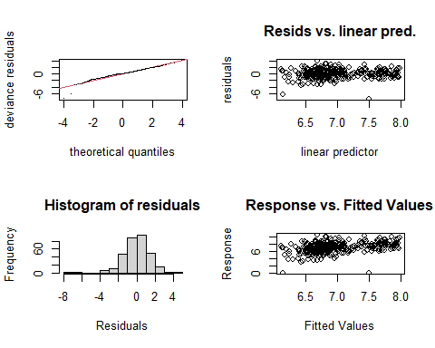

##   
## Method: REML Optimizer: outer newton  
## full convergence after 10 iterations.  
## Gradient range [-0.0002590989,0.002293237]  
## (score 548.7092 & scale 1.831842).  
## Hessian positive definite, eigenvalue range [0.01616427,156.0459].  
## Model rank = 47 / 47   
##   
## Basis dimension (k) checking results. Low p-value (k-index<1) may  
## indicate that k is too low, especially if edf is close to k'.  
##   
## k' edf k-index p-value  
## te(SalSurf_s,doy_s) 19.000 6.511 0.92 0.1  
## s(Year_fac) 27.000 0.994 NA NA  
##   
##   
## -------------summary-------------  
##   
## Family: gaussian   
## Link function: identity   
##   
## Formula:  
## BPUE_log1p ~ te(SalSurf_s, doy_s, k = c(5, 5), bs = c("cs", "cc")) +   
## s(Year_fac, bs = "re")  
##   
## Parametric coefficients:  
## Estimate Std. Error t value Pr(>|t|)   
## (Intercept) 6.98193 0.07805 89.45 <0.0000000000000002 ***  
## ---  
## Signif. codes: 0 '***' 0.001 '**' 0.01 '*' 0.05 '.' 0.1 ' ' 1  
##   
## Approximate significance of smooth terms:  
## edf Ref.df F p-value   
## te(SalSurf_s,doy_s) 6.511 19 2.207 <0.0000000000000002 ***  
## s(Year_fac) 0.994 26 0.040 0.408   
## ---  
## Signif. codes: 0 '***' 0.001 '**' 0.01 '*' 0.05 '.' 0.1 ' ' 1  
##   
## R-sq.(adj) = 0.121 Deviance explained = 14.2%  
## -REML = 548.71 Scale est. = 1.8318 n = 313  
## <<<<<<<<<<<<<<<<<<<<<<< modeling other East Suisun >>>>>>>>>>>>>>>>>>>>>>>>>  
##   
## -------------gam check-------------

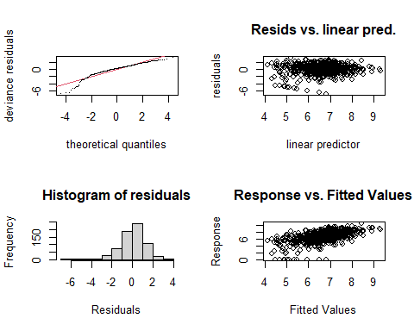

##   
## Method: REML Optimizer: outer newton  
## full convergence after 9 iterations.  
## Gradient range [-0.00001010638,0.000006244375]  
## (score 1209.566 & scale 1.89581).  
## Hessian positive definite, eigenvalue range [0.6022675,335.8209].  
## Model rank = 51 / 51   
##   
## Basis dimension (k) checking results. Low p-value (k-index<1) may  
## indicate that k is too low, especially if edf is close to k'.  
##   
## k' edf k-index p-value   
## te(SalSurf_s,doy_s) 19.0 13.2 0.87 <0.0000000000000002 ***  
## s(Year_fac) 27.0 18.2 NA NA   
## s(Station_fac) 4.0 2.0 NA NA   
## ---  
## Signif. codes: 0 '***' 0.001 '**' 0.01 '*' 0.05 '.' 0.1 ' ' 1  
##   
##   
## -------------summary-------------  
##   
## Family: gaussian   
## Link function: identity   
##   
## Formula:  
## BPUE_log1p ~ te(SalSurf_s, doy_s, k = c(5, 5), bs = c("cs", "cc")) +   
## s(Year_fac, bs = "re") + s(Station_fac, bs = "re")  
##   
## Parametric coefficients:  
## Estimate Std. Error t value Pr(>|t|)   
## (Intercept) 6.5467 0.1816 36.05 <0.0000000000000002 ***  
## ---  
## Signif. codes: 0 '***' 0.001 '**' 0.01 '*' 0.05 '.' 0.1 ' ' 1  
##   
## Approximate significance of smooth terms:  
## edf Ref.df F p-value   
## te(SalSurf_s,doy_s) 13.246 19 14.054 < 0.0000000000000002 ***  
## s(Year_fac) 18.242 26 2.223 0.000001 ***  
## s(Station_fac) 2.001 3 4.274 0.000966 ***  
## ---  
## Signif. codes: 0 '***' 0.001 '**' 0.01 '*' 0.05 '.' 0.1 ' ' 1  
##   
## R-sq.(adj) = 0.295 Deviance explained = 33%  
## -REML = 1209.6 Scale est. = 1.8958 n = 672  
## <<<<<<<<<<<<<<<<<<<<<<< modeling other Confluence >>>>>>>>>>>>>>>>>>>>>>>>>  
##   
## -------------gam check-------------

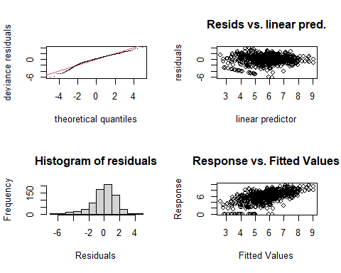

##   
## Method: REML Optimizer: outer newton  
## full convergence after 9 iterations.  
## Gradient range [-0.0003603327,0.0001005622]  
## (score 1357.527 & scale 2.444345).  
## Hessian positive definite, eigenvalue range [0.0003601512,350.3843].  
## Model rank = 52 / 52   
##   
## Basis dimension (k) checking results. Low p-value (k-index<1) may  
## indicate that k is too low, especially if edf is close to k'.  
##   
## k' edf k-index p-value   
## te(SalSurf_s,doy_s) 19.000000 15.036021 0.9 <0.0000000000000002 ***  
## s(Year_fac) 27.000000 20.384741 NA NA   
## s(Station_fac) 5.000000 0.000922 NA NA   
## ---  
## Signif. codes: 0 '***' 0.001 '**' 0.01 '*' 0.05 '.' 0.1 ' ' 1  
##   
##   
## -------------summary-------------  
##   
## Family: gaussian   
## Link function: identity   
##   
## Formula:  
## BPUE_log1p ~ te(SalSurf_s, doy_s, k = c(5, 5), bs = c("cs", "cc")) +   
## s(Year_fac, bs = "re") + s(Station_fac, bs = "re")  
##   
## Parametric coefficients:  
## Estimate Std. Error t value Pr(>|t|)   
## (Intercept) 5.8291 0.1319 44.18 <0.0000000000000002 ***  
## ---  
## Signif. codes: 0 '***' 0.001 '**' 0.01 '*' 0.05 '.' 0.1 ' ' 1  
##   
## Approximate significance of smooth terms:  
## edf Ref.df F p-value   
## te(SalSurf_s,doy_s) 15.0360206 19 21.001 <0.0000000000000002 ***  
## s(Year_fac) 20.3847410 26 3.125 <0.0000000000000002 ***  
## s(Station_fac) 0.0009215 4 0.000 0.821   
## ---  
## Signif. codes: 0 '***' 0.001 '**' 0.01 '*' 0.05 '.' 0.1 ' ' 1  
##   
## R-sq.(adj) = 0.379 Deviance explained = 41.1%  
## -REML = 1357.5 Scale est. = 2.4443 n = 701  
## <<<<<<<<<<<<<<<<<<<<<<< modeling other Suisun Marsh >>>>>>>>>>>>>>>>>>>>>>>>>  
##   
## -------------gam check-------------

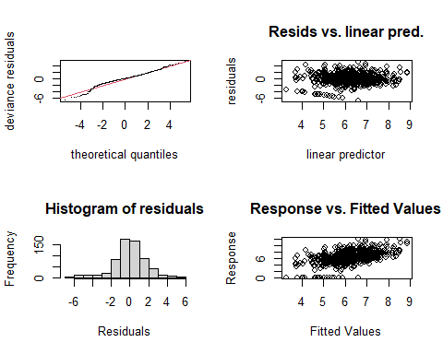

##   
## Method: REML Optimizer: outer newton  
## full convergence after 8 iterations.  
## Gradient range [-0.0001594469,0.00007417611]  
## (score 1259.493 & scale 2.897765).  
## Hessian positive definite, eigenvalue range [0.0001594073,313.857].  
## Model rank = 49 / 49   
##   
## Basis dimension (k) checking results. Low p-value (k-index<1) may  
## indicate that k is too low, especially if edf is close to k'.  
##   
## k' edf k-index p-value   
## te(SalSurf_s,doy_s) 19.000000 10.044054 0.93 0.005 **  
## s(Year_fac) 27.000000 19.692905 NA NA   
## s(Station_fac) 2.000000 0.000469 NA NA   
## ---  
## Signif. codes: 0 '***' 0.001 '**' 0.01 '*' 0.05 '.' 0.1 ' ' 1  
##   
##   
## -------------summary-------------  
##   
## Family: gaussian   
## Link function: identity   
##   
## Formula:  
## BPUE_log1p ~ te(SalSurf_s, doy_s, k = c(5, 5), bs = c("cs", "cc")) +   
## s(Year_fac, bs = "re") + s(Station_fac, bs = "re")  
##   
## Parametric coefficients:  
## Estimate Std. Error t value Pr(>|t|)   
## (Intercept) 6.1750 0.1415 43.63 <0.0000000000000002 ***  
## ---  
## Signif. codes: 0 '***' 0.001 '**' 0.01 '*' 0.05 '.' 0.1 ' ' 1  
##   
## Approximate significance of smooth terms:  
## edf Ref.df F p-value   
## te(SalSurf_s,doy_s) 10.0440535 19 8.148 <0.0000000000000002 ***  
## s(Year_fac) 19.6929051 26 3.057 <0.0000000000000002 ***  
## s(Station_fac) 0.0004692 1 0.000 0.571   
## ---  
## Signif. codes: 0 '***' 0.001 '**' 0.01 '*' 0.05 '.' 0.1 ' ' 1  
##   
## R-sq.(adj) = 0.258 Deviance explained = 29.4%  
## -REML = 1259.5 Scale est. = 2.8978 n = 628

sal_conversions

## # A tibble: 89,508 × 1,004  
## Region Month IBMR SalSurf draw_1 draw_2 draw_3 draw_4 draw_5 draw_6 draw_7  
## <fct> <int> <chr> <dbl> <dbl> <dbl> <dbl> <dbl> <dbl> <dbl> <dbl>  
## 1 SW Suis… 1 acar… 0.1 5.03 3.52 5.68 5.01 4.10 3.57 3.71  
## 2 SW Suis… 1 acar… 0.2 5.02 3.52 5.67 5.01 4.10 3.58 3.73  
## 3 SW Suis… 1 acar… 0.3 5.02 3.53 5.65 5.00 4.10 3.59 3.74  
## 4 SW Suis… 1 acar… 0.4 5.01 3.53 5.63 5.00 4.10 3.60 3.75  
## 5 SW Suis… 1 acar… 0.5 5.00 3.54 5.62 5.00 4.10 3.61 3.77  
## 6 SW Suis… 1 acar… 0.6 4.99 3.54 5.60 4.99 4.10 3.63 3.78  
## 7 SW Suis… 1 acar… 0.7 4.98 3.55 5.58 4.99 4.10 3.64 3.79  
## 8 SW Suis… 1 acar… 0.8 4.97 3.55 5.56 4.99 4.10 3.65 3.81  
## 9 SW Suis… 1 acar… 0.9 4.96 3.56 5.55 4.98 4.10 3.66 3.82  
## 10 SW Suis… 1 acar… 1 4.95 3.56 5.53 4.98 4.10 3.67 3.83  
## # ℹ 89,498 more rows  
## # ℹ 993 more variables: draw_8 <dbl>, draw_9 <dbl>, draw_10 <dbl>,  
## # draw_11 <dbl>, draw_12 <dbl>, draw_13 <dbl>, draw_14 <dbl>, draw_15 <dbl>,  
## # draw_16 <dbl>, draw_17 <dbl>, draw_18 <dbl>, draw_19 <dbl>, draw_20 <dbl>,  
## # draw_21 <dbl>, draw_22 <dbl>, draw_23 <dbl>, draw_24 <dbl>, draw_25 <dbl>,  
## # draw_26 <dbl>, draw_27 <dbl>, draw_28 <dbl>, draw_29 <dbl>, draw_30 <dbl>,  
## # draw_31 <dbl>, draw_32 <dbl>, draw_33 <dbl>, draw_34 <dbl>, …

Plot salinity-biomass relationships

sal_conversions_sum<-apply(select(sal_conversions, starts_with("draw_")), 1,   
 function(x) quantile(x, c(0.025, 0.5, 0.975)))  
  
sal_conversions_plot<-sal_conversions%>%  
 select(-starts_with("draw_"))%>%  
 bind_cols(tibble(l95=sal_conversions_sum["2.5%",],   
 median=sal_conversions_sum["50%",],   
 u95=sal_conversions_sum["97.5%",]))  
plot_sal_conversions<-function(group, data=sal_conversions_plot){  
   
 if(group!="All"){  
 data<-filter(data, IBMR%in%group)  
   
 ggplot(data, aes(x=SalSurf, y=median, ymin=l95, ymax=u95))+  
 geom_ribbon(alpha=0.4, fill="chartreuse4")+  
 ylab("Zooplankton biomass (log scale)")+  
 facet_grid(Region~month(Month, label=T))+  
 theme_bw()+  
 theme(axis.text.x=element_text(angle=45, hjust=1))  
 }else{  
 ggplot(data, aes(x=SalSurf, y=median, ymin=l95, ymax=u95, fill=IBMR))+  
 geom_ribbon(alpha=0.4)+  
 ylab("Zooplankton biomass (log scale)")+  
 facet_grid(Region~month(Month, label=T))+  
 scale_fill_viridis_d()+  
 theme_bw()+  
 theme(axis.text.x=element_text(angle=45, hjust=1))  
 }  
}

# Create plots for each IBMR group  
sal_conversion_plots <- tibble(group=c("All", unique(model_factors$IBMR)))%>%  
 mutate(plot=map(group, plot_sal_conversions))

## Salinity-biomass plots

### All

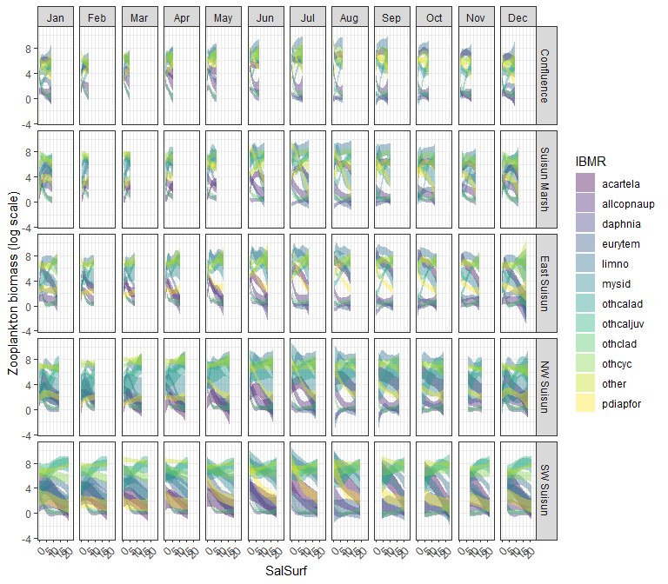

### acartela

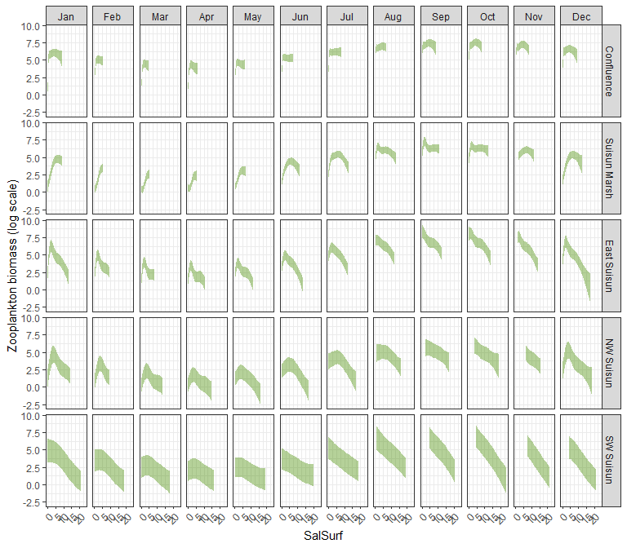

### daphnia

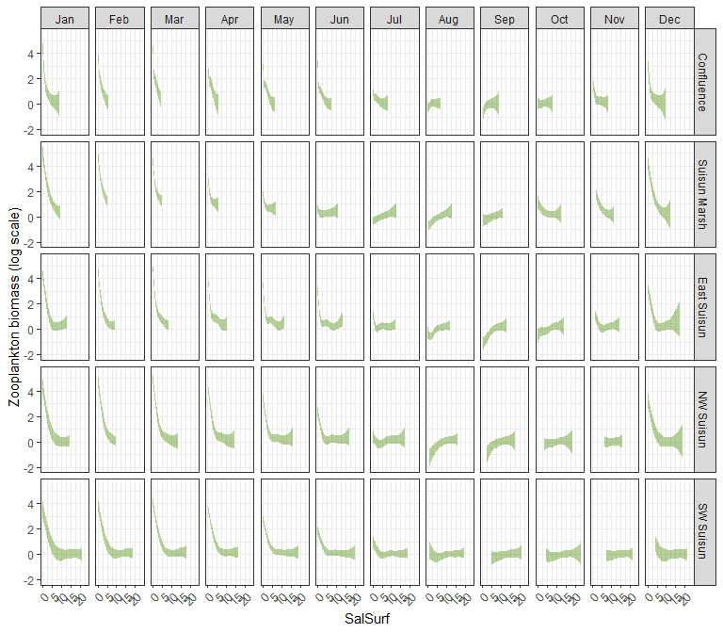

### eurytem

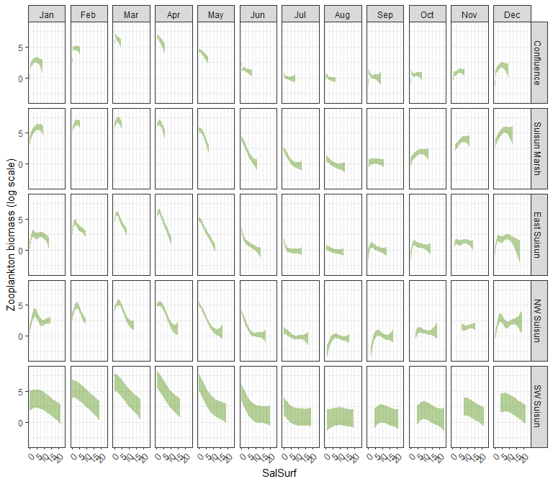

### othcalad

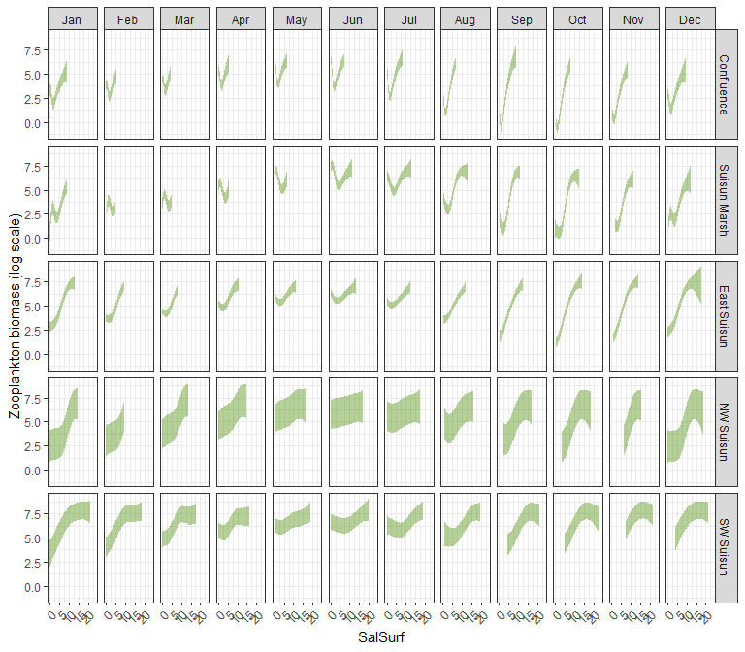

### othcaljuv

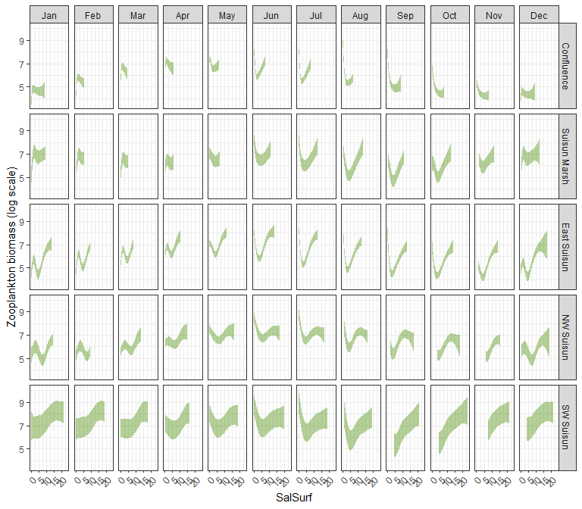

### othclad

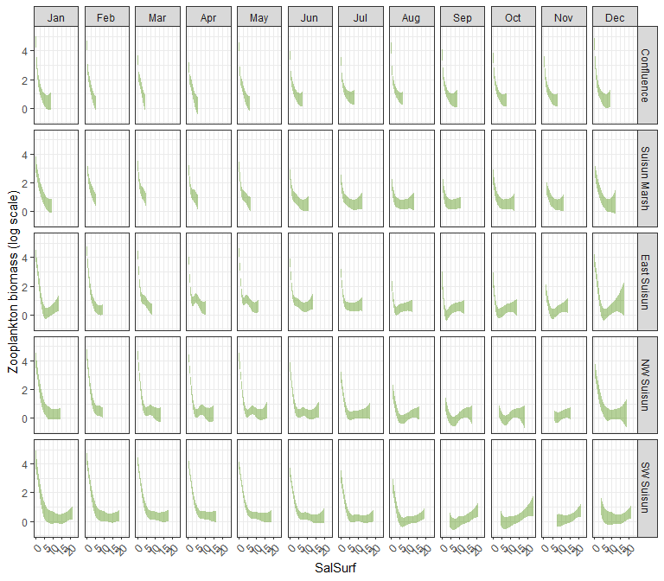

### pdiapfor

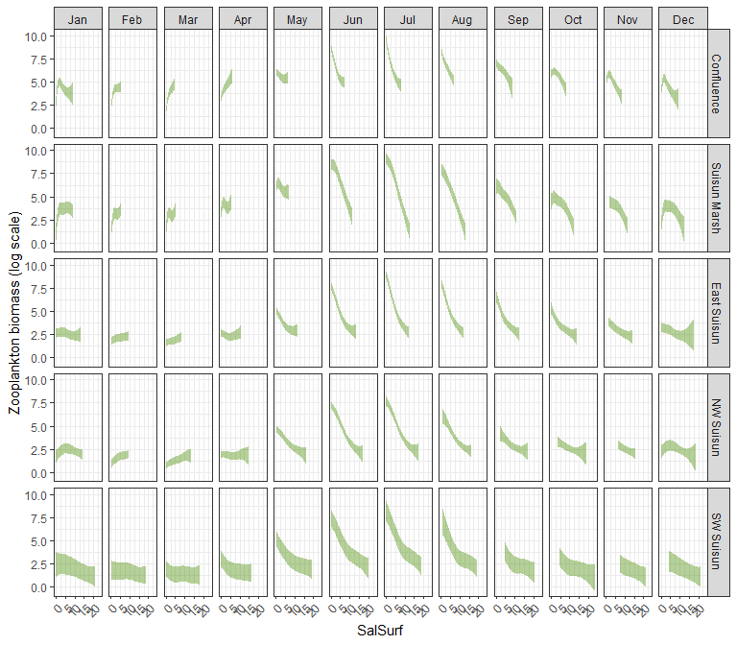

### allcopnaup

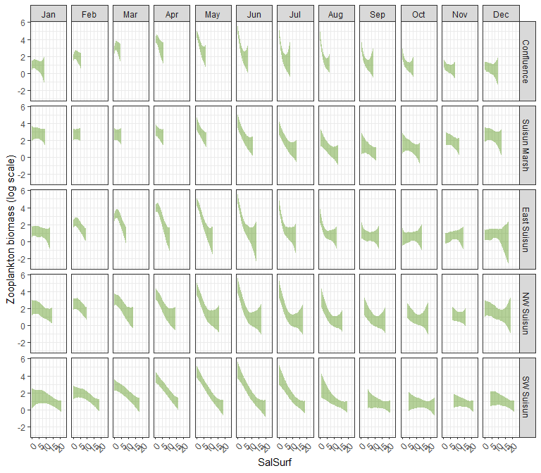

### limno

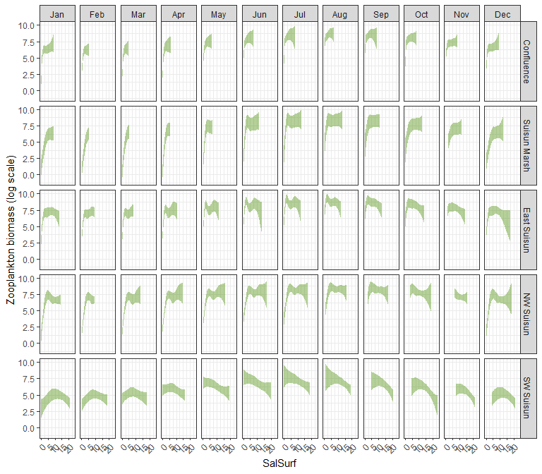

### mysid

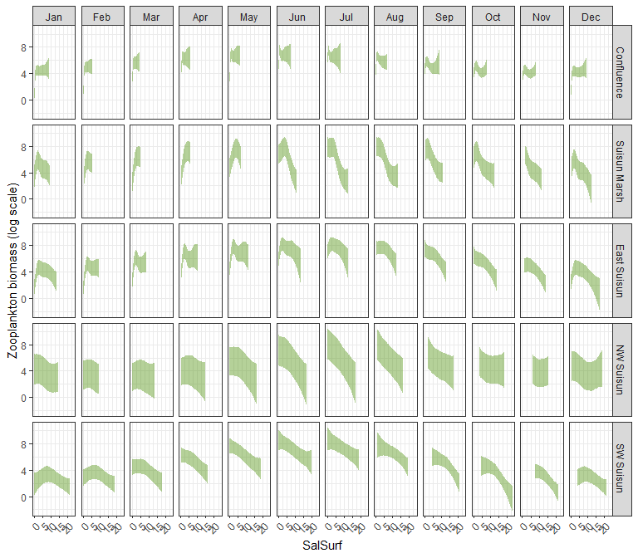

### othcyc

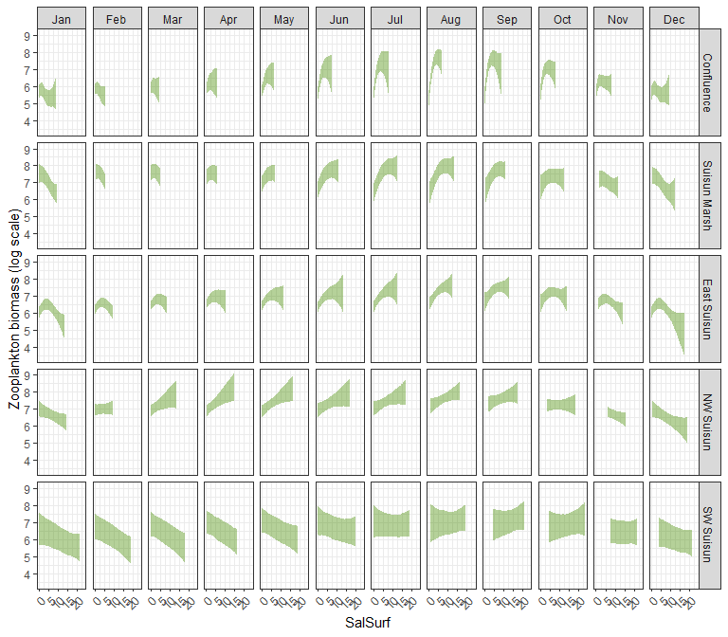

### other

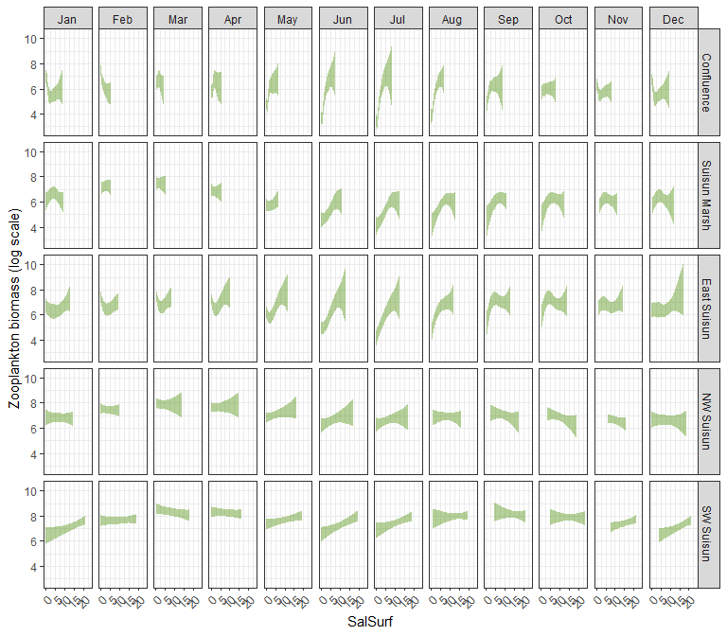

# Read salinity data

salinity_data<-read.csv(file.path("Data","converted_salinity_data.csv"))  
  
#Original file from CSAMP SDM  
original_scenario_file<-read.csv(file.path("Data","base_salinity_data_for_X2salmodel.csv")) %>% select(c(2:5)) %>% rename(sal_base=sal) %>%  
 add_row(year = 1997, month=1, region = "NE Suisun", sal_base=0.217891455)  
  
#Join the two datasets  
scenario_file <- original_scenario_file %>% left_join(salinity_data)

# Apply model

Load in the modeled salinity

scenario_names<-tibble(name=colnames(scenario_file))%>%  
 filter(str_detect(name, "sal_"))%>%  
 rev()  
  
scenario_sal<-scenario_file%>%  
 select(region, year, month, starts_with("sal_"))%>%  
 mutate(across(c(year, month), as.integer),  
 across(starts_with("sal_"), ~if_else(is.na(.x), sal_base, .x)))%>%  
 filter(region%in%unique(zoop_data_mass$SUBREGION))%>%  
 mutate(region=factor(region,   
 levels=c("Confluence", "Suisun Marsh", "NE Suisun",   
 "SE Suisun", "NW Suisun", "SW Suisun")))%>%  
 pivot_longer(cols=starts_with("sal_"), names_to="Scenario", values_to="Salinity")%>% # Prepare data for easier plotting  
 mutate(Scenario=factor(Scenario,   
 levels=scenario_names$name),  
 Salinity=round(Salinity, 1))

Plot modeled salinity

ggplot(scenario_sal,   
 aes(x=year, y=Salinity, color=Scenario))+  
 geom_line()+  
 scale_color_viridis_d(direction=-1)+  
 facet_grid(region ~ month(month, label=T))+  
 theme_bw()+  
 theme(legend.position = "bottom", axis.text.x=element_text(angle=45, hjust=1))

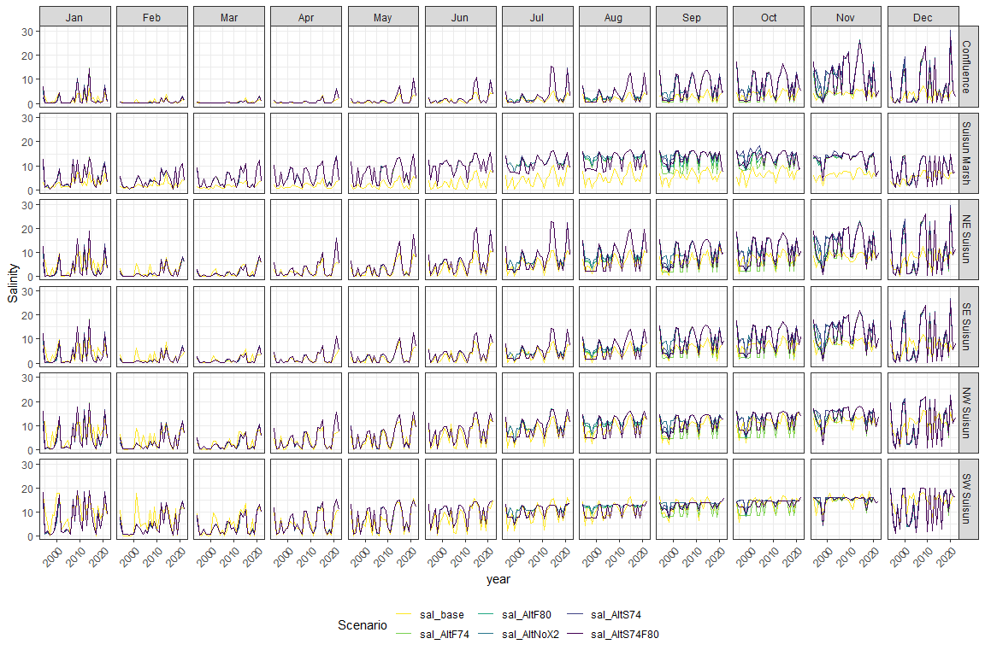

Calculate zoop abundance difference between each scenario and the baseline

zoop_saladjusted<-scenario_sal%>%  
 mutate(Salinity=as.character(Salinity),  
 IBMR=unique(model_factors$IBMR)[1])%>%  
 complete(region, year, month, Scenario, IBMR=unique(model_factors$IBMR))%>%  
 group_by(region, year, month, Scenario)%>%  
 mutate(Salinity=na.exclude(Salinity),  
 region2=if_else(region%in%c("NE Suisun", "SE Suisun"), "East Suisun", as.character(region)))%>%  
 ungroup()%>%  
 left_join(sal_conversions%>%  
 mutate(SalSurf=as.character(SalSurf)),  
 by=c("region2"="Region",  
 "month"="Month",  
 "Salinity"="SalSurf",  
 "IBMR"="IBMR"))%>%  
 select(-Salinity, -region2)%>%  
 mutate(across(starts_with("draw_"), ~exp(.x)-1))%>%  
 pivot_longer(starts_with("draw_"), names_prefix="draw_", names_to="draw", values_to="fit")%>%  
 mutate(fit=if_else(fit<0, 0, fit))%>%  
 pivot_wider(names_from="Scenario", values_from="fit")%>%  
 mutate(across(starts_with("sal_"), ~.x/sal_base))%>%  
 group_by(region, year, month, IBMR)%>%  
 summarise(across(starts_with("sal_"),   
 list(median=~median(.x, na.rm=T),   
 l95=~quantile(.x, 0.025, na.rm=T),   
 u95=~quantile(.x, 0.975, na.rm=T))),   
 .groups="drop")  
  
write_csv(zoop_saladjusted, file.path("Output","zoop sal adjustments.csv"))

You can find the final zoop salinity adjustments [here](https://github.com/sbashevkin/FLOATDrought/blob/main/Outputs/CSAMP%20zoop%20sal%20adjustments.csv)

## Prepare plots

Plot the missing model results resulting from out-of-range salinity values in the inputs

missing_adjusted_data<-zoop_saladjusted%>%  
 select(-ends_with("l95"), -ends_with("u95"))%>%  
 filter(IBMR=="acartela")%>%  
 pivot_longer(cols=starts_with("sal_"), names_to="Scenario", values_to="zoop_change")%>%  
 mutate(Scenario=str_remove(Scenario, fixed("_median")))  
  
ggplot(missing_adjusted_data,  
 aes(x=year, y=Scenario, fill=is.na(zoop_change)))+  
 geom_tile()+  
 scale_fill_viridis_d(name="Are the model results missing due to out-of-range salinity values?")+  
 facet_grid(region ~ month(month, label=T))+  
 theme_bw()+  
 theme(legend.position = "bottom", axis.text.x=element_text(angle=45, hjust=1))

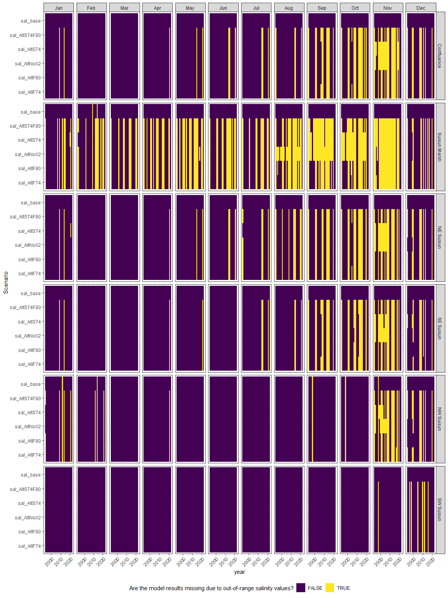

Plot the result

Create some plotting functions

neglop1p<-trans_new("neglop1p", transform=function(x) sign(x)*log(abs(x)+1), inverse=function(x) sign(x)*(exp(abs(x))-1))  
plot_scenario_result <- function(scenario, group) {  
   
 plot_data<-zoop_saladjusted%>%  
 filter(IBMR%in%group)  
   
 ggplot(plot_data,  
 aes(x=year, y=.data[[paste0(scenario, "_median")]], ymin=.data[[paste0(scenario, "_l95")]], ymax=.data[[paste0(scenario, "_u95")]]))+  
 geom_ribbon(alpha=0.4, fill="darkorchid4")+  
 geom_line(alpha=0.4, color="darkorchid4")+  
 scale_y_continuous(trans=neglop1p, breaks=c(-1000, -100, -10, -1, 0, 1, 10, 100, 1000))+  
 ylab("Scenario/baseline (log scale)")+  
 facet_grid(region ~ month(month, label=T))+  
 theme_bw()+  
 theme(legend.position = "bottom", axis.text.x=element_text(angle=45, hjust=1))  
}

# Create plots for each Parameter  
scenario_result_plots <- expand_grid(Scenario=unique(scenario_sal$Scenario)[-1],  
 IBMR=unique(model_factors$IBMR))%>%  
 mutate(plot=map2(Scenario, IBMR, ~plot_scenario_result(.x, .y)))

## Result plots

### sal_AltF74

#### acartela

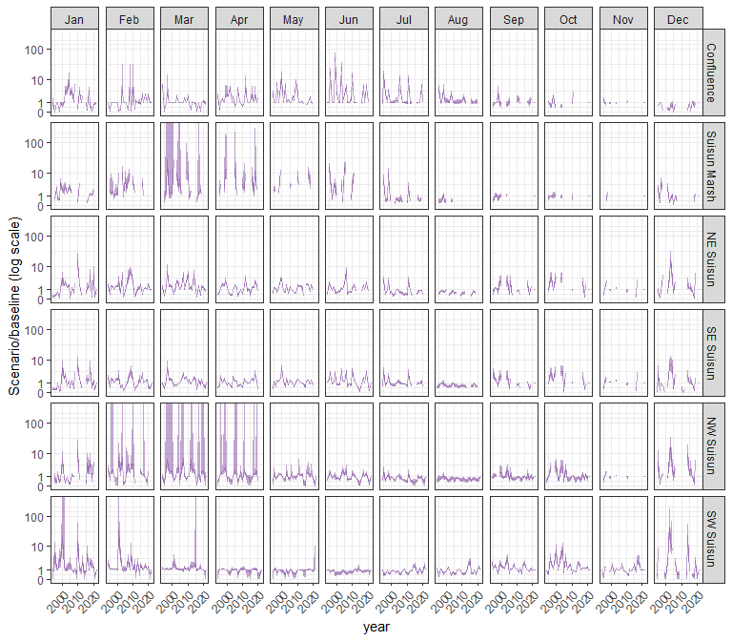

#### daphnia

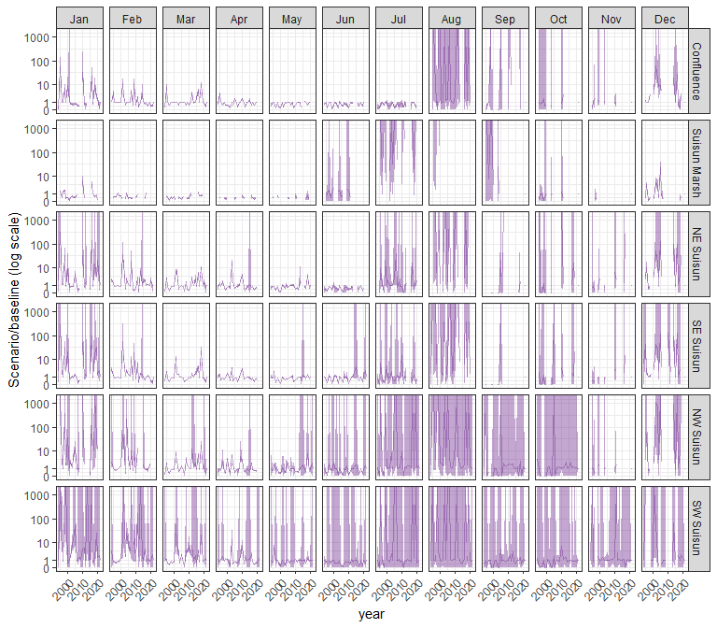

#### eurytem

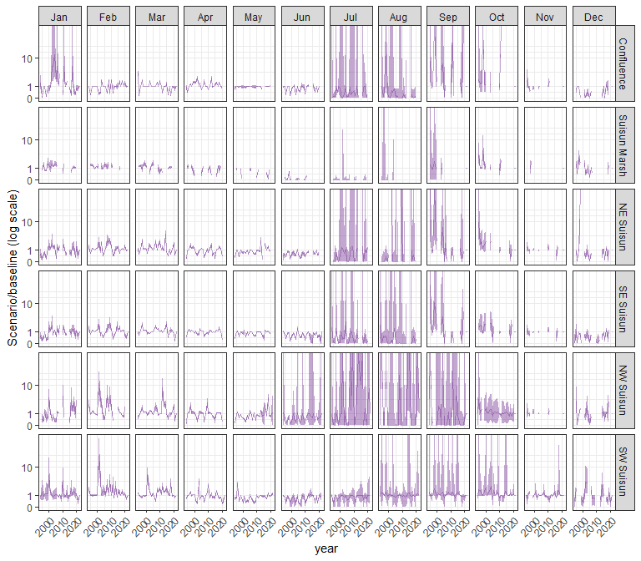

#### othcalad

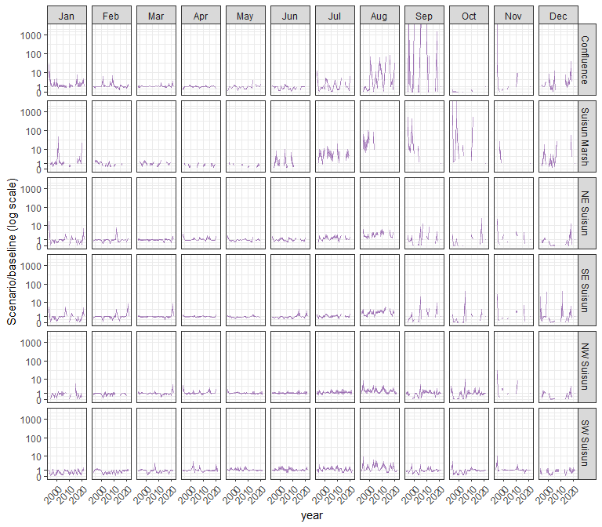

#### othcaljuv

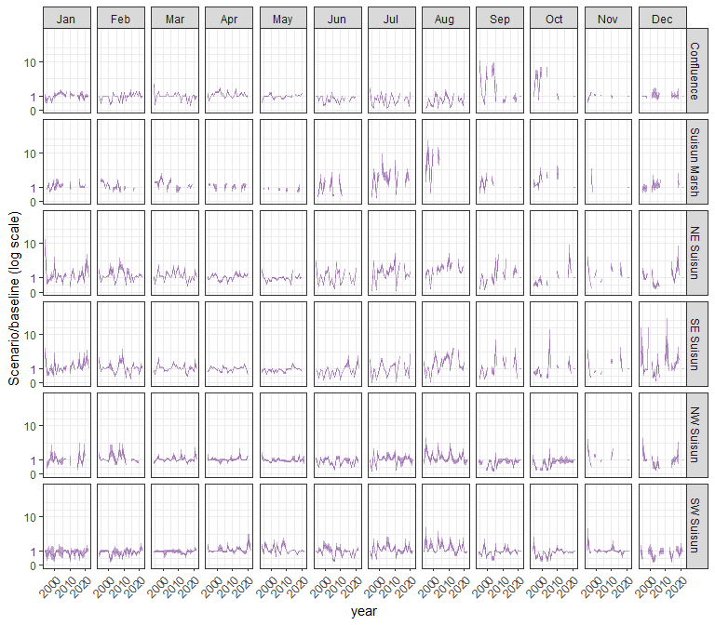

#### othclad

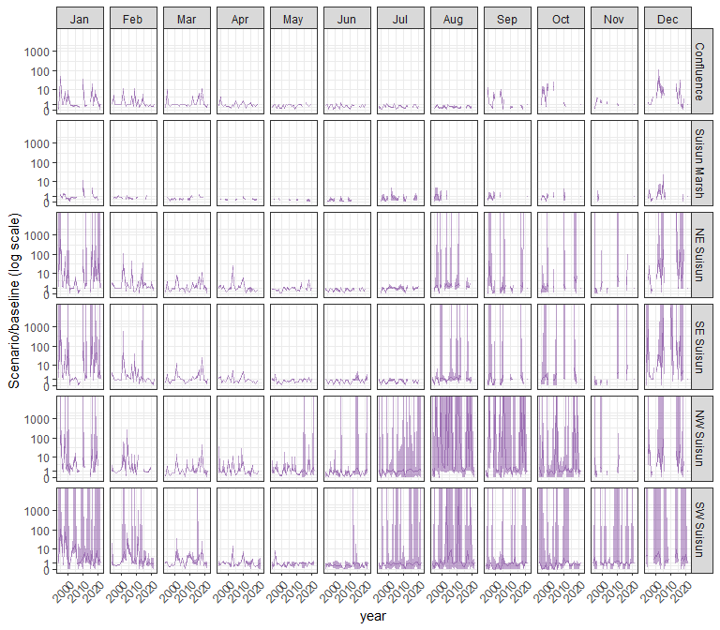

#### pdiapfor

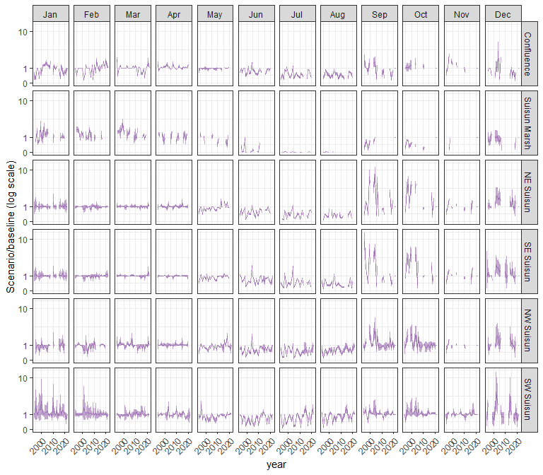

#### allcopnaup

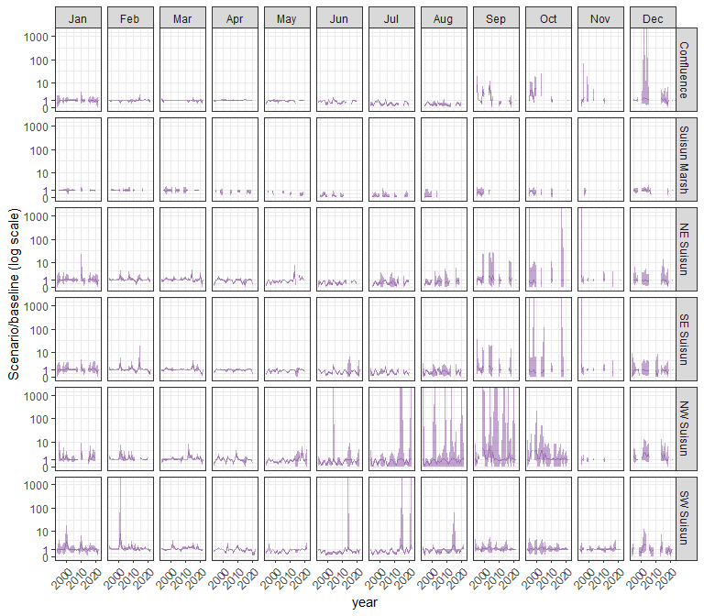

#### limno

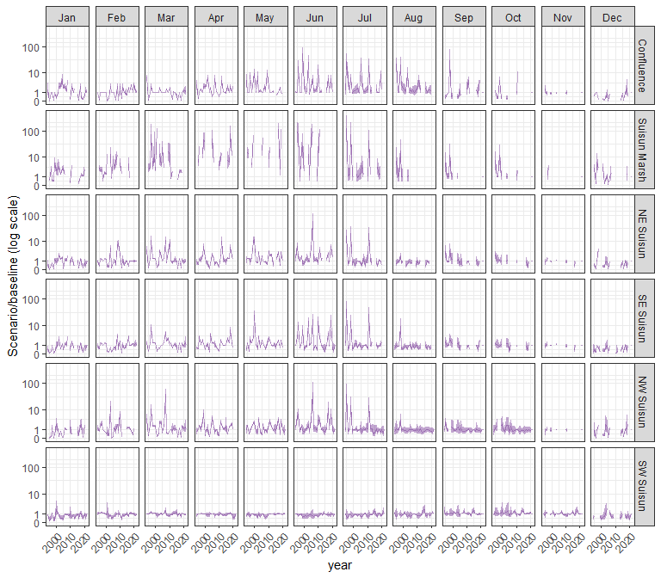

#### mysid

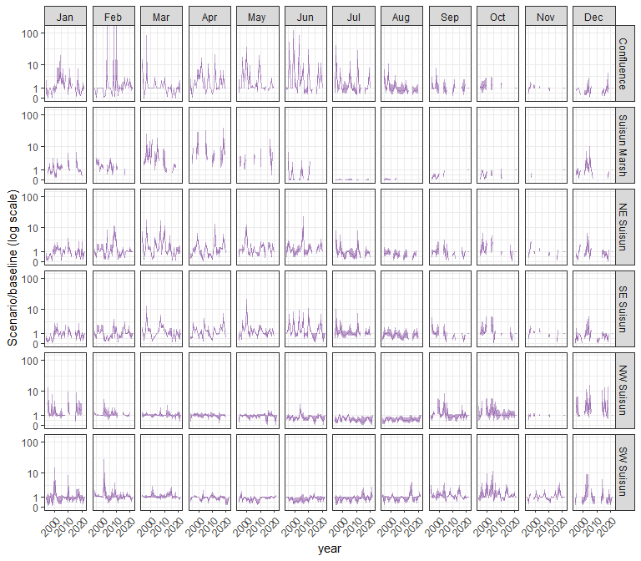

#### othcyc

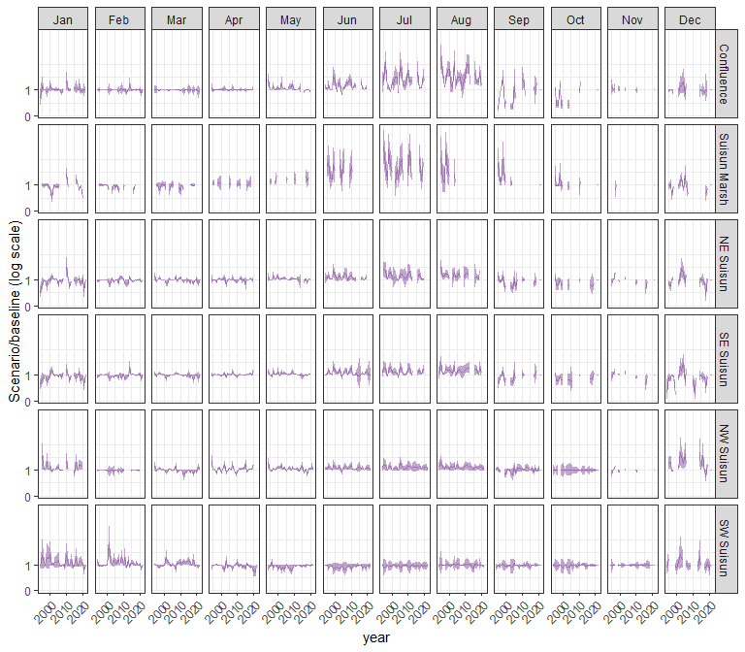

#### other

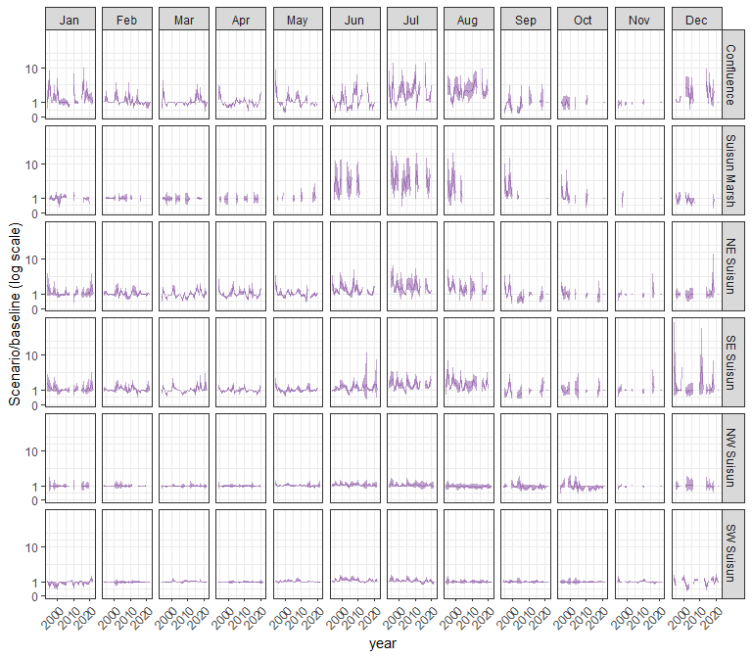

### sal_AltF80

#### acartela

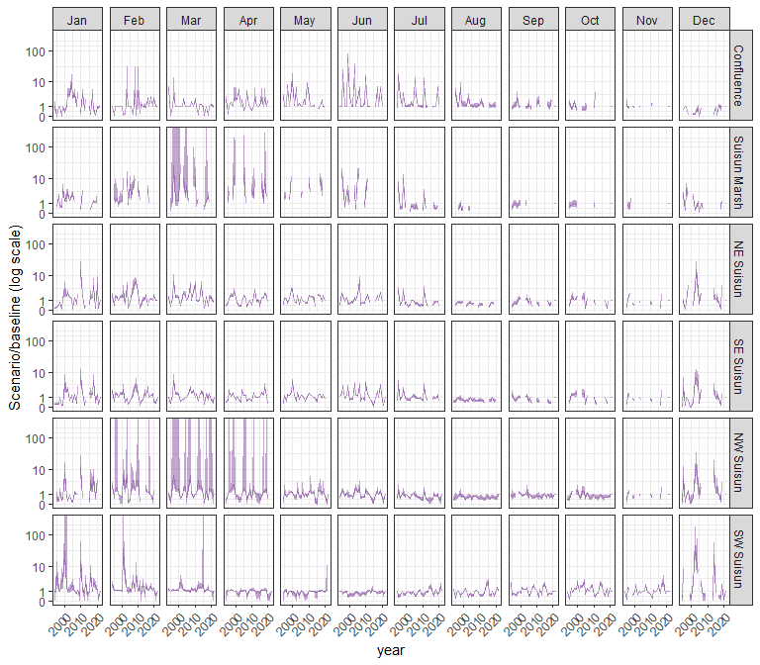

#### daphnia

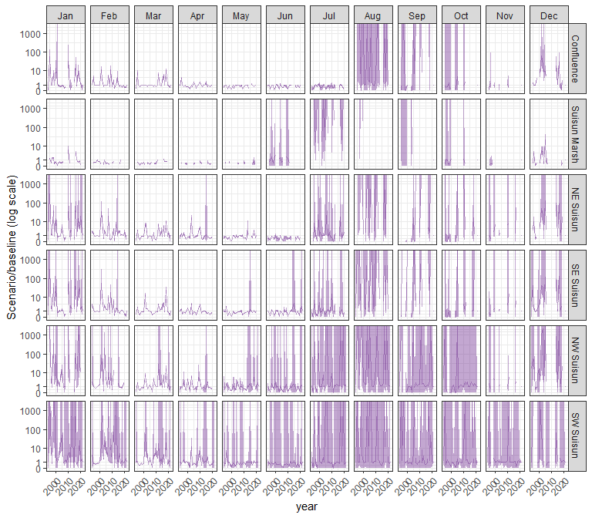

#### eurytem

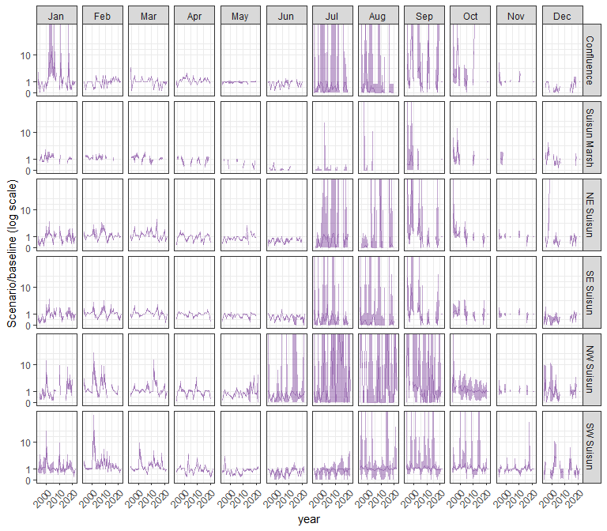

#### othcalad

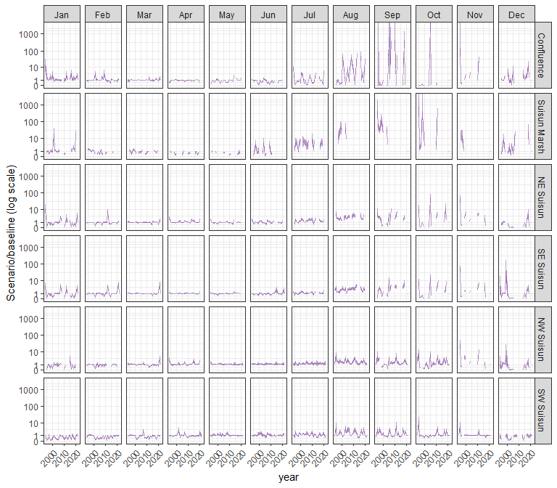

#### othcaljuv

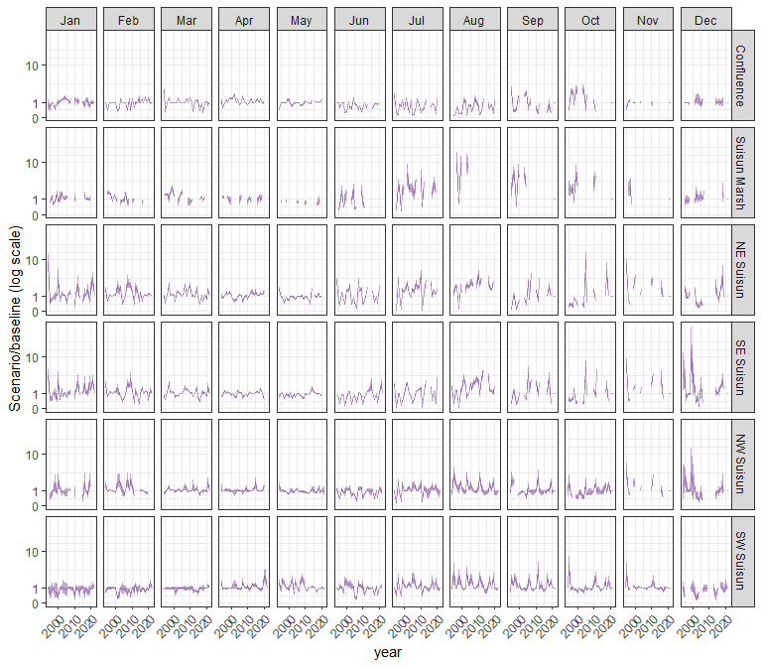

#### othclad

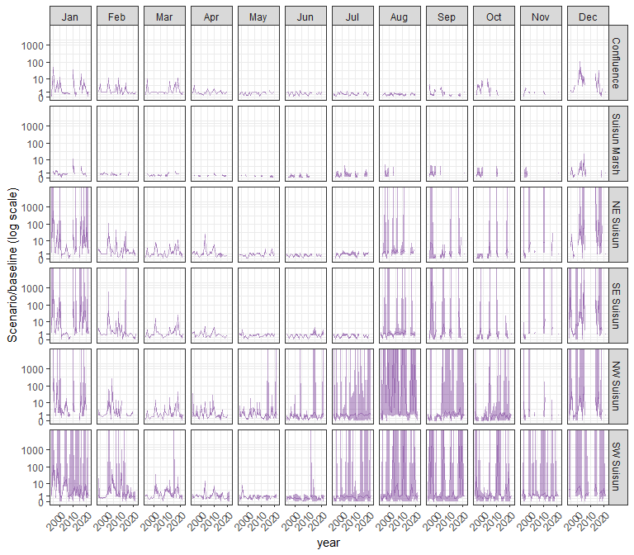

#### pdiapfor

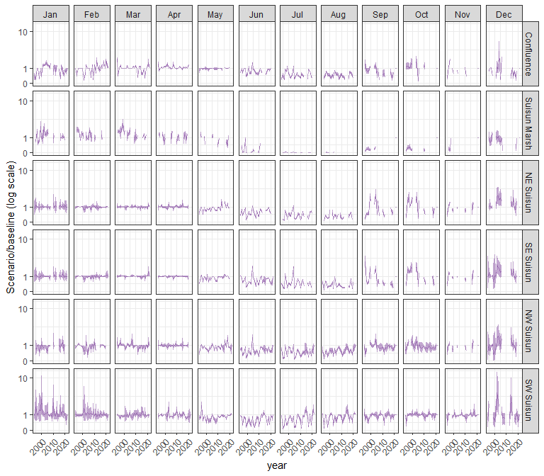

#### allcopnaup

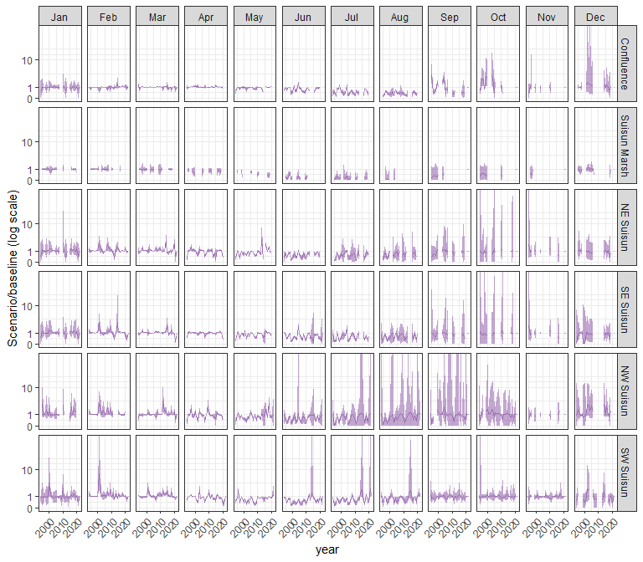

#### limno

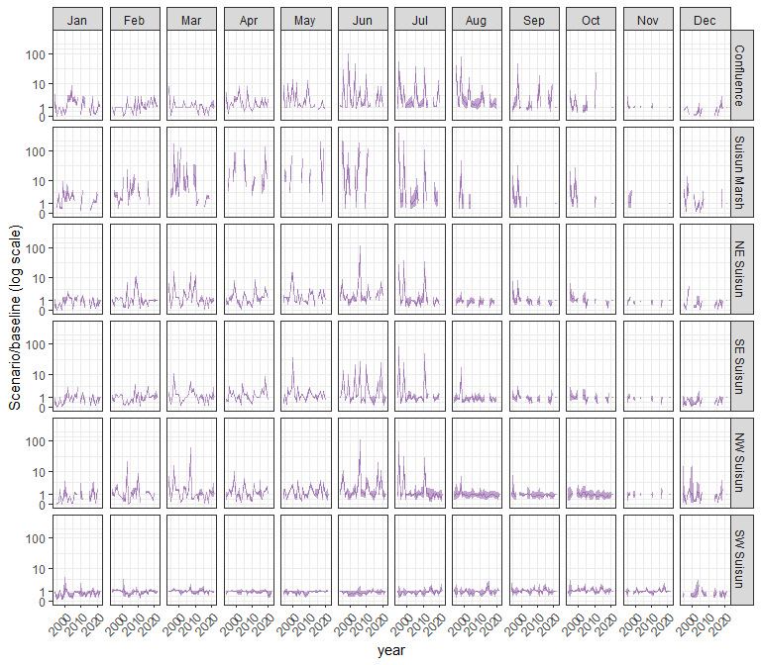

#### mysid

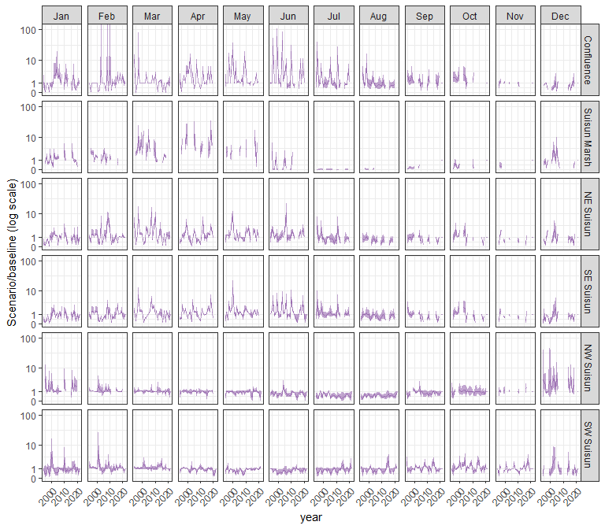

#### othcyc

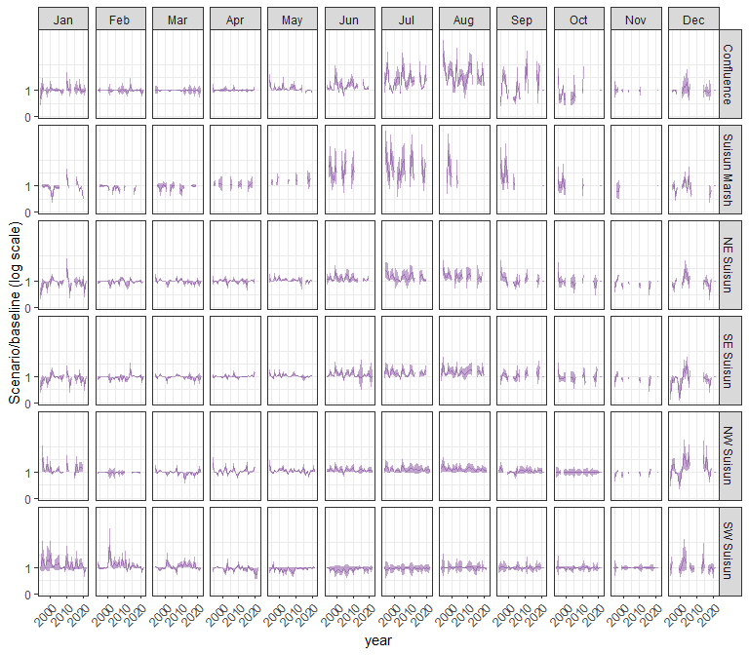

#### other

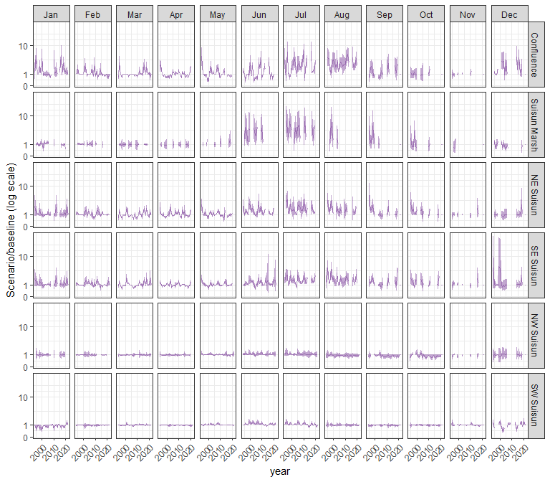

### sal_AltNoX2

#### acartela

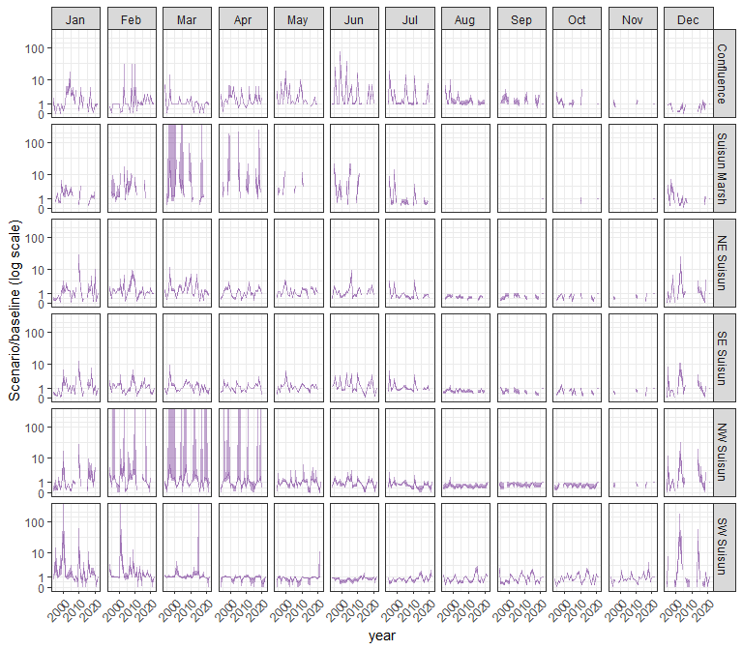

#### daphnia

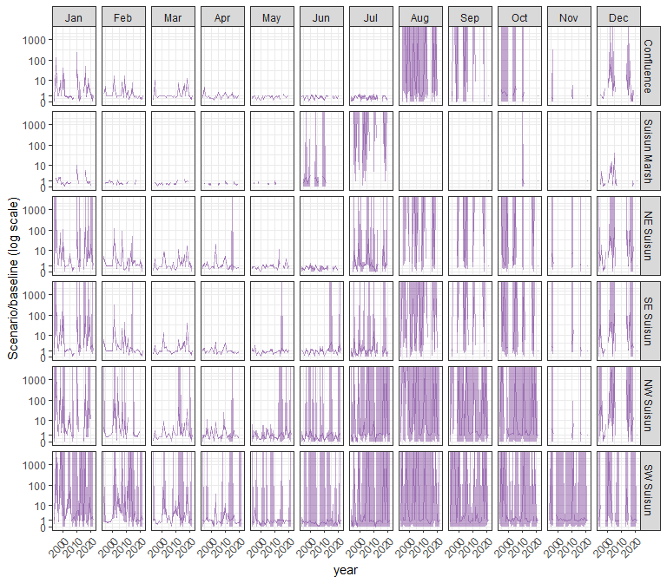

#### eurytem

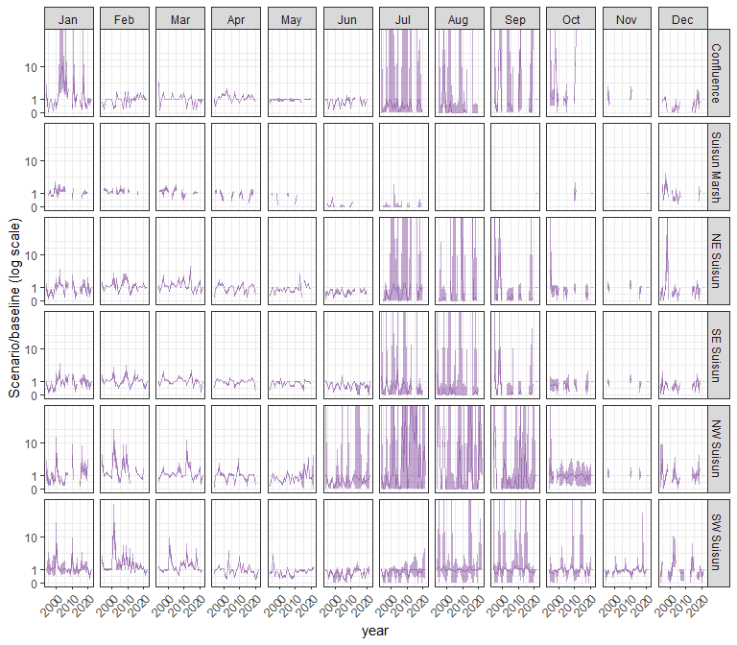

#### othcalad

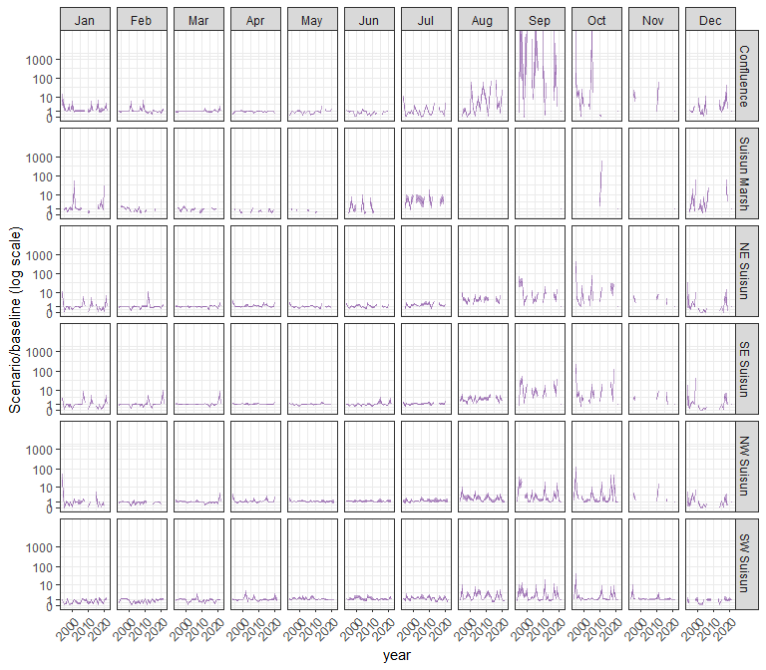

#### othcaljuv

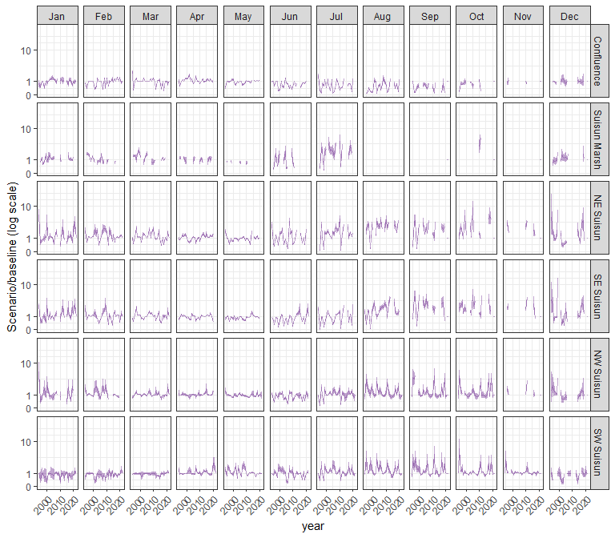

#### othclad

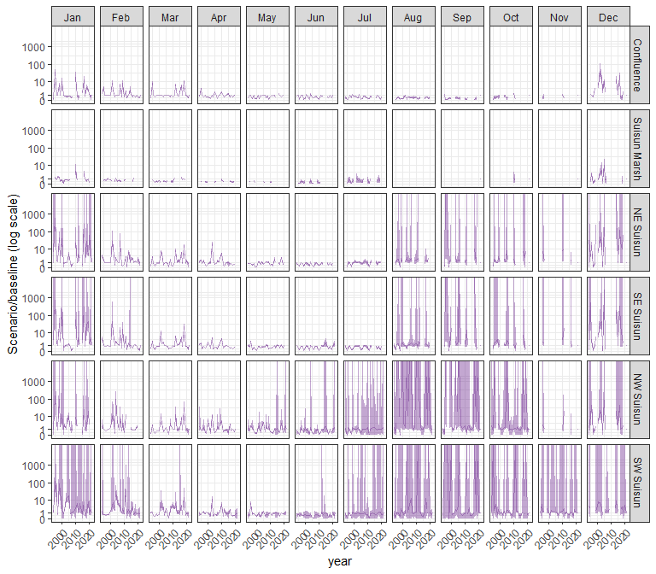

#### pdiapfor

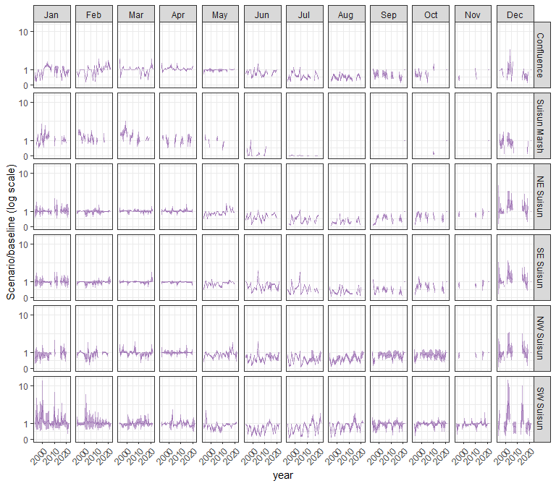

#### allcopnaup

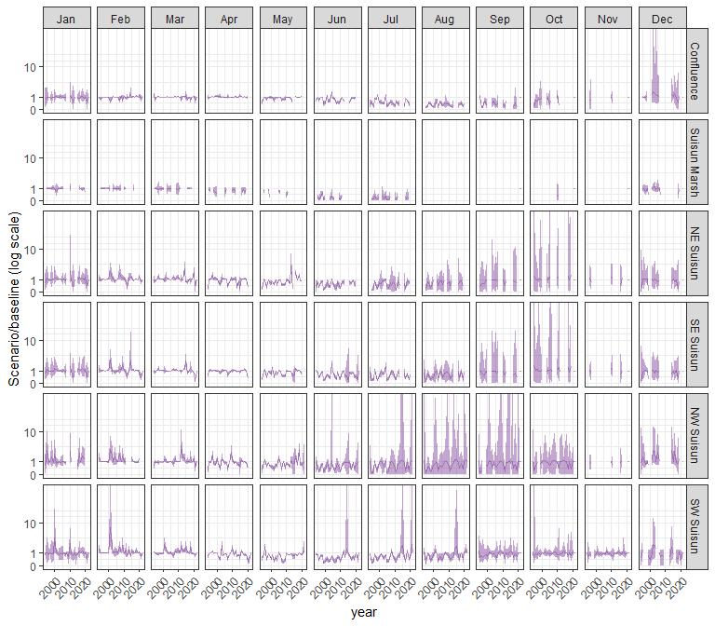

#### limno

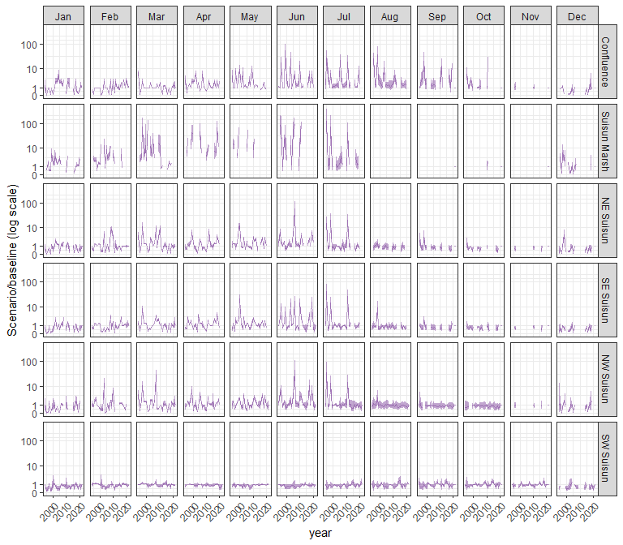

#### mysid

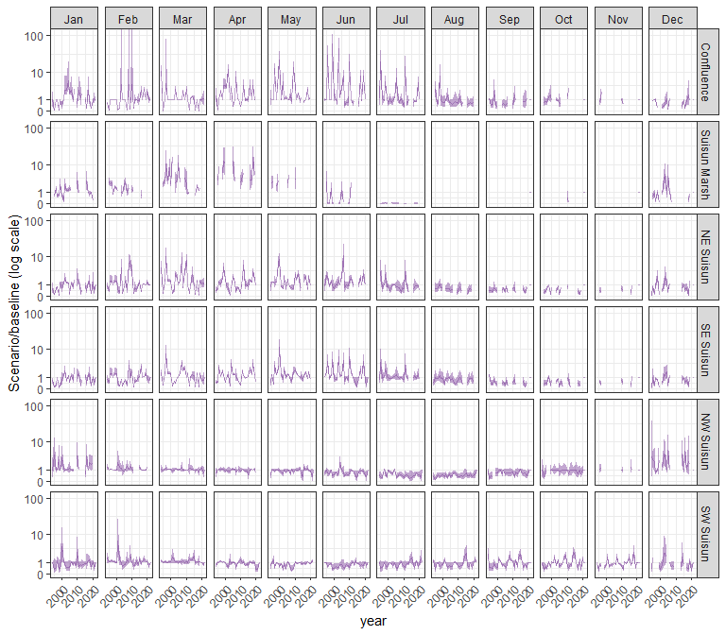

#### othcyc

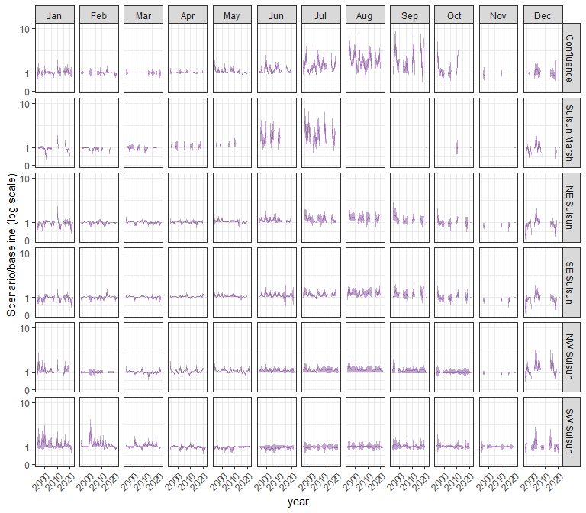

#### other

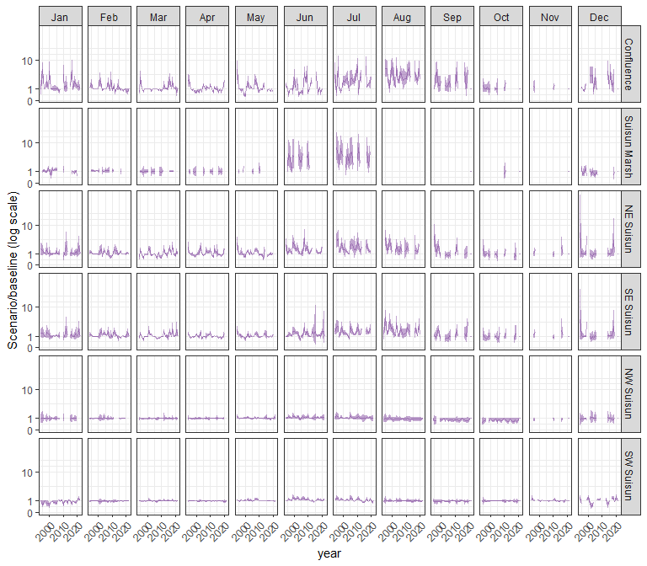

### sal_AltS74

#### acartela

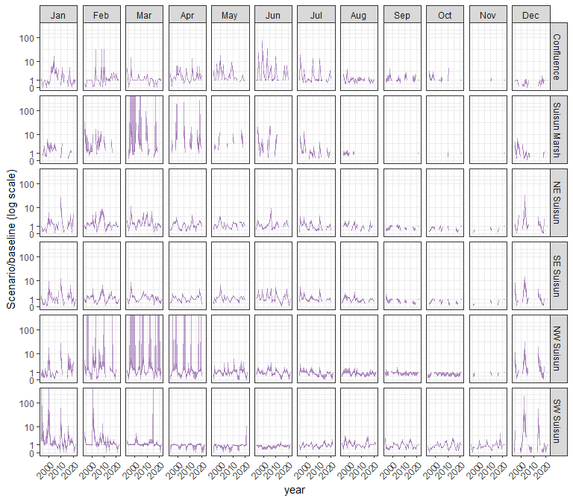

#### daphnia

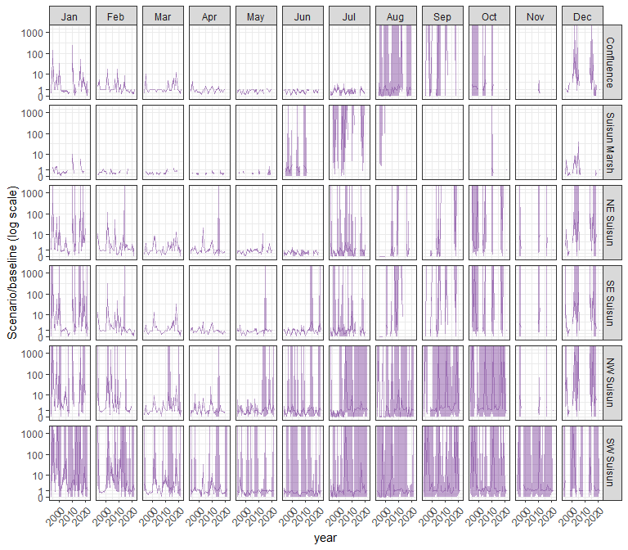

#### eurytem

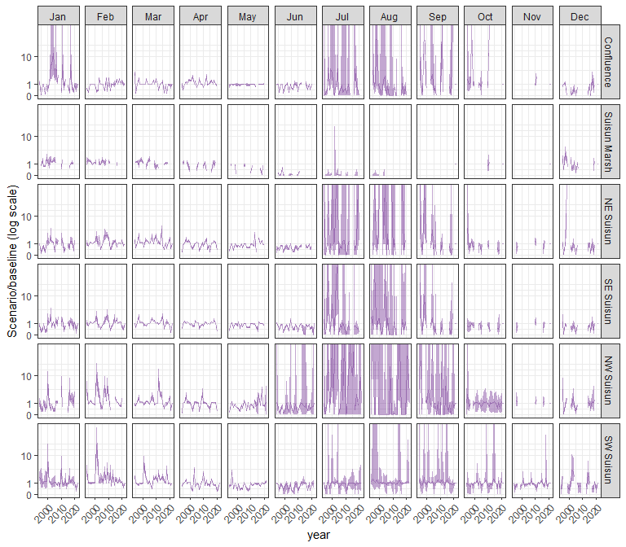

#### othcalad

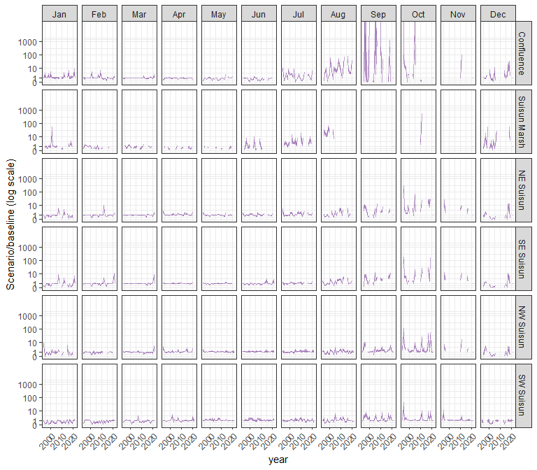

#### othcaljuv

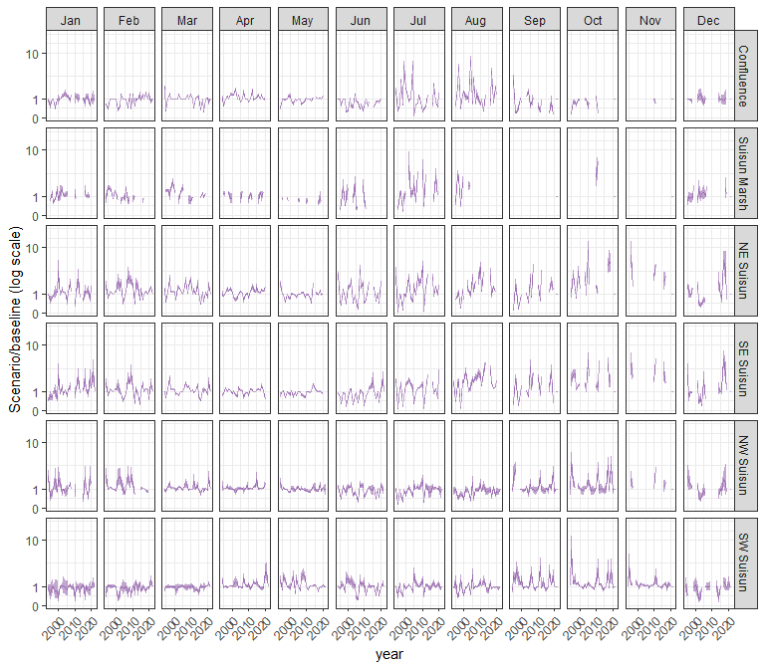

#### othclad

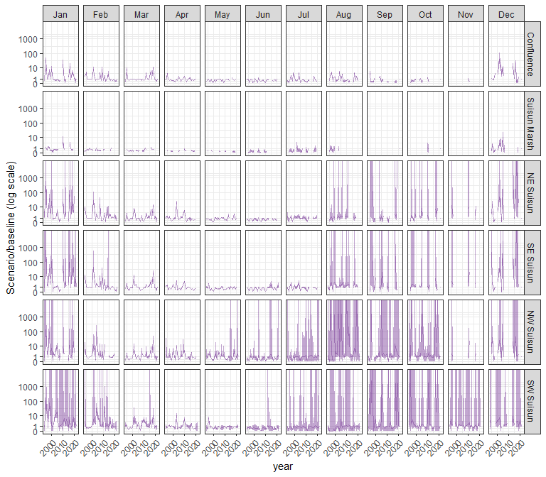

#### pdiapfor

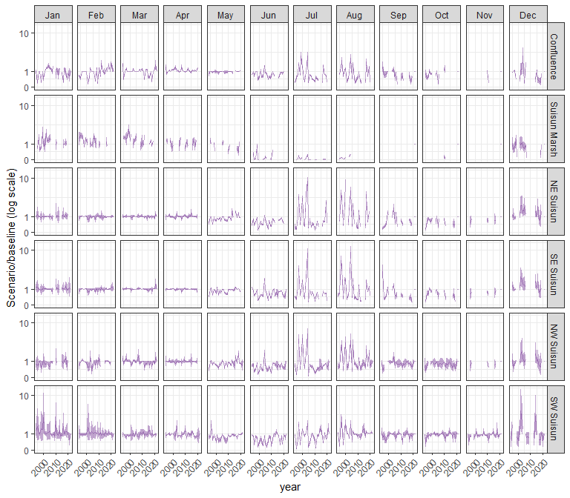

#### allcopnaup

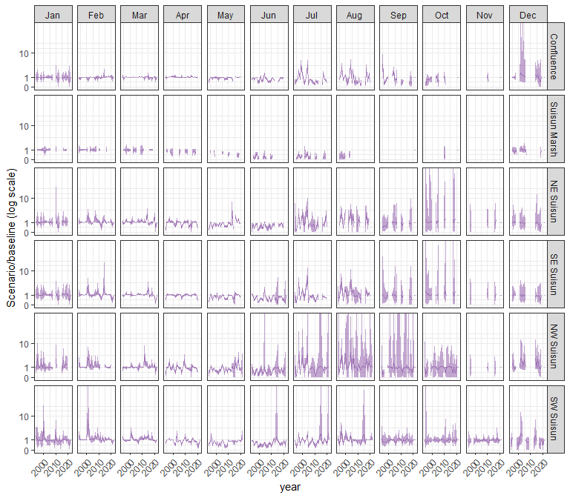

#### limno

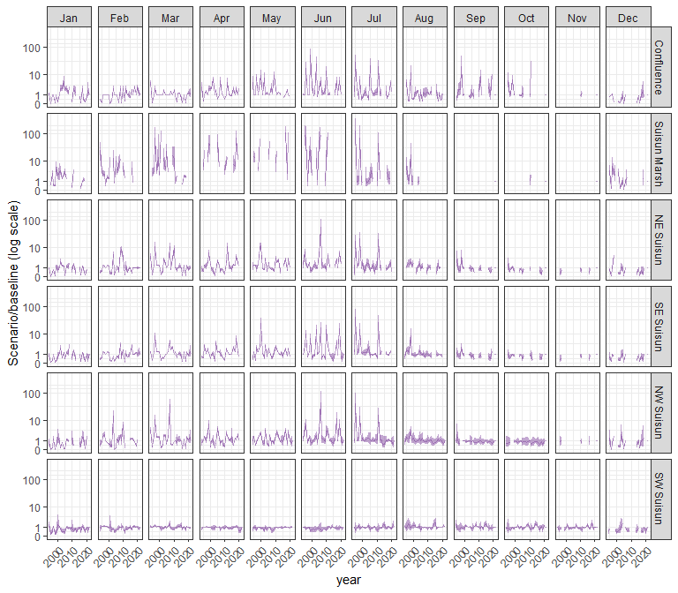

#### mysid

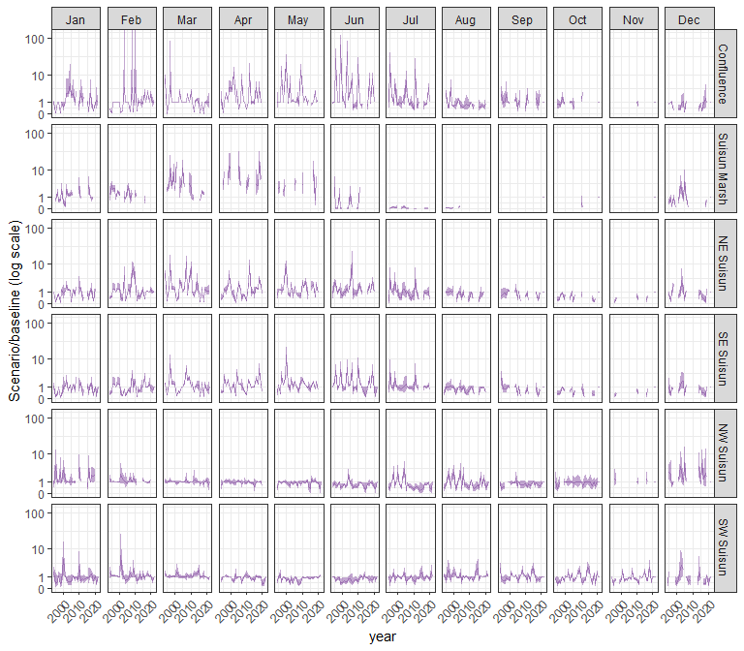

#### othcyc

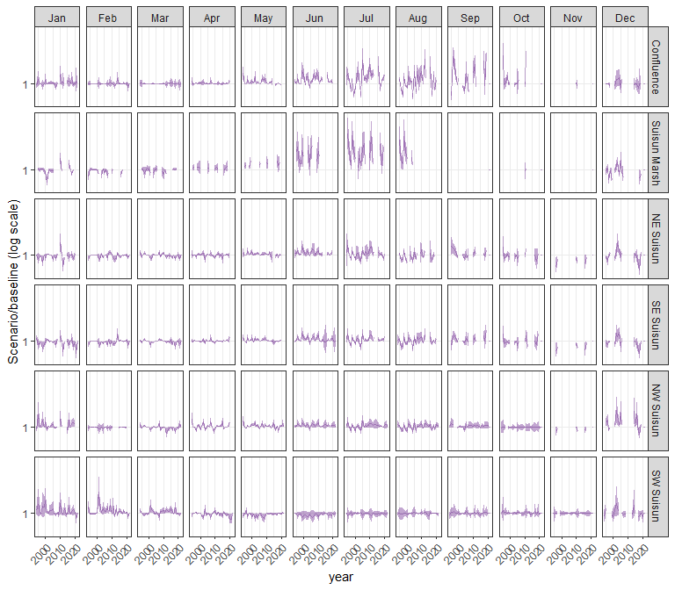

#### other

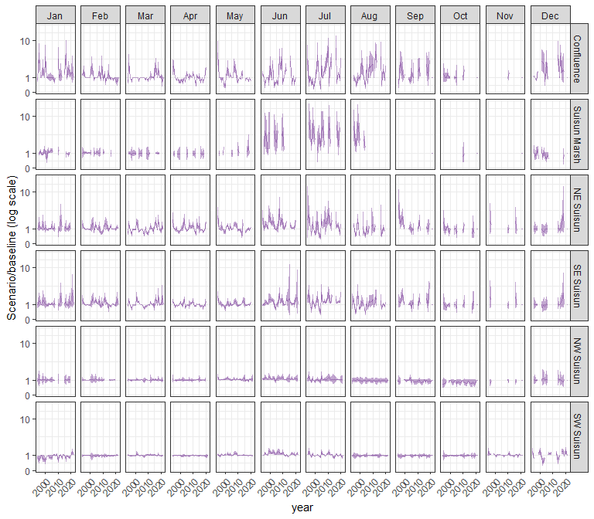

### sal_AltS74F80

#### acartela

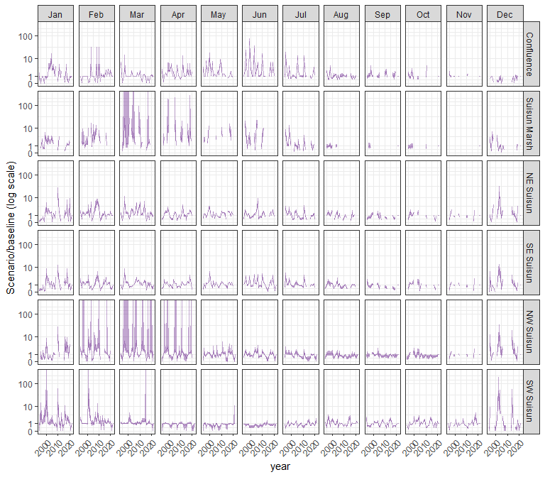

#### daphnia

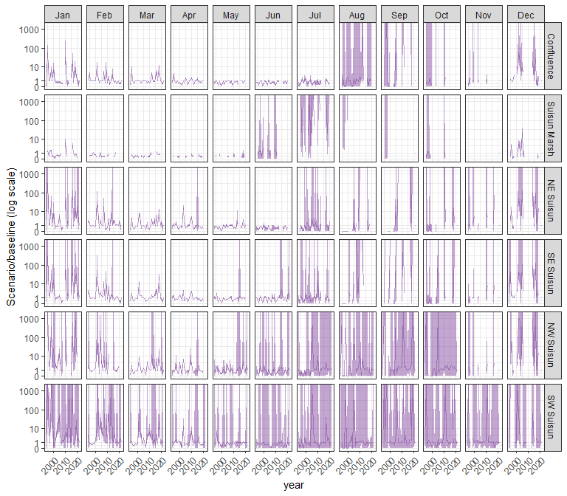

#### eurytem

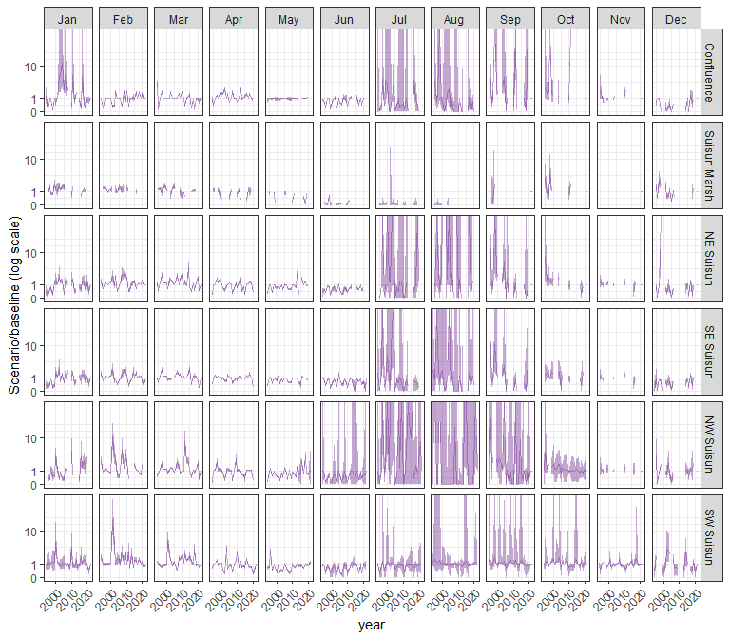

#### othcalad

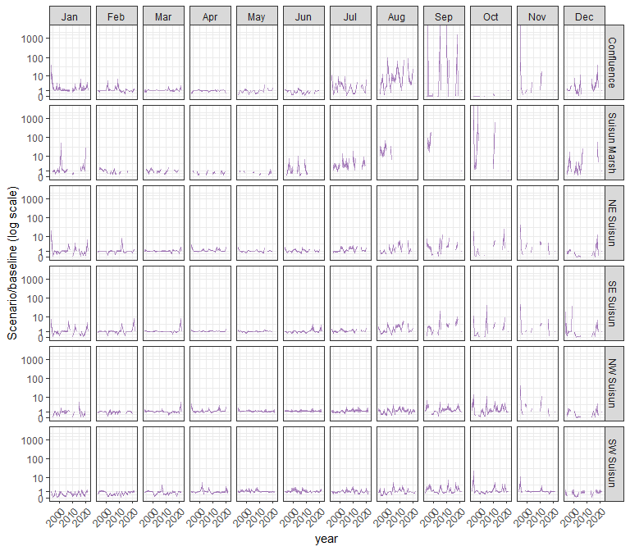

#### othcaljuv

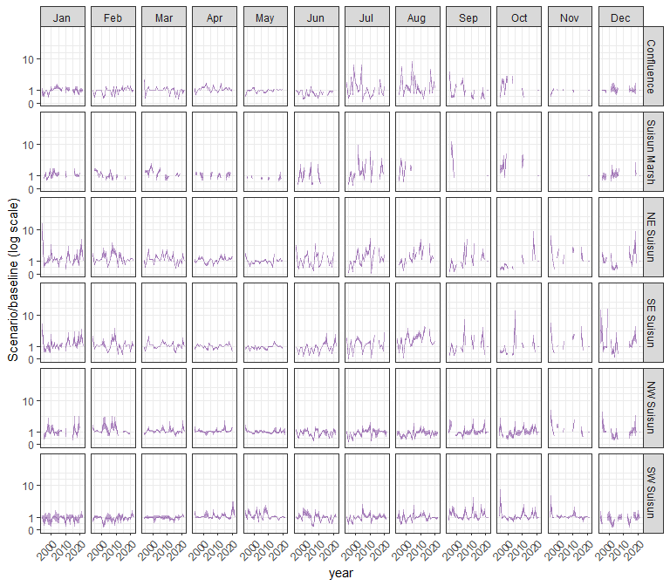

#### othclad

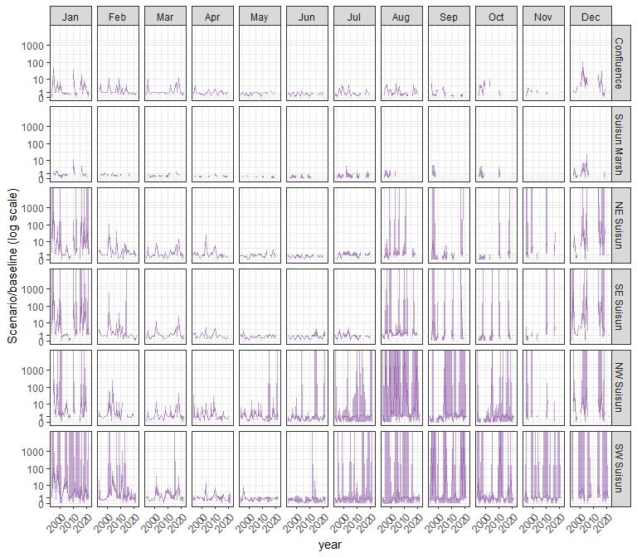

#### pdiapfor

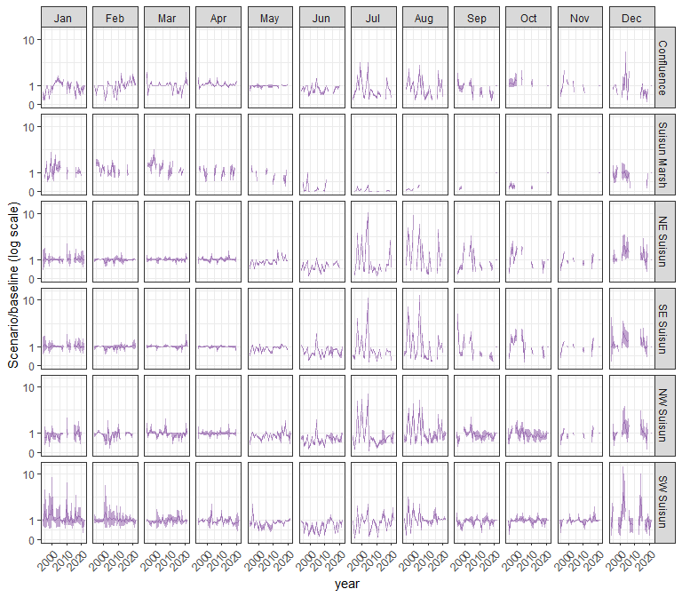

#### allcopnaup

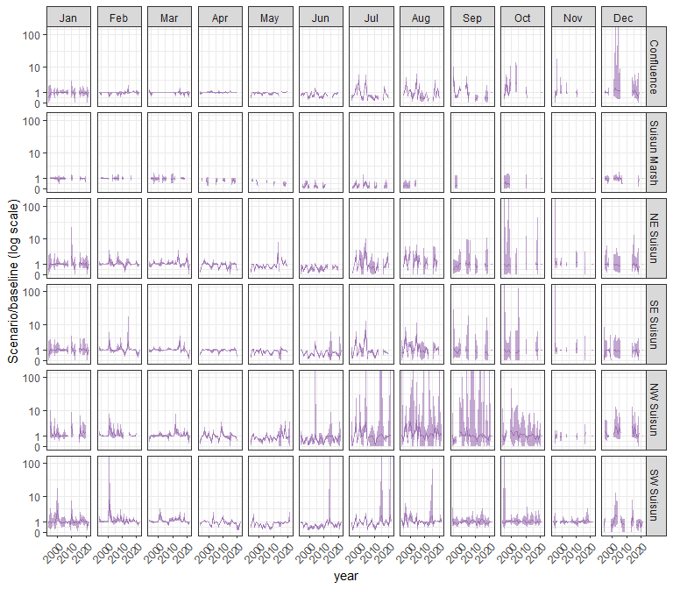

#### limno

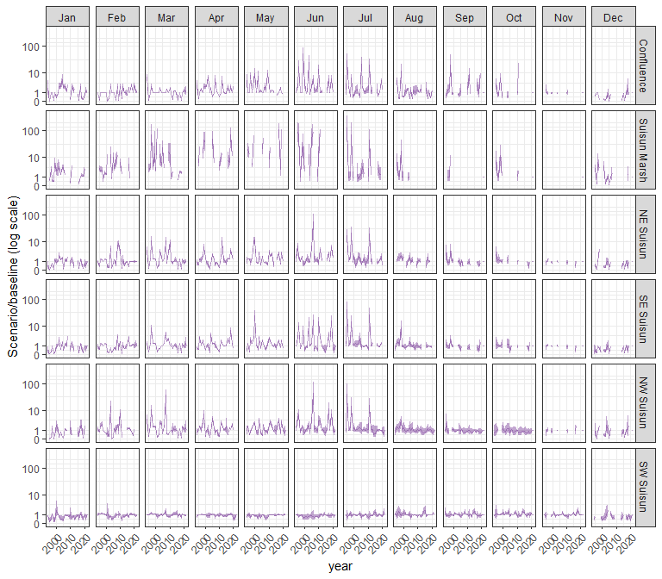

#### mysid

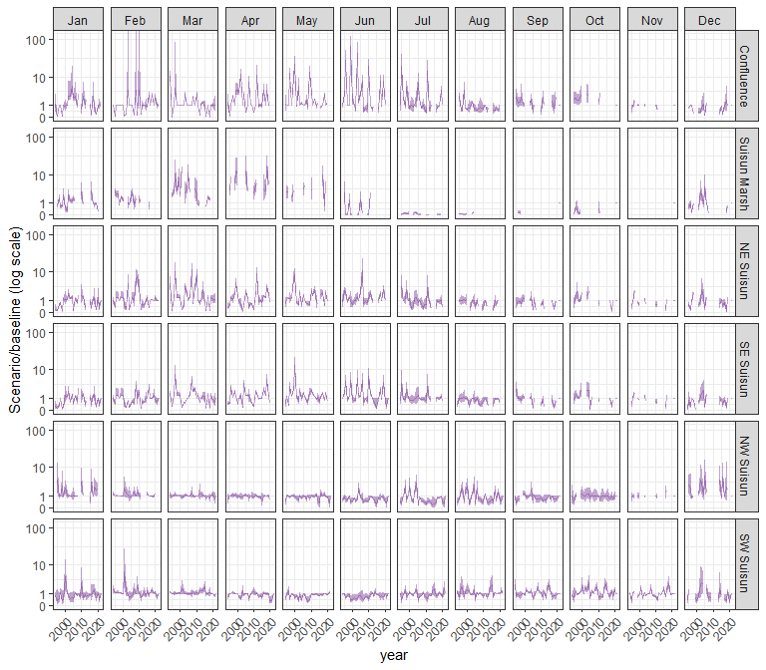

#### othcyc

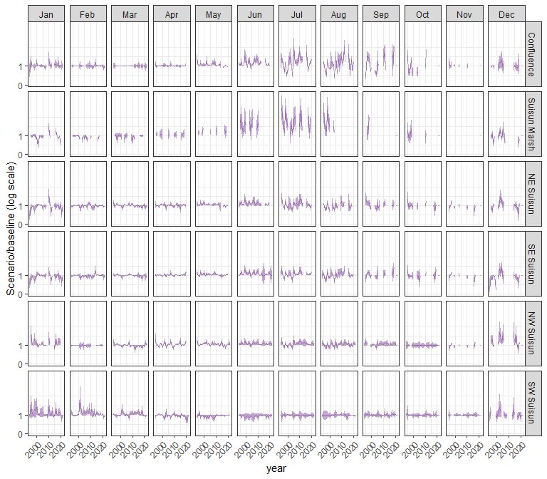

#### other

