California Statewide 1:100,000 Scale Routed Hydrography
Development and Distribution Report, September 2003
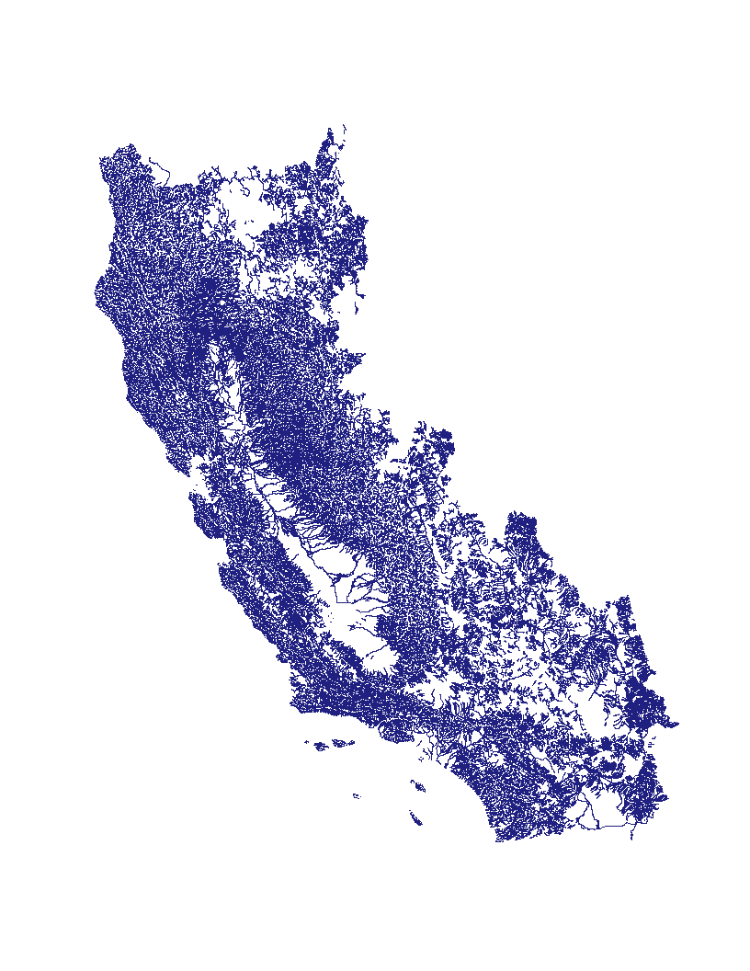
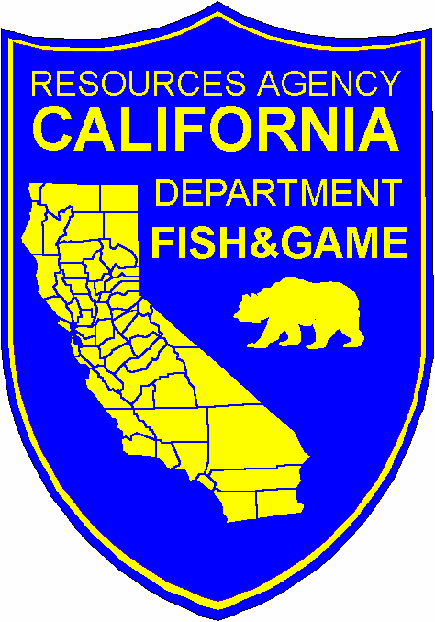



Contents:

The Dataset

Uses

History

Manual Stream Networking

Networking by GNIS and Stream Level

Adding Linework to the Dataset

Linear Referencing

Append HUCs

Output to Shapefile

Quality Checks

Managing and Review of Edit Requests

References

Appendix A: Stream Networking in ArcView 3.2

Appendix B: Linework Addition Procedure

Appendix C: Output Quality Check Procedures

Appendix D: Calhydro HUC Level Data Production Flowchart

The Dataset
The California Statewide 1:100,000 Scale Stream-Based Routed Hydrography Dataset (Calhydro) is comprised of measured hydrography developed by California Department of Fish and Game (CDFG) in conjunction with the Pacific States Marine Fisheries Commission (PSMFC). Calhydro was originated from digitized linework provided by the 1:100,000 scale National Hydrography Dataset (NHD) distributed by the United States Geological Survey (USGS). Calhydro is a “stream-based” hydrography because the linework provided was arranged or networked into what are commonly known as streams. The creation of Calhydro consisted of assigning streams with a unique identifier, the “Network ID”, then referencing the entire stream with measures from the mouth to the headwaters as one feature. To comply with the NHD, USGS Geographic Names Information System stream identifiers (GNIS points) and NHD stream level attributes are the standard networking factors in Calhydro. The current version of Calhydro is available for download from http://www.calfish.org/.

The usefulness of the Calhydro data begins with its simplicity. One of the primary goals in the development of the dataset was to create a measured streams coverage with a minimum number of records. Since many stream related surveys and data collection are performed using streams as the root event locator, a hydrographic dataset based on streams is a logical choice. Rather than receiving up to hundreds of returns when querying for a stream, a researcher now will only receive one. His/her event records are simplified also and measures don’t need to be combined to return a total stream measure.

Uses
The Calhydro data will support many applications from event mapping to data sharing between programs and agencies.
Cross referencing between different hydrographies is possible with unique Lattitude/Longitude Identifier (LLID).
The 1:100,000 scale Calhydro can be utilized as a jumping off point for more detailed hydro-centric projects such as localized hydrology studies.
The Calhydro development team encourages users of the dataset to modify and edit their own copy of Calhydro to meet their project needs. Please, when doing so, document your changes for later reference!

History
Prior to July 2002 Calhydro had been primarily in the possession of and under development by PSMFC personnel at Gladstone, OR with the assistance of CDFG Northern California North Coast Region Information Services Branch (NCNCR-ISB) personnel. Noteworthy accomplishments of the initial Calhydro team included the formatting of California statewide NHD HUC coverages into coverages specific to the Calhydro framework. The group then developed ArcInfo routines (.aml) to begin the networking process. Manual networking of streams that weren’t networked automatically was found to be necessary and PSMFC was successful at implementing an initial strategy to complete this task. Networking at the HUC level was discovered to be the practical solution to processing the data efficiently. After initial testing of the manual networking strategy, possession of Calhydro was transferred to the NCNCR-ISB office in Redding, CA where a data technician was assigned the task of completing the hydrography.

Manual Stream Networking
The two determining factors for Calhydro stream networking are, in order of priority, GNIS stream point features (available to CDFG as the “STREAM/RIVER” [Ftype] attribute in the cagnis2k.shp dataset,) and NHD [Level] attributes. The USGS “Geographic Names Information System Users Guide” can be viewed at Geographic Names Information System Data Users Guide. Information and download is available from the the State of California at The California Spatial Information Library - Geographic Names (GNIS). NHD stream level is a sequentially arranged numeric code derived from NHD-developed algorithms determining stream paths and flow levels. Stream level values are arranged from low to high with the lowest value (“1”) assigned to stream segments with the highest flow. Part of the stream level method is similar to the more familiar stream “order” where in a particular drainage the main stem receives the lowest value and all direct tributaries receive the next higher value and so on. NHD’s “Concepts and Content” document contains detailed explanation of stream levels and can be viewed online at this address: http://nhd.usgs.gov/chapter1/index.html.

Networking by GNIS and Stream Level
Although networking streams by GNIS determinants on the surface may seem straightforward, many challenges and pitfalls were discovered along the way and were met with the development of tools and error checking procedures to enable more accurate results. The standard for GNIS points representing streams include a point at the mouth and a point at the head of each stream as well as points along the stream corresponding to the boundaries of USGS 1:24,000 (7.5’) quadrangle maps. This is a logical and complete method for point placement, but unfortunately rendered the .aml routine developed for Calhydro ineffectual in many cases. The .aml routine in essence took GNIS points proximate to the stream mouth and followed the most efficient stream path to the like GNIS point at the head. The pitfalls to this approach included the frequent placement of multiple GNIS points at a given location, misplaced GNIS points not allowing for correct proximity determination, missing points associated with headwaters, gaps in linework preventing the completion of the network from the mouth to head, and incorrect (not coincident with quad map stream denotation) level values resulting in incorrect stream path determination. Visually cross referencing GNIS points with stream denotation on both 1:100,000 (100k) and 1:24,000 (24k) USGS quad maps was found to be a necessary practice in manually determining named stream courses.

Although every effort was made by ISB to adhere steadfastly to the GNIS and stream level networking parameters, many factors would inevitably contribute to the use of technician interpretation to complete certain stream networks. Interpretation of stream path using existing NHD linework would be needed when stream level assignement was confusing or “non-logical”. Figure 1 is an example of a case where arcs of the same stream level three-way intersect. The technician’s solution here was to network the north-south arcs (Network 1084) together because they join end to end and the east-west arc (Network 61148) was networked separately.

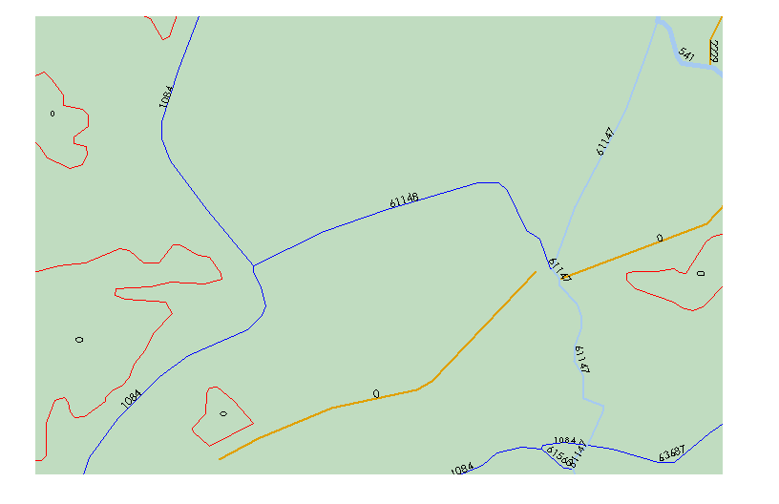
Figure 1

Networking streams according to the relative end-to-end alignment of arcs is a general rule followed when stream names and/or when stream level values were not available to determine the network. Arcs given the stream level value of “-9998” by NHD were generally not networked due to the even greater subjectivity necessary to determine networks in these cases. Some arcs or arc networks with level -9998 values were networked as they were determined by GNIS or visual consultation with quad maps or aerial photos to be wholly or part of named streams. Figure 2 is an example of such a case where the two orange arcs (indicating level -9998) labeled with Network ID 33241 belong to “Wood Slough” along with the level “5” arc to the northwest.

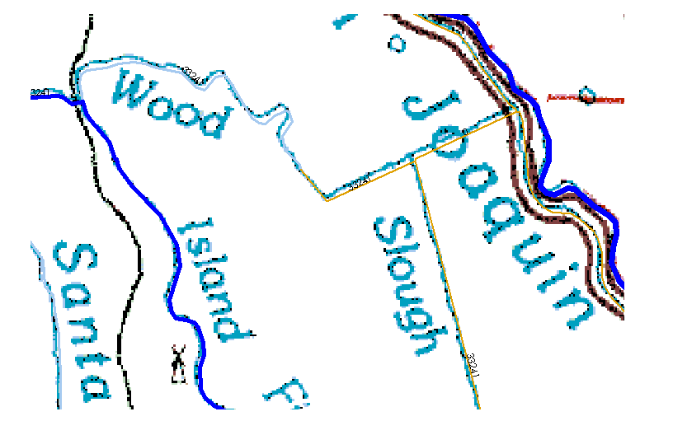
Figure 2
Adding Linework to the Dataset
Existing NHD linework was not modified during the process of creating Calhydro but situations did arise where the addition of linework was warranted. The most common of these situations involved “disconnection”, an occurrence where the linework did not connect at the mouth to its downstream branch. The decision in this case to add linework was determined by the presence of stream delineation on either 100k or 24k quads. All linework was heads up (on screen) digitized into the hydrography at a scale of 1:10,000 or larger from either of these quad maps.
It was supposed that when NHD linework was not present for a quad delineated stream it was due to accidental omission by NHD, and addition of linework for Calhydro would enhance rather than modify NHD. Many instances were observed where NHD linework ended at what appeared to be the boundary of a quadrangle and was not continued onto the next. Be aware that not all such cases of omitted linework were discovered during the course of creation of Calhydro, but many were. All linework added to the hydrography by ISB is indicated by the [Ftype] value “DFG CONNECTOR” in the “nhd” arc attribute table of the “Bigroutes” coverage feature. At the time of this document there were 692 linework additions to Calhydro.

Linear Referencing
Linear Referencing of stream features for Calhydro was done in ArcInfo/Arcedit 8.1.2 utilizing .aml’s written previous to July 2002. These .aml’s were eventually combined into the “delete_readcoords.aml” by the ISB data technician. The functions performed by “delete_readcoords.aml” include deleting previously referenced routes from the coverage, reading x/y coordinates from a list of coordinates located at or below the mouth of the streams to be routed, and routing the streams referenced from the point on the stream closest to the coordinates. This .aml enables automatic deleting and routing of multiple streams in a coverage from text lists.
Note: Original internal measures for NHD HUC coverages is in meters, the conversion into output in feet is performed as part the delete_readcoords.aml using the conversion factor of 1 meter = 3.280839895 feet.

Append HUCs
Once HUC coverages were complete and ready to be appended together into a larger coverage, an .aml written by CDFG/PSMFC staff was run to append the coverages into a coverage called Bigroutes. Once the HUCs were appended together, streams which cross HUC boundaries (i.e. streams which now include two or more segments) needed to be deleted and renetworked to prevent multiple routes utilizing the delete_readcoords_big.aml which is the “bigroutes” version of delete_readcoords.aml. This application works exactly the same as delete_readcoords.aml but edits the appended “bigroutes” coverage rather than individual HUC “nhd” coverages.
Note: ISB found it necessary also to repeat the routing procedure on streams that were found to have a “bigroutes” coverage vs. shapefile measures discrepancy. This discrepancy was found to be due to unresolved routing problems in the coverage at the head areas of streams that are bound by a lake or pond boundary. ArcInfo was found to abandon the networked arc at the centerline of the pond and follow the pond boundary in these situations (see Figure 3). Repeating the routing procedure on these streams at the “bigroutes” level corrected these routes.
Figure 3

Incorrectly routed stream
Output to Shapefile
Network

Pond Boundary
Mouth
Routed Network

Mouth
50 ft.
Pond Boundary
79 ft.
Correctly networked stream
Incorrectly Routed Stream
A tool set called “Hydrotools” was created by ISB for use in ArcView 3.2 to aid in creation of the output Calhydro shapefile. After conversion in ArcView 3.2 to shapefile, the shapefile was converted to a measured shapefile utilizing Hydrotools, stream measures were set, and stream and downstream properties added to the attribute table. The Stream Properties include the stream’s length in feet ([Length_ft]) and coordinate fields for both the mouth ([DownX] and [DownY]) and headwaters ([UpX] and [UpY]). Stream Properties in the attribute table eliminate the need to manually measure and locate streams. Downstream Properties ([Down_llid], [Down_name], and [Down_meas]) describe properties of the stream’s distributary; its LLID, name, and it’s measure at the confluence with the selected stream. Downstream properties are useful to identify unnamed streams by their downstream properties. Additionally, multiple unnamed streams with a common distributary can be spatially arranged by their respective Down measures. Finally, a [Mouth] field was added to the attribute table and populated with values explaining the absence of a Downstream (LLID), for example it may have no distributary because it terminates at the ocean.
Also included in the Hydrotools suite is an LLID calculator. LLIDs have been created for the entire statewide coverage so it is necessary that these established LLIDs are retained for updated versions of Calhydro and even edited streams retain the same LLID. The LLID calculator will only be used, then, for a new stream being added to Calhydro.
An ArcInfo coverage with a route.streams feature identical in format to the shapefile has been included as well in the distribution of the dataset. See Appendix A-D at the end of this document for tips on editing the Calhydro ArcInfo coverage.

Quality Checks
Numerous quality check procedures have been developed during the evolution of the Calhydro dataset, and two have been incorporated into the Hydrotools tool set. Included are a “Check for Duplicate LLIDs” query. The other is“Check for Multipart Features” which actually performs two functions. It will discover routes that are made up of two or more segments (e.g. routes with gaps) as well as routes that have not been referenced correctly to the mouth of the stream. If the stream was referenced to a point other than the mouth and more than one arc made up the route, measurement errors will result in the creation of a multipart feature. All multipart features have been repaired in the current release of Calhydro.
Stream names are an important part of the completed Calhydro dataset, as they aid in the querying capabilities of its users. To avoid query confusion special attention has been paid to assuring that a name query won’t result in a stream’s name and its downstream stream’s name being the same. This includes all braided channels. Only main stem channels have names associated with them in Calhydro (main stem derived from NHD [Level] values). ISB used a simple ArcView query in the shapefile/coverage under development for [Name] = [Down_Name] to expose these errors. ISB is also aware that at the release of the current version of Calhydro many streams are unnamed although they have potential GNIS names associated with them. A querying mechanism is under development to include more GNIS names in the data.

Managing and Review of Edit Requests
The Calhydro development team encourages interaction with Calhydro users and has created what they hope to be an ongoing means to do so with the “Edit Request”. Edit Request forms are included in the download package from Calfish in two formats, a Microsoft Word document and an Adobe Acrobat .pdf form. Calhydro staff allows for for users to send electronically either version of a completed form or fax to the address provided. Records of edit requests received are entered into a Microsoft Access database maintained at this time by ISB. As well, hardcopies from fax and electronic copies of Edit Request forms are kept on file at ISB.
All Edit Requests received by ISB are subject to review. Although a formal review procedure is yet to be developed, Calhydro staff has already received many edit requests from the interim release of the anadromous Calhydro (ver. 2003.2), all of which have been reviewed and those approved for edit have been incorporated into the current Calhydro release (ver. 2003.5). ISB reviewed all of the requests and approved all of those that fell within Calhydro development and editing parameters. A few of these requests were rejected by ISB for non-compliance with Calhydro standards. These rejections are also documented in the ISB maintained database.

References

United States Department of the Interior, U.S. Geological Survey, 2000, “The National Hydrography Dataset, Concepts and Contents” http://nhd.usgs.gov/chapter1/index.html

United States Department of the Interior, U.S. Geological Survey, 1995, Reston, VA, “Geographic Names Information System, Data Users Guide 6” http://mapping.usgs.gov/www/ti/GNIS/gnis_users_guide_toc.html

Appendix A: Stream Networking in ArcView 3.2
After initial experimentation with manual stream networking, ISB staff decided to use ArcView 3.2’s attribute editing and tool development capabilities for this task. Networking was accomplished at the HUC level rather than in the larger appended coverage to enable acceptable processing speed. Appending of HUCs into the larger statewide coverage is discussed elsewhere in this document. The ArcView networking project should include the ArcView extension developed specifically by ISB for Calhydro networking called “HydroCreate Tools (ver.1)” and a script called “addGNIS” developed by ISB to efficiently populate GNIS information into the dataset. In its simplest form, network editing in Calhydro is the process assigning values to the [Network ID] field in the “nhd” arc coverage for subsequent routing. We’ve come up with a few ways to make this task more accurate and less time consuming.
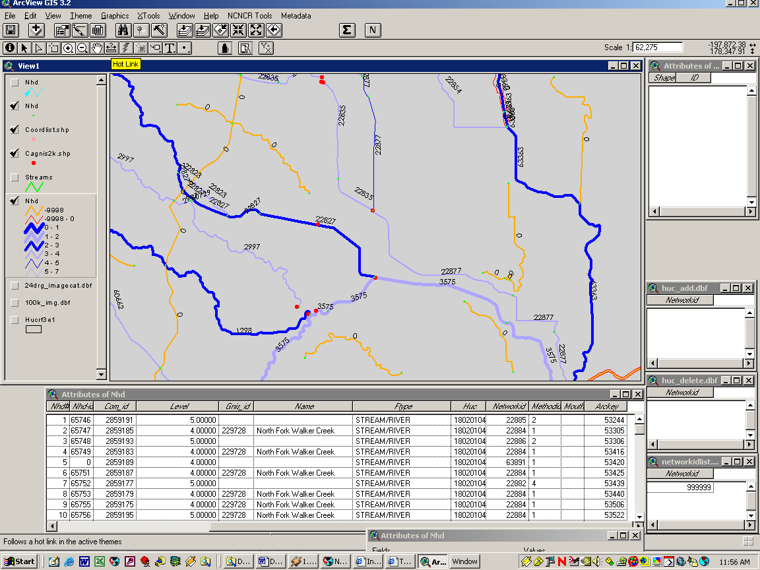
Figure 1: Typical ArcView Networking Environment

ArcView Setup
Several layers and tables are suggested to be included in the ArcView project for the successful networking to take place. First, the HUC coverage features you’re currently working with should be added to the view, these include the “nhd” or arc feature, the node feature for displaying arc endpoints, the streams feature for displaying a comparison of previously routed networks (helpful when making changes to networks), and an additional arc layer displayed with flow direction arrows (helpful when toggled and off occasionally when flow direction is not obvious otherwise). ISB found it helpful to display the original arc layer with graduated symbols and alternating colors of stream levels for a quick visualization of stream level paths (see Figure 1) and to label the arcs with their currently assigned Network ID value. Also present in the view are the Cagnis2k.shp “Stream” points (red dots), and links to USGS 24k and 100k quads. Finally, create a new point shapefile called “Coordlist.shp” and bring into the view, this will be populated while using the HydroCreate Tools. Also necessary for the proper function of the HydroCreate Tools are the inclusion of three .dbf tables, huc_add, huc_delete and networkidlist, each formatted with one unpopulated field labeled “Networkid”. All of these elements need to be stored in the same directory as the HUC coverage you’re working in on your Data drive along with the following object: the “delete_readcoords.aml” (this is the routing .aml).

HydroCreate Tools is a networking tool providing four buttons located in the ArcView View toolbar. They work with the “nhd” or arc layer activated and visible in the view. The “Gas pump” button retrieves an arc’s “Network ID” value by mouse clicking on the arc. Activating the adjacent “Draw” button assigns the retreived Network ID value to an arc by clicking on it. The “XY” button creates a point feature by mouse click in the view and populates an [ID] record in the “Coordlist.shp” attribute table. Network ID values will concurrently be populated into the associated .dbf tables during use of Hydrocreate Tools. These values are important later during the linear referencing (routing) process. The fourth “N” button when clicked on creates a new unique Network ID value (the next sequential value from the networkidlist.dbf) for assignment to new stream networks. If you want to assign a new Network Id to a stream, click on the “N” button rather than the “Gas pump” button before assigning values with the “Draw” button.

“addGNIS” is an ArcView script linked to a button labeled “G” visible when the nhd arc attribute table is active. To use select the appropriate GNIS point in the view and all of the arcs making up the network to be named, make the attribute table editable and active, then click on the “G” button in the toolbar. The selected records in the nhd arc attribute table will be populated with the point’s GNIS_ID, Name and a [Methodid] value of “1” indicating “networked via GNIS”. See the Calhydro metadata for explanation of [Methodid] values.

Important: When the necessary edits are completed to the HUC coverage you’re working in be sure to save all edits and close the project before running the routing .aml.

Appendix B: Linework Addition Procedure
ISB decided to use ArcMap/ArcInfo 8.1 to perform linework additions because of its integrated editing capabilities. Linework addition can be accomplished in ArcMap while retaining table relationships and utilizing ArcMap’s familiar graphic interface. Set the ArcMap editor to edit the arc feature within which you are working and with snapping enabled to ensure connection between the new line and existing linework, heads-up digitize in the direction of flow the new linework into the “nhd” arc feature at a scale of 1:10,000 or larger. Give the digitized linework a unique [ArcKey] value, a [Level] value of “-9999”, and an [Ftype] value of “DFG CONNECTOR” or something unique to your project. After saving edits the linework is then ready to be networked.

Appendix C: Output Quality Check Procedures
Numerous quality check procedures have been developed during the evolution of the Calhydro dataset, and two have been incorporated into the Hydrotools tool set (for use in ArcView 3.2). Included are a “Check for Duplicate LLIDs” query. Always run this before finalizing the output, and remember, LLIDs must be retained between versions so if duplicates are found involving an established stream and a new one, change the new LLID and retain the old one.

The other quality check in Hydrotools is “Check for Multipart Features” which actually performs two functions. It will discover routes that are made up of two or more segments (e.g. routes with gaps) as well as routes that have not been referenced correctly to the mouth of the stream. If the stream was referenced to a point other than the terminous and more than one arc made up the route, measurement errors will result in the creation of a multipart feature. If the route was made up of only one arc and was mis-referenced, the resultant reference point on the stream will be the endpoint of the stream closest to the reference coordinates.

To check for measures discrepancies between the routed coverage and the measured shapefile open the coverage’s nhd.secstreams info table in the ArcView project and run a summary table on the [Routelink#] field, adding [T-Meas]/Maximum. Join the summary table back to the measured shapefile joining [Routelink#] to [Streams#]. Create a new Number field in the attribute table and calculate the difference between the attribute table’s [Length_ft] values and the joined table’s [Max_T-Meas] values. Values calculated greater than 0 need to be checked for routing errors.

Stream names are an important part of the completed dataset, as they aid in the querying capabilities of its users. To avoid query confusion special attention has been paid to assuring that a name query won’t result in a stream’s name and its downstream stream’s name being the same. This includes all braided channels. Only main stem channels have names associated with them in Calhydro (main stem derived from NHD [Level] values). ISB used a simple ArcView query in the shapefile/coverage under development for [Name] = [Down_Name] to expose these errors. ISB is also aware that at the release of the current version of Calhydro many streams are unnamed although they have GNIS names associated with them. A querying mechanism is under development to solve this problem.

Other things to check for before finalizing the output:

Check that all streams with a null value for [Down_LLID] have associated [Mouth] values. Conversely, check that there are no [Mouth] values associated with streams with a [Down_LLID] value.

Check by simple query that there are no duplicate [Network ID] in the dataset. If so, reassign and re-route networks.

Appendix D: Calhydro HUC Level Data Production Flowchart

