This is just a basic example to illustrate the usage of Apache Spark with Cloudera's platform. You can build upon this code to include more complex data processing operations, additional transformations, and integrations with other Cloudera services or tools as needed.

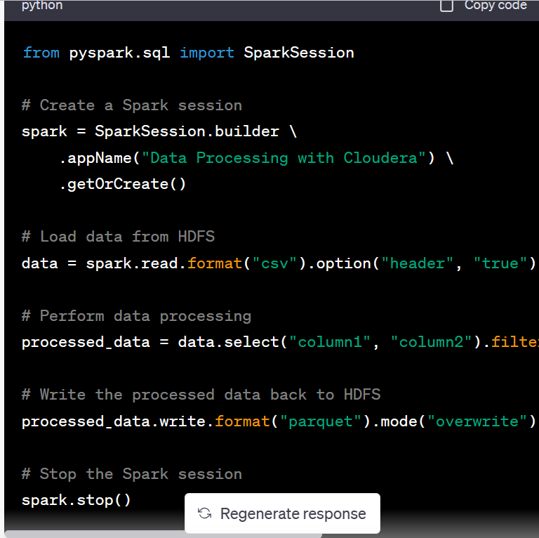

This is just a simple example to demonstrate the usage of HiveQL with Cloudera's platform. You can expand on this code by creating more complex table structures, defining partitions, performing joins, aggregations, and other SQL operations supported by HiveQL.

