Journal: *Hydrobiologia*

Type: Article

**Assessing a standardized method to identify optimal baselines for trophic position estimation in stable isotope studies of stream ecosystems**

Nathan T. Barrus*❖, Bryan M. Maitland†, Frank J. Rahel

NTB: Department of Zoology & Physiology and Program in Ecology, University of Wyoming, Laramie, WY, USA, nbarrus1@gmail.com, ORCiD = 0000-0001-7503-3120

BMM: Department of Zoology & Physiology and Program in Ecology, University of Wyoming, Laramie, WY, USA, bmaitland101@gmail.com, ORCiD = 0000-0002-4491-5064

FJR: Department of Zoology & Physiology and Program in Ecology, University of Wyoming, Laramie, WY, USA, frahel@uwyo.edu, ORCiD = 0000-0002-0932-3485

*Corresponding author: nbarrus1@gmail.com, (307) 431-0859

❖Current affiliation: Florida International University, Department of Biological Sciences, Miami FL, USA

†Current affiliation: University of Wisconsin-Madison, Aquatic Science Center for Limnology, Madison, WI, USA

**Statement of authorship**: Conceptualisation: NTB, BMM. Developing methods: NTB, BMM. Data analysis: NTB, BMM. Preparation of figures and tables: NTB. Conducting the research, data interpretation, writing: NTB, BMM, FJR. All authors contributed critically to the drafts and gave final approval for publication.

**Data accessibility statement**: The data and code supporting the results will be archived on GitHub and in the Zenodo public repository.

**Conflict of Interests**: None to declare.

**Abstract**

Nitrogen stable isotope ratios (15N:14N, δ15N) are widely used to quantify vertical trophic structure in aquatic ecosystems. However, comparing trophic structure across different geographical locations requires identifying suitable isotopic baselines due to large variation in isotope values at the base of food webs. Here, we evaluate the effectiveness of a standardized method for identifying optimal isotopic baselines developed for lowland temperate streams by applying it to stream systems spanning the Rocky Mountains–Great Plains ecotone. We assessed different taxonomic groups and functional feeding groups as optimal baselines following four criteria: 1) ease of collection and wide distribution, 2) low within-site δ15N variation, 3) δ15Nvalues are correlated with background δ15N variability, and 4) no systematic change in calculated consumer trophic positions across space (i.e., independent of system-specific δ15N variability). We found that Simuliidae (obligate filter feeders) met all four criteria and had the lowest within-site variation, likely because of similar feeding ecologies. Trophic position estimates based on Simuliidae baselines of three fish species, each with similar diets across the Rocky Mountains–Great Plains gradient, were independent of systematic δ15N variability. Further, two species that exhibited shifting diets across the ecotone were correctly adjusted. Our results suggest that the proposed screening procedure is adequate, and we recommend the use of Simuliidae or filter feeders in general as baseline organisms for stable isotope studies in temperate stream ecosystems. Given variability in δ15N values across the landscape, our identification of a regionally-derived baseline indicator organisms should aid in quantifying fish trophic position in stable isotope studies in lotic systems.

**Keywords**: stable isotope analysis, trophic level, isotopic baselines,

**Introduction**

Food webs depict trophic relationships among species that determine energy and material fluxes within and between ecosystems (Paine 1980, Thompson et al. 2012). One major goal in ecology is to understand how trophic relationships vary over space and time, which is often done by quantifying an organism’s trophic position on a continuous scale. Stable isotope analysis is now widely used to assess trophic position (Fry 1983, Cabana and Rasmussen 1996, Reid et al. 2008). In particular, the ratio of stable isotopes of nitrogen (15N:14N, δ15N) is used to estimate trophic position (TP) of organisms because of changes in the proportion of light to heavy nitrogen isotopes during trophic transfers from one trophic level to the next (DeNiro and Epstein 1981, Minagawa and Wada 1984, Fry 1988, Martinez del Rio and Wolf 2005), resulting in consumers having tissues enriched with the heavy isotope relative to their food resources. Such an approach can be used to quantify shifts in food web structure from species invasions (Vander Zanden et al. 1999, Rogosch and Olden 2020, Kirk, Maitland et al. 2021) or to understand contaminant biomagnification (Lepak et al. 2019). However, in aquatic ecosystems, large spatial variability in nitrogen isotope ratios at the base of local food webs can make the comparison of TP among sites or along environmental gradients problematic (Anderson & Cabana, 2005; Barnes *et al.*, 2008).

Variability in δ15N values arises from natural processes including in situ denitrification and nitrogen fixation, as well as from land use changes (Chappuis *et al.*, 2017). For example, anthropogenic sources of nitrogen (i.e. agriculture, sewage treatment, livestock manure) can increase the number of denitrified components of nitrogen in the system (i.e. ammonium and POM) through bacterial decomposition. Because bacteria preferentially use 14N over 15N when breaking down organic materials, the remaining nitrogen that enters aquatic ecosystems have elevated δ15N values (Di Lascio *et al.*, 2013), which can propagate up through food webs. In the Saint Lawrence lowlands in Quebec, Canada, primary consumer δ15N values increased up to 15 per mil with regional nitrogen loading from synthetic fertilizers and manure from pig, chicken and cattle operations (Anderson & Cabana, 2005). In contrast, watersheds in the northeastern United States dominated by natural forest cover exhibit variability in δ15N on the order of 2 per mille (Mayer *et al.*, 2002). In streams in northeastern Spain, δ15N values of basal resources are highest in human-impacted mainstem locations (Pastor *et al.*, 2013), and anthropogenic land-use practices have been shown to increase δ15N values in lacustrine systems in Rhode Island (Lake *et al.*, 2001) and boreal streams in south-central Sweden (Bergfur *et al.*, 2009). Accordingly, comparing TP estimates from different locations can lead to erroneous inferences of food webs structure and trophic relationships.

To account for the effects of geographic variation in isotope levels, TP is typically estimated relative to an isotope “baseline” (i.e., material representing geographic variation) using simple formula transformations or statistical analysis (Kjeldgaard et al 2021). These approaches generally use a proxy organism as a baseline to correct for background δ15N variation across space (Cabana and Rasmussen 1996, Post 2002, Jardine et al. 2012, Kristensen et al. 2016). While this proxy organism approach has been applied in food web studies, it has limitations which require careful consideration before a proxy baseline is selected. Primary consumers have short life cycles and high tissue turnover rates which prohibits useful interpretation of higher trophic levels due to differing temporal resolutions. So researchers have tended to collect all potential basal primary resources at a site (i.e., suspended and benthic organic matter, biofilms, filamentous algae, macrophytes, and riparian vegetation) in replicate multiple times during a given time interval (e.g., three times over growing period) and use the average δ15N values of the primary producers as the baseline (Vinagre *et al.*, 2008; Govender, Smit & Perissinotto, 2011; Caravalho et al., 2015). But collecting primary producers in streams is arduous and expensive because it requires many samples over many dates to adequately characterize baseline variation. Therefore, long-lived primary consumers, particularly bivalves, with tissue turnover rates closer to higher level consumers are more appropriate than primary producers (Vander-Zanden & Rasmussen, 2001; Jardine *et al.*, 2014). Bivalves also exhibit a uniform, specialized filter feeding strategy which can reduce additional variation from omnivorous feeding habits. However, bivalves and similar long-lived primary consumers can be sparsely distributed in many temperate stream ecosystems, rendering them impractical as baseline proxies.

Suitable primary consumer taxa to use as baseline indicators in temperate streams have been identified for Danish lowlands and for an eastern Canadian watershed (Anderson & Cabana, 2007; Kristensen *et al.*, 2016). However, few detailed comparative tests exist, and a consensus has yet to be reached for baseline proxies across regions. Our objective was to compare aquatic macroinvertebrate taxa and groups of taxa (i.e., functional feeding group; FFGs) as baseline indicators that reflect δ15N values at the base of food webs in streams that span the Rocky Mountain—Great Plains ecotone in western North America. These streams vary in land-use characteristics moving from upstream headwaters to downstream reaches, making them good systems to identify a widely usable and reliable baseline indicator. We used four criteria to identify an optimal invertebrate baseline (Kristensen *et al.*, 2016). The baseline taxon must: (1) have a wide geographic distribution, (2) have low with-in site variation of δ15N values, (3) have δ15N values that are correlated with background spatial variability in δ15N, and (4) give TP estimates of organisms higher in the food web that are free of environment influences of δ15N. As urbanization and agricultural land-use practices can influence δ15N values in aquatic ecosystems (Mayer et al., 2002; Anderson & Cabana, 2005), the identification of regionally-derived baseline indicator organisms should aid in quantifying fish trophic position in stable isotope studies in lotic systems.

**Methods**

*Study system and site selection*

We sampled sixteen 2nd-5th order stream sites distributed along the Rocky Mountain—Great Plains ecotone. Sites were selected to represent an environmental gradient based on elevation and land-use that resulted in a wide variation of δ15N values at the base of local food webs. Sites spanned the longitudinal (i.e., upstream-downstream) gradient of the three primary tributaries to the North Platte River in Wyoming, USA (Figure 1). The Sweetwater, Medicine Bow and Laramie rivers are snowmelt dominated with peak flows occurring in the spring and base flows occurring in mid-summer. Their watersheds transition from forested land at high elevations to agriculturally dominated land with some urbanization at low elevations.

*Longitudinal gradient and land use index variable*

Instead of using percent natural land cover as a variable to compare δ15N values among potential baselines (Kristensen *et al.*, 2016), we used a proxy variable for a site’s location along the longitudinal stream gradient developed by Maitland (2020). The proxy variable combines seven metrics of environmental conditions at a study site into an index of longitudinal stream position using the Axis 1 site score from a principal component analysis (PCA). Input variables to the PCA were elevation (m a.s.l.), stream slope (km/km), distance to North Platte River (km), Strahler stream order, mean August water temperature (℃), upstream drainage area (km2), and stream width (m). This longitudinal gradient index (PC1) explained 78% of site-level variation among the 16 study sites and described changes in environmental conditions from upstream, high-elevation, cold-water streams to downstream, low-elevation, warm-water streams. Upstream sites were more likely to be surrounded by natural land cover (e.g. forest, grassland, shrubland, and wetland land types; NLCD Database 2011), as evidenced by a strong negative correlation between PC1 and percent natural land cover at a site (Maitland, 2020). Maitland (2020) also found that PC1 (and thus the degree of natural land cover) was positively correlated with δ15N values of basal resources and primary consumers, consistent with previous research (Cabana and Rasmussen 1996, Lake et al. 2001, Kristensen et al. 2016). Thus, we used synthetic gradient variable (PC1) as a measure of local variation in δ15N values for all future analyses.

*Sample collection and preparation*

Samples were collected during summer 2016. Basal resources (i.e., primary uptake compartments) were sampled once in June, July, and August to account for fine-scale temporal variation in δ15N (Jardine *et al.*, 2014). Seston was collected by filtering three replicates of up to 10 L of water onto pre-combusted (550 °C, 4 hours) filters (Whatman GF/F, 47 mm O) in the field using a modified portable drill pump (Kelso & Baker, 2016). Biofilm was collected by scraping five cobble-sized rocks within the reach. Nine replicates of fine benthic organic matter (FBOM) were collected using a food baster by sucking material off the stream bed from randomly selected pools at each site. Filamentous algae was collected by hand. Macroinvertebrates were collected during the same sampling events during the summer of 2016. A D-framed kick net was used in a variety of habitats (i.e. riffle, pools, macrophytes, and river margins) to collect a representative sample of the macroinvertebrate assemblage. Macroinvertebrates were kept in filtered stream water for 24 hours to allow for gut clearance, then frozen. Muscle tissue samples were obtained from fish collected during the August sampling event using a backpack electrofishing unit (Smith-Root, Vancouver, WA). Brown Trout *Salmo trutta* (Linnaeus, 1758), Creek Chub *Semotilus atromaculatus* (Mitchill, 1818), Longnose Dace *Rhinichthys cataractae* (Valenciennes, 1842), Longnose Sucker *Catostomus catostomus* (Forster, 1773) and White Sucker *Catostomus commersonii* (Lacépède, 1803) were used because these species were found at greater than 50% of the sites. To minimize the number of fish euthanized, a muscle plug using a 5-mm biopsy punch was taken from fish greater than 300 mm in length. The remaining fish used for SIA or stomach content analysis were euthanized with a lethal dose of MS-222, placed on ice and then frozen upon returning to the lab. Those fish not retained were returned to the stream.

Macroinvertebrates were identified to family level using an invertebrate guide (Merritt *et al.* 2008). We classified macroinvertebrates into FFGs using a trait-based method. We obtained invertebrate trophic trait data from the USA Freshwater Biological Traits Database (Vieira *et al.* 2006), and then assigned trait affinity scores from 0 (absent) to 3 (strong affinity) using “fuzzy-coding” (Chevene *et al.* 1994, Maitland 2020). Because larvae and adults have different feeding behaviors, Elmidae were separated by life stage during identification.

When possible, we used individual macroinvertebrates for SIA but for small taxa we pooled individuals to ensure enough material for SIA. Muscle filets were removed from the anterior dorsal portion of each fish. Samples were oven dried (60 °C, 48 hours), ground into a homogenous powder, and weighed to the nearest 0.001 mg. Animal samples (~1.0 mg) and basal resources (~2.0 mg) were weighed into 8 x 5-mm tin capsules and analyzed for δ15N, δ13C, %C, %N and C:N ratio at the University of Wyoming Stable Isotope Facility using a Delta Plus XP Continuous Flow Stable Isotope Ratio Mass Spectrometer (Thermo Finnigan, Bremen, Germany) coupled to a Costech Analytical 4010 elemental analyzer. Carbon (13C:12C) and nitrogen (15N:14N) isotope ratios (R) were estimated relative to their respective International Atomic Energy Agency standards (Pee Dee Belemnite limestone and atmospheric nitrogen). Working internal standards were run as controls throughout analysis to ensure accurate measurements. Isotopic values are reported in per mill delta notation (Eq. 1):

where δ1 is either 13C or 15N, and R is the ratio of the heavy to lighter isotope. Analytical error (i.e., 1 SD of lab standard) of sample runs was estimated at 0.07‰ (δ13C) and 0.18‰ (δ15N) for the invertebrates, and 0.04‰ (δ13C) and 0.1‰ (δ15N) for the fish.

*Baseline selection*

Suitability of various macroinvertebrate taxa as baselines were based on the four criteria proposed by Kristensen et al. (2016). The baseline taxon must: (1) have a wide geographic distribution, (2) have low with-in site variation of δ15N values, (3) have δ15N values correlated with environmental influences of δ15N, (4) give trophic positions estimates of other consumers free of environment influences of δ15N. Although all analyses were performed for all macroinvertebrate taxa and FFGs, selection occurred progressively from each criterion. For example, if a macroinvertebrate taxon met the first criterion it would stay in the list of potential baselines and be evaluated for the second criterion, but if it did not meet the first criterion then it would be removed from the list.

*Criteria 1: Geographic Distribution*

The geographic distribution was expressed as the percentage of the 16 sites that contained a given macroinvertebrate taxon. We used a cut off of 75% of sites in the selection process as a reasonable value for identifying a widely distributed taxon. Although 75% was chosen arbitrarily, Kristenson et al. (2016) included two taxa that would fall below this mark, and the baseline identified by Kristenson et al. (2016) was found at 78.9% of sites. This makes our cutoff a more conservative measure of distribution while retaining the distribution levels of the best baselines in other studies.

*Criteria 2: Low Coefficient of Variation*

We calculated the coefficient of variation (CV) of δ15N values for all macroinvertebrate taxa and FFGs. A low coefficient of variation for δ15N indicates that a baseline candidate has a non-omnivorous diet. To calculate CV, we divided the standard deviation of δ15N signatures by the mean δ15N signature of each baseline candidate at each site. We then found the mean and 95% confidence intervals for each baseline candidate across sites.

We use one-way analysis of variance (ANOVA) to test for differences in CV values among baselines. Separate analyses were done on individual taxa and FFGs. The CV values were square root or log transformed to ensure normality. We used the Tukey HSD post hoc tests for pairwise-comparison using an alpha of 0.05.

*Criteria 3: Correlation with Longitudinal Gradient*

For all macroinvertebrate taxa and FFGs, we used least squares linear regression to assess relationships between the baseline’s δ15N position at sites along the longitudinal stream gradient. We wished to compare our baselines’ relationships to the longitudinal gradient with those of the basal resources. So, we did separate least squares linear regressions for four of the basal resources at our sites. Baselines with significant (*P* ≤ 0.05) relationships with the longitudinal gradient were considered suitable baselines.

*Criteria 4: Trophic Position Estimates Independent of Longitudinal Gradient*

We calculated trophic positions for Brown Trout, Creek Chub, Longnose Dace, Longnose Sucker, and White Sucker using each macroinvertebrate taxa and FFG as a baseline following (Post, 2002):

where TPconsumer is the trophic position of each individual fish at a site, δ15Nconsumer is the δ15N signature of each individual fish, δ15Nbaseline is the mean δ15N signature of the baseline at each site, Δ15N is the discrimination factor for each trophic transfer, and TLbaseline is the expected trophic level of the baseline. Discrimination factors were estimated using the methods of Caut et al. (2009).

To assess the difference between corrected TP estimates and uncorrected TP estimates of Brown Trout, Creek Chub, Longnose Dace, Longnose Sucker and White Sucker, we modified the above equation by removing the baseline correction. The resulting formula is:

*Stomach content analysis*

Short-term diet was characterized by using the stomach content analysis. The diet items from each stomach sample were identified into groups, counted, and weighed. To assess the relative importance of the diet items in the stomachs, we used an index of relative importance (%IRI). The index of relative importance takes into account the proportional number of diet items, the proportional weight of the items, and the frequency of occurrence of the items in diets (Cortés 1997). The items were grouped into one of seven categories: algae, amphibians, aquatic invertebrates, terrestrial invertebrates, fish, crayfish, and debris.

**Results**

*Criteria 1: Geographic Distribution*

Of the 21 taxonomic groups and 6 feeding groups, 8 taxonomic groups and 5 feeding groups were found at greater than 75% of sites (Criterion 1; Figure 2). Chironomidae, Elmidae-larvae, Elmidae-adult, Heptaganeidae, and Hydropyschidae were the most common taxa and were found at all sites (Figure 2). Perlidae was the least common taxon and was found at six sites. Collectors, Grazers, Filterers, Omnivores and Predators were the most common feeding groups and were found at all sites. Shredders were only found at 63% of sites. Thirteen baselines (8 taxonomic groups, 5 feeding groups) were considered sufficiently distributed and used in further analysis.

*Criteria 2: Low Coefficient of Variation*

We calculated the coefficient of variation (CV) for δ15N at each site for the 12 sufficiently distributed baselines groups (8 taxonomic groups, 5 feeding groups). CV varied by taxonomic group (ANOVA; F7,103 = 6.748, *P* < 0.001; Figure 2). Simuliidae had the smallest CV across sites and Elmidae-adult had the largest (Figure 2). Simuliidae were 1.57 CV units lower than Elmidae-adult, 1.59 CV units lower than Elmidae-larvae, 1.47 CV units lower than Chironimidae, 1.27 CV units lower than Dytiscidae, 1.20 CV units lower than Baetidae, and, although marginally significant, 1.01 CV units lower than Hydropsychidae (Tukey HSD test compared to Simuliidae CV; *P* < 0.001 for Elmidae-adult; *P* < 0.001 for Elmidae-larvae, *P* = 0.001 for Chironomidae; *P* = 0.007 for Dytiscidae, *P* = 0.013 for Baetidae, *P* = 0.070 for Hydropsychidae; Figure 2). The CV for Simuliidae was not different from Heptageniidae (Tukey HSD test, *P* = 0.999).

Coefficient of variation also varied by FFG, (ANOVA; F4,71 = 21.52, *P* < 0.001; Figure 2). Filterers had the smallest CV across sites and Collectors had the largest. The CV for Filterers was lower than all other FFGs (ΔCV units ≥ 1.16; Tukey HSD tests; P < 0.001; Figure 2).

*Criteria 3: Correlation with Environmental δ15N*

All basal resources (i.e., biofilm, FBOM, filamentous algae, seston) had δ15N signatures that increased with the longitudinal stream gradient (PC1), though the increase was only marginally significant for filamentous algae (R2 ≥ 0.105, *P* ≤ 0.068; Figure 3). All eight of the well distributed taxa and all five FFG’s had δ15N signatures that increased with PC1 (R2 ≥ 0.476; *P* < 0.001 Figure 3). All fish species had δ15N signatures that increased with PC1 (OLS regression, R2 ≥ 0.092; *P* < 0.001 Figure 3).

*Criteria 4: Trophic Position Estimates Independent of Environmental δ15N*

Stomach samples were collected from 98 brown trout, 77 creek chub, 77 longnose dace, 63 longnose sucker, and 84 white sucker, yielding a total of 399 diet samples. Brown Trout and Creek Chub mostly relied on aquatic invertebrates as a prey resource (%IRI), but occasionally consumed vertebrates(Figure 4). Brown Trout increased their reliance on crayfish further down the longitudinal gradient (i.e., higher PC1, Figure 4). Longnose Dace mostly relied on benthic invertebrates and rarely consumed other diet groups (Figure 4). White Sucker and Longnose Sucker mostly relied on benthic invertebrates, algae, and debris across the gradient (Figure 4).Uncorrected TP estimates for all five fish species were positively correlated with the longitudinal gradient (Figure 5; Figure 6). Correction of Brown Trout TP using the baselines significantly reduced the strength that the longitudinal gradient had on TP estimates (i.e., reduced the slope, Figure 5; Figure 6). Generally, an increase in TP along the longitudinal gradient remained even after correction by taxonomic groups, feeding groups, basal resource compartments, or bulk basal resources (Figure 5A,B; Figure 6 A,B). However, the relationship of TP and PC1 was removed and even reversed when correcting by the taxonomic groups Heptaganeidae and Chironomidae, respectively (Figure 5A,B).

Correction of Creek Chub TP using the baselines significantly reduced the strength that the longitudinal gradient had on TP estimates (i.e., reduced the slope, Figure 5). Generally, the correlation between TP and the longitudinal gradient was removed after correction by taxonomic groups, feeding groups, basal resource compartments, or bulk basal resources (Figure 5C,D, Figure 6 C,D). However, the positive correlation between TP and PC1 remained when correcting by the taxonomic groups Baetidae, Heptaganeidae and Chironomidae, but was reversed when correcting by the taxonomic group Dytiscidae (Figure 5C,D). Also, the positive correlation between TP and PC1 remained when correcting by the feeding group Grazers, but was reversed when correcting by the feeding group Predators (Figure C,D). When correcting by basal resources, positive correlations between TP and PC1 remained when correcting by the basal resources compartments biofilm, filamentous, FBOM and bulk basal resources (Figure 5C,D; Figure 6C,D).

Correction of Longnose Dace TP using the baselines significantly reduced the strength that the longitudinal gradient had on TP estimates (i.e., reduced the slope, Figure 5: Figure 6). Generally, the correlation between TP and the longitudinal gradient was removed after correction by taxonomic groups and feeding groups (Figure 5 E,F, Figure 6 E,F). The correlation between TP and PC1 was reversed when correcting by the taxonomic Chironomidae. When correcting by basal resources, the correlation between TP and PC1 remained after correcting by the basal resource compartments filamentous and FBOM (Figure 5 E,F, Figure 6 E,F).

Correction of Longnose Sucker TP using the baselines significantly reduced the strength that the longitudinal gradient had on TP estimates (i.e., reduced the slope, Figure 5; Figure 6). Generally, the correlation between TP and the longitudinal gradient was removed after correction by taxonomic groups and feeding groups (Figure 5 G,H, Figure 6 G,H). However, the positive correlation between TP and PC1 remained when correcting by the taxonomic groups Dytiscidae (Figure 5G,H). When correcting by basal resources, the correlation between TP and PC1 remained for all basal resource compartments and for bulk basal resources (Figure 5 G,H, Figure 6 G,H).

Correction of White Sucker TP using the baselines significantly reduced the strength that the longitudinal gradient had on TP estimates (i.e., reduced the slope, Figure 5: Figure 6). Generally, the correlation between TP and the longitudinal gradient was removed after correction by taxonomic groups and feeding groups (Figure 5 I,J; Figure 6 I,J). However, the positive correlation between TP and PC1 was reversed when correcting by the taxonomic groups Elmidae-larvae and Dytiscidae (Figures I,J). Also, the positive correlation between TP and PC1 was reversed when correcting by the feeding groups Omnivores, Collectors and Predators (Figure 6I,J). When correcting by basal resources, the correlations between TP and PC1 remained for the basal resource compartments filamentous, FBOM, and bulk basal resources (Figure 5 I,J; Figure 6 I,J).

**Discussion**

Obtaining consensus about suitable baseline indicators that account for geographic variation in δ15N values is a key step toward the improved use of stable isotope studies in aquatic ecosystems. Here, we evaluated the effectiveness of a standardized method for identifying optimal isotopic baselines developed for lowland temperate streams (Kristensen et al. 2016) by applying it to stream systems spanning the Rocky Mountains–Great Plains ecotone. The four criteria proposed by Kristensen et al., (2016) are important to meet when selecting a suitable baseline for estimating trophic positions of consumer organisms. Simuliidae emerged as the taxonomic group that met all four of the criteria in our system and in Danish lowland streams (Kristensen et al., 2016). Contrary to the majority of studies in the literature that use aquatic herbivores as baselines (Kjeldgaard et al., 2021), this standardized method indicates that taxonomic groups that are sestonic filter feeders (Filterers) may serve as the most reliable baselines when sufficiently distributed in stream ecosystems.

*Assessment of Criteria*

The distribution of aquatic macroinvertebrates poses a severe limitation when selecting suitable baselines. Sixty two percent of the taxonomic groups found within our region were not present at 75% of sites, and 87% of taxonomic groups in Danish Lowland streams were not sufficiently distributed (Kristensen et al., 2016). Using feeding groups rather than taxonomic groups may present an enticing alternative because using multiple taxonomic groups with similar feeding ecologies can increase the spatial coverage of a suitable baseline. But the classic River Continuum Concept (RCC) indicates that feeding ecologies change predictably along the longitudinal gradient based upon the relative amount and type of autochthonous or allochthonous resources (Citation). Indeed, we found that Shredders were insufficiently distributed because they were primarily located in the upper reaches of our region where riparian cover was highest. In the St. Lawrence watershed the feeding groups Filterers and Shredders were also removed from consideration as baselines for TP estimation because of low spatial distribution (Anderson & Cabana, 2007). To increase spatial coverage, others have used bulk primary consumers or bulk basal resources as baselines, but bulked groups do not reliably remove background variability of δ15N on TP estimates (Table 1). Without grouping methods that do not affect TP estimation, distribution will remain a major limitation when selecting suitable baselines. But large distributions alone are insufficient indicators of a suitable baseline.

In order for suitable baselines to track background variation in δ15N, taxonomic groups should exhibit low omnivory which can be estimated by measuring within site variation in δ15N. Mean within site δ15N is a metric that has been used in the past to measure low omnivory (Anderson & Cabana, 2007), but mean within site δ15N is likely poor metric of omnivory because there is a large range of δ15N values within basal resource compartments (Citation). Taxonomic groups that selectively use a single high δ15N resource will still have high δ15N signatures, thus within site variability (CV) in δ15N is likely a better metric of low omnivory. Strictly looking at the lowest within site variability in δ15N relative to other taxonomic groups would remove all taxonomic groups other than Simuliidae. Simulliidae were also the only taxonomic group classified as Filterers which removed the other feeding groups from consideration as suitable baselines. Exploring low CV relative to other taxonomic or feeding groups appears to be an effective criteria when identifying suitable baselines of background variation in δ15N signatures.

In contrast to high distribution and low within site CV, macroinvertebrate group δ15N signatures were all correlated with the environmental gradient which is consistent with the results found by Danish Lowland streams (Kristensen et al., 2016). This criterion was not used when selecting suitable baselines of background variation of δ15N in the St. Lawrence watershed (Anderson & Cabana, 2007). Correlations of δ15N signatures with the environmental gradient affirm that the taxonomic or feeding groups are tracking background variation in δ15N, but appear to be relatively common even among basal resource compartments and fishes (Table 1, Figure 3; Kristensen et al., 2016).

Finally, assessing if suitable baselines give TP estimates independent of environmental influence of higher order consumers (i.e., fishes) serves as a crucial check that the baseline is working how it is intended. But interpretation of “independence of the environmental gradient” is subjective to how TP is (or is not) expected to change with the environmental gradient. We echo the call by Kjeldgard et al., (2021) for the need of independent sources to inform these expectations. Previous methods for selecting suitable baselines have either not used this criterion (Anderson & Cabana, 2007) or have used mixing models to assess if diets changed along the environmental gradient which are still dependent on stable isotopes (Kristensen et al., 2016). Here we used Stomach Content Analysis which is independent of stable isotopes to show that Brown Trout exhibited a substantial shift in resource use along the environmental gradient. The shift informed our expectation that Brown Trout should increase TP moving down the longitudinal gradient.

*Identified Baselines*

A recent review found that the majority of studies in aquatic systems that calculate TP using stable isotopes use herbivores (e.g., Grazers) as baselines (Kjeldgrad et al., 2021), but results in our system and in Danish Lowland streams found that Simuliidae (detritivores- sestonic filter feeders) fit all four criteria for optimal baselines (Table 1; Kristensen et al., 2016). The prevalence of using herbivores in the literature may be a result of previous work that selected Phesonid grazing snails as optimal because they exhibited the lowest within site mean δ15N as an indicator of low omnivory (Anderson & Cabana, 2007). But, as previously discussed, low within site mean δ15N may not be the best indicator of low omnivory and Filterers were not well distributed in this study system (Anderson & Cabana, 2007). Our results coupled with those in Danish Lowland streams indicate that taxonomic groups that exhibit filter feeding may be particularly good baseline indicators (Table 1, Kristensen et al., 2016). Further, long-lived bivalves with longer tissue turnover rates that are thought to be the pinnacle of baselines corroborate this conclusion because they are sestonic filter feeders (Jardine et al., 2014). Additionally, sestonic filter feeders may serve as good baselines because seston was the best basal resource compartment that removed the influence of the environmental gradient on TP of fishes (Table 1).

Although Simulidae fit all four criteria, Hydropyschidae, the third taxonomic group with the lowest CV, effectively removed the influence of the longitudinal gradient on the TP of the five fishes in our study (Table 1). Successful removal of the influence of the longitudinal gradient on TP suggests that Hydropsychidae could be an effective baseline indicator even though it had higher within site CV values than Simuliidae. Hydropsychidae were categorized as omnivores in our study, but some species exhibit filter feeding strategies (Citation). It is possible that the most prevalent species of Hydropsychidae within our system exhibit filter feeding rather than omnivory.

*Conclusions*

Studies calculating TP using stable isotopes have used major 10 groups of baselines and 8 different methods (Kjeldgaard et al., 2021)*.* More work on standardizing procedures will combat variation in choices of baselines and methodology that complicates across-system syntheses of TP. Kjeldgaard et al., (2021) recommended that the first decision when calculating TP should be the selection of an appropriate baseline. The 4 criteria proposed by Kristensen et al., (2016) combined with our adjustment to criterion 4 present a promising standardized method for identifying adequate baselines for stream ecosystems. Using this approach, we found some concordance that the taxonomic group Simuliidae (Sestonic Filter Feeders) may be an adequate baseline for temperate streams where sufficiently distributed and long-lived macroinvertebrates are absent. Additional studies in other regions may further validate the use of this approach.

**Acknowledgements**

The University of Wyoming Biodiversity Institute provided funding for this research. ﻿Fish were collected under University of Wyoming IACUC Protocol #20160630FR00245-01, and in accordance with Wyoming Game and Fish Department Chapter 33 permit #1077. NTB was supported by a Wyoming Undergraduate Research Scholars Fellowship. BMM was supported by a George Menkens Scholarship from the University of Wyoming.

**References**

Table 1: synthesis of taxonomic, feeding, basal compartments, and bulk groups used to correct trophic position of higher order consumers (i.e., fish) from Kristensen et al., (2016) and the present study. The groups presented in this table are only those that met criteria 1 (i.e., sufficiently distributed). For criteria 4, the percentage was calculated by dividing the number of fish species that had TP estimates free of the environmental influence from both studies divided by the total number of fish species that were examined in both studies. Both studies examined Brown Trout, so the analysis of Brown Trout in Kristensen et al. (2016) and the present analysis of Brown Trout in the current study were treated as separate species for the percentage.

|  |  |  |  |  |  |
| --- | --- | --- | --- | --- | --- |
| **Group** | | **Study** | **Criterion 2:**  **Mean CV (± SD)** | **Criterion 3:**  **Correlated with Gradient** | **Criterion 4:**  **TP free of background variation (% Fish Spp)** |
| ***Taxonomic*** | |  |  |  |  |
|  | Elmidae-adult | Present | 0.239 (± 0.222) | Yes | (4/5) 80% |
|  | Elmidae-larvae | Present | 0.223 (± 0.200) | Yes | (4/5) 80% |
|  | Chironomidae | Present | 0.222 (± 0.200) | Yes | (2/5) 40% |
|  | Dytiscidae | Present | 0.169 (± 0.169) | Yes | (2/5) 40% |
|  | Baetidae | Present | 0.142 (± 0.124) | Yes | (4/7) 57% |
|  | Kristensen et al., (2016) | 0.080 (± 0.090) | Yes |
|  | Simuliidae | Present | 0.047 (± 0.027) | Yes | (7/7) 100% |
|  | Kristensen et al., (2016) | 0.028 (± 0.019) | Yes |
|  | Hydropsycidae | Present | 0.107 (± 0.064) | Yes | (5/5) 100% |
|  | Heptaganeidae | Present | 0.063 (± 0.078) | Yes | (3/5) 60% |
|  | *Gammarus pulex* | Kristensen et al., (2016) | 0.094 (± 0.061) | Yes | (1/2) 50% |
| ***Feeding*** | |  |  |  |  |
|  | Filterers | Present | 0.047 (± 0.027) | Yes | (6/7) 86% |
|  | Kristensen et al., (2016) | 0.030 (± 0.018) | Yes |
|  | Predator | Present | 0.223 (± 0.097) | Yes | (3/7) 43% |
|  | Kristensen et al., (2016) | 0.120 (± 0.063) | Yes |
|  | Omnivore | Present | 0.126 (± 0.076) | Yes | (4/7) 57% |
|  | Kristensen et al., (2016) | 0.063 (± 0.035) | Yes |
|  | Collector | Present | 0.390 (± 0.262) | Yes | (4/7) 57% |
|  | Kristensen et al., (2016) | 0.120 (± 0.087) | Yes |
|  | Scraper | Kristensen et al., (2016) | 0.130 (± 0.156) | Yes | (0/2) 0% |
|  | Grazer | Present | 0.162 (± 0.154) | Yes | (4/5) 80% |
|  | Shredder | Kristensen et al., (2016) | 0.120 (± 0.065) | Yes | (0/2) 0% |
| ***Basal*** | |  |  |  |  |
|  | filamentous | Present | n.d. | No | (1/5) 20% |
|  | FBOM | Present | n.d. | Yes | (1/5) 20% |
|  | seston | Present | n.d. | Yes | (4/5) 80% |
|  | biofilm | Present | n.d. | Yes | (3/5) 60% |
| ***Bulk*** | |  |  |  |  |
|  | Primary Producer | Present | n.d. | n.d. | (1/5) 20% |
|  | Primary Consumer | Kristensen et al., (2016) | n.d. | n.d. | (0/2) 0% |

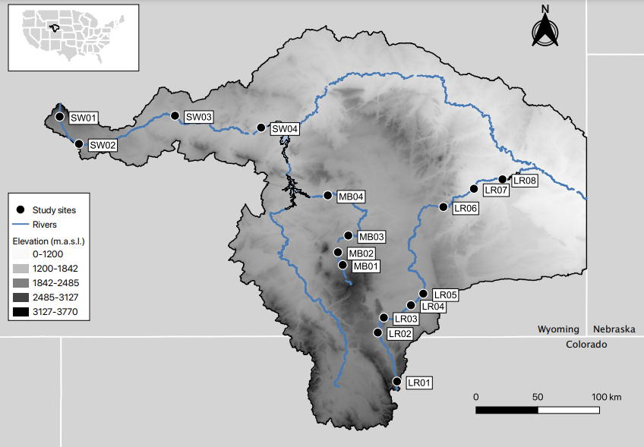

Figure 1: Map of the study area within the North Platte River drainage. LR corresponds to sites in the Laramie River, MB corresponds to sites in the Medicine Bow River, and SW corresponds to sites in the Sweetwater River.

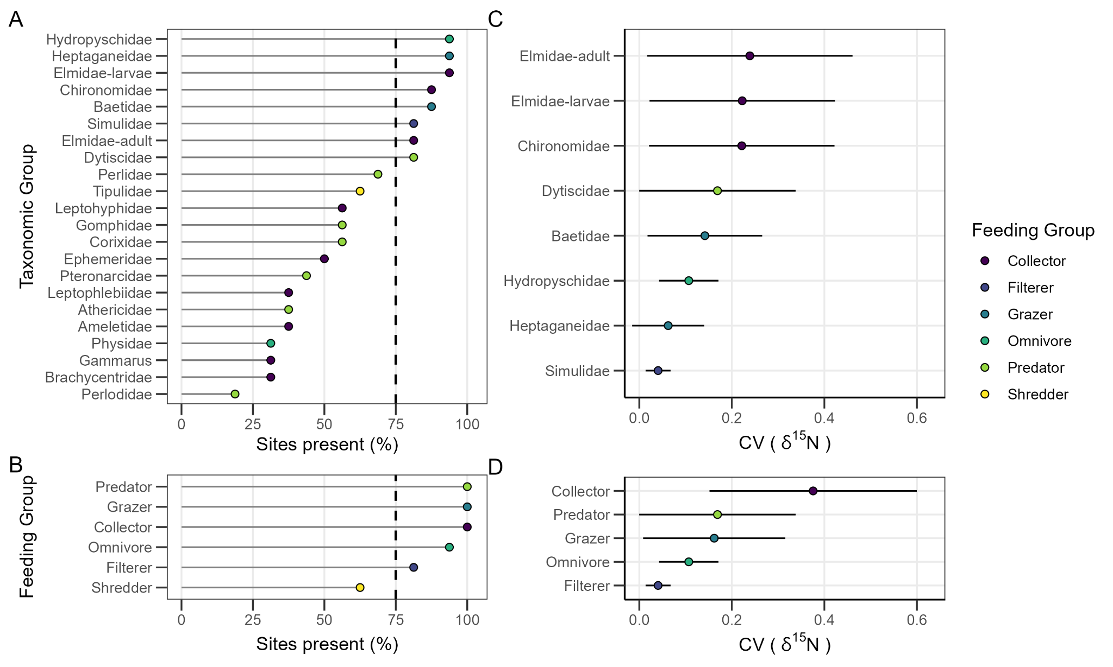

Figure 2. A) Taxonomic Group and B) Feeding Group distributions expressed as the percentage of sites found during the study. Also, each C) Taxonomic Group’s and D) Feeding Group’s mean Coefficient of Variation (CV) of δ15N across sites. Error bars are ± 1 standard deviation from the mean. CVs were only presented for the Taxonomic Groups and Feeding Groups that met criteria 1 (Present at >75% of Sites , A-B). Taxonomic Groups are colored by their respective Feeding Group.

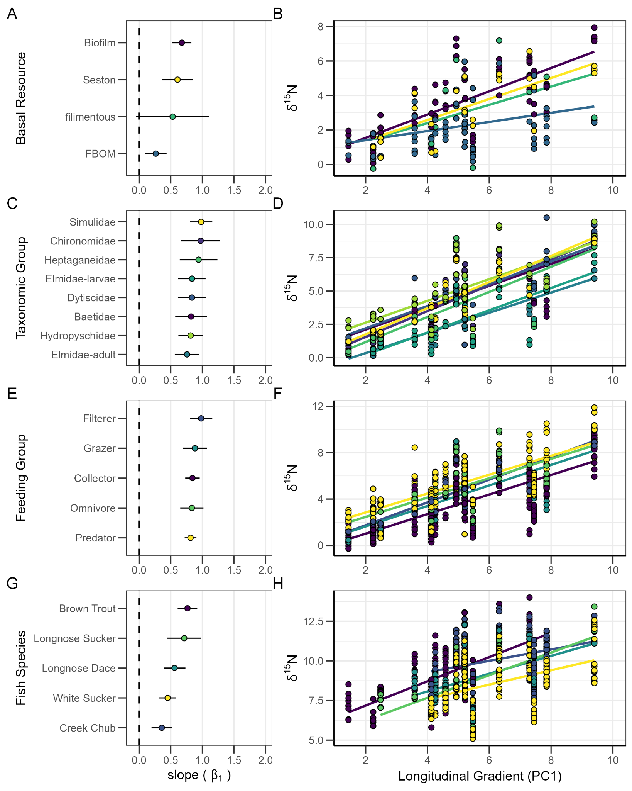

Figure 3. Relationships between the δ15N values of A-B) basal resources, C-D) Taxonomic Groups, E-F) Feeding Groups, and G-H) Fish in relation to position along the longitudinal gradient represented by PC1. A,C,E,G are the slopes (± 95 % CI) of the adjacent plot lines of best fit in B,D,F,H, and the colors in each scatter plot (B,D,F, H) correspond to the colors of the adjacent plots group (A,C,E,G). For example, White Sucker (WHS) are colored yellow in G) and H). The dashed line in A,C,E,G indicates a zero slope and indicates no relation between δ15N and PC1. For the scatterplots B,D,F, each point is the mean δ15N signature of the B) basal resource, D) Taxonomic Group, and F) Feeding Group. For the scatter plot H) each point is an individual fish’s δ15N signature. Upstream sites are to the left in the scatter plots. Please note the differences in the scale of the y-axis in the scatter plots.

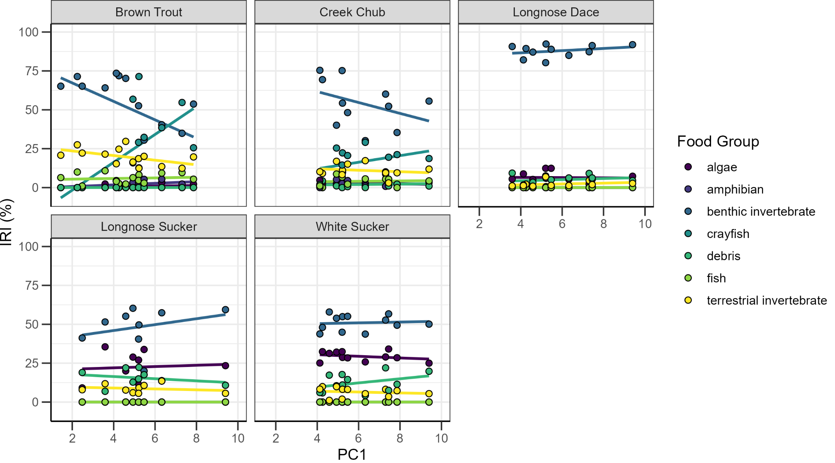

Figure 4. The relationship between IRI index of stomach contents and each fish’s position on the longitudinal gradient (PC1). Each point is the mean IRI index of the fish at each site, and colors correspond to the food group. The lines of best fit are represented but do not necessarily indicate a significant correlation.

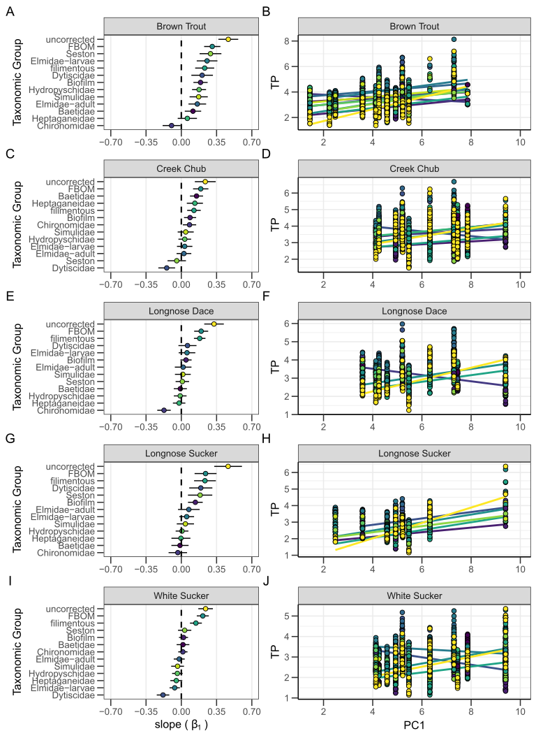

Figure 5: Relationships between TP of A-B) Brown Trout, C-D) Creek Chub, E-F) Longnose Dace, G-H) Longnose Sucker, I-J) White Sucker in relation to position along the longitudinal gradient represented by PC1. A,C,E,G,I are the slopes (± 95 % CI) of the adjacent plot lines of best fit in B,D,F,H,J and the colors in each scatter plot (B,D,F, H,J) correspond to the colors of the adjacent plots taxonomic group correction (A,C,E,G,I). Uncorrected TP estimates are in yellow. The dashed line in A,C,E,G,I indicates a zero slope and indicates no relation between TP and PC1. For the scatterplots, each point is the individual fish TP signature before (uncorrected) or after correction by taxonomic group. Upstream sites are to the left in the scatter plots. Please note the differences in the scale of the y-axis in the scatter plots.

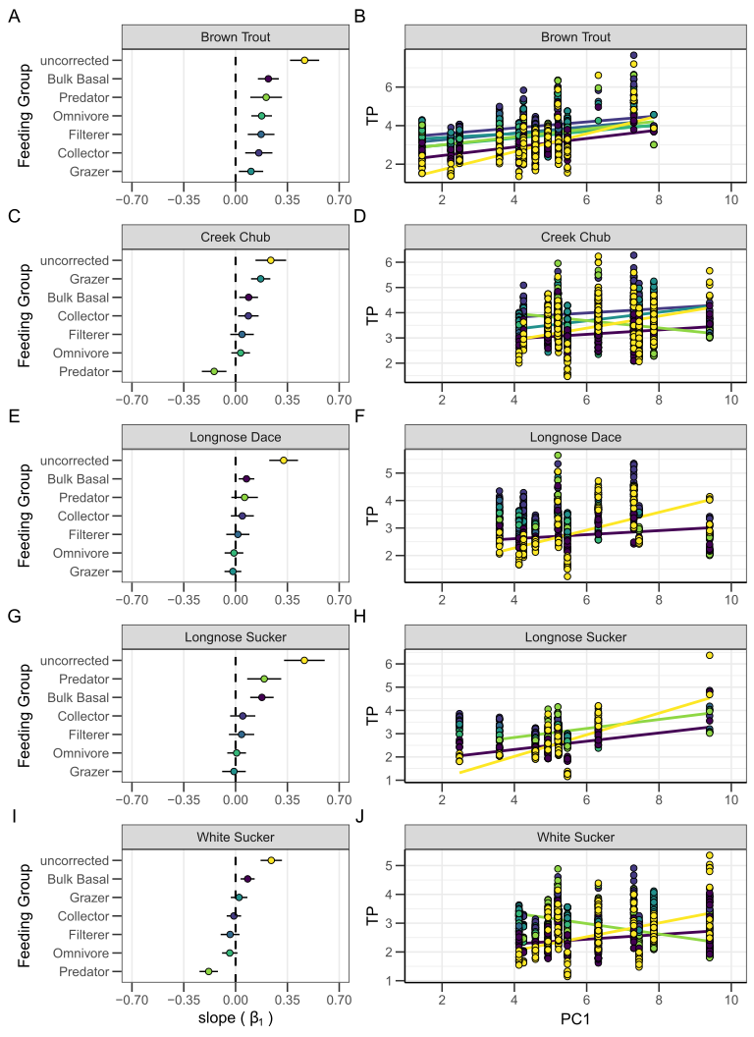

Figure 6: Relationships between TP of A-B) Brown Trout, C-D) Creek Chub, E-F) Longnose Dace, G-H) Longnose Sucker, I-J) White Sucker in relation to position along the longitudinal gradient represented by PC1. A,C,E,G,I are the slopes (± 95 % CI) of the adjacent plot lines of best fit in B,D,F,H,J and the colors in each scatter plot (B,D,F, H,J) correspond to the colors of the adjacent plots feeding group correction (A,C,E,G,I). Uncorrected TP estimates are in yellow. The dashed line in A,C,E,G,I indicates a zero slope and indicates no relation between TP and PC1. For the scatterplots B,D,F, H,J), each point is the individual fish TP signature before (uncorrected) or after correction by feeding group. Upstream sites are to the left in the scatter plots. Please note the differences in the scale of the y-axis in the scatter plots.