Table 1: Summary of baselines used to correct trophic position (TP) of higher order consumers (i.e., fish) from Kristensen et al., (2016) and the present study. Only groups that met criteria 1 (i.e., sufficiently distributed) are presented. The percentage for criteria 4 (variation removed) was calculated by dividing the number of fish species that had TP estimates free of the geographic variation divided by the total number of fish species that were examined in the study.

|  |  |  |  |  |  |
| --- | --- | --- | --- | --- | --- |
| **Group** | | **Study** | **Mean CV (± SD)** | **Correlated with Gradient** | **Variation removed & consistent with diet changes (% Fish Species)** |
| ***Taxonomic group*** | |  |  |  |  |
|  | Elmidae-adult | Present | 0.294 (± 0.226) | Y | (4/5) 80% |
|  | Elmidae-larvae | Present | 0.328 (± 0.284) | Y | (4/5) 80% |
|  | Chironomidae | Present | 0.246 (± 0.191) | Y | (2/5) 40% |
|  | Dytiscidae | Present | 0.169 (± 0.169) | Y | (2/5) 40% |
|  | Baetidae | Present | 0.110 (± 0.080) | Y | (4/5) 80% |
|  | Kristenson et al., (2016) | 0.080 (± 0.090) | Y | (1/2) 50%a |
|  | Simuliidae | Present | 0.041 (± 0.026) | Y | (5/5) 100% |
|  | Kristenson et al., (2016) | 0.028 (± 0.019) | Y | (2/2) 100% a |
|  | Hydropsychidae | Present | 0.146 (± 0.110) | Y | (5/5) 100% |
|  | Heptaganeidae | Present | 0.070 (± 0.057) | Y | (3/5) 60% |
|  | Gomphidae | Present | 0.172 (± 0.053) | Y | (2/5) 40% |
|  | *Gammarus pulex* | Kristenson et al., (2016) | 0.094 (± 0.061) | Y | (1/2) 50% a |
|  | Ephemeridae | Present | 0.167 (± 0.113) | Y | (4/5) 80% |
|  | Dytiscidae | Present | 0.190 (± 0.125) | Y | (2/5) 40% |
|  | Leptohyphidae | Present | 0.225 (± 0.151) | Y | (3/5) 60% |
|  | Perlidae | Present | 0.153 (± 0.067) | Y | (4/5) 80% |
| ***Feeding group*** | |  |  |  |  |
|  | Filterers | Present | 0.047 (± 0.027) | Y | (5/5) 100% |
|  | Kristenson et al., (2016) | 0.030 (± 0.018) | nd | (1/2) 50% a |
|  | Predator | Present | 0.223 (± 0.097) | Y | (3/5) 60% |
|  | Kristenson et al., (2016) | 0.120 (± 0.063) | nd | (0/2) 0% a |
|  | Omnivore | Present | 0.126 (± 0.076) | Y | (4/5) 80% |
|  | Kristenson et al., (2016) | 0.063 (± 0.035) | nd | (0/2) 0% a |
|  | Collector | Present | 0.390 (± 0.262) | Y | (4/5) 80% |
|  | Kristenson et al., (2016) | 0.120 (± 0.087) | nd | (0/2) 0% a |
|  | Scraper | Kristenson et al., (2016) | 0.130 (± 0.156) | nd | (0/2) 50% |
|  | Grazer | Present | 0.162 (± 0.154) | Y | (4/5) 80% |
|  | Shredder | Kristenson et al., (2016) | 0.120 (± 0.065) | nd | (0/2) 50% a |
| ***Basal*** | |  |  |  |  |
|  | filamentous | Present | nd | N | (1/5) 20% |
|  | FBOM | Present | nd | Y | (1/5) 20% |
|  | seston | Present | nd | Y | (4/5) 80% |
|  | biofilm | Present | nd | Y | (3/5) 60% |
| ***Average*** | |  |  |  |  |
|  | Primary Producer | Present | nd | nd | (1/5) 20% |
|  | Primary Consumer | Present | nd | nd | (4/5) 80% |
|  | Kristenson et al., (2016) | nd | nd | (0/2) 0% a |

a did not assess dietary changes with isotope-independent data along the gradient

**Figure Captions**

**Fig. 1** Map of study site locations within the North Platte River drainage in Wyoming, USA. LR = Laramie River, MB = Medicine Bow River, and SW = Sweetwater River.

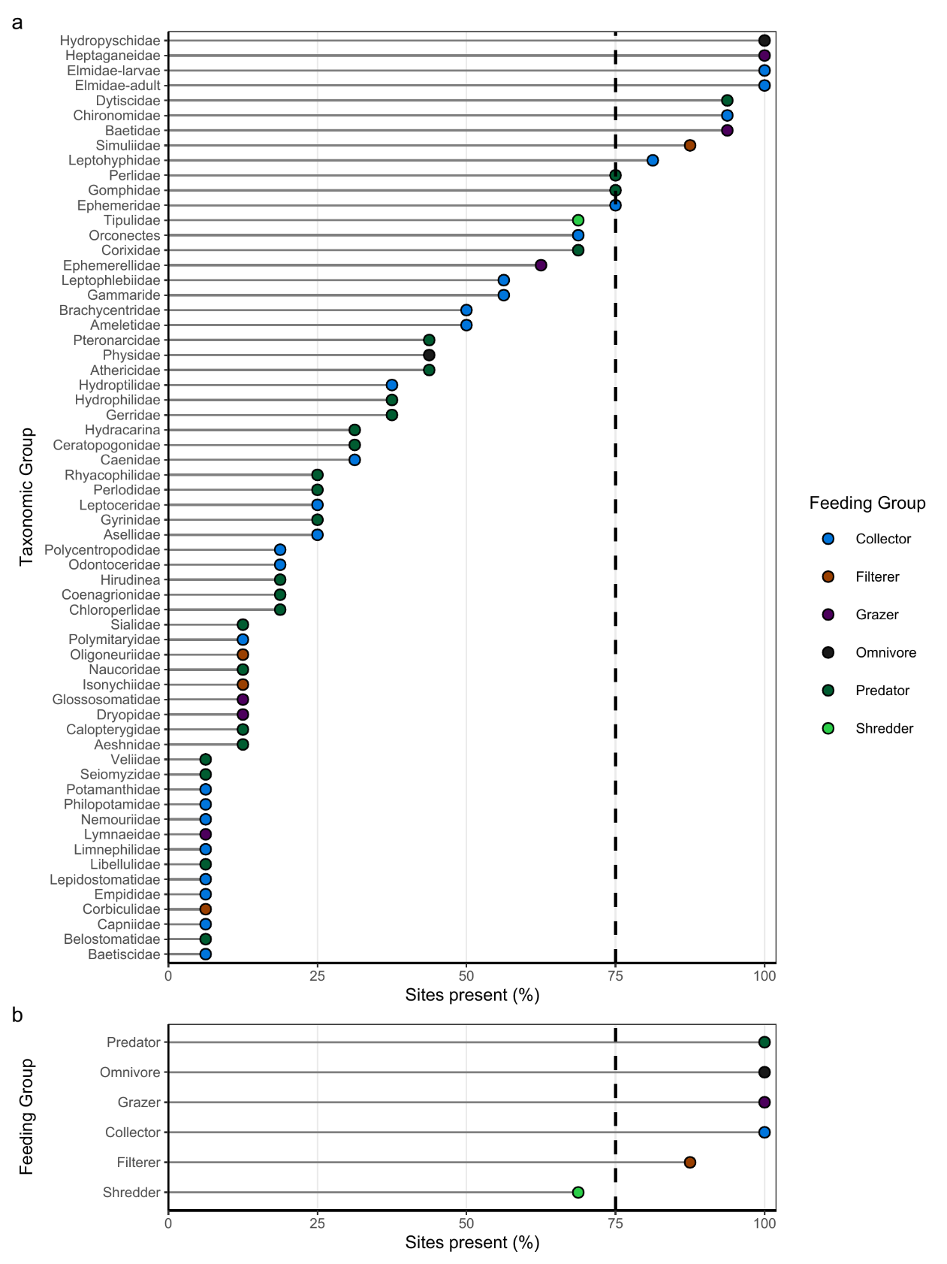

**Fig. 2** The geographic distribution of specific taxa (a) and functional feeding groups (b) expressed as the percentage of sites found during the study.

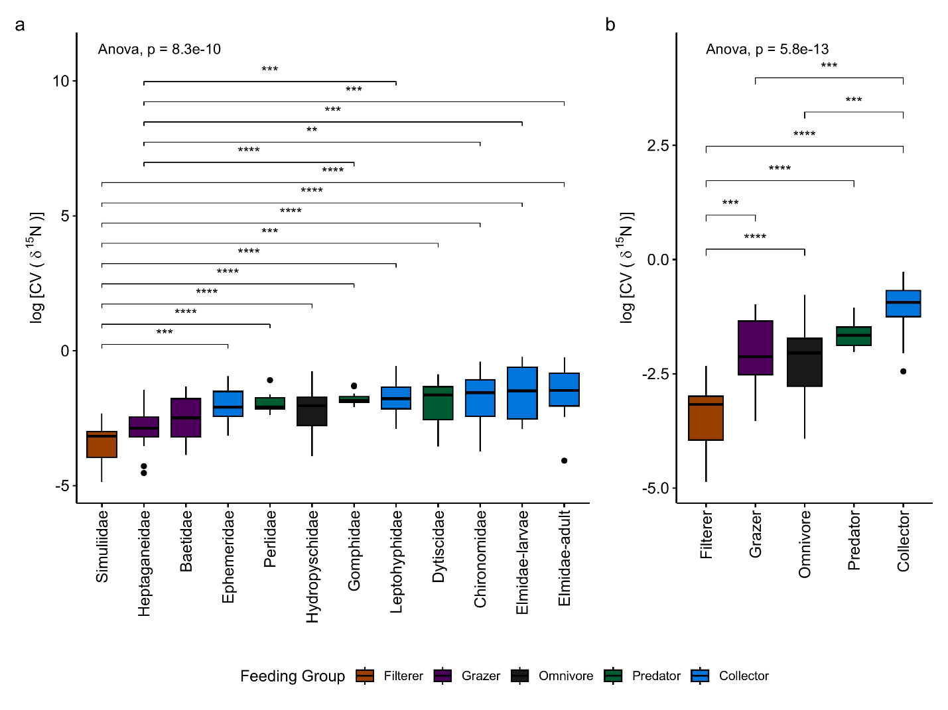

**Fig. 3** The log transformed mean Coefficient of Variation (CV) of δ15N across sites for the twelve taxonomic groups that were widely distributed (a) and the five functional feeding groups (b).

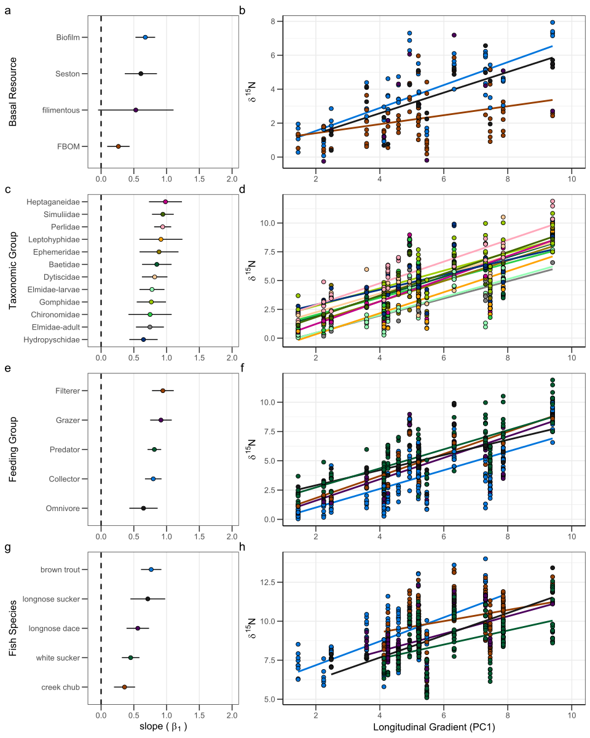

**Fig. 4** Relationships between δ15N values of food web compartments and PC1, which represents a longitudinal stream gradient. Panels a, c, e, and g show the slopes estimates (± 95 % CI) of the adjacent regressions in panels b, d, f, and h. Colors in each scatter plot (b, d, f, h) correspond to the colors of the adjacent fish species plots (e.g., White Sucker are colored blue in panels g and h). The dashed line in panels a, c, e, and g indicates a slope of zero (no relationship between δ15N values and PC1). Each point in panels b, d, and f are mean δ15N value, while points in panel H are δ15N values of individual fish.

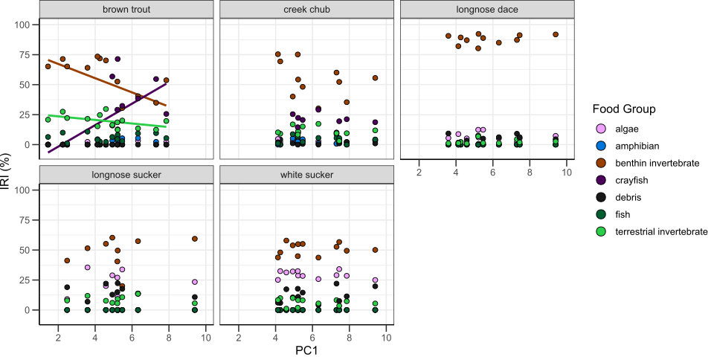

**Fig. 5** Relationships between the index of relative importance (IRI) based on stomach content analysis for fish species and the longitudinal gradient (PC1). Each point is the mean IRI index of the fish captured at that site, and colors correspond to the food group. The lines of best fit are only shown for significant relationships (*P* < 0.1).

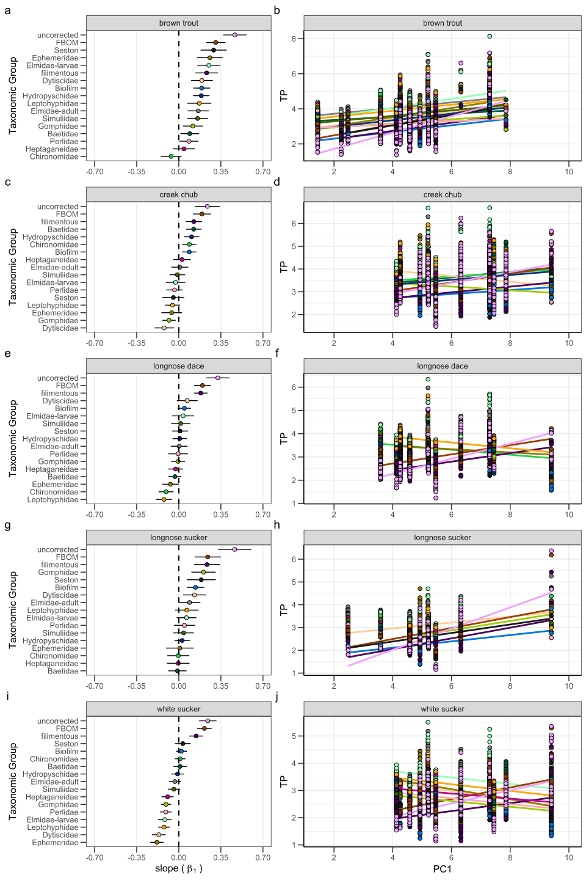

**Fig. 6** Relationships between TP of brown trout (a,b), creek chub (c, d), longnose dace (e,f), longnose sucker (g,h), and white sucker (i,j) in relation to position along the longitudinal gradient represented by PC1. Graphs to the left show the slopes (± 95 % CI) for the corresponding scatter plots to the right. The colors in each scatterplot correspond to the colors of the adjacent plots for the taxonomic group correction. Uncorrected TP estimates are in dark blue. The dashed line in a,c,e,g,i indicates a zero slope (i.e., no relation between TP and PC1). The lines of best fit are only presented for significant relationships (i.e., 95% CI for the slope does not overlap 0). For the scatterplots, each point is the individual fish TP signature before (uncorrected) or after correction by taxonomic group. Upstream sites are to the left in the scatter plots. Note the differences in the scale of the y-axis in the scatter plots.

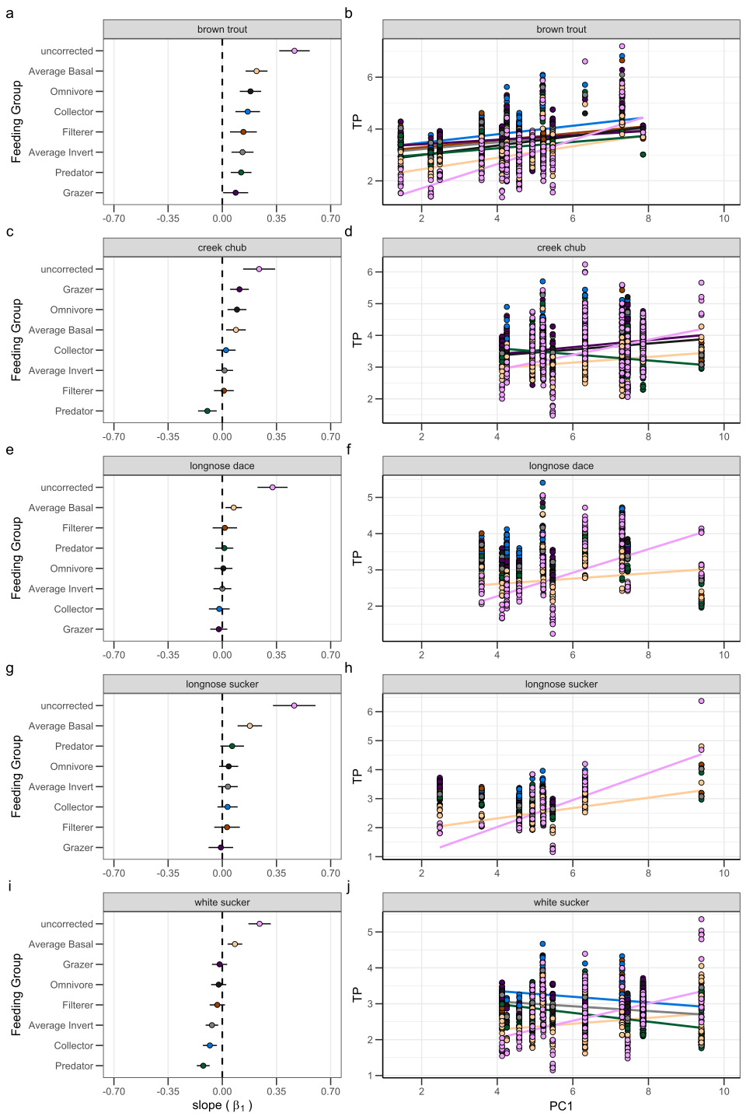

**Fig. 7** Relationships between TP of brown trout (a,b), creek chub (c, d), longnose dace (e,f), longnose sucker (g,h), and white sucker (i,j) in relation to position along the longitudinal gradient represented by PC1. Graphs to the left show the slopes (± 95 % CI) for the corresponding scatter plots to the right. The colors in each scatterplot correspond to the colors of the adjacent plots for the feeding group correction. Uncorrected TP estimates are in brown. The dashed line in a,c,e,g,i indicates a zero slope (i.e., no relation between TP and PC1). The lines of best fit are only presented for significant relationships (i.e., 95% CI does not overlap 0). For the scatterplots, each point is the individual fish TP signature before (uncorrected) or after correction by the indicated feeding group. Upstream sites are to the left in the scatter plots. Note the differences in the scale of the y-axis in the scatter plots.