Example

Brian Maitner

2025-09-08

## R Markdown

This is an R Markdown document. Markdown is a simple formatting syntax for authoring HTML, PDF, and MS Word documents. For more details on using R Markdown see <http://rmarkdown.rstudio.com>. A concise R markdown cheatsheet can be found at <https://github.com/rstudio/cheatsheets/raw/main/rmarkdown-2.0.pdf>.

When you click the **Knit** button a document will be generated that includes both content as well as the output of any embedded R code chunks within the document. You can embed an R code chunk like this:

summary(cars)

## speed dist   
## Min. : 4.0 Min. : 2.00   
## 1st Qu.:12.0 1st Qu.: 26.00   
## Median :15.0 Median : 36.00   
## Mean :15.4 Mean : 42.98   
## 3rd Qu.:19.0 3rd Qu.: 56.00   
## Max. :25.0 Max. :120.00

## Including Plots

You can also embed plots, for example:



Note that the echo = FALSE parameter was added to the code chunk to prevent printing of the R code that generated the plot.

## For this course

For this course, I want to see the code you use, so make sure NOT to set echo=FALSE. By using an .Rmd file, I can see exactly what you did and what it produced.

## Documenting object structure

avonet <- read.csv("https://github.com/bmaitner/Statistical_ecology_course/raw/refs/heads/main/data/Avonet/AVONET1_BirdLife.csv")  
  
str(avonet)

## 'data.frame': 11009 obs. of 37 variables:  
## $ Sequence : int 3103 3090 3125 3116 3092 3091 3089 3115 3130 3123 ...  
## $ Species1 : chr "Accipiter albogularis" "Accipiter badius" "Accipiter bicolor" "Accipiter brachyurus" ...  
## $ Family1 : chr "Accipitridae" "Accipitridae" "Accipitridae" "Accipitridae" ...  
## $ Order1 : chr "Accipitriformes" "Accipitriformes" "Accipitriformes" "Accipitriformes" ...  
## $ Avibase.ID1 : chr "AVIBASE-BBB59880" "AVIBASE-1A0ECB6E" "AVIBASE-ADBE44E1" "AVIBASE-68BF920B" ...  
## $ Total.individuals : int 5 10 11 4 8 1 6 5 7 5 ...  
## $ Female : int 2 4 4 4 4 0 2 2 1 2 ...  
## $ Male : int 0 6 5 0 4 1 2 3 5 3 ...  
## $ Unknown : int 3 0 2 0 0 0 2 0 1 0 ...  
## $ Complete.measures : int 4 8 8 3 4 1 4 4 6 4 ...  
## $ Beak.Length_Culmen: num 27.7 20.6 25 22.5 21.1 20 20.5 19.2 20 25.4 ...  
## $ Beak.Length_Nares : num 17.8 12.1 13.7 14 12.1 11.9 11.5 10.6 11.2 13.9 ...  
## $ Beak.Width : num 10.6 8.8 8.6 8.9 8.7 6.6 8.3 7.7 8.6 8.6 ...  
## $ Beak.Depth : num 14.7 11.6 12.7 11.9 11.1 12 10.9 9.6 11 13.2 ...  
## $ Tarsus.Length : num 62 43 58.1 61.2 46.4 48.7 52.6 60.3 43.6 62 ...  
## $ Wing.Length : num 235 187 230 202 218 ...  
## $ Kipps.Distance : num 81.8 62.5 56.6 64.1 87.8 42.9 38.9 81.3 49.5 77.8 ...  
## $ Secondary1 : num 160 127 175 138 130 ...  
## $ Hand.Wing.Index : num 33.9 32.9 24.6 31.7 40.2 25.8 24 37.8 30 32.3 ...  
## $ Tail.Length : num 169 141 186 141 154 ...  
## $ Mass : num 249 131 288 142 186 ...  
## $ Mass.Source : chr "Dunning" "Dunning" "Dunning" "Dunning" ...  
## $ Mass.Refs.Other : chr NA NA NA NA ...  
## $ Inference : chr "NO" "NO" "NO" "NO" ...  
## $ Traits.inferred : chr NA NA NA NA ...  
## $ Reference.species : chr NA NA NA NA ...  
## $ Habitat : chr "Forest" "Shrubland" "Woodland" "Forest" ...  
## $ Habitat.Density : int 1 2 2 1 1 1 1 1 1 2 ...  
## $ Migration : int 2 3 2 2 3 1 2 2 2 3 ...  
## $ Trophic.Level : chr "Carnivore" "Carnivore" "Carnivore" "Carnivore" ...  
## $ Trophic.Niche : chr "Vertivore" "Vertivore" "Vertivore" "Vertivore" ...  
## $ Primary.Lifestyle : chr "Insessorial" "Insessorial" "Generalist" "Insessorial" ...  
## $ Min.Latitude : num -11.73 -29.47 -55.72 -6.31 31.19 ...  
## $ Max.Latitude : num -4.02 46.39 23.73 -4.08 55.86 ...  
## $ Centroid.Latitude : num -8.15 8.23 -10.1 -5.45 45.24 ...  
## $ Centroid.Longitude: num 158.5 45 -60 150.7 45.3 ...  
## $ Range.Size : num 37461 22374973 14309701 35581 2936752 ...

## Example Figure 1

plot(x = avonet$Centroid.Latitude,  
 y = log10(avonet$Range.Size),  
 xlab = "Centroid Latitude",  
 ylab = "Range Size")  
trend_line <- lm(log10(avonet$Range.Size)~avonet$Centroid.Latitude)  
abline(trend_line,col="blue",lwd=3)

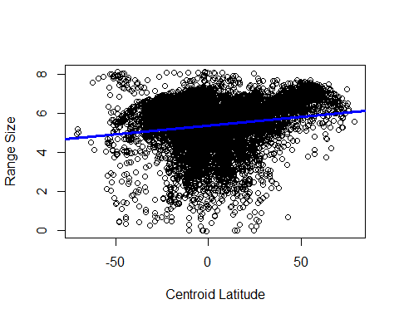

Figure 1. Range size increases with latitude

## Example Figure 2: The importance of proper scale

In biology, some patterns are often more easily seen when transformed in some way. The log transformation is a common transformation that has strong biological justifications. We’ll see why this is so later, but for now just take my word for it.

plot(x = avonet$Mass,  
 y = avonet$Wing.Length,  
 xlab = "Mass",  
 ylab = "Wing Length")

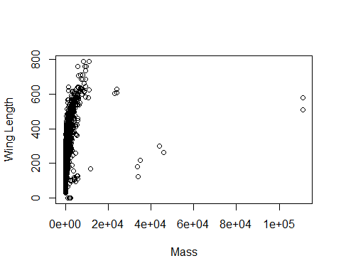 The pattern doesn’t appear very obvious here. There might be a relationship, but it’s a bit hard to tell. Let’s do a log10 transformation instead.

plot(x = log10(avonet$Mass),  
 y = log10(avonet$Wing.Length),  
 xlab = "log10(Mass)",  
 ylab = "log10(Wing Length)")

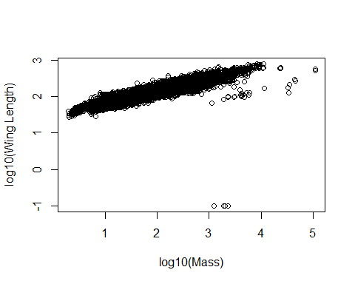 Much more clear now!

## Example Figure 3

Pelecaniformes <- subset(x = avonet,  
 subset = Order1 == "Pelecaniformes")  
  
names(Pelecaniformes)[4] <- "Order" #Rename Order1 to Order  
names(Pelecaniformes)[3] <- "Family" #Rename Order1 to Order  
  
boxplot(data=Pelecaniformes,log10(Mass) ~ Family)

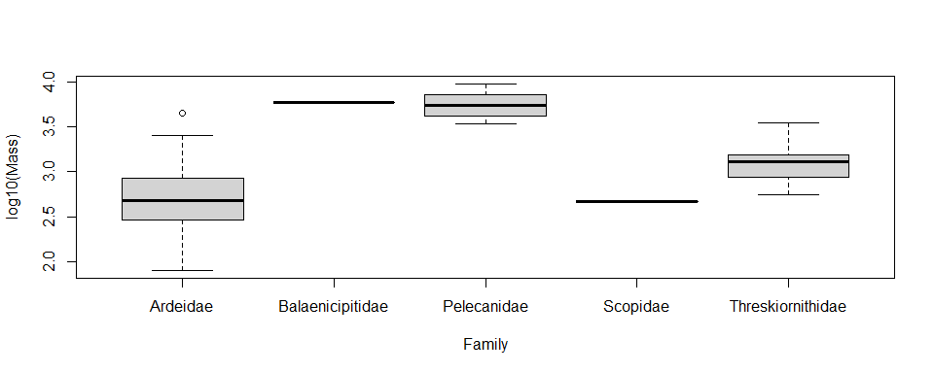

Figure 3. Body size varies across families in the Pelecaniformes

## Example table

avonet_continuous_traits <-  
avonet[c("Beak.Length_Culmen",  
 "Beak.Length_Nares",  
 "Beak.Width",  
 "Beak.Depth",  
 "Tarsus.Length",  
 "Wing.Length",  
 "Kipps.Distance",  
 "Secondary1",  
 "Hand.Wing.Index",  
 "Tail.Length",  
 "Mass")]  
  
avonet_beak <- avonet[c("Beak.Length_Culmen",  
 "Beak.Length_Nares",  
 "Beak.Width",  
 "Beak.Depth")]  
  
round(cor(avonet_beak),2)

## Beak.Length_Culmen Beak.Length_Nares Beak.Width Beak.Depth  
## Beak.Length_Culmen 1.00 0.97 0.74 0.71  
## Beak.Length_Nares 0.97 1.00 0.73 0.70  
## Beak.Width 0.74 0.73 1.00 0.91  
## Beak.Depth 0.71 0.70 0.91 1.00