From BOEM PNNL Draft Report
“Water and otolith samples collected in Northwest Alaska, the Alaskan Arctic, and Prince William Sound in 2020 and 2021 were analyzed for ⁸⁷Sr/⁸⁶Sr, Sr/Ca and Ba/Ca. Based on water chemistry, ⁸⁷Sr/⁸⁶Sr was the most discriminative marker for determining the provenance of pink salmon in this study.”

Previous studies have demonstrated that it takes approximately 3-4 weeks for otolith chemistry to reach equilibrium with the water (Doubleday et al., 2013),

Fish in PWS were collected from either Hartney Bay or Jackson Creek,

Fish were collected opportunistically in three different marine locations (Elson Lagoon, Kaktovik, Point Hope). Elson Lagoon is a bay located on the North Slope of AK, near Utqiaġvik (formerly Barrow). The Elson Lagoon watershed is made up of many small streams, draining an area of approximately 580 km² (Rawlins, 2021). The salinity of Elson Lagoon varies from 5 – 30 ppt, while water temperature ranges from -1 to 14°C (Sformo et al., 2019).

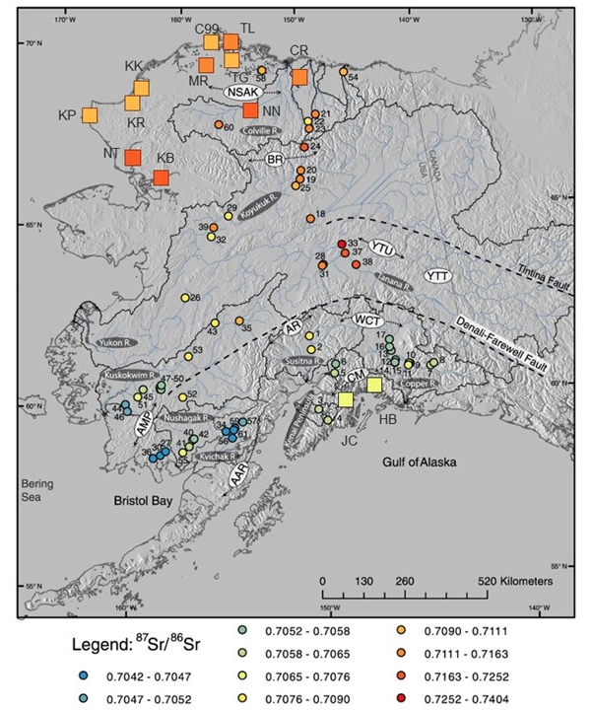

The question is: Are fish caught in North Alaska ( Elson Lagoon, Kaktovik, Point Hope) originating from

Strontium isotopic analysis of Prince William Sound fish revealed two general life history trends:

Are the hatcheries marine? Do we know generally where the hatchery fish are? Are there adipose fin clipped? Any other way to differentiate what hatchery pink salmon is

Ph is point hope is
Potential Approach: backtrack a “turnover reaction” from known origin samples
- Prince William Sound otoliths
  - Determine which are fw spawners based on Sr:Ca, or Ba:Ca (salinity influence)
  - Extract natal origin Sr8786 and Core Sr8786 from all known fw
  - Develop a turnover reaction and range of potential values based on the relatively narrow range of potential fw sr8786 values.
THEN
  - Filter out the marine otoliths (is there a difference between marine (hatchery) and estuary (intertidal)
  - Apply the same range of turnover dynamics to unknown origin fish to get a range of potential “True” strontium fw isotope ratios
  - Then use probabilistic framework to estimate likely provenance location using potential new isoscape.
OR
  - Using the established potential ranges of both CORE and FW ( and NACHOS derived turnoved dynamics from each location) produce timeseries from each potential location. Then use DTW to match our timeseries to those using a distance metric with fuzzy likelihoods

