SEG2105 Group Project – Deliverable 3 UML Diagram & CircleCI Console Screenshot

Professor: Miguel Garzon

Group Name: TBA

Group Members:

* Harsh Gupta (Group Leader)
* Bhalachandra Malghan
* Haard Trivedi
* Nischal Sharma
* Nishchal Nepal

Following is the UML Diagram representing the Domain Analysis of our Deliverable 2.

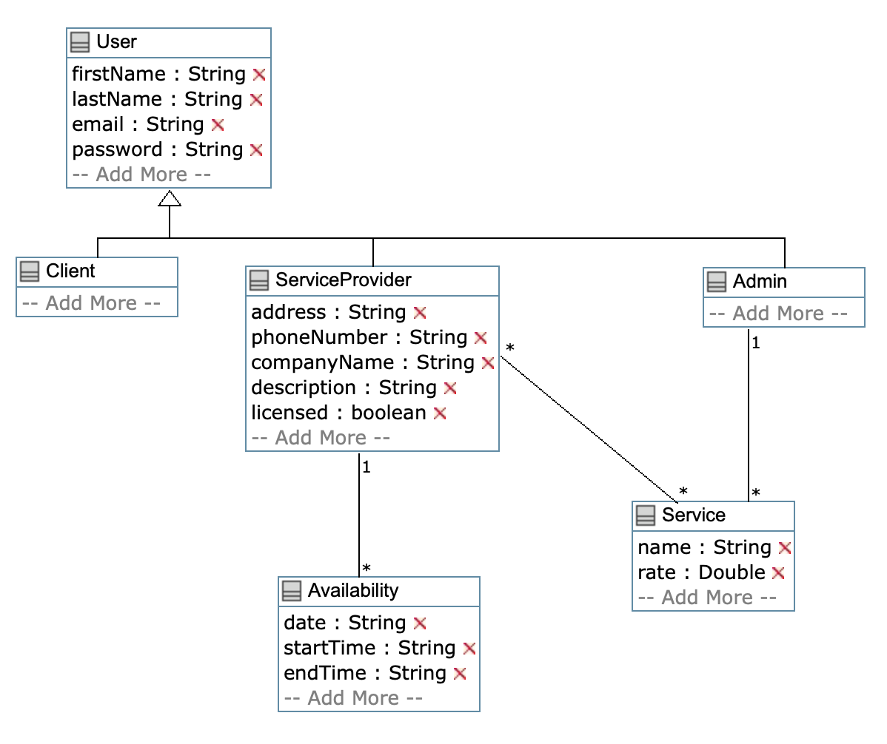

CircleCI Build Console Screenshot:

