Splunk Group Project

Part 1 – Windows Server Logs Instructions and Deliverables

1. Windows Server Logs Signatures Chart

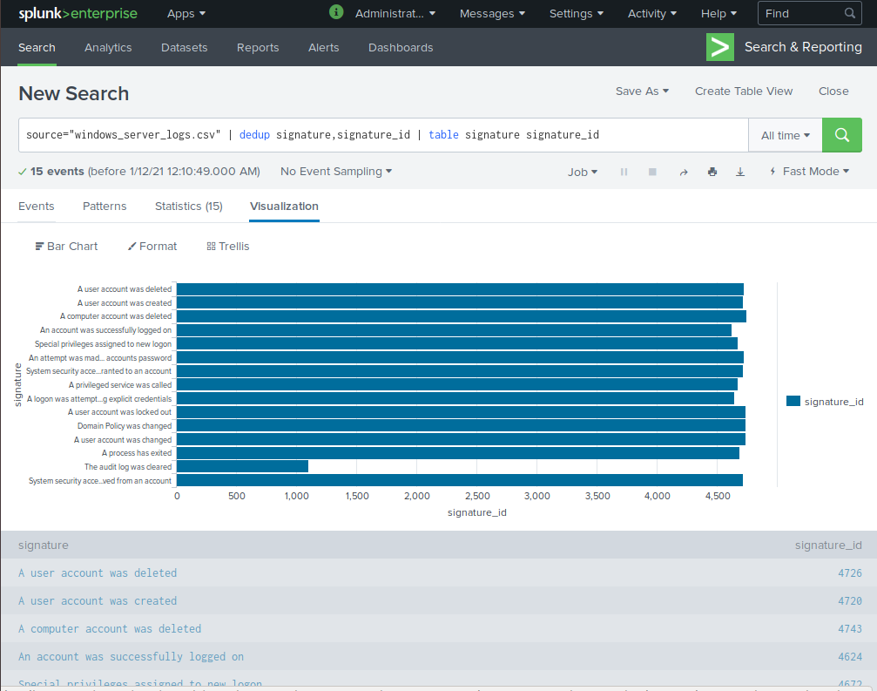

Windows Server Logs Signatures Dashboard

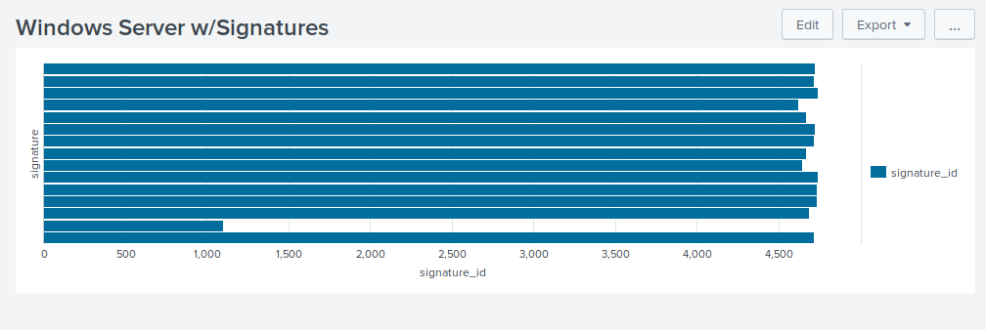

1. Report for count with percent and severity

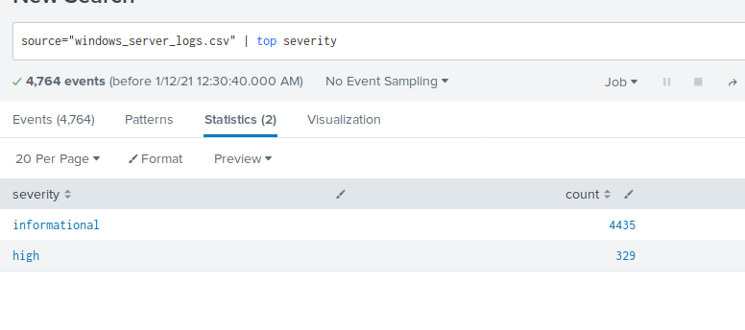

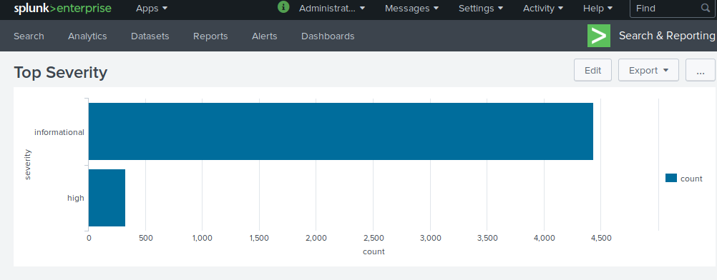

1. Used hint to check status.

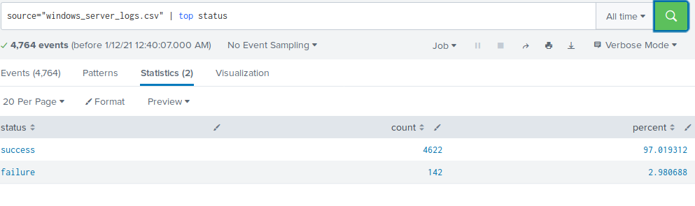

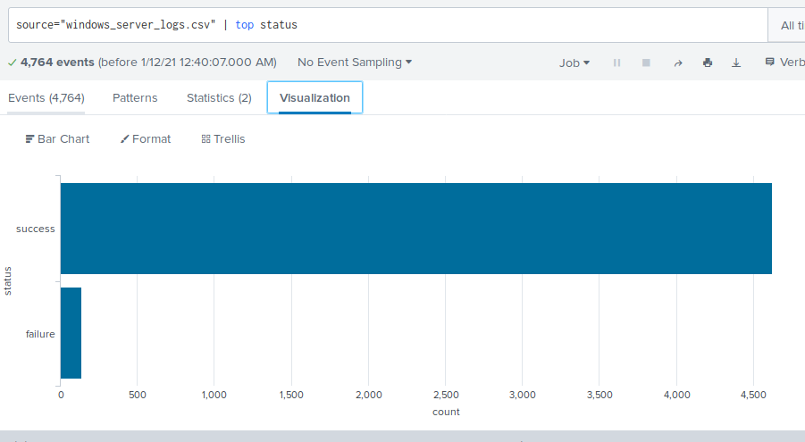

Alerts

1. Windows Fail Alert

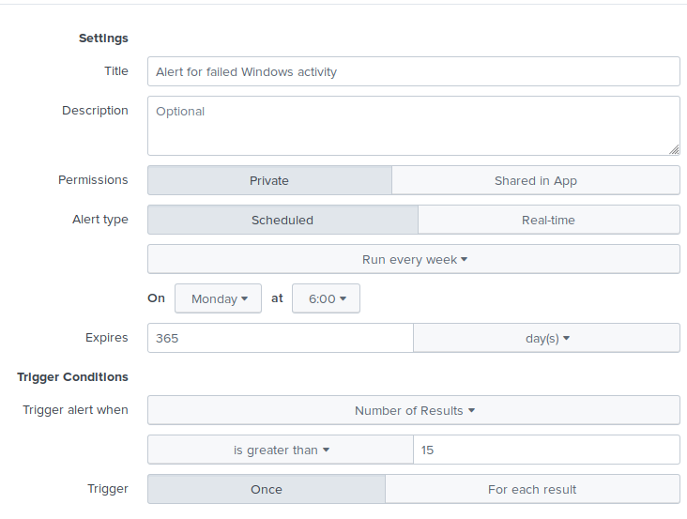

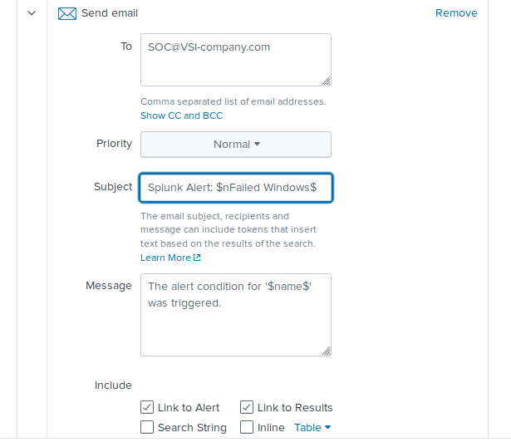

1. Successful logins hourly

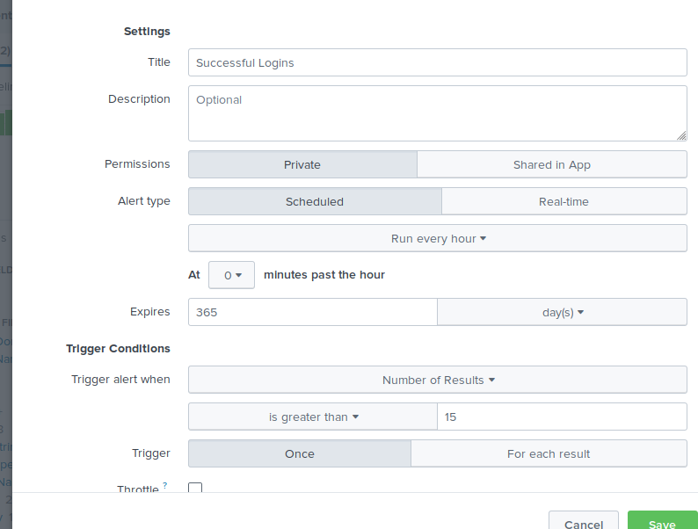

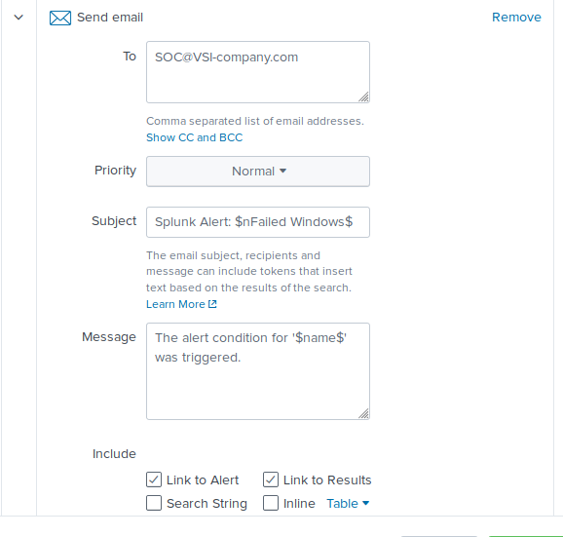

1. Signature and account was deleted

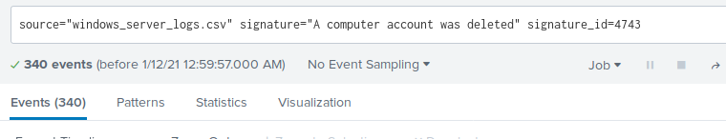

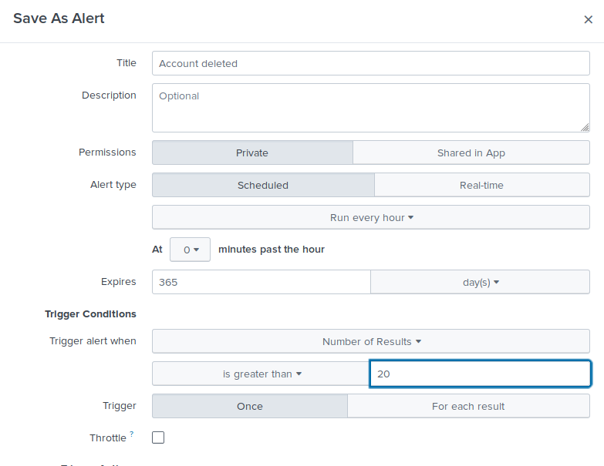

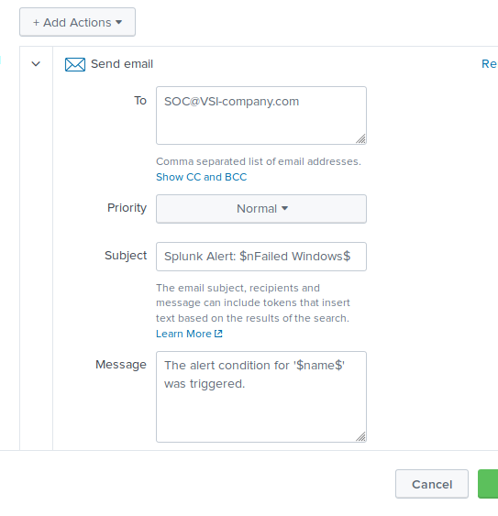

Part 2

1. Line Chart

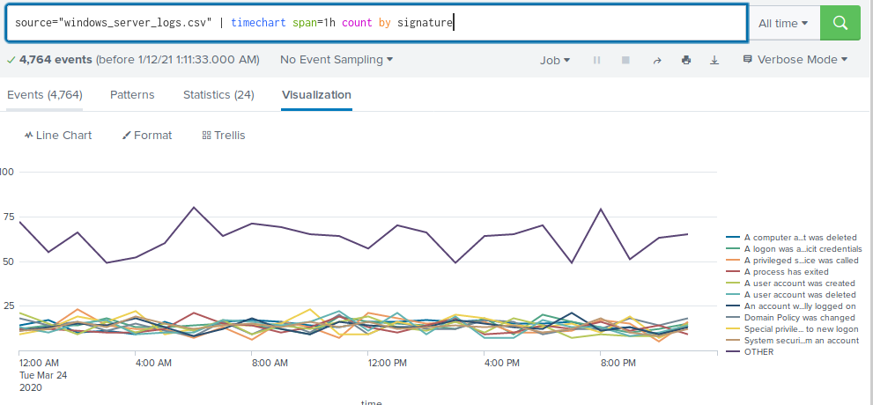

1. By user

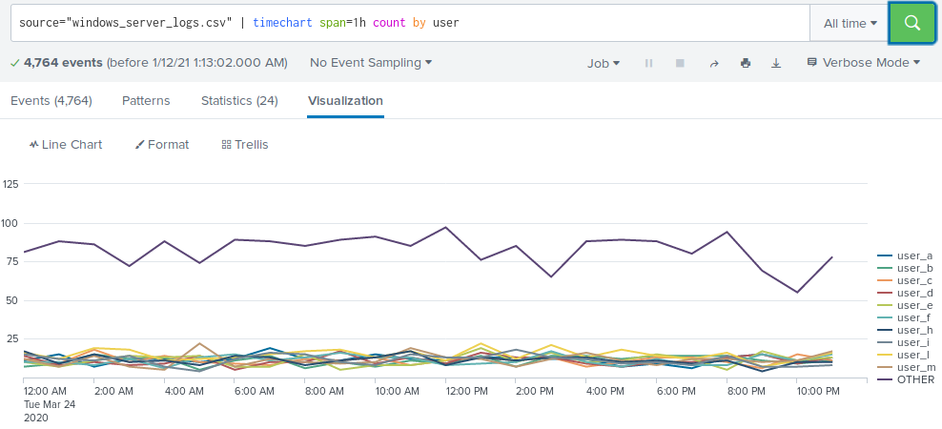

1. Bar chart by signature

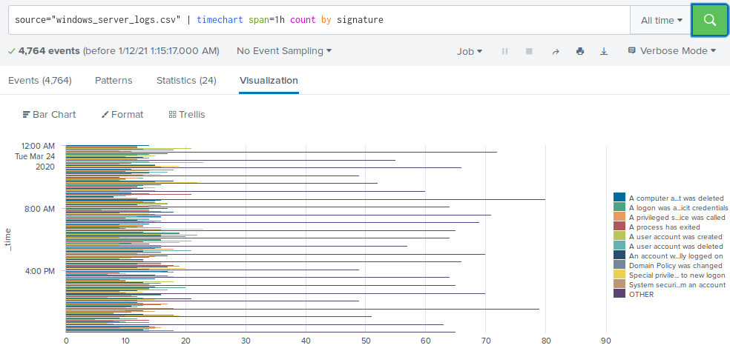

1. Bar chart by user

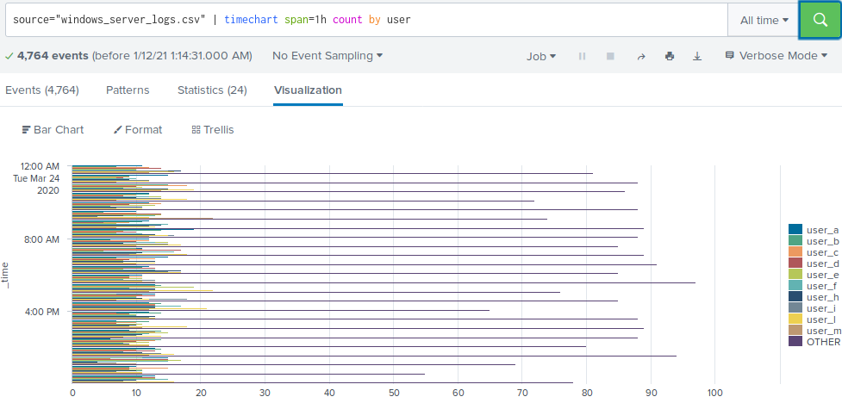

1. Statistical chart of count of different users

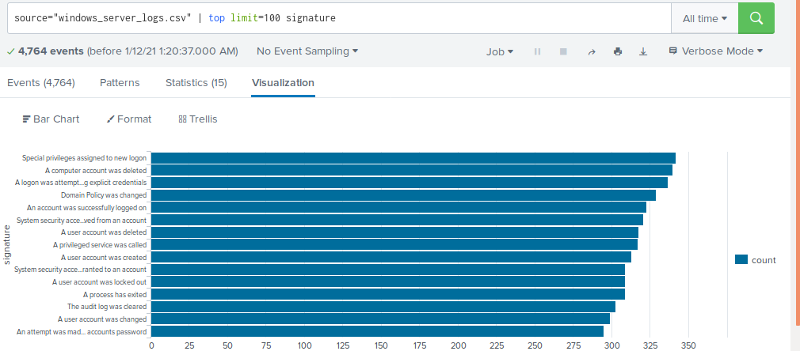

1. Gauge

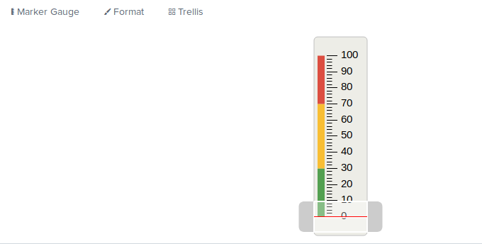

Dashboards

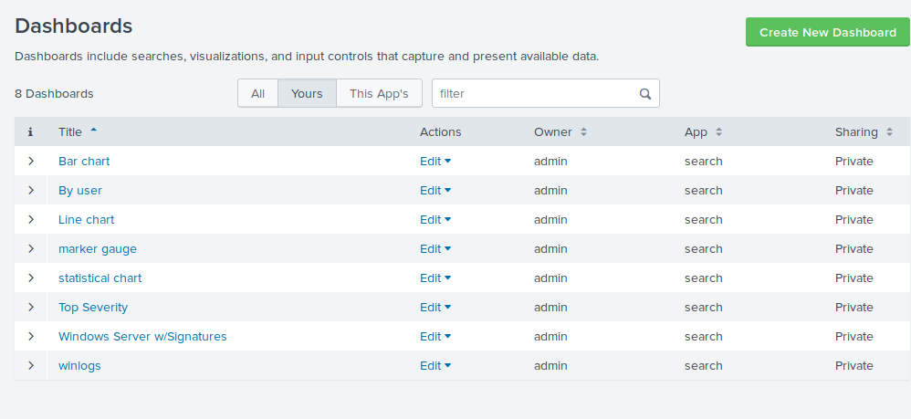

Part 2 – Apache Web Server Instructions and Deliverables

* 1. Report for methods

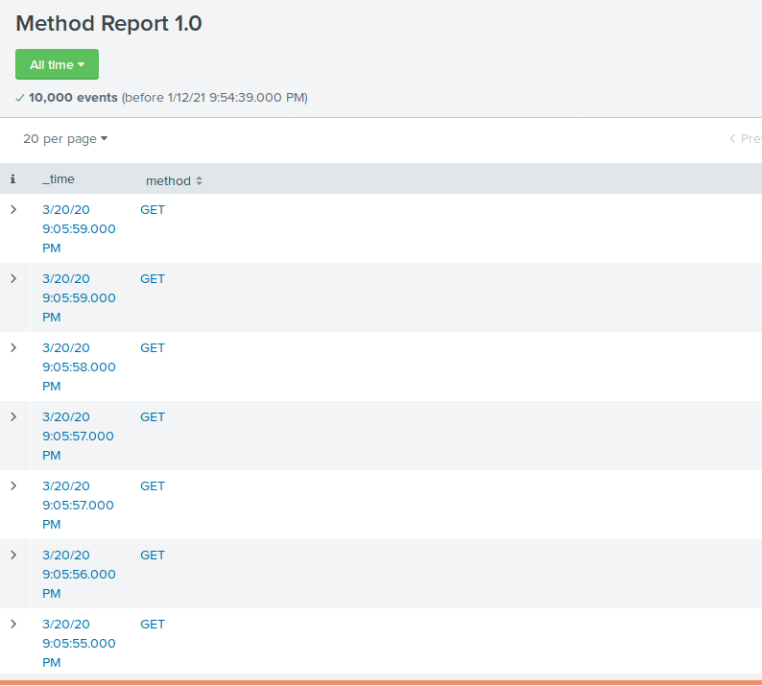

* 1. Report 10 domains that referred to VSI's website

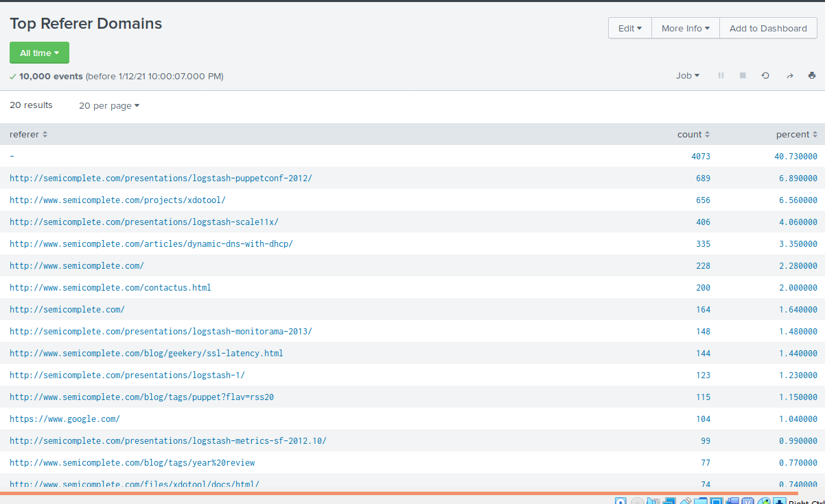

* 1. A report that shows the count of the HTTP response codes

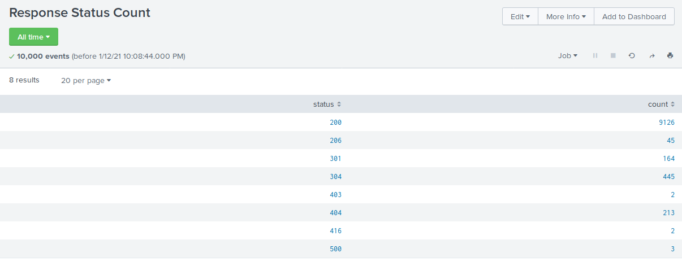

Alerts

* 1. Determine a baseline and threshold for hourly activity from a country other than the United States.



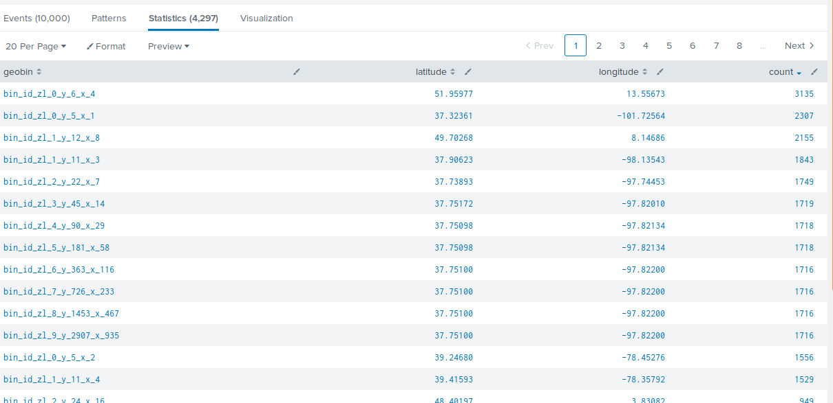

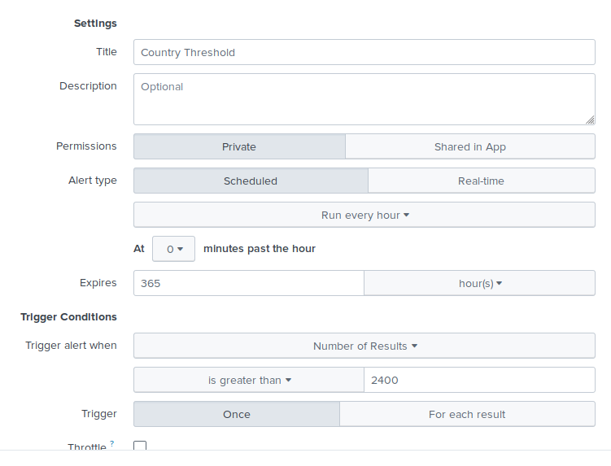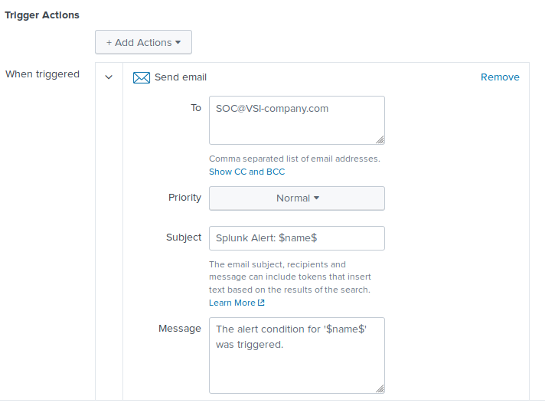

* 1. Determine an appropriate baseline and threshold for hourly count of the HTTP POST method.

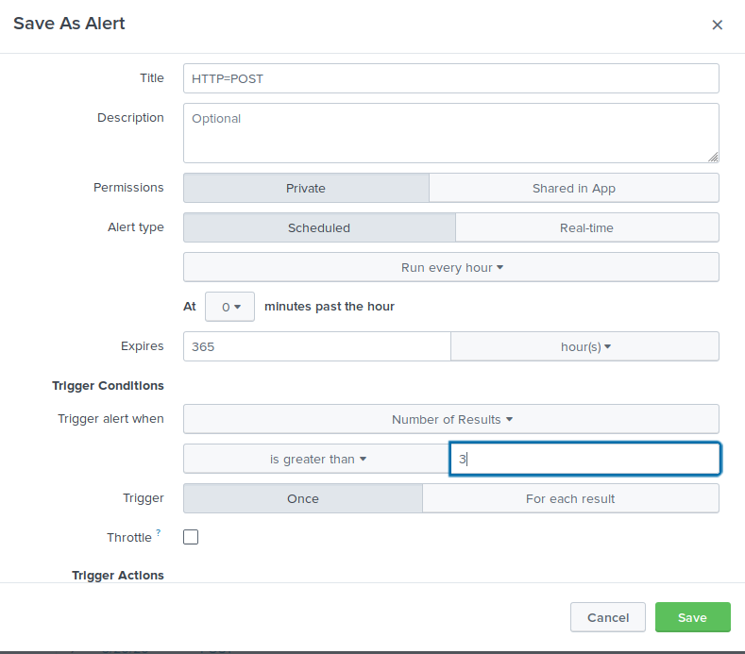 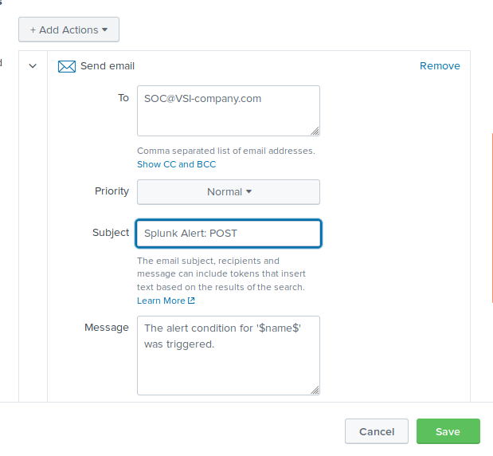

Visualization & Dashboards

1. A line chart that displays the different HTTP methods field over time.

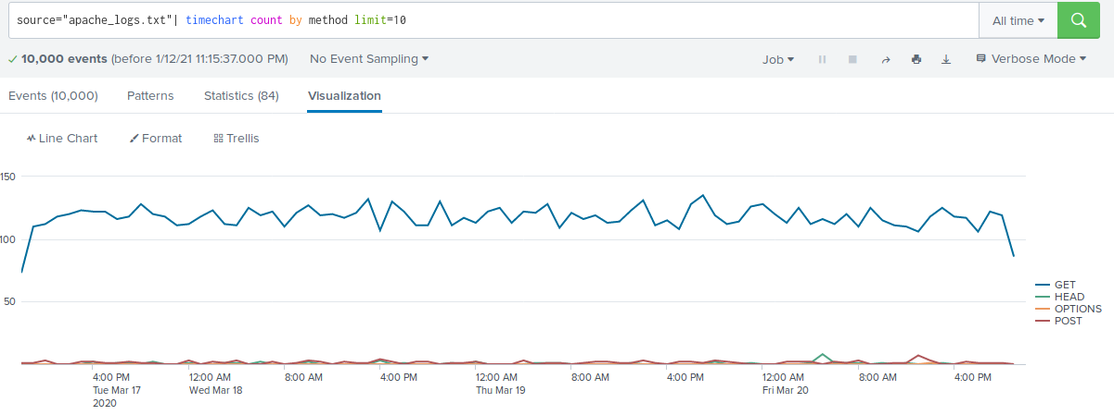

1. A geographical map showing the location based on the clientip field

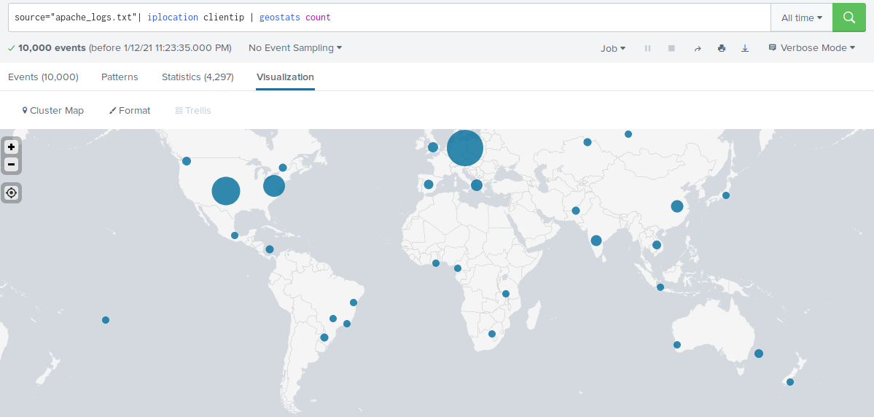

1. A bar, column, or pie chart that displays the number of different URIs.

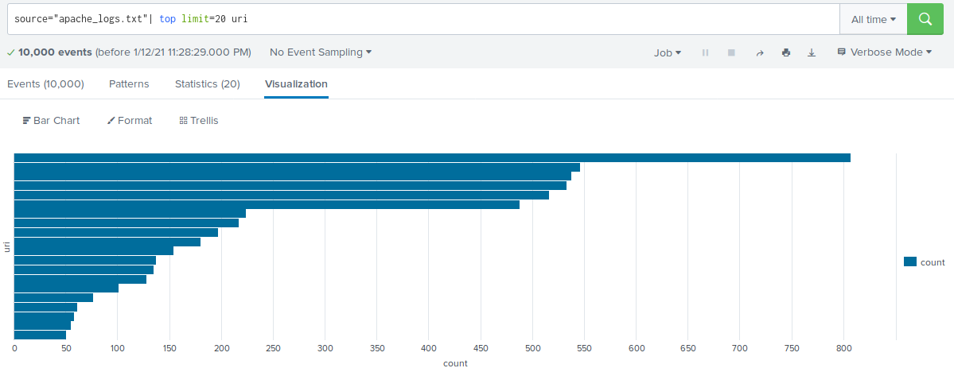

1. A bar, column, or pie chart that displays the counts of the top 10 countries.

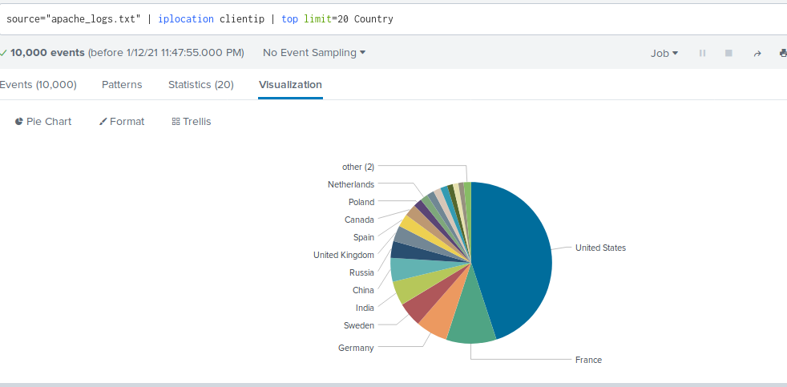

1. A statistical chart that illustrates the count of different user agents.

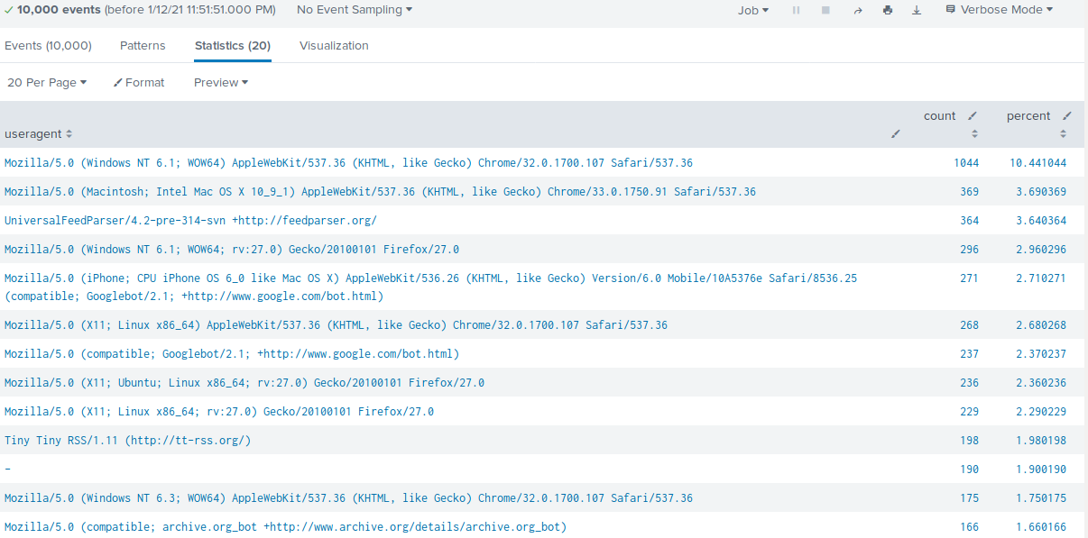

1. One single value visualization of your choice: radial gauge, marker gauge, etc.

On your dashboard, add the ability to change the time range for all your visualizations:

Be sure to title all your panels appropriately.

Align your dashboard panels as you see fit.