  - INTRODUCTION

Distributed path computation is a core functionality of modern communication networks and is expected to remain so, even though some recent proposals contemplate the use of more centralized solutions. Depending on the mode of information dissemination, and subsequent computation using the disseminated information, there are two broad classes of algorithms: link-state algorithms and distance-vector algorithms . In both approaches, nodes choose successor nodes for each destination based only on local information, with the objective that the chosen paths to the destination be efficient in an appropriate sense—e.g. having the minimum cost. Because end-to-end paths are formed by concatenating computational results at individual nodes, achieving a global objective implies consistency across nodes both in computation and in the information on which those computations are based. Inconsistent information at different nodes can have dire consequences that extend beyond not achieving the desired efficiency. Of particular signiﬁcance is the possible formation of transient routing loops1, which can severely impact network performance, especially in networks with no or limited loop mitigation mechanisms, e.g., no Time-to-Live (TTL) ﬁeld in packet headers or a TTL set to a large value. In the presence of a routing loop, a packet caught in the loop comes back to the same nodes repeatedly, thereby artiﬁcially increasing the traffic load many folds on the affected links and nodes.

The problem is aggravated by broadcast packets, which not only are always caught in any loop present in the network, but also generate replicated packets on all network links. The emergence of a routing loop then often triggers network-wide congestion, which can lead to the dropping or delaying of the very same control (update) packets that are needed to terminate the loop; thereby creating a situation where a transient problem has a lasting effect. Avoiding transient routing loops remains a key requirement for path computation in both existing and emerging network technologies.

1.2 PURPOSE OF THE PROJECT
The Distributed Path Computation with Intermediate Variables (DIV) algorithm that enables our goals of distributed, light-weight, loop-free path computation. DIV is not by itself a routing algorithm; rather, it can run on top of any routing algorithm to provide loop-freedom. DIV generalizes the Loop Free Invariant (LFI) based algorithms and outperforms previous solutions including known LFI and Diffusing Computation based algorithms, such as the Diffusing Update Algorithm . The main advantages of DIV are as follows:
1) Separation of Routing and Loop prevention: DIV separates routing algorithms from the task of transient loop prevention. Emancipating routing decisions from the task of loop-prevention simpliﬁes routing algorithms. In addition, DIV is not restricted to shortest path computations; it can be integrated with other distributed path computation algorithms. Where we explore a routing algorithm that attempts to increase the robustness of the network in terms of being able to re-route packets immediately (i.e., without the need for any route update) without causing a loop after a link or node failure.
2) Reduced Overhead: When applied to shortest path computations, DIV triggers synchronous updates less frequently as well as reduces the propagation radius of synchronous updates, where synchronous updates are time and resource consuming updates that might need to propagate to all upstream2 nodes before the originator is in a position to update its path. In fact, synchronous updates may altogether be removed if counting-to-inﬁnity is not a signiﬁcant issue (e.g., mitigated using a TTL); alternate mode.
3) Maintaining a path: A node can potentially switch to a new successor without forming a loop provably more quickly in DIV. This is particularly useful in situations where the original path is lost due to a link failure.
4) Convergence Time: When a node receives multiple overlapping cost updates3 from its neighbor, DIV allows the node to process and respond to the updates in an arbitrary manner, thus enabling an additional dimension for optimization.
5) Robustness: DIV can tolerate arbitrary packet reordering and losses without sacriﬁcing correctness.
The rules and update mechanism of DIV and their correctness proofs are rather simple, which hopefully will also facilitate correct and efficient implementations.

2.1 EXISTING SYSTEM
- Inconsistent information at different nodes can have dire consequences that extend beyond not achieving the desired efficiency. Of particular significance is the possible formation of transient routing loops, which can severely impact network performance, especially in networks with no or limited loop mitigation mechanisms, e.g., no Time-to-Live (TTL) field in packet headers or a TTL set to a large value.
- In the presence of a routing loop, a packet caught in the loop comes back to the same nodes repeatedly, thereby artificially increasing the traffic load many folds on the affected links and nodes.
- The problem, a significant issue even with unicast packets, is further aggravated by broadcast packets, which not only are always caught in any loop present in the network, but also generate replicated packets on all network links.
The emergence of a routing loop then often triggers network-wide congestion, which can lead to the dropping or delaying of the very same control (update) packets that are needed to terminate the loop; thereby creating a situation where a transient problem has a lasting effect. Avoiding transient routing loops remains a key requirement for path computation in both existing and emerging network technologies.

  - PROPOSED SYSTEM

Link-state algorithms, of which the OSPF protocol is a well-known embodiment; disseminate the state of each node’s local links to all other nodes in the network by means of reliable flooding.
- After receiving link-state updates from the rest of the nodes, each node independently computes a path to every destination.
- The period of potential information inconsistency across nodes is small so that routing loops, if any, are very short-lived. On the flip side, link-state algorithms can have quite high overhead in terms of communication storage, and computation.
- These are some of the reasons for investigating alternatives as embodied in distance-vector algorithms.

  - STUDY OF THE SYSTEM
DIV lays down a set of rules on existing routing algorithms to ensure their loop-free operation at each instant. This rule set is not predicated on shortest path computation, so DIV can be used with other path computation algorithms as well. For each destination, DIV assigns a value to each node in the network. To simplify our discussion and notation, we ﬁx a particular destination and from now on, speak of the value of a node. Some typical value assignments are as follows: (i) in shortest path computations, the value of a node could be its cost to-destination; (ii) as done in DUAL, the value could be the minimum cost-to-destination seen by the node from time t = 0; (iii) as done in TORA [23], the value could be the height of this node; (iv) as illustrated in Section IV, the value could be related to the number of next-hop neighbors for the destination, etc. We, however, impose one restriction on the value assignment: a node that does not have a path to a destination must assign a value of “inﬁnity” (the maximum possible value) to itself. Intuitively, this restriction prevents other nodes from using it as a successor which is sensible since it does not have a path to the destination in the ﬁrst place. This restriction turns out to be crucial for avoiding counting to-inﬁnity problems in shortest path environments.
The basic idea of DIV is that it allows a node to choose one of its neighbor as a successor only if the value of that neighbor is less than its own value: this is called the decreasing value property of DIV. This ensures that no routing loop can ever form.
However, how does a node then know the current value of one of its neighbors to ensure the decreasing value property? Clearly, each node must update its neighbors about its own current value by means of update messages. Since update messages are asynchronous, information at various nodes may be inconsistent and may lead to the formation of loops. This is where the non-triviality of DIV lies: it lays down speciﬁce update rules that guarantee that loops are not formed at any time even if the information at different nodes is inconsistent. DIV accomplishes this task by maintaining several intermediate variables that hold a replica of the value of a node at its neighbors and vice versa, and exchanging messages between neighboring nodes. Similar to (but not identical with) DUAL, the update mechanism sends update messages and for some of them, requires an acknowledgment from the neighbor.
Depending on the rules for sending acknowledgments, DIV can be operated in one of the following two modes: (i) the normal mode, and (ii) the alternate mode. In the normal mode, a neighbor can hold on to sending an acknowledgment until its own value is adjusted appropriately. In the alternate mode, on the other hand, the neighbor immediately sends the acknowledgment, but could temporarily lose all paths (to that particular destination). As we discuss later on, each mode embodies a different trade-off.

2.4 SOFTWARE REQUIREMENTS:

Operating System : Windows Xp
Front End : Java

2.5HARDWARE REQUIREMENTS

System : Pentium IV 2.4 GHz
Hard Disk : 40 GB
Floppy Drive : 1.44 MB
Mouse : Logitech.
RAM : 256 MB
Keyboard : 110 keys enhanced

SOFTWARE DEVELOPMENT LIFE CYCLE

SDLC is nothing but Software Development Life Cycle. It is a standard which is used by software industry to develop good software.

Stages in SDLC:

- Requirement Gathering
- Analysis
- Designing
- Coding
- Testing
- Maintenance

Requirements Gathering stage:

The requirements gathering process takes as its input the goals identified in the high-level requirements section of the project plan. Each goal will be refined into a set of one or more requirements. These requirements define the major functions of the intended application, define operational data areas and reference data areas, and define the initial data entities. Major functions include critical processes to be managed, as well as mission critical inputs, outputs and reports. A user class hierarchy is developed and associated with these major functions, data areas, and data entities. Each of these definitions is termed a Requirement. Requirements are identified by unique requirement identifiers and, at minimum, contain a requirement title and textual description.
These requirements are fully described in the primary deliverables for this stage: the Requirements Document and the Requirements Traceability Matrix (RTM). The requirements document contains complete descriptions of each requirement, including diagrams and references to external documents as necessary. Note that detailed listings of database tables and fields are not included in the requirements document. These requirements are fully described in the primary deliverables for this stage: the Requirements Document and the Requirements Traceability Matrix (RTM). The requirements document contains complete descriptions of each requirement, including diagrams and references to external documents as necessary. Note that detailed listings of database tables and fields are not included in the requirements document.

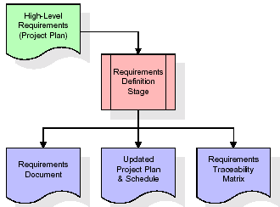

In the requirements stage, the RTM consists of a list of high-level requirements, or goals, by title, with a listing of associated requirements for each goal, listed by requirement title. In this hierarchical listing, the RTM shows that each requirement developed during this stage is formally linked to a specific product goal. In this format, each requirement can be traced to a specific product goal, hence the term requirements traceability.
The outputs of the requirements definition stage include the requirements document, the RTM, and an updated project plan.
- Feasibility study is all about identification of problems in a project.
- No. of staff required to handle a project is represented as Team Formation, in this case only modules are individual tasks will be assigned to employees who are working for that project.
- Project Specifications are all about representing of various possible inputs submitting to the server and corresponding outputs along with reports maintained by administrator
Analysis Stage:

The planning stage establishes a bird's eye view of the intended software product, and uses this to establish the basic project structure, evaluate feasibility and risks associated with the project, and describe appropriate management and technical approaches.
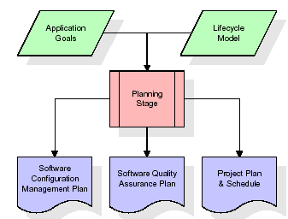

The most critical section of the project plan is a listing of high-level product requirements, also referred to as goals. All of the software product requirements to be developed during the requirements definition stage flow from one or more of these goals. The minimum information for each goal consists of a title and textual description, although additional information and references to external documents may be included. The outputs of the project planning stage are the configuration management plan, the quality assurance plan, and the project plan and schedule, with a detailed listing of scheduled activities for the upcoming Requirements stage, and high level estimates of effort for the out stages.

Designing Stage:

The design stage takes as its initial input the requirements identified in the approved requirements document. For each requirement, a set of one or more design elements will be produced as a result of interviews, workshops, and/or prototype efforts. Design elements describe the desired software features in detail, and generally include functional hierarchy diagrams, screen layout diagrams, tables of business rules, business process diagrams, pseudo code, and a complete entity-relationship diagram with a full data dictionary. These design elements are intended to describe the software in sufficient detail that skilled programmers may develop the software with minimal additional input.
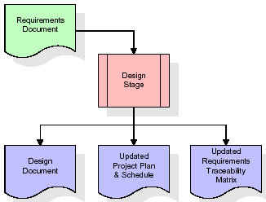

When the design document is finalized and accepted, the RTM is updated to show that each design element is formally associated with a specific requirement. The outputs of the design stage are the design document, an updated RTM, and an updated project plan.

Development (Coding) Stage:

The development stage takes as its primary input the design elements described in the approved design document. For each design element, a set of one or more software artifacts will be produced. Software artifacts include but are not limited to menus, dialogs, data management forms, data reporting formats, and specialized procedures and functions. Appropriate test cases will be developed for each set of functionally related software artifacts, and an online help system will be developed to guide users in their interactions with the software.
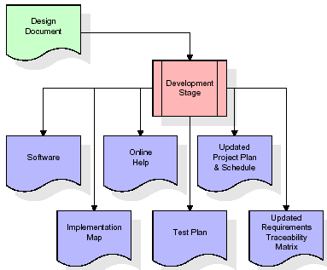

The RTM will be updated to show that each developed artifact is linked to a specific design element, and that each developed artifact has one or more corresponding test case items. At this point, the RTM is in its final configuration. The outputs of the development stage include a fully functional set of software that satisfies the requirements and design elements previously documented, an online help system that describes the operation of the software, an implementation map that identifies the primary code entry points for all major system functions, a test plan that describes the test cases to be used to validate the correctness and completeness of the software, an updated RTM, and an updated project plan.

Integration & Test Stage:

During the integration and test stage, the software artifacts, online help, and test data are migrated from the development environment to a separate test environment. At this point, all test cases are run to verify the correctness and completeness of the software. Successful execution of the test suite confirms a robust and complete migration capability. During this stage, reference data is finalized for production use and production users are identified and linked to their appropriate roles. The final reference data (or links to reference data source files) and production user list are compiled into the Production Initiation Plan.
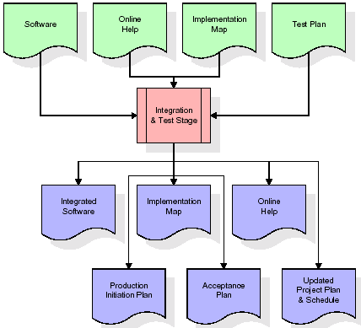

The outputs of the integration and test stage include an integrated set of software, an online help system, an implementation map, a production initiation plan that describes reference data and production users, an acceptance plan which contains the final suite of test cases, and an updated project plan.

Installation & Acceptance Test:

During the installation and acceptance stage, the software artifacts, online help, and initial production data are loaded onto the device or emulator. At this point, all test cases are run to verify the correctness and completeness of the software. Successful execution of the test suite is a prerequisite to acceptance of the software by the customer.
After customer personnel have verified that the initial production data load is correct and the test suite has been executed with satisfactory results, the customer formally accepts the delivery of the software.
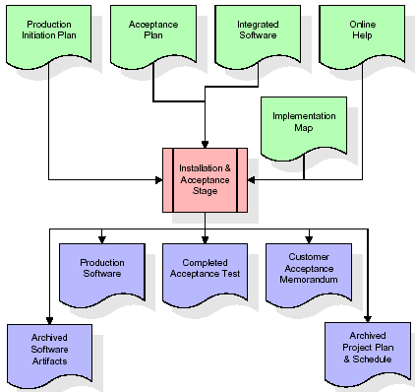
The primary outputs of the installation and acceptance stage include a production application, a completed acceptance test suite, and a memorandum of customer acceptance of the software. Finally, the PDR enters the last of the actual labor data into the project schedule and locks the project as a permanent project record. At this point the PDR "locks" the project by archiving all software items, the implementation map, the source code, and the documentation for future reference.

Maintenance:

Outer rectangle represents maintenance of a project, Maintenance team will start with requirement study, understanding of documentation later employees will be assigned work and they will under go training on that particular assigned category.
For this life cycle there is no end, it will be continued so on like an umbrella (no ending point to umbrella sticks).

2.6 SYSTEM ARCHITECTURE

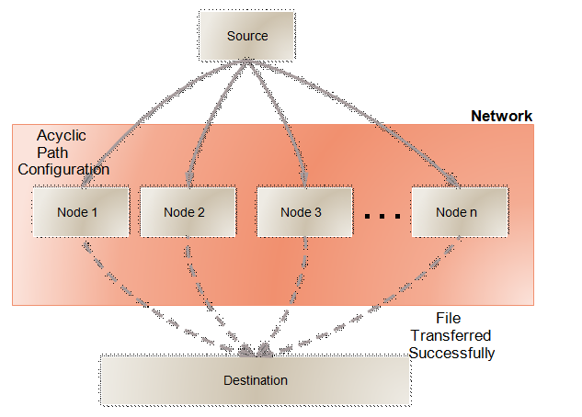

FEASIBILITY STUDY

The feasibility of the project is analyzed in this phase and business proposal is put forth with a very general plan for the project and some cost estimates. During system analysis the feasibility study of the proposed system is to be carried out. This is to ensure that the proposed system is not a burden to the company. For feasibility analysis, some understanding of the major requirements for the system is essential.
Three key considerations involved in the feasibility analysis are
ECONOMICAL FEASIBILITY
TECHNICAL FEASIBILITY
SOCIAL FEASIBILITY
3.1 ECONOMICAL FEASIBILITY

This study is carried out to check the economic impact that the system will have on the organization. The amount of fund that the company can pour into the research and development of the system is limited. The expenditures must be justified. Thus the developed system as well within the budget and this was achieved because most of the technologies used are freely available. Only the customized products had to be purchased.

3.2 TECHNICAL FEASIBILITY

This study is carried out to check the technical feasibility, that is, the technical requirements of the system. Any system developed must not have a high demand on the available technical resources. This will lead to high demands on the available technical resources. This will lead to high demands being placed on the client. The developed system must have a modest requirement, as only minimal or null changes are required for implementing this system.
3.3 SOCIAL FEASIBILITY

The aspect of study is to check the level of acceptance of the system by the user. This includes the process of training the user to use the system efficiently. The user must not feel threatened by the system, instead must accept it as a necessity. The level of acceptance by the users solely depends on the methods that are employed to educate the user about the system and to make him familiar with it. His level of confidence must be raised so that he is also able to make some constructive criticism, which is welcomed, as he is the final user of the system.

INTRODUCTION TO JAVA

Java is an object oriented language; it is basically support all concept of C and C++ with an additional features. Initially the language was called as “oak” but it was renamed as “java” in 1995.The primary motivation of this language was the need for a platform-independent(i.e. architecture neutral)language that could be used to create software to be embedded in various consumer electronic devices.
- Java is a programmer’s language
- Java is cohesive and consistent
- Except for those constraint imposed by the Internet environment. Java gives the programmer, full control

Finally Java is to Internet Programming where c was to System Programming.

Importance of Java to the Internet

Java has had a profound effect on the Internet. This is because; java expands the Universe of objects that can move about freely in Cyberspace. In a network, two categories of objects are transmitted between the server and the personal computer. They are passive information and Dynamic active programs. in the areas of Security and probability. But Java addresses these concerns and by doing so, has opened the door to an exciting new form of program called the Applet.

Applications and applets.

An application is a program that runs on our Computer under the operating system of that computer. It is more or less like one creating using C or C++ .Java’s ability to create Applets makes it important. An Applet I san application, designed to be transmitted over the Internet and executed by a Java-compatible web browser. An applet I actually a tiny Java program, dynamically downloaded across the network, just like an image. But the difference is, it is an intelligent program, not just a media file. It can be react to the user input and dynamically change.

Java Architecture
Java architecture provides a portable, robust, high performing environment for development. Java provides portability by compiling the byte codes for the Java Virtual Machine, which is then interpreted on each platform by the run-time environment. Java is a dynamic system, able to load code when needed from a machine in the same room or across the planet.

Compilation of code
When you compile the code, the Java compiler creates machine code (called byte code)for a hypothetical machine called Java Virtual Machine(JVM). The JVM is supposed t executed the byte code. The JVM is created for the overcoming the issue of probability. The code is written and compiled for one machine and interpreted on all machines .This machine is called Java Virtual Machine.

Compiling and interpreting java source code.

Source code
Pc compiler
Macintosh compiler
SPARC Compiler
Java Byte code

Platform independent
Java interpreter
Java interpretermacintosh

)))

Java interpreter(SPARC)
During run-time the Java interpreter tricks the byte code file into thinking that it is running on a Java Virtual Machine. In reality this could be an Intel Pentium windows 95 or sun SPARCstation running Solaris or Apple Macintosh running system and all could receive code from any computer through internet and run the Applets.

Simple:
Java was designed to be easy for the Professional programmer to learn and to use effectively. If you are an experienced C++ Programmer. Learning Java will oriented features of C++ . Most of the confusing concepts from C++ are either left out of Java or implemented in a cleaner, more approachable manner. In Java there are a small number of clearly defined ways to accomplish a given task.

Object oriented
Java was not designed to be source-code compatible with any other language. This allowed the Java team the freedom to design with a blank state. One outcome of this was a clean usable, pragmatic approach to objects. The object model in Java is simple and easy to extend, while simple types, such as integers, are kept as high-performance non-objects.

Robust
The multi-platform environment of the web places extraordinary demands on a program, because the program must execute reliably in a variety of systems. The ability to create robust programs. Was given a high priority in the design of Java. Java is strictly typed language; it checks your code at compile time and runtime.
Java virtually eliminates the problems of memory management and deal location, which is completely automatic. In a well-written Java program, all run-time errors can and should be managed by your program.

5.0 UNIFIED MODELLING LANGUAGE
Introduction: Systems design is the process or art of defining the architecture, components, modules, interfaces, and data for a system to satisfy specified requirements. One could see it as the application of systems theory to product development. There is some overlap and synergy with the disciplines of systems analysis, systems architecture and systems engineering.

UML DIAGRAMS

Unified Modeling Language:

The Unified Modeling Language allows the software engineer to express an analysis model using the modeling notation that is governed by a set of syntactic semantic and pragmatic rules.

A UML system is represented using five different views that describe the system from distinctly different perspective. Each view is defined by a set of diagram, which is as follows.
  - User Model View
    - This view represents the system from the users perspective.
    - The analysis representation describes a usage scenario from the end-users perspective.

  - Structural model view
    - In this model the data and functionality are arrived from inside the system.
    - This model view models the static structures.

- Behavioral Model View
It represents the dynamic of behavioral as parts of the system, depicting the interactions of collection between various structural elements described in the user model and structural model view.

- Implementation Model View
In this the structural and behavioral as parts of the system are represented as they are to be built.

- Environmental Model View

In this the structural and behavioral aspects of the environment in which the system is to be implemented are represented.

UML is specifically constructed through two different domains they are:
- UML Analysis modeling, this focuses on the user model and structural model views of the system.
- UML design modeling, which focuses on the behavioral modeling, implementation modeling and environmental model views.

5.1 Use Case
Use case Diagrams represent the functionality of the system from a user’s point of view. Use cases are used during requirements elicitation and analysis to represent the functionality of the system. Use cases focus on the behavior of the system from external point of view.
Actors are external entities that interact with the system. Examples of actors include users like administrator, bank customer …etc., or another system like central database.

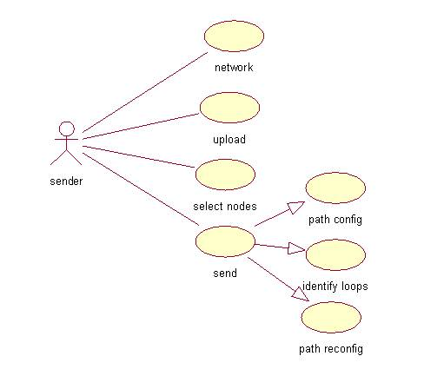
Fig: Usecase diagram

5.2 SEQUENCE DIAGRAM

A Sequence diagram in a Unified Modelling Language(UML) is a kind of interaction diagram that shows how processes operate with one another and in what order. It is a construct of a Message Sequence Chart. A Sequence diagram shows object interactions arranged in time sequence. It depicts the objects and classes involved in the scenario and the sequence of messages exchanged between the objects needed to carry out the functionality of scenario. Sequence diagram typically are associated with usecase realization

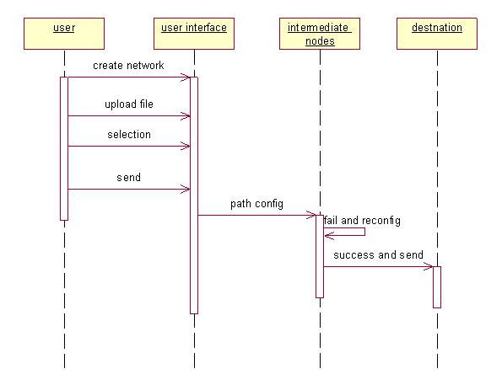

Fig: Sequence diagram

5.3 ACTIVITY DIAGRAM:

Activity diagrams are graphical representations of workflows of step-wise activities and actions with support for choice, iteration and concurrency. In the Unified Modeling Language , activity diagrams can be used to describe the business and operational step- by- step workflows of components in a system. An activity diagram shows the over all control flow of the system.
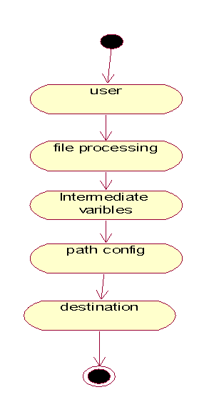

Fig: Activity diagram

6.1 MODULES:

      - Distributed Time-to-Live Module
      - Loop Free Routing Module
      - Robust Routing Module
      - shortest-path computation Module (or) shortest-path Simulation Module

6.2 MODULES DESCRIPTION:

1. Distributed Time-to-Live Module:
Time-to-Live (TTL) field in packet headers or a TTL set to a large value. In the presence of a routing loop, a packet caught in the loop comes back to the same nodes repeatedly, thereby artificially increasing the traffic load many folds on the affected links and nodes. The problem, a significant issue even with unicast packets, is further aggravated by broadcast packets, which not only are always caught in any loop present in the network, but also generate replicated packets on all network links. The emergence of a routing loop then often triggers network-wide congestion, which can lead to the dropping or delaying of the very same control (update) packets that are needed to terminate the loop; thereby creating a situation where a transient problem has a lasting effect. Avoiding transient routing loops remains a key requirement for path computation in both existing and emerging network technologies.

2. Loop Free Routing Module

The Loop free routing information dissemination and computation can also result in slower convergence. This is because each node depends on the computation results of its neighbors, which can introduce cyclic dependencies that increase the number of steps needed to reach a final, correct result. Indeed, when destinations become unreachable, a distance-vector algorithm may not even converge in a finite number of steps. This is known as the counting-to-infinity problem, which is absent from link-state algorithms where nodes compute paths independently.

Loop frees routing Main Features:

1) Separation of Routing and Loop prevention:
DIV separates routing algorithms from the task of transient loop prevention. Emancipating routing decisions from the task of loop-prevention simplifies routing algorithms. In addition, DIV is not restricted to shortest path computations; it can be integrated with other distributed path computation algorithms. We illustrate this in, where we explore a routing algorithm that attempts to increase the robustness of the network in terms of being able to reroute packets immediately (i.e., without the need for any route update) without causing a loop after a link or node failure.

2) Reduced overhead:
When applied to shortest path computations, DIV triggers synchronous updates less frequently as well as reduces the propagation radius of synchronous updates ,where synchronous updates are time and resource consuming updates that might need to propagate to all upstream2 nodes before the originator is in a position to update its path. In fact, synchronous updates may altogether be removed if counting-to-infinity is not a significant issue, alternate mode.

3) Maintaining a path:
A node can potentially switch to a new successor more quickly, while provably still guaranteeing loop prevention This is particularly useful in situations where the original path is lost due to a link failure.

4) Convergence Time:
When a node receives multiple overlapping cost updates3 from its neighbor, DIV allows the node to process and respond to the updates in an arbitrary manner, thus enabling an additional dimension for optimization

5) Robustness:
DIV an tolerate arbitrary packet reordering and losses without sacrificing correctness.
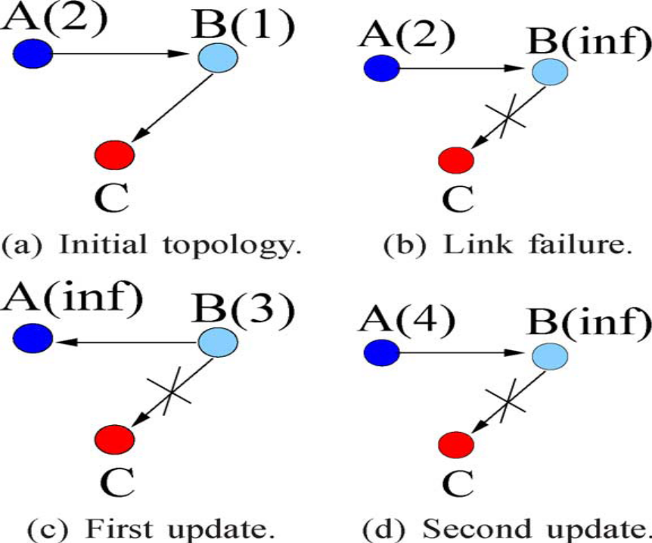
3. Robust Routing Module:
We illustrate the benefits of this decoupling using a cost function that instead of the standard shortest path distance function, seeks to maximize the number of next-hops available at all nodes for each destination. The availability of multiple next-hops ensures that the failure of any one link or neighbor does not impede a node’s ability to continue forwarding traffic to a destination. A failure results in the loss of at most one next hop to a destination, so that the node can continue forwarding packets on the remaining ones without waiting for new paths to be computed. In other words, the routing is robust to local failures.

4.shortest-path computation Module (or) shortest-path Simulation Module:
The shortest-path Simulations are performed on random graphs with fixed average degree of 5, but in order to generate a reasonable range of configurations, a number of other parameters are varied. Networks with sizes ranging from 10 to 90 nodes are explored in increments of 10 nodes. For each network-size, 100 random graphs are generated. Link costs are drawn from a bimodal distribution: with probability 0.5 a link cost is uniformly distributed in [0,1]; and with probability 0.5 it is uniformly distributed in [0,100]. For each graph, 100 random link-cost changes are introduced, again drawn from the same bimodal distribution. All three algorithms are run on the same graphs and sequences of changes.
Code For Creating Home Page:

package action;

import java.awt.BorderLayout;
import java.awt.event.ActionEvent;
import java.awt.event.ActionListener;
import javax.swing.JFrame;
import javax.swing.JMenu;
import javax.swing.JMenuBar;
import javax.swing.JMenuItem;
import javax.swing.JSplitPane;
import javax.swing.event.MenuEvent;
import javax.swing.event.MenuListener;
public class Simulation extends JFrame implements ActionListener,MenuListener
{
private JMenuBar bar;
private JMenu file;
private JMenuItem exit;
private JMenuItem send;
public static PaintPanel pp;
public Simulation()
{
bar=new JMenuBar();
file=new JMenu("File");
file.setMnemonic('f');
file.addMenuListener(this);
send=new JMenuItem("Send");
send.addActionListener(this);
send.setActionCommand("send");
send.setMnemonic('s');
file.add(send);

exit=new JMenuItem("Exit");
exit.addActionListener(this);
exit.setActionCommand("Exit");
exit.setMnemonic('x');
file.add(exit);

bar.add(file);
setJMenuBar(bar);
pp=new PaintPanel();
setLayout(new BorderLayout());
final JSplitPane spt = new JSplitPane(JSplitPane.VERTICAL_SPLIT,true);
spt.setDividerLocation(350);
spt.setLeftComponent(pp);
setTitle("Acyclic Distributed Path");
add(spt);
setVisible(true);
setDefaultCloseOperation(DISPOSE_ON_CLOSE);
setExtendedState (MAXIMIZED_BOTH);
}
public static void main(String args[])
{

new Simulation();
}
public void menuSelected(MenuEvent e)
{ // TODO Auto-generated method stub
}
public void menuDeselected(MenuEvent e)
{ // TODO Auto-generated method stub
}
public void menuCanceled(MenuEvent e)
{ // TODO Auto-generated method stub
}
public void actionPerformed(ActionEvent e)
{
if(e.getSource().equals(exit))
{
System.exit(0);
}
/*if(e.getSource().equals(send))
{
new SenderForm();
pp.routing();
}*/
}
}

Code for Creating Distance Vector:
package action;

import java.awt.*;
import javax.swing.*;
import javax.swing.table.*;
import javax.swing.border.*;
import java.util.*;
class DV extends JFrame
{
DV()
{
PaintPanel p=new PaintPanel();

Vector<Vector> data=new Vector<Vector>();
int j=0;
int z=1;
String abc="H";
for(int x=0;x<p.i;x++)
{
//j++;
Vector<String> row=new Vector<String>();
row.add("H"+x);

for(int u=0;u<p.i;u++)
{
//row.add("H"+x);
for(int v=0;v<p.i;v++)
{

// row.add(p.route[u][v]);
}
}

data.add(row);

}
//hello

// data.add(row);

Vector<String> cols=new Vector<String>();
for(int x=0;x<p.i;x++)
cols.add("H"+x);

JTable tab=new JTable(data,cols);

JTableHeader head=tab.getTableHeader();

Container c=getContentPane();
c.setLayout(new BorderLayout());
c.add("North",head);
c.add("Center",tab);

this.setSize(200,200);
this.setVisible(true);
this.setDefaultCloseOperation(JFrame.EXIT_ON_CLOSE);
}

}

Code For Transferring File :

package action;
import java.awt.Point;
import java.io.File;
import java.io.FileInputStream;
import java.io.FileNotFoundException;
import java.io.FileOutputStream;
import java.io.IOException;
import java.util.Iterator;
import java.util.Vector;
import javax.swing.JOptionPane;
public class TransferObject
{
private BufferTransfer bufferTransfer;
public static TransferObject transferObject;
byte[] buffer;
FileInputStream fis;
public TransferObject(String sname,String dname,String fname,BufferTransfer bufferTransfer) throws Exception
{
this.bufferTransfer=bufferTransfer;
transferObject=new TransferObject();
this.sname=sname;
this.dname=dname;
this.fname=fname;
bufferTransfer.setSource_name(sname); // Set Souce Name
bufferTransfer.setDestination_name(dname); // Set Destination name
bufferTransfer.setFilename(fname); // Set File Name
File f=new File(fname);
try {
fis =new FileInputStream(f);
buffer=new byte[fis.available()];
fis.read(buffer);
} catch (FileNotFoundException e) {
// TODO Auto-generated catch block
e.printStackTrace();
} catch (IOException e) {
// TODO Auto-generated catch block
e.printStackTrace();
}
bufferTransfer.setBuffer(buffer);
transferObject.neighbour_node(sname,dname,fname,bufferTransfer);
}
public TransferObject()
{}
int dest_avail_confirm=0,region_short_node=0,sdt=0,next_sdt=0,trans_port=0,trans_port_copy=0,dest_reach_confirm=0;
String sname,dname,fname,trans_node_type="";
Point s_point,reg_point; //For get source point
long trans_port_id; //Assign port id for transfer
Vector current_reg_vector=new Vector(); //For set Current region Host(Find out host 120 Distance)
Vector current_reg_vector_next=new Vector(); //For set Next Current region Host(include 120 Distance)
String region_short_node_name="None"; // Assign Next Host for Tranverse

// For declare value for next iteration loop

String not_reach_alternate_host="None",not_reach_alternate_host_copy="None";
Point not_reach_alternate_host_point = null;
int not_reach_hostport = 0;
int fdt=0;
public void neighbour_node(String sname,String dname,String fname,BufferTransfer bufferTransfer) throws Exception
{
dest_reach_confirm=0;
Iterator treeTraverse = PaintPanel.nt.getIterator(); // Iteration for Host information

while (treeTraverse.hasNext()) //Find out source and destination point
{
Host host = (Host) treeTraverse.next();
if (host.name.equalsIgnoreCase(sname))
s_point=host.position; //Assign Source Position
}
Iterator treeTraverse_dist = PaintPanel.nt.getIterator(); //Iterate all host from hostcontainer
while (treeTraverse_dist.hasNext())
{
Host host = (Host) treeTraverse_dist.next(); //Get Host list from HostContainer Class
sdt = (int)Math.sqrt(Math.pow((s_point.x-host.position.x), 2) + Math.pow((s_point.y-host.position.y), 2)); //Find the Distance from Source and iterate host
if ((sdt>0) && (sdt<=1000)&& (!bufferTransfer.getRefuse_packet_container().contains(host.host_id)) && (!bufferTransfer.getDestination_not_reachable_list().contains(host.name))&& (!bufferTransfer.getCrossing_host_name().contains(host.name))) //Check particular Region
{
current_reg_vector.add(host.name);
bufferTransfer.setRefuse_host_id(host.host_id);
//Code for Check Next iteration host are available(within next 1000 Region)
Iterator treeTraverse_dist_next = PaintPanel.nt.getIterator();
while(treeTraverse_dist_next.hasNext())
{
Host host_next = (Host) treeTraverse_dist_next.next(); //Get Host list from HostContainer Class
next_sdt = (int)Math.sqrt(Math.pow((host.position.x-host_next.position.x), 2) + Math.pow((host.position.y-host_next.position.y), 2)); //Find the Distance from Source and iterate host
if ((next_sdt>0)&&(next_sdt<=125)&& (!bufferTransfer.getRefuse_packet_container().contains(host_next.host_id)) && (!host_next.name.equals(sname)) && (!bufferTransfer.getCrossing_host_name().contains(host.name))) //Check particular Region
{
current_reg_vector_next.add(host_next.name);
}
} //End for check Next iteration
if ((region_short_node<=sdt) && ((current_reg_vector_next.size()>0)||(host.name.equals(bufferTransfer.getDestination_name()))) && (!bufferTransfer.getCrossing_host_name().contains(host.name)))
{
region_short_node=sdt;
region_short_node_name=host.name; //Assign next host
dest_reach_confirm++;
trans_port=host.hostPort; //get Unique port for next host
}
}
current_reg_vector_next.removeAll(current_reg_vector_next);
}
if (current_reg_vector.contains(dname)) //Check Destinatin host are avaiable in Region
{
JOptionPane.showMessageDialog(null,"Successfully sent");
String fob="Hosts/"+dname;
File f=new File(fob);
f.mkdir(); //Make Directory if not exists
FileOutputStream fos;
try {
fos = new FileOutputStream(fob+"/Output.txt"); //Genrate the .txt for output
fos.write(bufferTransfer.getBuffer()); //Generate output when File reach their Destination
fos.close();
} catch (FileNotFoundException e) {
// TODO Auto-generated catch block
e.printStackTrace();
}
bufferTransfer.setDestination_type("Destination");
new SubHostResponse(trans_port,bufferTransfer);
}
else if (!region_short_node_name.equals("None")) //Assign for next Host to Traverse
{
current_reg_vector.removeAll(current_reg_vector);
region_short_node=0;
sdt=0;
bufferTransfer.setCurrent_host(region_short_node_name);
bufferTransfer.setCross_host_name(region_short_node_name);
System.out.println("Next Host to Process-->"+bufferTransfer.getCurrent_host());
bufferTransfer.setDestination_type("Process");
new SubHostResponse(trans_port,bufferTransfer); //Control transfer to client(Such as Sender)
}
else //Prevent Data Packet Not reachable Condition (Two step back)
{
if (bufferTransfer.getCrossing_host_name().size()>=2)
{
try
{
if (bufferTransfer.getCrossing_host_name().size()>=2)
{
bufferTransfer.setDestination_not_reach_host(bufferTransfer.getCrossing_host_name().lastElement().toString()); //Assign particular Host name into Not Reachable list
trans_port=transferObject.freeup_Host(bufferTransfer.getCrossing_host_name().lastElement().toString(),bufferTransfer); //Free up surrounding host
bufferTransfer.getCrossing_host_name
().remove(bufferTransfer.getCrossing_host_name().lastElement()); //Remove From Travering Host List
bufferTransfer.setCurrent_host(bufferTransfer.getCrossing_host_name().lastElement().toString()); //Set Current host name to traverse next Iteration
trans_port=transferObject.freeup_Host(bufferTransfer.getCrossing_host_name().lastElement().toString(),bufferTransfer); ////Free up surrounding host (120 Distance from not reachable host)
bufferTransfer.getCrossing_host_name().remove(bufferTransfer.getCrossing_host_name().lastElement()); //Remove from Taversing Host list
System.out.println("Next Host to Process(Recover)-->."+bufferTransfer.getCurrent_host());
bufferTransfer.setDestination_type("Process"); //Set type for process another iteration
new SubHostResponse(trans_port,bufferTransfer); //Control transfer to client(Such as Sender)
}

}
catch(Exception e)
{
System.out.println("Exception in not reachable"+e.getMessage());
}
}
else if (bufferTransfer.getCrossing_host_name().size()>=1)
{
JOptionPane.showMessageDialog(null,"No More Sub Host Receiver Available in Next Host Region "+bufferTransfer.getCurrent_host());
bufferTransfer.setDestination_type("Failure");
}
else if (bufferTransfer.getCrossing_host_name().isEmpty())
{
JOptionPane.showMessageDialog(null,"Put Receiver Host in 125 Region");
bufferTransfer.setDestination_type("Failure");
}
else
{
JOptionPane.showMessageDialog(null,"Destination Not Reachable");
bufferTransfer.setDestination_type("Failure");
}
}
}
public int freeup_Host(String freeuphost_param,BufferTransfer bufferTransfer)
{
try
{
Iterator iterator_getpoint = PaintPanel.nt.getIterator();
while(iterator_getpoint.hasNext())
{
Host host_next_alter_host = (Host) iterator_getpoint.next(); //Get Host list from HostContainer Class
if (freeuphost_param.equals(host_next_alter_host.name))
{
not_reach_alternate_host_point=host_next_alter_host.position; //Get the Host point posistion
not_reach_hostport=host_next_alter_host.hostPort; //Get corresponding hostport
}
}
}
catch(Exception e)
{
System.out.println("Exception in Getting Point"+e.getMessage());
}
try
{
// Free up from refuse List host
Iterator treeTraverse_dist_freeup_host = PaintPanel.nt.getIterator();
while(treeTraverse_dist_freeup_host.hasNext())
{
Host host_next_free = (Host) treeTraverse_dist_freeup_host.next(); //Get Host list from HostContainer Class
fdt = (int)Math.sqrt(Math.pow((not_reach_alternate_host_point.x-host_next_free.position.x), 2) + Math.pow((not_reach_alternate_host_point.y-host_next_free.position.y), 2)); //Find the Distance from Source and iterate host
if (fdt<=125) //Check that particular host is avaiable in 125 Region Distance
{
bufferTransfer.getRefuse_packet_container().remove(host_next_free.host_id);
}
}
}
catch(Exception e)
{
System.out.println("Exception in Free-up Host"+e.getMessage());
}
return not_reach_hostport;
} //End function
}

Code for select nodes to trasfering file:

package action;
import java.awt.GridBagLayout;
import java.awt.GridBagConstraints;
import javax.swing.JOptionPane;
import java.io.File;
import java.util.Iterator;
import javax.swing.JFrame;
import javax.swing.JLabel;
import javax.swing.JButton;
import javax.swing.JFileChooser;
import javax.swing.filechooser.FileFilter;
import javax.swing.JTextField;
import javax.swing.JComboBox;
import java.awt.event.ActionEvent;
import java.awt.event.ActionListener;
import java.awt.Component;
import java.awt.*;
import javax.swing.*;
import java.util.*;

public class SenderForm extends JFrame implements ActionListener
{
private JLabel label1;
private JLabel label2;
private JLabel label3;
private JTextField txt1;
private JButton browse,submit,cancel;
private JComboBox sou,des;
private String name,sname,dname;
private GridBagLayout layout;
private GridBagConstraints cons;
private HostContainer containerOBJ;
int host_count,u,k,l,m=0,j;
int[] p=new int[30];

int i=-1;
public SenderForm()
{
super("Select File to Traversing..");
containerOBJ=PaintPanel.nt;
layout=new GridBagLayout();
setLayout(layout);
cons=new GridBagConstraints();
host_count=containerOBJ.size();
final String source_nodes[]=new String[host_count];
Iterator treeTraverse = containerOBJ.getIterator();
while (treeTraverse.hasNext())
{
i++;
Host host = (Host) treeTraverse.next();
source_nodes[i]=host.name;
}

label1=new JLabel("Select Source Node");
label1.setToolTipText("Source");
cons.fill=GridBagConstraints.HORIZONTAL;
addComponent(label1,0,4,5,5);

sou=new JComboBox(source_nodes);
sou.setMaximumRowCount(5);
cons.fill=GridBagConstraints.HORIZONTAL;
addComponent(sou,0,12,5,5);

label2=new JLabel("Select Destination Node");
label2.setToolTipText("Destination");
cons.fill=GridBagConstraints.HORIZONTAL;
addComponent(label2,15,4,5,5);

label3=new JLabel();
label3.setForeground(Color.RED);
label3.setToolTipText("path");
cons.fill=GridBagConstraints.HORIZONTAL;
addComponent(label3,150,2,5,5);

des=new JComboBox(source_nodes);
des.setMaximumRowCount(5);
cons.fill=GridBagConstraints.HORIZONTAL;
addComponent(des,15,12,5,5);
txt1=new JTextField();
txt1.setToolTipText("TextBox");
cons.fill=GridBagConstraints.HORIZONTAL;
addComponent(txt1,20,2,5,5);
browse=new JButton("Browse");
cons.fill=GridBagConstraints.HORIZONTAL;
addComponent(browse,20,10,5,5);
browse.addActionListener(this);
submit=new JButton("Submit");
cons.fill=GridBagConstraints.HORIZONTAL;

addComponent(submit,30,2,2,2);

submit.addActionListener(new ActionListener(){
public void actionPerformed(ActionEvent ea)
{

if (txt1.getText().equals(""))
{
JOptionPane.showMessageDialog(null,"Select FileName you want to Transfer");
}
else if (sou.getSelectedItem().equals(des.getSelectedItem()))
{
JOptionPane.showMessageDialog(null,"Please Select Different Destination Name");
}
else if(host_count<3)
{
JOptionPane.showMessageDialog(null,"Number of Receiver should be Greater 10");
}
else if(host_count>50)
{
JOptionPane.showMessageDialog(null,"Number of Receiver should be Greater 50");
}

else
{
BufferTransfer bufferTransfer=new BufferTransfer();
sname=(String)sou.getSelectedItem();
dname=(String)des.getSelectedItem();
label3.setText("Path:");
String s1=sname.substring(4);
String d1=dname.substring(4);
int s=Integer.parseInt(s1);
int d=Integer.parseInt(d1);
u=s;
k=d;
l=d;
if(PaintPanel.via[u][k]!=k)
path();
else{label3.setText(label3.getText()+s+"----"+d);}
if(PaintPanel.route[s][d]==9999){

label3.setText(label3.getText()+"No Link");
JOptionPane.showMessageDialog(null,"No Link between selected nodes");}

else{

try {
new TransferObject(sname,dname,txt1.getText(),bufferTransfer);
} catch (Exception e) {
// TODO Auto-generated catch block
e.printStackTrace();

}
}
}

}//end of action performed
});//end of link actionlistener

cancel=new JButton("Cancel");
cons.fill=GridBagConstraints.HORIZONTAL;
addComponent(cancel,30,10,5,5);
cancel.addActionListener(this);
cancel.setActionCommand("cancel");
setVisible(true);
setSize(400,400);

}

public void path()
{
label3.setText(label3.getText()+u);
while(PaintPanel.via[u][k]!=k)
{
u=PaintPanel.via[u][k];
p[m]=u;
m++;
}//end of while

for(j=0;j<m;j++)
{

label3.setText(label3.getText()+"---"+p[j]);
}//end of for

label3.setText(label3.getText()+"---"+k);
}//end of path

private void addComponent(Component component,int row,int column,int width,int height)
{
cons.gridx=column;
cons.gridy=row;
cons.gridwidth=width;
cons.gridheight=height;
layout.setConstraints(component, cons);
add(component);
}
public void actionPerformed(ActionEvent ae)
{
if (ae.getSource()==browse)
{
JFileChooser chooser = new JFileChooser();
chooser.setCurrentDirectory(new File("."));
chooser.setFileFilter(new FileFilter()
{
public boolean accept(File f)
{
return f.getName().toLowerCase().endsWith(".jpg")|| f.isDirectory();
}
public String getDescription() {
return "JPEG Files";
}
});//end of chooser,setfilter
int returnVal = chooser.showOpenDialog(this);
if (returnVal == JFileChooser.APPROVE_OPTION)
{
name = chooser.getSelectedFile().getPath();
File filename = chooser.getSelectedFile();
txt1.setText(filename.getAbsolutePath());
System.out.println("Cover Image" +name);
}
} //End Code For browse
if(ae.getSource().equals(cancel))
{
setVisible(false);
} }//end of action performed
}

INTRODUCTION TO TESTING

8.1 Introduction to Testing:
Testing is a process, which reveals errors in the program. It is the major quality measure employed during software development. During testing, the program is executed with a set of test cases and the output of the program for the test cases is evaluated to determine if the program is performing as it is expected to perform.

8.2 TESTING IN STRATEGIES

- we are going to test whether the links between the nodes are established in a proper way

- whether the routing table is specified with accurate values

- testing ,whether packets are transferring without link between the nodes

- if transfer information is being maintained at the hosts

In order to make sure that the system does not have errors, the different levels of testing strategies that are applied at differing phases of software development are:
Unit Testing:

Unit Testing is done on individual modules as they are completed and become executable. It is confined only to the designer's requirements.

Each module can be tested using the following two Strategies:
Black Box Testing:
In this strategy some test cases are generated as input conditions that fully execute all functional requirements for the program. This testing has been uses to find errors in the following categories:
- Incorrect or missing functions
- Interface errors
- Errors in data structure or external database access
- Performance errors
- Initialization and termination errors.
In this testing only the output is checked for correctness.

The logical flow of the data is not checked.

White Box testing :
In this the test cases are generated on the logic of each module by drawing flow graphs of that module and logical decisions are tested on all the cases. It has been uses to generate the test cases in the following cases:

- Guarantee that all independent paths have been Executed.
- Execute all logical decisions on their true and false Sides.
- Execute all loops at their boundaries and within their operational bounds
- Execute internal data structures to ensure their validity.

Integrating Testing :

Integration testing ensures that software and subsystems work together a whole. It tests the interface of all the modules to make sure that the modules behave properly when integrated together. In this case the communication between the device and Google Translator Service.

System Testing :

Involves in-house testing in an emulator of the entire system before delivery to the user. It's aim is to satisfy the user the system meets all requirements of the client's specifications.

Acceptance Testing :

It is a pre-delivery testing in which entire system is tested in a real android device on real world data and usage to find errors.

Test Approach :

Testing can be done in two ways:

- Bottom up approach
- Top down approach

Bottom up Approach:

Testing can be performed starting from smallest and lowest level modules and proceeding one at a time. For each module in bottom up testing a short program executes the module and provides the needed data so that the module is asked to perform the way it will when embedded with in the larger system. When bottom level modules are tested attention turns to those on the next level that use the lower level ones they are tested individually and then linked with the previously examined lower level modules.
Top down approach:
This type of testing starts from upper level modules. Since the detailed activities usually performed in the lower level routines are not provided stubs are written. A stub is a module shell called by upper level module and that when reached properly will return a message to the calling module indicating that proper interaction occurred. No attempt is made to verify the correctness of the lower level module.

Validation:
The system has been tested and implemented successfully and thus ensured that all the requirements as listed in the software requirements specification are completely fulfilled. In case of erroneous input corresponding error messages are displayed.

8.3 Test Cases:

The basic objective of writing test cases is to validate the testing.
A test case in software engineering is a set of conditions or variables under which a tester will determine whether an application or software system meets specifications. It may take many test cases to determine that a software program or system is functioning correctly. Test cases are often referred to as test scripts, particularly when written. Written test cases are usually collected into test suites.
A test case has components that describes an input, action or event and an expected response, to determine if a feature of an application is working correctly.

Test Case1:
Action: Mouse Click
Expected Output: Nodes have to be displayed at clicked position.

Test Case2:
Action: Link between two nodes
Expected Output: If the given two nodes exists link is displayed.

Test Case3:
Action: Counting number of nodes.
Expected Output: If number of nodes is less than three a message is displayed that number of nodes should be greater than three.

Test Case4:
Action: Distance between nodes.
Expected Output: The distance between two nodes should be less than thousand. If it is greater than thousand an error message is displayed.

Test Case5:
Action: Data transfer
Expected Output:
Path exists data will be transferred from source to destination.
Path does not exists data will not be transferred from source to destination.

Test Case6:
Action: Checking transferred file
Expected Output: Transferred file should be in the destination folder.

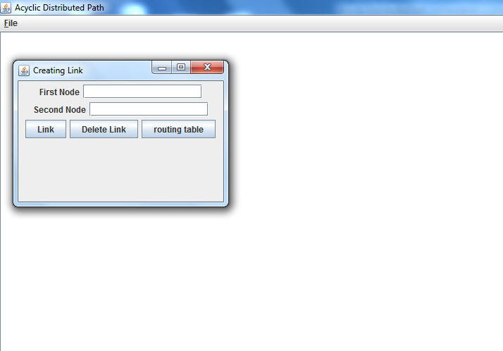

Figure 1: This is the home page where we can add nodes and links.

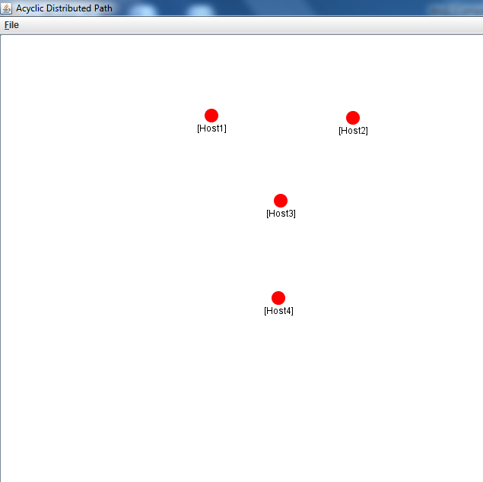

Figure 2: This is the screen after adding nodes at desired positions.

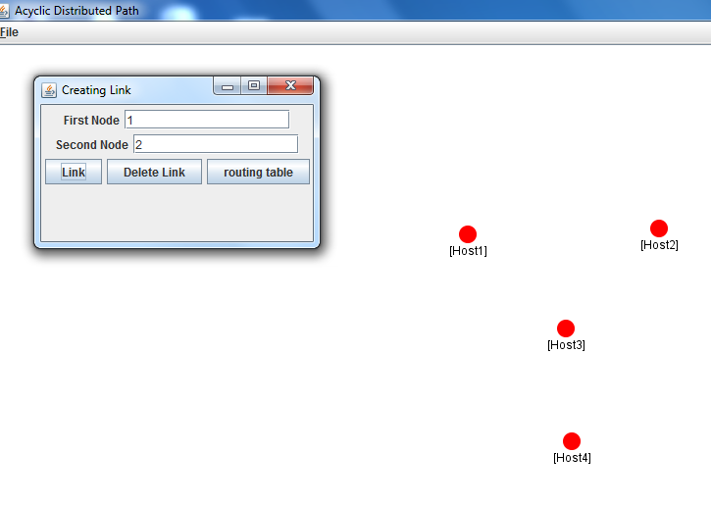

Figure 3: This is the screen in which we are creating the link between selected nodes.

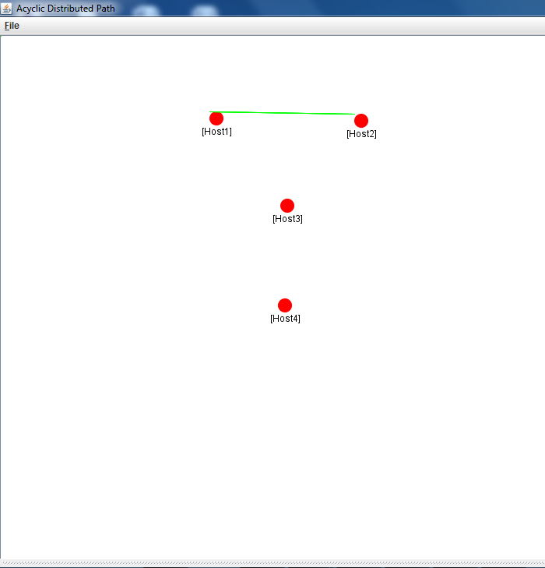

Figure 4: This is the screen after creating a link between first and second node.

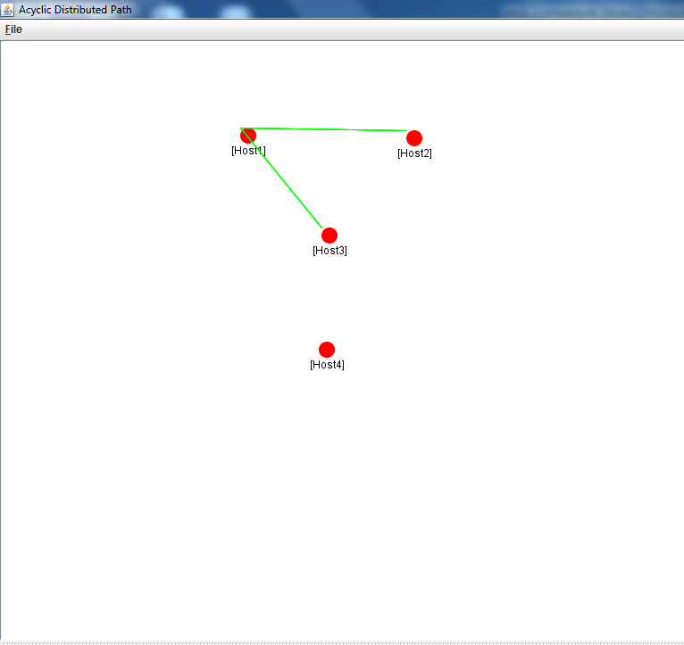

Figure 5: This is the screen creating links between first and third node.

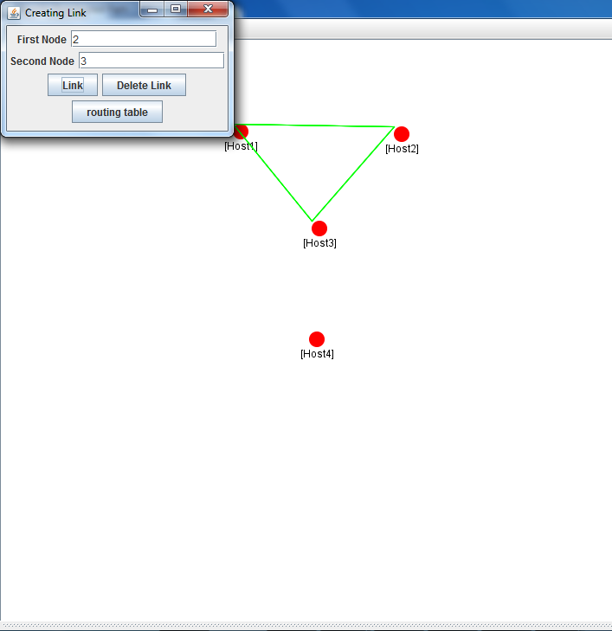

Figure 6: In this screen we are creating a link between second and third node.

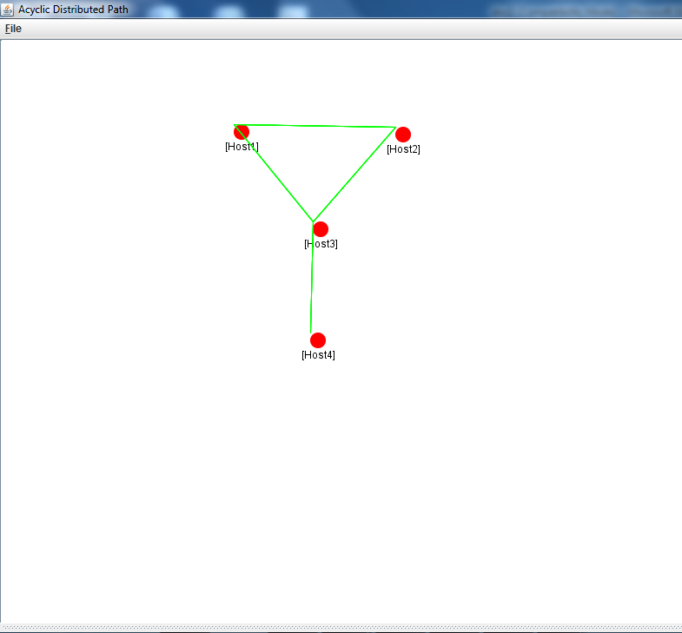

Figure 7: In this screen we are creating a link between third and fourth node.

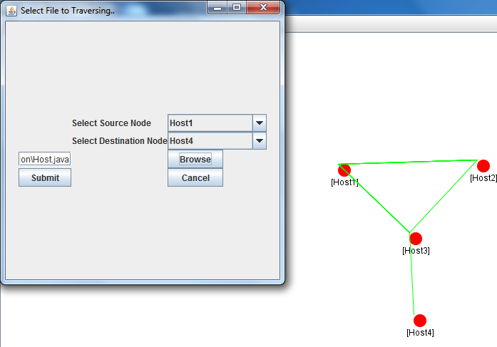

Figure 8: In this screen we are selecting source node & destination node.

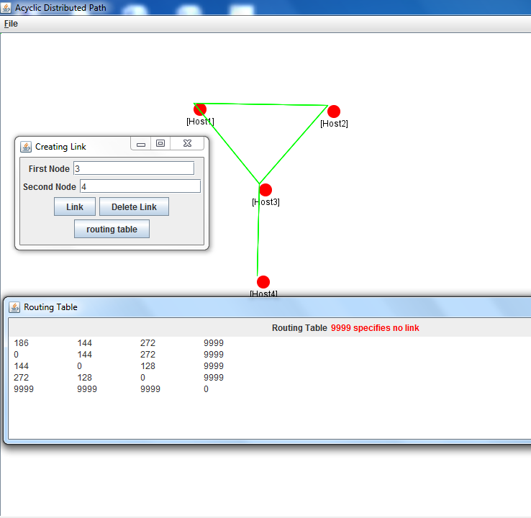 Figure 9: In this screen we are displaying the routing table for the given graph.

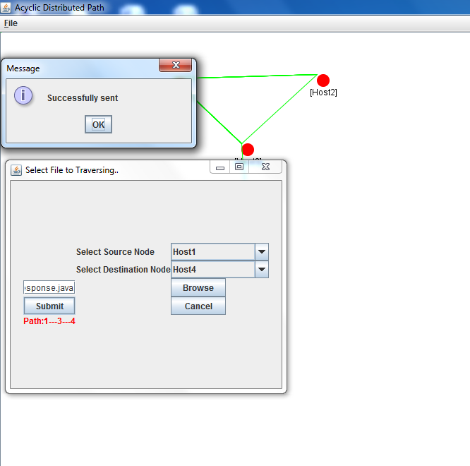

Figure 10: In this screen the file is transferred between source and destination based on the routing table. The path is also specified on the screen in which the file is transferred.

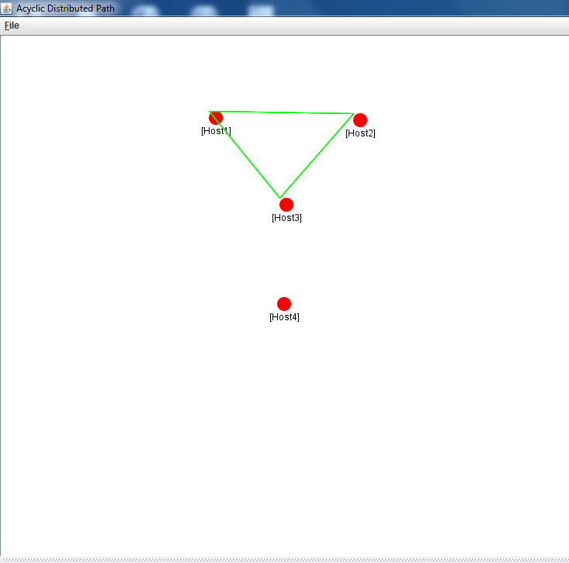

Figure 11: In this screen we are removing a link which already exists.

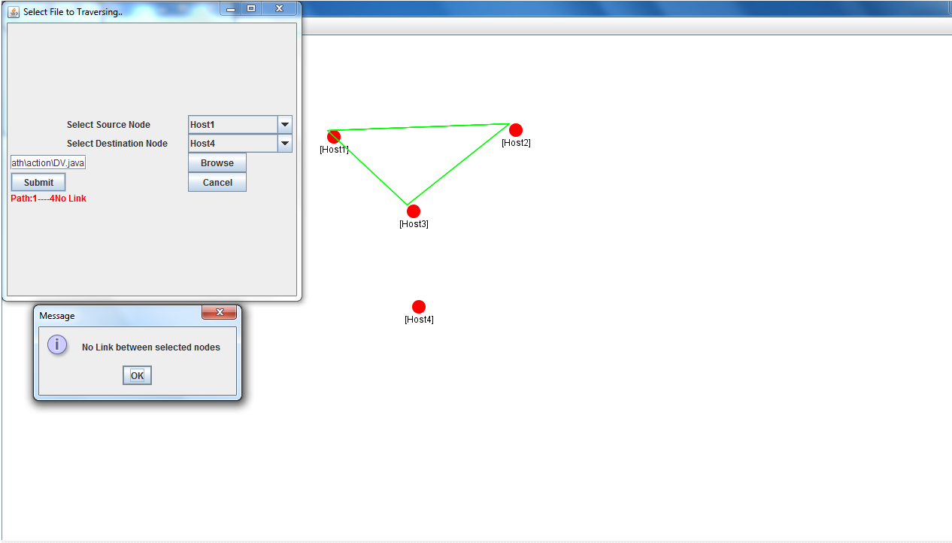

Figure 12: In this screen when we select node 4 as destination, since there is no path to node 4 the same message is displayed. So here a transient loop will be formed between nodes 1 and 3.

Distance-vector algorithms have advantages over link-state algorithms, In this paper, we present a novel algorithm, Distributed Path Computation with Intermediate Variables (DIV), that achieves this by laying down a rule-set over existing routing algorithms and defining an efficient update mechanism for enforcing those rules; both are easy to implement. DIV can be used with any routing algorithm. When used with shortest-path computation algorithms, DIV was shown to perform better than current alternatives, such as diffusing update algorithm (DUAL) (and, consequently, the protocols based on DUAL), both analytically and by simulation along various metrics. Another significant advantage of DIV is that it handles message losses and out-of-sequence delivery, and allows nodes to adopt arbitrary policies for handling multiple overlapping updates, opening up the possibility of various optimizations. Finally, the rule-set and proof of correctness of DIV are intuitive, which should facilitate efficient (and correct) implementations. The benefits of an operation decoupled from shortest path computations were illustrated through the DIV-R algorithm. DIV-R assigns node values with the view of optimizing the network’s “local repair” ability in the event of node (or link) failures. We believe this flexibility of DIV to have applicability in other environments.

[1] N. Feamster, H. Balakrishnan, J. Rexford, A. Shaikh, and K. van der Merwe, “The case for separating routing from routers,” in Proc. ACM SIGCOMM Workshop FDNA, Portland, OR, Sep. 2004, pp. 5–12.
[2] A. Shankar, C. Alaettinoglu, K. Dussa-Zieger, and I. Matta, “Transient and steady-state performance of routing protocols: Distance-vector versus link-state, Internetw” Res. Exper., vol.6, no. 2, pp. 59–87, Jun. 1995.
[3] A. Myers, E. Ng, and H. Zhang, “Rethinking the service model: Scaling Ethernet to a million nodes,” presented at the ACM SIGCOMM Hot-Nets, San Diego, CA, 2004.
[4] Y. Ohba, “Issues on loop prevention in MPLS networks,” IEEE Commun. Mag., vol. 37, no. 12, pp. 64–68, Dec. 1999. Authorized licensed use limited to: University of Pennsylvania. Downloaded on March 01,2010 at 17:57:19 EST from IEEE Xplore. Restrictions apply.
RAY et al.: ALWAYS ACYCLIC DISTRIBUTED PATH COMPUTATION 319
[5] P. Francois and O. Bonaventure, “Avoiding transient loops during IGP convergence in IP networks,” in Proc. IEEE INFOCOM, Miami, FL, Mar. 2005, vol. 1, pp. 237–247.
[6] J. Moy, “OSPF version 2,” Internet Engineering Task Force, RFC 2328, 1998 [Online]. Available: http://www.rfc-editor.org/rfc/rfc2328.txt
[7] A. Shaikh and A. Greenberg, “Experience in black-box OSPF measurement,”
in Proc. ACMSIGCOMM IMW, San Francisco, CA, Nov. 2001,pp. 113–125.
[8] G. Malkin, “RIP version 2,” Internet Engineering Task Force, RFC 2453, 1998 [Online]. Available: http://www.rfc-editor.org/rfc/rfc2453.txt
[9] R. Albrightson, J. J. Garcia-Luna-Aceves, and J. Boyle, “EIGRP – Afast routing protocol based on distance vectors,” presented at the Netw./Interop. 1994.
[10] E. Gafni and D. Bertsekas, “Distributed algorithms for generating loop-free routes in networks with frequently changing topology,”IEEE Trans. Commun., vol. COM-29, no. 1, pp. 11–18, Jan. 1981.
[11] P. M. Merlin and A. Segall, “A failsafe distributed routing protocol,”IEEE Trans. Commun., vol. COM-27, pp. 1280–1288, Sep. 1979.
[12] J. M. Jaffe and F. M. Moss, “A responsive routing algorithm for computer networks,” IEEE Trans. Commun., vol. 30, pp. 1768–1762, Jul.1982.
[13] J. J. Garcia-Lunes-Aceves, “Loop-free routing using diffusing computations,”IEEE/ACMTrans. Netw., vol. 1, no. 1, pp. 130–141, Feb. 1993.
[14] S. Vutukury and J. J. Garcia-Luna-Aceves, “A simple approximation to minimum-delay routing,” in Proc. ACM SIGCOMM, 1999, pp. 227–238.
[15] S. Vutukury and J. J. Garcia-Luna-Aceves, “MDVA: A distance-vector multipath routing protocol,” in Proc. IEEE INFOCOM, Anchorage, AK, Apr. 2001, vol. 1, pp. 557–564.
[16] K. Elmeleegy, A. L. Cox, and T. S. E. Ng, “On count-to-infinity induced forwarding loops in Ethernet networks,” in Proc. IEEE INFOCOM, 2006, pp. 1–13.
[17] Transparent interconnection of lots of links
[18] “802.1aq—Shortest path bridging,”
[19] D. Bertsekas and R. Gallager, Data Networks, 2nd ed. Englewood Cliffs, NJ: Prentice-Hall,
1991.
[20] W. T. Zaumen and J. J. Garcia-Luna-Aceves, “Dynamics of distributed shortest path routing algorithms,” in Proc. ACM SIGCOMM, Zurich, Switzerland, Sep. 1991, pp. 31–42.
[21] P. Humblet, “Another adaptive distributed shortest-path algorithm,”
IEEE Trans. Commun., vol. 39, no. 6, pp. 995–1003, Jun. 1991.
[22] E. W. Dijkstra and C. S. Scholten, “Termination detection for diffusing computations,” Inf. Process. Lett., vol. 11, no. 1, pp. 1–4, Aug. 1980.
[23] V. D. Park and M. S. Corson, “A highly adaptive distributed routing algorithm for mobile wireless networks,” in Proc. IEEE INFOCOM,1997, vol. 3, pp. 1405–1413.
[24] A.-L. Barabási and R. Albert, “Emergence of scaling in random networks,”Science, vol. 286, pp. 509–512, 1999.
[25] B. Fortz and M. Thorup, “Internet traffic engineering by optimizing OSPF weights,” in Proc. IEEE INFOCOM, 2000, vol. 2, pp. 519–528.

ONLINE RESOURCES

www.roseindia.net
www.softlandindia.com/java.html
http://www.java.sun.com

