**Name- Akansha Gupta (29460069) Manasie Bajpai (30150698)**

# Question 1:

**(a)**

**A close up of a logo

Description generated with very high confidence**

Given Tampering, Fire and Alarm are related to each other by common effect.

As per the case whenever there will be fire it will lead to smoke, thus causing a link between fire and smoke.

Whenever there is fire alarm in the building the chances of evacuation are more making these 2 nodes related.

If there is evacuation the newspaper tends to write a report, thus making evacuation and report linked and alarm, evacuation and report linked through causal chain

Tampering



Smoke

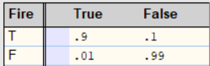

Report

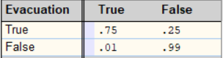

Fire



Evacuation

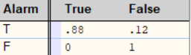

Alarm

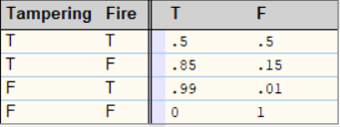

**(b)**

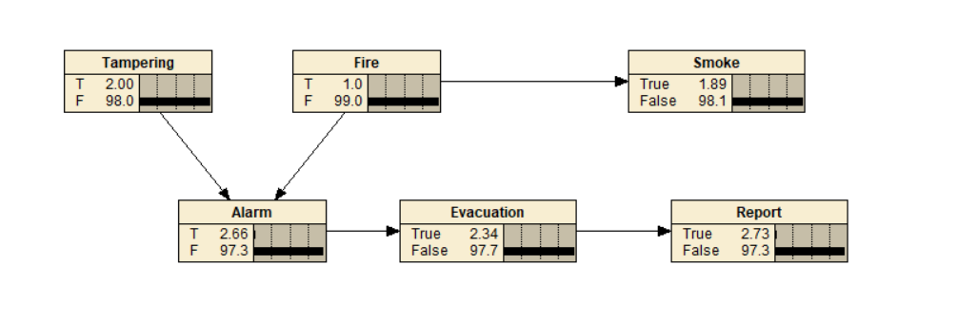

(i) Pr(Alarm = T) = 2

(ii) Pr(Report = T) =2.73

(iii) Pr(Report = T|Smoke = T) = 32

(iv) Pr(Tampering = T|Fire = F, Report = T) = 53.5

(v) Pr(Tampering = T|Smoke = F)= 2

Common effect comes into picture here where Tampering and Fire are independent and so is the descendent of Fire which is Smoke, independent of Tampering

(vi) Pr(Tampering = T|Smoke = F, Report = T)= 51.9

As the report is evidence and it is the descendent of Alarm making it evidence as well, this will make tampering and fire dependent because of common effect and as smoke is descendent of fire, smoke and tampering are dependent. This will be true only if report is an evidence as common effect will come into picture only at that point, thus it changes our belief.

(vii) Pr(Tampering = T|Fire = F, Report = T, Smoke = T)= 53.5

Fire is evidence here, thus blocking the path is between Smoke and tampering, making them d-separated or independent.

**(c)**

(i)Tampering ⊥⊥ Evacuation

Answer- False

Explanation- Tampering, Alarm and Evacuation form a causal chain thus making Tampering and Evacuation dependent on each other

(ii)Tampering ⊥⊥ Evacuation | Alarm

Answer- True

Explanation- If Alarm is given it makes the causal chain path inactive thus making Tampering and Evacuation independent.

(iii)Tampering ⊥⊥ Evacuation | Smoke

Answer- False

Explanation- Tampering causes Alarm, Alarm causes evacuation causing a causal chain, thus tampering effects evacuation even if smoke is given which is independent of tampering.

(iv) Tampering ⊥⊥ Fire

Answer- True

Explanation- Tampering is independent of Fire based on common effect

(v) Tampering ⊥⊥ Fire | Alarm

Answer- False

Explanation- As alarm is given making tampering and Fire dependent of each other under the common effect

(vi) Alarm ⊥⊥ Smoke

Answer- False

Explanation- Alarm, smoke is caused by fire, thus making alarm, smoke dependent on each other by the property of common cause.

(vii) Smoke ⊥⊥ Report

Answer- False

Explanation- Alarm, smoke is caused by fire, thus making alarm, smoke dependent on each other by the property of common cause. Alarm will cause evacuation which will lead to report, thus making alarm and report dependent by the property of causal chain. Hence, smoke and report are dependent on each other.

(viii) Smoke ⊥⊥ Tampering

Answer- True

Explanation- Tampering and Fire are independent using common effect and so is the descendent of Fire which is Smoke, independent of Tampering.

(ix) Smoke ⊥⊥ Tampering | Alarm

Answer- False

Explanation- Tampering and Fire are dependent given alarm and so is the descendent of Fire which is Smoke, dependent of Tampering applying the common effect.

(x) Smoke ⊥⊥ Tampering | Report

Answer- False

Explanation- As the report is evidence and it is the descendent of Alarm making it evidence as well, this will make tampering and fire dependent because of common effect and as smoke is descendent of fire, smoke and tampering are dependent.

**(d) Bayesian Decision Network**

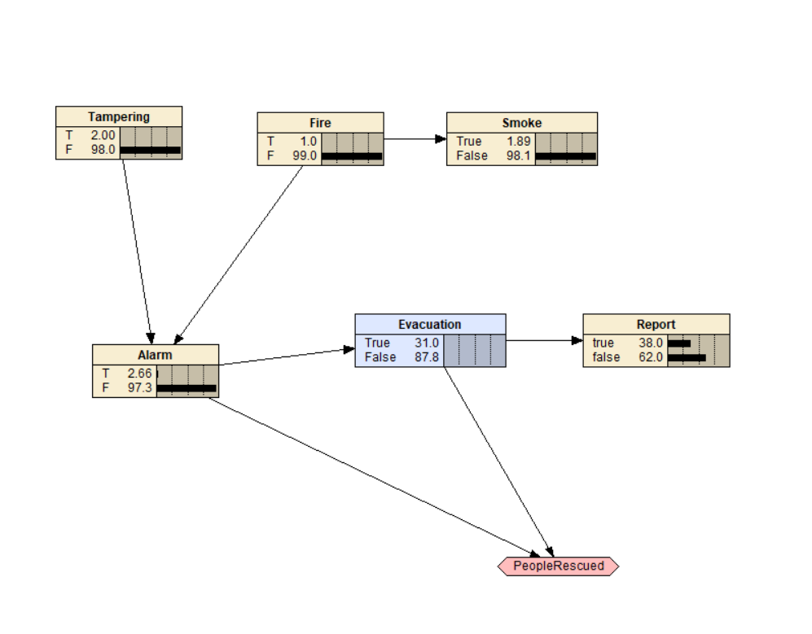

In the above diagram, Evacuation node changes from chance to decision node. People rescued has been taken as the utility node connecting it with the decision node and alarm which will impact the utility. Utility node values are taken as per our assumptions based on evacuation and alarm as mentioned below-

**Utility Table**

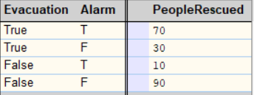

1. When Evacuation is true, and Alarm is on there is a fair chance of people getting rescued thus have 70 as the column value
2. When Evacuation is true Alarm is off, there are no casualties caused thus making the value 30 as there was an evacuation done despite of no alarm
3. When there is no evacuation and the alarm rang, there is less chance that people will get rescued and so has the utility value as 10
4. No evacuation was done and there was no alarm has the highest utility value as no causalities will be caused and there was no evacuation activity as well.

As we know, Informational Links indicates when a chance node needs to be observed before a decision is made.

Thus, above BDN has one information link from Alarm to Evacuation, as Alarm should be observed before evacuation should be done.