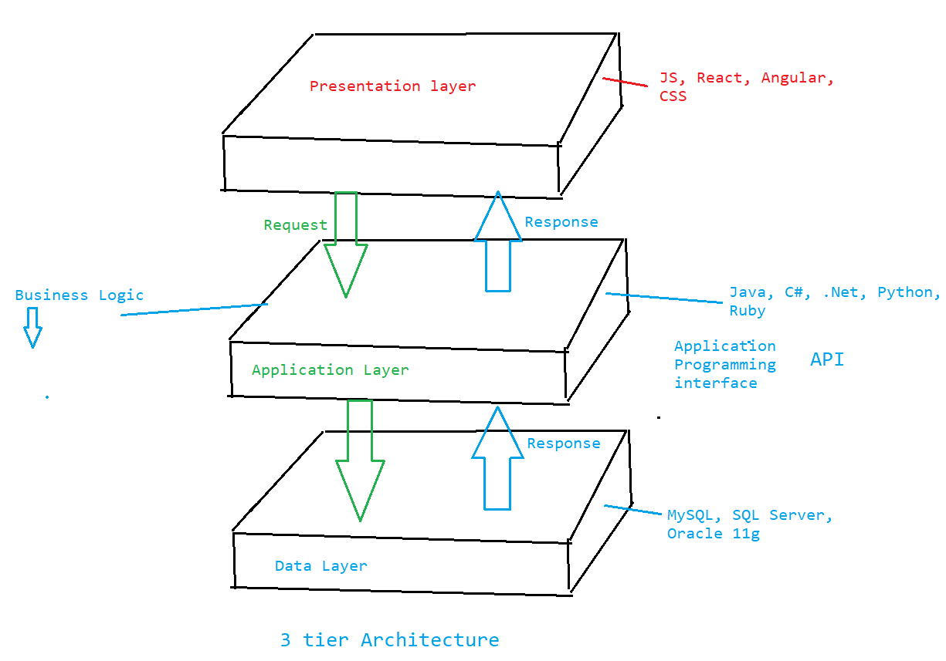

1. Presentation layer: It is responsible to show the output to the end user. Example can be a browser on which user tries to perform some actions and able to see the output.

2. Application layer: It is responsible to perform the validation as per the business logic through which it takes the request from the client (browser) and pass it to the data layer to fetch the output and let it to the presentation layer.
It sends the request and get the response that will be treated as an output.

3. Data Layer: It is the one which holds the data and provides to the API as a part of response which will further feed to the presentation layer.

