Telecom Project Notes
- Introduction:
Sending voice, data, picture, fax, etc., from one point to another using electronic media is termed as telecommunication and in short it terms as telecom.
Examples include Phone, Radio, Television and Internet.

- Parts of Telecom Domain:
- Business Support System(BSS) : This domain takes care of all the needs of customer. That is, it is responsible for generation of bills, fulfilling additional requirements, addressing each of the customer queries, providing value added services to the end user etc.(# We work under BSS Domain)
- Operational Support System(OSS): This domain works on activating and deactivating the services for customers. Restoring the services etc.

- Business Flow(the ways of revenue generation for service provider):
Telecom operators charge their customers in multiple ways, some of the ways are listed below:
- One Time Charge: Charged once at the time of connection.
- Rental Charges: These are the charges taken from the customers on monthly basis against a service provided. For example, your telephone monthly charges would be Rs 499 regardless you use it or not.
- Value added service Charge: If any extra services are subscribed, then these charges are charged.
- Usage charge: Depending upon the use of services these charges are taken
- Roaming charge
- Service Tax
- Documentation Charge
- SMS Charge

- Different Ways of Billing:
- Pre-pay Billing : where customer pays in advance and after that starts using a service. Usually, prepaid customers do not receive any invoice and they are charged in real time.
- Post pay Billing: Here, customers buy products and services and use them throughout the month, and by end of the month, invoices are generated by the service provider and sent those invoices to the customers to make their due payment.
- Interconnect Billing: The network operator is usually financially responsible for services provided to its customers by other networks regardless of whether or not the customer pays for the service.
- Roaming Charges: When a customer goes from one network operator's coverage area to another operator's coverage area, first operator would pay marginal charges to second operator to provide services to their customers. Such type of charges are settled through roaming billing.
- Convergent Billing: Convergent billing is the integration of all service charges onto a single customer invoice.

- Billing Systems:
Keeping track of all the billings and services would be very difficult manually, so a billing system is used which provides flexibility to both the service providers and customers.
- Features Of billing Systems:
- Rating & billing: This involves rating the products or services usage and producing monthly bills.
- Payment processing: This involves posting of the customer payments to customer's account.
- Credit control and collections: This involves chasing the outstanding payments and taking appropriate actions to get the payments.
- Disputes and adjustments: This involves recording any customer disputes against their bills and creating adjustments to refund the disputed amount in order to settle the disputes.
Pre-pay and post-pay services: This involves supporting both pre-paid and post-paid customer base.
- Multilingual & multiple currencies: Multilingual and multiple currencies support is required if the business is spread across the globe and have multinational customers.
- Inter-carrier settlements: This involves sharing of revenue between carriers that provide services to each other's customers.
- Products & services: This involves providing flexible way to maintain various products and services and sell them individually or in packages.
- Discount applications: This involves defining various discount schemes in order to reduce customer churn and attract and increase customer base.

- Technical flow (How Exactly the Billing System Works?):
CRM – Customer relationship Management
Siebel CRM is used and Amdocs billing is Used For bill Generation.
System Architecture:
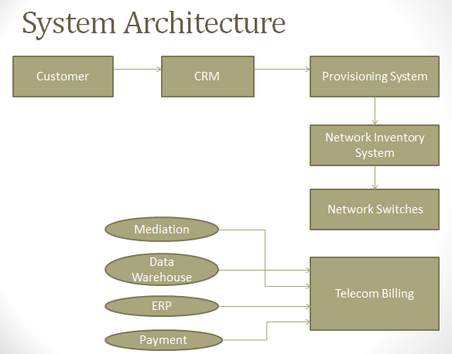

CRM/OMOF: This is the first system from where a customer order is captured and customer is created into the system. The CRM/OMOF(order management order Fulfillment) system keeps customer-related information along with product and services.
What does CRM do?

Actively tracks and manages customer information.
Connects your entire team from any device.
Intelligently captures customer emails.
Simplifies repetitive tasks so you can concentrate on leads.
Delivers instant insights and recommendations.
Extends and customises as your business grows.
Why CRM matters?

CRM helps you ditch clunky processes and manual effort so you can get on with business.
You’ll find more leads, close more deals, keep more customers and grow your business.
One place to store all customer information means your conversations are always personal, relevant, and up to date.

Provisioning System: Here the customer request will get segregated according to the core domain and then it will be transferred to a particular domain where it belongs. After taking provisioning commands, this system contacts with core network system to activate,
deactivate or suspend the services.

Network Inventory System: This system maintains all the network identifiers like phone numbers, MSISDN, IP addresses, e-mail, addresses, etc., and technically it is called Network Inventory System. This system is responsible to maintain the life cycle of network identifiers.

Network Switches: Network switches are responsible to provide all the services to the end customers based on what services have been provisioned for the customer.
Mediation: In this system all the usage made by customer is available i.e. call records, international calls, STD calls, SMS, MMS, data Usage etc. the CRD(Call Record Details) are available in ASN(Abstract Syntax Notation) format in the mediation. When the data transfer from mediation to any stage is required to be done it is done in xml format.
Data Warehouse: Billing System dumps various customer information into the Data warehouse system. This information includes service usage, invoices, payments, discounts and adjustments, etc.
ERP: An Enterprise Resource Planning ERP system provides modules to handle Financials, Human Resources and Supply Chain Management, etc. Billing System interface with this system is used to post all the financial transactions like invoices, payments, adjustments.
Payments: All payment related factors management.
- CRM Basic View:
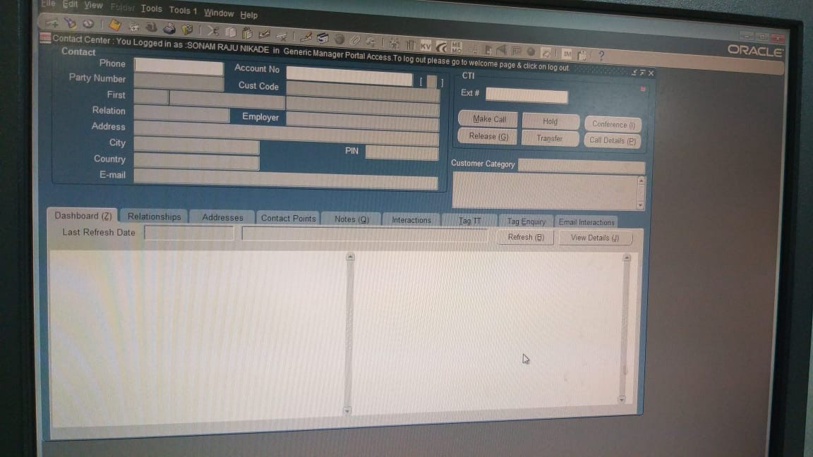
- Different tabs of CRM:
- Dashboard:
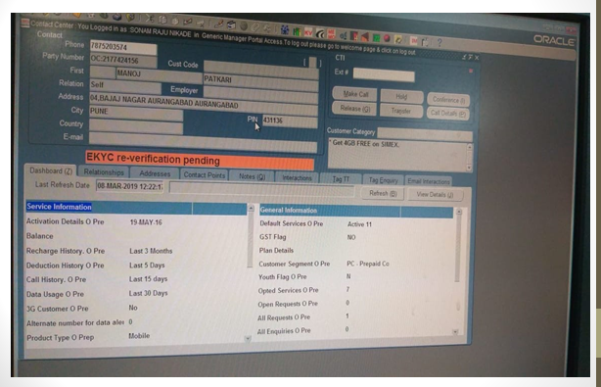
Here all service and general information related to customer is displayed.
. Scenarios
1. Verify that Operator is able to click on Dashboard tab.
2. Verify that Operator is able to seen the service information and general information.
3. Verify that Operator is able to see last refresh date and time in box.
4. Verify that Operator is able to click on refresh button.
5. Verify that Operator is able to click on view details button.
6. Verify that Operator is able to scroll down and scroll up under service information.
7. Verify that Operator is able to scroll down and scroll up under general information
B. Testing Performed
1. Smoke Testing
2 .Functional Testing
2.1 Behavioural coverage
2.2 Error handling coverage.
2.3 Backend coverage
3.Usability testing
5. Regression Testing

- Relationships:
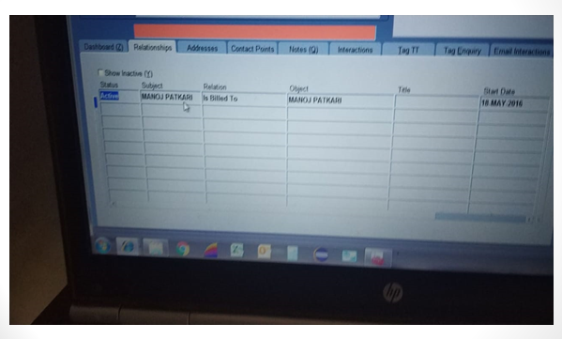
It consists of the customer details, if any other number is connected with the same customer. Billing details like to whom the bill is sent to etc. when the service started, all these details are available here.
A.)Scenarios→
- Verify Operator is able to click on relationships tab
- Verify the show inactive checkbox is operating as expected
- Verify data in grid is populated correctly
B) Types of testing:
- Sanity Testing
- Functional Testing
- Behavioural coverage
- Error handling coverage.
- Backend coverage
- Usability testing
- Regression Testing
- Addresses:
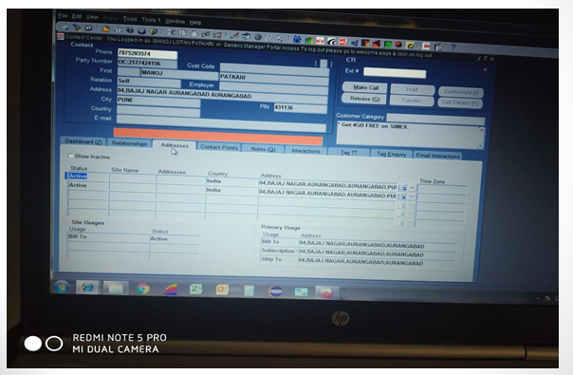
Here the active addresses of customer are available, on which address the bill should be sent, on which address the customer subscriptions are added each detail related to address about the customer is available here.
- Scenarios
- Verify User can click on Address tab
- Verify the functionality of show inactive checkbox
- Verify the status is rightly displayed
- Verify a new address can be added and old address is marked as inactive
- If new address is added, verify the primary usage is changed accordingly
- Verify new address is saved in database correctly
- Testings
- Sanity testing
- Functional Testing
- Behavioural coverage
- Error handling coverage.
- Backend coverage
- Usability testing
- Regression Testing
- Contact points:
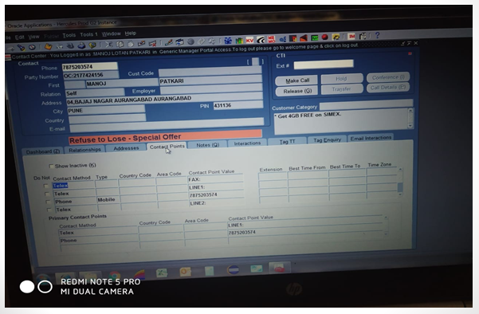
In this tab different contact points that is different ways of contacting customer are mentioned.
- Scenarios
- Verify contact points tab is clickable
- Verify the functionality of show inactive checkbox
- Verify the functionality of Do Not checkbox
- Verify data in primary contact fields table
- Testings performed
- Sanity testing
- Functional Testing
- Behavioural coverage
- Error handling coverage
- Usability testing
- Database testing
- Regression Testing

- Notes
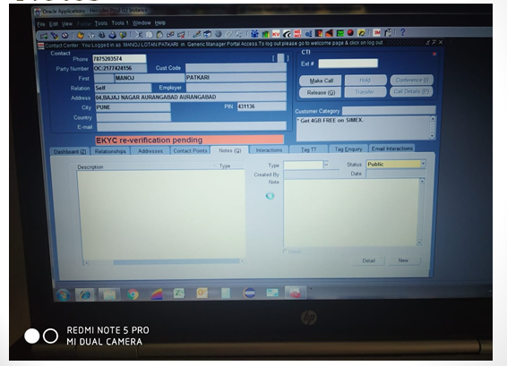
In this tab the description and notes of customer request can be added.
- Scenarios:
- Verify type dropdown is working fine
- Verify Status can be selected as Public/private
- Verify created by and date is auto populated
- Verify User can write in Notes text field
- Verify User can save a new note
- When new note is saved it is reflected in description and Type section
- Verify Newly added note is reflected in database.
- Interactions:
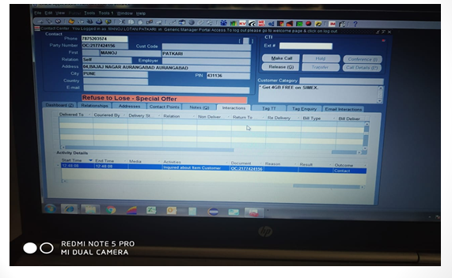
It displays whole status and the path followed by the customer request.
- Scenarios:
- Verify the activity details section has all required information
- Verify the start time and end time of the request
- Verify if the request is still not closed, end time should not be visible
- Verify by clicking on document name we can view the document
- Verify in the grid available we can see the data is well updated as per process
- Verify the scroll bars are working as expected
- Testings Performed:
- Sanity testing
- Functional Testing
- Behavioural coverage
- Backend coverage
- Usability testing
- Regression Testing

- Tag TT:
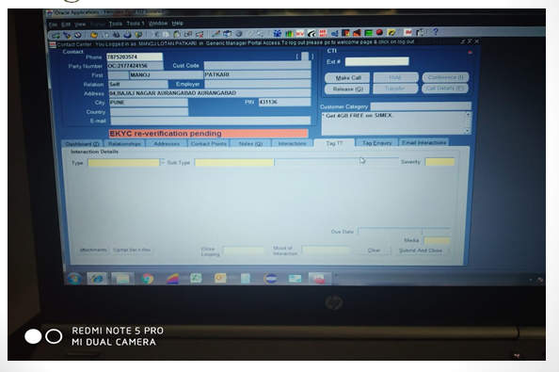

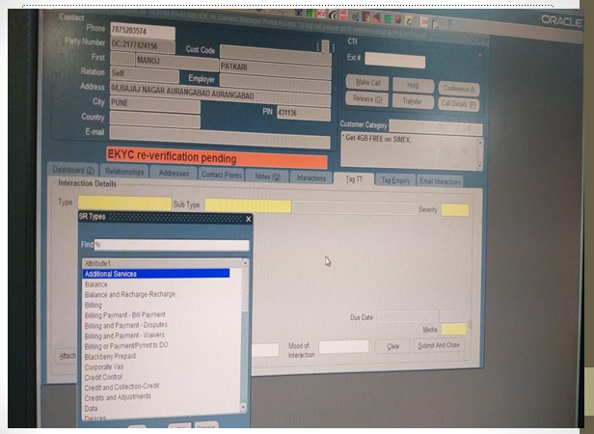

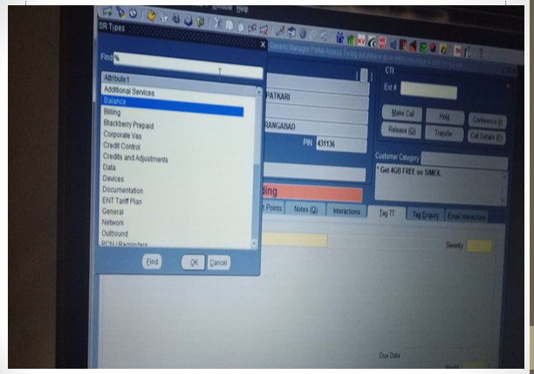
In this tab we can set problem type, its subtype, its severity etc.
- Scenarios:
- To select type the type popup is opening
- The find filter is working fine in Type popup
- Depending upon type selection, subtype is getting displayed
- Verify the severity of issue can be set
- Verify Due date is auto populating based on severity
- Verify functionality of clear button
- Verify attachments can be uploaded using attachment button
- Verify the functionality of submit and clear button
- Testings Performed:
- Sanity testing
- Functional Testing
- Behavioural coverage
- Backend coverage
- Usability testing
- Regression Testing
- Error handling coverage
Boundary value analysis

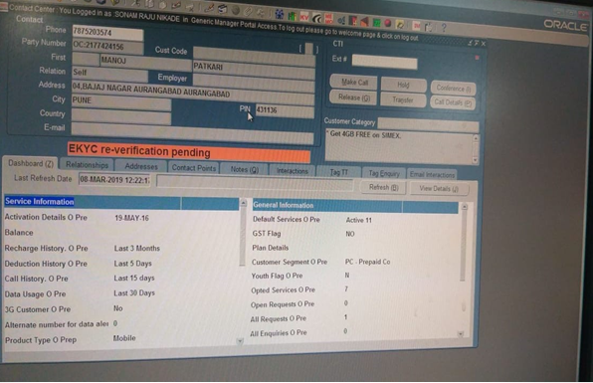

Interview Questions
      - Tell me about your project?
      - Explain Business flow of project
      - Tell me Technical flow of your project
      - What kind of issue you have faced in last project? In the last project we have faced like due to data base server issue we couldn’t test the functionality so we have raised to technical( server team) and raised in scrum call and resolved the issue and then completed testing
      - What was the last defect raised in project? In last project on dashboard functionality last refresh date and time not displayed after click over refresh button
      - Table name crm_dashboard, crm_relationship, crm_adress, crm_tagtt

