**[Semester Project Overlook Hotel]**

**Ameya Mahankal, 326157**

**Bozhidar Manev, 326391**

**Joan Tamm, 325753**

**Radoslav Kiryazov, 326155**

**Zsolt Nóvé, 326345**

**Software Technology Engineering**

**Semester 1**

**[23/03/2022]**

Version: May, 2019

**Table of Contents**

**Background Description** **4**

**Problem Statement** **5**

**Definition of purpose** **6**

**Delimitation** **6**

**Methodology** **7**

**Time schedule** **8**

**Risk assessment** **9**

**Sources of Information** **10**

**Appendices** **11**

# Background Description

Overlook hotel is a small family-owned business that has unfortunately fallen behind the times. Their booking management method is outdated, causing the staff and the guests unnecessary confusion and problems, which could be easily avoided. The aim of the project is to modernise the already existing system, used by the hotel(client), with a new, more reliable and easy to use single user offline system managed by one person on a single computer.

The hotel currently uses a ledger staffed by the receptionist at the front desk to book reservations for its guests. This is proving to be a challenge for the staff to manage and organise, which could lead to inconveniences for the guests. It could also impact the future reputation of the hotel.

Although there are cloud-based programs that are meant for booking, they are prone to data loss, making them less reliable and appealing alternatives for their current methodology.

The hotel has 32 rooms and 5 suites over two floors of various sizes and prices which can also accommodate additional requests such as extra bed, smoking, late arrival etc[1].

# Problem Statement

The hotel is losing business due to the lack of a proper booking system. The limitations of the ledger are already reached.

Issues:

* Registering the details of the guest(name, home address, date of birth, nationality)
* Managing guests' details
* Displaying a list of free rooms
* Assigning rooms to each guest
* Adjusting the price of each room
* Managing the demands of the guest(smoking, discount, changing rooms, late arrival, extra bed etc)
* Avoiding double-booking of rooms
* Handling check-in and check-out of guests
* Displaying a list of guests that will arrive on a certain day and with assigned room

# Definition of purpose

The purpose of the program is to facilitate the booking process, reducing the number of errors caused by the lack of a precise method for room booking in Overlook Hotel.

# 

# Delimitation

1. Not developing a multi-user system.
2. Not keeping a historical archive of bookings and guests.
3. Not developing an online booking system.
4. Not developing a cloud-based program.

# Methodology

An analysis of the problem will be done to help in the designing of the UML diagrams.

By using the diagrams as a guide, the process of implementing the functions of the program will begin.

Multiple testing sessions will be done to detect problems in the implementation process of the program.

After the analysis, the process of designing the UML diagrams in Astah will begin. The UML diagrams will showcase the proper number of classes, their instance fields, and the corresponding methods within them.

The implementation process will be done in IntelliJ. The program in IntelliJ will be constructed based on the UML diagrams. The implementation process will be divided by the number of designed classes between the members of the group. Each member will take the responsibility of building a part of the program.

Multiple meetings will be held for testing the program and fixing the problems related to the implementation process.

# Time schedule

**(Using the waterfall model)**

**Analysis**

*23/March/2022*

Approximate hours spent : 125h

**Design**

*(20/April/2022)*

Approximate hours spent : 325h

**Implementation**

*(02/May/2022)*

Approximate hours spent . 450h

**Testing**

*(20/May/2022)*

Approximate hours spent : 230h

**Handing-in**

*(02/June/2022)*

Approximate hours spent : 20h

# Risk assessment

| Risks | Likelihood  Scale: 1-5  5 = high-risk | Severity  Scale: 1-5  5 = high-risk | Product of likelihood and severity | Risk mitigation e.g. Preventive- & Responsive actions | Identifiers | Responsible |
| --- | --- | --- | --- | --- | --- | --- |
| Scope Creep | 3 | 4 | 12 | We will regularly review the scope of the project to ensure we do not develop unnecessary functions | Lack of project management practices | Bojidar Manev |
| Difference between the design of the program and its implementation in IntelliJ | 4 | 4 | 16 | Regular comparisons between code and its implementation in IntelliJ | The program is functioning differently than how it was envisioned in Astah | Ameya Mahankal |
| Website support and maintenance. | 5 | 2 | 10 | Supporting the server hosting the website and updating info regarding the clients business. | The information provided in the website does not correspond to the new updated one. | Radoslav Kiryazov |
| Client dissatisfaction with usability. | 1 | 5 | 5 | Satisfying the requests of client, providing regular updates and performing tests with employees. | Client employees unable to operate the program causing problems between the team an the client. | Joan  Tammo ,  Zsolt Nóvé |

# Sources of Information

Jon Duckett. 2011. HTML & CSS Design and Build Websites. Tony Gaddis. 2015. Starting out with Java-Early Objects. 5th ed. Haywood Community College

Kenneth H. 2012. Rosen. Discrete Mathematics and its Applications. 7th ed. Monmouth University

Jon Duckett. 2011. HTML & CSS Design and Build Websites.

# Appendices

Our contract:

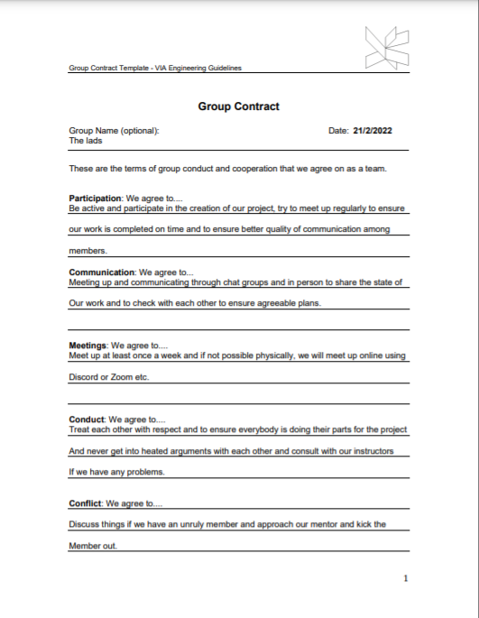

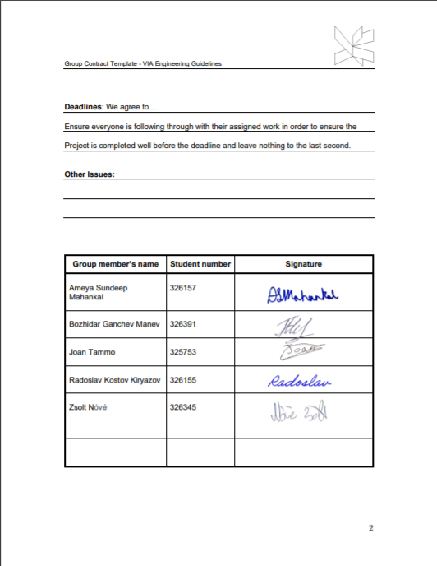

1. Transcript of Overlook Hotel interview