Two-Sample t-Test

12/02/2021 20:59

# Abstract

Outcome variable: *BodyFatPctg*  
Predictor (grouping) variable: *Group*  
Null difference in means: *0*  
Alternative hypothesis: *two.sided*

A two-sample t-test is employed to check if the difference in means equals 0. According to the result, we can reject the null difference and get the conclusion, two.sided, at the significance level of 0.05.

### Two-Sample t-Test

The two-sample t-test is used to determine if the means of two independent populations are equal under normal distributed assumption.

# Descriptive Statistics

Table 1 gives the basic information of the analyzing data set. Observations with missing values are removed when calculating.

$Table 1.$ Completeness of data.

|  |  |  |
| --- | --- | --- |
|  | Observation | Incomplete Observation (not used) |
| Number | 23 | 0 |

Table 2 gives the descriptive statistics.

$Table 2.$*Descriptive statistics.*

|  |  |  |  |  |
| --- | --- | --- | --- | --- |
| Group | n | Percent | BodyFatPctg mean | sd |
| *Men* | 13 | 56.52 | 14.9 | 6.8 |
| *Women* | 10 | 43.48 | 22.3 | 5.3 |
| *All* | 23 | 100.00 | 18.1 | 7.1 |

The box plots for each group are given by

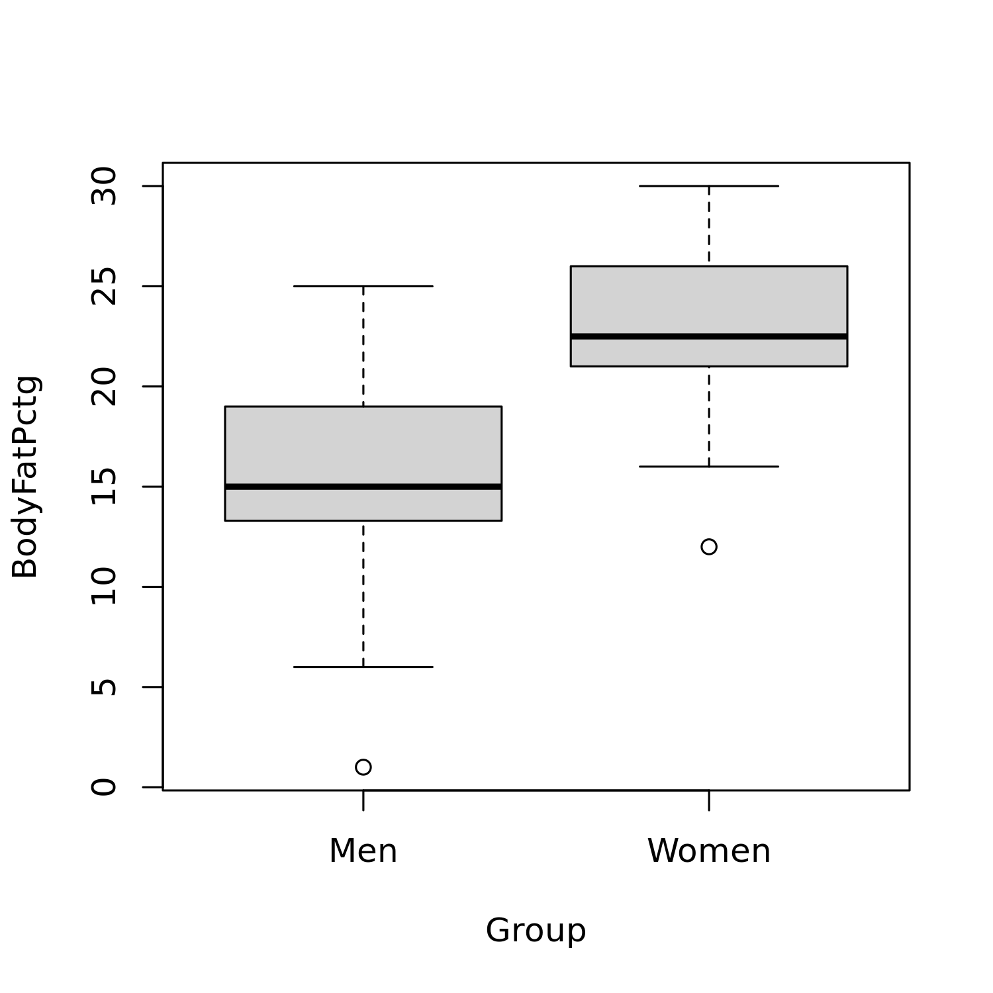

$Figure 1.$ Box plot for each group.

The box plot shows the shape of the distribution and its central value for each sample. In a box, the ends of the box are the upper and lower quartiles.

# Results

The mean estimations are given along with their difference, and the 95% confidence interval of the difference in Table 3.

$Table 3.$ Two groups data comparison.

|  |  |  |  |  |
| --- | --- | --- | --- | --- |
| mean in group Men | mean in group Women | Difference | Lower | Upper |
| 14.946 | 22.29 | -7.344 | -12.798 | -1.889 |

To test the homogeneity of variances, Bartlett’s test is employed (Bartlett 1937).

$Table 4.$ Result of Bartlett test.

|  |  |  |
| --- | --- | --- |
| Bartlett’s K-squared | df | p-value |
| 0.601 | 1 | 0.438 |

Bartlett’s test is used to test if *k* samples are from populations with equal variances. The null hypothesis of Bartlett’s test is that the variances of all populations are the same. Thus, if the *p*-value is less than the chosen significance level (typically 0.05), then the null hypothesis is rejected and there is evidence that at least two variances are different.

In this case, Bartlett’s test *p*-value is greater than 0.05, indicating that the variances in different groups are the same.

Based on the above result, a t-test with an option “two.sided” and “equal variance assumption” is employed (Birnbaum, Tingey, and others 1951; Durbin 1973). The following table gives the results of the t-test, t-statistic, degree of freedom, and *p*-value.

$Table 5.$ Results of the two-sample t-test.

|  |  |  |  |  |  |
| --- | --- | --- | --- | --- | --- |
|  | Null Value | Alternative Hypothesis | t | df | p-value |
| Two Sample t-test | 0 | two.sided | -2.8 | 21 | 0.011 |

It is the result of the t-test. The most important is the *p*-value. If it is less than a given threshold (commonly used significance level is 0.05), the null hypothesis is rejected. In other words, the alternative hypothesis can be accepted. If it is greater than the threshold, the null hypothesis cannot be rejected. The null hypothesis can be accepted.

The test *p*-value is less than or equal to 0.05,indicating that there is significant difference between the difference of the two groups and the null value. In other words, the sample mean is different from the null value.

## Assumption Checking

In this section, we will check the normal distribution assumptions of the model. First, we give the following Q-Q plot.

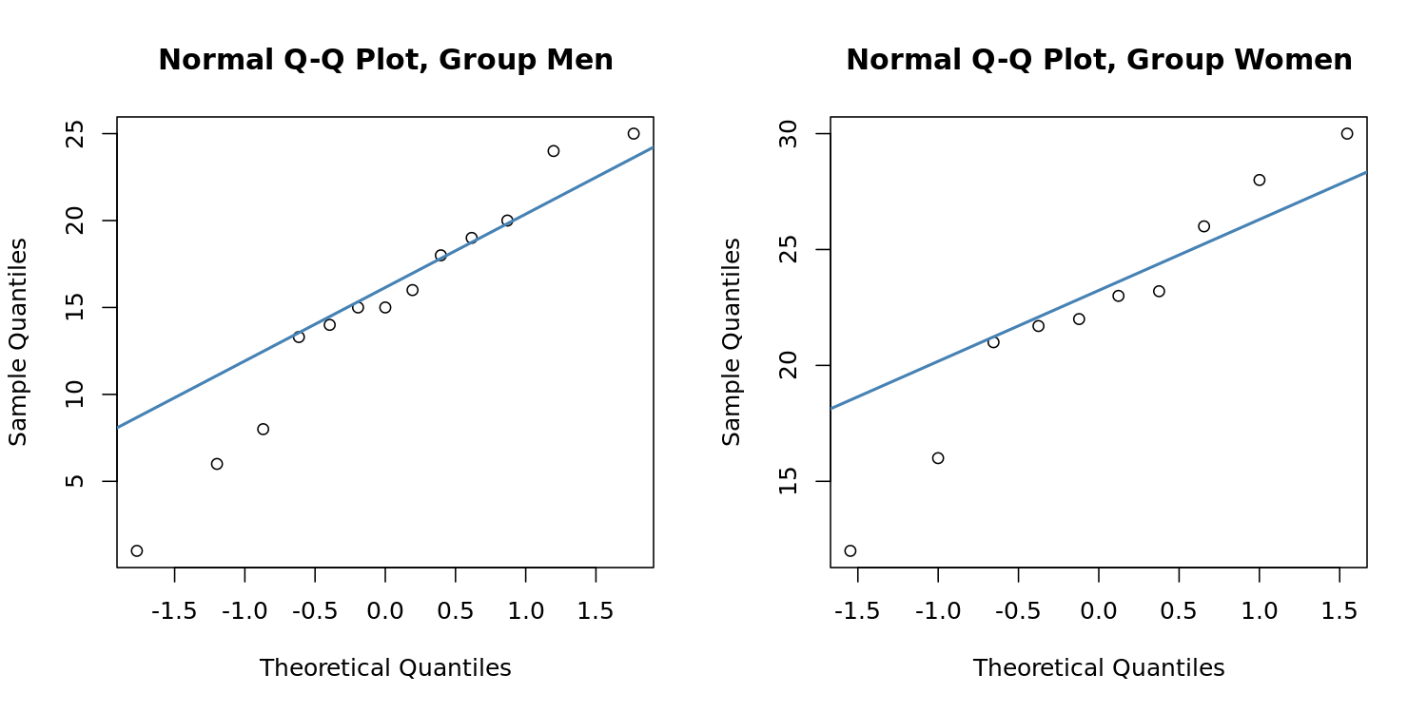

$Figure 2.$ Normal Q-Q plot for each group.

QQ plot is a graphical method for comparing two probability distributions by plotting their quantiles against each other. One is the estimated distribution of the observations and the other is the normal distribution. If the points are located around the diagonal line, then the population where the sample comes from is normally distributed.

If the observations are located around the diagonal line, it is normally distributed.

Then, we employ both the Shapiro-Wilk test and the Kolmogorov-Smirnov test to check the normality assumption of the data. The results are given by:

$Table 6.$ Results of normality assumption checking.

|  |  |  |
| --- | --- | --- |
|  | Statistics | p-values |
| Kolmogorov-Smirnov test, Group=Men | 0.174 | 0.825 |
| Shapiro-Wilk test, Group=Men | 0.958 | 0.730 |
| Kolmogorov-Smirnov test, Group=Women | 0.204 | 0.727 |
| Shapiro-Wilk test, Group=Women | 0.952 | 0.691 |

An important assumption of the t-test is that the population(s) being compared should follow a normal distribution(s). In this section, the Q-Q plot and normality test are employed to check this assumption.

# Conclusions

Based on the above results, we can get the following conclusions:

* There is a significant difference between the mean difference and the null value at the significance level of 0.05. In other words, the difference of the means is different from the null value.
* The normal distribution assumption can be acceptable. The t-test result is recommended.

# Terminology

***confidence interval:*** In statistics, a confidence interval (CI) is a type of interval estimate, computed from the statistics of the observed data, that might contain the true value of an unknown population parameter.

***p-value:*** The *p*-value is, for a given statistical model, the probability that, when the null hypothesis is true, the statistical summary would be greater than or equal to the actual observed results.

***standard deviation:*** In statistics, the standard deviation is a measure that is used to quantify the amount of variation or dispersion of a set of data values.

***sample mean:*** In statistics, the sample mean is defined as the average of n observations from the sample.

***t-test statistic(t):*** A statistic, which is constructed by the sample, follows a known distribution asymptotically under a null hypothesis. Hence, it can be used to test hypotheses and define p-value.

***normality:*** Normality means that the distribution of the test is bell-shaped.

***degrees of freedom:*** In statistics, the number of degrees of freedom is the number of values in the final calculation of a statistic that are free to vary.

# References

Bartlett, Maurice Stevenson. 1937. “Properties of Sufficiency and Statistical Tests.” *Proceedings of the Royal Society of London. Series A-Mathematical and Physical Sciences* 160 (901): 268–82.

Birnbaum, ZW, Fred H Tingey, and others. 1951. “One-Sided Confidence Contours for Probability Distribution Functions.” *The Annals of Mathematical Statistics* 22 (4): 592–96.

Durbin, James. 1973. *Distribution Theory for Tests Based on the Sample Distribution Function*. Vol. 9. Siam.