The objective of this assignment was to create a program that generated 100 random genome sequences. Each sequence should be 10 characters long. We should also test the program using concurrency and report the differences between single thread and multithread.

First, I decided to use an Array list for anything that I knew what the length was going to be beforehand. It seemed like this would be a more efficient use of memory space than an Array List since we would not be adding more items into them. For example, I used this to input into the RandomStringGenerator class the 4 characters for our genome sequence. I also use this to save the 100 genome samples that are an output for our program.

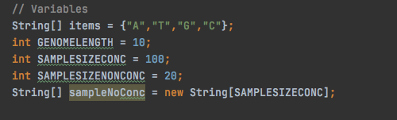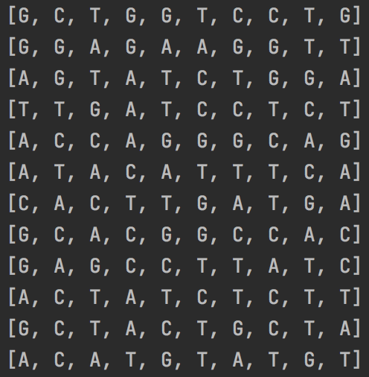

Once I had done the manual 100 genome sequence I added the possibility of multithreading. In the test in the main class we have 5 threads with 20 samples each. I had to create a second constructor in order to have some additional information needed for multithreading. I overrode the run() method from the thread class and had it also run my main createRandomString() method. When timing how long it took to run everything I realized that I had to use join() before ending the time calculation for multithreading in order for it to make sure to run and finalize all threads first.

The final calculations showed that multithreading was usually a few million nanoseconds faster than when I calculated the single thread. Below is a sample output of my tests.

