Samuel Morales Zamorano
IT: 1044 (Marron)
HW_07

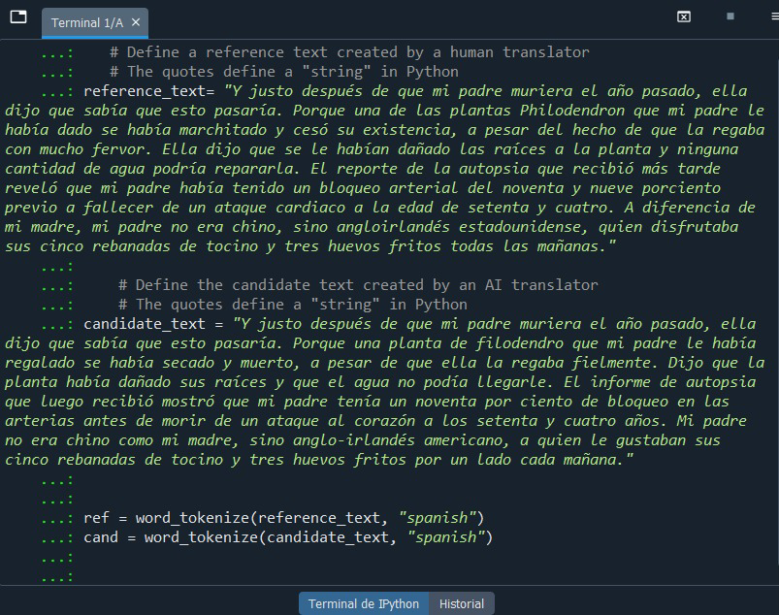
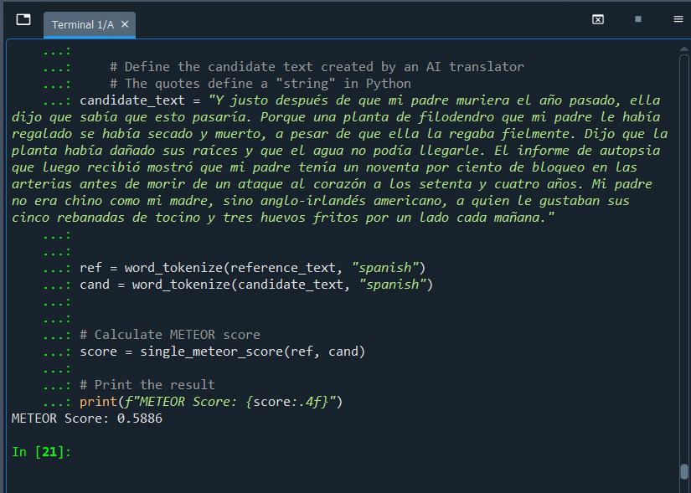
Task 1: Python.

Task 2: Creative writing.
Peter had never been a good liar; everyone could always read him like an open book. But when the principal asked who had broken the lab microscope, he surprised even himself. With a steady voice and a calm expression, he said he had been nowhere near the science room. The lie slipped out cleanly, almost elegantly, and the principal believed him instantly. As he walked out of the office, Peter felt a rush—part victory, part guilt. He had protected his best friend, but something in him had shifted. If lying could be that easy, he wondered what else he might be capable of.

Task 3: “The Joy Luck Club” summary.
The life of Ying-Ying is full of symbolisms between appearance and reality. The pain of losing her first husband made her take decisions that would be burdened. One was to have an abortion and the other was to marry again. Both make them look like an old poor woman. And it was not until her first husband died, that she could love the second.
Her life story is hidden even from her daughter, but both stories ended up with similarities. A primary theme of this section is that strength lies in confronting the past. Both mother and daughter need to evaluate life and gather the threads to use them as tools to regain the spirit.
Ying Ying has determined that freeing her daughter’s strength will be her legacy.

La vida de Ying-Ying está llena de simbolismos entre la apariencia y la realidad. El dolor de perder a su primer marido la llevó a tomar decisiones que le supondrían una carga. Una fue abortar y la otra fue volver a casarse. Ambas la hacen parecer una anciana pobre. Y no fue hasta que murió su primer marido cuando pudo amar al segundo.
La historia de su vida está oculta incluso para su hija, pero ambas historias terminan con similitudes. Un tema principal de esta sección es que la fuerza reside en enfrentarse al pasado. Tanto la madre como la hija necesitan evaluar la vida y reunir los hilos para utilizarlos como herramientas para recuperar el espíritu.
Ying Ying ha decidido que liberar la fuerza de su hija será su legado.

