Exam 3P
Course Title: | Terminología Especializada en Tecnología Inglés-Español
Course ID: | IT0627 (Marron), 26-1
Cohort ID: | 6.2
Exam Date: | 09 Dec 2025

General Instructions: Print your name in the upper right-hand corner of this paper. Read each item carefully. Be sure that you understand exactly what is being asked of you. Do not look at other student’s exams. If you have a question or a request during the exam, raise your hand and the instructor will call on you.

This is an open book exam. You may use HW_10 to help you with the exam. Attempt to answer all questions, even if you are uncertain. Whenever possible, provide answers in bullet list format with complete content. Tasks will be evaluated by sub-tasks. Three (3) points are available for each sub-task: Accuracy (1 pt), Completeness (1 pt), and Sufficiency (1 pt). Points will be awarded in 0.1 increments. Answer in English unless requested to do so otherwise.

Task 1 (6 pts)
The figure below is from Sir David Mackay’s chapter on the advantages of sexual reproduction. Answer the following questions related to this figure.
- What is meant by the term, evolutionary fitness?
- Explain the difference between the graphs shown in (b) and (c) .

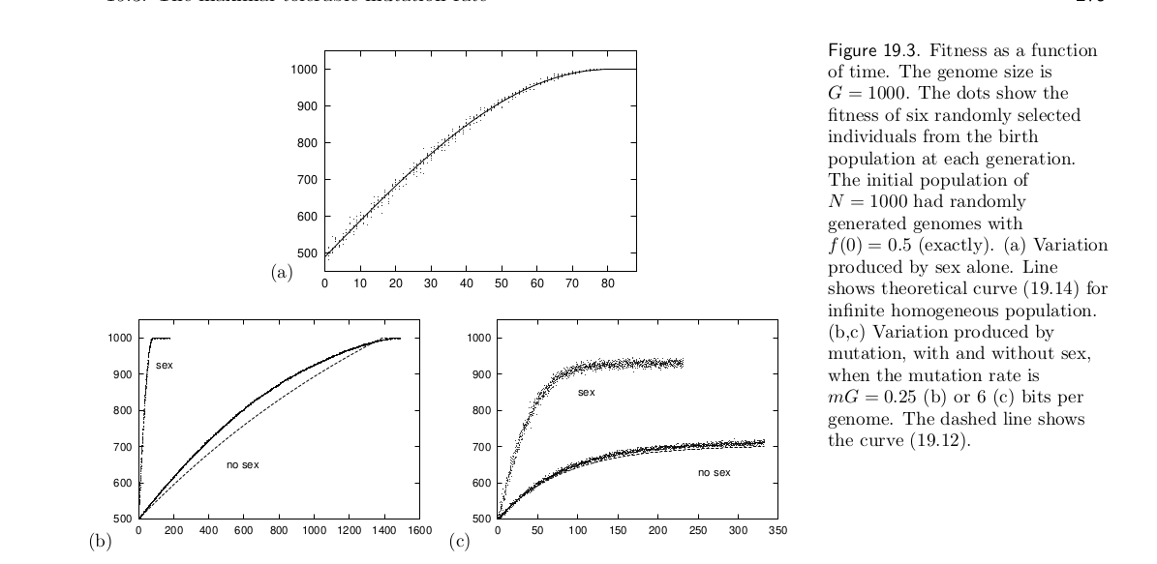

Task 2 (6 pts)
In the "real world", large organizations (both public and private) get work done by hiring contractors through an RFP (Request for Proposal) process.
- Define the term, RFP and explain how it relates to contract work.
- Briefly explain the main reasons why the RFP process is used for hiring contractors.

Task 3 (6 pts)
Astrobiology is an emerging science “that has come to the forefront of astronomy in recent years and promises to answer one of the most fundamental questions of humanity.” Answer the following questions related to astrobiology.
- What is the science of astrobiology?
- Three important lines of research in astrobiology are i) defining a habitable environments, ii) identifying biosignatures, and iii) defining technosignatures. Briefly explain what is meant by each of these research areas.

Task 4 (6 pts)
Current agribusiness models of agriculture are costly in terms of their required inputs (water, fertilizers, pesticides, land conditioners, etc.) as well as their huge environmental impact. Modern methods of agriculture are not sustainable. One readily achievable method of enhanced productivity with a lower environmental cost is crop rotation Another option is to reduce the consumption of animal protein in favor of plant protein. Answer the following questions.
- Why do many people consider crop rotation as a "top priority" for agriculture?
- What are the advantages of crop rotation?
- What are your thoughts on an animal-based vs. a plant-based diet?

Task 5 (6 pts)
There is little doubt that artificial intelligence (AI) agents will transform our world. The question is, Will the transformations be benign, like the use of electricity, or will this technology overpower us? The AI Futures Project predicts a rather dystopian future while Richard David Hames sees a promising outcome. Answer the following questions.
- Do you consult AI agents? About how often do you interact with AI agents on a weekly basis?
- Given the two readings above, what are your thoughts concerning the dangers and the promise of AI?

Task 6 (9 pts)
Define the following terms in English.

exoplanetary | polyunsaturated
affect vs effect | epidemiology
arable | stochasticity
gravimetric | catalyst
monoculture | deleterious
resilience | genome
synergistic vs antagonistic | qualitative vs quantitative
antioxidant | symmetry
Large Language Model (LLM) | prompt engineering
reinforcement learning with human feedback (RLHF) | emergence

MacKay, D. J. (2003). Information theory, inference and learning algorithms. Cambridge university press.
Focus on astrobiology. Nat Astron 8, 1 (2024). https://doi.org/10.1038/s41550-024-02193-z
Yang, X., Xiong, J., Du, T., Ju, X., Gan, Y., Li, S., ... & Butterbach-Bahl, K. (2024). Diversifying crop rotation increases food production, reduces net greenhouse gas emissions and improves soil health. Nature Communications, 15(1), 198.
Andrews, C. J., Raubenheimer, D., Simpson, S. J., & Senior, A. M. (2025). Associations between national plant-based vs animal-based protein supplies and age-specific mortality in human populations. Nature Communications, 16(1), 3431.
AI 2027 https://ai-2027.com/
The Future of AI: A Radcal Vision for Humanity's Next Chapter htps://richarddavidhames.substack.com/p/the-future-of-ai

