Exam 1
Course Title: | Terminología Especializada en Económica y Mercados Bursátiles
Course ID: | IT0522 (Marron, 25-2)
Cohort ID: | 5C
Exam Date: | 13 Feb 2025

General Instructions: Print your name in the upper right-hand corner of this paper. Read each item carefully. Be sure that you understand exactly what is being asked of you. Begin your answers on the backside of this paper if possible and add extra sheets of paper as needed. Be sure to write your name on any and all extra sheets of paper. Staple all exam papers together when you are finished.

Do not look at other student’s exams. If you have a question or a request during the exam, raise your hand and the instructor will call on you.. Do not leave your desk without permission. If you finish early, raise your hand and the instructor will call on you.

This is a closed book exam. Attempt to answer all questions, even if you are uncertain. Whenever possible, provide answers in bullet list format with complete content. Tasks will be evaluated by sub-tasks. Three (3) points are available for each sub-task: Accuracy (1 pt), Completeness (1 pt), and Sufficiency (1 pt). Points will be awarded in 0.1 increments. Answer in English unless requested to do so otherwise.

Task 1 (6 pts)
Briefly summarize your paper on the history of a field of economics in Mexico. Recount the general history of the field you selected, but focus on the present state of the discipline in Mexico.

Task 2 (6 pts)
Traditional economics is defined as the study of choice under conditions of scarcity. All choice carries an opportunity cost.

Evaluate the statements above by answering the following questions:
- According to economics, what is scarce?
- Why does economics state that opportunity cost results from choice?

Task 3 (6 pts)
A theorem of standard (Western) economics is that in a market system, individuals are not simply free to do what they want but are constrained by the resources they control. From this it follows that some individuals may have more or less resources under their control than others.

- Explain the differences between a traditional economy, a centrally controlled economy, and a market economy.
- Would individuals be economically constrained under the other two economic systems? Explain why or why not.

Task 4 (6 pts)
Explain the flows in the following model (Fig. 1-1 The Standard Circular Flow Model)
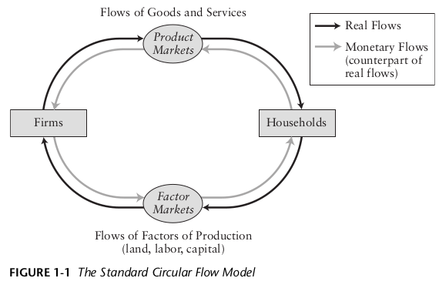

Task 5 (6 pts)
Explain the flows of materials and energy in the following model (Fig. 1-2 A Broader Circular Flow Model)

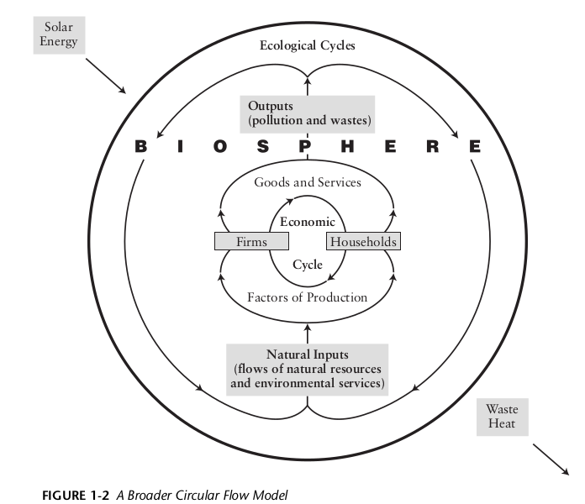

Task 6 (3 pts)
Barring strange and unusual events, a functional biosphere is a necessary and sufficient condition for the existence of the human species. That is, human existence is possible if and only if there is a functional biosphere. Why does excess consumption (i.e, extractive capitalism fueled by neoclassical economics) jeopardize human existence?

Task 7 (9 pts)
Modern banking systems consist of a central bank and various other types of banks. The central bank is a nation’s principal monetary authority.

Answer the following questions regarding banking systems:
- Compare the structure and functions of the central banks of México (Banco de México) and the US (Federal Reserve). How are they different? How are they the same?
- What is a bank? What are the functions of a bank? What types of banks exist in México?
- Define the terms in English: i) loan, ii) IOU, iii) assets, iv) liabilities, v) reserves, vi) net worth
- Translate the terms to Spanish: i) loan, ii) IOU, iii) assets, iv) liabilities, v) reserves, vi) net worth

