Study Guide for Exam 1
Course Title: | Terminología Especializada en Económica y Mercados Bursátiles
Course ID: | IT0524 (Marron, 25-2)
Cohort ID: | 5C
Exam Date: | 13 Feb 2025

General Instructions: A detailed and thorough study and review of the following tasks will prepare you for our first (partial) exam.

Task 1
Be able to write a condensed summary from your paper on the history of a field of economics in Mexico. Your condensed summary should certainly recount the history of the economic field you selected, but it must focus on the present state of the field in Mexico. You should be able to write this condensed summary in both English and Spanish.

Task 2
Traditional economics is defined as the study of choice under conditions of scarcity. All choice carries an opportunity cost.

Evaluate these statements by answering the following questions:
- According to economics, what is scarce?
- Why does economics state that opportunity cost results from choice?

Task 3
A theorem of standard (Western) economics is that in a market system, individuals are not simply free to do what they want but are constrained by the resources they control. From this follows that individuals may have more or less resources under their control than others.

- Explain the differences between a traditional economy, a centrally controlled economy, and a market economy.
- Would individuals be economically constrained under the other two economic systems? Explain why or why not.

Task 4
Explain the flows in the following model (Fig. 1-1 The Standard Circular Flow Model)
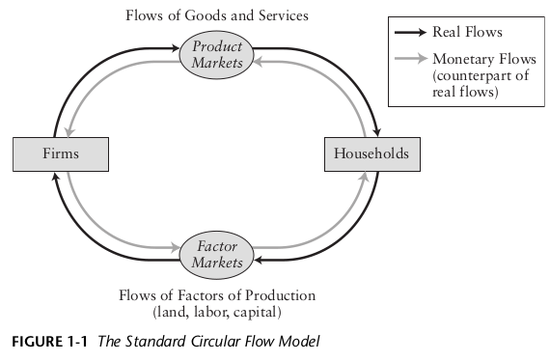

Task 5
Explain the flows of materials and energy in the following model (Fig. 1-2 A Broader Circular Flow Model)

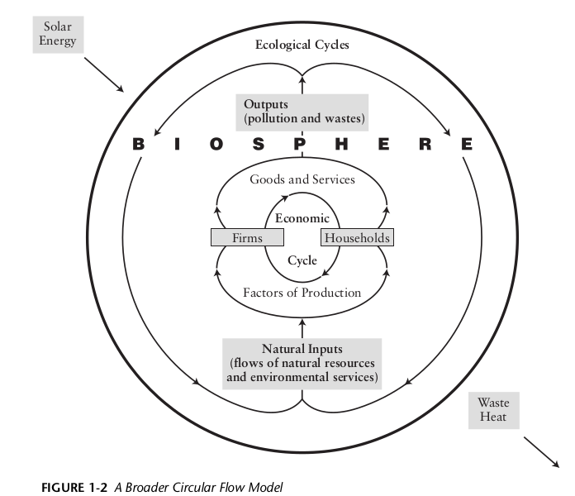

Task 6
Barring strange and unusual events, a functional biosphere is a necessary and sufficient condition for the existence of the human species. That is, human existence is possible if and only if there is a functional biosphere. Why does excess consumption (i.e, extractive capitalism fueled by neoclassical economics) jeopardize human existence?

Task 7
Modern banking systems consist of a central bank and various other types of banks. The central bank is a nation’s principal monetary authority.

Answer the following questions regarding banking systems:
- Compare the structure and functions of the central banks of México (Banco de México) and the US (Federal Reserve). How are they different? How are they the same?
- What is a bank? What are the functions of a bank? What types of banks exist in México?
- Define the terms in English: i) loan, ii) IOU, iii) assets, iv) liabilities, v) reserves, vi) net worth
- Translate the terms to Spanish: i) loan, ii) IOU, iii) assets, iv) liabilities, v) reserves, vi) net worth

